**NM-PROJECT_PRODUCT DEMAND-PHASE 2**

**Name: Jay Adithya V**

**Reg.no:2021503716**

**Product Demand Prediction (Case Study)**

A product company plans to offer discounts on its product during the upcoming holiday season. The company wants to find the price at which its product can be a better deal compared to its competitors. For this task, the company provided a dataset of past changes in sales based on price changes. You need to train a model that can predict the demand for the product in the market with different price segments.

The dataset that we have for this task contains data about:

the product id; store id; total price at which product was sold; base price at which product was sold; Units sold (quantity demanded);

Hope you now understand what kind of problem statements you will get for the product demand prediction task. In the section below, let's walk through predicting product demand with machine learning using Python.

**CODE:**

**import** pandas **as** pd

**import** numpy **as** np

**import** matplotlib.pyplot **as** plt

plt**.**style**.**use('ggplot')

plt**.**rc('patch', force_edgecolor**=True**,edgecolor**=**'black')

plt**.**rc('hist', bins**=**'auto')

**from** sklearn.preprocessing **import** StandardScaler

**from** sklearn.metrics **import** mean_squared_error

**from** sklearn.model_selection **import** train_test_split

test **=** pd**.**read_csv('../csv_folder/test.csv')

test

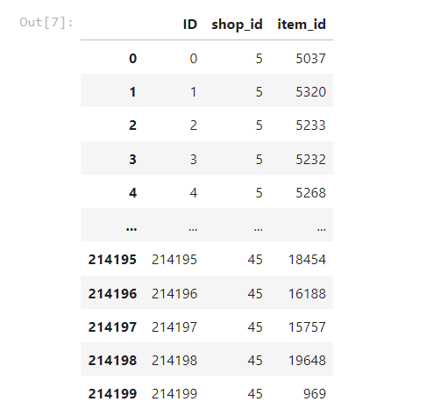

train **=** pd**.**read_csv('../csv_folder/sales_train.csv')

train **=** train**.**pivot_table(index **=** ['shop_id','item_id'],

values **=** ['item_cnt_day'],

columns **=** ['date_block_num'],

fill_value **=** 0,

aggfunc**=**'sum')

train

