Proposal for Find Dry Chargers

Title: Find Dry Chargers: Chris Duhaime, Michael Johnson, Jason Nestor, John Sauter.

Description: Locate chargers for electric vehicles in places where it isn’t raining.

User Story: **As a** driver of an electric vehicle on a long trip **I want** to charge my car in places where it isn’t raining **so that** I won’t get wet.

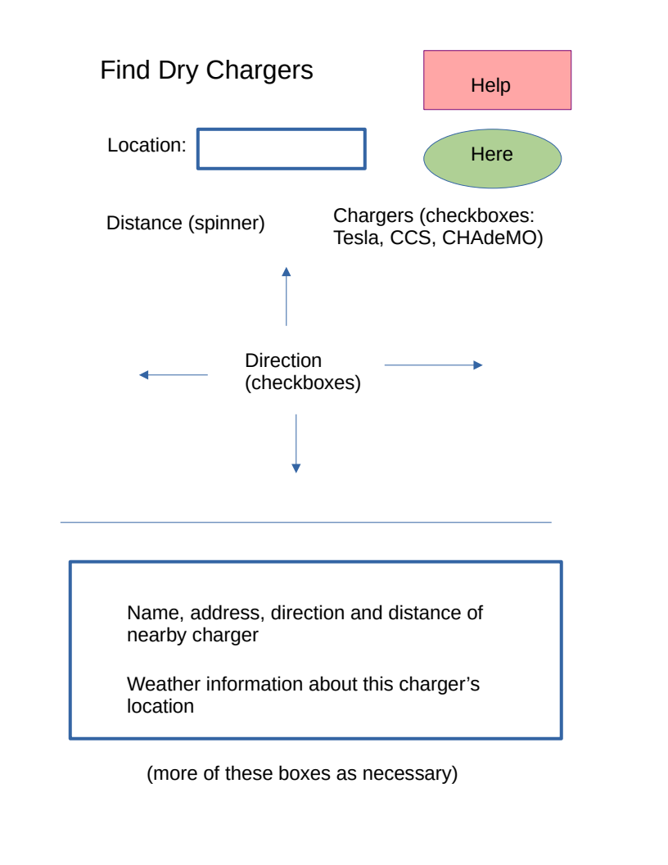Wireframe:

APIs to be used: Open Weather for geocoding and weather, Open Charge Map to find electric vehicle chargers.

Tasks: The project is divided into tasks based on functions. Our layout designer will learn Foundation, lay out the pages, and teach the rest of us how to use Foundation. Our mathematician will figure out the distance and direction of two points on the surface of the Earth. Our artist will create a consistent pallet and set of shapes for the parts of the application, so it will look well-integrated. Our data designer will specify the names and structures of the data needed to connect the HTML to the JavaScript, and the JavaScript to local storage and the two web sites. Programmer #1 will write the code to get information from Open Charge Map. Programmer #2 will write the code to get information from Open Weather. Programmer #3 will be responsible for integrating the work of all the others into a completed application. Our project leader will assign tasks and get out of everybody’s way so they can finish them on time. Each role will be assigned to a member of the team. Some team members may get more than one assignment.