Circuit Court, D. Connecticut.
WESTINGHOUSE ELECTRIC & MFG. CO.
v.
NEW ENGLAND GRANITE CO. et al.

No.919.
August 29, 1900.

In Equity. Suit for infringement of patents.

West Headnotes

Patents 291 27(1)

291 Patents
291II Patentability
291II(A) Invention; Obviousness
291k27 Application to New Use
291k27(1) k. In General. Most Cited Cases

The production of a new, or nonanalogous, or unexpected result by the substitution of one element for another although they were theoretically known equivalents, may involve invention.

Patents 291 56

291 Patents
291II Patentability
291II(D) Anticipation
291k50 Prior Knowledge or Use
291k56 k. Different Use or Purpose. Most Cited Cases

The related Tesla patents, No. 381,968 for an electro-magnetic motor, No. 382,280, for the electrical transmission of power by the method described in No. 381,968, and No. 382,279, for a specific construction of motor embodying the invention of the other two, which is, broadly, a system of electrical distribution and transmission by means of alternating currents, were not anticipated, but mark a distinct advance in the art, in which the utilization of the alternating current for the transmission of power was not only previously unknown, but believed to be impossible by eminent electricians.

*951 Frederic H. Betts and Kerr, Page & Cooper (Leonard E. Curtis, on the brief), for complainant.

Mitchell, Bartlett & Brownell, for defendants.

TOWNSEND, District Judge.
Final hearing on bill and answer raising questions of patentability and infringement of complainant's three patents granted to Nikola Tesla May 1, 1888, namely, Nos. 381,968, 382,280, and 382,279. No. 381,968 is for an electro-magnetic motor. No. 382,280 is for the electrical transmission of power by the method of operation described in No. 381,968. Patent No. 382,279 is for a specific construction of motor embodying the invention of the other two patents. It is not claimed that the defendant Batterson has infringed, and as to him the bill may be dismissed. The patents in suit relate to the art of electrical transmission of power by the use of mechanically generated alternating electric currents. It is, of course, understood that the real nature of electricity is still unknown, and that the nomenclature used herein, such as ‘currents,‘ ‘flowing,‘ etc., are merely convenient technical terms to indicate certain known results. The electric current induced by a mechanical generator- a dynamo- is necessarily alternating in character; that is, alternating in direction, so that the current, acting on an armature, *952 first tends to actuate it in one direction and then reverses said effect, and neutralizes such actuation. Such a current flows uninterruptedly and regularly, but rises in intensity from zero to maximum, and falls from maximum to zero, and then repeats said variations in the opposite direction. Its curve of increase or decrease of strength is indicated by a wave line or sine curve. Every mechanically generated current is naturally and originally an alternating current. Formerly it was not considered practicable to use mechanically generated currents until their alternations were straightened out by means of commutators, which reversed the direction of the current so as to make it flow continuously through the conductors. A current which is periodically reversed by a commutator which thus breaks the current between the changes in direction and takes off the current in sections, is known as a ‘reversed‘ or ‘alternated‘ current. This distinction between an alternating and an alternated current should be carefully noted. An alternating current continues to act in opposite directions as originally generated. An alternated current has been so reversed that the whole flows in one direction, and is then known as a ‘continuous current. When so reversed by commutators as to become continuous, the current loses certain characteristics essential to its highest efficiency. Prior to the Tesla inventions, only reversed or alternated electric currents were used for the transmission of power. The application of this system for the transmission of power was limited, for various reasons; among others, because a large current could not be safely used at sufficiently high pressure for long distances. On the other hand, the pure alternating current was practically unlimited in volume and pressure, and a change of pressure could be economically effected by the use of a transformer. Prior to Tesla's inventions, however, these rapid alternations of the alternating current prevented the motor from starting its revolution, and interfered with its continuing in operation, except when in synchronism with the generator. It was, therefore, impracticable for varying loads.

The problem which was presented to Nikola Tesla, and which he successfully solved, was, how to overcome the difficulties attendant upon the use of the alternating currents so that their inherent vitality and untrammeled energy might be utilized for the unlimited transmission of power. In an electric motor the tendency of the armature is always towards the pole or point of maximum magnetic intensity. If a loosely-pivoted or freely-moving magnetic bar or armature be suspended midway between two coils of insulated wire wound in opposite directions on a soft iron bar, and one of the coils is electrically energized, north and south poles will be formed at the ends of the soft iron bar, their location depending upon which coil is energized; but, if both coils be equally energized, the two poles will neutralize each other, and cause a resultant north pole midway between the coils. If, now, the current in one coil be made weaker than in the other, said pole will move towards the coil of greater electrical energy. The magnetic bar or armature will follow the shifting position of the pole, and by thus gradually varying the energy in the coils the armature may be alternately caused to move from the pole of one coil along towards the pole of the other coil. The alternating current generated *953 by an electrical machine, as before stated, constantly varies from maximum intensity to zero in one direction, and then from zero to maximum intensity in the opposite direction. In the invention of the patents in suit Tesla availed himself of this characteristic feature of alternating currents in the following way: In constructing a motor he arranged on an annular soft iron core to pairs of magnetizing coils, each pair at right angles to the other,-that is, one coil of one pair at the top, and one at the bottom,- and one coil of the other pair at each opposite side of said core, and mounted an armature in the center. Then, connecting them with an alternating current generator, he caused a current from one pole of said generator to pass through one pair of coils and a current from the other to pass through the other pair. If the cycles of alternating currents be regarded as divided into 360 degrees, then, as shown in the Tesla illustrations, they will have a relative displacement of 90 degrees. In such position the lines of magnetic force traversing the two coils will be at maximum in one while at minimum in the other. This relative displacement marks the differing phase or time relation of the two currents. The effect of passing two equal currents through said coils would be to cause the pole of maximum intensity to pass midway between the poles of the respective pair of coils. But the effect of the ordinary operation of the generator, as before explained, was to cause the current in each pair of coils to vary from zero to maximum and to zero, and then to shift in the opposite direction; the intensity of the current flowing to one pair of coils being at maximum, while that of the other was at zero, and one increasing while the other decreased, and the result being to shift said poles so as to make them travel entirely around said core.

Fifteen days after the issue of the patents in suit Tesla read before the American Institute of Electrical Engineers a paper entitled ‘A New System of Alternate Current Motors and Transformers,‘ in which, inter alia, he said:

‘The transmission of power has been almost entirely confined to the use of continuous currents, and notwithstanding that many efforts have been made to utilize alternate currents for this purpose, they have, up to the present, at least as far as known, failed to give the result desired. * * * The subject which I now have the pleasure of bringing to your notice is a novel system of electric distribution, and transmission of power by means of alternate currents, affording peculiar advantages, particularly in the way of motors, which I am confident will at once establish the superior adaptability of these currents to the transmission of power, and will show that many results heretofore unattainable can be reached by their use; results which are very much desired in the practical operation of such systems, and which cannot be accomplished by means of such continuous currents. Before going into a detailed description of this system, I think it necessary to make a few remarks with reference to certain conditions existing in continuous current generators and motors, which, although generally known, are frequently disregarded. In our dynamo machines, it is well known, we generate alternate currents, which we direct by means of a commutator, a complicated device, and it may be justly said, the source of most of the troubles experienced in the operation of the machines. Now, the currents so directed cannot be utilized in the motor, but they must- again by means of a similar unreliable device- be reconverted into their original state of alternate currents. The function of the commutator is entirely external, and in no way does it affect the internal current machines, the currents appearing as continuous only in the external circuit during their transit from generator to motor. In view simply of this fact, *954 alternate currents would commend themselves as a more direct application of electrical energy, and the employment of continuous currents would only be justified if we had dynamos which would primarily generate, and motors which would be directly actuated by such currents. But the operation of the commutator on a motor is twofold: Firstly, it reverses the currents through the motor; and, secondly, it effects automatically a progressive shifting of the poles of one of its magnetic constituents. Assuming, therefore, that both of the useless operations in the system- that is to say, the directing of the alternate currents on the generator and reversing the direct currents on the motor- be eliminated, it would still be necessary, in order to cause a rotation of the motor, to produce a progressive shifting of the poles of one of its elements, and the question presented itself how to perform this operation by the direct action of alternate currents. I will now proceed to show how this result was accomplished.

‘In the first experiment a drum-armature was provided with two coils at right angles to each other, and the ends of these coils were connected to two pairs of insulated contact-rings, as usual. A ring was then made of thin insulated plates of sheet iron, and wound with four coils, each two opposite coils being connected together, so as to produce free poles on diametrically opposite sides of the ring. The remaining free ends of the coils were then connected to the contact-rings of the generator armature, so as to form two independent *955 circuits, as indicated in Figure 9. It may now be seen what results were secured in this combination, and with this view I would refer to the diagrams Figures 1 to 8a. The field of the generator being independently excited, the rotation of the armature sets up currents in the coils, C, C, varying in strength and direction in the well-known manner. In the position shown in Figure 1 the current in coil C is nil, while coil C1 is traversed by its maximum current, *956 and the connections may be such that the ring is magnetized by the coils C1, C1, as indicated by the letters N, S, in Figure 1a, the magnetizing effect of the coils, c, c, being nil, since these coils are included in the circuit of coil C.

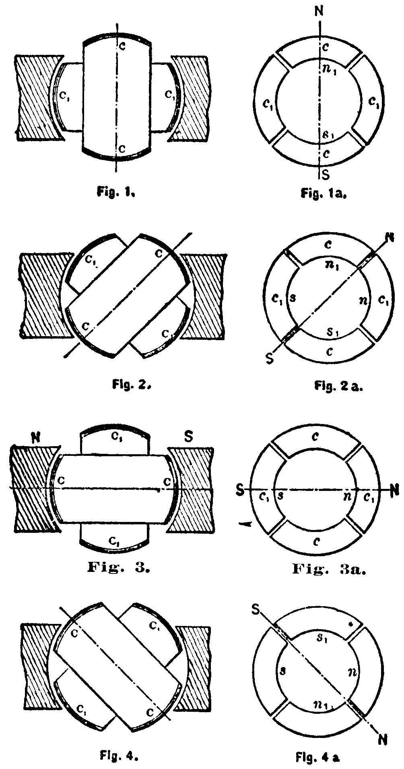

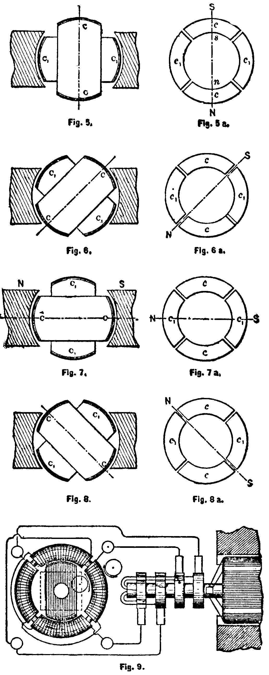

‘In Figure 2, the armature coils are shown in a more advanced position, one-eighth of one revolution being completed. Figure 2a illustrates the corresponding magnetic condition of the ring. At this moment the coil C1 generates a current of the same direction as previously, but weaker, producing the poles n1, s1, upon the ring. The coil C also generates a current of the same direction, and the connections may be such that the coils c, c, produce the poles n, s, as shown in Figure 2a. The resulting polarity is indicated by the letters N, S, and it will be observed that the poles of the ring have been shifted one-eighth of the periphery of the same. * * * A reference to the poles of the ring are shifted once around its periphery, and each revolution producing like effects, a rapid whirling of the poles in harmony with the rotation of the armature is the result. If the connections of either one of the circuits in the ring are reversed, the shifting of the poles is made to progress in the opposite direction; but the operation is identically the same. Instead of using four wires with like result, three wires may be used, one forming a common return for both circuits. * * * In applying this principle to the construction of motors, two typical forms of motor have been developed: First, a form having a comparatively small rotary effort at the start, but maintaining a perfectly uniform speed at all loads, which motor has been termed 'synchronous'; second, a form possessing a great effort at the start, the speed being dependent on the load.‘

The claims in issue in patent No. 381,968 are as follows:

‘(1) The combination, with a motor containing separate or independent circuits on the armature or field-magnet, or both, of an alternating current generator containing induced circuits connected independently to corresponding circuit in the motor, whereby a rotation of the generator produces a progressive shifting of the poles of the motor, as herein described.‘

‘(3) The combination, with a motor having an annular or ring-shaped field magnet and a cylindrical or equivalent armature, and independent coils on the field magnet or armature, or both, of an alternating current generator having correspondingly independent coils, and circuits including the generator-coils and corresponding motor-coils in such manner that the rotation of the generator causes a progressive shifting of the poles of the motor in the manner set forth.‘

That of patent No. 382,280 is as follows:

‘(1) The method herein described of electrically transmitting power, which consists in producing a continuously-progressive shifting of the polarities of either or both elements (the armature or field magnets or magnets) of a motor by developing alternating currents in independent circuits, including the magnetizing coils of either or both elements, as herein set forth.‘

The claims in issue of patent No. 382,279 are as follows:

‘(1) The combination, with a motor containing independent inducing or energizing circuits or closed induced circuits, of an alternating current generator having induced or generating circuits corresponding to and connected with the energizing circuits of the motor, as set forth.

‘(2) An electro-magnetic motor having its field magnets would with independent coils and its armature with independent closed coils, in combination with a source of alternating currents connected to the field coils, and capable of progressively shifting the poles of the field magnet, as set forth.

‘(3) A motor constructed with an annular field-magnet would with independent coils and a cylindrical or disk armature wound with closed coils, in combination with a source of alternating currents connected with the field-magnet coils and acting to progressively shift or rotate the poles of the field, as herein set forth.‘

Complainant's theory of the Tesla invention is shown by the following citation from the brief:

*957 ‘It will be observed that to produce a shifting of the magnetic pole in one case, and a consequent movement of an armature corresponding thereto, each coil A and B must be traversed by a current of variable strength, and, in order to secure uniformity of the movement of the pole or resultant, it follows that the variations in strength of current in the two coils must be gradual, and preserve definite relations to each other throughout the cycle of variation in strength which the two currents undergo. This principle lies at the foundation of Tesla's brilliant discovery, the gist of which was the utilization of the alternating currents generated by an alternating current dynamo or generator for effecting such shifting of the magnetic poles or resultant attractive forces upon the armature of a motor, and thus causing such armature to rotate in response thereto. His broad invention was the production in a motor of a progressively shifting magnetic field (or pole) by means of two or more independent alternating currents, differing in phase, and circuits which preserve the independent character and phase relation of such currents.‘

Defendants' position is shown by the following extract from their briefs:

‘Referring further to the apparatus of Tesla, Waterman says: 'Briefly, then, the apparatus consists of a ring field magnet having one set of coils tending to magnetize it on one diameter and another tending to magnetize it on a diameter at right angles to the first, and these sets of coils or circuits are so connected to a proper generator as to be traversed by currents such as would be generated by two coils at right angles to one another rotating in a two-pole field.’ It will be seen from this that complainants claim a broad discovery and a broad invention based thereon. Defendants, on the other hand, contend that the alleged discovery was old, that its application was old, and that since the days of Arago there was never any room for a broad invention in the 'obvious' application of the alleged 'discovery'; and that the present state of the art has been developed from the earlier art including Arago's rotation by the mere application of engineering skill possessed by skilled electricians who have applied their knowledge as the progressive demands of the times called for it, supplemented by inventions special to the motor, or the generator, or the connecting circuits severally, and in no way entitling Tesla or any other patentee to prevent the sale of generators and motors through the ownership of an all-controlling patented 'system.'‘

The well-known Arago rotation is described as follows:

'Arago's method of producing rotation in a copper disk consists of suspending it by its center so as to make it lie horizontally above the poles of a horseshoe magnet, and then rotating the magnet about a vertical axis. The rotation of the disk is due to that of the magnetic field in which it is suspended; and we should expect that, if a similar motion of the field could be produced by any other means, the result would be a similar motion of the disk.‘

The chief contention of defendants is that there is no substantial difference in character between alternating and reversed currents, and that the art of electric lighting illustrated in the alleged anticipations showed such an analogous use of reversed currents that the substitution of alternating for reversed currents did not involve invention. Defendants further contend that the principle of reversibility was well known in the art, and, as the inventors of electric lighting apparatus state that by a reversal of their action power may be produced, Tesla is deprived of all claim to the exercise of the inventive faculty; that is, that the same apparatus may be used as a generator or dynamo-electric machine, or may be reversed, and used as a motor or electro-dynamic machine. (This word ‘reversibility‘ has no relation, in this connection, to the word ‘reversed‘ as applied to currents.) In support of their contentions defendants chiefly rely upon four prior publications, namely, the Baily article of 1879, *958 the Siemens patents of 1878, Deprez/Article of 1880-84, and the Bradley application of May 9, 1887. The subject of Baily's paper was ‘A Mode of Producing Arago's Rotation.‘ He says:

‘Possibly the rotation of the magnet may be the only practicable way of producing a uniform rotation of the field, but it will be shown in this paper that the disk can be made to rotate by an intermittent rotation of the field, effected by means of electro-magnets.‘

The text and drawings describe and show four pairs of magnets arranged in a circle. By successively energizing one diagonally opposite pair after another by means of a commutator making and breaking the current the disk was caused to travel about in said circle. As to this device defendants' expert says:

‘The field magnets, with their energizing circuits and copper disk, constructed and operated as Baily shows and describes, constituted a two-phase alternating current motor, the copper disk or armature of which was operated by a rotating magnetic field. The lines of force of the rotating magnetic field cut through the copper disk, and set up therein electromotive forces, which cause currents to flow in close induced circuits formed by the continuous metallic mass of the disk.‘

Baily merely showed how to apply a series of successive impulses to the disk by an intermittent rotation of the field, and thus produce Arago's rotating field with stationary magnets instead of a moving magnet; and he showed how the motion of the disk could be reversed. That he conceived the idea of a uniform rotation by a manifestly impossible and impracticable construction appears from this statement:

‘In one extreme case- viz, when the number of electro-magnets is infinite-we have the case of a uniform rotation of the magnetic field, such as we obtain by rotating permanent magnets.‘

But Baily did not claim to have established a continuous rotating field, or to know any way in which a uniform rotation could be produced. He did not use alternating currents, but reversed currents. He was not dealing with the subject of the transmission of power. Defendants' expert admits that his paper merely describes a laboratory experiment. As complainants say in their brief:

‘The action of the Baily intermittent field in propelling the disk may be compared to propelling a boat with oars hung on pins so as to be incapable of feathering, and which are held rigidly in the water for a considerable time after each stroke before they are advanced for the next. It is evident that this method of propulsion would involve a large waste of power, since the oars would act alternately to propel and to stop the boat, and the method would be practically useless. Using the same analogy, the action of Tesla's continuously rotating field would be like that of the ordinary screw propeller, in which all the power is applied in a continuous push forward.‘

The Siemens British patent No. 3,134 of 1878, for improvements in apparatus for the dynamical production and application of electricity, and for its regulation when applied for illumination, ‘relates to apparatus applicable as dynamo-electric apparatus for the conversion of mechanical power into electricity, or as electro-dynamic apparatus for the application of electricity to produce motive power,‘ but describes apparatus ‘as of the dynamo-electric kind, whereby mechanical power applied to drive it is converted into electricity.‘ But the patentee states that ‘with suitable modifications these apparatus are generally applicable also as electro-dynamic machines, *959 their rotary parts being caused to revolve and give out mechanical power when electricity is applied to them.‘ The patentee also says:

‘The machines described with reference to the figures in sheets II., III., and IV. of the accompanying drawings may obviously be arranged in an inverted manner; that is to say, the electro-magnets might be made to revolve round a stationary coiled armature. Also the machines described, as well as that shown in sheet I., instead of being driven by mechanical power so as to generate electricity, may be made to give out mechanical power by exciting their coils by electricity from an external source.‘

Counsel for defendants describe their apparatus as follows:

‘This Siemens apparatus consists of a stationary field magnet having inner and outer polar projections, C, C1, energized by a continuous current supplied through an outside source, or through the commutators, G. Within the circle between these polar projections lies the cylindrical portion of a dish-shaped armature, J, carrying two sets of coils. These coils are offset, as shown in Fig. 4, so that the current of one set is displaced by 90 degrees from the current of the other set. The two terminals of one set of coils are connected respectively to two of the collector rings, H, H, while the two terminals of the other coils are respectively connected to the other two rings.‘

And as to said apparatus complainant's expert makes the following admission:

‘It is, of course, quite easy now to see that some of the machines that were known in the art prior to Tesla's invention- such, for example, as the Siemens and Gramme multiple-circuit machines- could, by properly taking off their currents, have been used as polyphase machines, and also that, if any one had coupled two of these properly arranged machines in a certain way, and used them in a certain way, the system so produced would have involved the use of the invention afterwards made by Tesla.‘

Claim 4 of said patent is as follows:

‘The construction of a dynamo-electric or electro-dynamic machine, wherein for the disk referred to in the preceding claim there is substituted a cylindrical shell carrying coils, and revolving between the poles of interior and exterior radiating electro-magnets, substantially as herein described with reference to the figures in sheet IV. of the accompanying drawings.‘

Counsel for defendants therefore claim:

‘That any generator, be it straight current or alternating current, single-phase, two-phase, or what not, may be reversed, and used as a motor. Supply it with currents such as it generates, and it will operate as a motor, * * * (and that) the reversing of such apparatus as Siemens or Bradley is all that there is to the so-called Tesla invention. The art knew it could be done, and how to do it.‘

They therefore contend that ‘this (Siemens) patent is a full disclosure of the subject-matter in issue in‘ the first and second patents in suit.

This patent is chiefly for means to convert motive power into electricity. It does not specifically relate to, or describe, or fully show a system of apparatus for the transmission of power. It not only fails to refer to any difference of phase, or to point out how the armature and overlapping coils are to be coupled together to produce such phase, but it repeatedly describes the use of commutators in order to create a continuous or direct current. At this date it was not known that an alternating current machine could be used as a motor. Motors then were operated only by a direct or continuous current, so far as the record shows. The ‘suitable modifications‘ to change this machine into a motor are nowhere described. In view of the repeated reference to commutators, the modifications must *960 be presumed to relate to such continuous current machines; and in view of the then state of the art such suitable modifications would have required such a series of experiments, and such a departure from the existing theories, and such development and application of devices in unexpected and nonanalogous ways as, would in themselves have constituted invention. Siemens himself, as late as 1884, and Alteneck, the other inventor of said Siemens patent, in 1881, admitted that they did not know that alternating currents could be used as motors. This evidence was objected to on the ground that the publications containing said statements are not duly proved, but the fact is established by other sufficient evidence. The statements in the German Siemens patent are quite as favorable to complainant as to defendants, and will not be discussed.

May 9, 1887, about six months before the filing of the Tesla application, Charles B. Bradley filed his application for a dynamo-electric machine- that is, a generator- for converting power into electricity as in Siemens. Counsel for defendants say:

‘In this application a two-phase machine is shown. The armature consists of a simple Gramme ring having its common winding connected to four collecting rings, c, d, e, f, as shown in Fig. 2. From these rings alternating currents of different phase are transmitted to be used as desired. The two phases of the alternating currents are clearly explained. The potential at one pair of terminals being maximum when the other is zero, so that when the connections are made between the respective terminals two currents will flow, but the 'second’ current will differ from the first by exactly half a phase; that is, when the first current is at maximum, the second will be zero, and, conversely, when the first is zero, the second will be maximum. Bradley, after having fully explained his construction, and pointed out the two-phase feature, states: 'It is obvious that my machine may be used as a motor as well as a generator, and that it may, when so used, be fed or actuated either by continuous or alternating currents, or both.'‘

The claims in said application cover an alternating current generator. Defendants chiefly rely on the foregoing statement in the original application. And on the third claim of the patent, which is as follows:

‘(3) An alternating current dynamo-electric machine, in which the armature winding or conductor is connected to two pairs of contact rings or equivalent contact devices at points of said winding, which differ in phase by one-quarter of a period, one pair being at or about the maximum difference of potential when the other pair is at or about the same potential, substantially as described.‘

The single specific object of Bradley's construction stated in said specification was to obviate ‘difficulties and limitations‘ in prior constructions wherein the machine was idle during a part of the time. He suggests that this may be done by rectifying one of the alternating currents by a commutator, and then combining the two or by connecting each with a separate circuit. He does not show how he would use them in the latter case to operate a motor, nor did he indicate any combination of the alternate currents for a single motor, or show that he had any conception of their use, if at all, otherwise than separately in a single-phase motors. A comparison of the Bradley application prior to Tesla with the Bradley patent issued subsequent to Tesla shows that in the former he described a method and illustrated an apparatus designed to obviate the objections to a two-phase alternating current by combining both currents in one *961 by means of a transformer, while from the latter he omitted this description and method, and inserted figures which, while strikingly suggestive of the apparatus shown by Tesla, failed to show that he conceived the Tesla idea, or sought to secure the object of Tesla's invention. For this reason, and further because Bradley's application is limited in scope, and ambiguous and indefinite; because it fails to show that he had any conception of the Tesla idea of ‘the utilization of the motor for the purpose of progressively shifting the magnetic poles of a plurality of alternating currents by circuits which preserved the independence and differing time relation of their phases‘; because, even if the idea had been first conceived by Bradley, it was not sufficiently described to disclose the principle or method of operation; because Tesla was the first to reduce this principle to practice,- Bradley does not anticipate or limit.

Defendants' chief reliance is on the Marcel Deprez publications of 1880-84, and rightly so, for Deprez not only disclosed the principle which Tesla utilized, but he gave a mathematical demonstration of the rotating field. Complaint's expert's admission on this point is as follows:

‘The article demonstrated mathematically the fact, which is also stated in the Tesla patents, that the polar line of an annular magnet may be shifted about through the entire circumference of the ring by the action of two magnetizing forces properly related.‘

On this point counsel for defendants say:

‘The motor is a device which Deprez invented in 1881, and to which he gave the name 'annular comparer.’ It is substantially the same as the motor described in the patents in suit, and shown in Figs. 1a to 8a, and Fig. 9. This also is admitted by complainant's expert, Waterman, where he says: 'The structure consists of a ring wound with four coils in a manner similar to the ring of Fig. 9 of patent No. 381,968.' And again: 'It (the Deprez comparateur) takes advantage of the theory of the parallelogram of forces to produce a resultant magnetic field by winding coils upon a ring in a manner similar to the ring field of Fig. 9 of the Tesla patent No. 381,968.'‘

The foregoing article was entitled as follows:

‘Electricity.- On the Electrical Synchronism of Two Relative Motions, and its Application to the Construction of a New Electrical Compass. Essay by Mr. Marcel Deprez.‘

Deprez then says:

‘Having given two bodies, each animated by a distinct motion of rotation about the same axis, to find the means of reproducing their relative displacement at a distance and at any number whatever of different points at once by obtaining an absolute synchronism, such is the problem that we have set out to solve by the following process: 'Imagine a ring, Pacinotti kind, arranged between the poles of a magnet, as in the ordinary magneto-electric machines, with this difference: that, in place of being stationary, the magnet can revolve about the axis of the ring. Moreover, four brushes are keyed two by two at right angles on the collector, whose circumference they divide into four quarters. Their distance apart remains unchanged, but we can displace the system around the axis of the coil. Finally, the two brushes situated at the extremities of the same diameter are connected to the entrance and exit of a device that I had invented towards the end of 1881, and to which I gave the name of 'annular comparer of currents.’ It is a stationary ring of iron, which carries two windings, divided up in such a manner that there is alternation between the sections belonging to each of the two different circuits. It follows therefrom that, taking one of the sections as a point of departure, if *962 we number successively each of the following ones, all those that are affected by a number of the same parity are connected together, and the whole forms thus two windings which end each at the extremities of two diameters perpendicular to each other. We perceive, then, that if we throw into them two currents simultaneous, but of different strength, there will tend to be formed on the circumference of the ring four poles, whose lines of junction would be perpendicular; but the magnetic actions, which are exerted in their direction, are combined according to a resultant, whose position will depend on the ratio of the currents, and not on their absolute strength. A magnetized needle arranged in the center of the device will set itself according to this polar line, which will thus be plainly marked.‘

Counsel for defendants further say as follows:

‘Deprez then describes the generator, and shows how, when the brushes are stationary, and there is no relative movement between them and the field magnet of the generator two currents are generated, which are transmitted to the motor, and set up a stationary field, on account of which 'the needle of this latter takes then a position that we shall consider as initial.’ The initial position having been determined, Deprez says: 'Let us then revolve the magnet, leaving the brushes stationary. To each angle described by the polar line there will correspond a definite value of the ratio of the two magnetic components, and consequently of the two currents sent into the comparer; a ratio that will increase from zero up to 1. This last value will be reached when the line of the poles of the magnet shall be a bisector of the angle of the line of brushes. The two currents which traverse the comparer having become equal, the needle will make an angle of 45 degrees with its initial position. To sum up, the arc described by the needle will be the same as that of the magnet of the ring for each eighth of a revolution.' Now, whenever the field magnet is moved as indicated, the currents generated and transmitted to the motor are alternating currents, having a difference of phase of 90 degrees. If the movement is through only part of a circumference, the alternations are not complete cycles, but the currents are none the less induced alternating currents, and are conveyed to the motor to set up a progressive-shifting magnetic field. If the field magnet makes a complete revolution, the resultant field makes a complete revolution, and so also does the motor armature. The apparatus which constitutes Deprez's complete electrical system is shown below, being taken from an article describing the same, contained in 'Centralblatt fur Electrotechnik.'

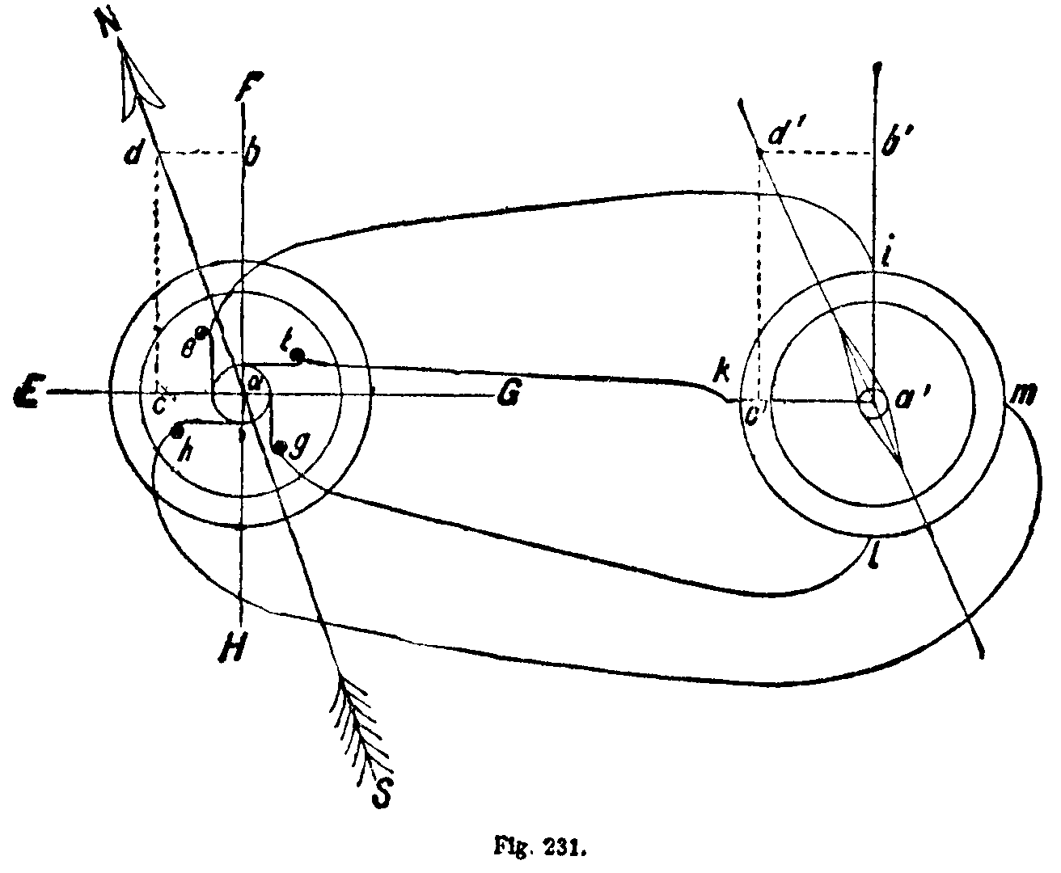

'In this article, referring particularly to Fig. 231, shown above, Deprez says: 'One winding has its poles at i1, the other at k, m. These poles are *963 connected with e, g, j, h.' This having been done, and the apparatus put in operation, the article says: 'A current will then flow through g, l, i, e, whose intensity is proportional to the component a, b, and a current will flow through h, m, k, f, whose intensity is proportional to the component a, c. The component of the magnetization in the comparer will be produced accordingly, and the position of the needle will correspond thereto. It will be evident from what has been said that the needle of the comparer will always show the relative movement of the electro-magnet towards the brushes.'‘

The only result suggested by Deprez of his solution of his problem is the following:

‘I have thought out, as a practical application of this process, a new electric compass. It is sufficient, in order to realize this device, to place vertically the axis of the revolving ring, and to suppress the permanent magnet that served as indicator. Its action is then replaced by that of the earth, which is sufficient to reproduce the phenomena that we have just analyzed. The resultant of the terrestrial magnetic actions at one point can really be decomposed into two components, of which one is its projection on a horizontal plane, and coincides with the magnetic meridian, and the other directed according to the vertical line. This latter, parallel to the axis of the ring, can exercise no inductive effect on the induced wire, while the action of the first component is similar to that of the magnet of the preceding arrangement. From that time, the brushes remaining stationary, every displacement, however small it be, of the magnetic meridian, will be disclosed by an identical displacement of the needle of the comparer, which thus fulfills the role of the most sensitive compass. In order to avoid all disturbing influence due to the proximity of me metallic pieces, we shall arrange on top of the mast of the ship the revolving ring, to which we shall communicate its motion of rotation by such means as we shall judge most simple. This motion is not in any manner obliged to remain uniform, since the angles traversed by the needle of the comparer are a function, as has already been said, only of the ratio of the two currents that traverse it,- a ratio entirely independent of the speed of rotation. As to the graduation of the apparatus, the details given above are sufficient to make understood how it should be brought about.‘

All that Deprez demonstrated, therefore, was, that if a field was made in which the field magnet varied relative to the brushes, or vice versa, the angle of variation would be indicated by the needle in another machine, which would move quickly or slowly as the brushes or magnets shifted relative to each other, and would indicate the new angle subtended between the brushes and the magnet. The only useful, practical application of this device was to attach it to a machine which would produce currents, and to use the earth or a ship to indicate the shift of position by means of a needle on top of the mast. This apparatus failed to teach any one that alternating currents could be used as a source of power in a motor. It was a mere indicator. It did not involve the utilization of two alternating currents differing in phase as a source of power in producing a continuous magnetic field. It did not depend upon any constant, regular, progressive currents; and, so far as the evidence shows, it was like the apparatus of Baily, confessedly a mere laboratory experiment. That Deprez did not conceive of the Tesla idea of utilizing regular, progressive, constant alternations of current is conclusively shown by his own statement in 1884, after the publication of this paper, and after the invention of the Golard and Gibbs alternating current systems for lighting, when he published another paper, in which he criticised the system, and stated that one of the most serious objections to it was that it was not applicable to the transmission*964 of power, and adds: ‘I must further remark that alternating currents are of no use in the transmission of power. They are suitable only for lighting purposes.‘ In fine, the evidence shows that, as Prof. Sylvanus Thompson says in his work on this general subject: ‘Deprez's theorem bore no fruit. It remained a geometrical abstraction.‘ The underlying thought disclosed and applied in the Tesla patents is such a use of the rapidly successive opposing alternations of the alternating current regularly and constantly recurring in such differing phases as would not only prevent the alternations from stopping the armature, but would become a source of power. It was essential, to the practical development of this idea, that the alternations should rise and fall and succeed each other progressively and constantly, and should be arranged, as counsel for complainant puts it, ‘like the crank on a locomotive in which there is no dead center, but one crank is always pushing forward.‘ Tesla's invention, considered in its essence, was the production of a continuously rotating or whirling field of magnetic forces for power purposes by generating two or more displaced or differing phases of the alternating current, transmitting such phases, with their independence preserved, to the motor, and utilizing the displaced phases as such in the motor. Baily does not describe the use, with alternating currents, of displaces phases. He only describes the producing of intermittently shifting poles by means of a commutator or reverser, which is just what Tesla disclaims. Neither Siemens nor Bradley describes the utilization of such displaced phases of alternating currents with their independence preserved in a motor. Deprez describes a parallelogram of forces, and its application to indicate at any given moment the angle between two parts of a source of current. He did not contemplate the use of alternating currents, nor utilize their continuous and constant movement, nor did he utilize said current to produce power, nor did he have any idea of a whirling field of forces to propel a motor.

What, then, was the status of the art in 1887, when Tesla filed these applications? Nine years had elapsed since the grant of the Siemens patent, which, according to counsel for defendants, ‘is a full disclosure of the subject-matter in issue in patents Nos. 381,968 and 382,280,‘ and its ‘references, * * * at the hands of the skilled electrician, * * * would naturally, and as a matter of course, have resulted in an organization of elements constituting a system for the electrical transmission of power, and embodying essentially the system‘ of said patents. Eight years had elapsed since Baily. It was four years since Marcel Deprez's article, according to defendants' counsel, ‘described the very thing that complainant claims is Tesla's discovery, and explained the theory of operation‘ of an apparatus which ‘is an operative two-phase alternating current generator supplying two-phase alternating currents to produce a rotating field ina motor‘ similar to the Tesla motor. Prior to Tesla's invention, no alternating current motors were in use. Although there had been an urgent demand for some practical means of utilizing alternating currents for transmission of power, none had been found. The continuous and unparalleled development of the electric art had *965 for years increasingly emphasized the want of an electric motor capable of distributing power for long distances, and had vainly called for the solution of the problem of the use of alternating currents for this purpose. The leading electricians of the day concurred with Deprez in his declaration, after he had devised his comparateur, that alternating currents could not be utilized in the transmission of power, and that the future belonged to continuous currents. In these circumstances Tesla patented his invention, and thus first disclosed the method and apparatus now generically known as the ‘Tesla polyphase inventions,‘ and introduced a new method, a new means, and a new terminology into the art. Six months later he read his paper before the American Institute of Electrical Engineers, and announced that previous efforts to utilize alternate currents had failed; that he had brought forth a novel system for the transmission of power; and explained its theory and demonstrated its operation by exhibiting a working motor; and no one of the electricians present questions his claim or criticised his apparatus. The statements made by electricians at said meeting are supported by abundant quotations from the contemporaneous literature of the day, and it does not appear that the recognition of Tesla as an original inventor of said system and of the means for its practical application was ever disputed until this suit was brought. There is nothing in the record to detract from the claims then made. Tesla did not discover the parallelogram of forces; he did not discover the rotary field; but he was the first to explain how to do practically what Baily had said could be done by an impracticable infinity of magnets, and others had said could be done, but without showing how it could be done. He harmonized the hitherto opposing alternations, while preserving their character and power. Since the date of the Tesla patents in suit there has been a revolution in the art, due to the utilization of the means therein described.

The contention that the transfer from the electric light art to the electric power art did not involve intention cannot be successfully maintained. Even if it be assumed that the art of electric lighting is, in a sense, analogous to that of electrical transmission of power, the result was new and unexpected. It has been already shown in what respects a reversed current differs from an alternating current. The question as to how far they are alike is of minor importance, because it is admitted that the reversed or broken current is not the same for the practical purposes to which this invention is especially adapted. Therefore, although Deprez, in one of his publications, suggested that his system might be used for an impracticable and almost infinitesimal amount of power, the fact that these currents had never been practically used for any such purpose, and cannot, even now, be practically used for currents of high potential, shows that it required invention to select from an art that particular kind of current which was necessary for the production of the best results, and to adapt the mechanism of an art, analogous or nonanalogous, to its practical application. The very fact that all the earlier electricians assumed or asserted that reversed and alternating currents were the equivalents of each other was one of the errors *966 which retarded the Tesla discovery, and the practical application of the polyphase principle.

The view most favorable to the contention of the defendants upon all the evidence presented may be fairly stated thus: Prior inventors had stated that electric light machines could be so reversed as to furnish power, although it is not proved that any one had shown a method for their use, or the practical application thereof, or had ever made such practical application. No prior publication explained how to utilize this alleged well-known reversibility, and no prior machine applied it. To the question why, if it was so obvious that the operation of the apparatus might be reversed, and alternating currents then used, such method was not put in practical operation, the only answer of defendants is that ‘there had been, up to 1885, no commercial system of distribution of alternating currents.‘ But, if this is so, is it not because the foremost electrical experts throughout the world had united in the opinion, after repeated futile experiments, that alternating currents were useless for the transmission of power, and that the future belonged to continuous currents? ‘The apparent simplicity of a new device often leads an inexperienced person to think that it would have occurred to any one familiar with the subject, but the decisive answer is that with dozens, and perhaps hundreds, of other laboring in the same field, it had never occurred to any one before. ‘ C. & A. Potts & Co. v. Creager, 155 U.S. 597, 15 Sup.Ct. 194, 39 L.Ed. 275. Siemens, chiefly relied on to support this contention, does not describe any mode of using alternating currents; does refer to the use of commutators, and only refers to the use of said apparatus as an electro-dynamic machine ‘with suitable modifications,‘ which are nowhere described. The impracticability as motors of reversed currents induced by commutators shows that Siemens, Baily, and others did not discover the Tesla invention. They were discussing electric light machines with commutators. Tesla first stated the discovery how these alternations could be thus utilized, and showed the machine and method adapted for this purpose. He is entitled to a patent for this discovery, as were the discoverers of the use of anthracite coal instead of bituminous coal, or of the hot blast instead of the cold blast in the manufacture of iron, or of the practical application of electricity to the telegraph or telephone. Judge Blatchford once sustained a patent for insulating electric wires by means of gutta-percha, and said:

‘The gist of the invention is the discovery of the fact that gutta-percha is a nonconductor of electricity, and the application of that fact to practical use. The claim is valid, even though a metallic wire covered with gutta-percha existed before the plaintiff's invention, if it was not known that gutta-percha was a nonconductor of electricity, and could be used to insulate the wire. ‘ Colgate v. Telegraph Co., 6 Fed.Cas. 86.

It is not necessary to go to this extent in sustaining these patents. The complainant may safely rest its case on the general principles laid down in the various decisions of the supreme court, and extended and developed in C. & A. Potts & Co. v. Creager, supra.

But, if the evidence already considered be disregarded, and it should be assumed that alternating and alternated currents were *967 theoretically known equivalents, even then the argument of counsel for defendants does not appear to be sound. They contend that a superior result, by reason of the substitution of one known equivalent for another, does not constitute invention. But the first substitution or application of such theoretical equivalent to produce a new or nonanalogous or unexpected result may involve invention. Tesla applied the alternating current to do what the alternated current had never before done, namely, to produce a new, unexpected, and practical system of transmission of power. A careful study of the evidence has led to the conclusion that Tesla made a new and brilliant discovery. But, even if this be incorrect, it is proved that by a new combination and arrangement of known elements he produced a new and beneficial result never attained before.

The technical defense of noninfringement by reason of the fact that defendants use only a motor, and that there is no allegation or proof of conspiracy with the owners of the plant which supplies the power, was not pressed on the argument, and, as six days were spent in the discussion of the questions on the merits, this point will not be considered. If any amendment is necessary, it should be allowed.

The contention of defendants that Tesla does not describe an operative machine is not satisfactorily proved. It is proved that in fact various practical motors have been manufactured according to his invention. The model of the particular patented construction selected to Rove defendants' contention, and claimed to correspond most nearly to defendants' construction, failed to show a capacity of self-starting, and, when once started, revolved in either direction; but complainant showed on the hearing various differences between the construction shown in the drawing of the patent, and the model, which, it was claimed, accounted for the failure.

The defendants use a three-phase transmitting system, comprising a three-phase generator, three transformers, and a three-phase motor. The argument based on the use of transformers was not pressed. The following diagram represents said system:

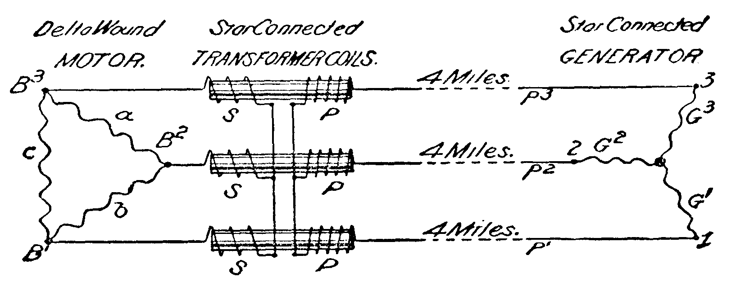

Mr. Clarke, defendants' expert, describes the construction and operation of said apparatus as follows:

‘In said exhibit diagram G is a convention representation of the generator, in which F is a stationary field magnet excited from an external source by means of a continuous current dynamo. A is a revolving armature, and G1, G2, and G3, are three induced circuits on the armature, in which respectively, are generated three alternating currents of differing phase. Said induced*968 circuits of the generator are interconnected by joining together one end of each circuit, as shown on the diagram at the center of the armature. The other ends of said generator circuits are, respectively, connected with three terminals, T1, T2, T3, as illustrated, diagrammatically, of course. C1, C2, C3, represent the transformers located some four miles from the generator, each of which consists substantially of a laminated iron core, x, a primary coil P, and a secondary coil S. One end of each of the primary coils of the transformers, C1, C2, C3, is connected, respectively, with the generator terminals T1, T2, T3, and hence with corresponding generator circuits G1, G2, G3, by means of the conductors P1, P2, P3. And the other ends of said primary coils are simply connected with one another, as shown. One end of each secondary coil, S, of the transformers C1, C2, C3 is connected, respectively, with the secondary conductors, S1, S2, S3, which, in turn, are connected with the terminals B1, B2, B3, of the Cushman motors M1, M2, M3. The interconnected field magnet circuits of said motors are represented by a, b, c, and the revolving armatures of I. The remaining three ends of the secondary coils are connected, respectively, with three conductors going to the motors. Said manner of connecting the secondary coils together is known in the art as a 'Y’ connection, on account of its fancied resemblance to the three arms of the letter Y, and is also known as a 'star' connection. It will be seen that the primary coils, P, of said transformers, and likewise the three inducing circuits G1, G2, G3, of the generator, are star-connected. As will be observed from the diagram of Concord system, the field-magnet circuits a, b, c, of the Cushman motors are not star-connected, but that all the ends of said coils are interconnected in the manner shown in the diagram; and said manner of connecting the field-magnet circuits of the motors is known as a 'delta' connection, from its diagrammatical resemblance to the Greek letter of that name. The rotation of the armature, A, of the generator, G, within its field magnet, F, sets up three alternating currents of differing phase, which flow in the inducing circuit G1, line wire P1, and primary coil, P, of the transformer C1; and in the inducing circuit G2, line wire P2, and primary coil P, of the transformer C2; and in the inducing circuit G3, line wire P3, and primary coil, P, of the transformer C3, respectively. The connecting together of the inducing circuits of the generator and the primary coils of the transformers star-fashion, as before explained, results in such an interconnection between said inducing circuits and primary coils and their connecting line wires as to make them all interdependent, so that the line wires P1, P2, P3 not only serve as conductors, each for one of the alternating currents referred to, but also as conductors or parts of circuits for the other two currents; and also so that no one of the primary coils, P, of the transformers C1, C2, C3 receives current exclusively derived from or generated by any one of the inducing circuits of the generator, but in fact receives current which is due to more than one of the generator circuits. In other words, in the Concord system, and as shown in the diagram thereof, the generator does not have independent inducing circuits connected with corresponding and independent transformer primary coils by means of separate and independent conductors or line wires, and so that each primary coil derives current only from a corresponding generator circuit, and by means of conductors serving as parts of circuits for the current due to a corresponding generator circuit only. The alternating currents which are developed by the generator and flow through the line wires and primary coils of the transformers connected therewith do not flow through any circuit of the motors, or, in fact, go further than the transformers; for, as shown in the diagram, no circuits or devices connected with the motors are connected with any circuits or devices that are in electrical communication with the generator. The currents for operating the motors are connected with any circuits or devices that are in electrical communication with the generator. The currents for operating the motors are produced as follows: The alternating currents from the generator, which flow through the primary coils of the transformers, cause the magnetism or lines of force in the iron cores x, x, x to vary in strength and alternately in direction, whereby three electro-motive forces differing in phase, and acting in alternatively opposite directions, are set up in the three secondary coils S, S, S, respectively, of the transformers, C1, C2, C3, and thereby three alternating currents of differing phase are caused by flow respectively through the three field-magnet circuits a, b, c of the motors. Said currents in the motor *969 circuits set up rotating magnetic poles in the field magnet of the motor, and a rotating magnetic field, whereby currents are induced in the closed coils of the armature, I, and which is set in motion by the reaction between the last-mentioned currents and the magnetic field, as hereinbefore described. Three ends of the secondary coils of the transformers being connected star-fashion, and the other three ends being connected respectively by three conductors each to one of the three terminals B1, B2, B3 of the field-magnet circuits of the motor, which are delta-connected, said secondary coils, motor circuits, and connecting wires are interdependent, so that no one field-magnet circuit of the motor receives current from more than one of said coils. And no one of the connecting wires S1, S2, S2 serves soley as a conductor of current for any one motor circuit, but answers as a conductor of current for more than one of said circuits.‘

In this construction no circuit consists of two conductors specially devoted to any one of the differing phase currents. In the patented apparatus each one of the independent circuits is especially devoted to a single one of the differing phase currents. The serious question raised in this branch of the case is as to the construction of the word ‘independent‘ in the patents. Counsel for defendants contends that ‘the word as used in the patent evidently refers to the physical relations which exist, and not to any result produced. ‘ Counsel for complainant contends that Tesla's ‘broad invention * * * was the production in a motor of a progressively-shifting magnetic field by means of * * * independent alternating currents differing in phase, and circuits * * * which preserve the independent character and phase relation of such currents.‘ The specifications and drawings of said patents describe and show six independent transmitting wires which are repeatedly referred to as constituting independent circuits, and the claims emphasize this independency. In defendants' motor the coils of generator and motor are so interconnected that each line wire not only serves as a conductor for its own phase, but also for the other currents. Defendants' contention is fairly stated by counsel for complainant as follows:

‘The defendants contend that currents of electricity belonging to each of the circuits are, therefore, at times all flowing in the same wire or wires, and that at certain instants in the operation of the same- i.e. when each of the single transmission wires is, for an incredibly short period, transmitting no potential (i.e. change from plus to minus)- two of the coils of the motor are supplying current to the third. * * * They cite the admission of Mr. Waterman that 'analytically’ it is perfectly true that currents of electricity of differing phase may be at times regarded as simultaneously flowing in the same circuit.‘

This statement of Waterman, however, should be read in connection with his further statement, as follows:

‘The net result of it all is that, in a manner more or less complex to follow, these electro-motive forces so cancel out that there is in each circuit a current differing in phase by 120 degrees from the current in each of the others, so that in the motor it is not possible to tell how the current got there, or over what kind of a circuit (i.e. whether over a three-wire or a six-wire circuit).‘

Counsel for defendants argue:

‘That the term 'independent,’ as used by Tesla, means such separation as is consistent with having the complete circuits traversed by the same currents,-currents which at any and every point are of the same quantity, intensity, *970 and phase,- so that, as Mr. Clarke puts it, each motor circuit receives its current from a corresponding generator circuit, and from no other. It cannot refer to circuits which are interdependent in such sense that two of the circuits are at times strictly in series with one another and in multiple with the third, and so are not 'independent' in any sense. The whole system is an interdependent, and not an independent, system.‘

The following significant statement, however, is found near the end of the specification of the first patent No. 381,968:

‘By 'independent’ I do not mean to imply that the circuits are necessarily isolated from one another, for in some instances there might be electrical connections between them to regulate or modify the action of the motor without necessarily producing a new or different action.‘

The claims, therefore, confessedly cannot be read as requiring isolation of the circuits, but at most only such independence as is necessary for the purpose of producing a rotary field; that is, the connections must be such as not to interfere with the independency of the circuits which operate to shift the poles. The only practical result from defendants' use of three conductors instead of six is an improvement ‘to regulate the action of the motor,‘ which result was anticipated by Tesla, as above; and it is proved that it was known in the prior art that one of these arrangements was a substitute for the other. Inasmuch as the defendants have not invented any new idea, but have adopted an old contrivance which performs the same result in substantially the same way by a formal and unsubstantial change in means, and by circuits which, while in some sense interdependent, are operatively independent, and which preserve and utilize the vital element, independence of phase, these circuits must be held to be the equivalents of the independent circuits of the patent, the word ‘independent‘ being interpreted to mean operatively independent, so as to embrace the true spirit and essence of the Tesla invention. This conclusion is supported by a great number of illustrations of similar uses of such independent conductors as in the general field of the arts. As the expert for complainant has pointed out, in railroads, cash carriers, and electric telegraphs, the tracks, the earth, or a single wire will serve as common but independently acting conductors. It does not seem necessary to further discuss this contention based on a technical verbal distinction. Defendants' three wires are operatively independent; they are actually independent while in action; they are independent enough to do the required work.

This case involves a diversity of complicated questions of the scope and effect of certain language, of the prior art, and of the operation of electrical apparatus. All these questions have been exhaustively discussed with singular ability and learning by the able counsel herein. If the contentions of defendants as to the scope of the patents in suit are proved, the question of infringement of the patented independent circuits is not free from difficulty. If ‘independence‘ means ‘isolation,‘ the patents are valueless. But if complainant's contention is correct, and if Tesla is entitled now to the broad claim which no one denied when he announced it to the American Institute of Electrical Engineers as his ‘novel system of electrical distribution and transmission of power by means of alternate currents*971 * * * which will at once establish the superior adaptability of these currents to the transmission of power, and will show use,‘ then there can be no question that defendants have infringed. The foregoing language has been again quoted in order to emphasize how consistently, at the end of 10 years, after a review of all possible questions, Tesla stands upon his original statement of his invention.

Infringement of the first claim of patent No. 381,968, necessarily implies infringement of the method patent No. 382,280. The finding that the circuits of the defendants are independent, in the sense of the Tesla patents, is decisive against the defendants as to the infringement of the first and second claims of patent No. 382,279; and the field magnet of defendants' motor, while differing in some respects from that of the third claim of No. 381,968, is annular, or ring-shaped, within the meaning of said claim, and infringes it.

At the close of the defendants' brief is printed the ‘decision of the imperial court of Germany on Tesla patent.‘ The only reference thereto in said brief is in the statement that in said suit, ‘brought to obtain a cancellation of Tesla's patents, a German patent to one Haselevander (including the rotary current system employed by defendants) was partially annulled because of the publication of this American patent to Bradley,‘ and in the following statement:

‘It should also be mentioned that the imperial court held that the system employed by defendants does not infringe the German Tesla patent corresponding to the patents involved in this suit; that court holding with us that our system is a dependent system, and not having the independent circuits of the Tesla patents and inventions.‘

It is somewhat difficult to determine, from said opinion, the scope of the issues involved; but it appears that some German firm had applied to have two Tesla German patents canceled on the ground that they had not been worked, but ‘have only been used to the disturbance of the electro-technical industry in Germany.‘ Tesla, as defendant, admitted that he had not actually worked his invention, but had fulfilled his duty by a license to a firm which had pledged itself to work the patents; and, furthermore, that certain alleged infringers, by using a rotary-current three-wire system, which seems to have been substantially like that of defendants herein, had ‘worked‘ his invention, and thereby saved him from the statutory penalty. The court held as follows:

‘By 'independent’ is not meant to be expressed that the circuits are necessarily isolated from each other, since in single cases electrical connections can exist between them, in order to regulate the working of the motor, without necessarily producing a new or another manner of working. Then also nothing is gained for him thereby. Entirely disregarding the fact that after the striking out of the sentence, which clearly occurred in order to avoid unclearness, the independence of the circuits is only so to be understood as is shown from the drawing and description, namely, as conditioned by a completely independent outgoing and return conductor, there would also never be able to read into the stricken-out sentence that therein the linking of the circuits in the meaning of the rotary-current system had been thought of, for this linking removes the independence of the circuits, while the erased sentence will only admit such connections as permit the independence of the circuits to exist.‘

*972 But this statement is a mere obiter dictum. The explanatory language relied upon by complainant in the patent in suit had been stricken out of said German patent. The decision was upon two patents not shown to be the same as those in suit herein. The applications therefor were not filed until May, 1888, and not until after the Tesla invention had been described in a printed publication. But, even if this decision is to be construed as insisting upon a construction unfavorable to that here contended for by complainant, it should only be considered in connection with the foregoing facts. Here the question of independence is directly presented on a different issue, in view of a different state of the art, upon a different patent, from which the explanation of the word ‘independent‘ has not been erased. No sufficient reason has been shown why the conclusion of the German court should be followed in determining the question of infringement herein.

The search lights shed by defendants' exhibits upon the history of this art only serve to illumine the inventive conception of Tesla. The Arago rotation taught the schoolboy 50 years ago to make a plaything which embodied the principle that a ‘rotating field could be used to rotate an armature.‘ Baily dreamed of the application of the Arago theory by means of a confessedly impossible construction. Deprez worked out a problem which involved the development of the general theory in providing an indicator for a ship's compass. Siemens failed to disclose the ‘suitable modifications‘ whereby his electric light machine might be transformed into a motor, and Bradley is almost equally vague. Eminent electricians united in the view that by reason of reversals of direction and rapidity of alterations an alternating current motor was impracticable, and the future belonged to the commutated continuous current. It remained to the genius of Tesla to capture the unruly, unrestrained, and hereto opposing elements in the field of nature and art, and to harness them to draw the machines of man. It was he who first showed how to transform the toy of Arago into an engine of power, the ‘laboratory experiment‘ of Baily into a practically successful motor, the indicator into a driver. He first conceived the idea that the very impediments of reversal in direction, the contradictions of alternations, might be transformed into power-producing rotations, a whirling field of force. What others looked upon as only invincible barriers, impassable currents, and contradictory forces, he brought under control, and, by harmonizing their directions, taught how to utilize in practical motors in distant cities the power of Niagara.

A decree may be entered for an injunction and an accounting as to all the claims in suit.

C.C. Conn. 1900.
Westinghouse Elec. & Mfg. Co. v. New England Granite Co.
103 F. 951

END OF DOCUMENT

