Circuit Court of Appeals, Sixth Circuit.
DAYTON FAN & MOTOR CO.
v.
WESTINGHOUSE ELECTRIC & MFG. CO.

No. 962.
November 5, 1902.

West Headnotes

Patents 291 7.11

291 Patents
291I Subjects of Patents
291k4 Arts
291k7.11 k. Use or Operation of Machine or Apparatus as Affecting Process. Most Cited Cases

Patents 291 11

291 Patents
291I Subjects of Patents
291k10 Machines
291k11 k. In General. Most Cited Cases

An inventor may be entitled to a patent for the method or process for producing a new and useful result, and also for a mechanical means by which it is produced when the method or process is susceptible of being performed by other known means, and the means invented are such a character as to merit a patent.

*563 Albert H. Walker, for appellant.

Thomas B. Kerr and Parker W. Page, for appellee.

*562 Appeal from the Circuit Court of the United States for the Southern District of Ohio.

For former opinion, see 106 Fed. 724.

Before LURTON, DAY, and SEVERENS, Circuit Judges.

SEVERENS, Circuit Judge.
The bill which was filed in the cause by the appellee complains of the infringement by the appellant of rights secured by letters patent No. 511,559, issued December 26, 1893, to Nikola Tesla, and by letters patent No. 511,560, issued on the same day to the same grantee, both of which patents the appellee claims to own by assignment. The patents (both of them) relate to Tesla's system of electrical power transmission, disclosed in his patents Nos. 382,279 and 382,280, issued May 1, 1888, and are for improvements in said system. The grounds upon which the appellant rested its defense at the hearing in this court were that the claims of the patents on which the appellee founded its suit were void for want of invention, and also that the inventions covered by said claims had been the subjects of a former patent (No. 416,193) issued to the same inventor, and that, as an invention cannot lawfully be twice patented, these later patents were void. Other grounds for disputing the validity of the patents were nor pressed; nor was infringement denied, if the patents were to be held valid.

A brief description of Tesla's original invention, in which he developed his system in its application to the construction and operation of motors propelled by electro-magnetic power, is necessary to a clear understanding of the patents in suit. It consisted of an electro-magnetic generator so organized as to develop and transmit through two or more independent circuits alternating currents proceeding in definite succession to the motor; and a motor constructed in circular form, and so organized as to receive the respective alternating currents from the generator upon corresponding segments into which the ring of the motor is divided, and having an armature rigidly fixed in the center of the motor to an operating shaft extending transversely therethrough, the outer end of said armature being free and extending to a close proximity with the ring of the motor, and so susceptible of being actuated around its rigid center by the continuous shifting of the pole produced by the successive impulses of the currents proceeding from the generator to the respective segments of the ring. This organization is shown in the figure below.

A more particular description of the generator is unnecessary to be now stated, for the controversy relates almost wholly to the circuits and motor, though its construction and operation are incidentally involved, and will be referred to in the discussion of the principal subjects. But it will be useful to describe somewhat more particularly the motor and the method of its operation. We have stated that the ring of the motor was in segments. It was only theoretically so, for in fact it was entire. It was made of material which constitutes a good conductor, and around each pair of its several alternate segments is coiled one of the wires of a circuit coming from the generator, in the manner shown by the diagram. The alternating currents, *564 coming in succession through the coils, successively energize the segments of the ring on which they are respectively wound. The flow of the current develops magnetism, and this sets up polarity. The poles of the respective segments meet in the ring of the motor, and a consequent pole is established, resulting from the conjoint influence of the two currents; and this consequent pole will be manifested along the ring between the poles of the two pairs of segments, the location of the pole being governed by the relative strength of the two currents, and the armature will constantly turn to this pole. Thus, when the motor is being operated, the consequent pole will be shifted as the current in one pair of the segments of the ring grows stronger, and the current in the corresponding pair of segments grows weaker, and vice versa. The circuits are disposed in corresponding pairs on the opposite segments of the motor ring, and, by successively energizing them with their currents, the pole is kept moving progressively from place to place around the ring, drawing by its attraction the free end of the armature, and thereby rotating the shaft to which the armature is attached. The following figure illustrates the machine and its mode of operation:

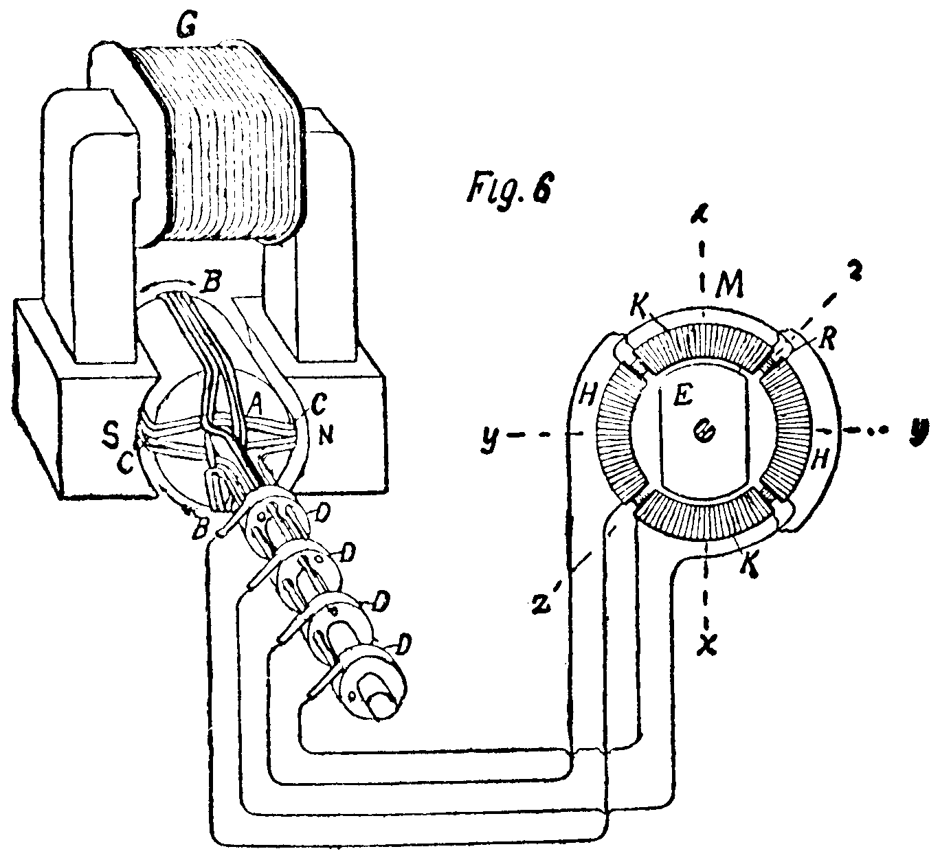

On the left is the generator. On the right is the motor. Between them are shown two independent circuits, carrying alternating currents, extending from the generator to the respective segments of the motor, H, H, and K, K. When the current in the coils K, K, is nil, and the current in coils H, H, is at its maximum, the pole will be equidistant between the latter on the line x, x, as shown, and, of course, the armature will stand on the same line. If, now, the current in the coils H, H, be diminished and that in the coils K, K, be increased, the pole will be carried over to the right hand, toward the *565 line, z, z, the armature following it. Then, if the coils in K, K, are receiving a still stronger current, and those in H, H, a weaker one, the pole will be carried over to the right still further toward the line y, y, the armature continuing to follow it; and so on progressively through the rotation.

In these patents the alternating currents are said to be of differing phases; that is, as we understand, having varying degrees of strength or voltage manifested at the same moment of time. It is not necessary to go into an explanation of the method by which the generator supplies the alternating currents, and determines the order of their succession.

We learn that, very shortly after this original invention, it was found that it was of great practical importance to dispense with the peculiar generators of the original structure, and, if possible, to substitute the simpler form of generators adapted to the transmission of currents over single circuits. The patents in suit are some of a considerable number containing many devices which the same inventor produced to meet this requirement. The substantial improvement made by them was to take out of the generator, and to carry over into the circuits near to the motor, the provision for effecting the succession of the alternating currents by which the motor is operated. The circuit court held the patents involved in this suit valid and infringed. The defendant in that court, upon this appeal, submits the questions whether these patents are valid, in view of the then state of the art, and whether they can be sustained as covering independent inventions, in view of a previously patented invention of the same patentee relating to the same subject, and, as is strenuously contended by counsel, covering the identical inventions of the patents in suit.

Proceeding to the first question, we insert here for reference Fig. 1 of the drawings annexed to patent No. 511,599, which fairly illustrates, in a general way, the changes made in the original structure in order to bring the current from the generator by a single circuit:

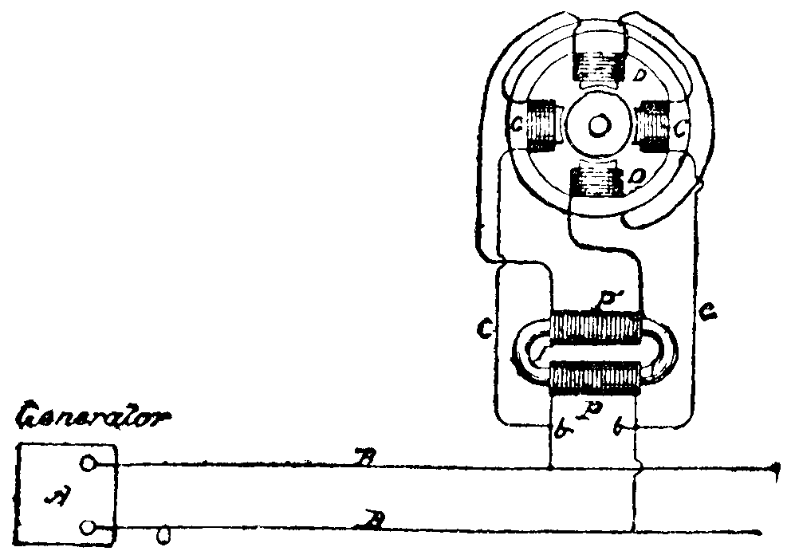

B, B, are the lines of the single circuit. At b, b, the lines are divided, one of each of the divided lines passing uninterruptedly to the segments C, C, of the motor. The other lines are connected with the primary coil, P, of a transformer or induction coil, T. A secondary current is set up in the coil, P, which is carried by the secondary*566 circuit to the segments D, D, of the motor. The current, which is taken off the original circuit, is delayed by the process of induction, and the delay is so regulated that it reaches the motor in a predetermined order of succession to that of the primary circuit. This method of causing by induction one current to lag behind the other is only one of many ways of effecting that result, but it explains the scheme on which these patents were founded.

It is not seriously disputed that the original invention of Tesla, above mentioned, was new and patentable. But it is contended that the particular inventions of the patents in suit were not new, or at most were not beyond the skill of those practiced in the art, in view of what had already been attained and published in the development of the subject, at the time when these patents were applied for, by other scientific men and by himself in previously patented inventions. The history of this development involves too long an account to be here given, and we must content ourselves with a general statement of the conditions which existed at the time to which the objection has reference. It was, of course, known how alternating currents could be produced. It was also known that a current could be divided, and one of the divided currents be made to lag behind the other, either by induction of one of them, or by using smaller wire in one of the circuits, or different material, and probably in other ways. So the method of generating electro-magnetism, and the laws of its operation, and many methods by which it could be employed for practical purposes, were understood; and, especially taking into account what Tesla had himself discovered, devised, and patented, it was known that electro-motive power might be used for operation a motor distant from the generator. One method was disclosed by his original invention, which employed two or more circuits. Other ways had been disclosed by his original invention, which employed two or more circuits. Other ways had been disclosed in his later patents, in which the special characteristic was the method of organization by which he dispensed with all but one of the circuits leading from the generator, and thereby also dispensing with the generator of double circuits; and in some, one or more, he had disclosed special means for operating a motor upon his general scheme. But no one else had publicly disclosed, so far as we can discover, nor had he himself disclosed, and dedicated to the public, the particular inventions which are disclosed by the patents in suit.

An argument of great research and cogency was made by counsel for the appellant to establish the fact of the existence of the condition of the art at the date of the application for the patents in suit, as we believe it was, and have conceded it to have been. But it is still contended that, conceding the fact to be that no one had made these particular inventions, yet that, so much was known to men learned in the science or skilled in the art of the subject, it did not involve invention to devise these ways and means for accomplishing the desired result. As to this it must be said that the subject is one of the most abstruse and subtle of all the practical sciences, and its pursuit involves the exercise of the keenest intelligence and most patient research that gifted men can bestow upon it. We ought, therefore, to be cautious, when a distinct and practical improvement *567 is made so useful in art, in denying to the author the reward which the law gives to meritorious inventions.

It is true, then, that the laws governing the action of electro-magnetism were, in general, understood, and many advances had been made toward applying it to practical uses, but no one beside Tesla had ever been able to devise practicable means for applying its energy to the operation of a motor with any substantial result. Without going through with an analysis of the testimony, this is the resultant fact, as we gather it from the record. The effect of Tesla's own previous inventions, and particularly of his previous patent 416,193, upon the patents in suit, we shall discuss later, in connection with the question whether these patents cover inventions which were the subjects of a patent or patents already granted to the same inventor. Recurring to the question of lack of invention, it is further to be observed that, both before and after Tesla's original invention, the public interest in the development of ways and means for applying the forces of electricity and magnetism to effect motive power for practical use was intense, and many scientific men were endeavoring to discover how and by what means this could be done. And notwithstanding Tesla had devised a general scheme by which it could be done, and had supplied a form or forms of apparatus by which it could be accomplished, the field remained open to invent any new subordinate methods or means for carrying to a useful result the scheme which he had inaugurated. The fact that, in such circumstances, no one accomplished it, is cogent evidence that these later inventions of Tesla were beyond the compass of the ordinary skill of the profession and beyond the line which divides the products of such skill from invention. In the case of Dowagiac Mfg. Co. v. Superior Drill Co., 115 Fed. 886, 894, in commenting upon a case involving similar conditions, we emphasized the value, as evidence of invention, of such facts.

In each of the applications for the patents in suit, the inventor disclaims, for the purposes thereof, other methods and means which he had embodied in other applications. We think the inventions of the patents which form the basis of the controversy were not anticipated by anything theretofore discovered by others, and were, so far as concerns their merits, patentable.

Then as to the objection that these patents are for subject-matter which had been already covered by Tesla's prior patent No. 416,193. The former patent referred to as covering the inventions of the patents in suit is Tesla's patent No. 416,193, issued December 3, 1889, upon an application filed May 20, 1889, and is for a combination of motor and circuits. The claims are as follows:

(1) An alternating current motor, having two or more energizing circuits, the coils of one circuit being composed of conductors of large size or low resistance, and those of the other of fewer turns, of smaller size or higher resistance, as set forth. (2) In an alternating current motor, the combination, with long and short field-cores, of energizing coils included in independent circuits, the coils on the longer cores containing an excess of copper or conductor over that in the others, as set forth. (3) The combination, with a field-magnet composed of magnetic plates having an open center and pole-pieces or cores of different length, of coils surrounding said cores and included in independent circuits, the coils on the longer cores containing an excess of copper over that in the others, as set forth. (4) The combination, *568 with a field-magnet composed of magnetic plates having an open center and pole-pieces or cores of different length, of coils surrounding said cores and included in independent circuits, the coils on the longer cores containing an excess of copper over that in the others, and being set in recesses in the iron core formed by the plates, as set forth.

This first claim represents the invention of certain specific means for delivering at the motor alternating currents in a predetermined order of succession. This is done by so varying the capacity in the two circuits for self-induction or resistance (one or both) resulting from the difference of material used in the circuits, or from their mode of construction (one or both), as to accomplish the intended purpose of delaying one of the currents behind the other. The properties utilized by these means for producing the succession of the currents are those of self-induction and resistance in the circuit. These terms (‘self-induction and resistance‘) are used to signify means of hindering or delaying the current in circuits, as contradistinguished from induction proper, which consists in taking off, in part, the current of the circuit by placing a conductor in proximity to such circuit, and within its influence, which is thereupon transmitted over another line or circuit. The second claim is for a subordinate feature, consisting of the introduction into such motors of alternate long and short field-cores carrying the coils of the respective circuits, the longer cores having an excess of copper or conductor over that in the others. This claim is also for specific means aiding in the result intended to be accomplished by the means mentioned in the first claim. The third claim, too, is for special means intended to promote the advantages of the first claim. The fourth claim consists of the same combination as the third, with the added feature that the cores are ‘set in recesses in the iron core formed by the plates.‘ This claim is also for auxiliary means introduced into the mechanism already set forth in the preceding claims. Thus it will be seen that the whole body of the claims in this patent relates to the construction of motors and circuits capable of utilizing the properties of self-induction and resistance in the circuit to effect the delivery of alternating currents in such succession as to induce a sustained rotation of the motor.

The first (in number) of the patents in suit is No. 511,559, issued December 26, 1893, upon an application filed December 8, 1888. The claims are these:

(1) The method of operating motors having independent energizing circuits, as herein set forth, which consists in passing alternating currents through both of the said circuits, and retarding the phases of the current in one to a greater or less extent that in the other. (2) The method of operating motors having independent energizing circuits, as herein set forth, which consists in directing an alternating current from a single source through both circuits of the motor, and varying or modifying the relative resistance or self-induction of the motor circuits, and thereby producing in the currents differences of phase, as set forth.

This patent relates to a method or methods of transmitting alternating currents proceeding from one original source through both of the energizing circuits of the motor, and at the same time retarding the phases of the current in one circuit to a greater or less extent that in the other. The patentee disclaims the specific means which he employs*569 in the method or methods which he discloses as his invention, reciting that they are the subjects of other applications. Claim 1 consists of a method of operating the motor by passing alternating currents to it through independent circuits, and retarding the phases of the current in one circuit more or less than in the other. The main line is not included, except as it is implied form the specification that the independent circuits will be connected with it and be energized therefrom. This is the broad statement of the method which Tesla employs in such of his constructions as use several circuits divided from one main circuit proceeding from the generator. Having disclaimed the apparatus by which the method is practiced, it is not particularized, but is suggested in a general way. The invention consists in dispensing with more than one circuit from the generator by dividing the main line at some point, which may be near the motor, and by interposing in the divided lines some means known to the electrical art for regulating the flow of the current through the lines in such way as that they shall successively energize the different segments of the motor. The patentee says in his specifications that this distribution may be effected by induction of the one current from the other, or by what is known as ‘derivation,‘ in which case he inserts in one of the circuits a resistance or self-induction coil, in either of which cases the current is retarded so that it alternates with that over the other line in arriving at the motor; and he illustrates by several forms of apparatus how his method may be pursued. But these suggested forms are not exclusive of other devices adapted to the purpose, which, as he says, were well known. The second claim is substantially the same as the first, but is more restricted, in that it limits the method of producing the alternation of the currents by confining it to the use of means for varying the relative resistance of self-induction in the motor circuits.

Patent No. 511,560, issued December 26, 1893, upon an application filed December 8, 1888, is for apparatus. It relates to means employed in the transmission of electrical power to a motor through divided currents derived from a single current proceeding from the generator; the said divided currents being so regulated with reference to each as to arrive at their destination in the motor alternately. With what has already been stated about the nature of these inventions, it will be sufficient to lead to an understanding of this patent, so far as the purposes of this case require, to state those claims which are supposed to be infringed, namely, claims 1, 2, and 6, which are these:

(1) The combination with a source of alternating currents, and a circuit from the same, of a motor having independent energizing circuits connected with the said circuit, and means for rendering the magnetic effects due to said energizing circuits of different phase, and an armature within the influence of said energizing circuits. (2) The combination with a source of alternating currents, and a circuit from the same, of a motor having independent energizing circuits connected in derivation or multiple are with the said circuit, the motor or energizing circuits being of different electrical character, whereby the alternating currents therein will have a difference of phase, as set forth. (6) In an alternating-current motor, the combination with the field-magnets or cores and independent energizing currents of different active resistance, and adapted to be connected with the line or transmission*570 circuit, of an armature wound with closed energizing coils or conductors, as set forth.

Claim 1 is for a combination made up of a generator, a single circuit leading therefrom, independent energizing circuits connected with said single circuit, a motor connected with said circuits, having an armature within the influence of said circuits, and means for rendering the current in the circuits of different phases. With respect to this last element no specific means are called for. They may consist of any means of the class designated. But the patentee, in his specification, disclaims other means than those employed, in case he takes one of the currents from the other by derivation,- that is, by a circuit which is connected with the other so as to divide the current, as distinguished from induction, where the new line is not connected with the other; and the means are thereby limited to the former class. This combination is of all the elements which make up an entire machine. Claim 2 is much like claim 1, when the latter is limited by the statement in the specification above mentioned, except that the armature is not mentioned, with the addition of specific means for effecting the alternation of phases in the currents by making the circuits of different electrical character. Claim 6 introduces a new element into the combination, namely, an armature wound with closed energizing coils or conductors,- a specific device to aid in effecting the general result.

It is contended by counsel for the appellant that ‘the invention of claim 2 of the patent in suit, No. 511,559, is necessary to the use of the motor of the former Tesla patent, No. 416,193,‘ and also ‘that the invention of claims 1, 2, and 6 of the other patent in suit, No. 511,560, is necessary to the use of the motor‘ of said former patent, and, further, that claim 1 of the patent in suit, No. 511,559, is a broad generic claim, which covers the said former patent. From these deductions it is insisted that, so far as concerns the claims of the later patents which are here relied on, they are for the same invention as that of the earlier patent, and therefore void. We will take up these several propositions in their order:

First. Is the invention of claim 2 of patent No. 511,559 ‘necessary to the use‘ of the motor of No. 416,193? Claim 2 of No. 511,559 is for ‘the method of operation motors having independent energizing circuits, as herein set forth, which consists in directing an alternating current from a single source through both circuits of the motor, and varying or modifying the relative resistance or self-induction of the motor circuits, and thereby producing in the currents differences of phase, as set forth.‘ The claim is for a method of accomplishing a certain result. That method may be practiced by the employment of any means adapted to the purpose, and then known to the art, or which might thereafter become known. To be sure, if the mechanical means employed are the subject of a patent, the party who uses the process must have or secure the right to use the patented method. Assuming for the moment that claim 2, just mentioned, was for a combination of generic means, such a claim would cover all known means of the kind enumerated. And it would cover all equivalents which might thereafter be discovered by the ordinary skill of the art, and were not the fruit of invention; and it would dominate the latter, if the latter *571 was of an improvement merely of the means covered by the former invention. But the invention of means hitherto unknown would be an independent invention, not covered by the patent, and, according to the well-settled rule, would of itself be entitled to a patent. If such an invention of improvements were made by a stranger, it cannot be doubted that he would be entitled to a patent for it. It might be that it would be impracticable for him to use it without acquiring the privilege of the underlying invention; nor could the owner of the latter use the improvement, except by treaty with the owner of it. And no valid reason exists why the patentee of an invention may not enjoy the privilege of a stranger in thereafter obtaining a patent for an independent invention made by him, although it relate to the matter of his former patent, and was described, but not claimed, therein, provided he has not dedicated such independent invention to the public; and this, in the present instance, the patentee had not done. And we applied the rule, where the same person was the author of both inventions, in Thomson-Houston Electric Co. v. Ohio Brass Co., 26 C.C.A. 107, 80 Fed. 712. Now, as already been stated, all the claims of the patent No. 416,193 are for special means or apparatus designed to be employed in carrying out the inventor's method of operating his motor, as described in patent No. 511,559. Since, therefore, the invention of the specific means covered by these claims for the special means and the generic invention were for independent inventions, and neither had been given to the public, it was competent for the inventor to take out a patent for each; and we do not perceive that in such case it would be material that the taking out of the one patent was prior to that of the other. In the present instance the invention of the method (or generic means, as we have assumed, for argument, it might be) shown by claim 2 of the later patent no more covers the separate invention of the former patent than does every broad patent cover every invention of special matter covered by such broad invention. But we shall recur to this subject later.

2. It is further claimed that the invention of claims 1, 2, and 6 of the other of said later patents, No. 511,560, is necessary to the use of the motor described in the former patent, No. 416,193, and is therefore for the same invention. But as has already been stated, both the claims of the earliest of these two patents, No. 416,193, are for certain specific means for producing the requisite succession of the currents. Generally stated, they are means for producing that result by the particular methods characterized as self-induction and resistance, whereby the current in one of the circuits is made to lag behind the other.

Claim 1 of No. 511,560 is this:

‘The combination with a source of alternating currents, and a circuit from the same, of a motor having independent energizing circuits connected with the said circuit, and means for rendering the magnetic effects due to said energizing circuits of different phase, and an armature within the influence of said energizing circuits.‘

This combination includes all the elements which constitute the machine first invention of this class of motors, by dispensing with a generator which should be competent to send out alternating currents *572 over two or more independent lines, and substituting a generator with a single circuit, and then, by dividing the current and regulating its movement in the divided lines, produce the due succession of the currents at the motor. This was an important step, and greatly advanced his original invention for practical purposes. The new invention permeated the whole structure. He was entitled to claim all the co-operating elements in his new combination, and to have a patent therefor, and such patent would cover the known means for effecting the particular operations comprehended by it. If he also invented specially arranged apparatus, not theretofore known, for executing some of the subordinate functions of the whole machine, he was, upon the principles above referred to, entitled to a patent for that also. This was what he did by his invention covered by the patent No. 416,193. It was an independent invention, representing an improvement upon the known means for effecting a beneficial purpose, which improvement was not within the compass of the patent for the principal combination.

Claim 2 is as follows:

‘The combination with a source of alternating currents, and a circuit from the same, of a motor having independent energizing circuits connected in derivation or multiple are with the said circuit, the motor or energizing circuits being of different electrical character whereby the alternating currents therein will have a difference of phase, as set forth.‘

This claim is of the same character as claim 1. It contains some modifications thereof, but it stands on the same footing for the application of the principles referred to in the consideration of the first claim, and the like result to that there indicated must follow.

Claim 6 is this:

‘In an alternating-current motor, the combination with the field magnets or cores and independent energizing circuits of different active resistance, and adapted to be connected with the line or transmission circuit, of an armature wound with closed energizing coils or conductors, as set forth.‘

This claim is also of the same character as claim 1, though it also suggests a peculiar construction, by winding the armature with closed energizing coils or conductors. We need not repeat the conclusions (which we have already stated with reference to the previous claims) respecting the result which follows upon a comparison with the invention of patent No. 416,193.

Then it is also said that claim 1 of patent No. 511,559 is broad and generic, and that it covers the patent No. 416,193, previously issued. It is true that the claim referred to is of the character ascribed to it. We have so treated it, but it does not follow that it covers the former invention. As we have explained, it does not cover it, because the former patent is for an independent invention of special means for fulfilling some of the requirements of the broad patent.

We have significantly referred to the fact that some of the claims in the patents considered are for methods, and others for apparatus, for the purpose of founding a distinction in the nature of the inventions. We have assumed, for the purpose of the discussion, that certain claims for methods might be regarded as claims for generic means, but in fact they are made as claims for methods; *573 and there is not doubt that it is established by authority that an inventor may be entitled to a patent for the method or process for producing new and useful results, and also for the means by which it is produced, when the method or process is susceptible of being performed by known means, and the means invented are of such a character as to merit a patent. Merrill v. Yeomans, 94 U.S. 568, 24 L.Ed. 235. If no means were known for practicing the method, the patentee would be obliged to specify some means; otherwise the invention could not be used. This doctrine has special application to the patent No. 511,559, which is wholly for methods, when compared with No. 416,193, which is wholly for apparatus.

In support of his contention, the learned counsel for the appellant relies with much confidence upon the authority of the cases of Miller v. Manufacturing Co., 151 U.S. 186, 14 Sup.Ct. 310, 38 L.Ed. 121, and Palmer Pneumatic Tire Co. v. Lozier, 62 U.S.App. 651, 33 C.C.A. 255, 90 Fed. 732; the latter being a case decided by this court. But these cases do not support the doctrine for which he contends. On the contrary, they are both founded on the invention of a spring which the inventor devised to put into the combination of parts of a cultivator. It extended from the beam carrying the hoes to and under a grooved wheel pinioned on a post standing on the axle of the cultivator. The spring was so constructed that when the cultivator hoes were down and at work, the spring would tend to hold them down to their place. It also had the capacity to assist in raising the beam, and, of course, the hoes, out of and free from the ground as soon as the operator should start the upward movement. The first patent was for this spring, when adapted to perform both functions in combination with other parts of the cultivator. The second patent was for the same spring in so far as it was adapted to the function of assisting in raising the beam; but that part of the spring which was adapted to holding the implement down, although described, was not claimed, and was in fact immaterial, since the lifting did not employ the peculiarities of that part of the spring adapted to effect the depressing of the beam. The supreme court held that, inasmuch as the former patent included the invention of those characteristics which helped to lift the beam, as well as those which tended to hold it down, and the later patent was for a spring having only the same characteristics for lifting the beam, the so-styled new invention was parcel of that already patented. Substantially the same doctrine was applied in McClain v. Ortmayer, 141 U.S. 419, 12 Sup.Ct. 76, 35 L.Ed. 800. McClain had invented a pad for horse collars, which employed a double spring, having a hook at each end, for the purpose of securing the pad to the forward and rearward rolls of the collar, respectively; and he claimed as his invention a pad provided with such an attachment. Afterwards, perceiving that a single spring adapted to attachment to the forward roll would in many instances be more useful than a double spring, he applied for and obtained a patent for a single spring adapted to securing the pad to the forward roll. This second patent *574 was held void, for the reason that there was no new invention; the inventor having patented simply a part of the invention previously patented. So, in Palmer Pneumatic Tire Co. v. Lozier, the former patent was for a rubber fabric of peculiar construction, when put into a pneumatic tire in combination with other elements. As in the case of the spring, the fabric was the only thing new in the combination of the parts of the tire, and was only an improvement of the former fabric which had been used in the same place and for the same purpose. The whole invention was exhausted in devising the fabric, and it was for that invention that the patent was granted. Moreover, the invention could not be practiced by any means generally known, but only by the means thus specifically described. The later patent was for the same fabric, and that only. There was no new inventive act. The patentee had simply extracted the kernel of his former patent, and brought it over to constitute the consideration for a new grant. Both the cases referred to stand upon the ground that the first patent had been given for the actual invention, and could not be supported without it. And the court in each instance, disregarding mere formal appearances, looked to the substance of things, and refused to recognize as original that which it knew was old. In the Miller Case, Mr. Justice Jackson, after canvassing a number of previous cases, said:

‘The result of the foregoing and other authorities is that no patent can issue for an invention actually covered by a former patent, especially to the same patentee, though the terms of the claims may differ.‘

And in the Palmer Pneumatic Tire Co. Case, this court, following the Miller Case, said:

‘That decision shows that it is not necessary to the rule that the patents should be for coextensive inventions, or that the subject-matter thereof should be technically the same.‘

We have no disposition to depart from the rules in respect to the identity of patents, and the method of determining it, here adverted to, which we deem sound and reasonable; but it would be a misapplication of them, and contrary to their spirit and purpose, to say that independent inventions may not be the proper subjects of independent patents, even though they may relate to the same subject-matter, and one may dominate the other in the same field. The distinction seems clear, and pains were taken in both of the above cases to point it out. In the Miller Case, Mr. Justice Jackson after referring to several cases, further said:

‘A single invention may include both the machine and the manufacture it creates, and in such case, if the inventions are really separable, the inventor may be entitled to a monopoly of each. It is settled, also, that an inventor may make a new improvement on his own invention of a patentable character, for which he may obtain a separate patent; and the cases cited come to this point, and to this point only, that a later patent may be granted when the invention is clearly distinct from and independent of one previously patented.‘

And in the Palmer Pneumatic Tire Co. Case this court said:

‘Undoubtedly, as pointed out in Miller v. Manufacturing Co., supra, if the second patent is for a distinct and separate invention, or to put the matter in another way, has not been made integral with another invention already *575 patented, so as to be fairly necessary to its use, it should be sustained, if the other requisite conditions exist.‘

And we referred to the opinion delivered by Judge Taft in a former case,-that of Thomson-Houston Electric Co. v. Ohio Brass Co., 54 U.S.App. 1, 26 C.C.A. 107, 80 Fed. 712,- which was an illustration of that class of cases, and was one where the patent was sustained. Another case of the same class is that of Allington & Curtis Mfg. Co. v. Globe Co. (C.C.) 89 Fed. 865, where a patent for improvements on a machine had been taken out pending a prior application for a patent for the machine itself. Subsequently a patent was granted for the machine. It was held by Judge Taft, again distinguishing the case of Miller v. Eagle Manufacturing Co., that the granting of the former patent did not invalidate the latter. And in a more recent case- Thomson-Houston Electric Co. v. Jeffrey Mfg. Co., 41 C.C.A. 247, 101 Fed. 121- this court again emphasized the distinction made in the foregoing cases, and held that, the device in the later patent being substantially that patented by a former patent, the latter patent was void. To the same effect is Thomson-Houston Electric Co. v. Hoosick R. Co., 27 C.C.A. 419, 82 Fed. 461, in the circuit court of appeals for the Second circuit. And see, also, Industrial Mfg. Co. v. Wilcox & Gibbs Sewing Mach. Co., 50 C.C.A. 387, 112 Fed. 535.

The learned counsel lays special stress in his brief upon the language contained in the opinion of this court in the Palmer Pneumatic Tire Co. Case, where we said, as a deduction from the Miller Case, that ‘the rule rests upon the broad and obvious ground that, if the second patent is for an invention that was necessary to the use of the invention first patented, it cannot be sustained.‘ But we were there considering a class of cases where the subject-matter of the later patent was an essential and necessary part of the former invention, and covered by the patent granted therefor; and the observation quoted has no application to that other class of cases where the subject-matter of the later patent (that is, the invention covered by it) was not a component part of the former invention, but was an independent invention, not necessary to the composition of the first, or included in it. And in a later part of the opinion, as has been already stated, we expressly distinguished the latter class of cases from the former.

We are of the opinion that the patents in suit are not void by reason of the inventions covered by them having been previously patented, and, infringement not being denied, the judgment must be affirmed.

C.A.6 1902.
Dayton Fan & Motor Co. v. Westinghouse Electric & Mfg. Co.
118 F. 562, 55 C.C.A. 390

END OF DOCUMENT

