Circuit Court of Appeals, Seventh Circuit.
DIAMOND METER CO.
v.
WESTINGHOUSE ELECTRIC & MFG. CO.

No. 1,314.
January 31, 1907.

Appeal from the Circuit Court of the United States for the Northern Division of the Southern District of Illinois.

PATENTs- ELECTRIC POWER TRANSMISSION- SPLIT-PHASE MOTORS.
The inventions covered by the Tesla patents Nos. 511,559 and 511,560, for a method of transmitting electrical power and means for practicing such method known as the ‘Split-Phase Motor,‘ held, under the evidence, to have been made prior to April 20, 1888, and therefore not anticipated by the Ferarris or Shallenberger publications. Such patents disclose invention, and were not anticipated by anything in the prior art, nor are they for the same invention as patent No. 401,520, previously granted to the same inventor on a later application and also covered by the British patent No. 6,527 of 1889, and therefore do not constitute a case of double patenting, and are not affected by the expiration of such British patent.

West Headnotes

*704 The decree adjudges that appellant is an infringer of both claims of the Tesla patent No. 511,559, and of the first four claims of patent No. 511,560, issued December 26, 1893, the one for improvements of method and the other of means of electrical transmission of power.

The general nature of the new method of No. 511,559 is described in the following portions of the specification and in the claims: ‘In certain patents heretofore granted, I have shown and described a system of electrical power transmission in which each motor contains two or more independent energizing circuits through which were caused to pass alternating currents, having in each circuit such a difference of phase that by their combined or resultant action they produced a rotary progression of the poles or points of maximum magnetic effect of the motor and thereby maintained the rotation of its movable element. In the system referred to and described in said patents, the production or generation of the alternating currents, upon the combined or resultant action of which the operation of the system depends, is effected by the employment of an alternating current generator with independent induced circuits which, by reason of the winding or other construction of the generator, produced currents differing in phase, and these currents were conveyed directly from the generator to the corresponding motor coils by independent lines or circuits. I have, however, discovered another method of operating these motors, which dispenses with one of the line circuits and enables me to run the motors by means of alternating currents from a single original source.

‘Broadly stated, this invention consists in passing alternating currents, obtained from one original source, through both of the energizing circuits of the motor, and retarding the phases of the current in one circuit to a greater or less extent than in the other.

‘The distribution of current between the two motor circuits may be effected by induction or by derivation. In other words, I may pass the alternating current from the source through one energizing circuit and induce by such current a second current in the other energizing circuit. Or, on the other hand, I may connect up the two energizing circuits of the motor in derivation or multiple arc with the main circuit from the source. In either event I make *705 due provision for maintaining a difference of phase between the currents in the two circuits or branches.

‘In carrying out my invention I have used various means for securing this result. For example, when I induce a current in one of the circuits from the current flowing in the other, I employ a form of converter or bring the two circuits into such inductive relations as will produce the necessary difference of phase. Or, when I obtain the two energizing currents by derivation, I make the two circuits of different degrees of self-induction by inserting a resistance or self-induction coil in one of said currents, or I combine these devices in different ways, as I shall more specifically describe hereinafter. * * *

‘In an application filed of even date herewith, I have shown and described other ways of accomplishing this result, among which may be noted the introduction of a resistance capable of variation in each motor circuit, or the use of a resistance in one circuit and a self-induction coil in the other. * * *

‘What I claim herein is:

‘(1) The method of operating motors having independent energizing circuits, as herein set forth, which consists in passing alternating currents through both of the said circuits and retarding the phases of the current in one circuit to a greater or less extent than in the other.

‘(2) The method of operating motors having independent energizing circuits, as herein set forth, which consists in directing an alternating current from a single source through both circuits of the motor and varying or modifying the relative resistance or self-induction of the motor circuits and thereby producing in the currents differences of phase, as set forth.‘

Fig. 1 is illustrative of the inductive method, and Fig. 2 of the derivative.

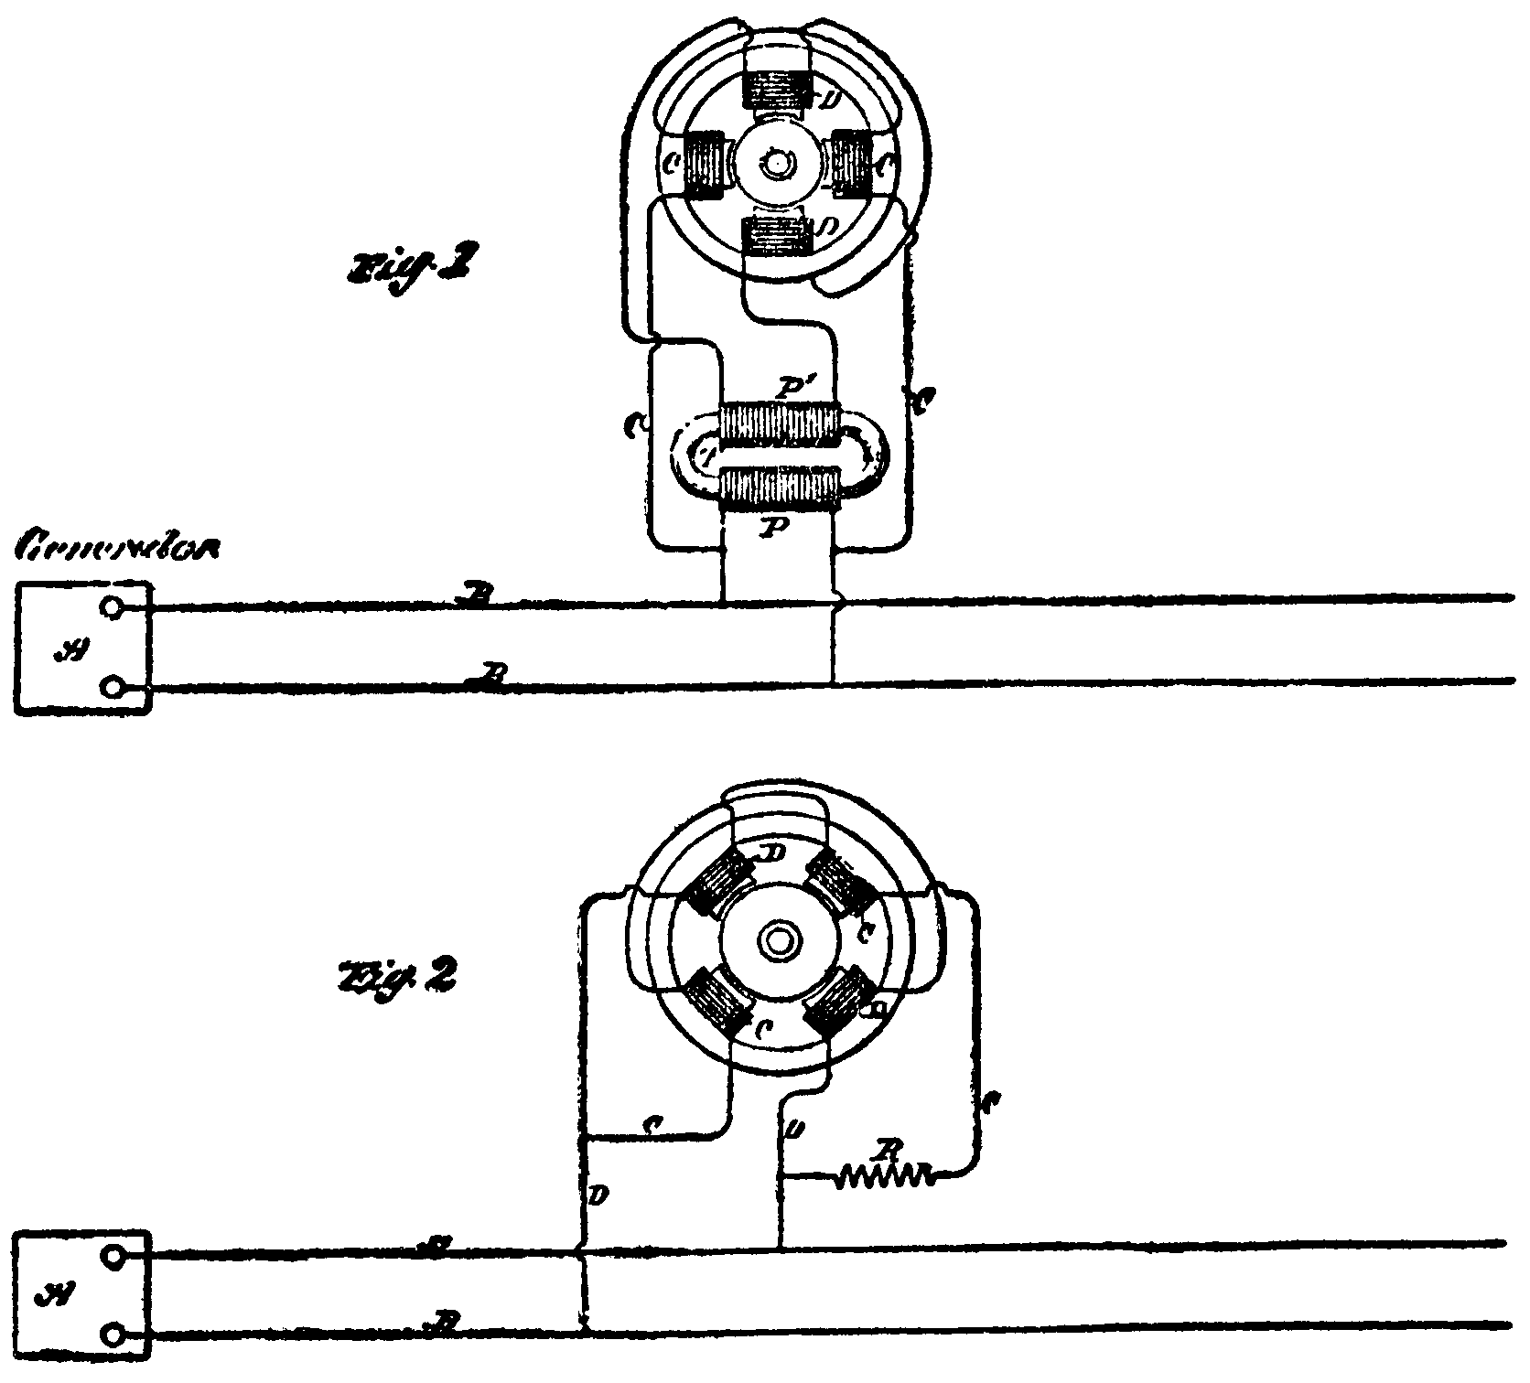

*706 In the specification of patent 511,560 Tesla said:

‘My present application relates to the means employed when the two energizing currents are obtained from a single source by derivation.

‘In explanation of what appears to be the principle of the operation of my invention and of the functions of the several instrumentalities comprised thereby, let it be assumed that the two energizing circuits of an alternating current motor, such, for example, as I have described in my patent No. 382,280, dated May 1, 1888, are connected up in derivation or multiple are with the conductors of a circuit including an alternating current generator. It is obvious that if both circuits are alike and offer the same resistance to the passage of the current no rotary effect will be produced, for, although the periods of the currents in both circuits will lag or be retarded to a certain extent with respect to an unretarded current from the main circuit, their phases will coincide. If, however, the coils of one circuit have a greater number of convolutions around the cores, or a self-induction coil be included in one of the circuits, the phases of the current in that circuit are retarded by the increased self-induction. The degree of retardation may readily be secured by these means which will produce the difference in electrical phase between the two currents necessary for the practical operation of the motor. If in lieu of increasing the self-induction of one circuit a dead resistance be inserted, the self-induction of such circuit exerts a correspondingly diminished effect, and the phases of the current flowing in that branch are brought more nearly in unison with those of an unretarded current from the main line, and the necessary difference of phase between the currents in the two energizing circuits thus secured. I take advantage of these results in several ways. For example, I may insert variable resistances in both branches or energizing circuits, and, by varying one or the other so as to bring the phases of the two currents more or less in unison with those of the unretarded current, I may thus vary the direction of the rotation of the motor. In lieu of resistances I may employ variable self-induction coils in both circuits. Or I may use a resistance in one and a self-induction coil in the other and vary either or both.

‘ * * * A reduction of resistance in one circuit imparts to the motor rotation in one direction, while a reduction of the resistance in the other circuit will produce a rotation in the opposite direction. By means of the two resistances, therefore, capable of variation or of being bodily withdrawn from or inserted in the circuits by any well-known means, a perfect regulation of the motors is secured. * * *

‘In Fig. 7 the usual means for varying the resistance or self-induction of the motor circuits at will are indicated by the lever, M, sliding over a series of resistance plates, and by a core, N, which is adapted to be moved in and out of the induction coil, S.

‘Similar results may be secured by such a construction or organization of the motor as will yield the necessary differences of phase. For example, one set of energizing coils may be of finer wire than the other, or have a greater number of convolutions, or each circuit may contain the same number of convolutions, but composed of different conductors, as, for instance, one of copper, the other of German silver. I have represented this in Fig. 6, in which the coils, C, are indicated by closer lines than coils, D.‘

Figs. 6 and 7 are as follows:

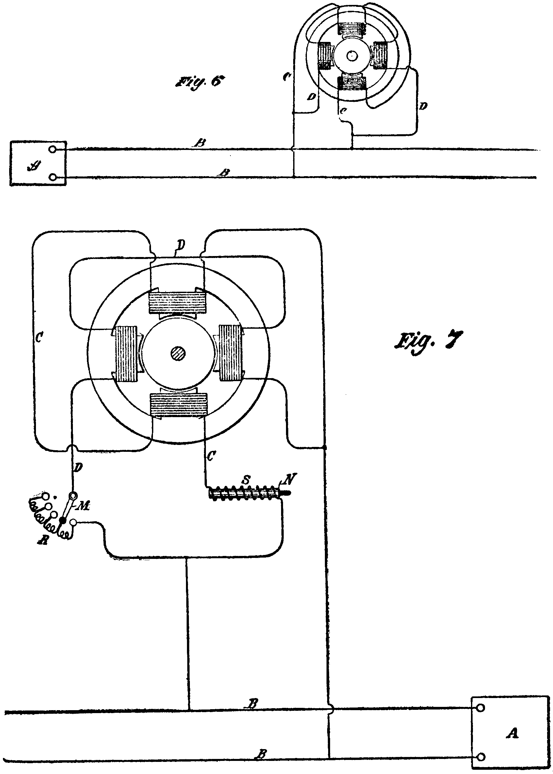

*707 The claims, of whose infringement complaint was made, read thus:

‘(1) The combination, with a source of alternating currents and a circuit from the same, of a motor having independent energizing circuits connected with the said circuit, and means for rendering the magnetic effects due to said energizing circuits of different phase and an armature within the influence of said energizing circuits.

‘(2) The combination, with a source of alternating currents and a circuit from the same, of a motor having independent energizing circuits connected in derivation or multiple arc with the said circuit, the motor or energizing *708 circuits being of different electrical character, whereby the alternating currents therein will have a difference of phase, as set forth.

‘(3) The combination, with a source of alternating currents and a circuit from the same, of a motor having independent energizing circuits connected in derivation or multiple are with the said circuit and of different active resistance, as set forth.

‘(4) In an alternating current motor, the combination, with field magnets, of independent energizing currents, adapted to be connected in multiple arc with the conductors of the line or transmission circuit and a resistance or self-induction coil in one or both of the said motor circuits, as set forth.‘

In connection with the defense of double patenting, claim 5 is brought into the case:

‘(5) In an alternating current motor, the combination, with the field magnets or cores, of independent energizing coils adapted to be connected in multiple arc with the line or transmission circuit, and a variable resistance or self-induction coil included in one or both of the motor circuits, as set forth.‘

If the patents are valid, appellant concedes infringement.

The defenses are anticipation, want of invention, double patenting, and prior foreign patenting.

Respecting anticipation, the facts, as we find them to be, are summarized in the opinion.

As no anticipation is found, the prior art, with notice of which Tesla was chargeable, is limited to his own polyphase motor, referred to in the patents in suit, and to Overbeck's laboratory demonstration of the equivalency of three modes of producing two alternating currents of differing phases, one mode being by the use of a two-phase generator, and the other two being by splitting a single current and causing the part in one branch (either induced or derived) to lag. In one of appellant's briefs Overbeck's experiments and appellant's application of them to the patents in suit are diagrammed thus:

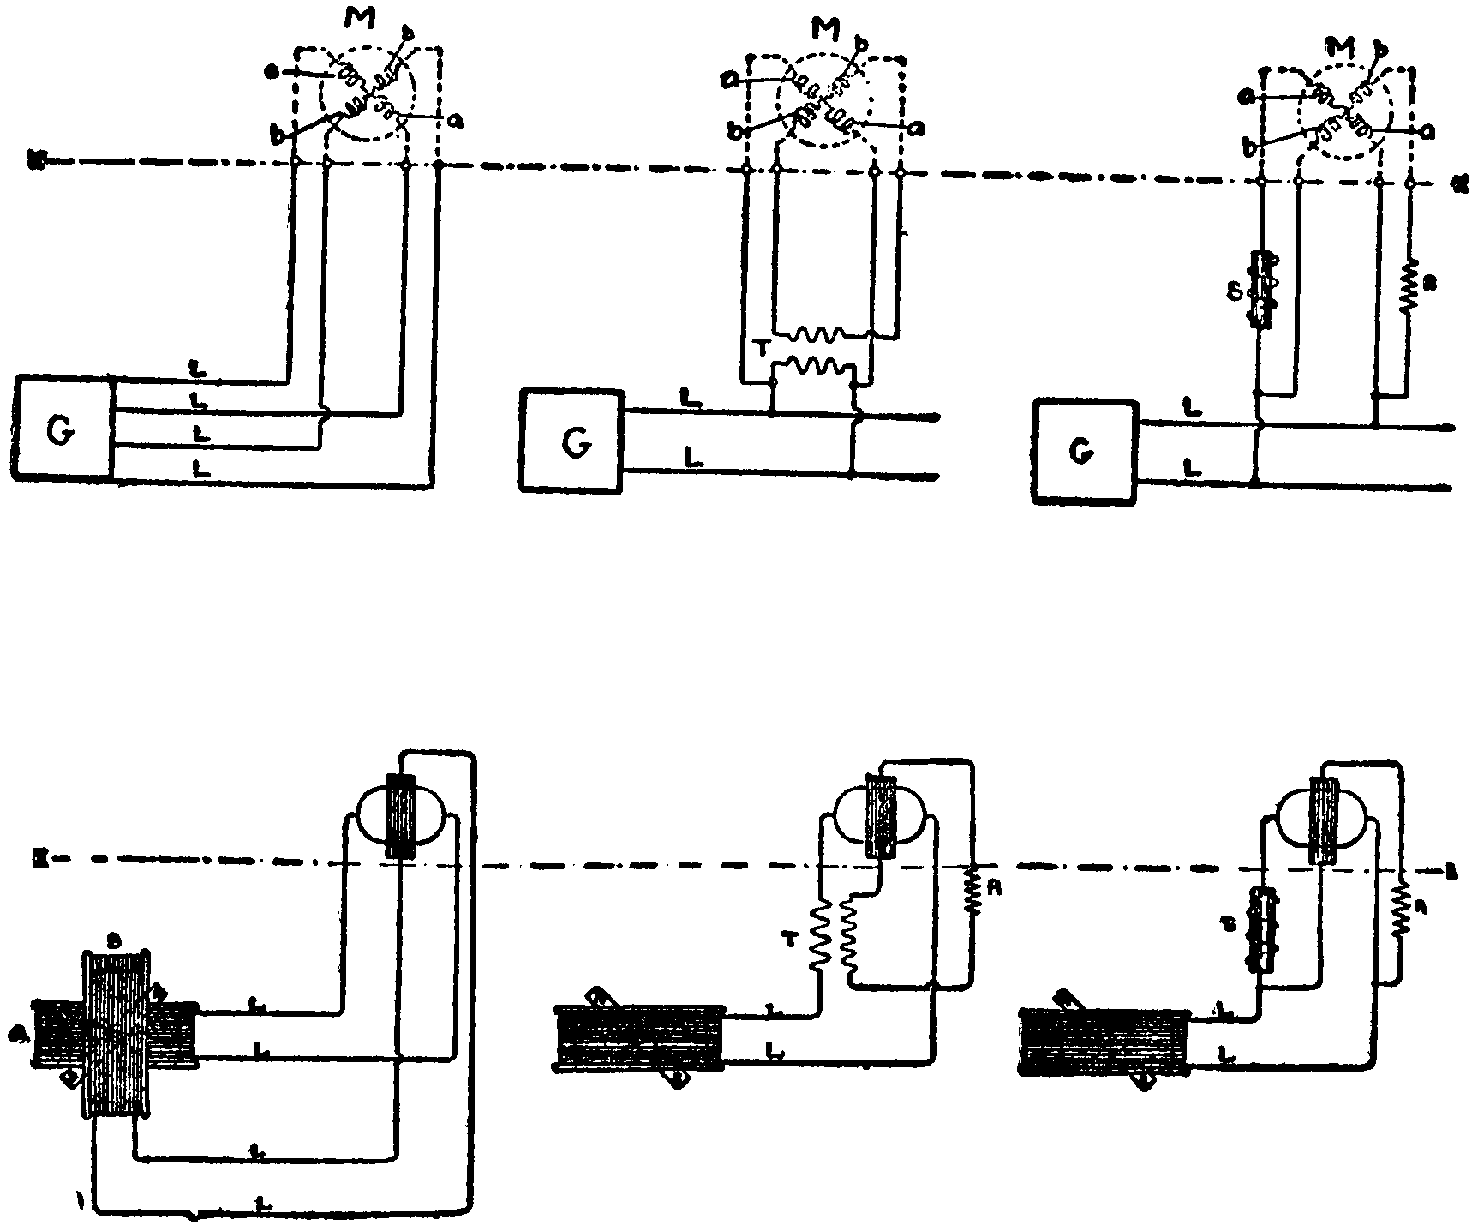

*709 The defense of double patenting is founded on a comparison of the patents in suit, particularly claim 5 and Fig. 7 of No. 511,560, with Tesla's patent No. 401,520, issued April 16, 1889, on an application filed February 18, 1889, for a ‘method of operating electro-magnetic motors.‘

The specification of No. 401,520 states:

‘As is well known, certain forms of alternating-current machines have the property, when connected in circuit with an alternating-current generator of running as a motor in synchronism therewith; but, while the alternating current will run the motor after it has attained a rate of speed synchronous with that of the generator, it will not start it. Hence, in all instances heretofore where these 'synchronizing-motors,’ as they are termed, have been run, some means have been adopted to bring the motors up to synchronism with the generator, or approximately so, before the alternating current of the generator is applied to drive them. In some instances mechanical appliances have been utilized for this purpose. In others special and complicated forms of motor have been constructed. I have discovered a much more simple method or plan of operating synchronizing-motors, which requires practically no other apparatus than the motor itself. In other words, by a certain change in the circuit-connections of the motor I convert it at will from a double-circuit motor, or such as I have described in prior patents and applications, and which will start under the action of an alternating current, into a synchronizing-motor, or one which will be run by the generator only when it has reached a certain speed of rotation synchronous with that of the generator. In this manner I am enabled to very greatly extend the applications of my system and to secure all the advantages of both forms of alternating-current motor.

‘The expression 'synchronous with that of the generator’ is used herein in its ordinary acceptation; that is to say, a motor is said to synchronize with the generator when it preserves a certain relative speed determined by its number of poles and the number of alternations produced per revolution of the generator. Its actual speed, therefore, may be faster or slower than that of the generator; but it is said to be synchronous so long as it preserves the same relative speed.

‘In carrying out my invention I construct a motor which has a strong tendency to synchronism with the generator. The construction which I prefer for this is that in which the armature is provided with polar projections. The field-magnets are wound with two sets of coils, the terminals of which are connected to a switch mechanism, by means of which the line-current may be carried directly through the said coils or indirectly through paths by which its phases are modified. To start such a motor, the switch is turned onto a set of contacts which includes in one motor-circuit a dead resistance, in the other an inductive resistance, and, the two circuits being in derivation, it is obvious that the difference in phase of the current in such circuits will set up a rotation of the motor. When the speed of the motor has thus been brought to the desired rate, the switch is shifted to throw the main current directly through the motor-circuits, and although the currents in both circuits will now be of the same phase the motor will continue to revolve, becoming a true synchronous motor.‘ * * *

‘I believe that I am the first to operate electro-magnetic motors by alternating currents in any of the ways herein suggested or described; that is to say, by producing a progressive movement or rotation of their poles or points of greatest magnetic attraction by the alternating currents until they have reached a given speed, and then by the same currents producing a simple alternation of their poles, or, in other words, by a change in the order or character of the circuit-connections to convert a motor operating on one principle to one operating on another, for the purpose described.‘

And the claims are these:

‘(1) The method of operating an alternating current motor herein described by first progressively shifting or rotating its poles or points of greatest attraction, and then, when the motor has attained a given speed, alternating the said poles, as described.

‘(2) The method of operating an electro-magnetic motor herein described, which consists in passing through independent energizing-circuits of the motor *710 alternating currents differing in phase, and then, when the motor has attained a given speed, alternating currents coinciding in phase, as described.

‘(3) The method of operating an electro-magnetic motor herein described, which consists in starting the motor by passing alternating currents differing in phase through independent energizing-circuits, and then, when the motor has attained a given speed, joining the energizing-circuits in series and passing an alternating current through the same.

‘(4) The method of operating a synchronizing-motor, which consists in passing an alternating current through independent energizing-circuits of the motor and introducing into such circuits a resistance and self-induction coil, whereby a difference of phase between the currents in the circuits will be obtained, and then, when the speed of the motor synchronizes with that of the generator, withdrawing the resistance and self-induction coil, as set forth.‘

The defense of prior foreign patenting is based on section 4887, U.S. Rev. St. (U.S. Comp. St. 1901, p. 3382), as it stood when the patents in suit were issued:

‘Sec. 4887. No person shall be debarred from receiving a patent for his invention or discovery, nor shall any patent be declared invalid, by reason of its having been first patented or caused to be patented in a foreign country, unless the same has been introduced into public use in the United States for more than two years prior to the application. But every patent granted for an invention which has been previously patented in a foreign country shall be so limited as to expire at the same time with the foreign patent, or, if there be more than one, at the same time with the one having the shortest term, and in no case shall it be in force more than seventeen years.‘

The foreign patent on account of which the patents in suit are said to have expired is British patent No. 6,527 of 1889. It is substantially the same as the domestic patent No. 401,520.

The patents here in suit, as well as the basic patents relating to the rotating-field motor-principle, have been in litigation repeatedly. In connection with the voluminous record and briefs we have read the following cases: Westinghouse Co. v. Granite Co. (C.C.) 103 Fed. 951; Westinghouse Co. v. Granite Co., 110 Fed. 753, 49 C.C.A. 151; Westinghouse Co. v. Royal Weaving Co. (C.C.) 115 Fed. 733; Westinghouse Co. v. National Electric Co. (C.C., E.D. Wis., not reported); Tesla Electric Co. v. Scott & Janney (C.C.) 97 Fed. 588; Westinghouse Co. v. Dayton Co. (C.C.) 106 Fed. 724; Dayton Co. v. Westinghouse Co., 118 Fed. 562, 55 C.C.A. 390; Westinghouse Co. v. Catskill Co. (C.C.) 94 Fed. 868; Westinghouse Co. v. Catskill Co. (C.C.) 110 Fed. 377; Westinghouse Co. v. Catskill Co. (C.C.) 121 Fed. 831; Westinghouse Co. v. Stanley Co. (C.C.) 129 Fed. 140; Westinghouse Co. v. Stanley Co., 133 Fed. 167, 68 C.C.A. 523; Westinghouse Co. v. Stanley Co., 138 Fed. 823, 71 C.C.A. 189; Westinghouse Co. v. Roberts (C.C.) 125 Fed. 6; Westinghouse Co. v. Mutual Life Ins. Co. (C.C.) 129 Fed. 213; Westinghouse Co. v. Electric Appliance Co. (C.C.) 133 Fed. 397; Westinghouse Co. v. Electric Appliance Co. (C.C.) 142 Fed. 545; Jefferson Co. v. Westinghouse Co., 139 Fed. 385, 71 C.C.A. 481.

Appellant's counsel urge their case with thoroughness and zeal, and they properly insist upon their right to our independent judgment of the merits of each defense as now presented.
Charles A. Brown and Charles E. Pickard, for appellant.

Parker W. Page and Thomas B. Kerr, for appellee.

Before GROSSCUP, BAKER, and SEAMAN, Circuit Judges.

BAKER, Circuit Judge (after stating the facts).
Applications for the patents in suit were filed on December 8, 1888. Shallenberger on April 20, 1888, and Ferarris on April 22, 1888, made disclosures that void these patents unless the fact be that Tesla made the improvements in question at an earlier date. May 15, 1888, Tesla applied for patents, *711 which were granted as Nos. 555,190 and 511,915, on the inductive splitphase motor. This form was then regarded by Tesla and his attorney as more important than the derivative split-phase motor. Shortly afterwards the Westinghouse Company began negotiations for the purchase of the Tesla motor inventions; arrangements were consummated in July; and Tesla thereupon went to Pittsburg to instruct the Westinghouse engineers. Delay from May to December is thus accounted for. Tesla has no pecuniary interest in this litigation. His testimony is positive that he operated the ‘Exhibit Motor‘ in all of the ways involved in these patents as early as September, 1887. The ‘Exhibit Motor,‘ as we understand it to have stood in September, was a rotating-field motor, the ends of whose windings were loose. These four wires could be coupled to the four wires of a two-phase alternating current generator, and the motor would then run in the manner described in the basic patents of May 1, 1888. These four wires could also carry, in turn, each of the phase-splitting means covered by the patents in suit, and when so equipped could be coupled to the two wires of a single-phase alternating current generator, and the motor would then run as an inductive or a derivative split-phase motor. So the exhibit is not regarded as proving anything beyond its capability of having built into it the phase-splitting devices. But the prolonged cross-examination, in our judgment, does not derogate in the least from the direct testimony that the exhibit was used as stated.

Brown, an electrical engineer, in 1887 and 1888 was financially concerned in the inventions that Tesla was then making. He has no interest in this litigation. When Tesla showed him the polyphase motor, designed to be coupled to the four wires of a two-phase generator, he raised the objection that it would not work in connection with the systems of single-phase generators and line-wires which were then in general use throughout the country. His testimony is positive that shortly afterwards, in the ‘summer‘ or ‘summer or fall‘ of 1887, Tesla fully disclosed the methods and means of the split-phase motor by the use of the ‘Exhibit Motor.‘ We are not impressed by the parallel columns of alleged discrepancies between his testimony and that of Tesla. Advocates' argument is familiar that if witnesses agree in details their stories have been fixed up, and if they disagree in details neither is to be believed in respect to the vital matters about which they are in accord. So far as we can judge from the printed page, Brown was a reliable witness. It should not be doubted that he saw at some time what he says he saw. The Court of Appeals for the Second Circuit ( 121 Fed. 831, 58 C.C.A. 167), on a record less complete than that presented here, concluded that Brown was mistaken in the year; that he first saw the split-phase motor in the ‘summer‘ or ‘summer or fall‘ of 1888. We find that Brown was not mistaken, for these reasons: He fixes the place at Tesla's laboratory, 89 Liberty street, New York. Tesla gave up this laboratory and went to Pittsburg in July, 1888, stayed a year, and when he returned to New York took quarters in a different street; and Brown relates the time to the early days of the polyphase invention. As Tesla began filing applications for split-phase improvements as early as May, 1888, for Brown to have seen for the first time the ‘Exhibit Motor‘ operated as a splitphase*712 motor at the Liberty street laboratory in any summer or fall, the year 1887 must be accepted.

Nellis ran a stationary engine at 89 Liberty street. Tesla rented power from his employers. Nellis sometimes stayed at night to furnish power for Tesla and was admitted to the laboratory. His testimony appeals to us as that of an uneducated, entirely disinterested and honest witness. He says that he saw Tesla operate the ‘Exhibit Motor‘ with two wires, holding one in each hand and touching one and then the other to the motor, whereupon it would turn one way and then reverse. Of course the motor would not operate unless the circuit was closed; but neither Nellis's failure to see accurately nor his mistakes in narrating what he saw should deprive his testimony of the effect that the exhibit was operated as a two-wire rotating-field motor. The time was in the fall or winter. The only fall or winter during which these things could have occurred at 89 Liberty street was that of 1887.

The absence of other physical exhibits is accounted for by a fire in Tesla's laboratory. By mere chance the ‘Exhibit Motor‘ was not destroyed. It was at the Patent Office at the time, for use in the interference case between Ferarris and Tesla.

Page, attorney for Tesla in securing patents, is convincing in his testimony that Tesla fully disclosed the split-phase inventions, including those of the patents in suit, in the early part of April, 1888. He fixes the time positively as being later than the 6th and earlier than the 18th of that month. A canceled check fixes April 6th as the day he paid the final fees on the basic patents which were issued on May 1st. He is sure that Tesla had not then informed him of the split-phase methods and means, because, when told, he was greatly perturbed over the question of having the basic patents withheld from issue on the date already fixed upon. After consulting with his then partners in New York, he finally went to Washington to confer with an associate. This date is fixed by a hotel charge as being the 27th. He is positive that the disclosure was more than a week earlier, because it was made in connection with Tesla's discussion with him of an application for a patent on an alternating current regulator, issued October 9, 1888. This application was filed April 24, 1888. A bill for services and disbursements shows that the drawings were paid for on the 21st, and that the written part of the application was completed on the 18th.

This is not a case where witnesses, years afterwards, are brought in to antedate an alleged anticipation by the efforts of unaided memory. Certain time-marks are indisputably fixed. The only escape would be to discredit the accounts of the occurrences themselves. Furthermore, it is not as if the witnesses were now called for the first time. Tesla and Page particularly have had this question brought to their attention repeatedly, beginning with the Ferarris interference, when the matters were fresh in mind.

An incident in connection with the purchase of Tesla's motor inventions we deem corroborative. In 1887-88 Shallenberger, since deceased, was an electrical engineer and inventor in the employ of the Westinghouse Company. Independently he invented polyphase and split-phase motors. When Tesla's polyphase patents of May 1st came *713 to his notice he was grievously disappointed. On behalf of his company he went to New York in June to look into the advisability of buying the Tesla inventions. The purchase, consummated on July 7th, included the polyphase patents, the application of May 15th for inductive split-phase motors, and the inventions of the patents in suit, for which applications were to be filed later. If Shallenberger had not been convinced by his investigation that Tesla had anticipated him in every feature of both sorts of rotating-field motors, it seems to us incredible that he should have failed to apply for patents and should have advised the purchase of the Tesla inventions.

There is no direct evidence to put into the opposite scale. Two negative circumstances are counted on by appellant to prove that Tesla's story is false. Anthony was electrical engineer, expert, and inventor for the Mather Company of Manchester, Conn. He visited Tesla's laboratory in January or February, 1888. Tesla was at Manchester in March with a view to interesting the Mather Company in the polyphase motor. On neither occasion did Tesla disclose to Anthony that a rotating-field motor could be built that would operate when connected to a single-circuit line. Tesla says that he did not, because Brown had instructed him ‘not to give away any new ideas,‘ and to confine his explanations to the polyphase motors that were submitted to Anthony to test. The other circumstance is that he did not make an earlier disclosure to his attorney. But if he disclosed when Page says he did, the alleged anticipations fail. Tesla gives two reasons. One is that, if he told Page of the two-wire motor before the patents for the four-wire motor were completed, Page might think the two-wire motor of so much greater importance that he would not bestow the care on the patents in hand that he otherwise would. The other is that he delayed in telling his attorney in the belief that the two-wire motor patents would detract from the commercial value of the four-wire motor patents. It is only unexplained silences that support the argument that because Tesla did not tell he had not then produced the split-phase motors. And the argument is based on an inconclusive inference, for accomplishment and silence may coexist. We regard the explanations as probable. If improbable, the resulting inconclusive inference does not assail the credibility of Brown, Nellis, and Page. On the whole record we have no doubt that Tesla antedated Ferarris and Shallenberger.

The prior art, therefore, is limited to Tesla's polyphase invention and to Overbeck's demonstration. The polyphase invention, ‘considered in its essence, was the production of a continuously rotating or whirling field of magnetic forces for power purposes by generating two or more displaced or differing phases of the alternating current, transmitting such phases, with their independence preserved, to the motor, and utilizing the displaced phases as such in the motor.‘ Westinghouse Co. v. Granite Co., 103 Fed.(C.C.) 951; Id., 110 Fed. 753, 49 C.C.A. 151. Overbeck had proven as a fact in the science of electricity that two alternating currents of differing phases could be obtained not only from two out-of-step sources of generation, but also by splitting a single current and inserting means of retardation in one of the branches. The argument is that no invention was required to *714 uncouple the motor of the May 1st patents from the four wires of the two-phase generator and then to couple up the same motor to the four wires that had been split from the single phase generator. By referring to the illustrations taken from appellant's brief it will be seen that the assumption is made that the methods and means of the patents in suit resulted from the substitution above the line X, X, of the rotating-field motor of the patents of May 1st for Overbeck's current-testing instrument. And the assumption is attempted to be justified by italicizing the words from the specification, ‘I have, however, discovered another method of operating these motors, which dispenses with one of the line circuits and enables me to run the motors by means of alternating currents from a single original source.‘

If the assumption were accepted, we should not be ready to deny invention. Patents are granted for advances in the useful arts, not for increments of knowledge. On the basis of the assumption, this case would not stand as a transference of useful means within an art, or from art to art; it would be art's first application of an empirical teaching of science. Whether the accomplishments of the patents in suit would have been developed under the hands of an ordinary workman skilled in the electric motor art, or whether they would have lain unknown unless first visualized in the imagination of an inventor, are questions concerning which the experts differ antipodally. If we had doubts as to which experts voice the saner view, the success and value of these improvements should face us towards invention.

But when the specifications, drawings, and claims are taken together and examined in connection with the actual conditions relating to the practical question of transmitting power by electricity, we think the assumption is entirely unwarranted. Before the improvements of the patents in suit were made a power company could build a dam, put in turbines to run dynamos, and erect line wires to carry the current to consumers. By commutators at the power plant the alternating could be converted into a one-way current, which would run direct-current motors. Their power and the radius within which they could be used were quite limited. The synchronous alternating current motors would not start on application of the current, and would not continue if their loads threw them out of synchronism with the generator. When Tesla devised the polyphase motor, meaning thereby the rotating-field motor whose motor circuits are of the same electrical character and value, it will be remembered that Brown's objection in substance was that factory owners could not be expected to buy such motors unless and until power companies should reorganize their existing plants and put up additional sets of line wires. Though a power plant and line wires and a motor in a customer's factory, when connected, may be viewed as a unit electrically, practically they are separate. The practical, the commercial problem that Tesla solved was to put on the market a rotating-field motor that consumers of electricity could purchase and attach to the single alternating current wires of a power plant. The polyphase and the split-phase are both rotating-field motors. In that sense, and in that sense only, is the italicized sentence from the specification, when read with all the context, to be taken; for the polyphase and the split-phase motors differ from each other *715 radically. While the motor circuits of the polyphase must be of the same electrical character and value, the motor circuits of the splitphase must not be of the same electrical character and value. Take the split-phase motor of Fig. 6. To produce it a polyphase motor would have to be reconstructed by making one of the motor circuits of finer wire than the other. The same is true when copper is used for one motor circuit and German silver for the other. On examination it is found that every form of split-phase motor illustrated, described, and claimed in the patents in suit differs in the same way from the polyphase motor. Couple the two motor circuits of a split-phase motor to the line circuits from a two-phase generator, and, assuming the differences of phase in the motor circuits and in the line circuits to be the same, the split-phase motor will not work; the polyphase works in that connection, and in no other.

Finally, want of invention is urged from the fact that at about the same time Ferarris, Shallenberger, Anthony, and Jackson produced the same results in the same way. The argument involves the leveling of Tesla to a mechanic skilled in the electric motor art by assuming that the gentlemen named are of the mechanic rank. That Ferarris and competent patent authorities did not deem the assumption true as to him is proved by Ferarris's applying for and taking out patents in European countries, and by his interferences with Tesla's applications. Shallenberger obtained a patent on an electric-meter mechanism involving the split-phase principle. Apparently he thought this was all that was left open to him out of his independent inventions of the polyphase and split-phase motors. The tentative suggestion in the letter of Jackson, a university professor of physics, may be dismissed as a rebound from the disclosure in Anthony's letter to him. Anthony's letter, March 11, 1888, is accepted as showing that he then comprehended, if he had not then practiced, the principles of the split-phase motors. His previous examination and study of Tesla's polyphase motor induced, we believe, the train of thought and experiments which he now says did not involve invention. His letter, however, leads us to conclude that he was of a different opinion at the time, and that he would have applied for patents on split-phase motors had he not been restrained by a sense of professional honor. The contemporaneous opinions of these highly trained men we value as corroboration. We think they were right in ranking themselves inventors. And it is not unprecedented that the spirit of a particular period should bring forth within the same lines a galaxy of geniuses.

Our judgment on this record is that, to these unanticipated methods and means of producing a new and useful practical result, we cannot deny the quality of invention.

Was Tesla prevented from receiving and the government from granting the monopolies of the patents in suit by reason of the prior issuance of patent No. 401,520? The applications for the patents in suit were pending when the application for patent No. 401,520 was filed. The statute requires the applicant to point out clearly and to claim distinctly the new thing of which he is asking a monopoly. These considerations must be borne in mind in examining the application which became patent No. 401,520. The specification and claims *716 of this patent, as set forth in the statement, show that synchronous motors, polyphase motors, and split-phase motors were recognized as being then old in the art. Each form was therefore open to the use of the public so far as patent No. 401,520 was concerned. If some one was otherwise empowered to shut off the free use of synchronous motors or of polyphase motors or of split-phase motors, that was another matter. What was distinctly pointed out and claimed as new was a method of operating synchronous motors. One trouble with them had been that they were not self-starting. Tesla said: Take a synchronous motor; apply to it, for starting purposes, the rotating-field of either a polyphase or a split-phase motor; when synchronism is attained, cut out the rotating-field, and there is the synchronous motor in full operation.

Counsel argue that, particularly in view of claim 5 and Fig. 7 of patent in suit No. 511,560 and of the parts of the specification relating to such claim and figure, no invention was required to discover the method of patent No. 401,520, and therefore the invention that was covered by No. 401,520 was the invention now claimed under the patents in suit.

The variableness in the dephasing devices, described in No. 511,560, is for the purpose of regulating and reversing a split-phase motor. Differences of phase must be maintained if the split-phase motor is to operate. Motors, to be synchronous motors, must be supplied with single-phase current. Claim 5 and Fig. 7 have no ‘switch mechanism, by means of which the (full and unimpeded) line-current may be carried directly through the motor coils or indirectly through paths by which its phases are modified,‘ as is required in No. 401,520. But even if the mechanical combination necessary to the method of No. 401,520 were described in No. 511,560, invention may have been involved in prescribing the method of use claimed in No. 401,520. As the Supreme Court said in Carnegie Co. v. Cambria Co., 185 U.S. 403, 22 Sup.Ct. 698, 46 L.Ed. 968:

‘If the mere fact that a prior device might be made effective for the carrying on of a particular process were sufficient to anticipate such process, the absurd result would follow that, if the process consisted merely of manipulation, it would be anticipated by the mere possession of a pair of hands.‘

So, looking only collaterally at the question of inventiveness in the method of No. 401,520, we are not prepared to reject the presumption which is carried by the grant.

But if the premise that no invention was displayed in the method of No. 401,520 were true, the conclusion would not necessarily follow that some other invention was covered by that patent, and that such other invention was the invention described and claimed in the patents in suit. From what has already been said, our conclusion may be gathered that No. 401,520, whether good or bad, does not touch the patents in suit.

‘Every patent granted for an invention which has been patented in a foreign country‘ shall expire at the same time with the foreign patent. The invention which was patented in British patent No. 6,527 of 1889, being the invention patented in No. 401,520, was not the invention for which the patents in suit were granted.

The decree is affirmed.

C.A.7 (Ill.),1907.
Diamond Meter Co v. Westinghouse Electric & Mfg Co
152 F. 704, 81 C.C.A. 630

END OF DOCUMENT

