Module 1 Critical Thinking Assignment

**Figure 1**

*Simple Calculator Pseudocode*

HEADER: file name, author, institution, module, date, and description

# Function for user input

FUNCTION user_input() RETURNS tuple[float, float]

PRINT “Provide a number:”

INPUT num1

PRINT “Provide a number:”

INPUT num2

RETURN (num1, num2)

# Function that calculates and prints results

FUNCTION calculate_and_print_results(num1: float, num2: float) RETURNS None

PRINT "Part 1: Addition and Subtraction"

PRINT "Addition: ", CALL add_numbers(num1, num2)

PRINT "Subtraction: ", CALL subtract_numbers(num1, num2)

PRINT "Part 2: Multiplication and Division"

PRINT "Multiplication: ", CALL multiply_numbers(num1, num2)

PRINT "Division: ", CALL divide_numbers(num1, num2)  
# Function that adds 2 numbers

FUNCTION add_numbers(num1: float, num2: float) RETURNS float

return num1 + num2

# Function that subtracts 2 numbers

FUNCTION subtract_numbers(num1: float, num2: float) RETURNS float

RETURN num1 - num2

# Function that multiplies 2 numbers

FUNCTION multiply_numbers(num1: float, num2: float) RETURNS float

RETURN num1 * num2

# Function that divides 2 numbers

FUNCTION divide_numbers(num1: float, num2: float) RETURNS float OR None

TRY

RETURN num1 / num2

EXCEPT ZeroDivisionError

PRINT “Error: can’t divide by zero”

# Main function

FUNCTION main() RETURNS None

num1, num2 = CALL user_input()

CALL calculate_and_print_results(num1, num2)

# Entry point of the program

IF __name__ == ‘__main__’

CALL main()

*Note. This pseudocode illustrates the algorithm used in the Python script for calculating basic arithmetic operations, including addition, subtraction, multiplication, and division. It outlines the functions required to perform these operations and handles exceptions such as division by zero. The pseudocode serves as a conceptual guide for understanding the logical flow of the program before implementing it in code.*

**Figure 2**

*Source Code for Simple Python Calculator*

"""

File Name: Cline_Jason_SolutionW1.py

Author: Jason Todd Cline

Institution: Colorado State University Global

Class: CSC500-1

Term: 24FB

Module: 1

Date Created: 08/18/2024

Last Modified: 08/18/2024

Description:

This program gets two floats from the user and then

adds, subtracts, multiply, and divides the two numbers.

The results are then printed for the user.

"""

def user_input() -> tuple[float, float]:

"""

Prompts the user to provide two numbers and returns them as a tuple.

Returns:

tuple[float, float]: A tuple containing the two numbers provided by the user.

"""

num1 = float(input("Please provide a number: "))

num2 = float(input("Please provide another number: "))

print()

return num1, num2

def calculate_and_print_results(num1: float, num2: float) -> None:

"""

Prints the results of addition, subtraction, multiplication, and division of two numbers.

Args:

num1 (float): The first number.

num2 (float): The second number.

"""

print("Part 1: Addition and Subtraction\n")

print(f"Addition: {add_numbers(num1, num2)}")

print(f"Subtraction: {subtract_numbers(num1, num2)}")

print("\nPart 2: Multiplication and Division\n")

print(f"Multiplication: {multiply_numbers(num1, num2)}")

print(f"Division: {divide_numbers(num1, num2)}")

def add_numbers(num1: float, num2: float) -> float:

"""

Adds two numbers.

Args:

num1 (float): The first number.

num2 (float): The second number.

Returns:

float: The sum of the two numbers.

"""

return num1 + num2

def subtract_numbers(num1: float, num2: float) -> float:

"""

Subtracts two numbers.

Args:

num1 (float): The first number.

num2 (float): The second number.

Returns:

float: The difference between the two numbers.

"""

return num1 - num2

def multiply_numbers(num1: float, num2: float) -> float:

"""

Multiplies two numbers.

Args:

num1 (float): The first number.

num2 (float): The second number.

Returns:

float: The product of the two numbers.

"""

return num1 * num2

def divide_numbers(num1: float, num2: float) -> float | None:

"""

Divides two numbers.

Args:

num1 (float): The first number.

num2 (float): The second number.

Returns:

float: The quotient of the two numbers.

Raises:

ZeroDivisionError: If the second number is zero.

"""

try:

return num1 / num2

except ZeroDivisionError as error:

print(f"Error: {error}")

def main() -> None:

"""

This function is the entry point of the program.

It prompts the user for input, calls the user_input function to get two numbers,

and then calls the calculate_and_print_results function to display the results.

"""

num1, num2 = user_input()

calculate_and_print_results(num1, num2)

if __name__ == "__main__":

main()

*Note. This figure displays the source code used for performing basic arithmetic operations, including addition, subtraction, multiplication, and division. The code is implemented in Python and is designed to prompt the user for two numeric inputs, then compute and print the results of various arithmetic operations on these inputs. The functions add_numbers(), subtract_numbers(), multiply_numbers(), and divide_numbers() perform the respective operations*

**Figure 3**

*Execution and Testing of Calculator Program*

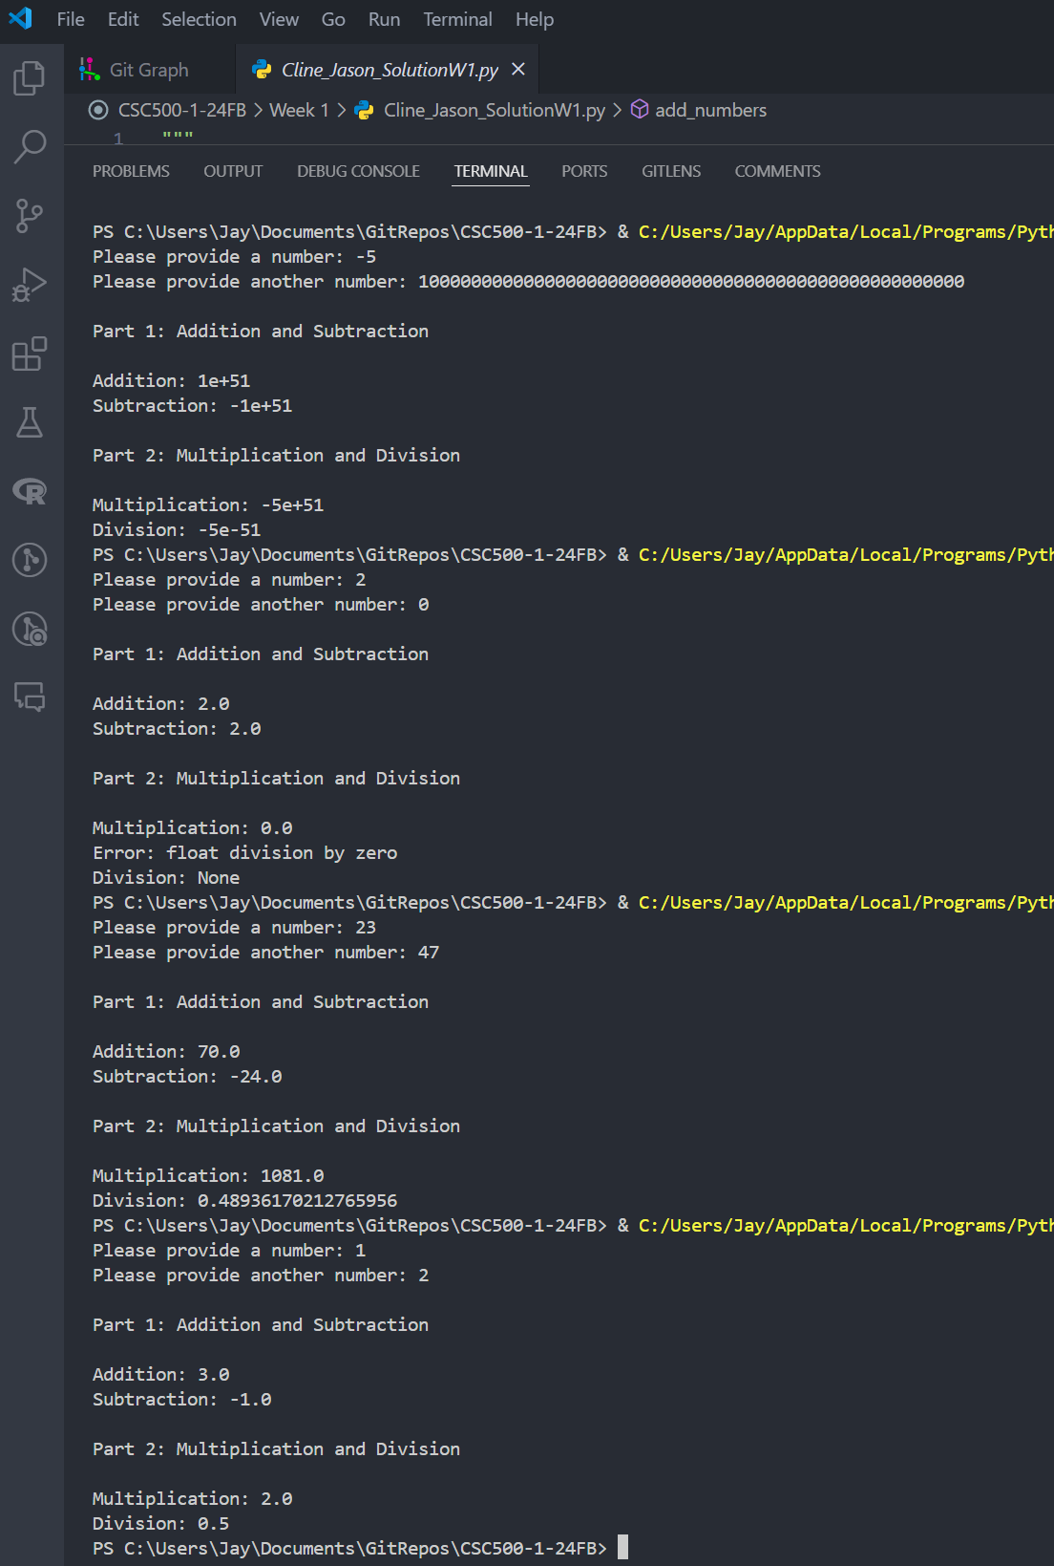

*Note. Python output of a simple calculator script that demonstrates addition, subtraction, multiplication, and division.*

References

Cline, J. T. [Jay4rmTheBay]. (2024). *CSC500-1-24FB* [Source code]. GitHub.<https://github.com/Jay4rmTheBay/CSC500-1-24FB>