**Assignment-1**

Name: Mahla Hemanshi D.

Roll Number: A028

Admission Number: U20CS028

Subject: CO

Question.1) Take a decimal number from command line and convert into binary number.

Answer:

C file

#include<stdio.h>

#include<stdlib.h>

#include "coa1_1.h"

*int* main(*int* *argc*, *char* \**d*[])

{

*long* *long* *int* b = dtob(atoi(*d*[1]));

     printf("The binary number of %d is %lld.\n", atoi(*d*[1]),b);

}

Header file:

*long* *long* *int* dtob(*long* *long* *int* *decimal*)

{

*long* *long* *int* binary=0,x=1;

       while((x*2)<=*decimal*)

            x*=2;

       while(x>0)

       {

*long* *long* *int* a=*decimal*/x;

*decimal*-=a*x;

            x/=2;

            binary=binary*10+a;

       }

    return binary;

}

Output:

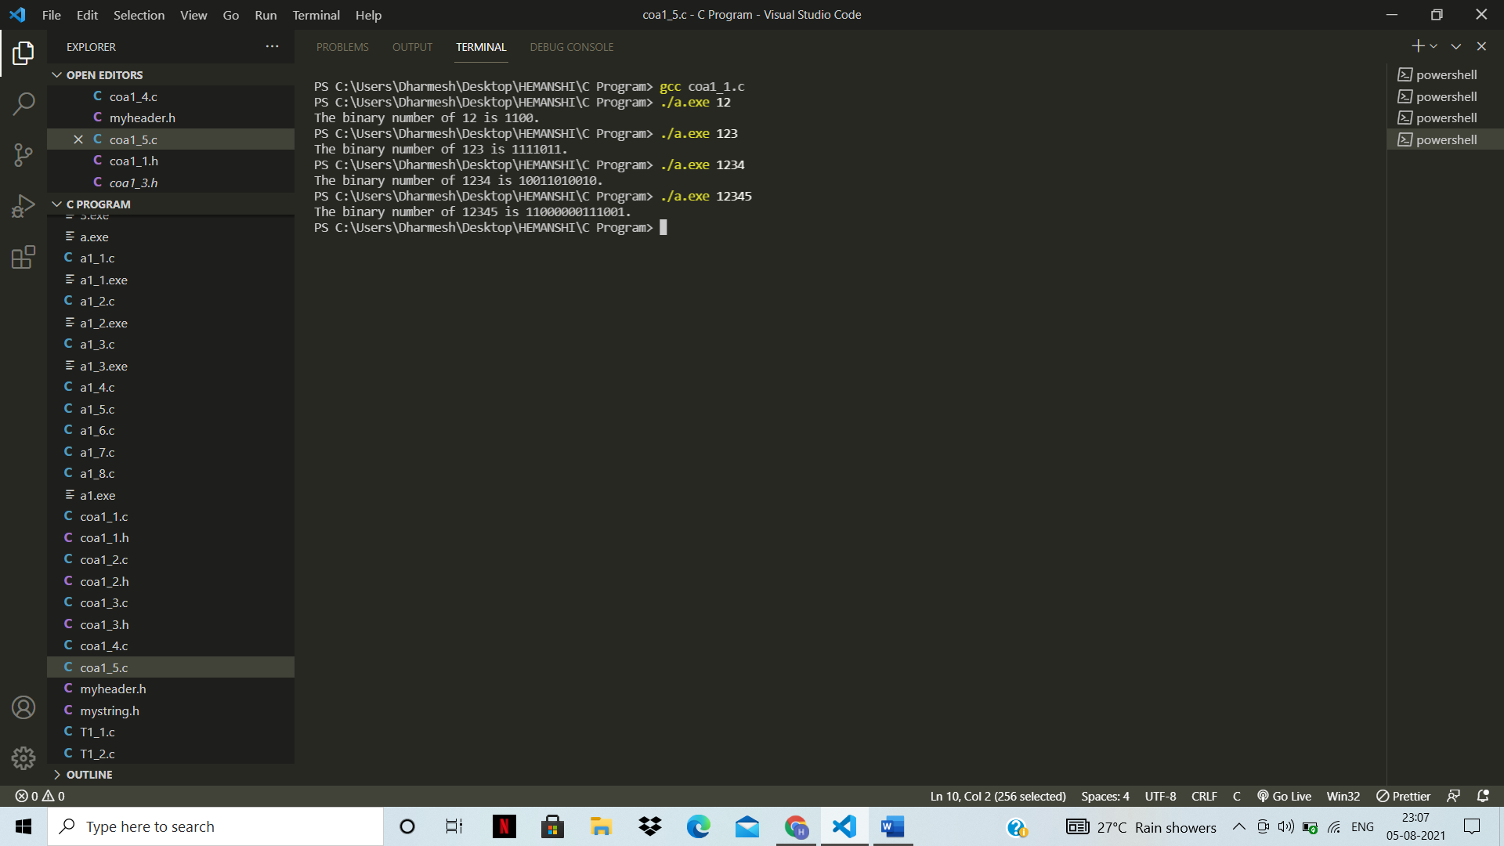

Question.2) Take a binary number from command line and convert into decimal number.

Answer:

C file:

#include <stdio.h>

#include <stdlib.h>

#include "coa1_2.h"

*int* main(*int* *argc*, *char* \**argv*[])

{

    printf("The decimal number of %d is %d.\n",atoi(argv[1]),btod(atoi(argv[1])));

    return 0;

}

Header file:

*int* btod(*int* *x*)

{

*int* r,answer=0,i=1;

    while(*x*)

    {

        r=*x*%10;

        answer+=r*i;

*x*=*x*/10;

        i=i*2;

    }

    return answer;

}

Output:

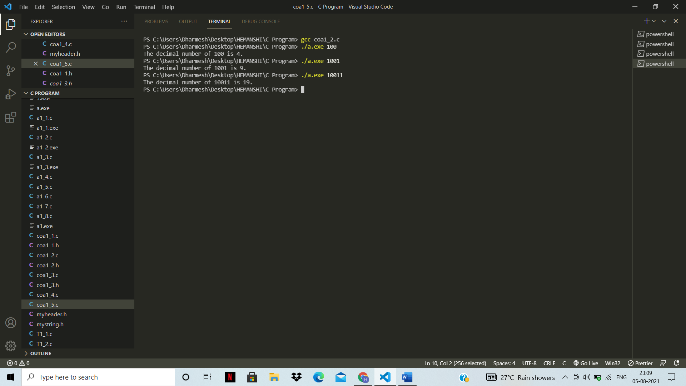

Question.3) Take a decimal number from command line and display its factorial using recursion.

Answer:

C file:

#include<stdio.h>

#include<stdlib.h>

#include "coa1_3.h"

*int* main(*int* *argc*, *char* \**argv*[])

{

    printf("The factorial of %d is %d.\n",atoi(*argv*[1]),facto(atoi(*argv*[1])));

    return 0;

}

Header file:

*int* facto(*int* *x*)

{

    if(*x*==0 || *x*==1)

    {

        return 1;

    }

    return *x*\*facto(*x*-1);

}

Output:

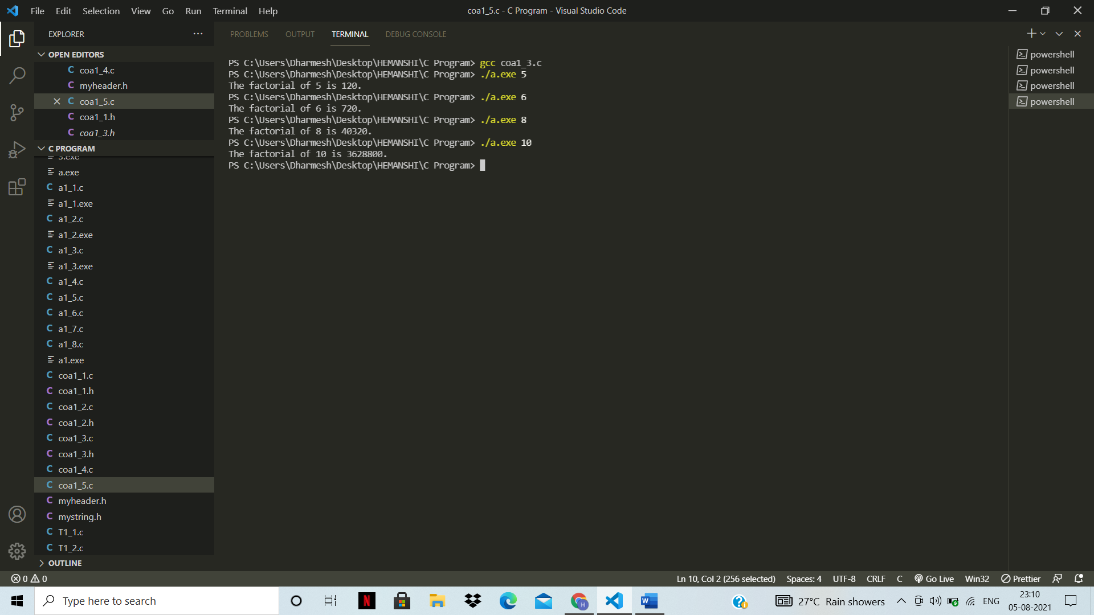

Question.4) Add two 8-digits unsigned binary given from command line.

Answer:

Header file for both questions (4&5):

#include<stdlib.h>

#include<string.h>

// Function for binary to decimal convertion

*long* *long* *int* btod(*long* *long* *int* *x*)

{

*long* *long* *int* answer=0,r=0,i=1;

    while(*x*)

    {

        r=*x*%10;

        answer+=r*i;

*x*=*x*/10;

        i=i*2;

    }

    return answer;

}

// Function for decimal to binary convertion

*long* *long* *int* dtob(*long* *long* *int* *x*)

{

*long* *long* *int* y=*x*,answer=0,p=10,i=1;;

*long* *long* *int* reminder;

    while(y)

    {

        reminder=y%2;

        if(y==*x*){

            i=1;

        }

        else{

            i=10*i;

        }

        answer+=i*reminder;

        y=y/2;

    }

    return answer;

}

// addition of Unsigned binary two numbers

*void* addition_of_unsigned_binary_numbers(*long* *long* *int* *x*, *long* *long* *int* *y*)

{

*long* *long* *int* a,b;

    a=btod(*x*);

    b=btod(*y*);

    printf("%lld",dtob(a+b));

}

// addition of two signed binary numbers

*void* addition_of_signed_binary_numbers(*char* \**x*, *char* \**y*)

{

*int* s1=0,s2=0;

    if(*x*[0]=='1')

    {

        s1=1;

    }

    if(*y*[0]=='1')

    {

        s2=1;

    }

*char* h[10]={'\0'},    j[10]={'\0'};

*int* i;

    for(i=1;i<8;i++){

        h[i-1]=*x*[i];

            j[i-1]=*y*[i];

    }

    j[i]='\0';

    h[i]='\0';

*long* *long* *int* p,q;

    p=btod(atoll(h));

    q=btod(atoll(j));

    if(s1)

    {

        p=p*(-1);

    }

    if(s2)

    {

        q=q*(-1);

    }

*long* *long* *int* answer=p+q;

    if(answer<0)

    {

        printf("1");

        answer=answer*(-1);

    }

    else

    {

        printf("0");

    }

    printf("%lld",dtob(answer));

}

C file:

#include <stdio.h>

#include <stdlib.h>

#include "myheader.h"

*int* main (*int* *argc*, *char* \**argv*[])

{

    printf("The addition of two binary numbers %lld and %lld is ",atoll(*argv*[1]),atoll(*argv*[2]));

    addition_of_unsigned_binary_numbers(atoll(*argv*[1]),atoll(*argv*[2]));

    return 0;

}

Output:

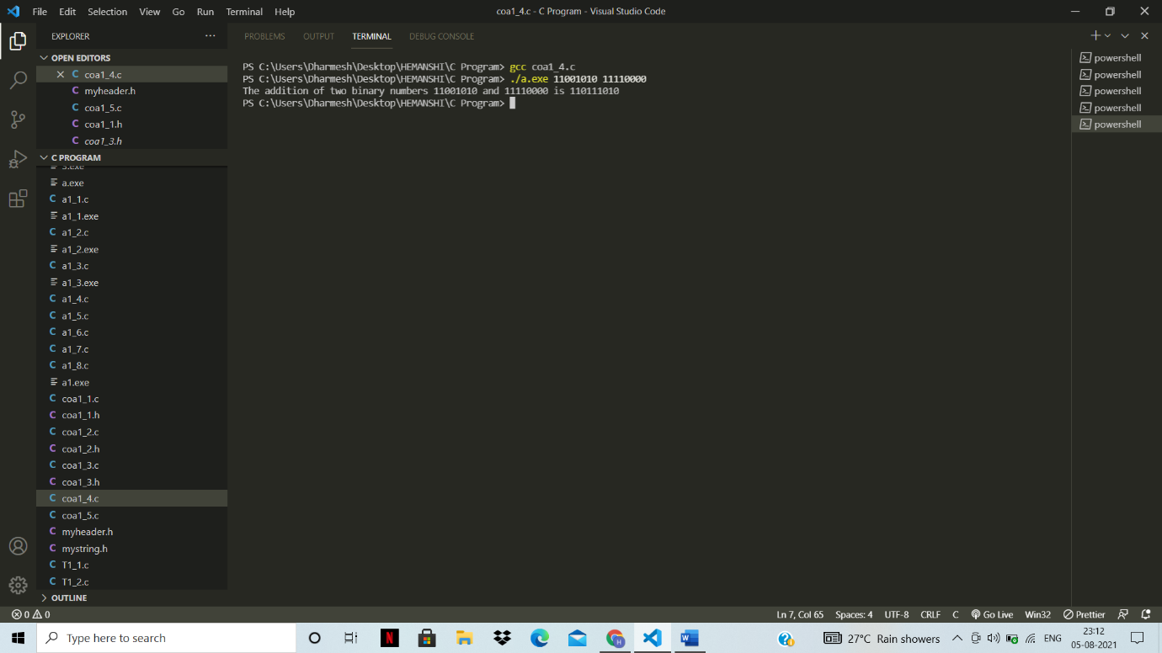

Question.5) Add two 8-digits signed binary given from command line.

Answer:

C file:

#include <stdio.h>

#include <stdlib.h>

#include"myheader.h"

*int* main(*int* *argc*, *char* \**argv*[])

{

    printf("The addition of two binary numbers %s and %s is ",*argv*[1],*argv*[2]);

    addition_of_signed_binary_numbers(*argv*[1],*argv*[2]);

    return 0;

}

Output:

