**ASSIGNMENT 4&5**

Name: Hemanshi Mahla

Roll number: A028

Admission number: U20CS028

Subject: CO

1bit half adder (1 of 12)

x1

x1

x1

x1

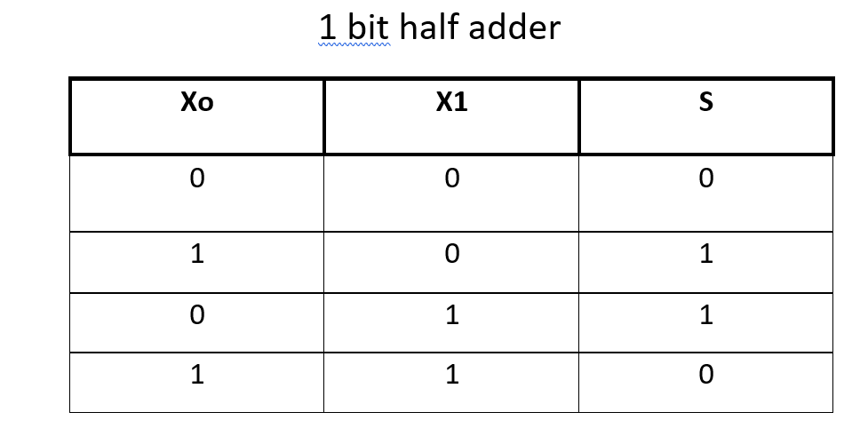

1bit half subtractor (2 of 12)

x1

x1

x1

x1

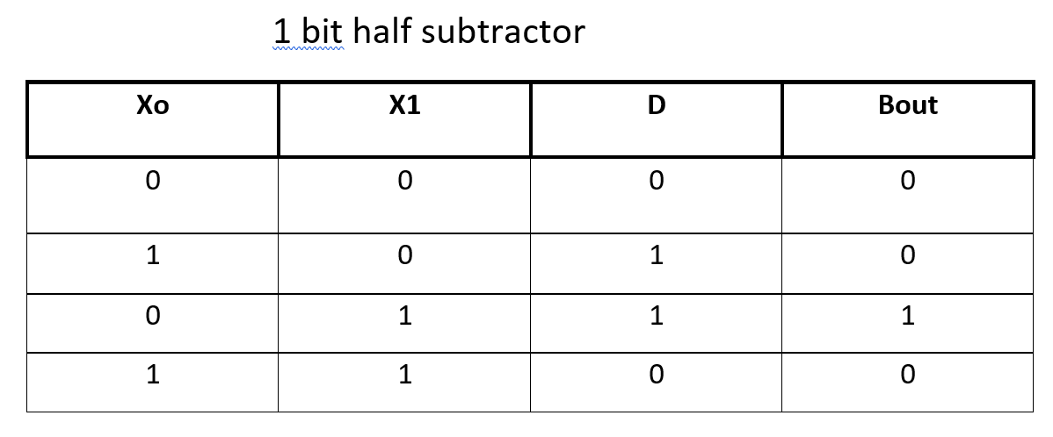

1bit full adder (3 of 12)

x1

x1

x1

x1

x1

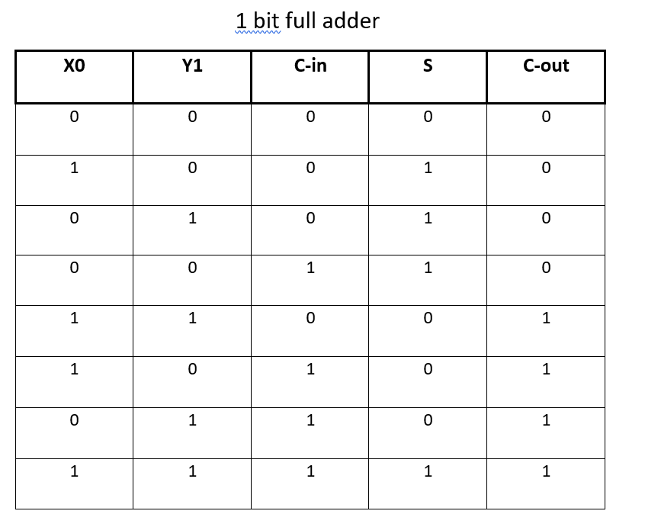

1bit full subtractot (4 of 12)

x1

x1

x1

x1

x1

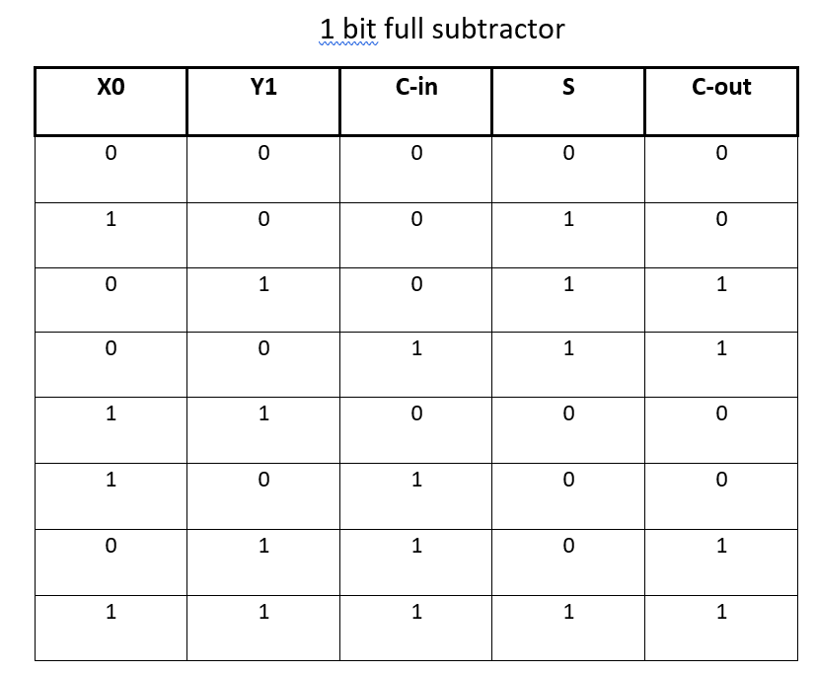

2bit full adder (5 of 12)

x1

x1

x1

x1

x1

x1

bit full adder

1

x1

1

bit full adder

x1

2bit full subtractor (6 of 12)

x1

x1

x1

x1

x1

x1

bit full subtractor

1

x1

1

bit full subtractor

x1

4bit full adder (7 of 12)

x1

x1

x1

x1

x1

x1

x1

x1

x1

x1

x1

x1

x1

x1

4bit full subtractor (8 of 12)

x1

x1

x1

x1

x1

x1

x1

x1

x1

x1

x1

x1

x1

x1

8bit full adder (9 of 12)

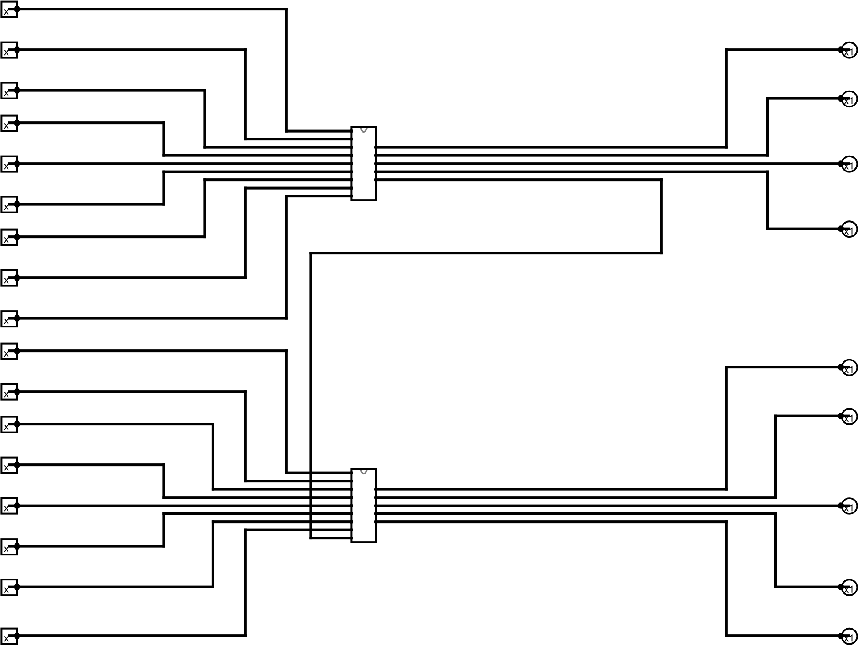

8bit full subtractor (10 of 12)

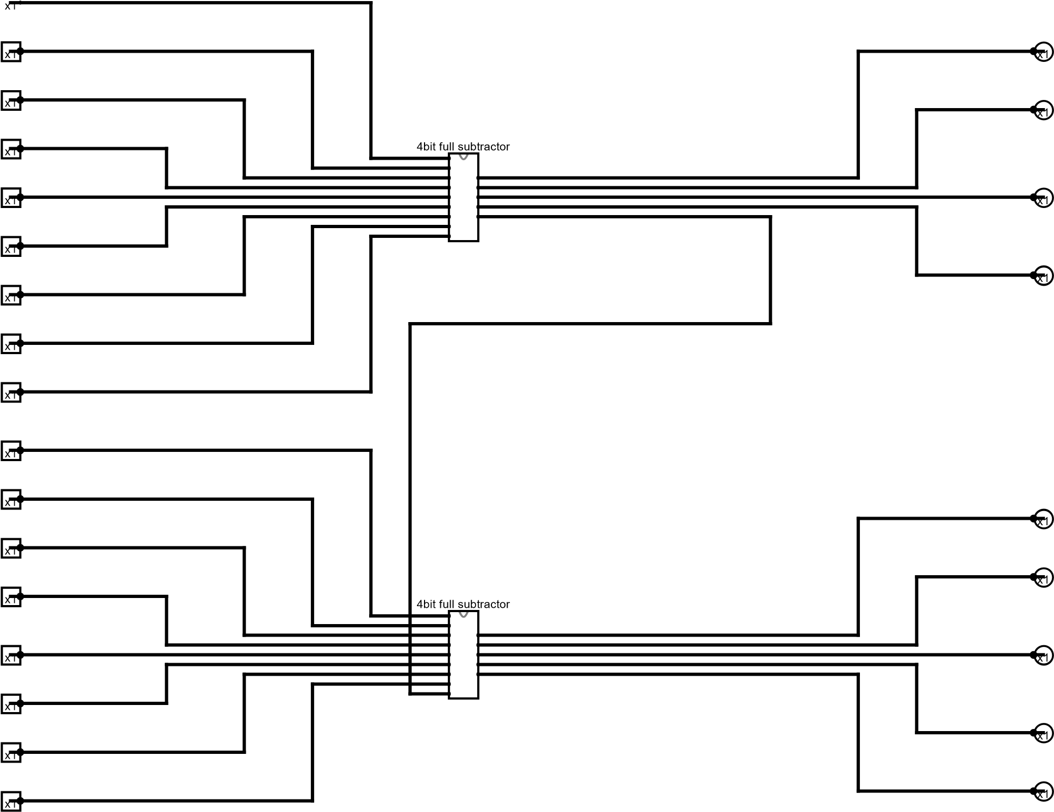

16bit full adder

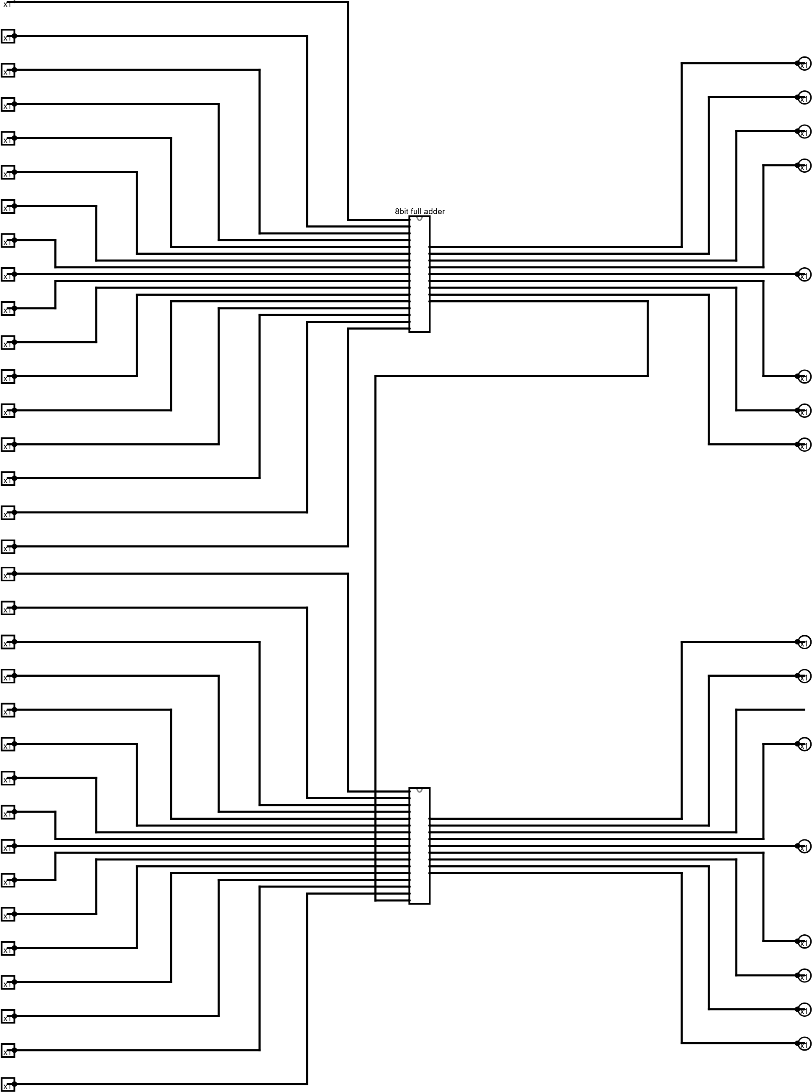

16bit full subtractor (12 of 12)

