Video Game Sales Visualization Project Report

Problem Statement
Analyze and visualize global video game sales data to provide actionable insights for: - Game Publishers (e.g., Nintendo, EA, Ubisoft) - Game Developers/Studios

Target Audiences & Questions

1. Game Publishers
- Which genres make the most revenue?
- Which platforms are most profitable?
- What are the sales trends over time?
- Which regions bring the most revenue?
- Who are our top competitors?

2. Game Developers / Studios
- What are the top-performing games of all time?
- Which genres are oversaturated vs. underexplored?
- Which platforms should we target?
- Who are the top publishers to pitch to?

Step-by-Step Process

Data Loading & Screening (Python)
- File Used: vgsales.csv from Kaggle
- Loaded using: pandas

Initial Checks:
- .shape, .info(), .describe()
- Checked for duplicates → ✅ None found
- Missing values → Found 4 rows with missing Year → ✅ Dropped

Data Cleaning:
- Removed unnecessary columns: Rank and Unnamed
- Renamed columns for clarity
- Handled Year column formatting to convert to integer

Validity Checks:
- Verified year range (1980–2020)
- Noted missing years (2018 & 2019 were not present)

Exploratory Data Analysis (EDA)

Genre Insights:
- Action is the top-selling genre globally
- Puzzle and Strategy among the lowest

Platform Insights:
- PS2 leads in total global sales
- Xbox 360 and PS3 closely follow

Publisher Insights:
- Nintendo dominates global sales
- EA and Activision follow

Regional Insights:
- North America is the strongest market (49%)
- EU and JP follow
- ‘Other’ region has minimal contribution

Yearly Trend:
- Peak in global sales between 2005–2010
- Steady decline afterward

Outlier Detection:
- Used IQR method to detect outliers
- Filtered dataset to analyze low/mid-tier game behavior
- Also kept original dataset for full-range insights

Sales Distribution:
- Used log scale histograms to visualize the skew
- Confirmed long tail of low-selling games

Visualizations in Python (Matplotlib & Seaborn)

Charts Created:
- Genre Sales bar chart
- Platform Sales bar chart
- Heatmap of Genre vs Region Sales
- Boxplots per Genre (Global Sales)
- Sales Distribution histograms (Linear + Log Scale)
- Outlier Filtering using IQR
Tools used: - Seaborn for styling - .agg() for grouped summaries

Final Dataset for Tableau
- Created one final cleaned CSV with all needed columns
- Used this for dashboarding instead of multiple exports

Tableau Dashboards (2 Distinct Dashboards)

Developer Dashboard

1. Genre Sales Spread
- Boxplot of Global Sales per Genre (log scale)
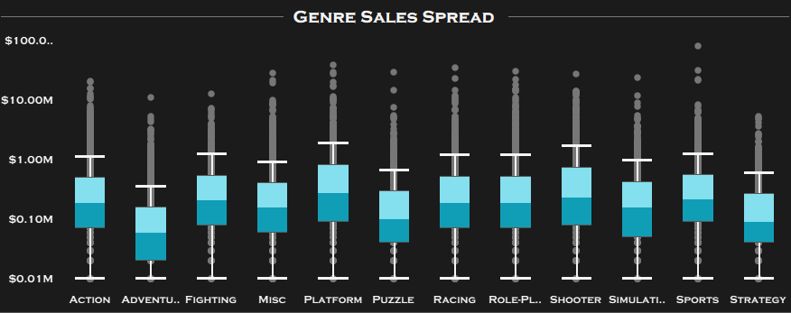

2. Regional Genre Analysis
- Heatmap + Embedded dual bar charts:
  - Top: Total sales per genre
  - Right: Total sales per region
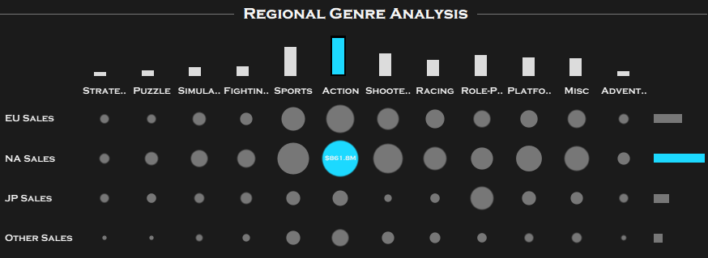

3. Platform Analysis
- Tornado chart: Sales vs. Game count per platform
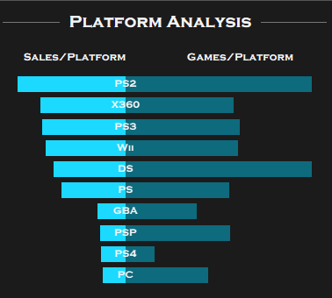
- Bubble chart: Top 10 platforms by volume.
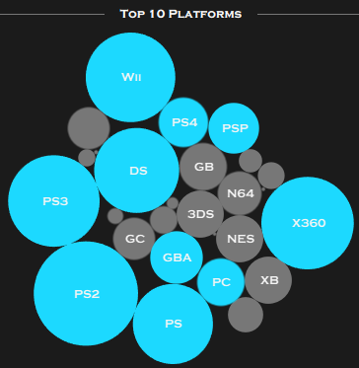

Publisher Dashboard

1. Yearly Sales Trend
- Line chart with KPIs: Year sales, trend %, and tooltip.
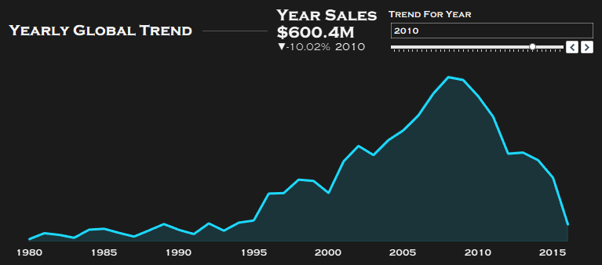

2. Region Sales Donut
- Donut chart showing % share of each region.
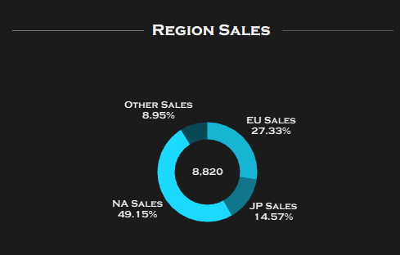

3. Competitors Analysis
- Bar charts for Top and Bottom 10 publishers.
- Highlighted publishers above average in cyan/orange.
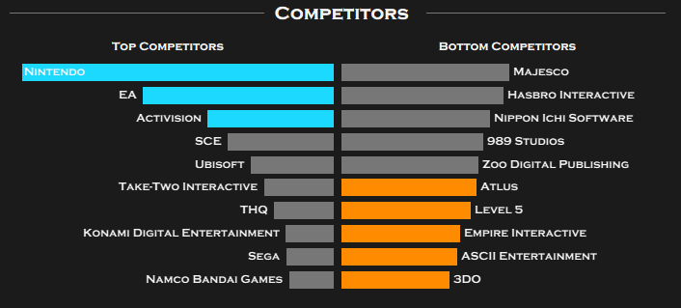

4. Genre Breakdown
- Tornado chart: Genre Sales vs Game Count.
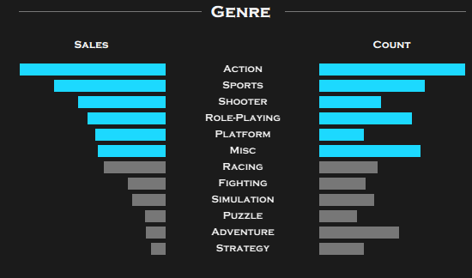

Dashboard Design
- Dark theme with bright blue & orange accents
- Modern side nav (PDF, LinkedIn, Tableau, Export)
- Interactive filters and KPIs
- Used icons for navigation and readability

Key Insights
- Publishers should double down on Action, Sports, Shooter genres
- Developers can pitch to Nintendo and focus on PS2/X360 style markets
- Sales peaked in 2010, followed by steady decline — possibly due to mobile gaming or platform transitions
- North America and Europe dominate the global gaming market

Outcome
- Built a full-stack dashboard solution from raw CSV to business-ready visual insights
- Made fully interactive dashboards for both Game Developers and Game Publishers
- Designed for hiring managers, interviewers, or product/data teams to explore in Tableau Public

Final Deliverables
- Developer Dashboard (Tableau)
- Publisher Dashboard (Tableau)
- Final Cleaned CSV (1 version)
- Python EDA Notebook (optional, not public)
- PDF Report + PowerPoint Summary

