**Storyboard**

**Name:** Jada Johnson (2209658)

**Course Code/Name:** CIT2011 - Web Programming

**Class/Time:** Wednesdays, 6 - 8 PM (UE1)

**Teacher:** Christine Anuli

**Due Date:** June 14, 2025

**Website Layout**

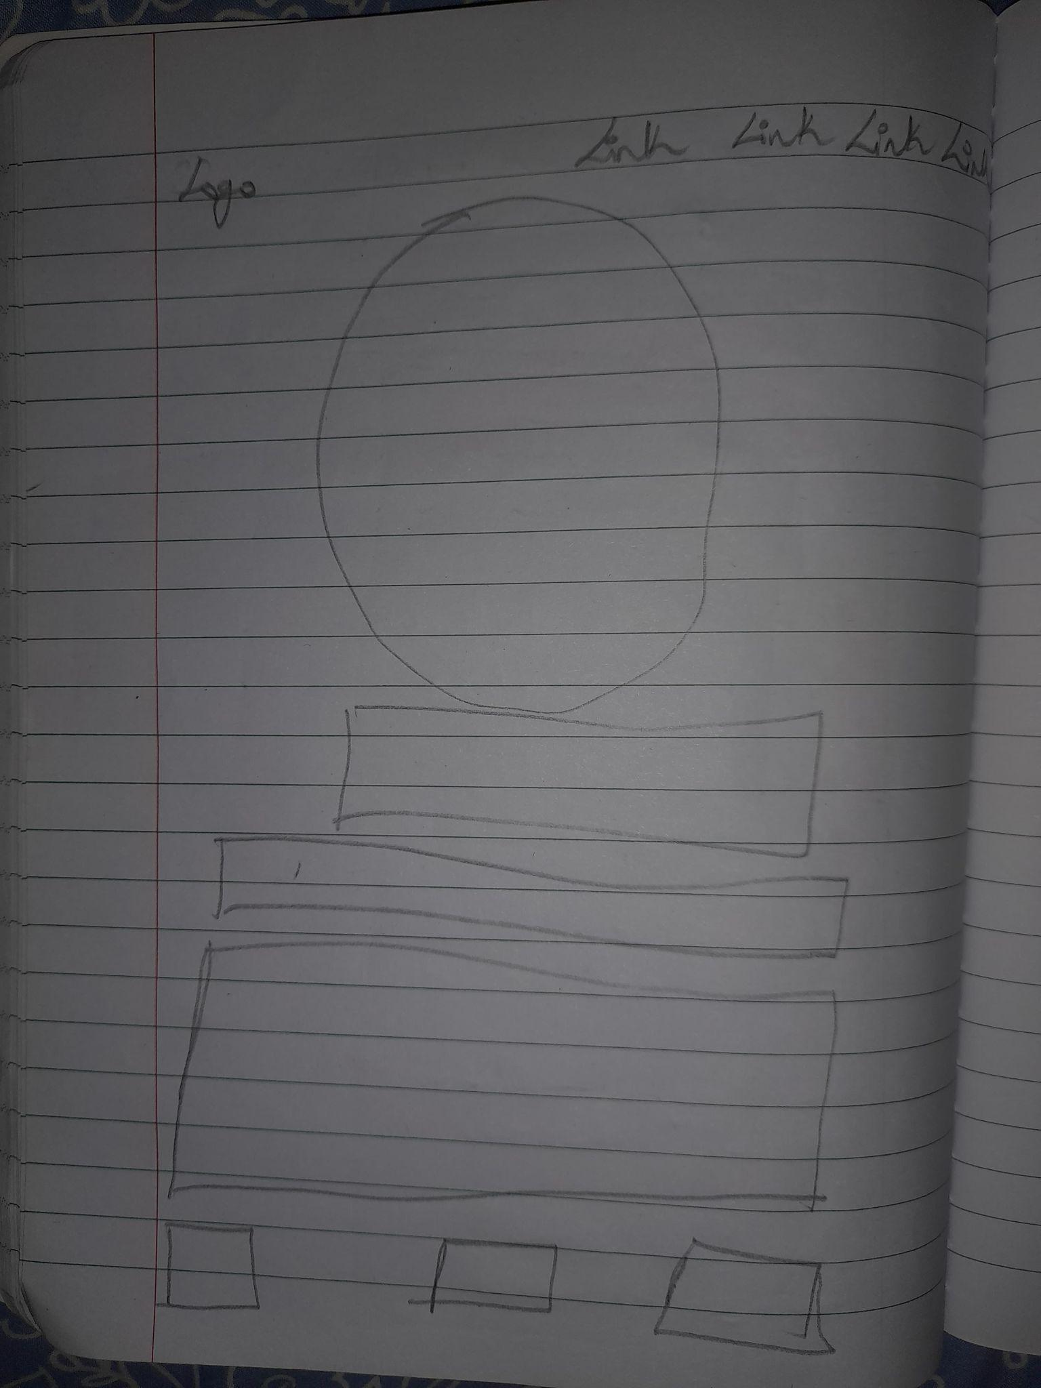

**Home Page**

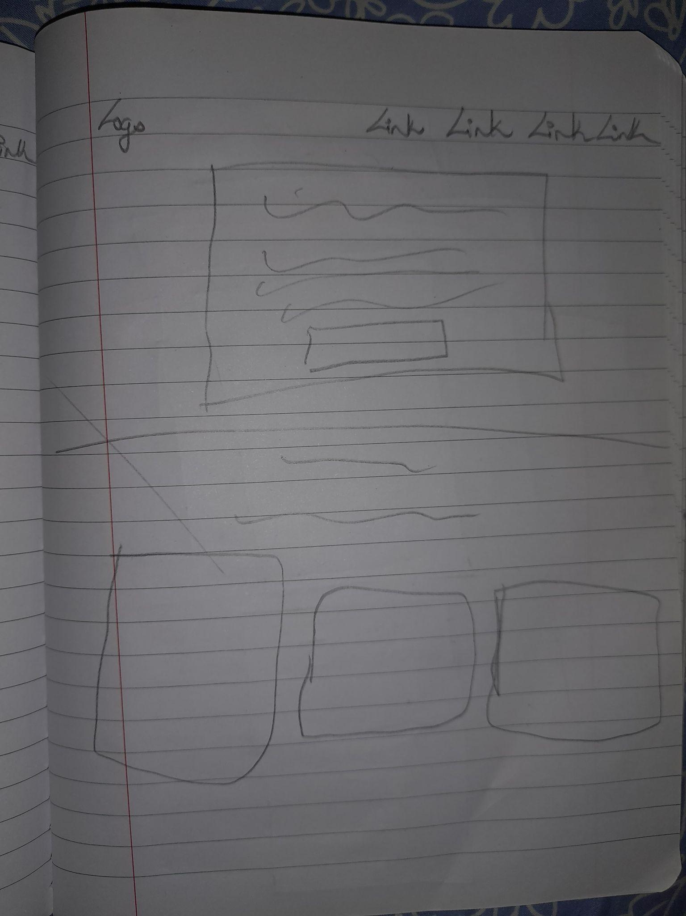

**About Me Page 1**

**About Me Page 3**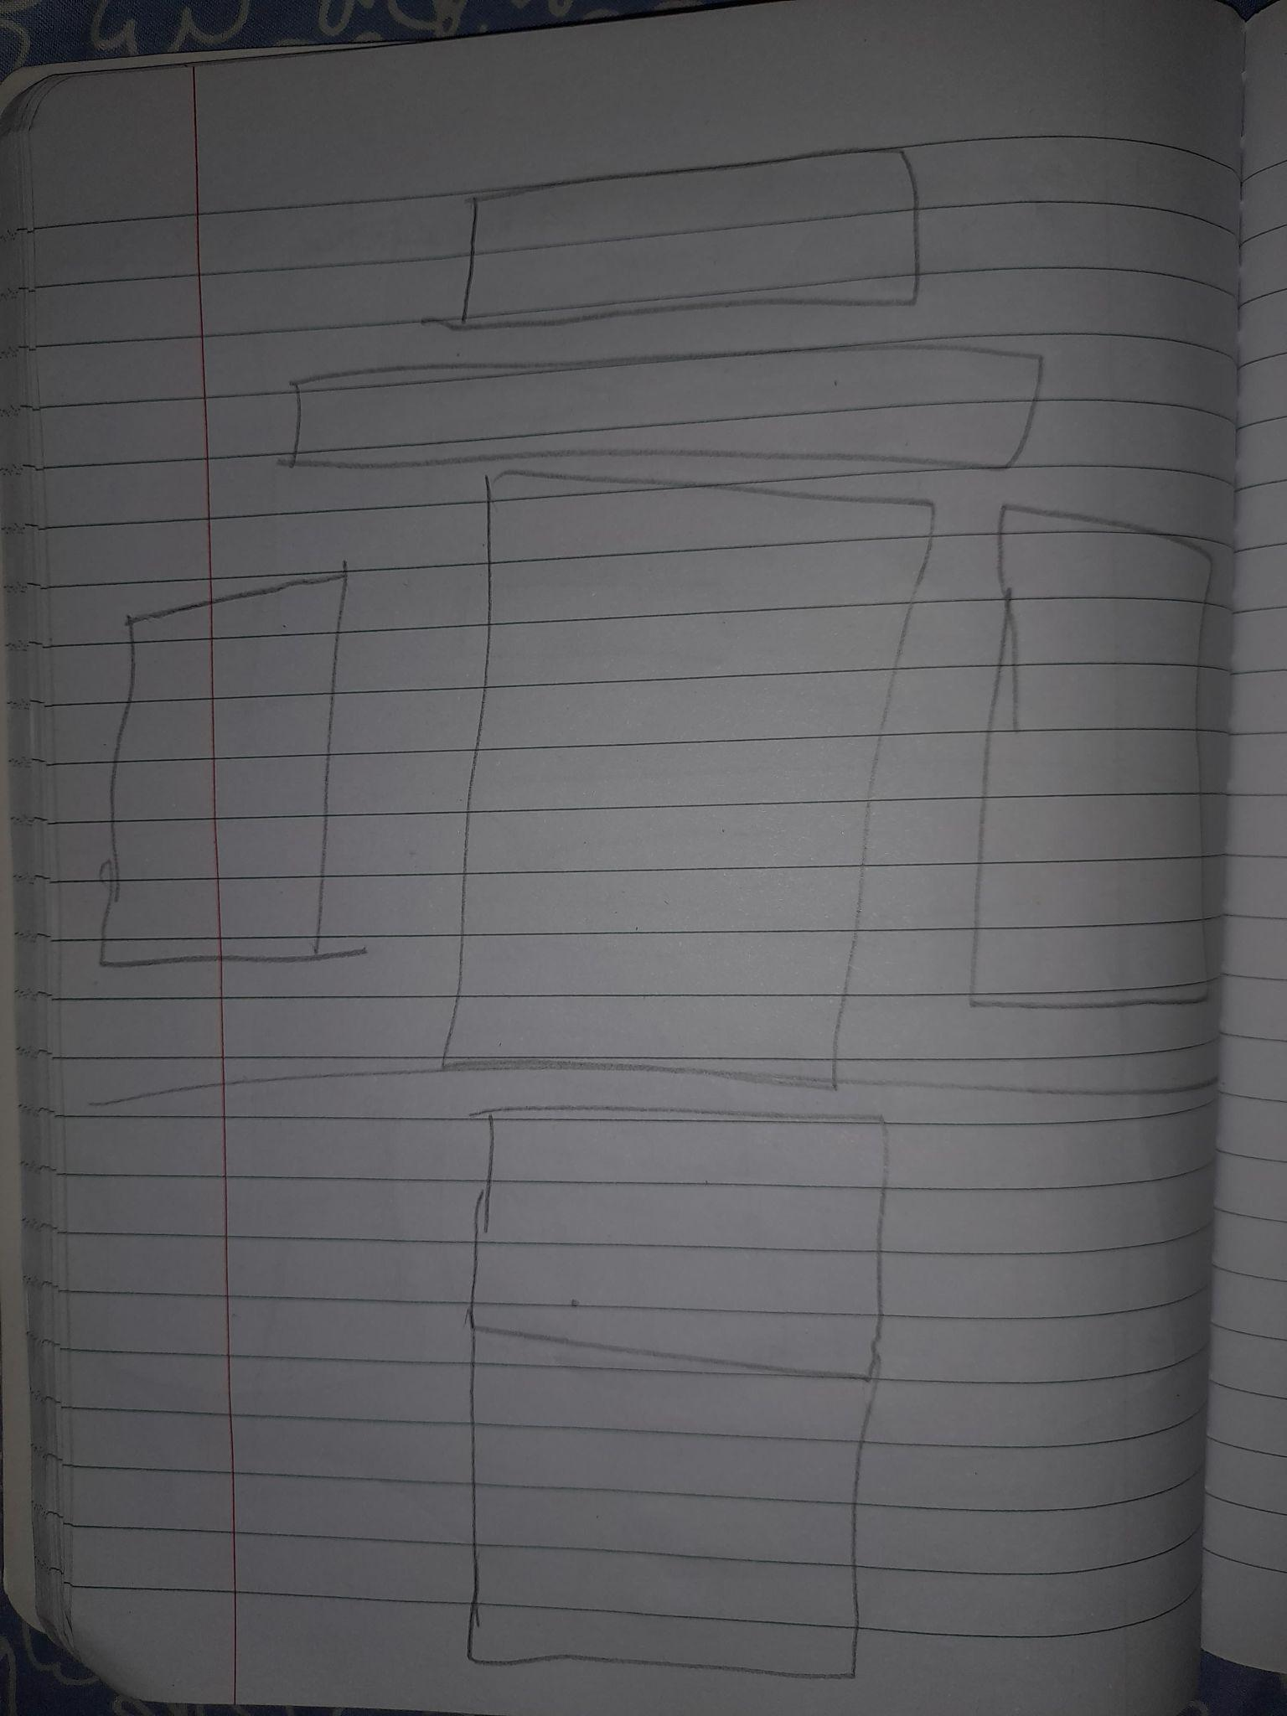

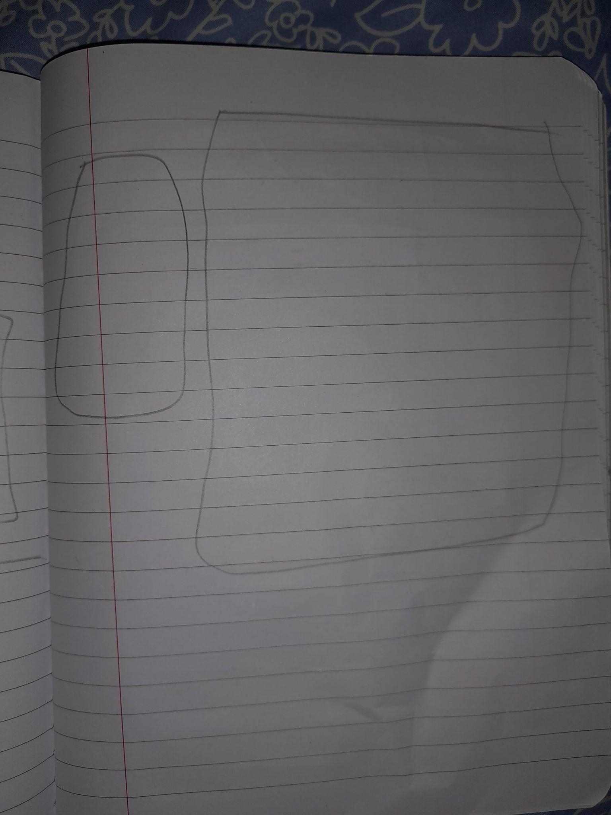

**About Me Page 3**

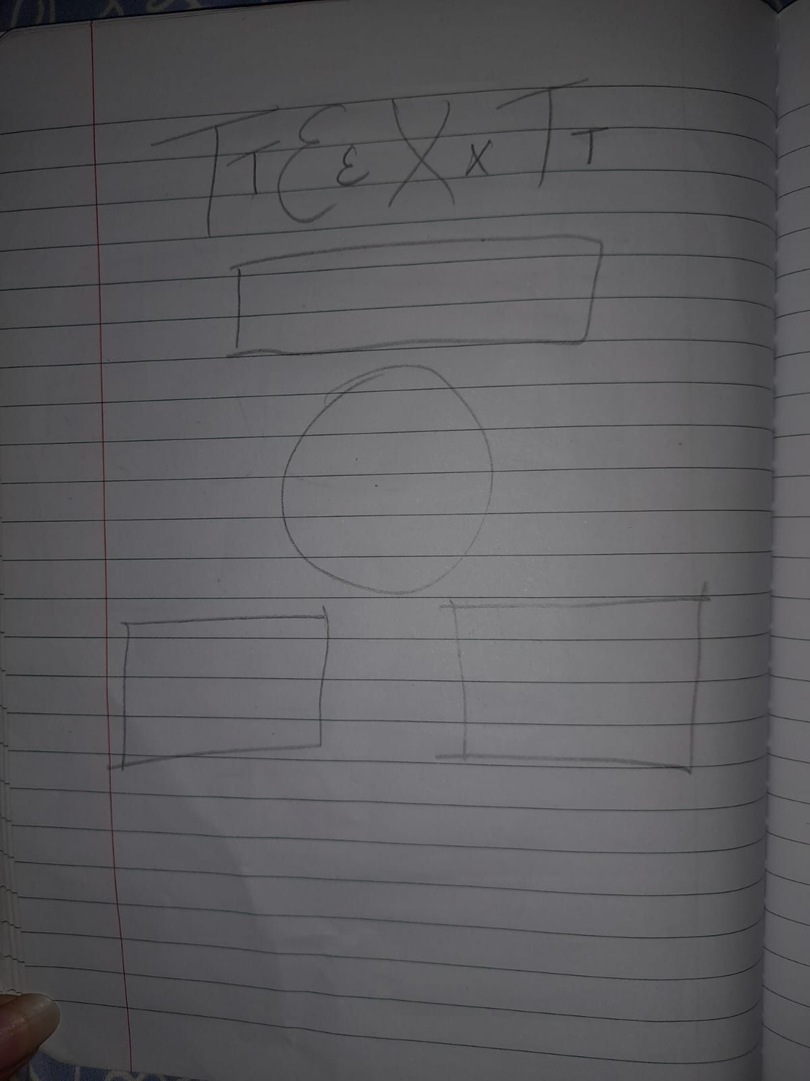

**Professional Page 1**

**Professional Page 2**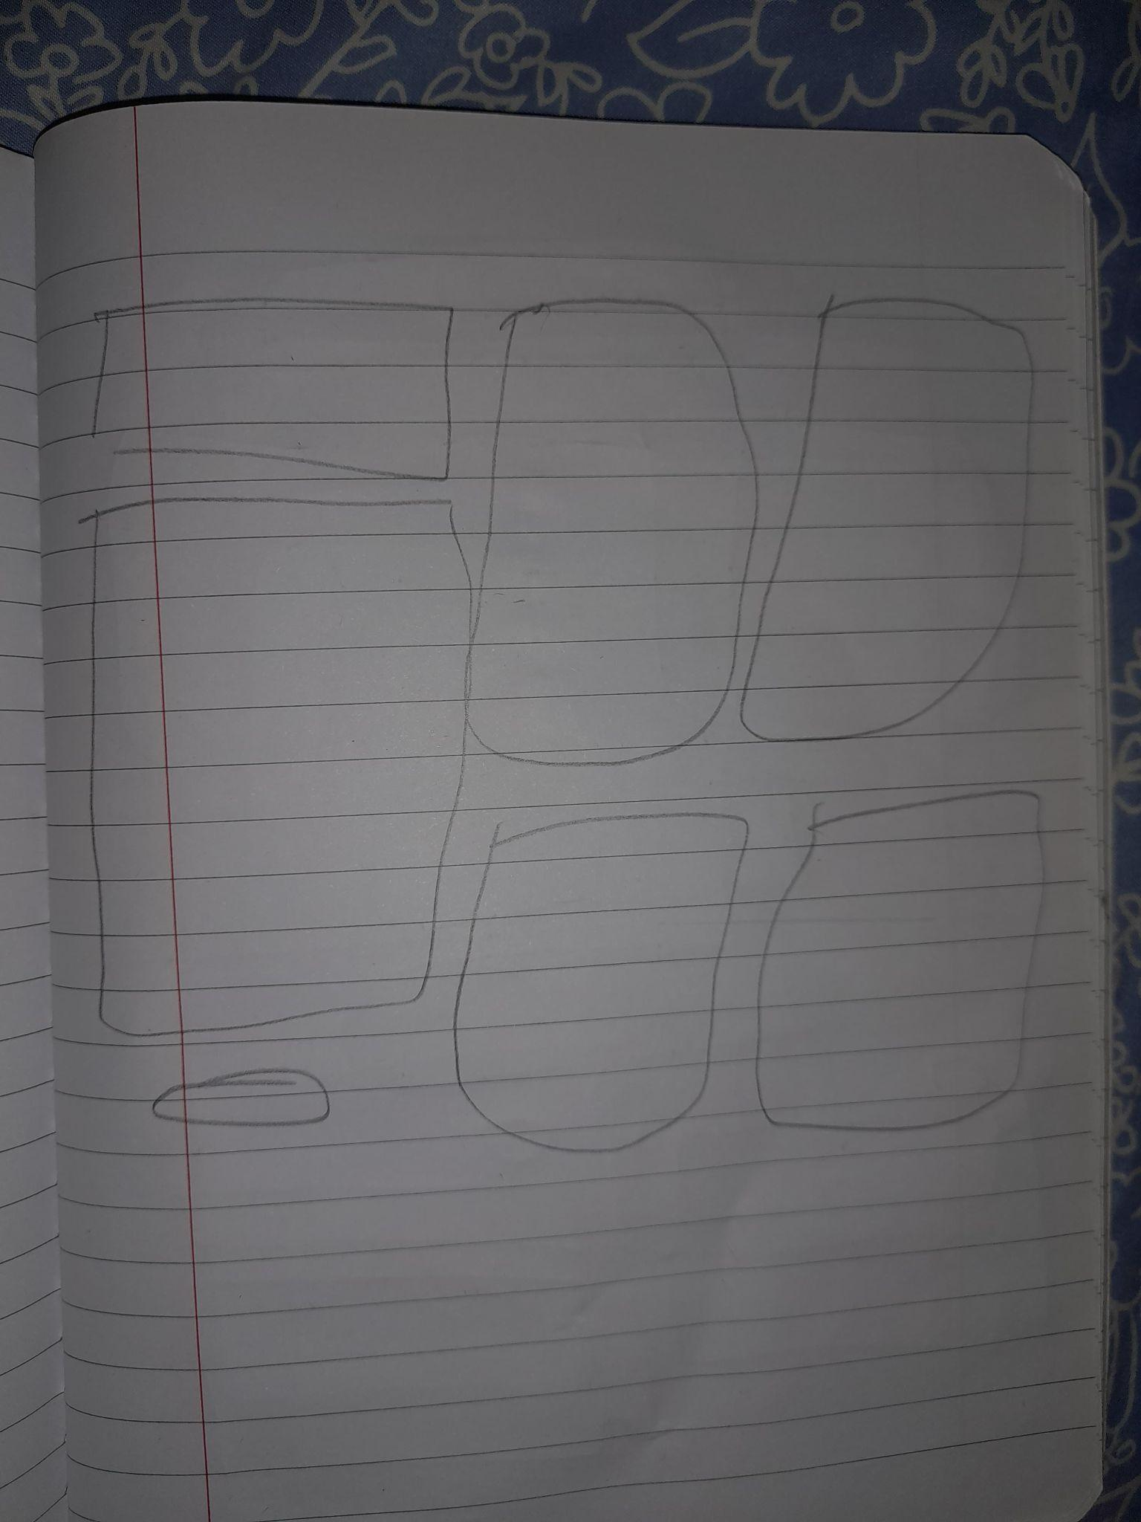

**Professional Page 3**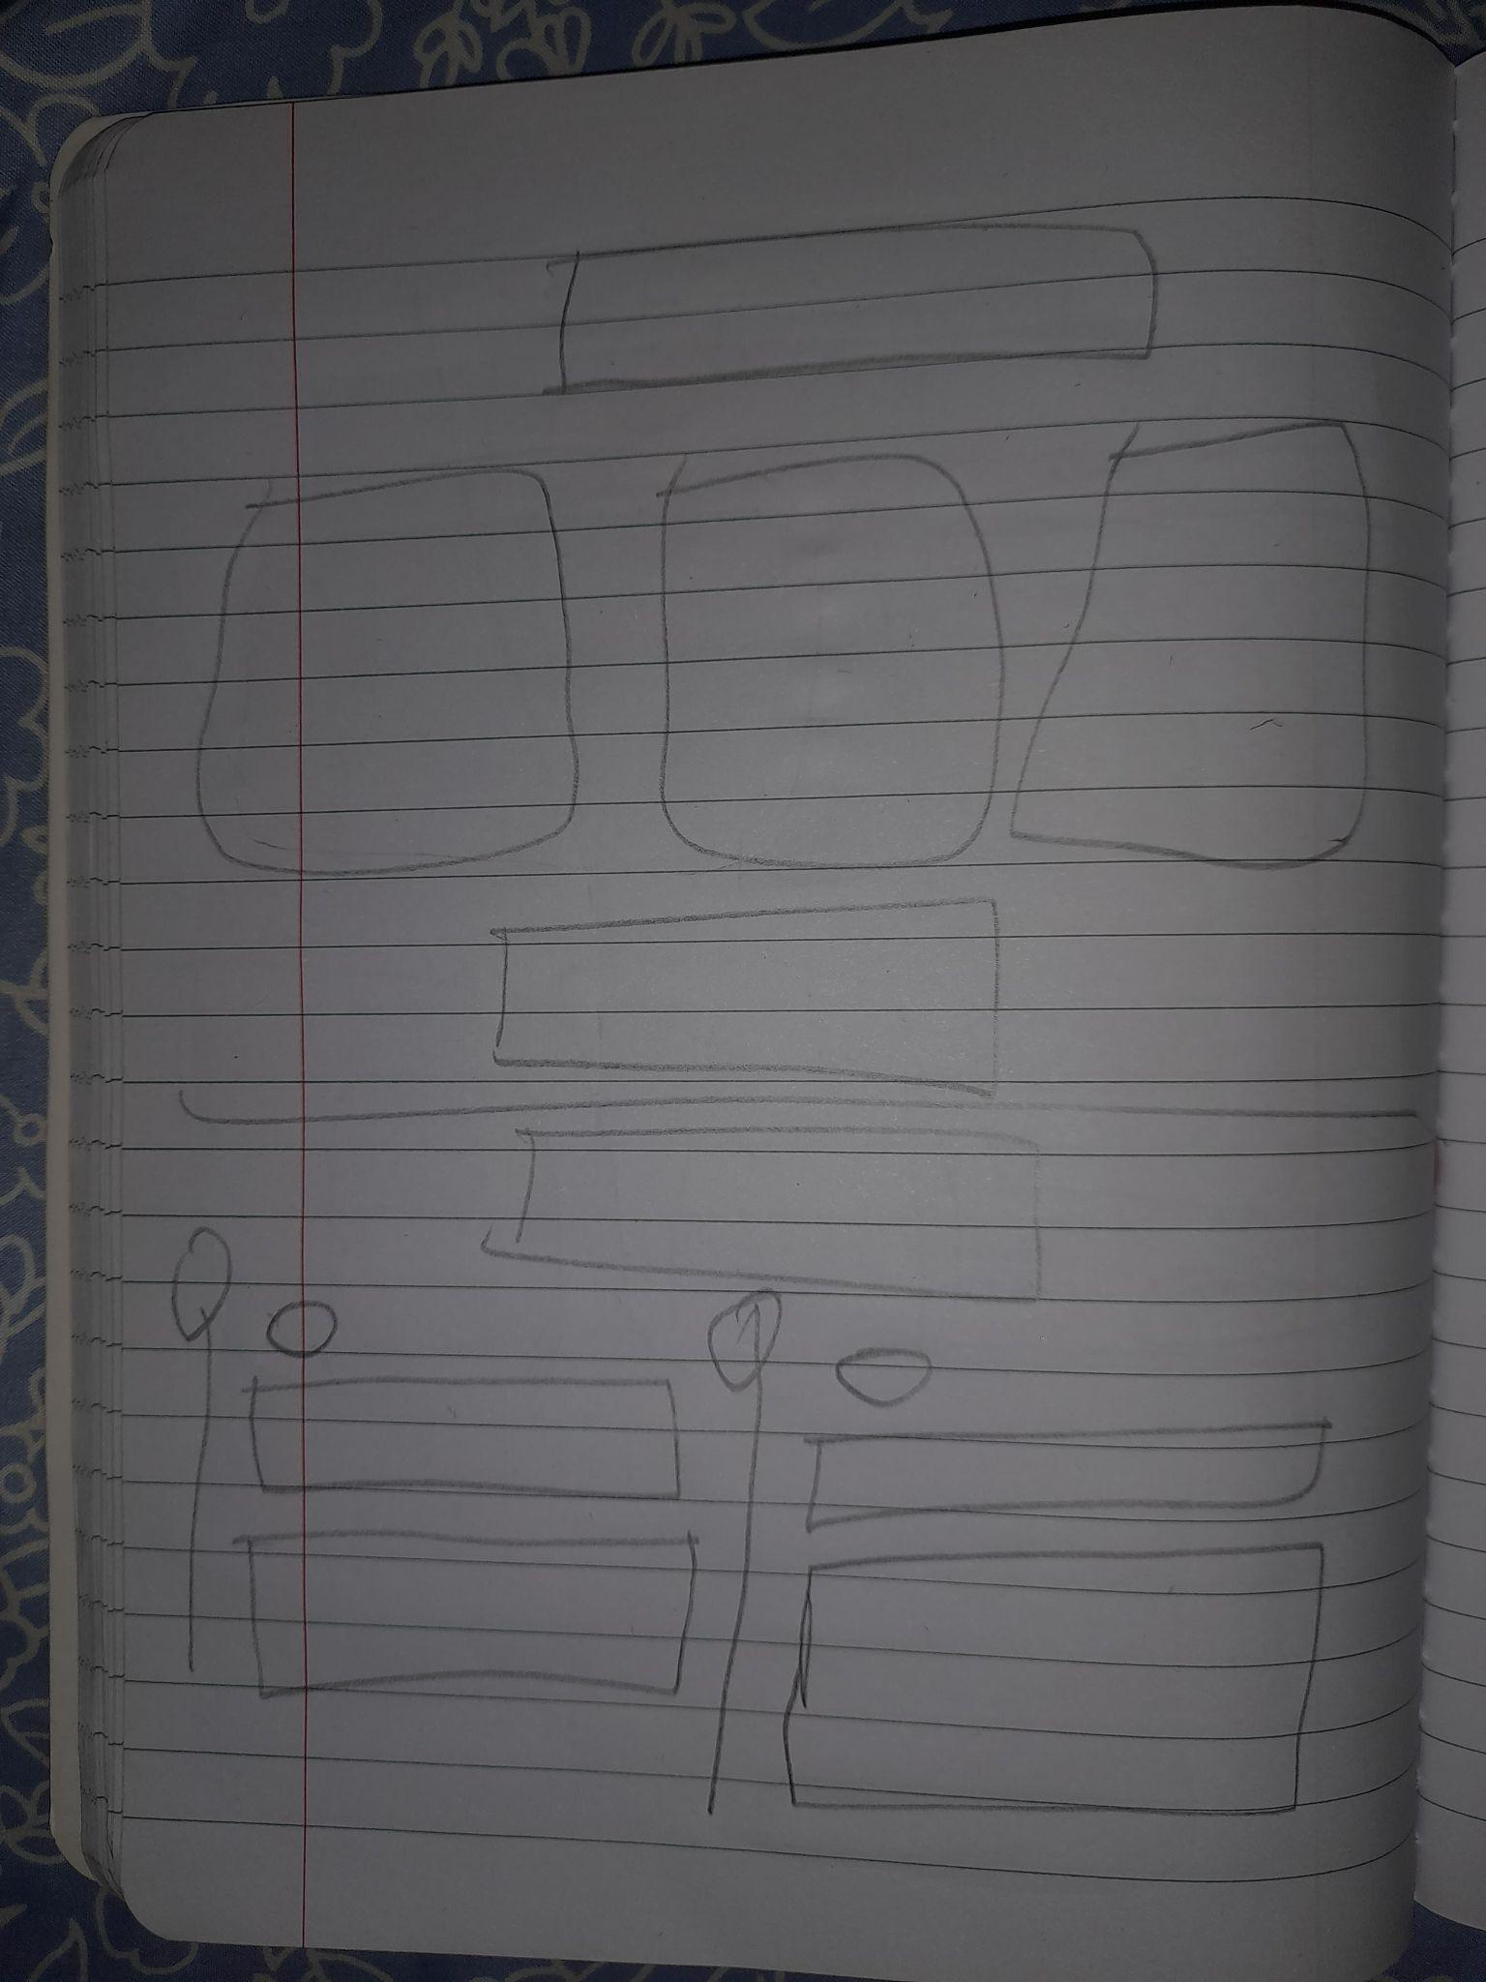

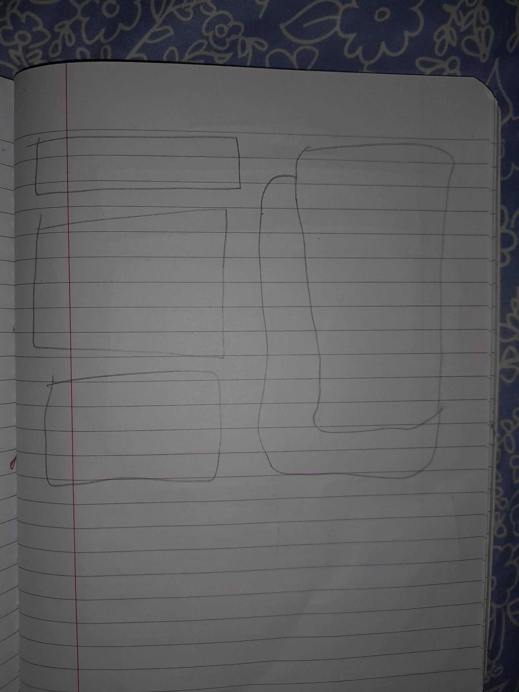

**Personal Development Page 1**

** Personal Development Page 2**

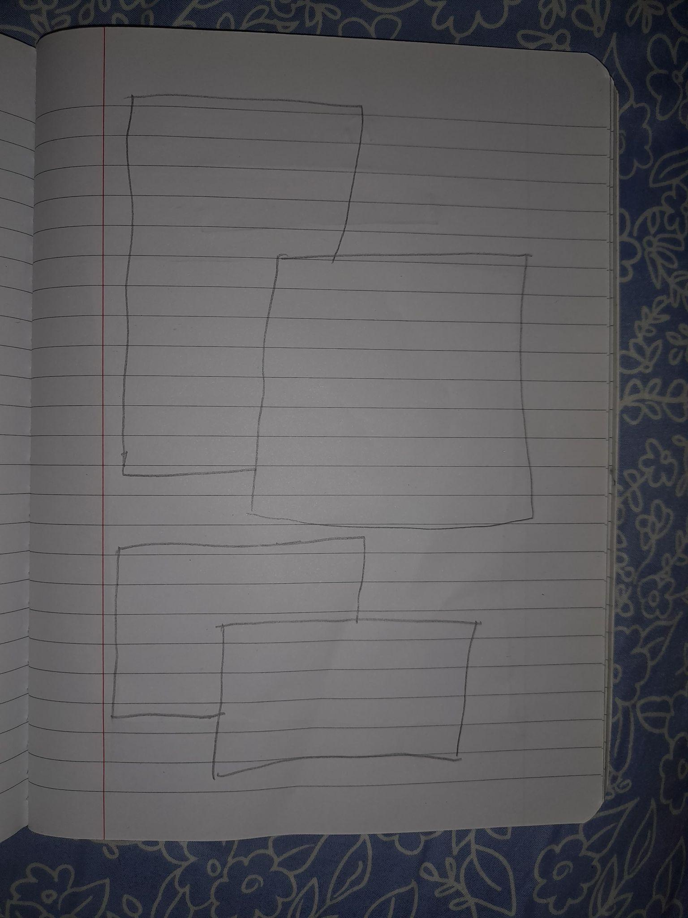**Personal Development Page 3**

**Personal Development Page 4**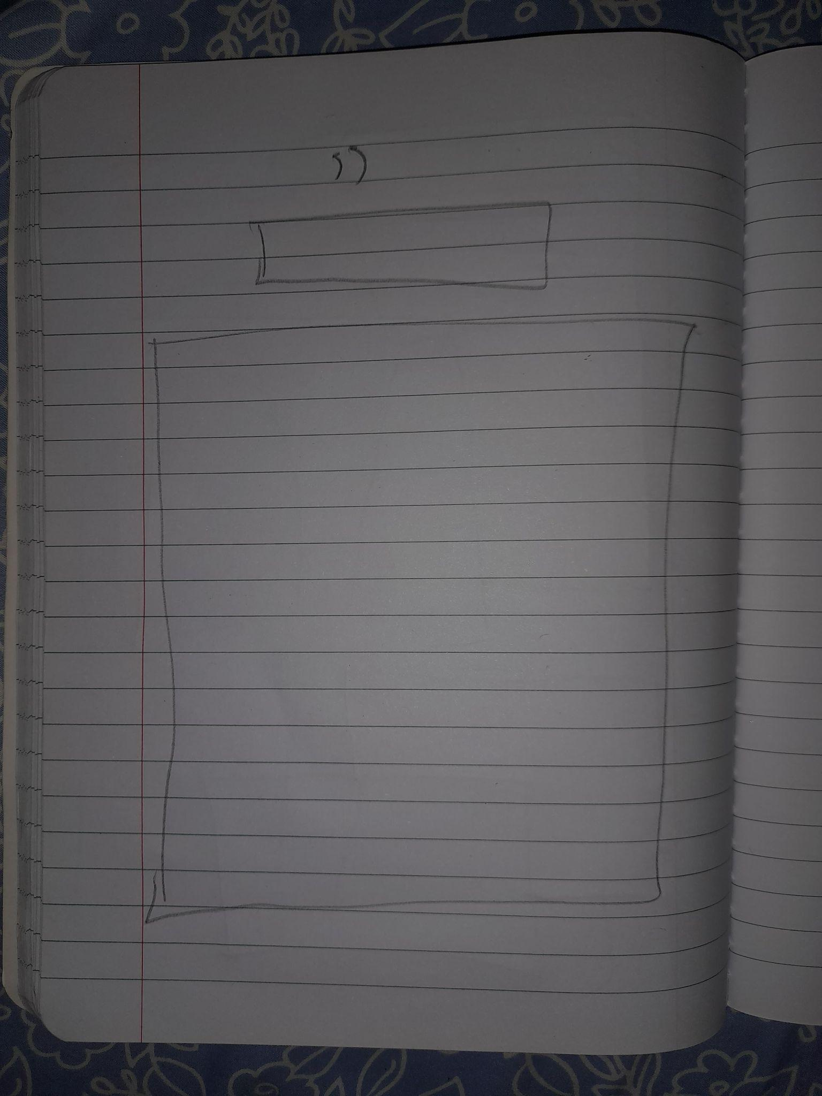

**Color Psychology**

**On Home Page -** I've chosen a red, green, and cream color scheme with a hint of orange. This vibrant color, I felt, reflected my enthusiastic, optimistic, and pleasant nature. Furthermore, after completing some research, I noticed that people interpret different colours as expressing different feelings, such as red for love (or hate), orange for excitement, and green for happiness. I've highlighted my name and details in red to show my enthusiasm for what I do as a CS student and the many successes I can achieve as one.

**On Professional Page** - With a more monochromatic palette, I chose red for my portfolio page. This exhibits my enthusiasm for the profession of programming and what I have accomplished thus far in the field of computer science.

**On Personal Development Page** - Has a slightly muted appearance, with more neutral colors such as rich reds, pinks, greens, browns, and creams to achieve a down-to-earth feel. This is considered because Chris Widener and Jim Rohn's "Twelve Pillars" touch on life experiences and values that everyone should take seriously, such as not wasting time on the smaller, more trivial things in life, setting goals for the future and doing everything in your power to make them attainable, and so on.

**On the About Me Page** - I chose a significantly brighter color scheme of brilliant pinks and purples. I wanted folks to look at my about page and receive a sense of elegance with a hint of passion for what I do. On this page, I discuss my personality, interests, the person I most admire in my life, and what motivates me to be who I am today.

**Reference:** Stillman, J. (n.d.). *The psychology of color: How to use it in your marketing*. The Hustle by HubSpot. Retrieved from <https://blog.hubspot.com/the-hustle/psychology-of-color>

**List of Web Pages and Their Usage**

| **Web Page** | **Purpose** |
| --- | --- |
| Home | Provides basic information about me; it should have a navigation bar, a footer, and a few buttons. |
| Professional | Tell you about my future goals, vision, and mission statement, as well as what it would take to get to that position. |
| Personal Development | My opinion on Chris Widener and Jim Rohn's "Twelve Pillars" and how I can use what I've read in real life. |
| About Me | Touches on the fundamentals of who I am, my core characteristics, and how they have influenced me as I grew up, my hero, and how much they have influenced me, and lastly, my thoughts on the Keirsey Temperament Sorter Personality Test Results. |

**Media I’m Planning to Use**

| **Media** | **Purpose** |
| --- | --- |
| Photo | Background Images or Person / Item Reference |

**Hosting Link:**