Displaying Assorted Data

Alternative methods of combining and comparing data is through the use of non-standard joins and unions. Your goal for this week is to reveal interesting pieces of information through the use of these methods.

For this assignment, write queries that will answer the questions below. Save every query to a SQL script named DisplayAssortedData. Use -- to write a comment above each query, noting the question it refers to. Additionally, take a screenshot of the query and result set for each question, and insert it below the corresponding question.
NOTE: no data found may be an answer! This means the query ran without error, but there were no records found (no data present in the table matching the selected conditions).

Your supervisor at VaporGames has asked you to compile some data to present at the company’s annual meeting. The information being requested is a generalized overview of information across several tables, and should be accomplished through the use of a UNION, UNION ALL, MINUS, INTERSECT, CROSS-JOIN or SELF-JOIN.
- Display the USERID of any users who have not made an order.
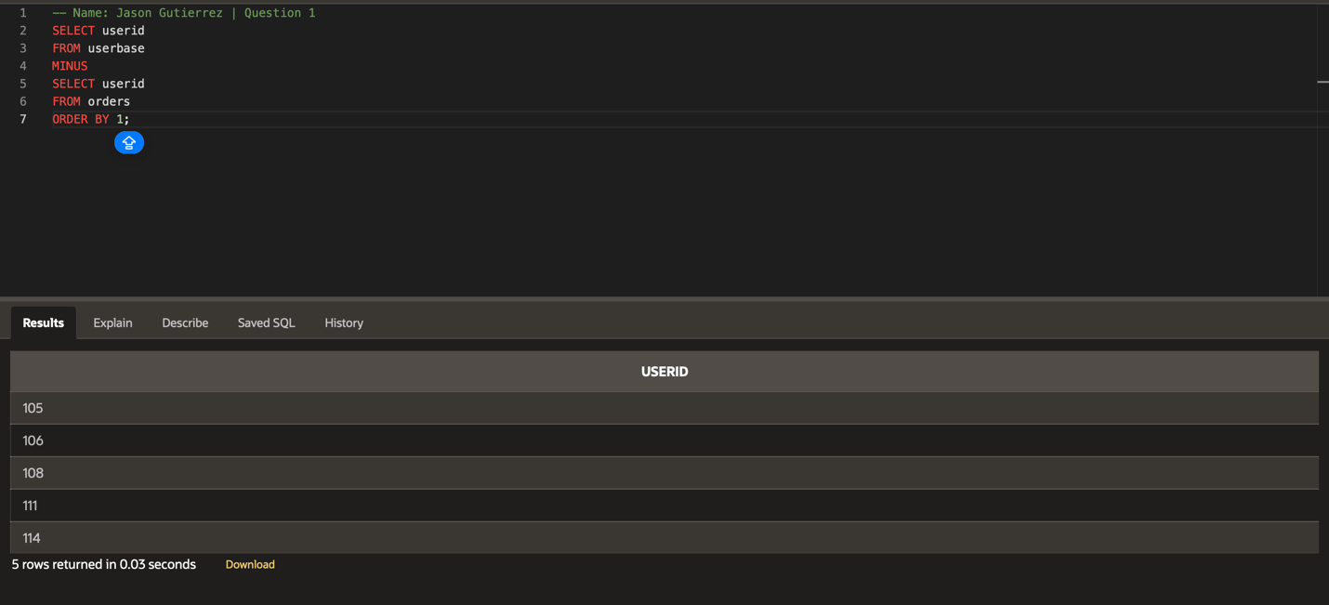
- Display the PRODUCTCODE of any products that have no reviews.
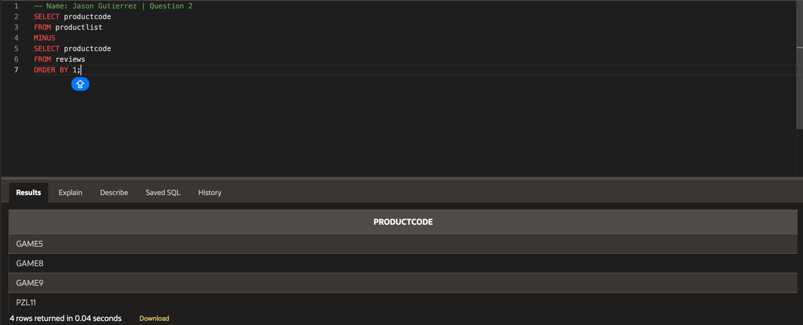
- Display all data in the USERBASE table. Show another column that states “Adult” for any user that is at least 18 years old, and “Minor'' for all other users.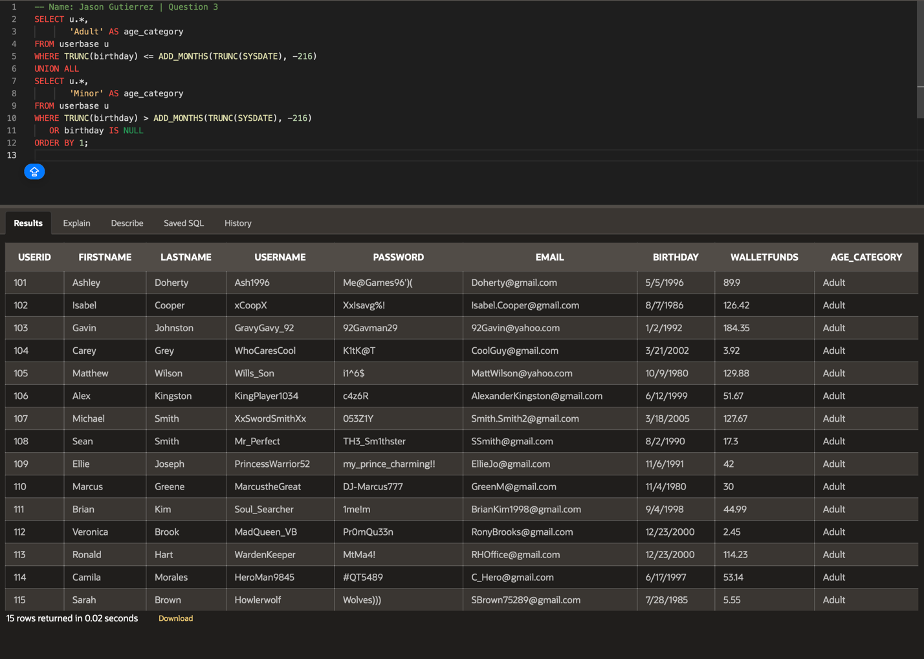

- Display all data in the PRODUCTLIST table. Show another column that states “On Sale” for any product that is priced at $20 or less, and “Base Price” for all other products.
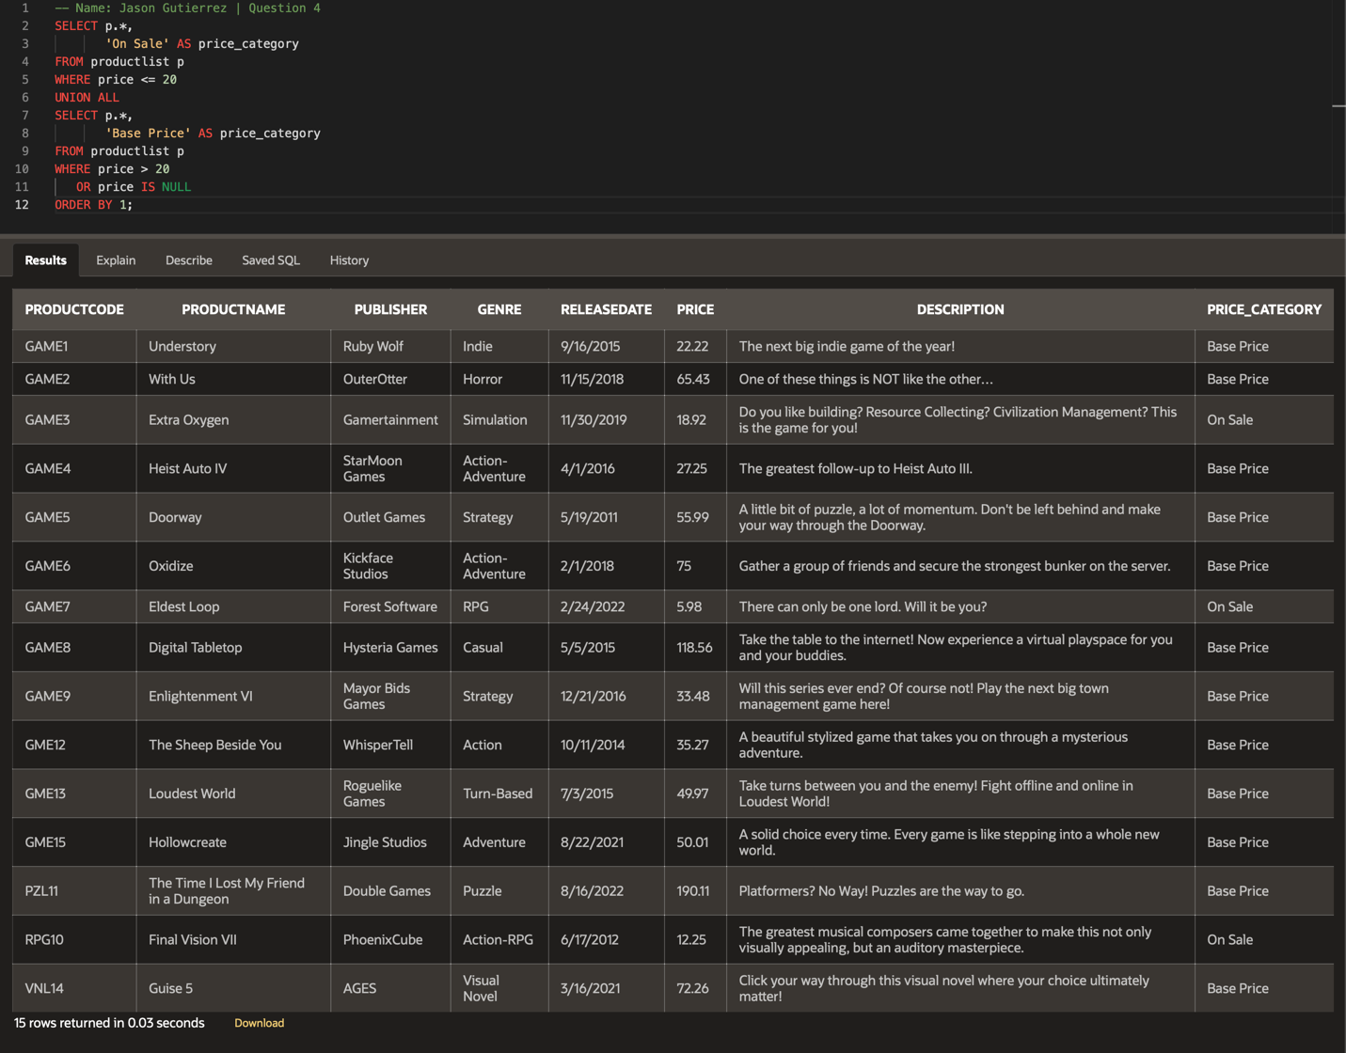
- Display the USERID of any user who has played the product with a PRODUCTCODE of GAME6 and has a user profile image.
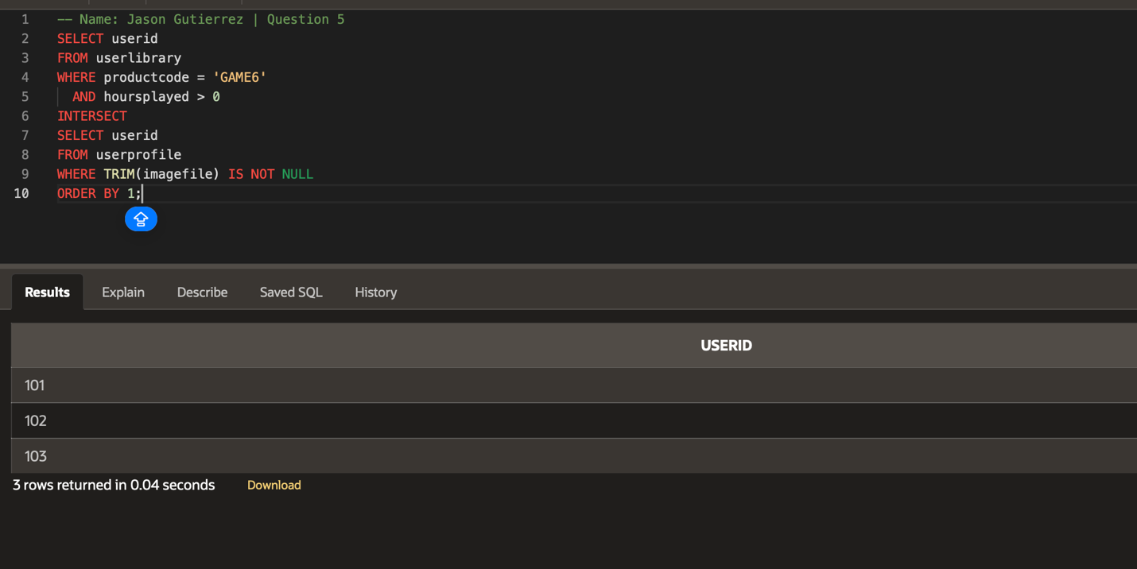
- Display any PRODUCTCODE from the intersect of the WISHLIST and REVIEWS table, where the product is in POSITION 1 or 2, and has a review RATING of 3 or higher.
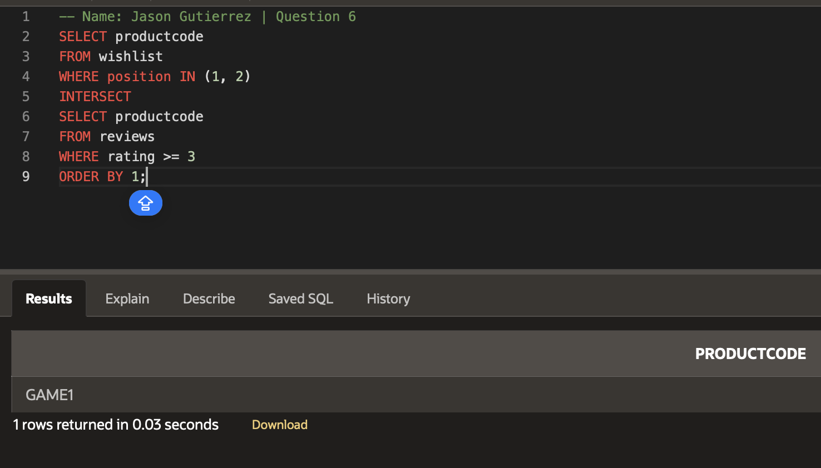
- Display both user’s USERNAME and BIRTHDAY for any users who share the same BIRTHDAY.
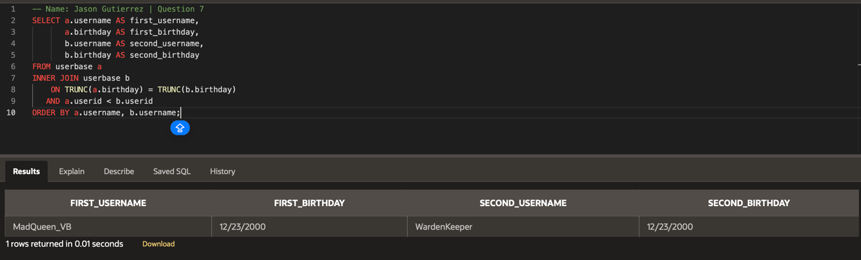
- Display the Cartesian Product of the USERLIBRARY table cross joined with the WISHLIST table.
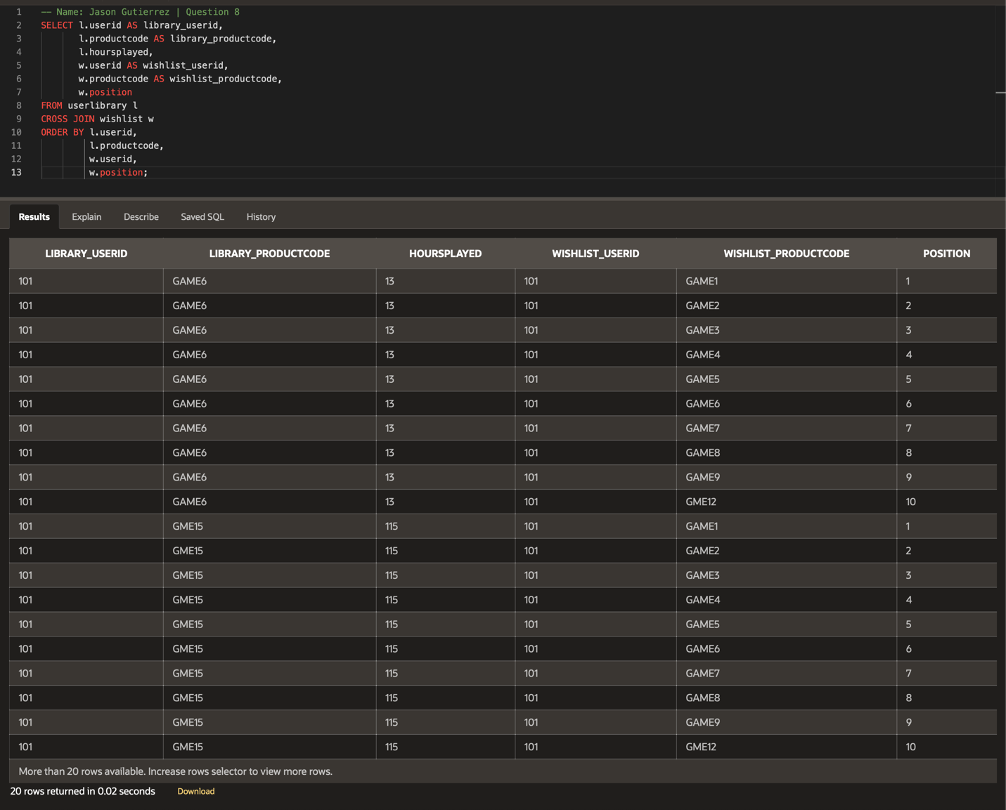
- Perform a union all on the USERBASE and PRODUCTLIST tables to generate data on all users and products.
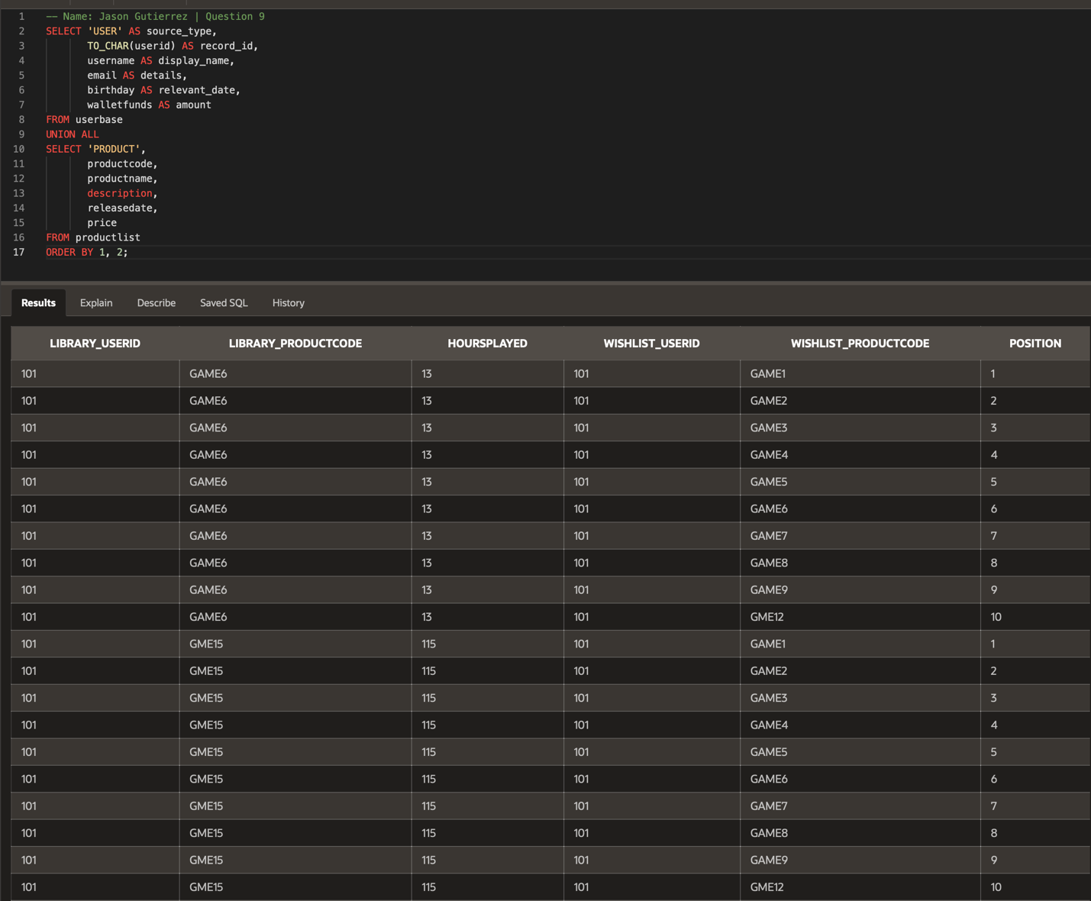
- Perform a union all on the CHATLOG and USERPROFILE tables to generate data on user activity.
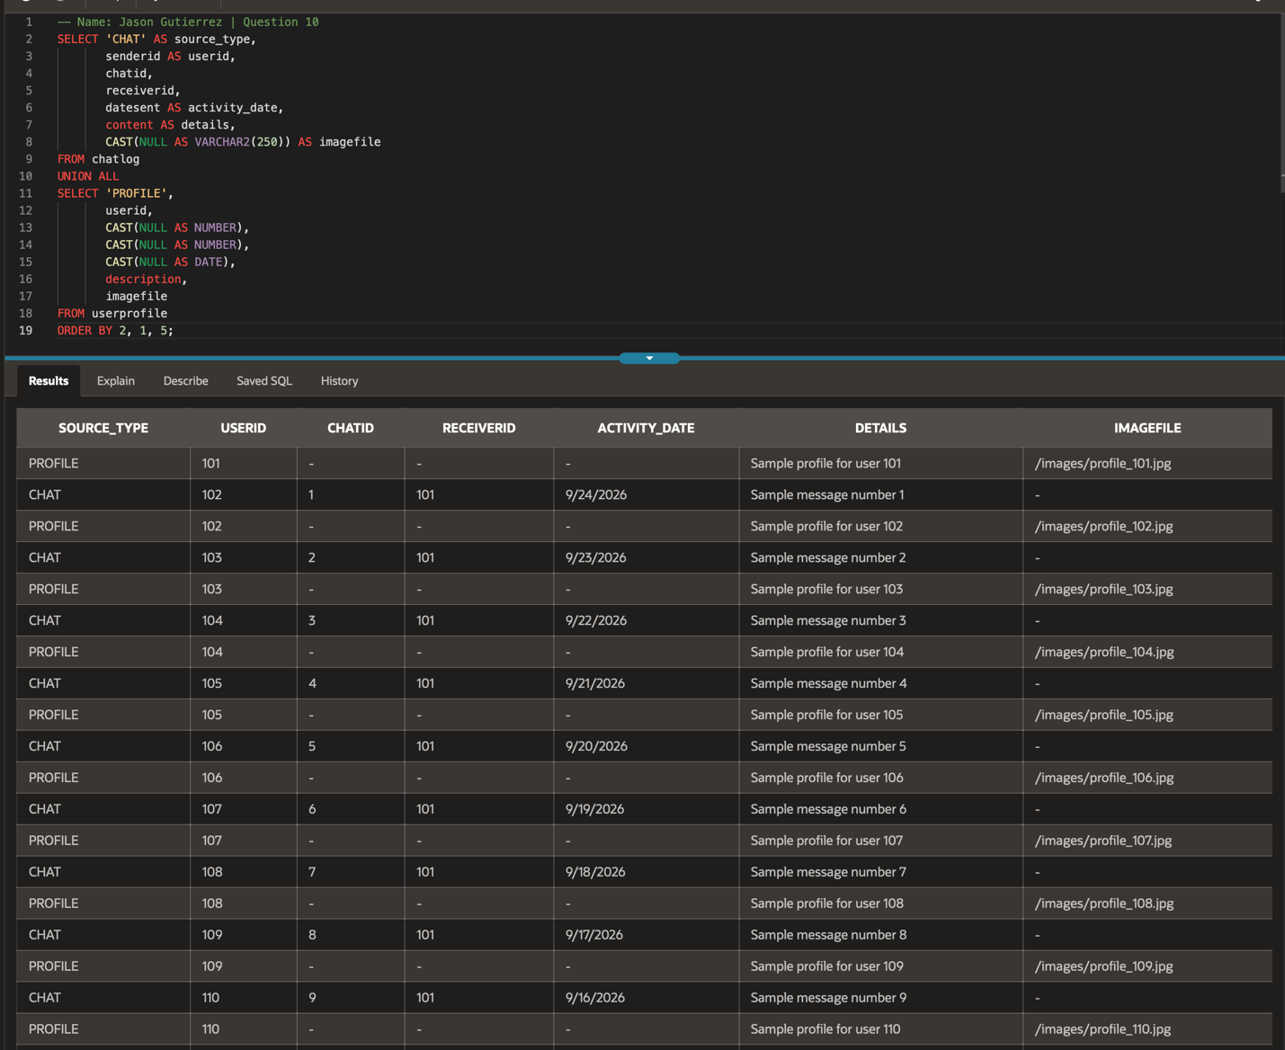
- Display the USERNAME of all users who have not received an INFRACTION.
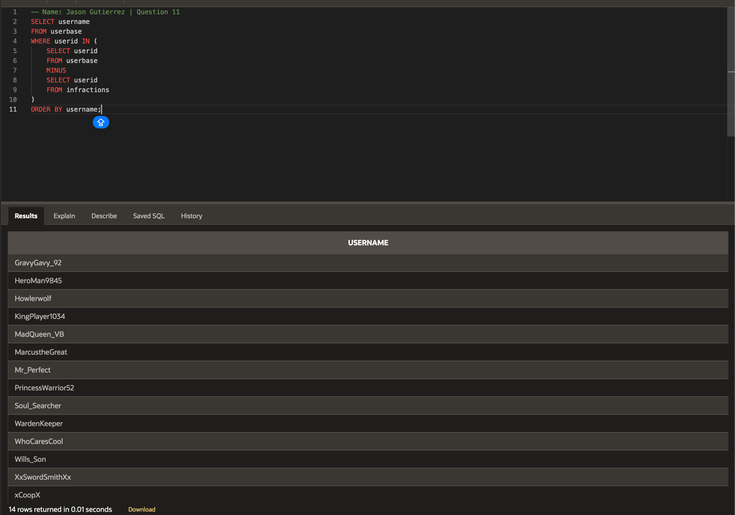
- Display the TITLE and DESCRIPTION of any COMMUNITYRULES that have not been broken.
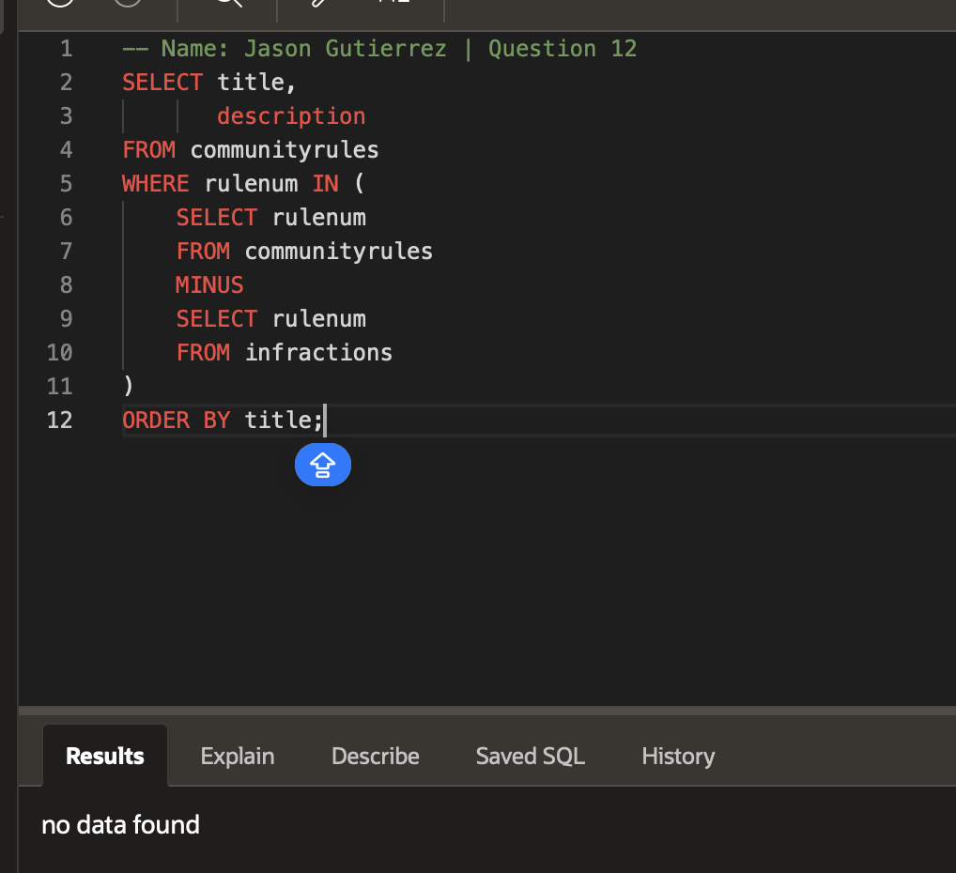
- Display the USERNAME and EMAIL of all users who have received a penalty for their INFRACTION.
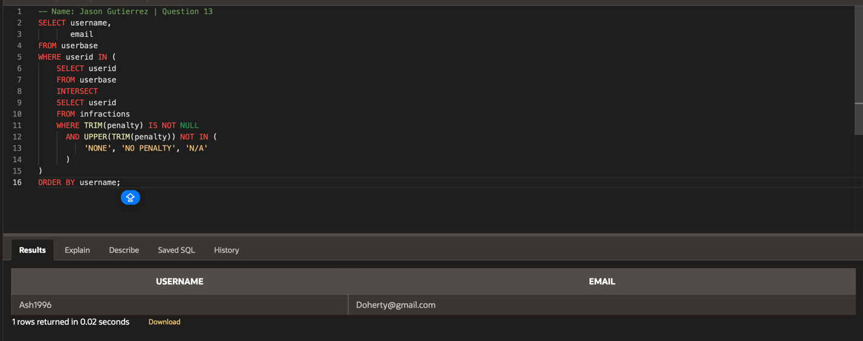
- Display the dates where an INFRACTION was assigned and a USERSUPPORT ticket was submitted on the same day.
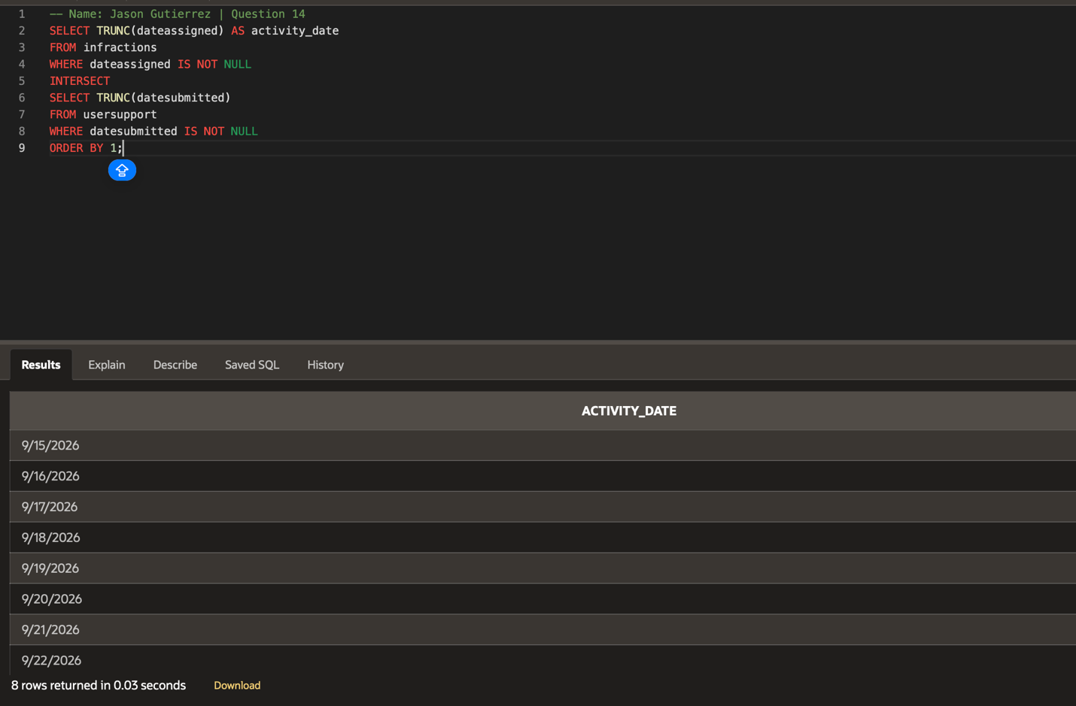
- Display every COMMUNITYRULES TITLE and PENALTY.
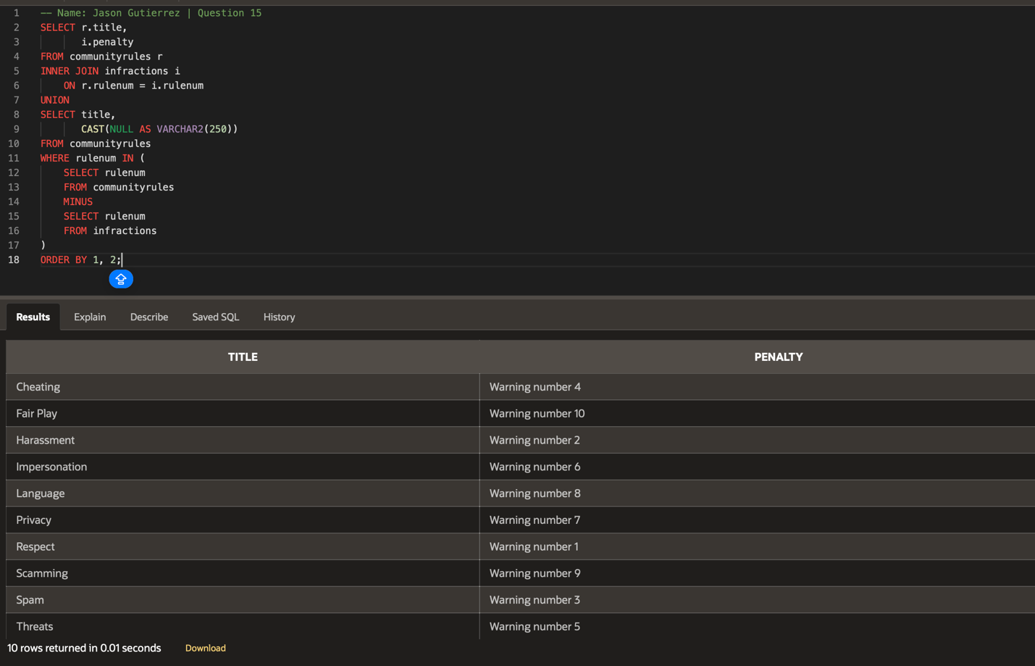
- Display all data in the COMMUNITYRULES table. Show another column that states “Bannable'' for any rule with a 10 or higher SEVERITYPOINT, and “Appealable” for all other rules.
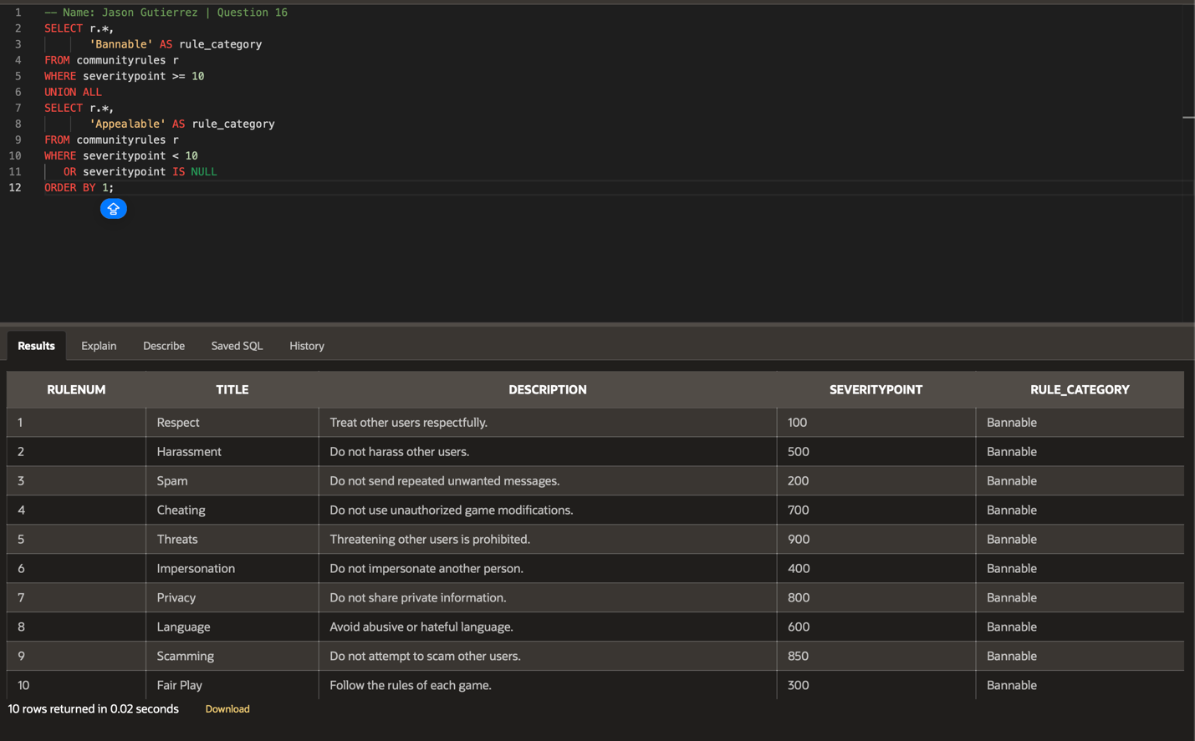
- Display all data in the USERSUPPORT table. Show another column that states “High Priority” for any ticket that is not closed and has not been updated in the past week.
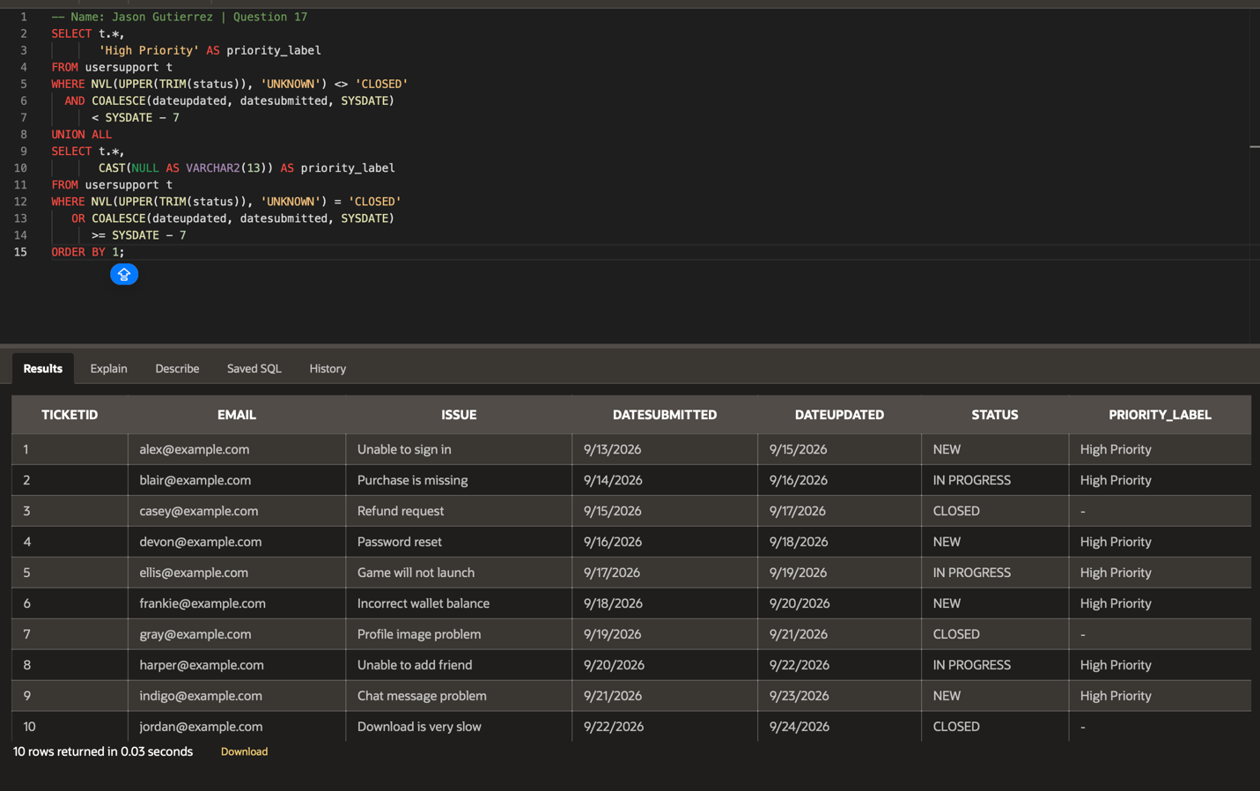
- Display the Cartesian Product of the USERSUPPORT table cross joined with the INFRACTIONS table.
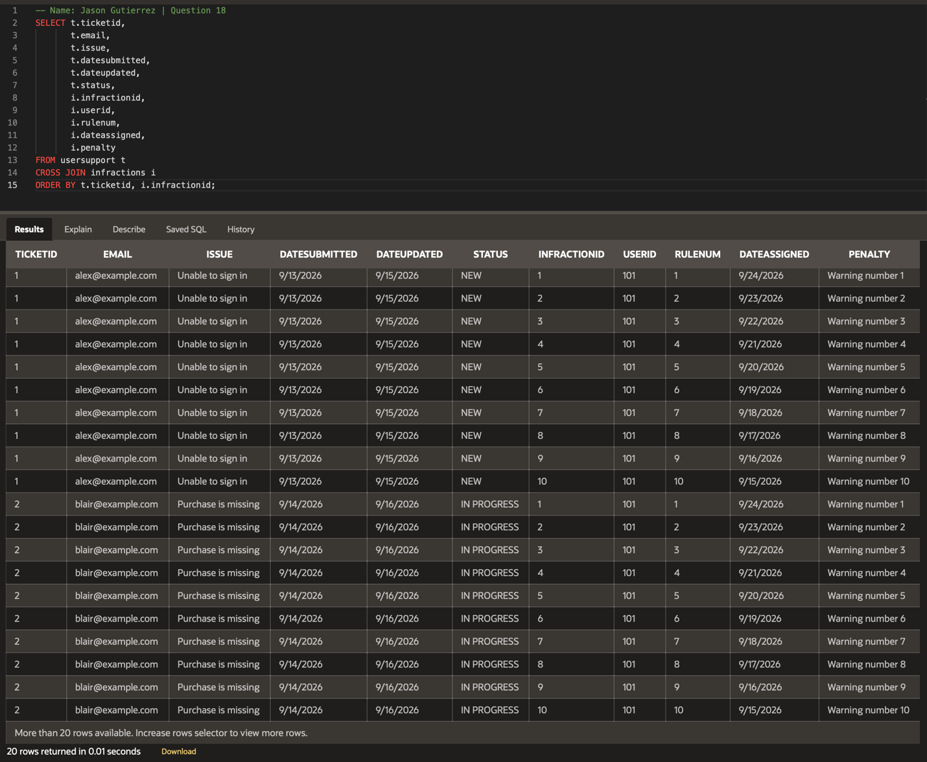
- Display both TICKETIDs and DATEUPDATED for any support tickets that are ‘CLOSED’ and the last DATEUPDATED was on the same day.
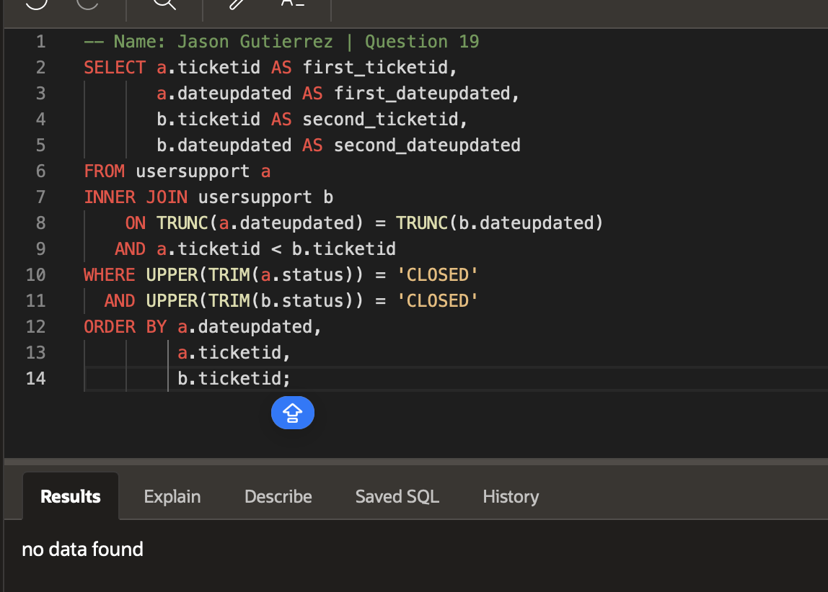
- Perform a union all on the USERBASE and INFRACTIONS tables to generate data on user activity.