Verifying the Database State

VaporGames has just hired you as a new database developer. In order to become familiar with their current database design, you have been asked to perform some simple queries.

For this assignment, write queries that will answer the questions below. Save every query to a SQL script named VerifyDBState. Use -- to write a comment above each query, noting the question it refers to. Additionally, take a screenshot of the query and result set for each question, and insert it below the corresponding question.
Example Screenshot: 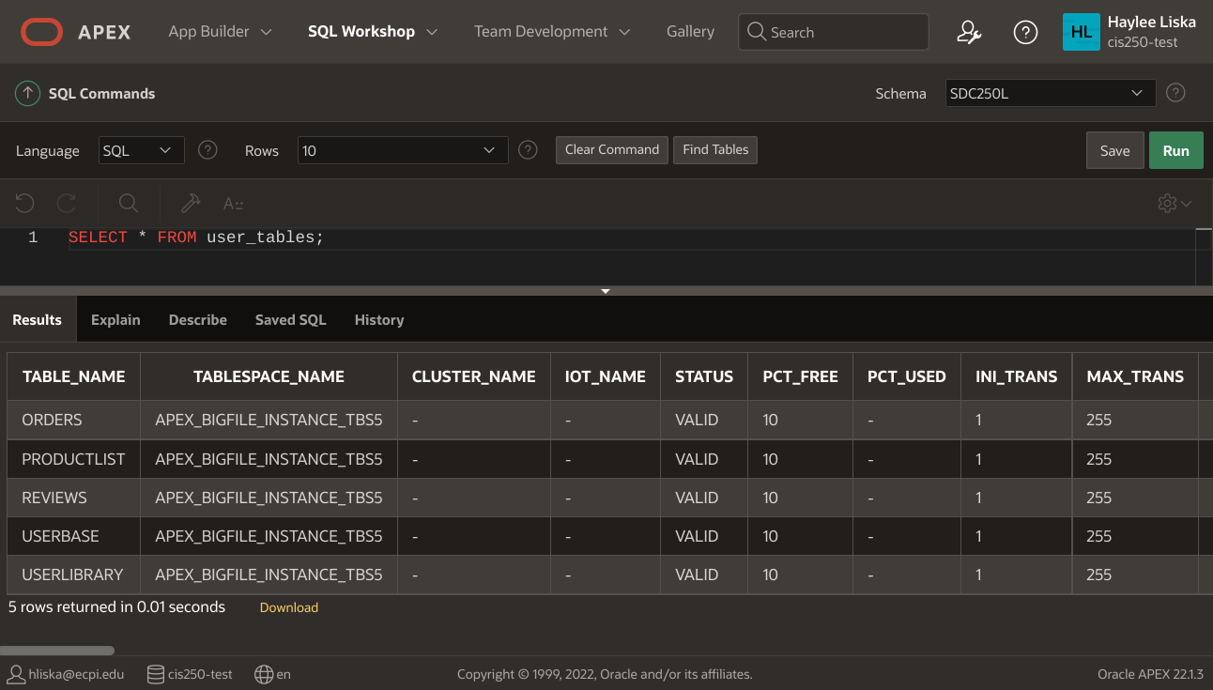

- Check which users have access to the database by displaying the USER_ID, USERNAME, CREATED, and PASSWORD_CHANGE_DATE from the USER_USERS table. 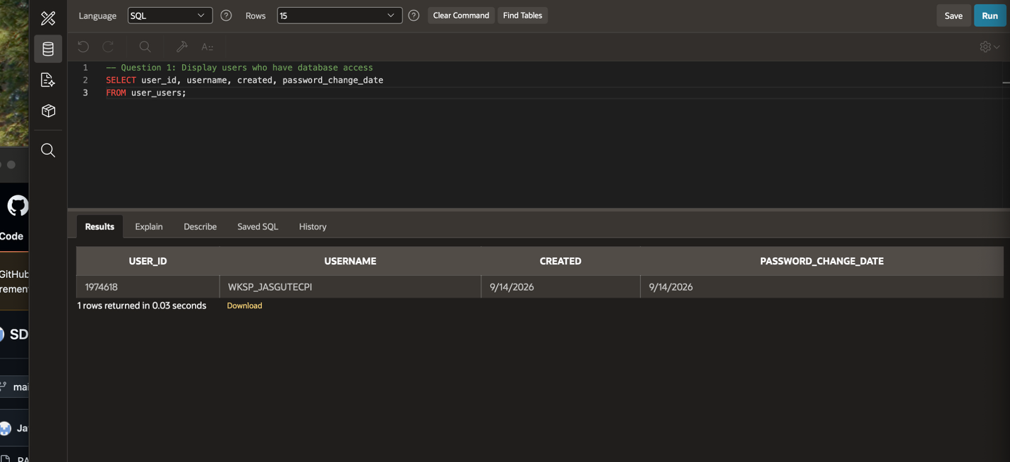
- Check what tables are present in the database by displaying everything in USER_TABLES.
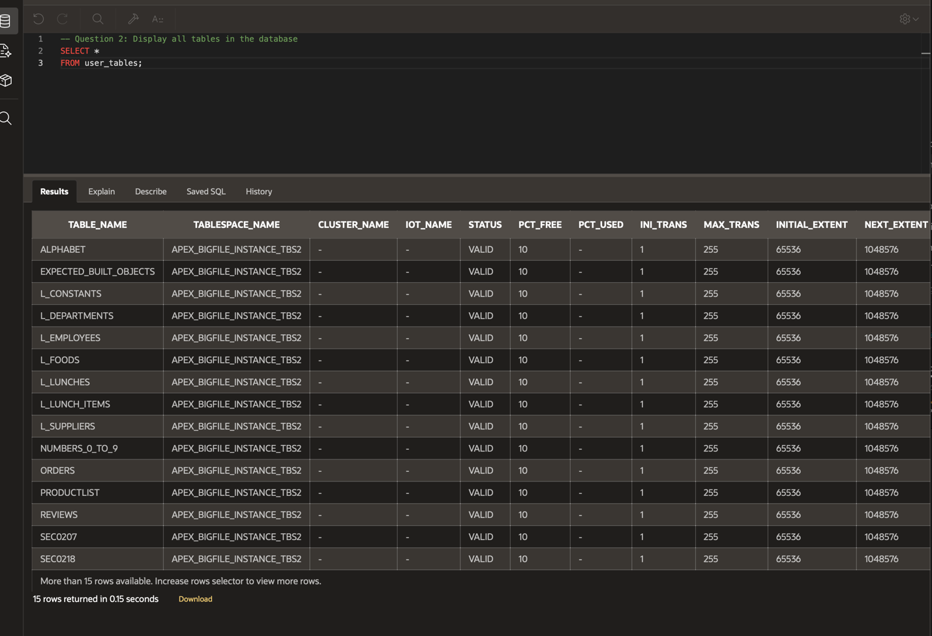
- Examine the design of each table by running the DESCRIBE command:

  - Describe the ORDERS table
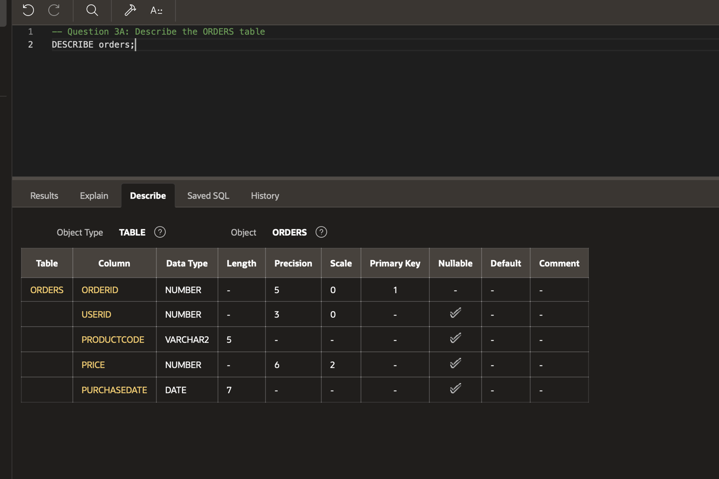
  - Describe the PRODUCTLIST table
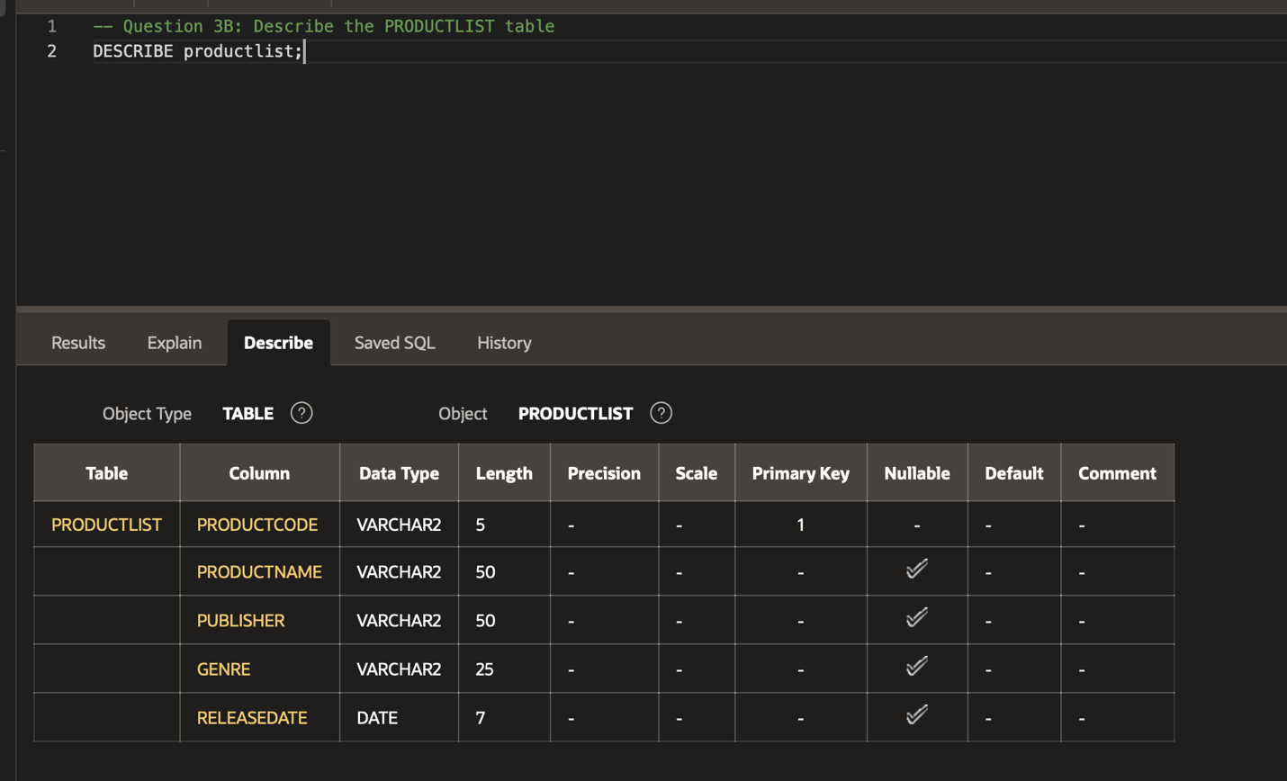
  - Describe the REVIEWS table
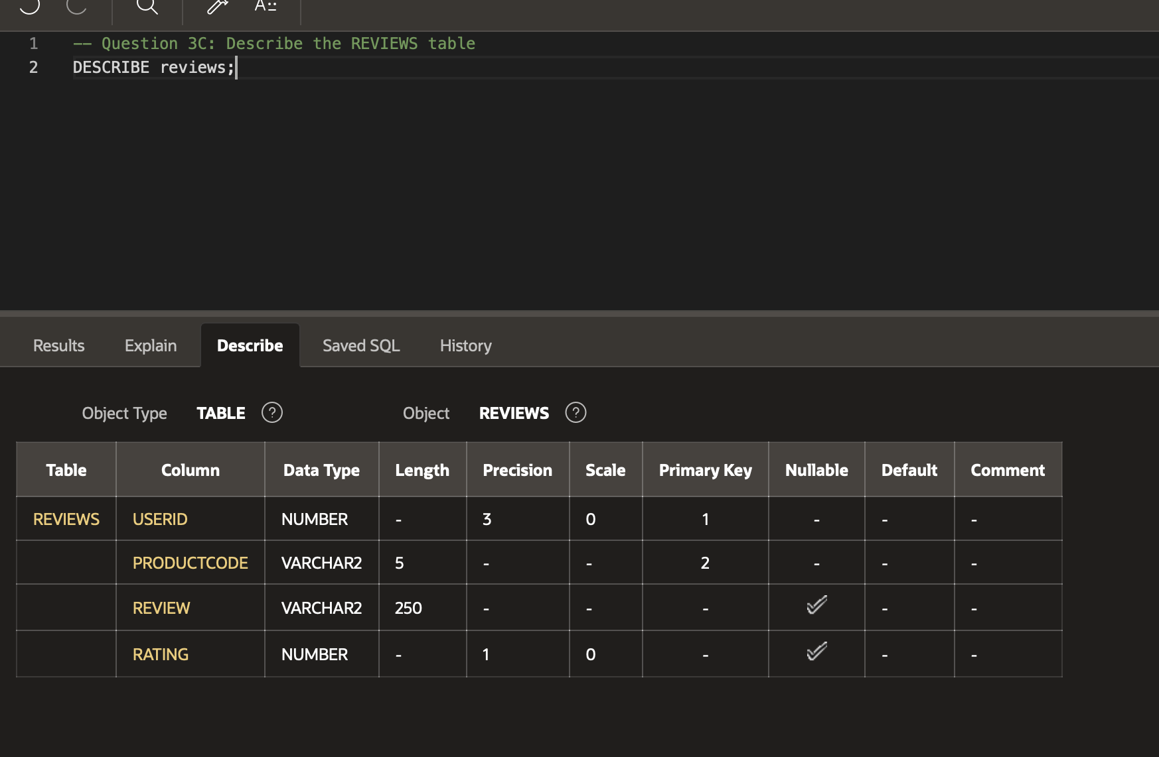
  - Describe the STOREFRONT table
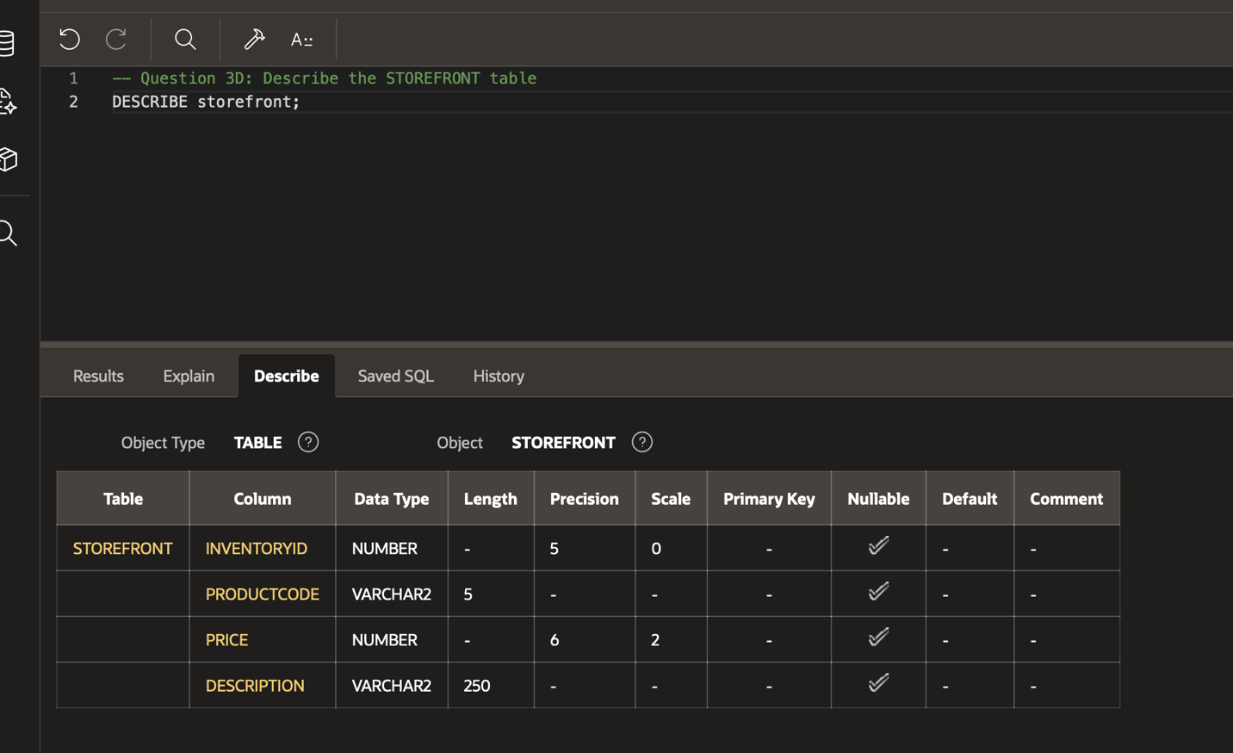
  - Describe the USERBASE table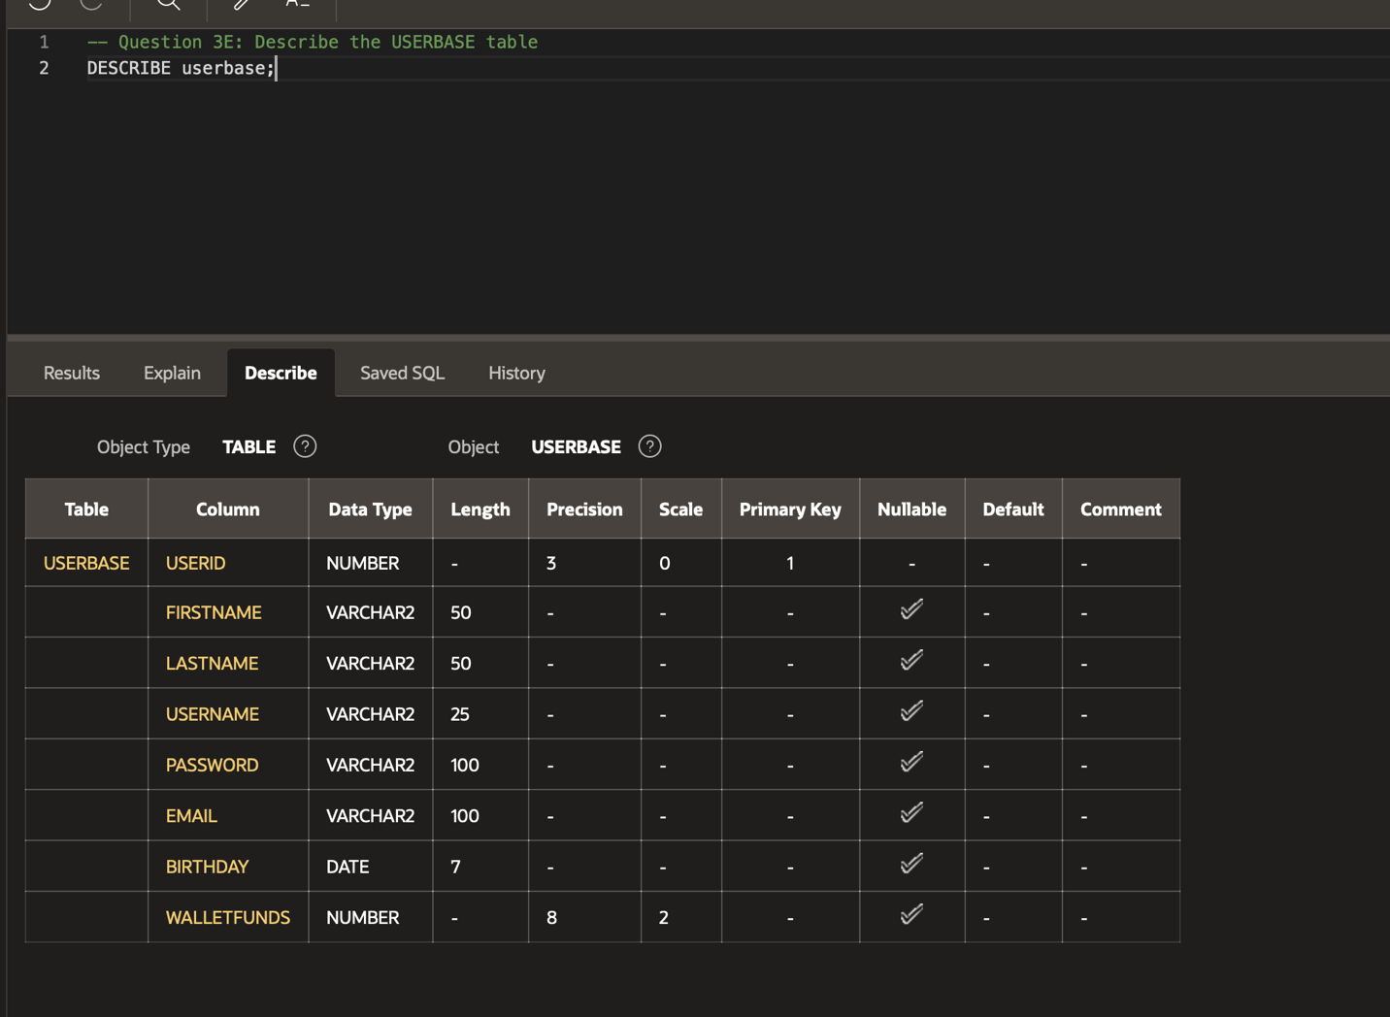
  - Describe the USERLIBRARY table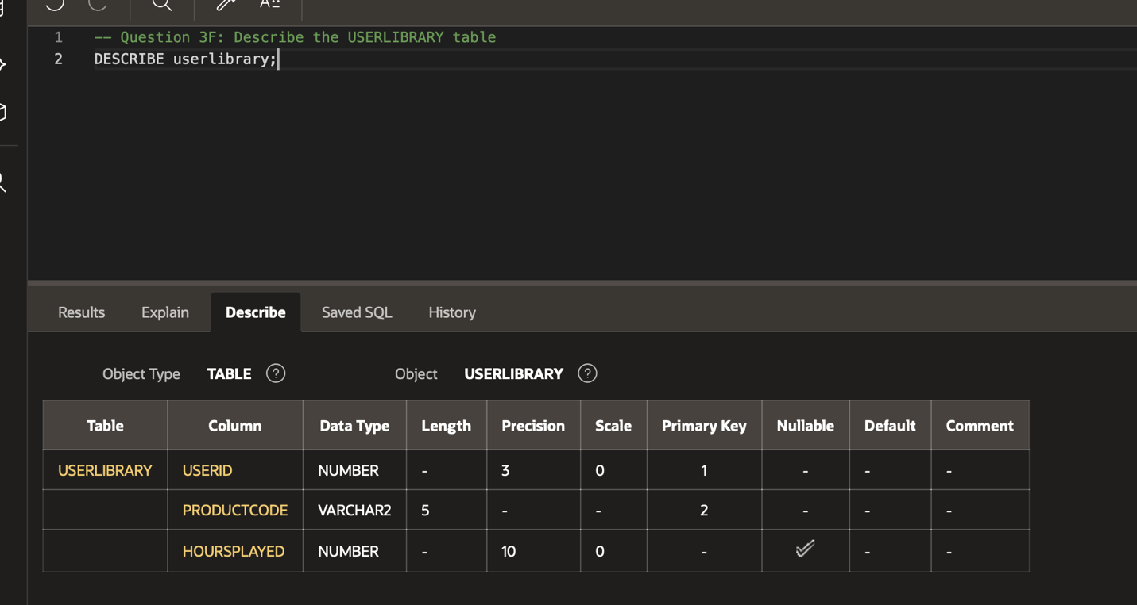

- Display all data currently present in the database:
  - Display everything in the ORDERS table
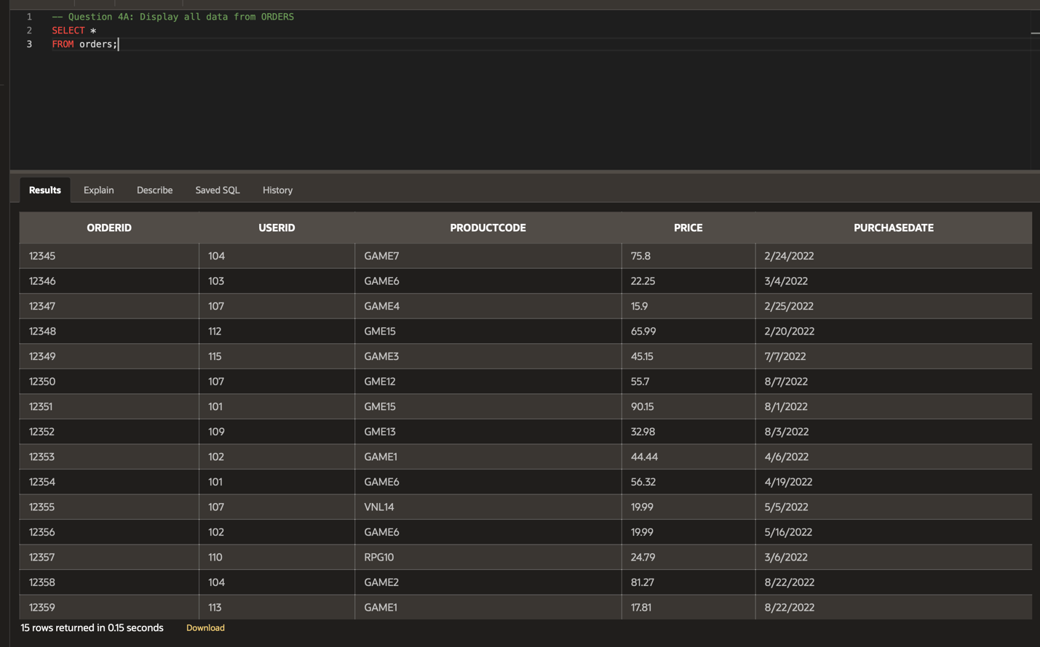
  - Display everything in the PRODUCTLIST table
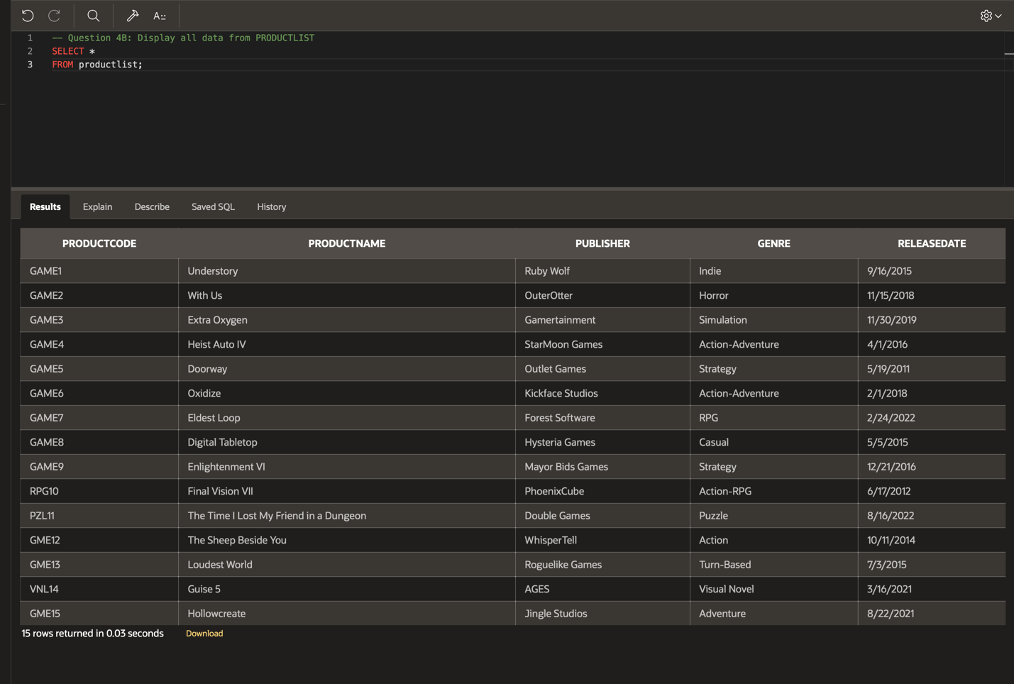
  - Display everything in the REVIEWS table
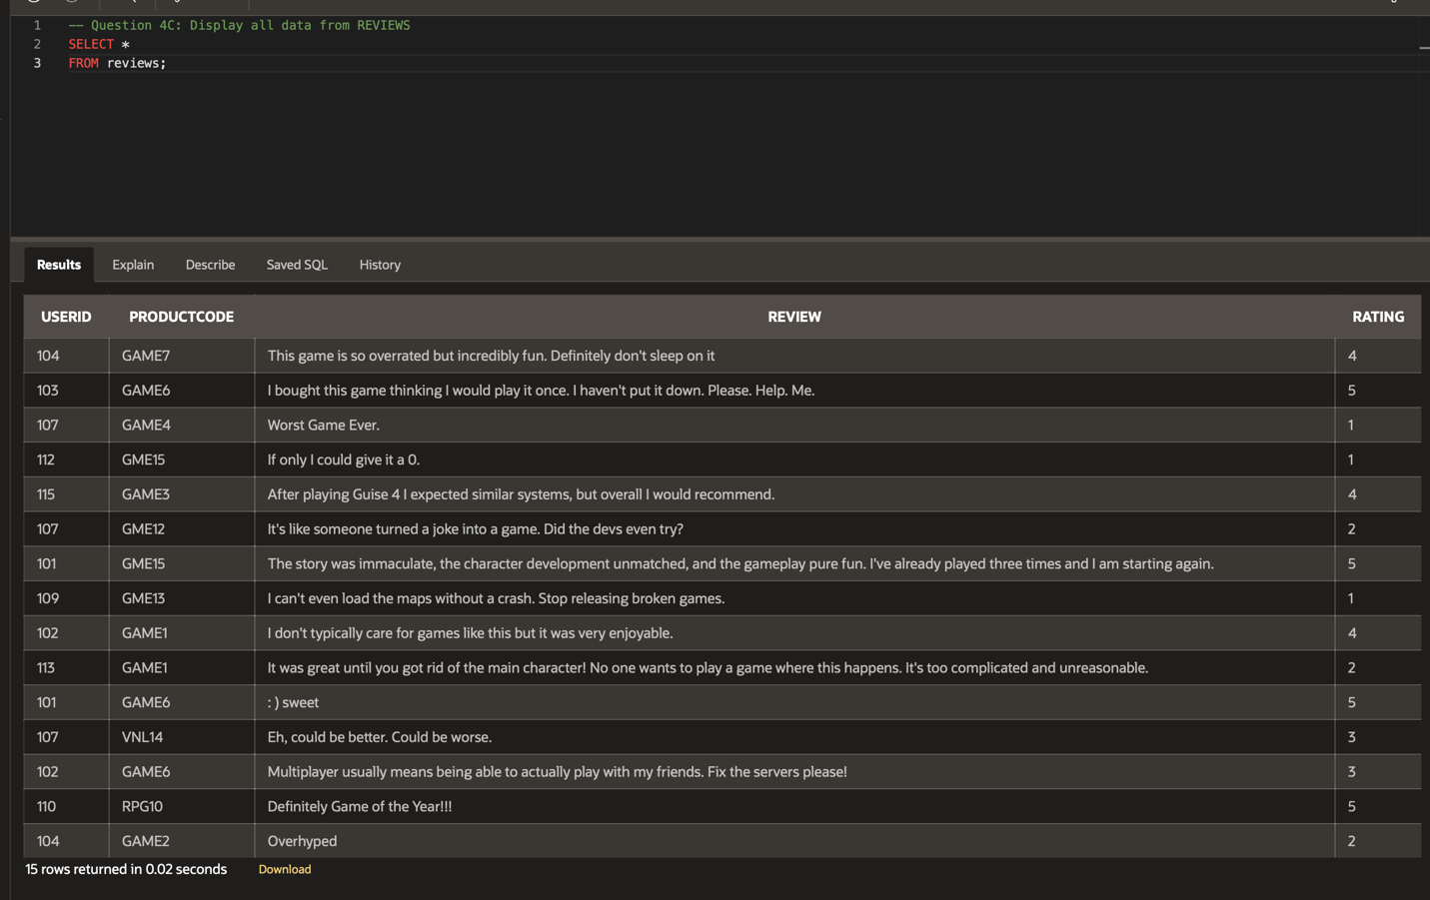
  - Display everything in the STOREFRONT table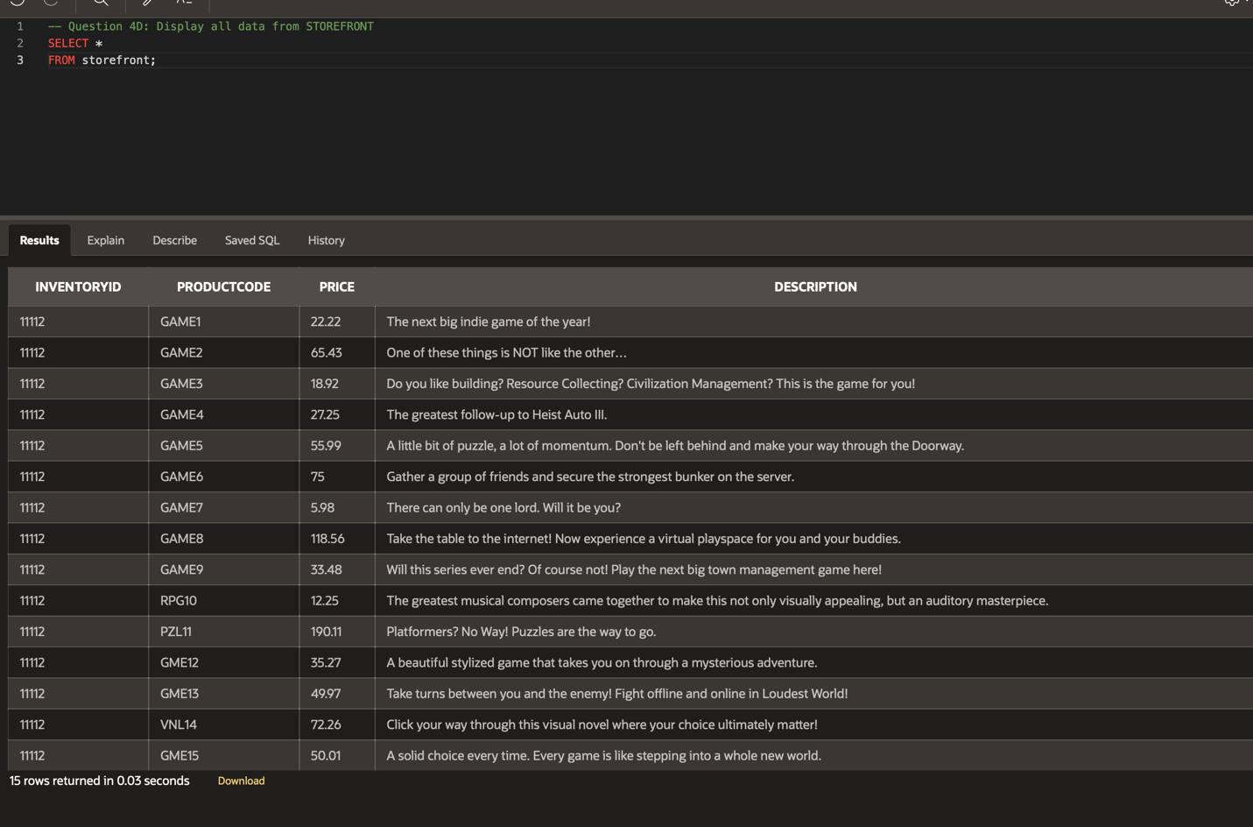
  - Display everything in the USERBASE table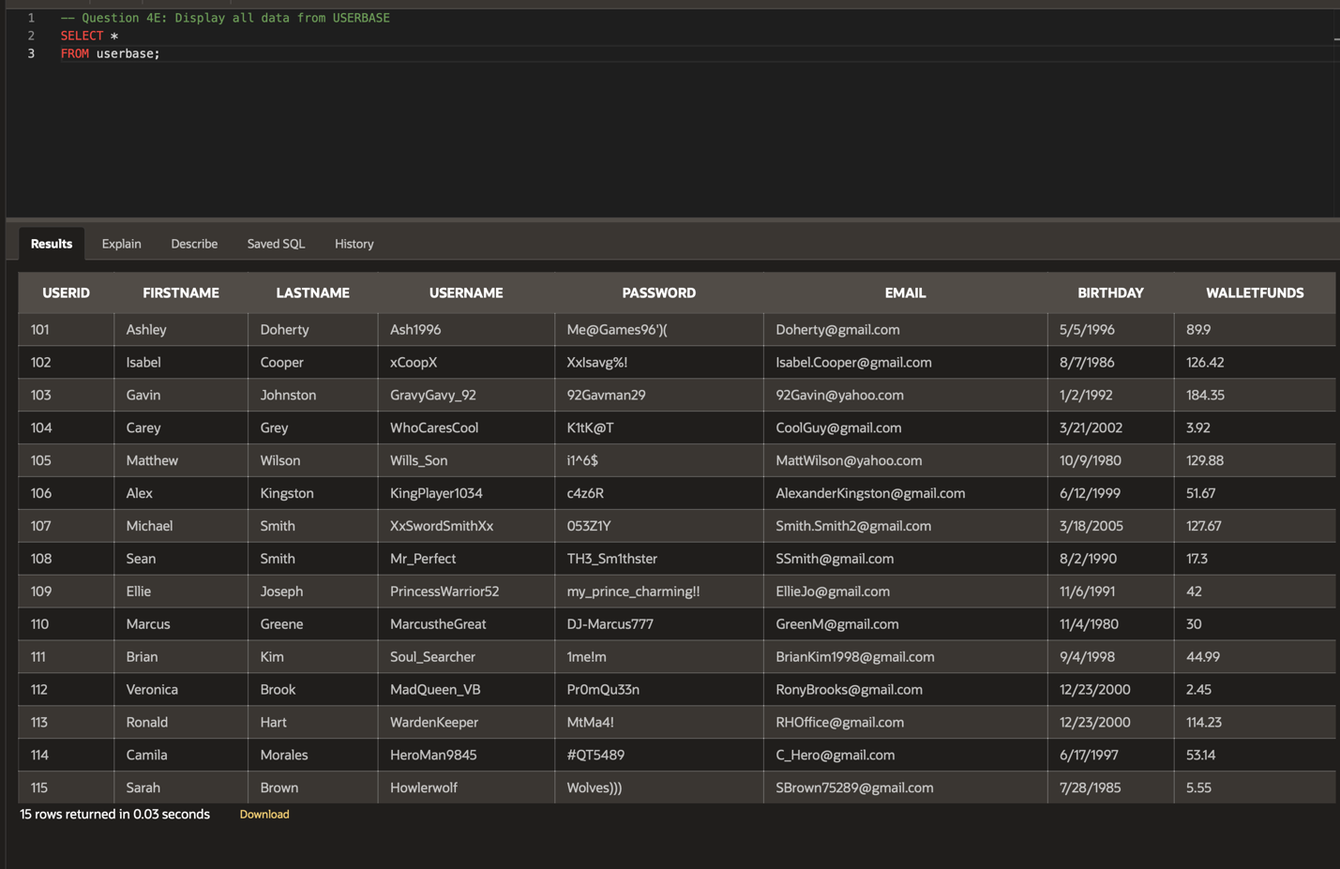
  - Display everything in the USERLIBRARY table
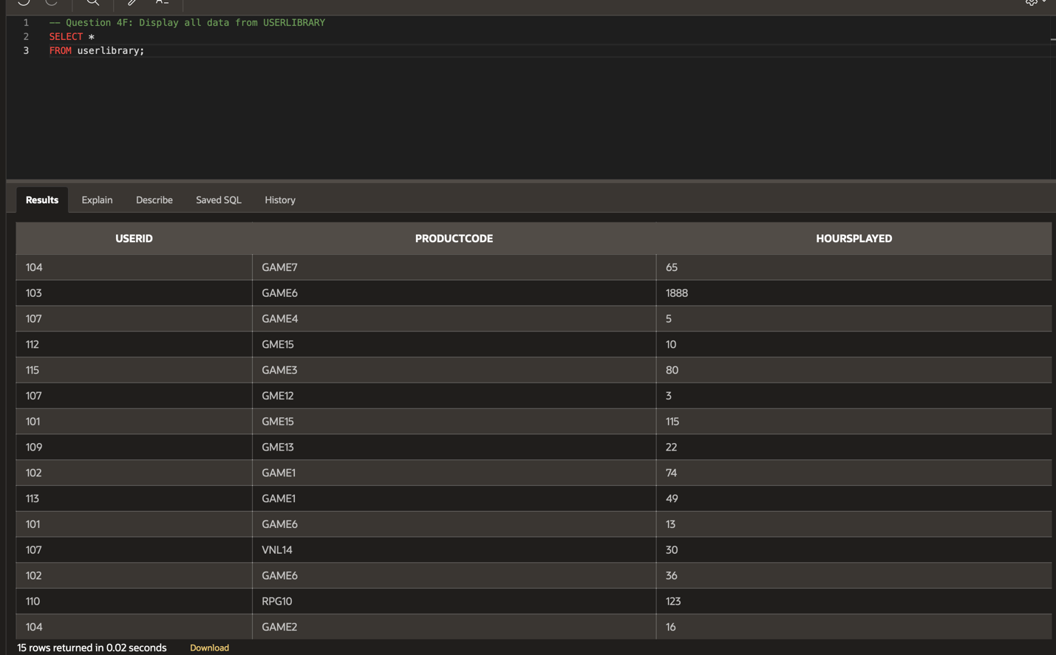

- Check what constraints are present in the database by displaying the TABLE_NAME, CONSTRAINT_NAME, CONSTRAINT_TYPE, and STATUS from the USER_CONSTRAINTS table.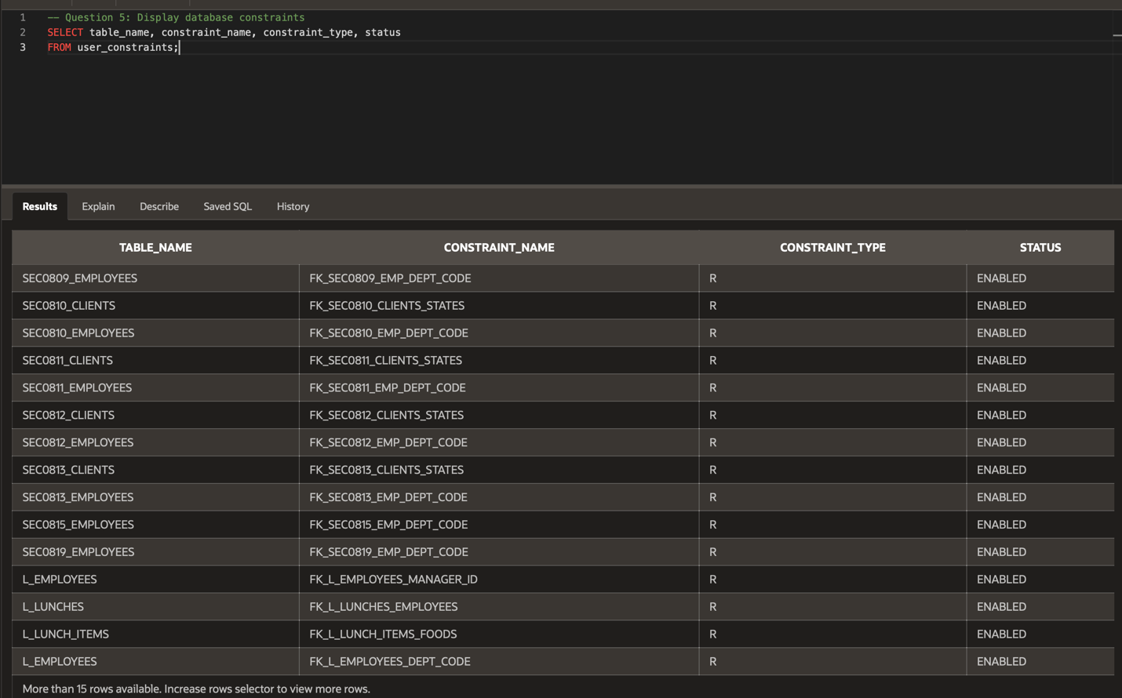
- Check what views are present in the database by displaying the VIEW_NAME and TEXT columns in the USER_VIEWS table.
NOTE: no data found is an acceptable answer! This means the query ran without error, but there were no records found (no data present in the table matching the selected conditions).
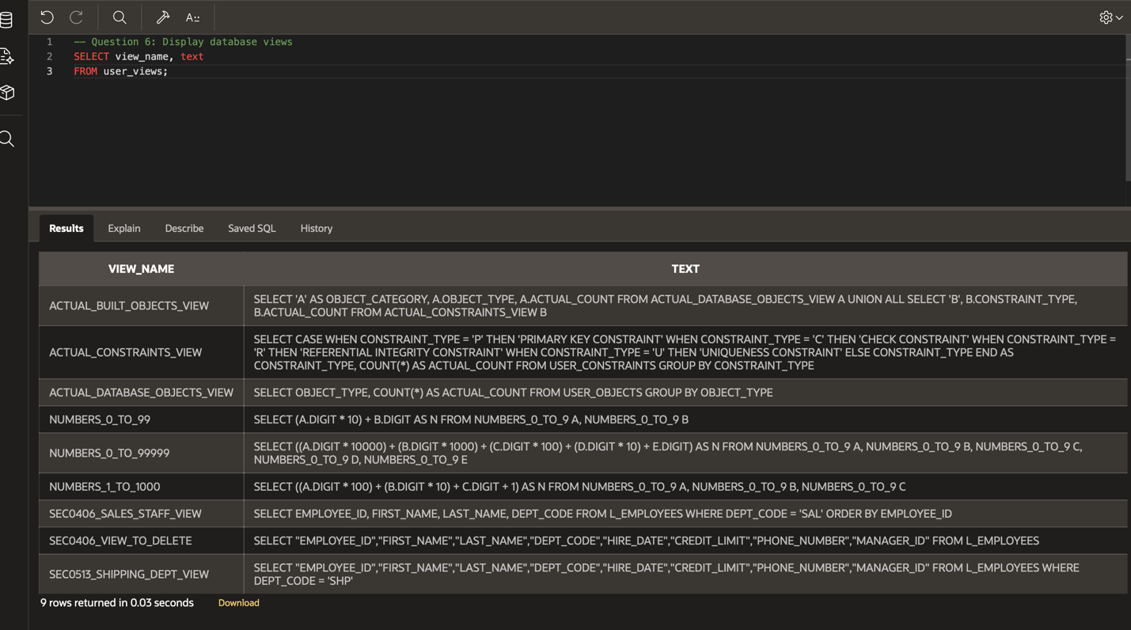
- Display every USERNAME in alphabetical order.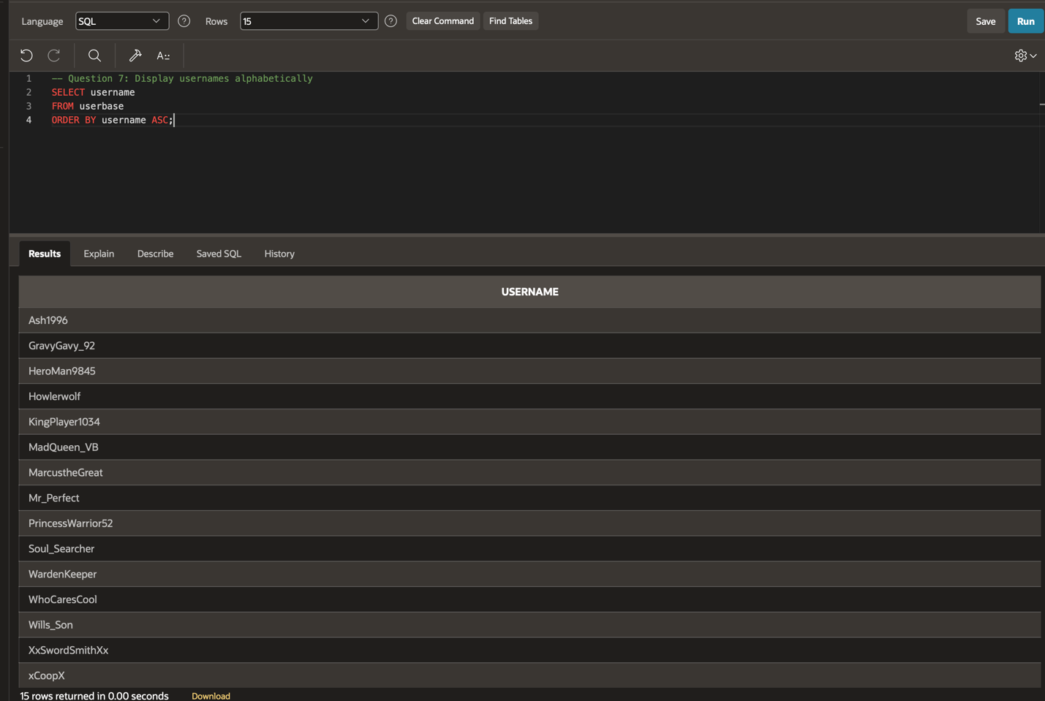
- Display the FIRSTNAME, LASTNAME, USERNAME, PASSWORD, and EMAIL of any user who has a yahoo email address. 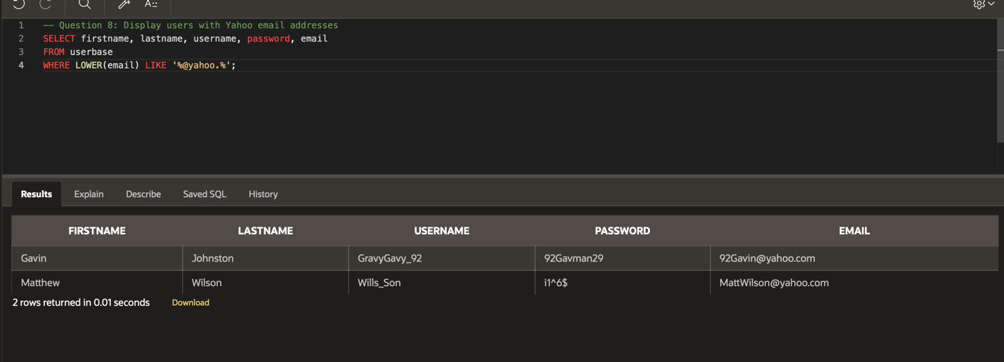
- Display the USERNAME, BIRTHDAY, and WALLETFUNDS of any user who has less than $25 in funds. 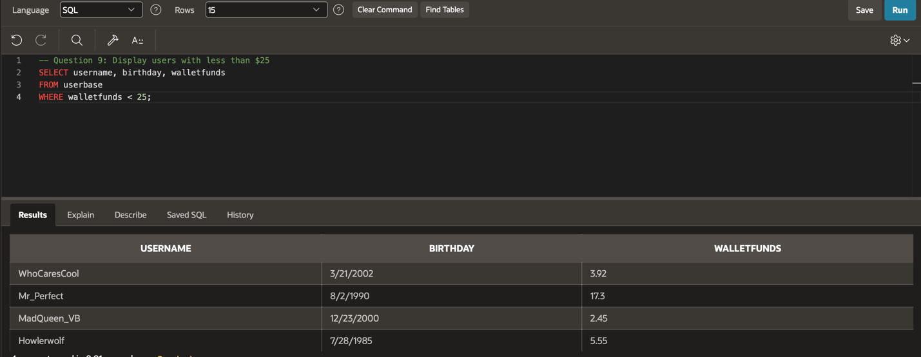
- Display the USERID and PRODUCTCODE of any user who has more than 100 HOURSPLAYED.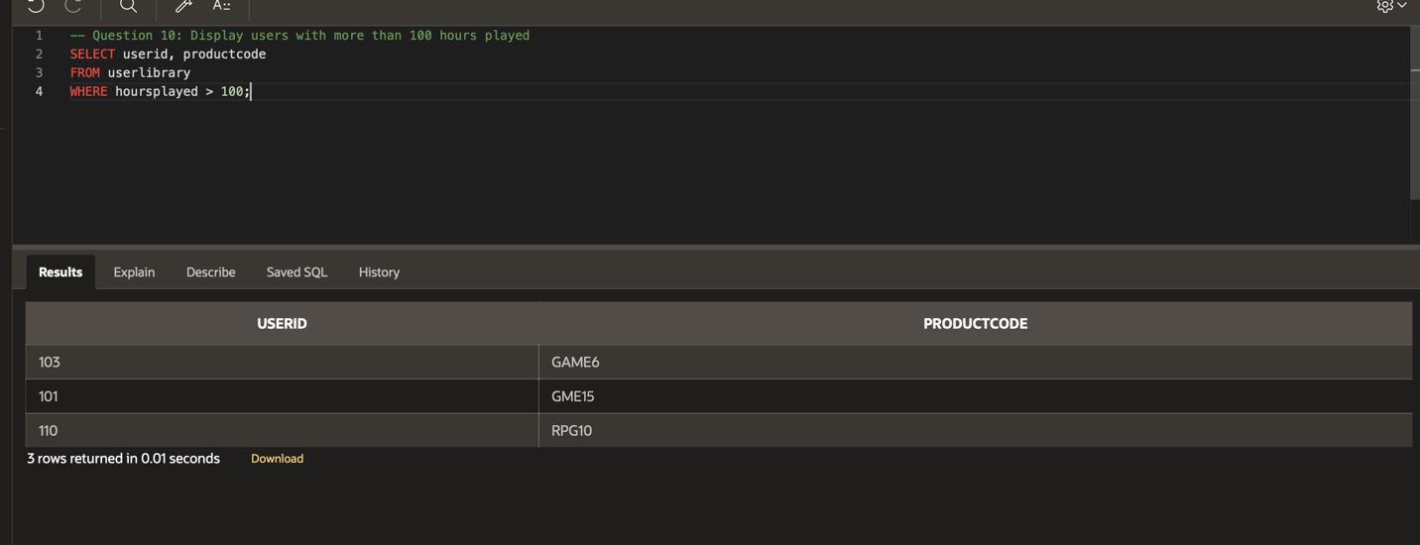
- Display the PRODUCTCODE of any game that has less than 10 HOURSPLAYED.
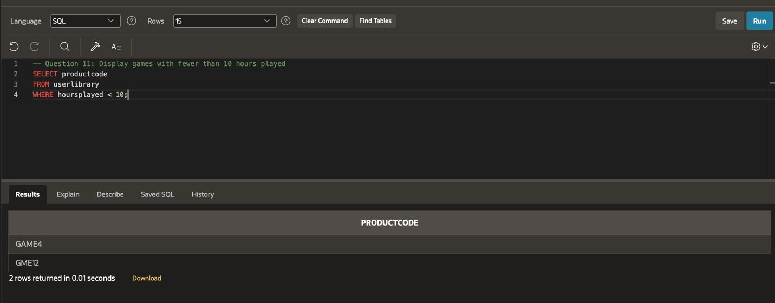
- Display every unique PUBLISHER.
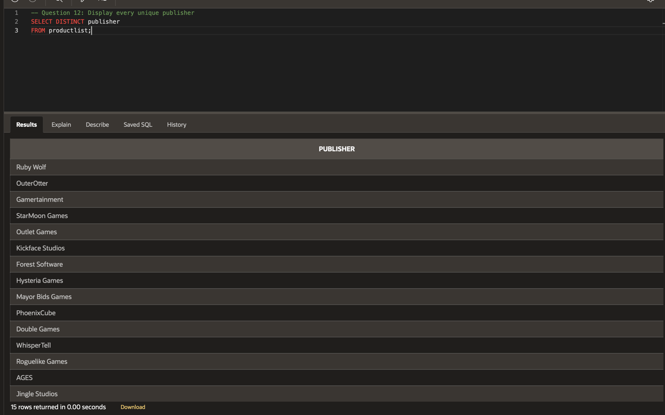
- Display the PRODUCTNAME, RELEASEDATE, PUBLISHER, and GENRE of all products, sorted by GENRE.
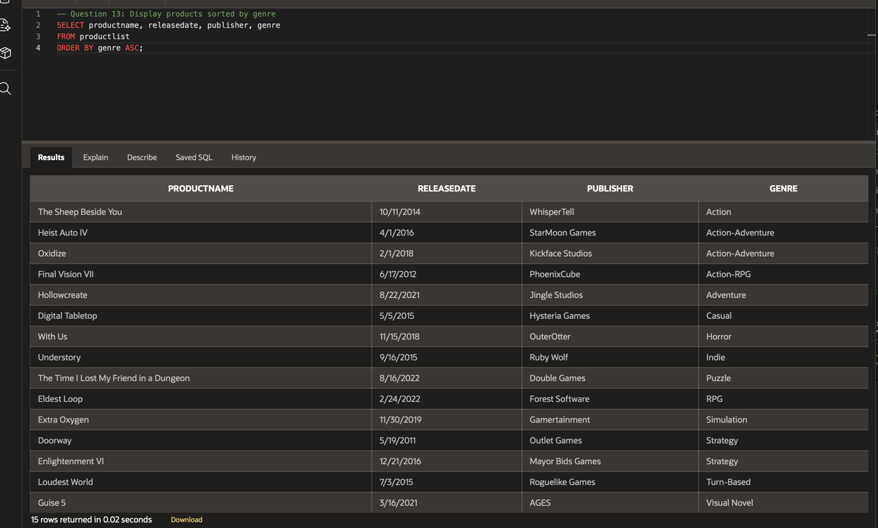
- Display the PRODUCTCODE and PUBLISHER of any product in the ‘Strategy’ GENRE.
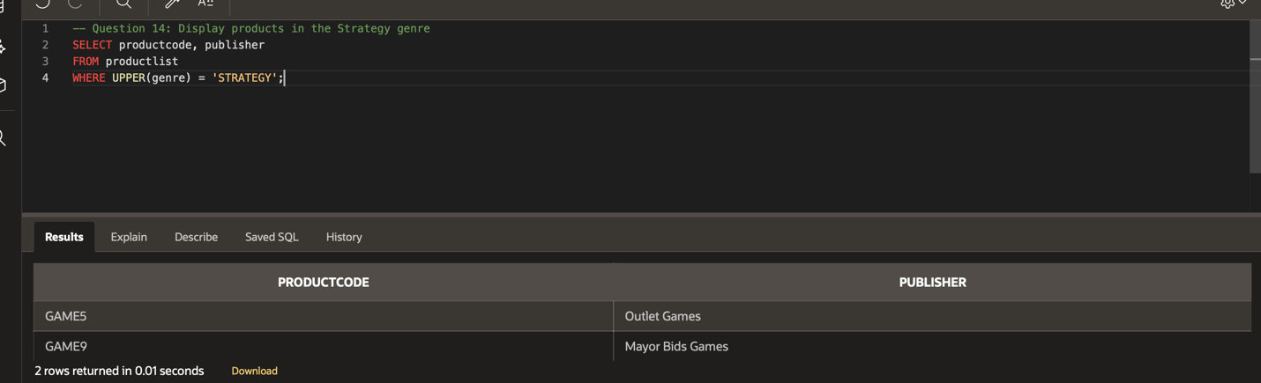
- Display the PRODUCTCODE, DESCRIPTION, and PRICE for any product that costs more than $25, sorted by descending PRICE.
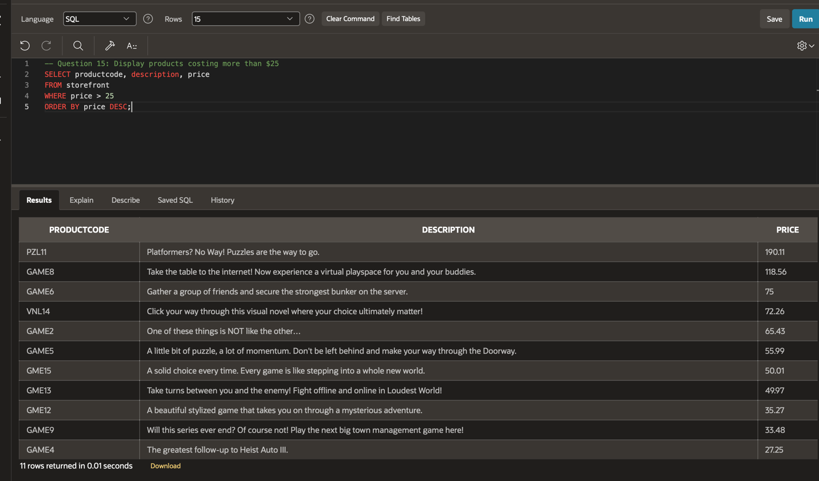
- Display the INVENTORYID and PRICE of all products in the STOREFRONT table, sorted by ascending PRICE.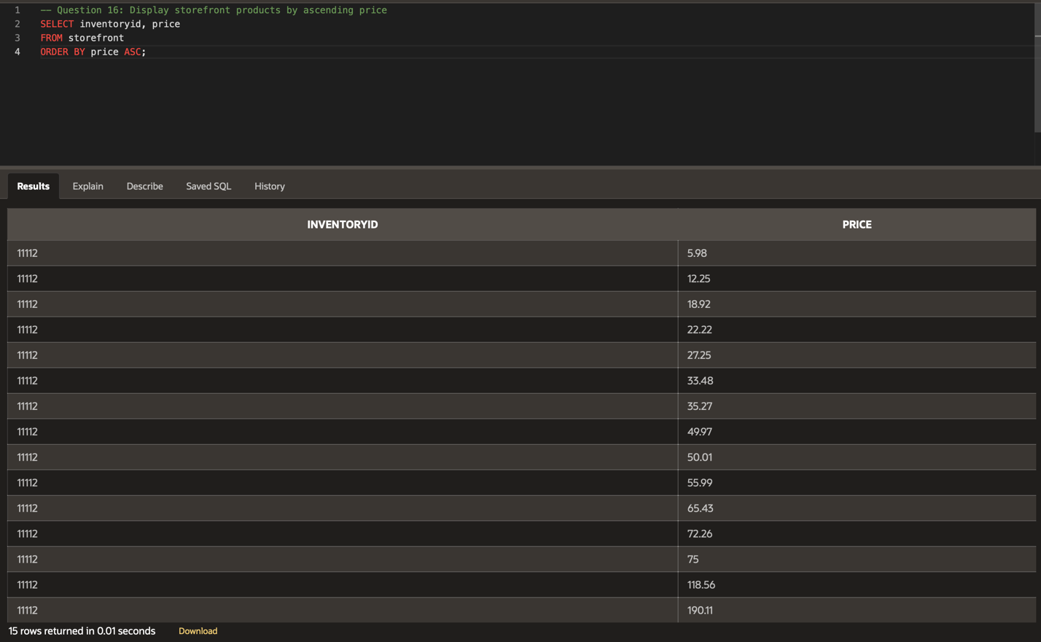
- Display the PRODUCTCODE and REVIEW of any product with a RATING of 1.
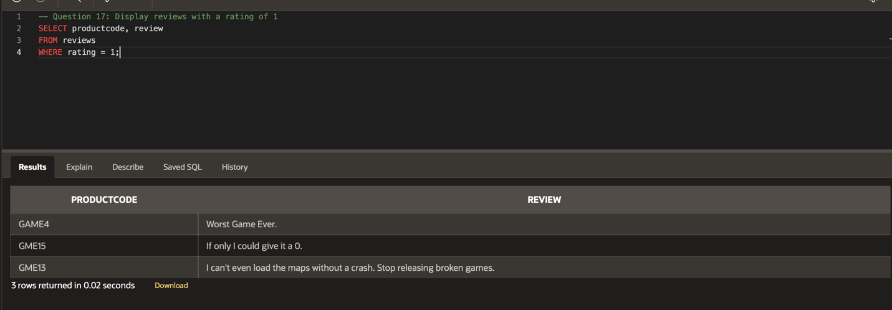
- Display the PRODUCTCODE and REVIEW of any product with a RATING of 4 or higher.
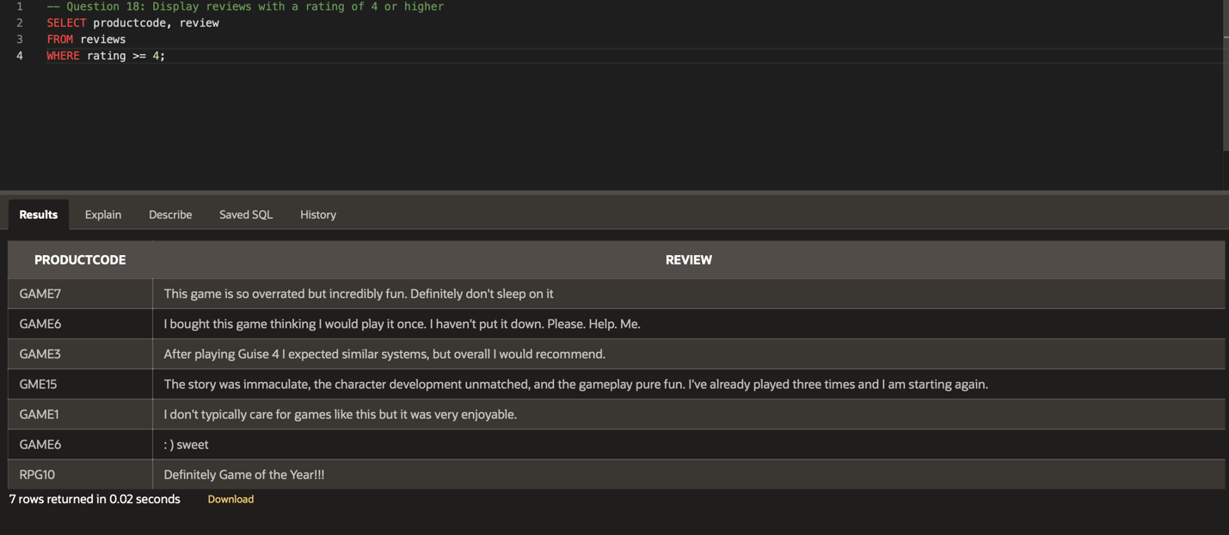
- Display every unique USERID from users who have placed an order.
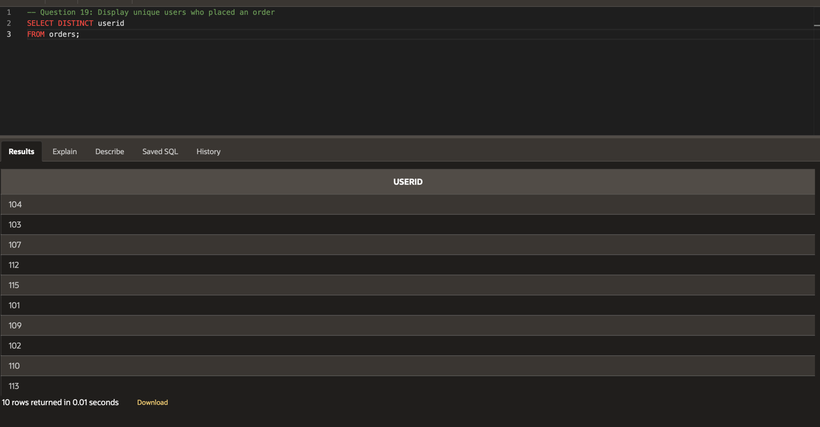
- Display all order data, sorted by the earliest PURCHASEDATE.