Adding Referential Integrity

Now that all of the new features have been implemented, it is time to start connecting the tables through primary-foreign key relationships. Once that is complete, VaporGames is looking for some quick reports on their data.

For this assignment, write queries that will answer the questions below. Save every query to a SQL script named AddReferentialIntegrity. Use -- to write a comment above each query, noting the question it refers to. Additionally, take a screenshot of the query and result set for each question, and insert it below the corresponding question.
NOTE: no data found may be an answer! This means the query ran without error, but there were no records found (no data present in the table matching the selected conditions).

- Enforce referential integrity by adding foreign key constraints to: ORDERS, REVIEWS, and USERLIBRARY.
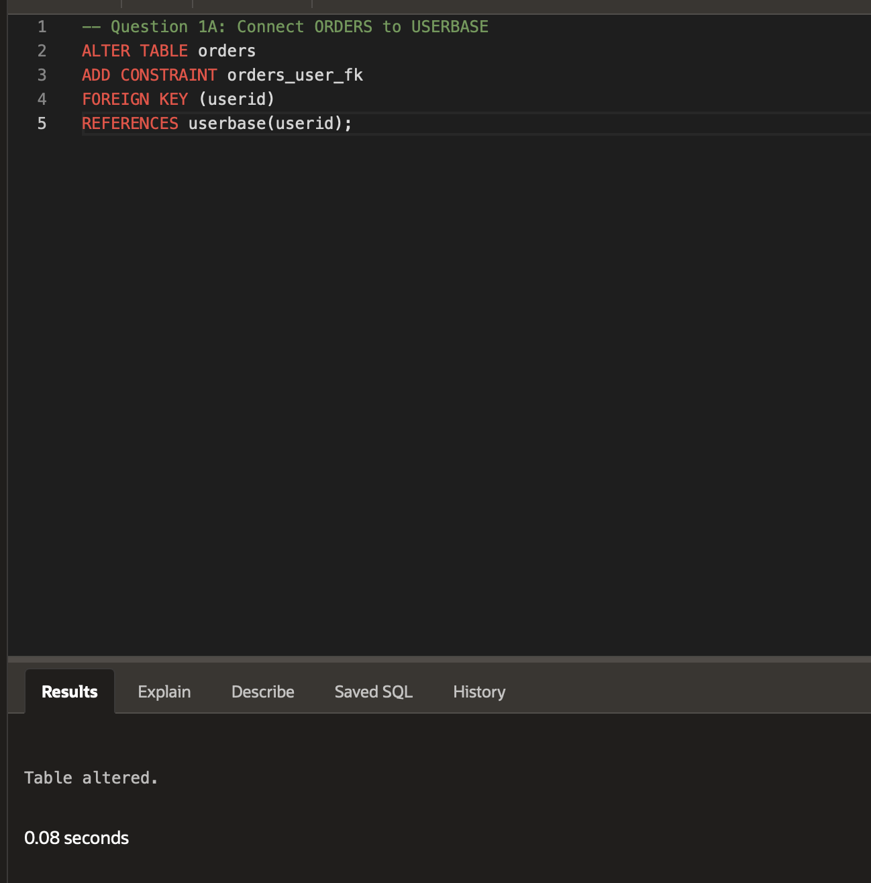
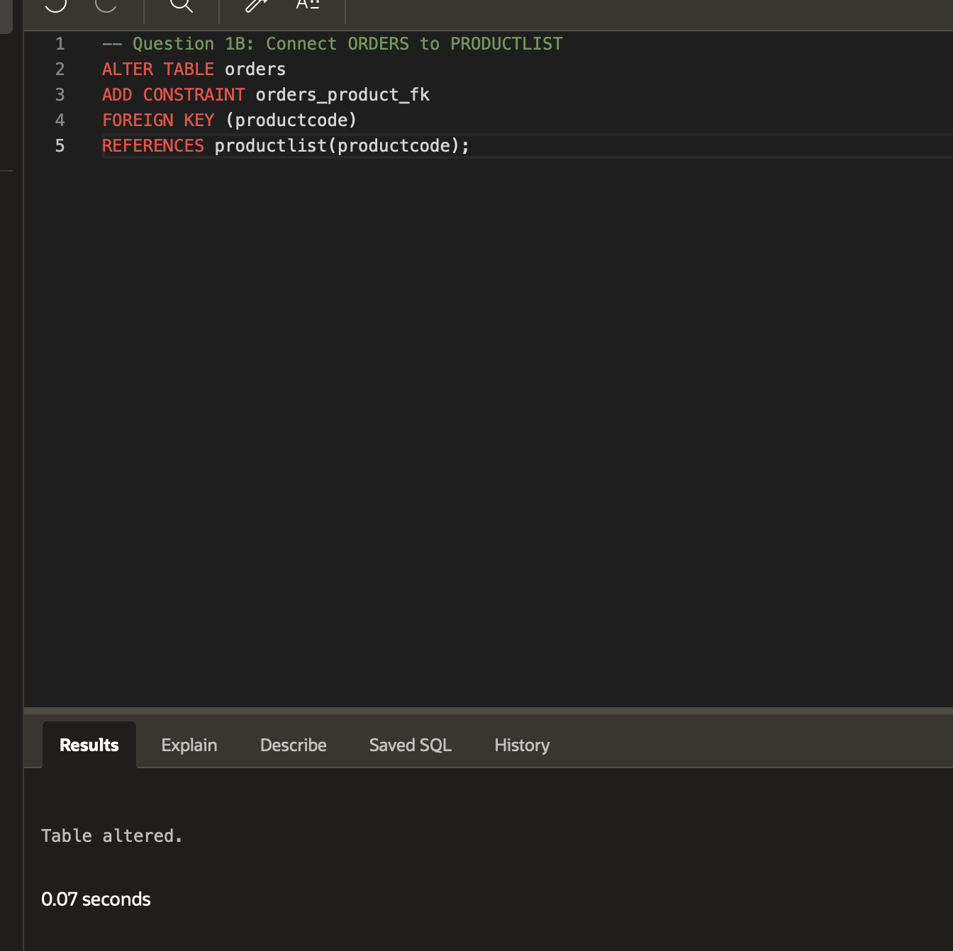
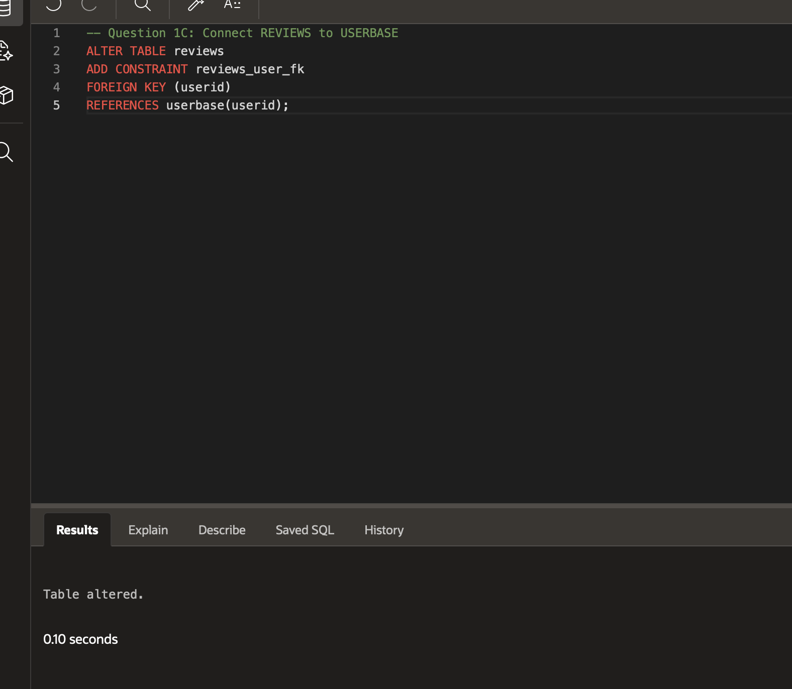
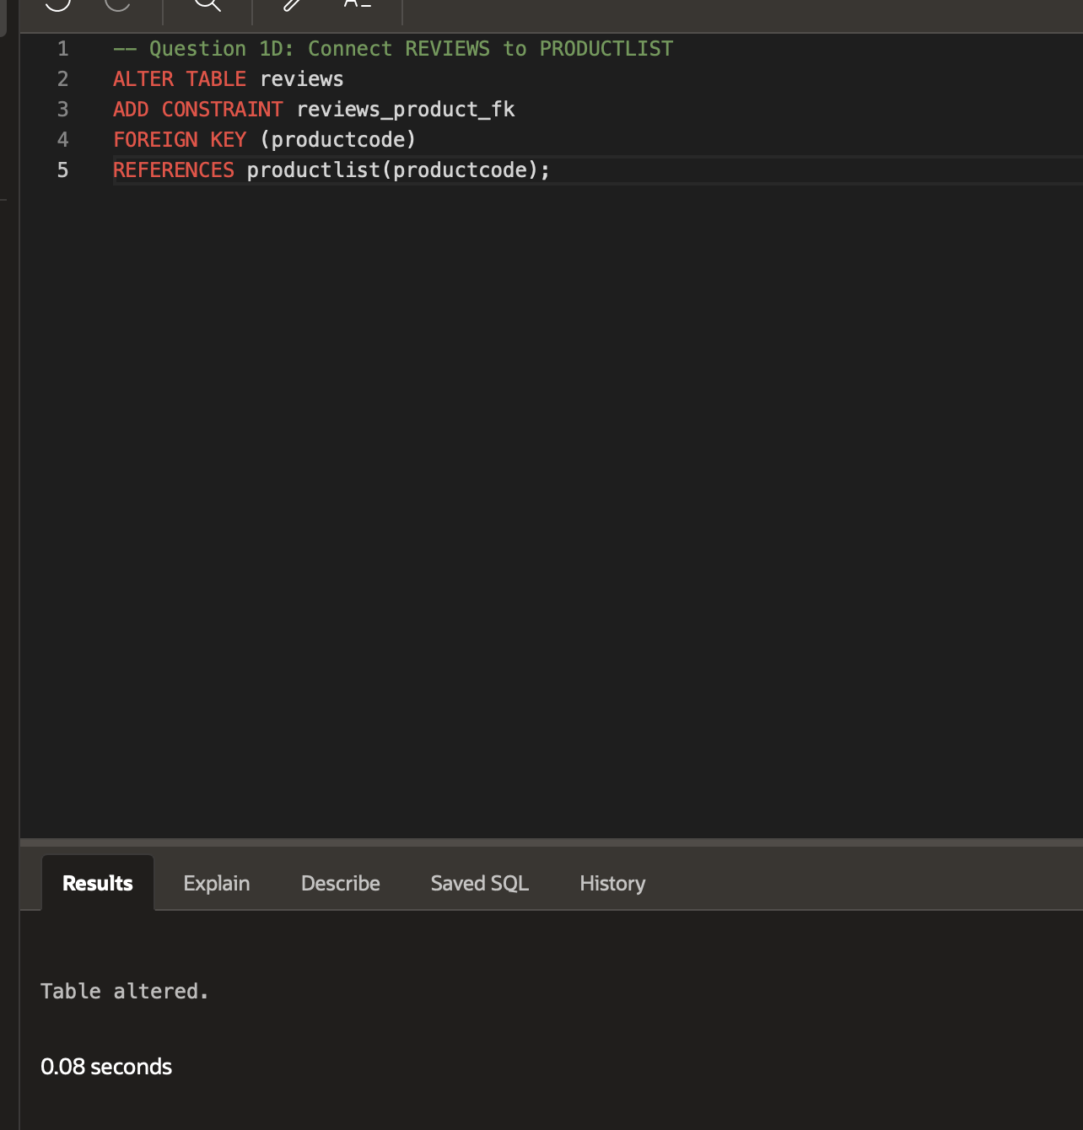
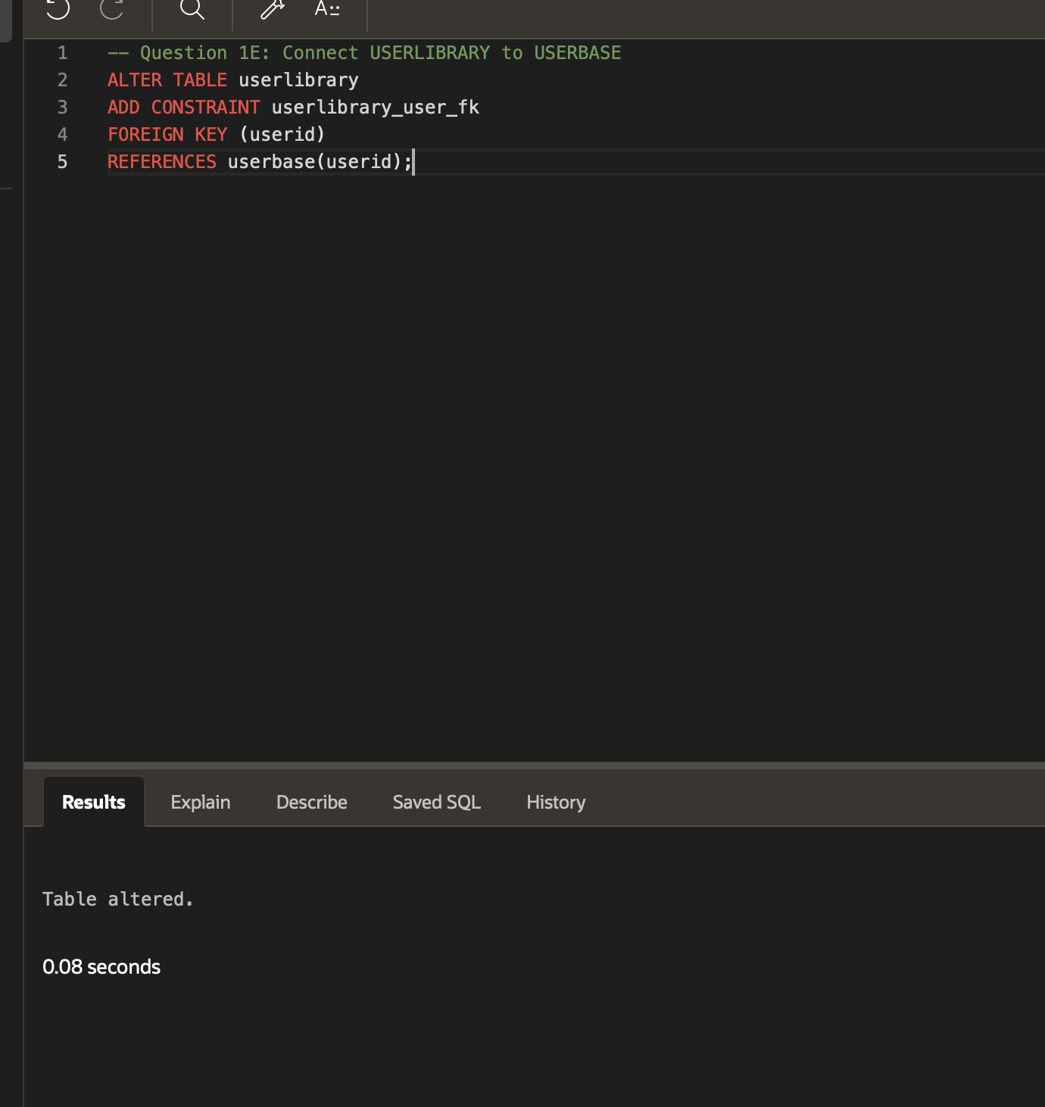
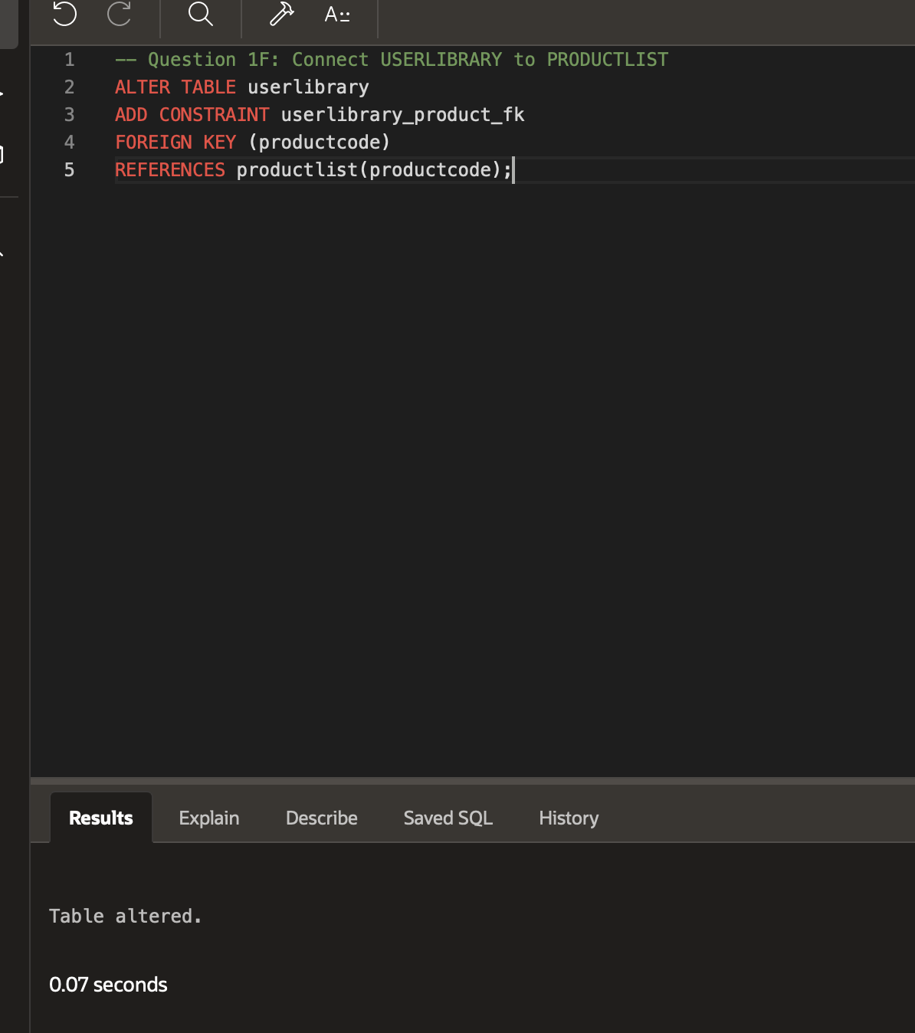
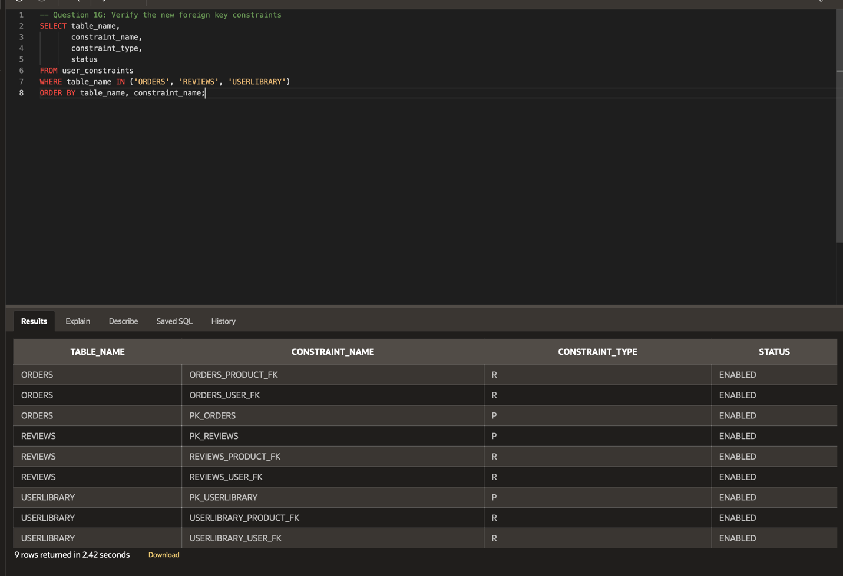
- VaporGames is considering implementing a moderator team from its USERBASE. Your task is to display the full name and USERNAME of every user who is at least 18 years old. A user’s full name should include their FIRSTNAME and LASTNAME separated by a single space (ex: if the FIRSTNAME is ‘John’ and the LASTNAME is ‘Doe’, the user’s full name would be ‘John Doe’).
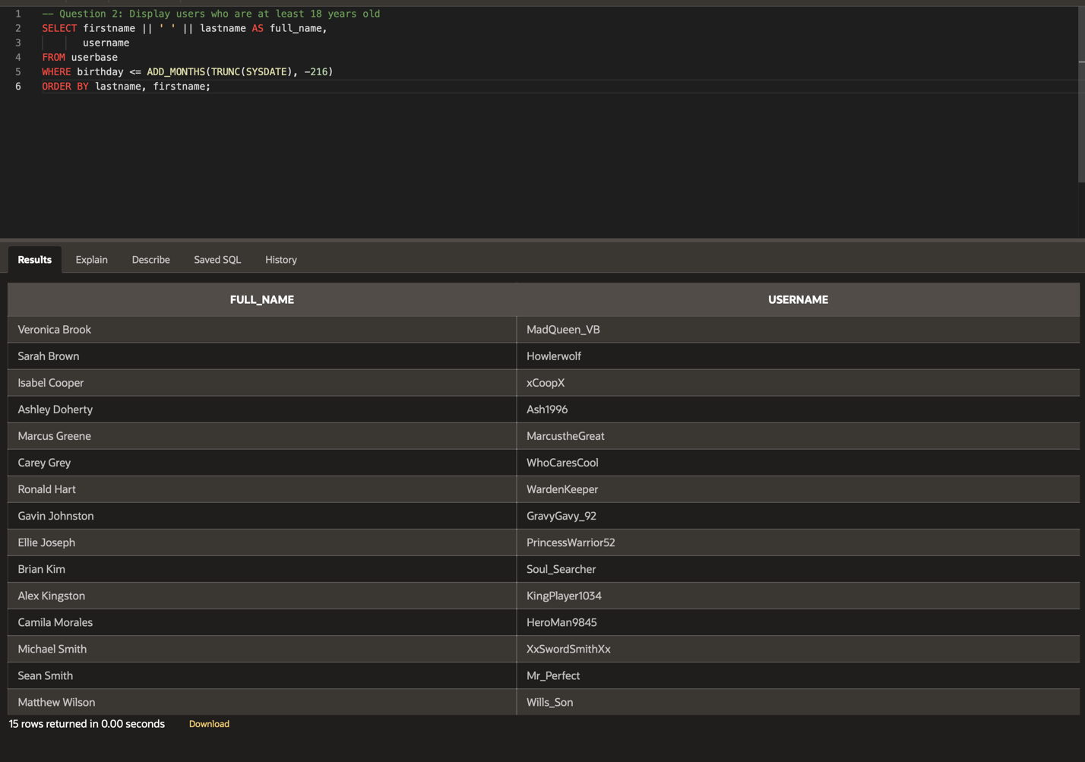
- There are growing complaints from users that the character limit for a username is too small. Your task is to find the maximum length of a USERNAME and the average length of a USERNAME in the USERBASE table.
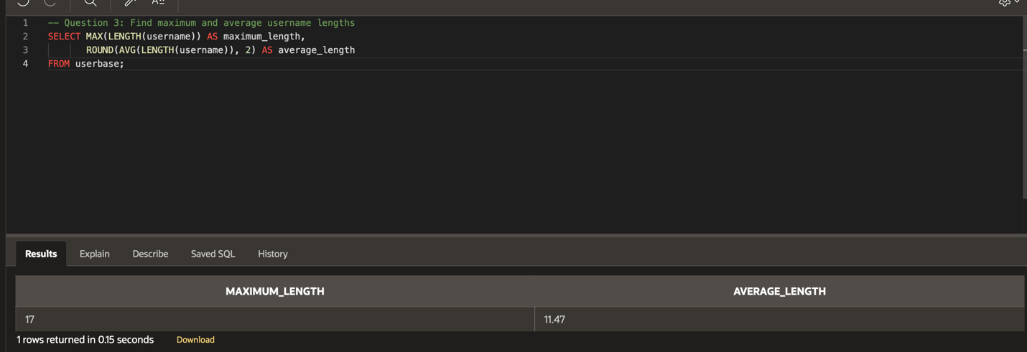
- There are concerns from the Customer Support staff that the account security questions are not creative enough. Your task is to display every QUESTION that starts with ‘What is’ or ‘What was’ in the SECURITYQUESTION table.
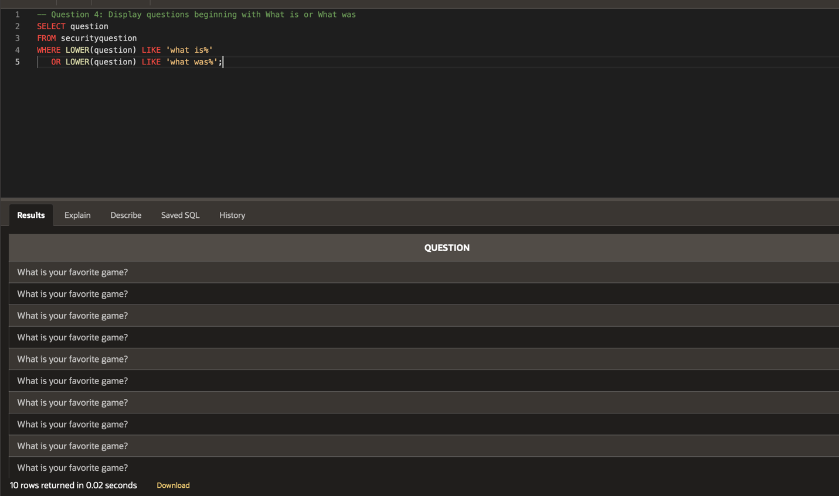

- The Marketing team at VaporGames wants a look at the popularity of each game. Your task is to display the PRODUCTCODE, lowest RATING, and number of reviews for each product in the REVIEWS table. Order the results in descending order of the REVIEW count.
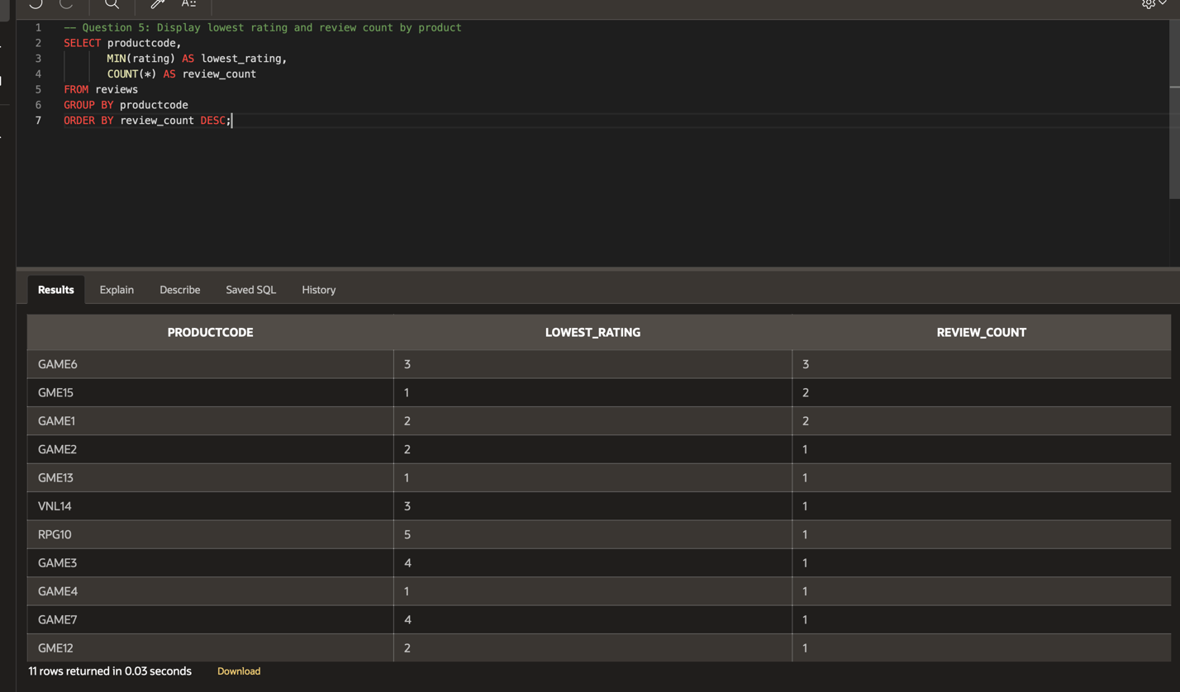
- The Marketing team would also like some data from the WISHLIST table. Your task is to display any PRODUCTCODE that is ranked at POSITION 1, as well as the number of users who have the product ranked at that position.
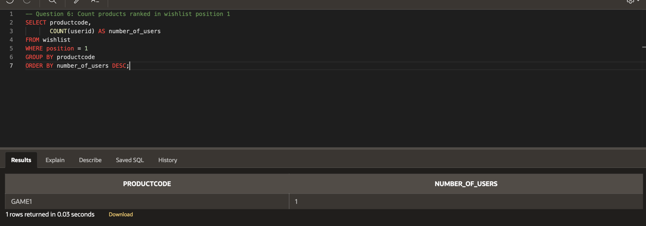
- Next, VaporGames is interested in a quick look at its profits. Your task is to display the USERID and the total amount each user has spent in ORDERS.
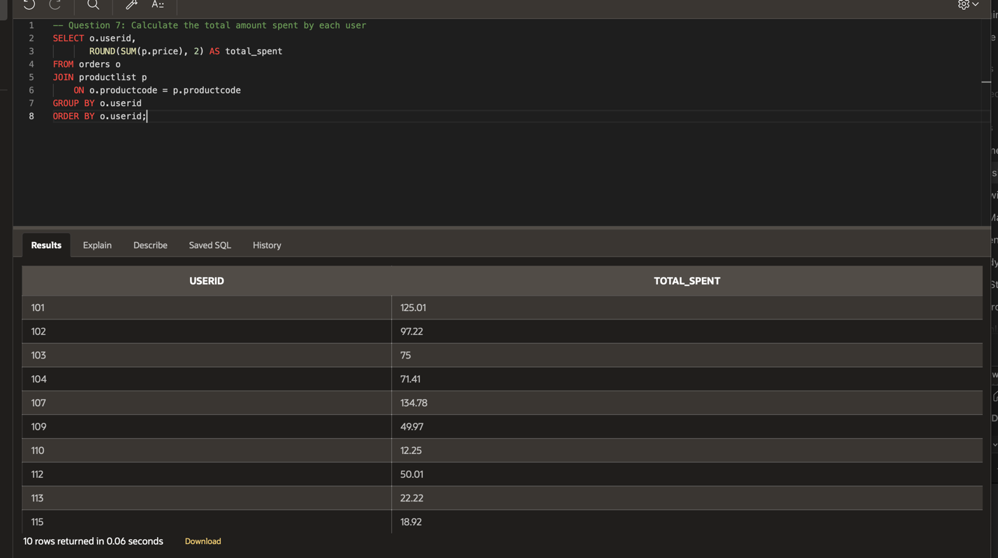
- Determine the most profitable days of the site by showing the gross profits of all orders categorized by their PURCHASEDATE, sorted in descending order of profit.
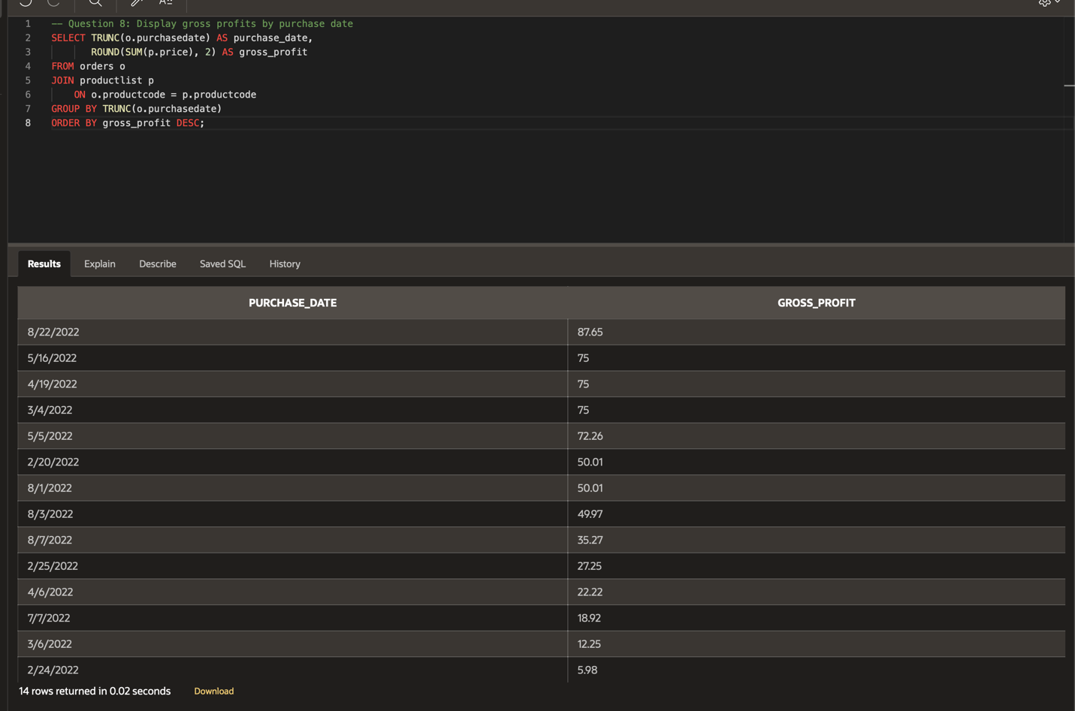
- To help with upcoming sale ideas, you decide to identify games with the most play time amongst the user base. Your task is to display the PRODUCTCODE and sum of HOURSPLAYED from the USERLIBRARY table. Limit the results to the top 5 games with the most play time and order them in descending order by HOURSPLAYED.
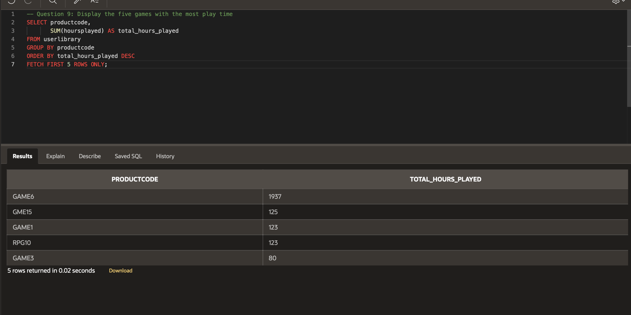
- Users who have incurred too many infractions need to be banned from the site. Create a view showing a list of each USERID and the count of infractions they have received, sorted with the highest infraction count first.
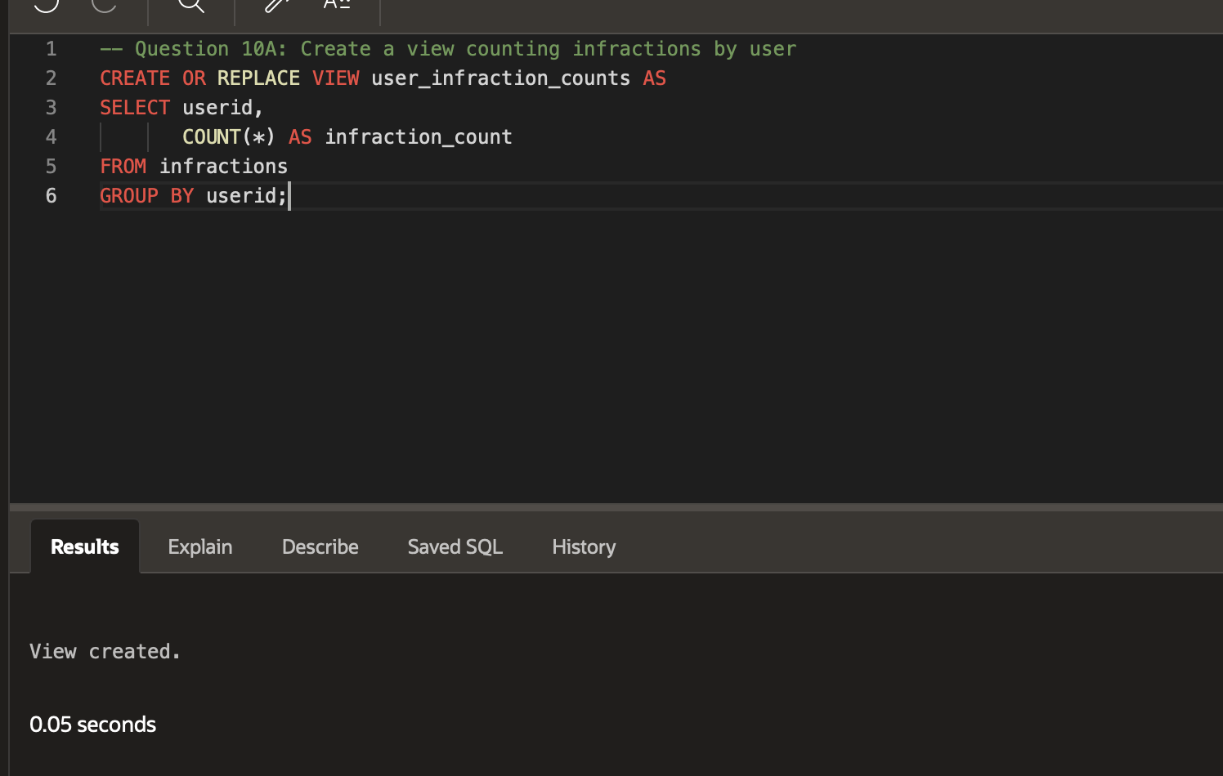
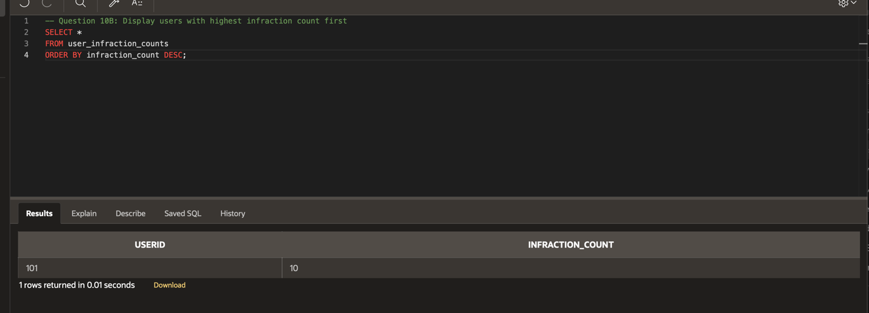
- Similarly, incurring the same infraction too many times is a potentially bannable offense. Create a view showing a list of each USERID, RULENUM, and number of times the user broke that RULENUM, sorted by USERID.
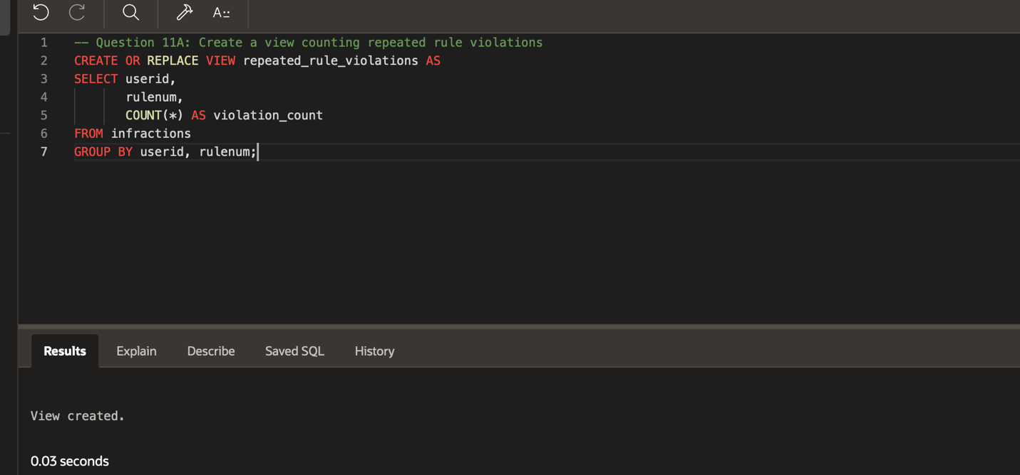
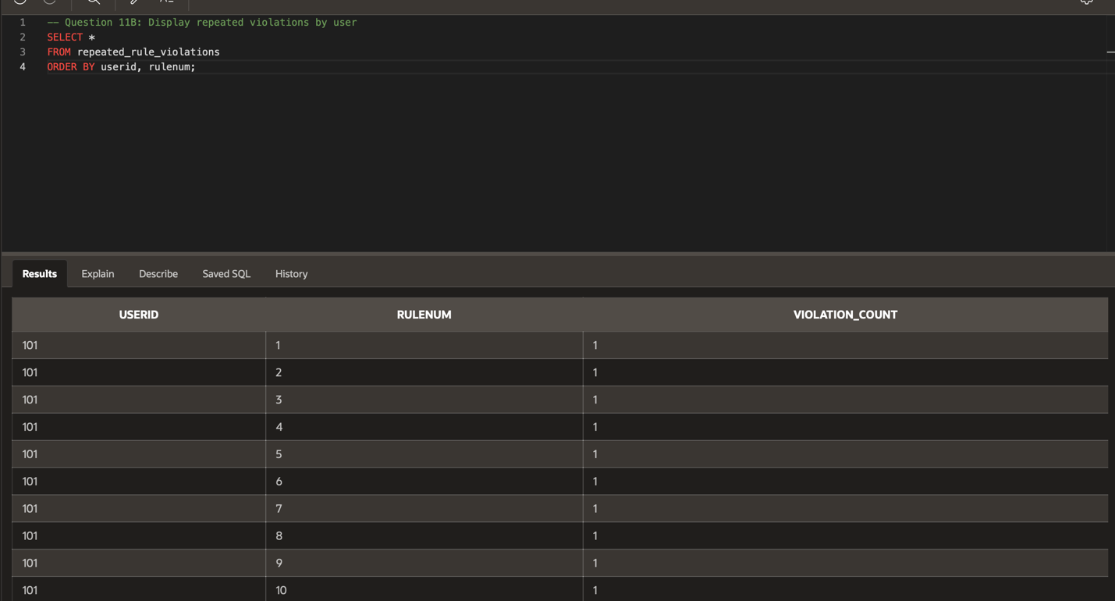
- The Customer Support staff wants to ensure that the penalties being assigned for community guideline violations are reasonable. Help the Customer Support team by displaying every RULENUM, PENALTY that has been assigned for breaking said rule, and the number of times that PENALTY has been assigned to that RULENUM.
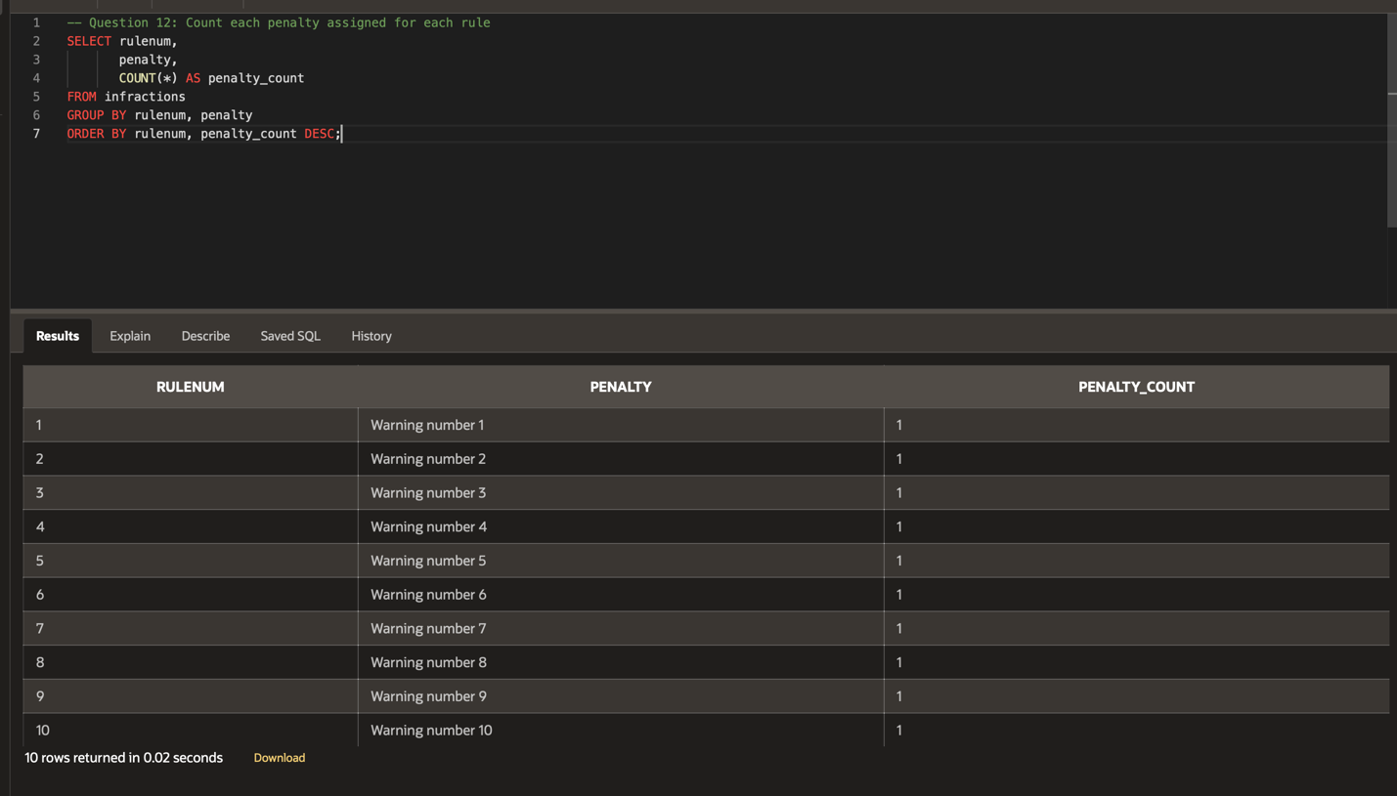
- The ticketing system you implemented last week has been a huge success with the Customer Support staff. The team would like to see some statistics on their turn around time with tickets. Your task is to display the average, maximum, and minimum time between the DATEUPDATED and DATESUBMITTED for all tickets with a STATUS of ‘CLOSED’.
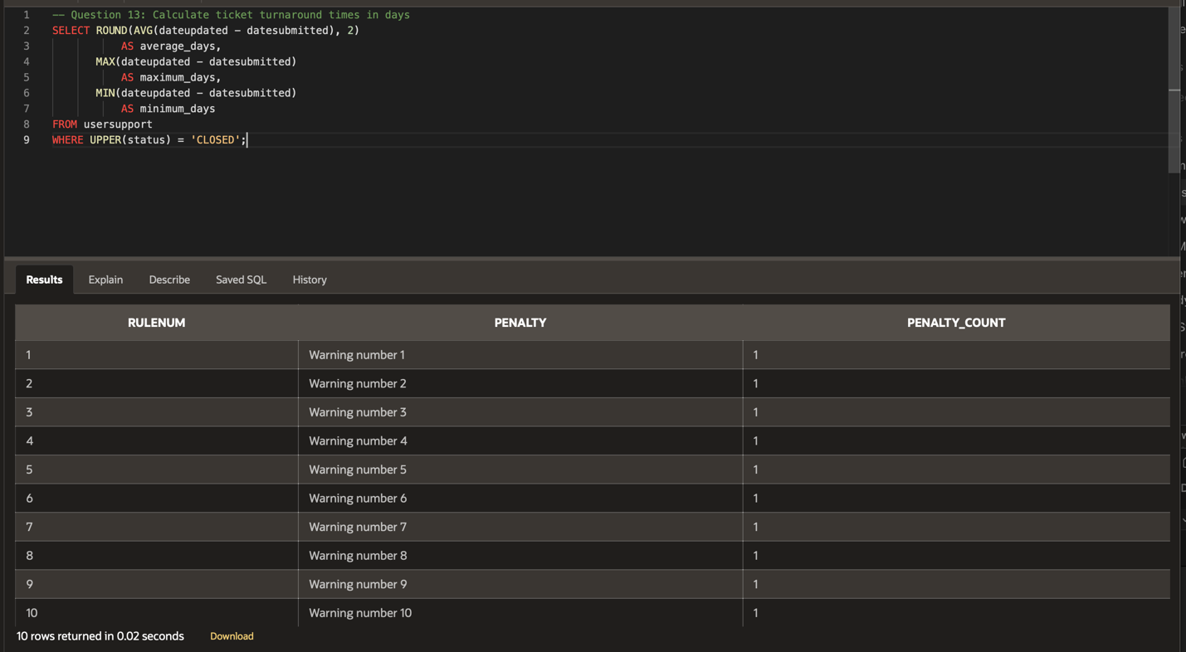
- To check if the ticketing system is being used carelessly, display the EMAIL, ISSUE, and the count of times that ISSUE has been submitted, for all tickets with a STATUS of ‘NEW’, grouped by the DATESUBMITTED and ordered by the count.
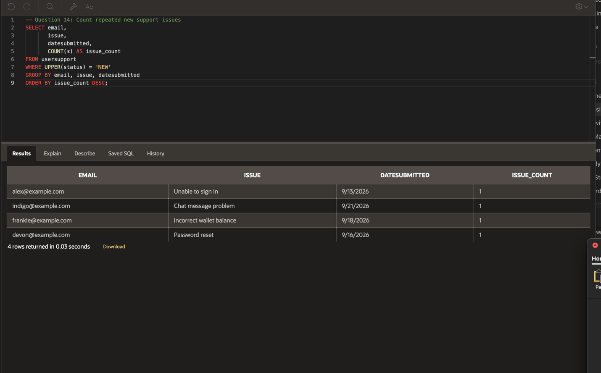
- New account security protocols have been implemented on the VaporGames platform. Verify if any current users do not comply with these protocols by displaying any user who has their FIRSTNAME or LASTNAME in their PASSWORD.
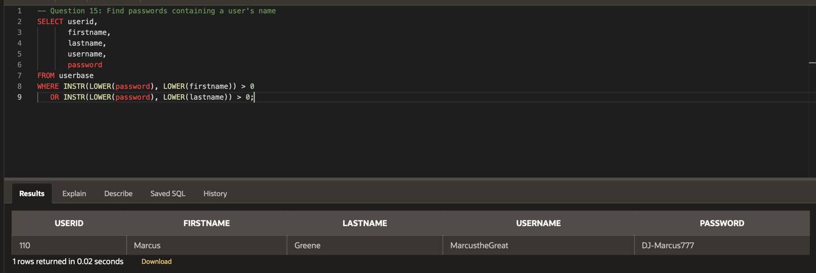
- Assist the Marketing team once again with determining the average cost of a product based on who it is published by. Display every PUBLISHER and average PRICE of their products, sorted in alphabetical order of PUBLISHER.
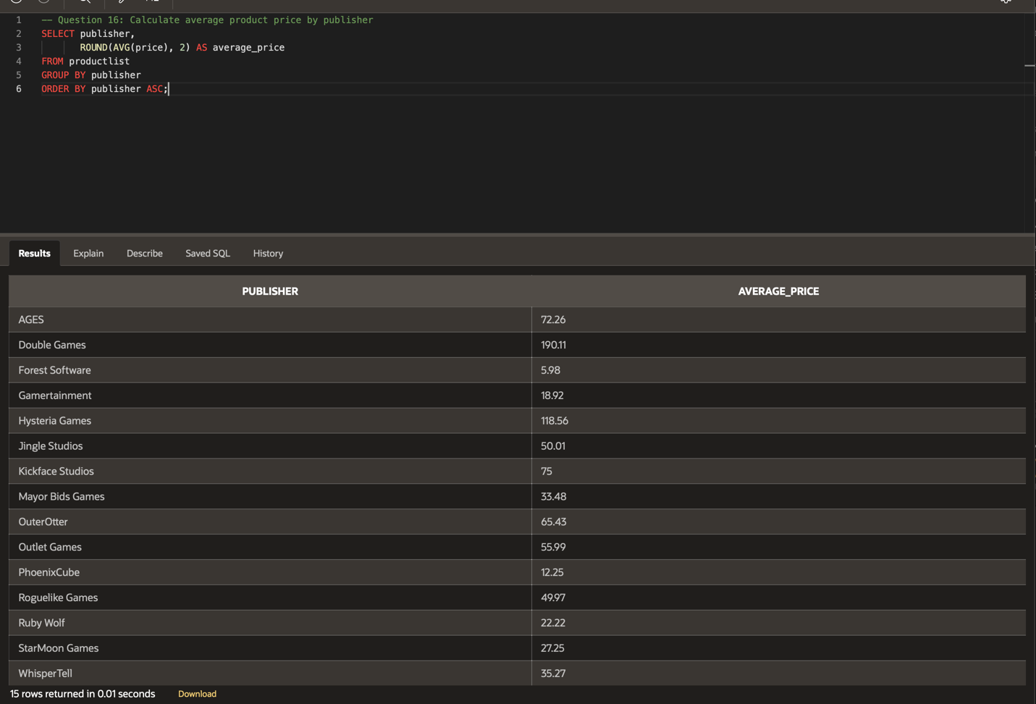
- Create a view that displays the PRODUCTNAME and PRICE for all products with a RELEASEDATE over 5 years ago. Apply a 25% discount to the PRICE.
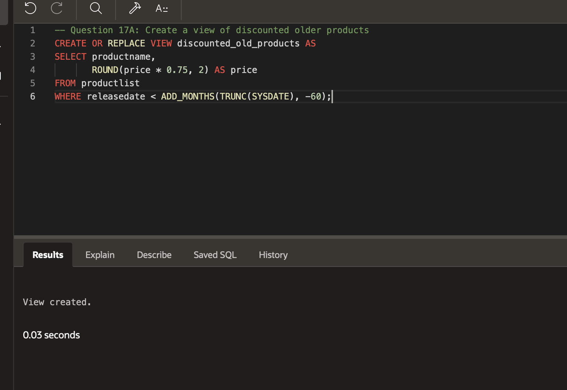
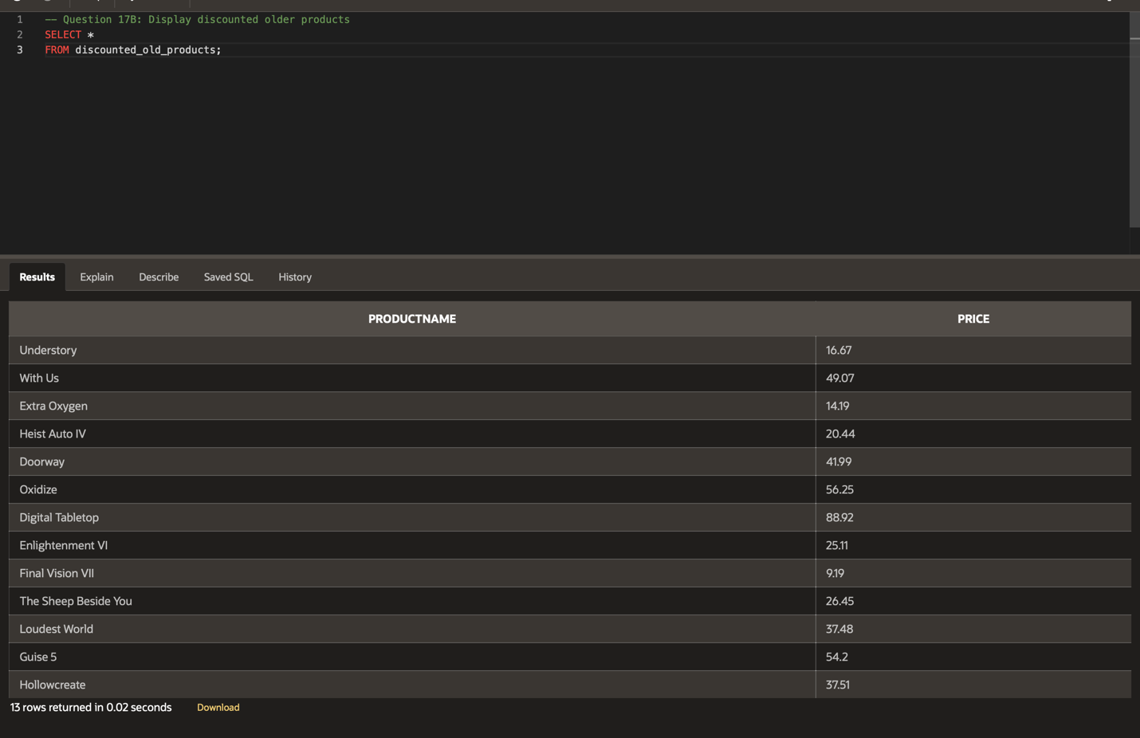
- Calculate the maximum and minimum PRICE of all products based on GENRE.
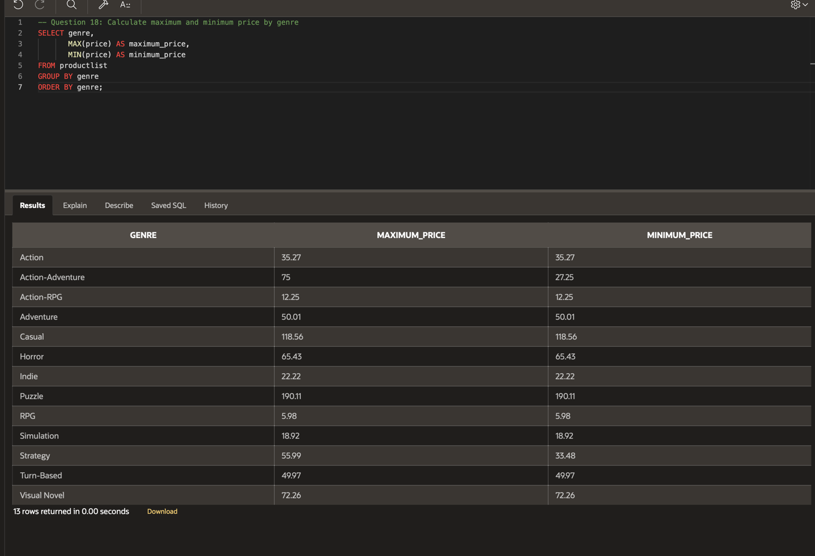
- Next, help out the community admins by creating a view that displays everything in the CHATLOG table from any messages with a DATESENT between now and the previous week.
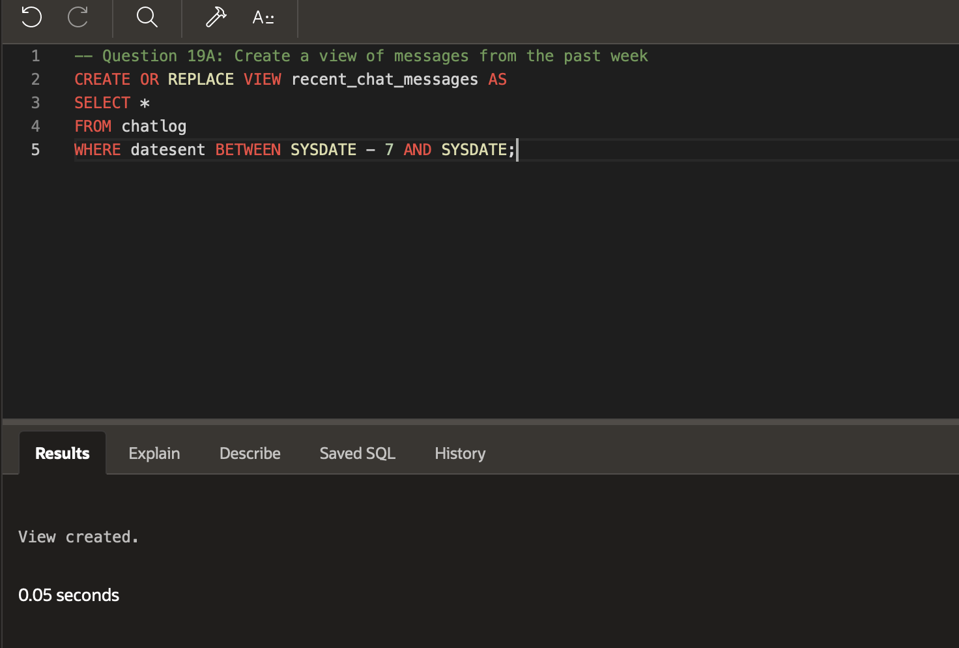
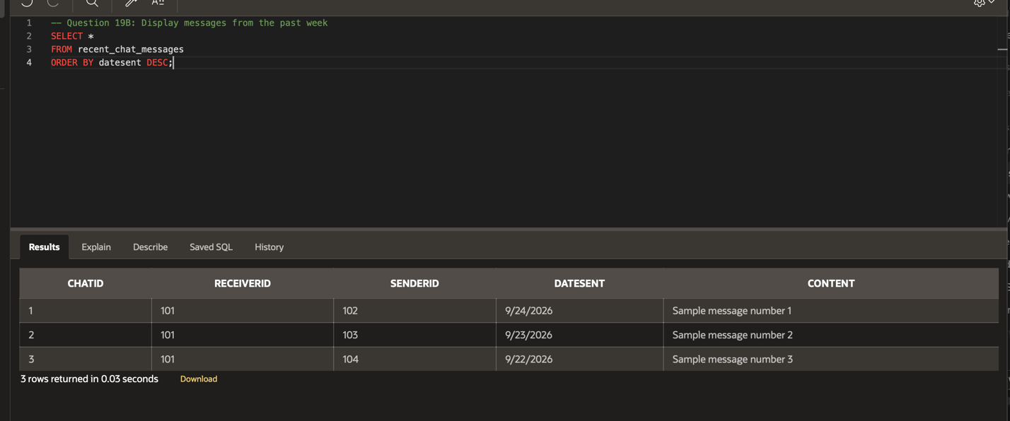
- Finally, create a view that displays the USERID, DATEASSIGNED, and PENALTY for any user whose PENALTY is not null and the infraction was assigned within the last month.
