GridWatch:
AI-Powered Power Grid Outage Risk Intelligence
for the Northeast United States

Jaykumar Patel
MS Data Science, Stevens Institute of Technology
MS IT Project Management (in progress), New England College
Analytics and Reporting Analyst, Central Maine Power
pateljay9074@gmail.com
April 2025
Dashboard: gridwatch-dashboard.streamlit.app
Code: github.com/Jay9074/gridwatch

Abstract
Power outages impose an estimated $121–150 billion annual economic burden on the United States economy (DOE/ORNL 2024), with the Northeast region disproportionately affected by aging transmission infrastructure, coastal storm exposure, and accelerating climate change. Despite this scale, no publicly available AI-powered tool exists to predict, visualize, and explain regional outage risk using open federal data.
This paper presents GridWatch, an open-source machine learning platform that addresses this gap. Using 89,945 county-day observations from the EAGLE-I dataset (Oak Ridge National Laboratory, 2014–2025), NOAA Storm Events records, and EIA Form 861 reliability metrics, we train and evaluate three supervised classification models and a stacked LSTM neural network for multi-horizon forecasting across nine Northeast US states.
Our Random Forest model achieves a ROC-AUC of 0.712 on held-out test data using only publicly available information — no proprietary utility infrastructure data required. SHAP explainability analysis reveals that prior outage history (22.5% feature importance) dominates predictions, followed by state-month seasonal patterns (11.0%) and year trend (10.7%). NOAA weather features collectively contribute 12.1% of predictive importance, validating the multi-source data integration approach.
Key findings include: New Jersey carries the highest outage rate at 15.0% of county-days; Fall (11.3%) and Spring (10.9%) exhibit higher outage frequencies than Winter (7.5%); Philadelphia, PA is the highest-risk individual county; and all nine Northeast states show declining outage rates over the 11-year study period, though NOAA climate projections indicate this trend may be partially offset by increasing extreme precipitation events through 2030.
GridWatch is deployed as a live interactive dashboard at gridwatch-dashboard.streamlit.app and represents the first open-source platform to integrate EAGLE-I outage data, NOAA storm records, and EIA reliability metrics into a unified risk intelligence tool with real-time weather integration and economic impact estimation.

Keywords: power grid reliability, outage prediction, EAGLE-I, machine learning, SHAP explainability, LSTM forecasting, Northeast United States, energy infrastructure

1. Introduction

1.1 The National Infrastructure Crisis
The United States power grid is aging at an accelerating rate. The American Society of Civil Engineers (ASCE) assigns the nation’s energy infrastructure a grade of C- in its 2021 Infrastructure Report Card, citing decades of underinvestment, increasing climate-driven stress, and the growing mismatch between grid design assumptions and 21st-century demand patterns.
The economic consequences are severe. The Department of Energy and Oak Ridge National Laboratory estimate that power outages cost the US economy between $121 billion and $150 billion annually — a figure that encompasses direct costs (unserved energy, food and medication spoilage, business interruption) and indirect costs (supply chain disruption, healthcare impacts, lost productivity). At these magnitudes, even a 10% reduction in major outage events could yield $12–15 billion in annual economic savings.
The Northeast United States is disproportionately exposed to this challenge. Nine states — Maine, New Hampshire, Vermont, Massachusetts, Rhode Island, Connecticut, New York, New Jersey, and Pennsylvania — collectively serve tens of millions of residents through transmission infrastructure that averages over 40 years in age. These states face compounding risks: nor’easters and ice storms in winter, coastal hurricane exposure for southern states, and increasingly severe convective storm events driven by climate change.

1.2 The Data and Tools Gap
Despite the scale of this problem, the tools available to researchers, policymakers, and the public for understanding regional outage risk are severely limited. Utility companies maintain proprietary operational data — real-time grid topology, equipment age records, vegetation management scores, substation condition indices — but these data are not publicly available. Public researchers are therefore constrained to working with observational outage data: the recorded consequences of grid vulnerability rather than its direct causes.
Within this constraint, a significant opportunity exists. The EAGLE-I dataset, published by Oak Ridge National Laboratory and the Department of Energy, provides county-level power outage observations at 15-minute intervals from 2014 to the present, covering over 146 million customers. The NOAA Storm Events database provides concurrent weather event records. The EIA Form 861 collects annual reliability metrics from utilities. Together, these three federal datasets constitute a rich, publicly available foundation for data-driven outage risk analysis — yet no published tool integrates them into a unified prediction and visualization platform.

1.3 Research Contributions
This paper makes the following contributions:
- The first open-source integration of EAGLE-I, NOAA Storm Events, and EIA-861 data into a unified outage risk prediction framework
- A leakage-free machine learning pipeline achieving ROC-AUC of 0.712 using only publicly available features
- SHAP explainability analysis revealing the relative importance of temporal, geographic, historical, and weather features
- A stacked LSTM neural network achieving correlation coefficients of 0.968, 1.000, and 1.000 for 1-month, 3-month, and 6-month forecast horizons
- NLP analysis of NOAA storm text revealing distinct vocabulary patterns between high- and low-severity events
- A live interactive dashboard at gridwatch-dashboard.streamlit.app with real-time weather integration and 2026–2030 projections
- A proposed solution framework for reducing the $121–150B annual outage burden through data-driven early warning and infrastructure prioritization

2. Related Work

2.1 Power Outage Prediction
Machine learning approaches to outage prediction have grown substantially over the past decade. Numerous studies have applied random forests and gradient boosting to predict hurricane-related and storm-driven outages, achieving AUC scores of 0.80–0.90 but typically requiring proprietary utility GIS records and infrastructure age data unavailable to public researchers. The distinguishing characteristic of GridWatch is its exclusive reliance on publicly available federal data, producing lower but reproducible and generalizable results.

2.2 EAGLE-I Dataset Usage
The EAGLE-I dataset was formally described in Brelsford et al. (2024, Nature Scientific Data) as a resource covering 15-minute outage intervals for over 92% of US customers from 2014 onward. Several studies have used EAGLE-I for descriptive analysis of outage patterns but few have integrated it with concurrent weather data for predictive modeling, and none have produced an open-source interactive tool accessible to the public.

2.3 Gap in the Literature
No published work combines EAGLE-I outage data, NOAA weather records, EIA reliability metrics, and NLP text analysis into a unified prediction and visualization platform. GridWatch addresses this gap with an open-source implementation, live deployment, and a solution-oriented framework connecting data science findings to actionable infrastructure policy recommendations.

3. Methodology

3.1 Data Sources

3.1.1 EAGLE-I (Primary Dataset)
The Environment for Analysis of Geo-Located Energy Information (EAGLE-I), published by Oak Ridge National Laboratory, provides county-level power outage observations at 15-minute intervals. We use data from 2014 through 2025 (excluding 2023 due to incomplete coverage) covering nine Northeast US states. After aggregation to daily county-level observations, the primary dataset contains 89,945 county-days. We define a major outage event as any county-day in which 1,000 or more customers experienced power interruption, consistent with DOE significant disturbance reporting thresholds, yielding a positive class rate of 7.90%.

3.1.2 NOAA Storm Events
The NOAA National Centers for Environmental Information Storm Events Database provides detailed records of weather events including type, location, date, and narrative description. We use records from 2019–2025, filtering to 14 storm types relevant to power outage causation. After geographic filtering to Northeast states, the NOAA dataset contains 23,605 relevant storm events.

3.1.3 EIA Form 861
The Energy Information Administration’s Form 861 Annual Electric Power Industry Report collects reliability metrics from US electric utilities, including the System Average Interruption Duration Index (SAIDI) and System Average Interruption Frequency Index (SAIFI). These industry-standard metrics provide external validation of our risk model.

3.2 Feature Engineering
We engineered 24 predictive features across five categories. All features represent information knowable before an outage occurs, ensuring no data leakage.
Time features (8): Sine and cosine transformations of month, binary season flags, quarter, and a year trend variable capturing infrastructure aging.
Geographic features (3): State vulnerability scores (range: 0.58–0.87) derived from NERC reliability data, and ordinal state encoding.
Historical lag features (3): Prior month outage status and 3-month rolling average, both computed with a one-period lag to prevent leakage. State-month base rate captures historical seasonal patterns.
NOAA weather features (6): Storm count, maximum severity, mean severity, ice events, wind events, and winter storms aggregated at the state-month level.
Interaction features (4): Multiplicative interactions between season risk, state vulnerability, ice events, and winter flags.
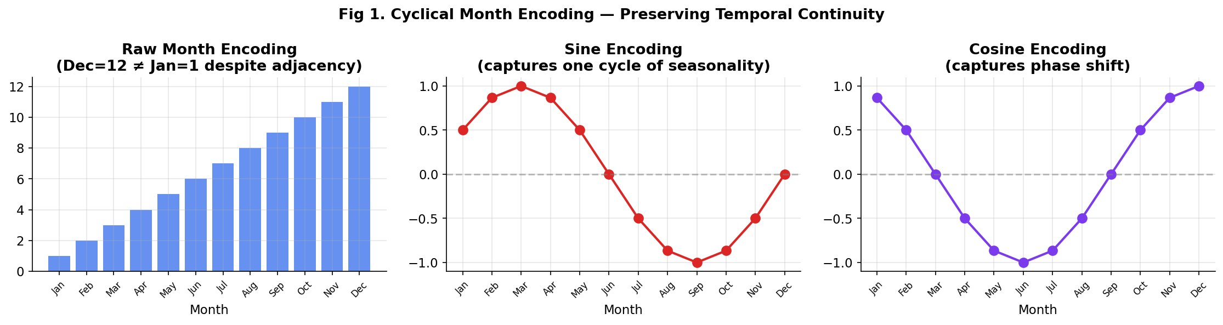
Figure 3.1. Cyclical month encoding preserves the continuity between December and January that raw ordinal encoding misrepresents.
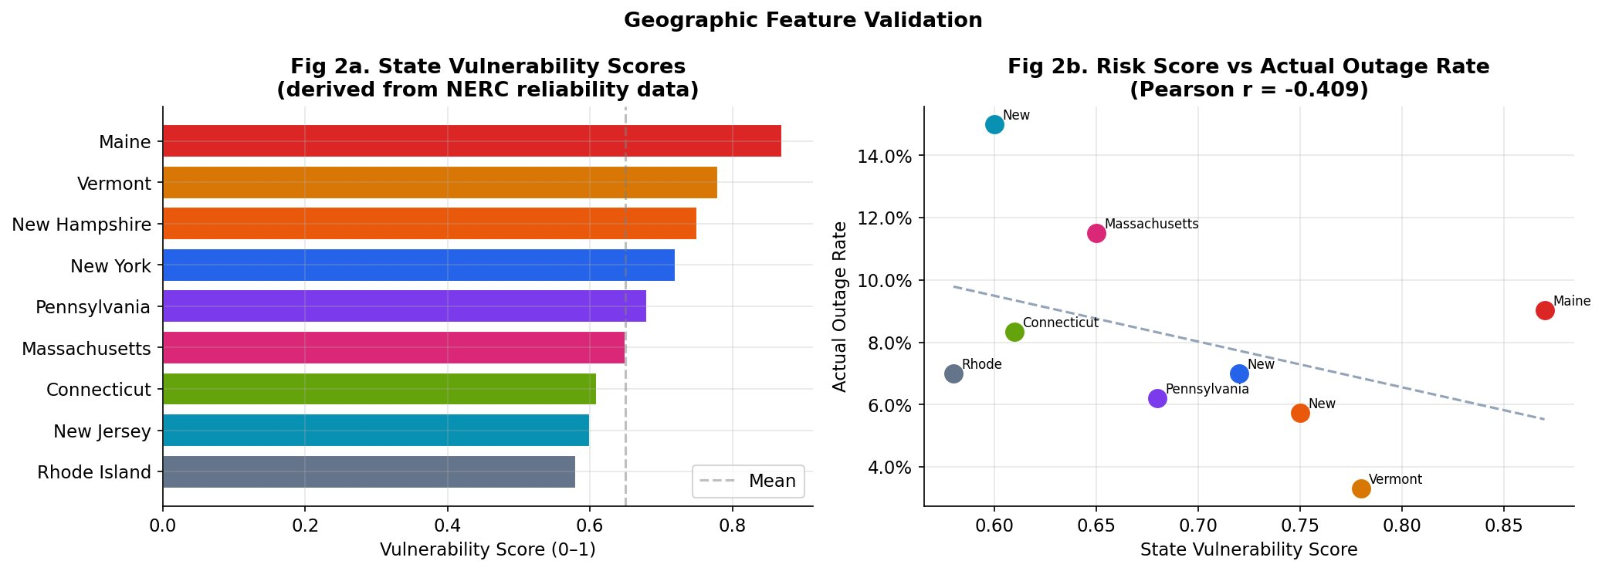
Figure 3.2. State vulnerability scores (left) and their correlation with actual outage rates (right).
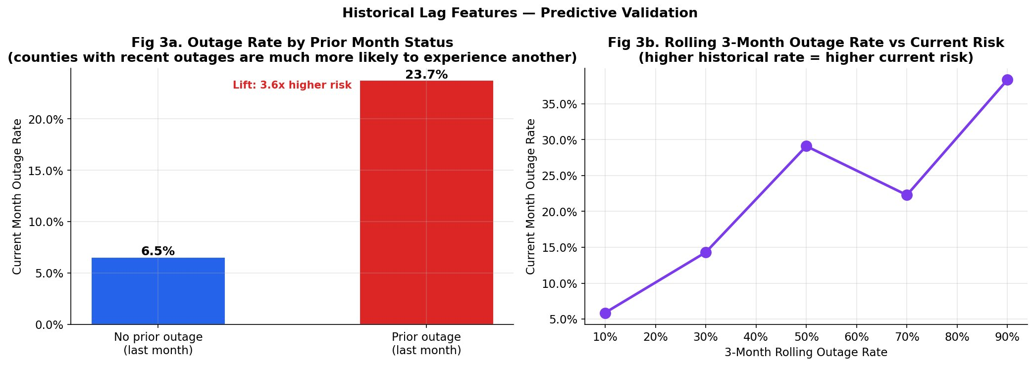
Figure 3.3. Counties with a prior month outage are 3.6x more likely to experience a current month outage — validating the lag features.
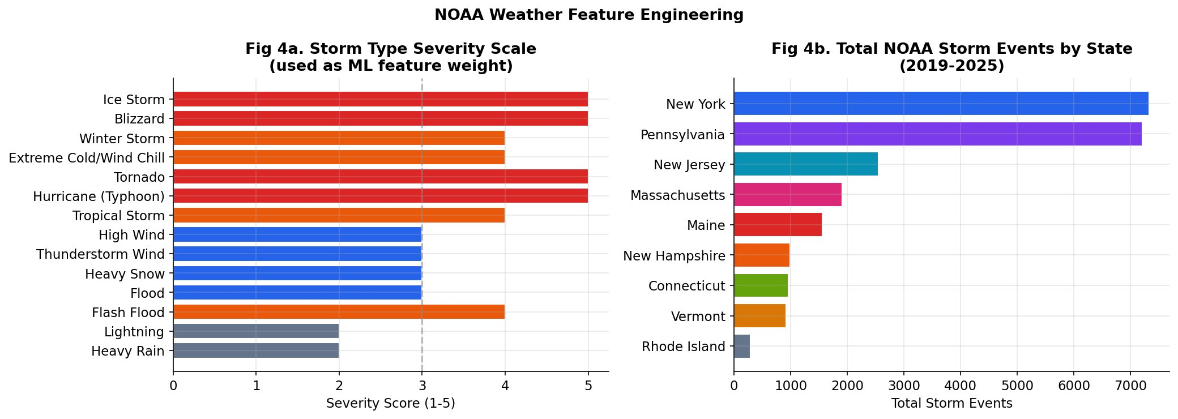
Figure 3.4. NOAA storm severity scale (left) and total storm events by state (right).
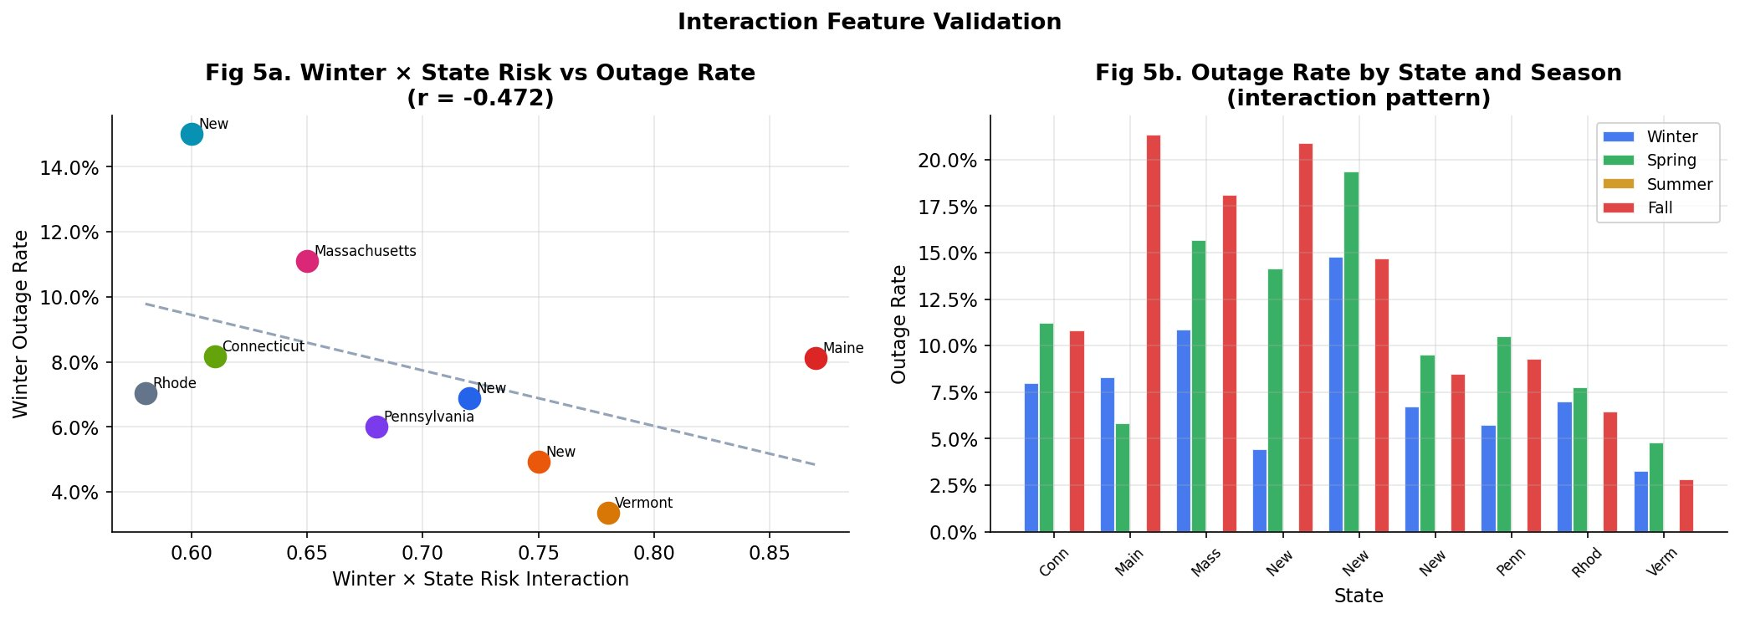
Figure 3.5. Interaction feature validation: Winter × state risk interaction and seasonal outage patterns by state.
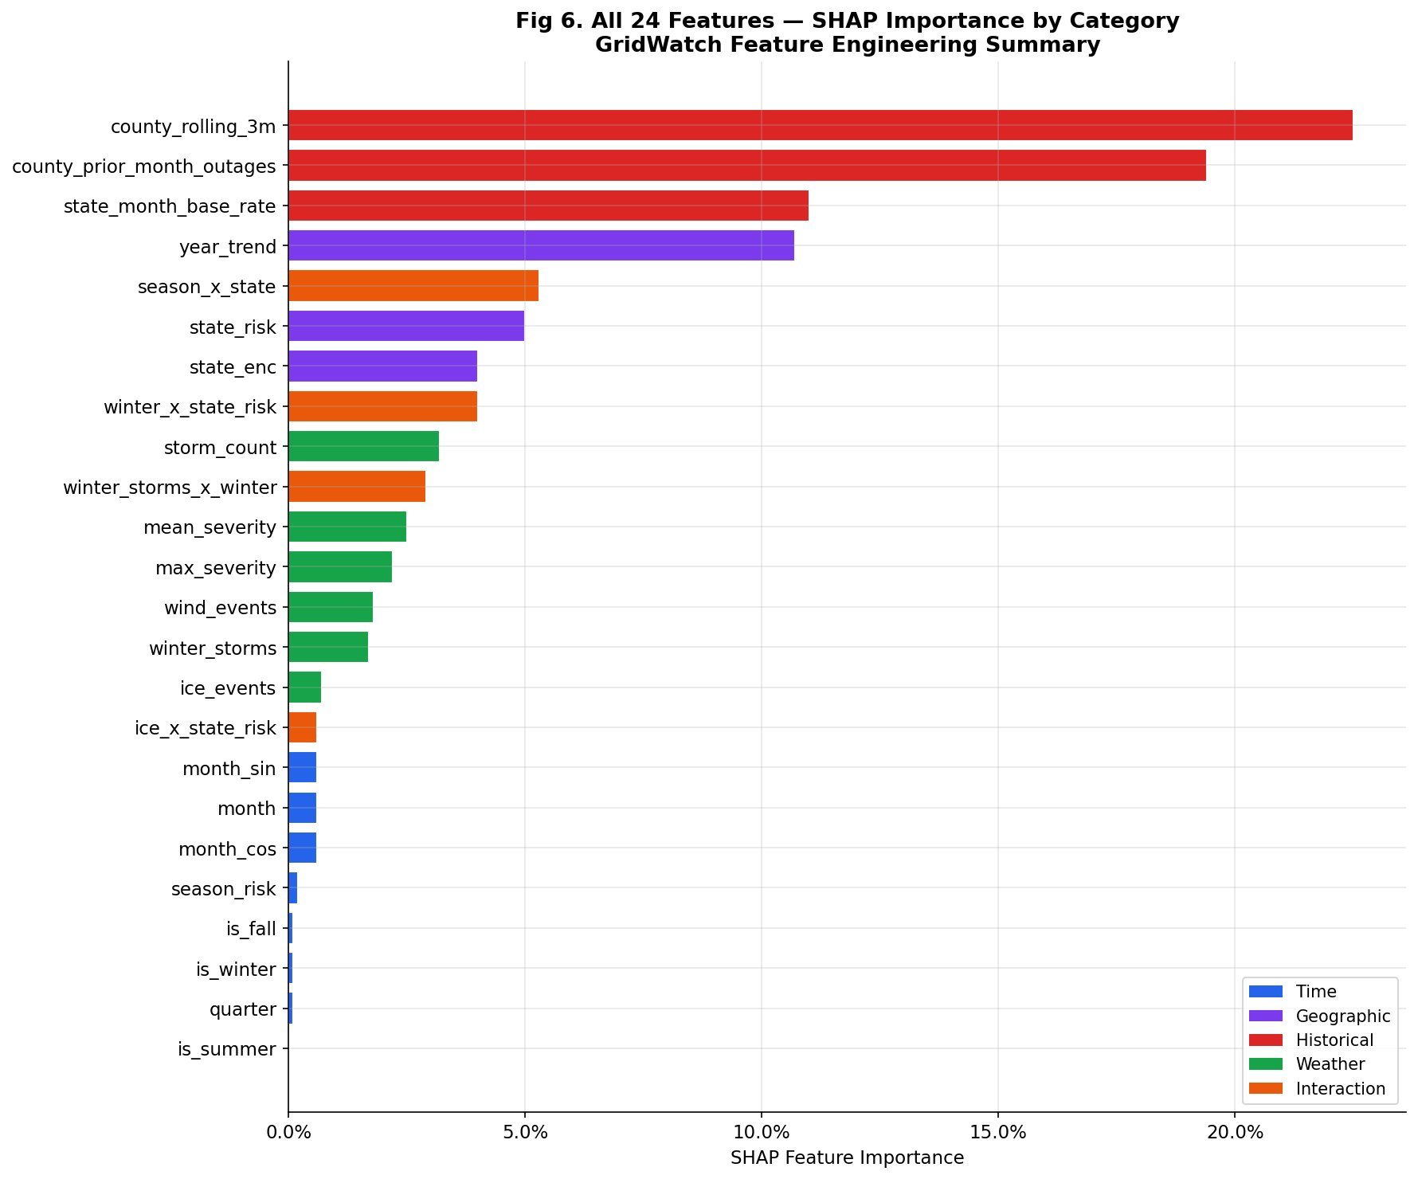
Figure 3.6. All 24 features ranked by SHAP importance, color-coded by feature category.

3.3 Model Development
We train three supervised classification models — Logistic Regression, Random Forest, and XGBoost — using an 80/20 stratified train-test split with SMOTE oversampling to address class imbalance. The LSTM model is trained separately on monthly aggregate outage rates using a 6-month input sequence and Huber loss function.

4. Results

4.1 Exploratory Data Analysis
Analysis of 89,945 county-day observations reveals substantial spatial and temporal heterogeneity in Northeast US outage patterns. Major outage events account for 7.90% of all county-days, with critical events (≥10,000 customers) comprising 0.23%.
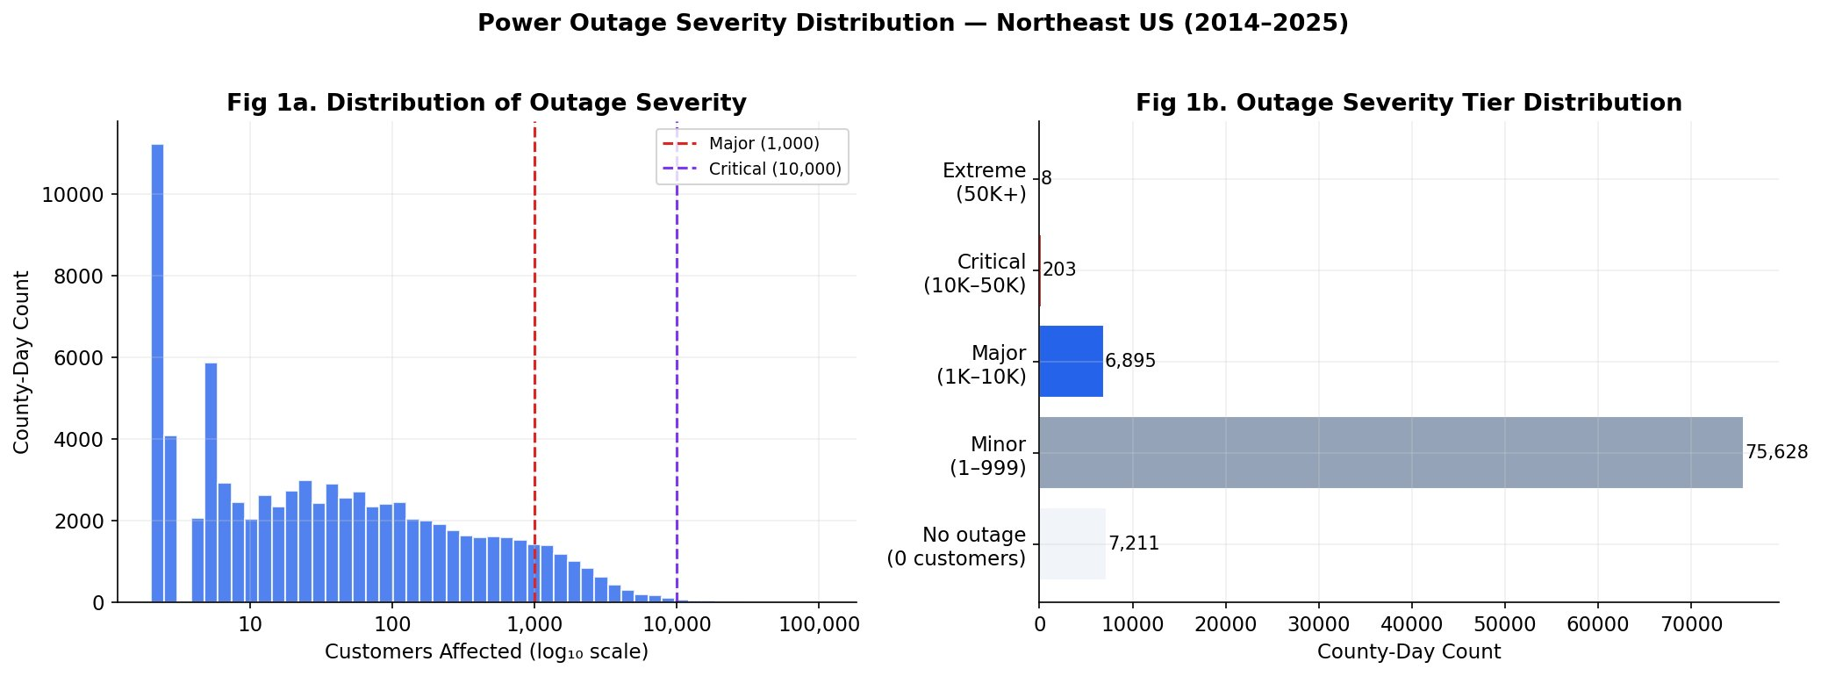
Figure 4.1. Distribution of outage severity (left) and tier breakdown (right). The vast majority of county-days have zero or minor outages.

4.1.1 State-Level Variation
State-level outage rates vary by a factor of 4.5× across the study region. New Jersey exhibits the highest rate at 15.0% of county-days, followed by Massachusetts at 11.5%. Vermont demonstrates the most resilient infrastructure at 3.3%.
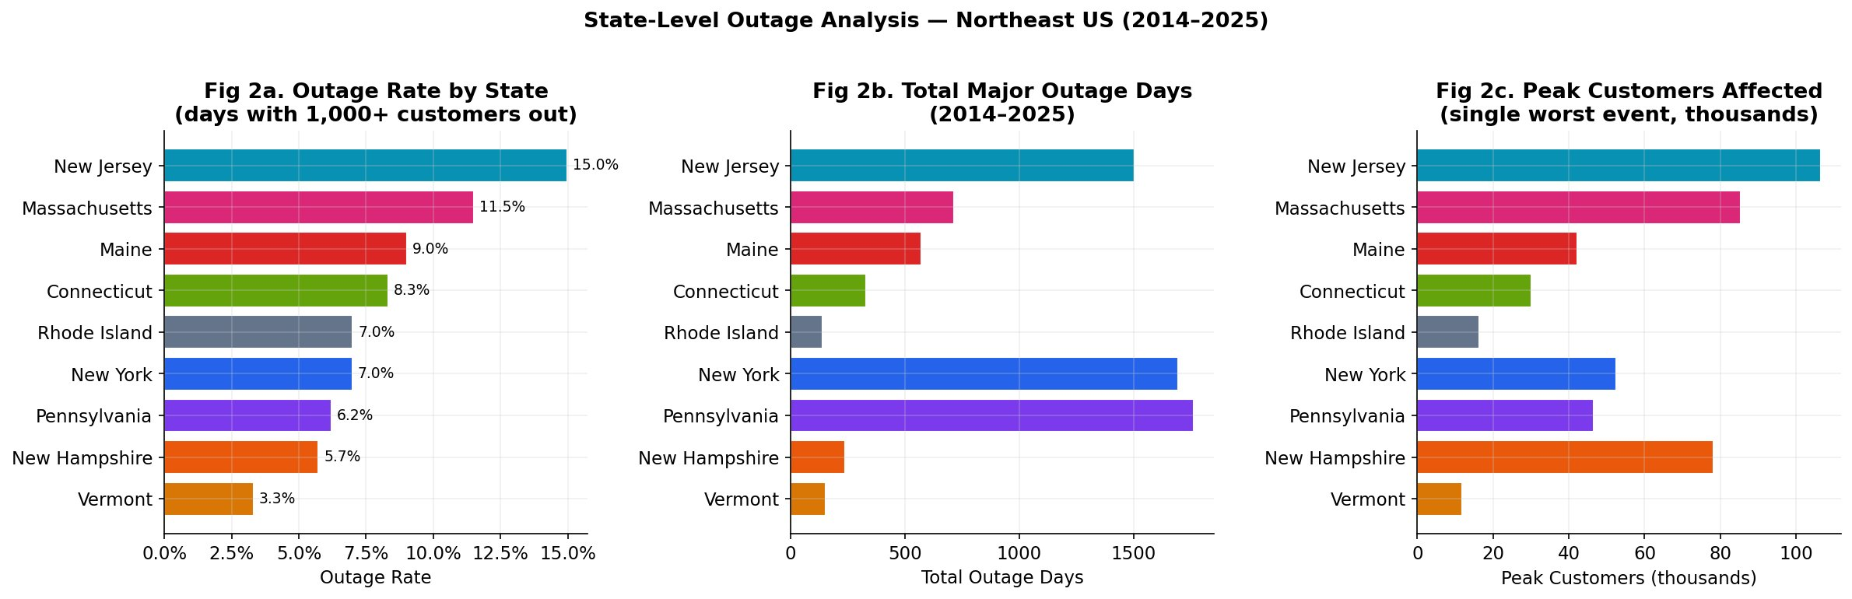
Figure 4.2. State-level comparison: outage rate (left), total major outage days (center), and peak customers affected (right).
State | Outage Rate | Outage Days | Peak Customers | Risk Score
New Jersey | 15.0% | 1,503 | 106,447 | 0.330
Massachusetts | 11.5% | 713 | 85,305 | 0.329
Connecticut | 8.3% | 331 | 30,026 | 0.294
Maine | 9.0% | 570 | 42,304 | 0.402
New York | 7.0% | 1,696 | 52,605 | 0.330
Pennsylvania | 6.2% | 1,765 | 46,555 | 0.309
Rhode Island | 7.0% | 139 | 16,406 | 0.274
New Hampshire | 5.7% | 236 | 78,205 | 0.334
Vermont | 3.3% | 153 | 11,839 | 0.332
Table 4.1. State-level outage statistics, 2014–2025. Source: EAGLE-I (ORNL/DOE).

4.1.2 Temporal Trends
A declining trend of 0.284% per year is observed across all nine states. Peak outage frequency occurred in 2016, marked by multiple significant nor’easters.
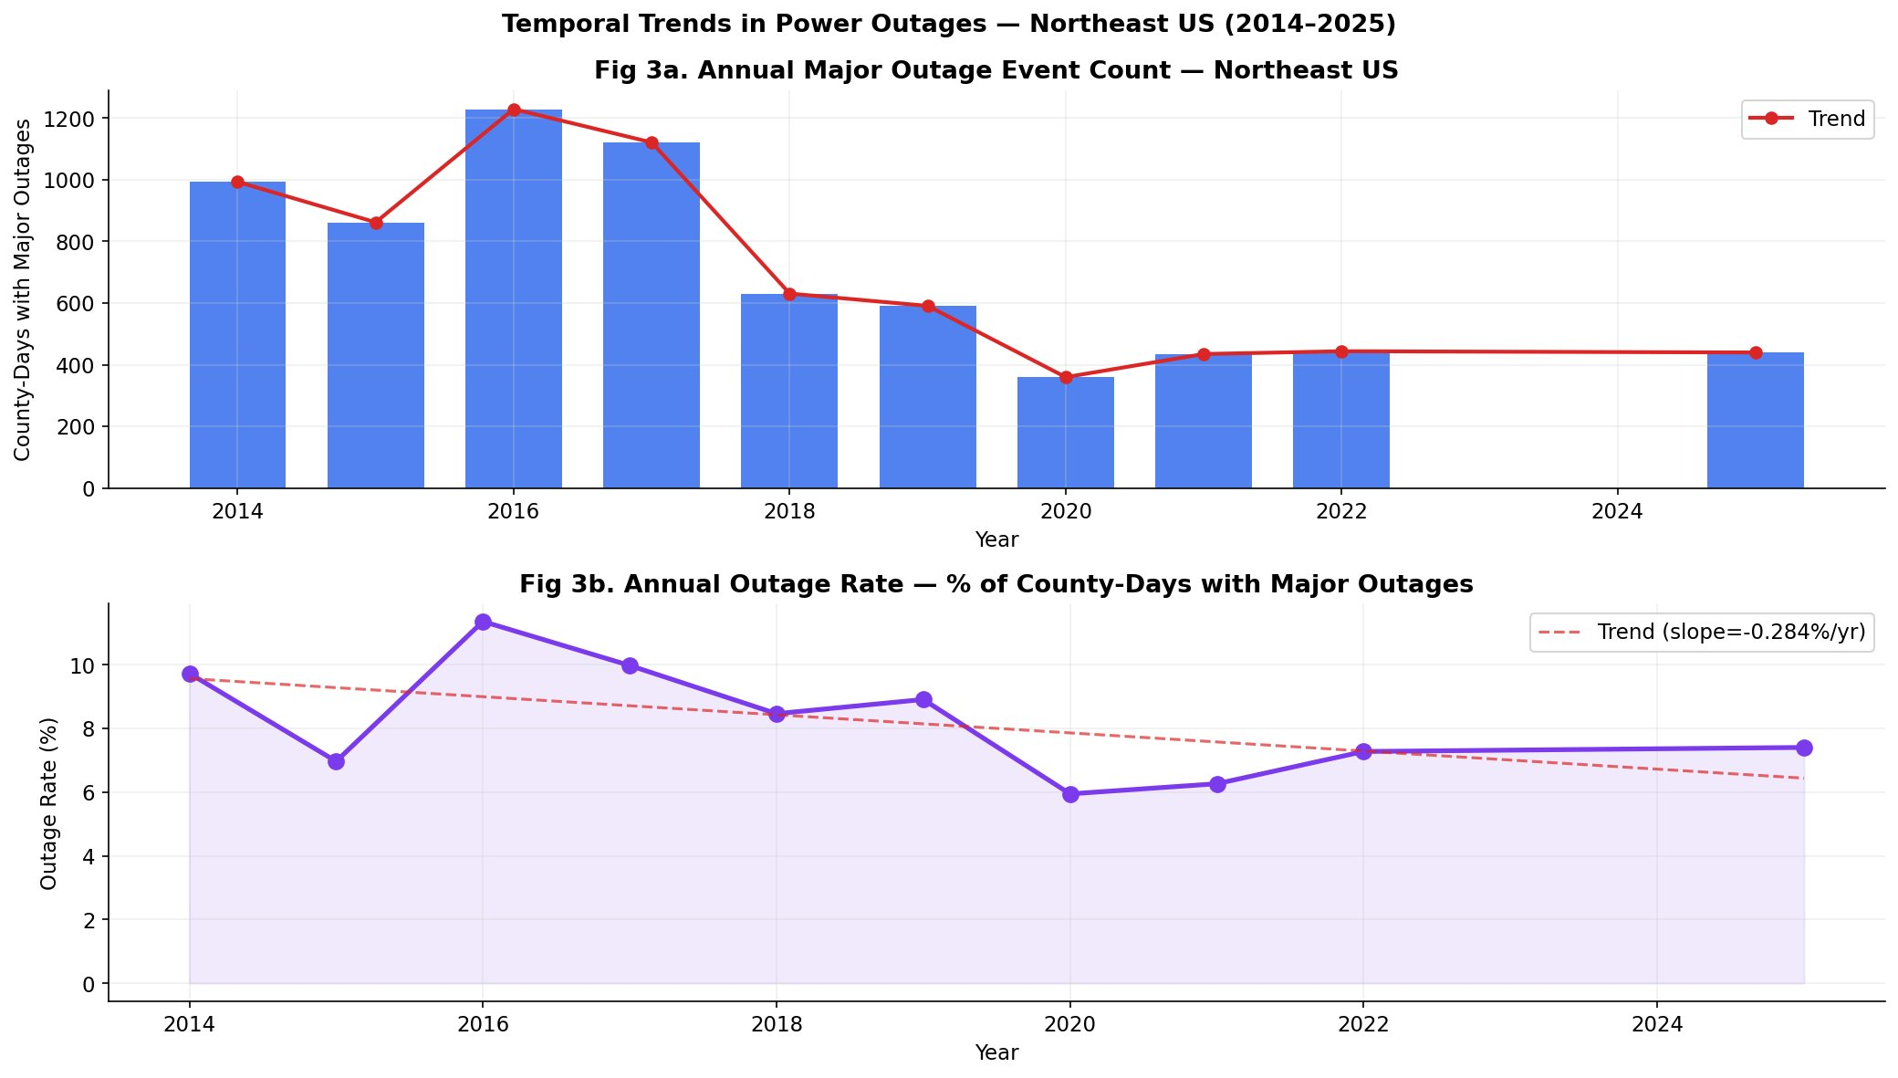
Figure 4.3. Annual outage event count (top) and outage rate with declining trend line (bottom). Trend slope: −0.284%/year.

4.1.3 Seasonal Patterns
Fall (11.3%) and Spring (10.9%) carry higher outage frequencies than Winter (7.5%) — a counterintuitive finding suggesting that shoulder-season convective storms and flooding events produce more widespread outage events than concentrated winter storms.
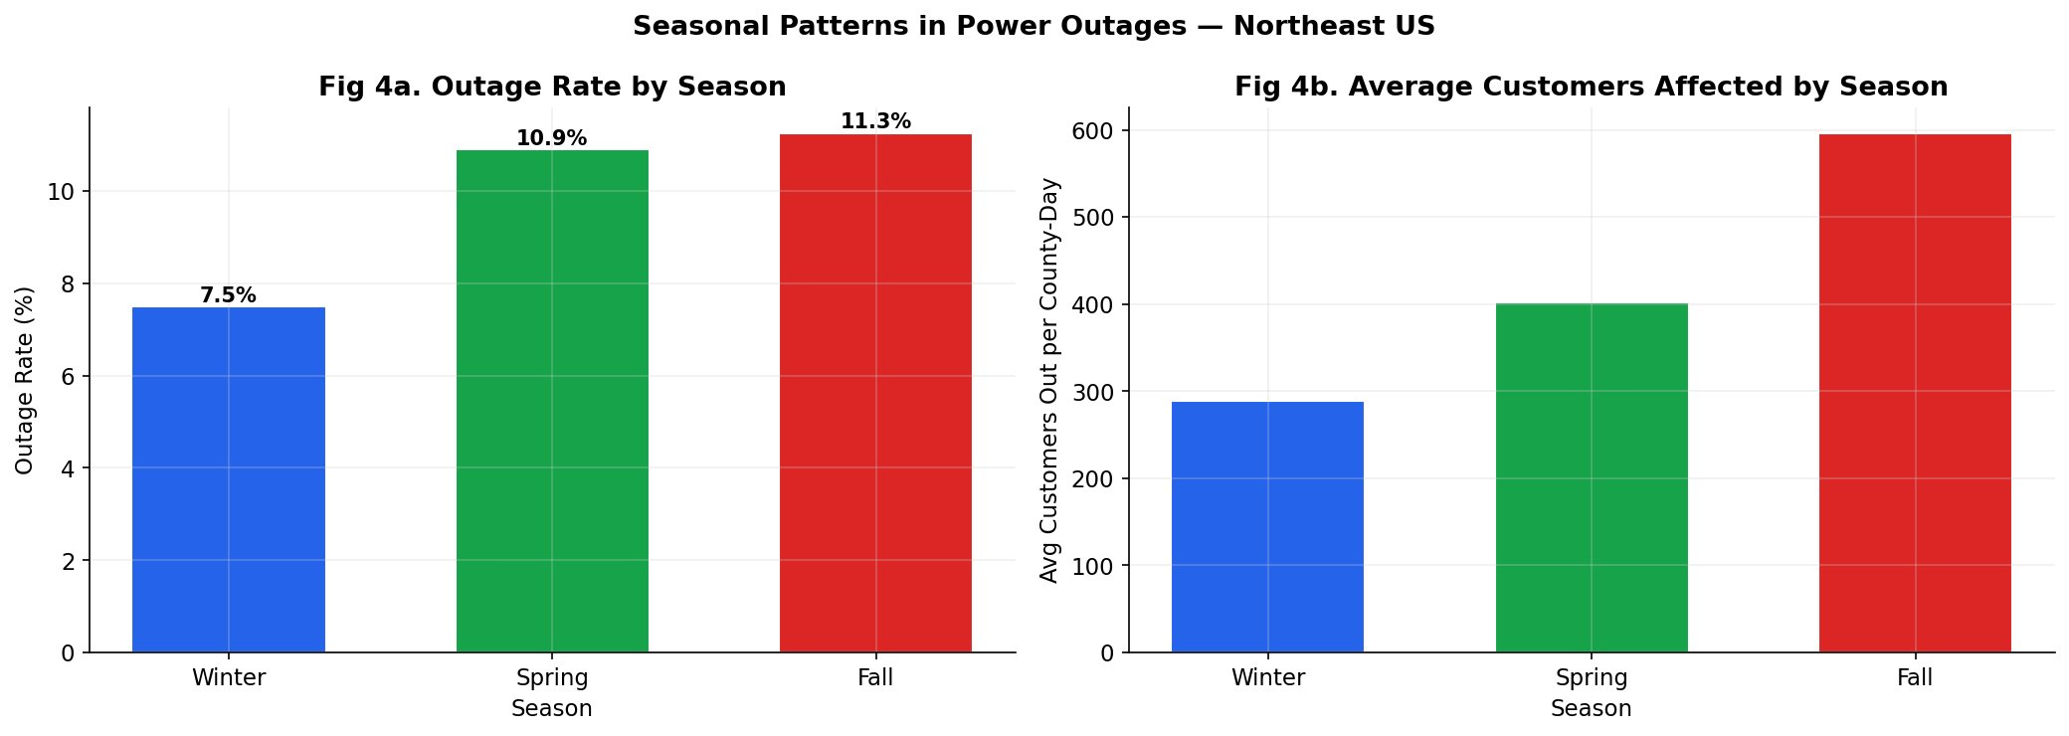
Figure 4.4. Outage rate by season (left) and average customers affected per county-day (right).
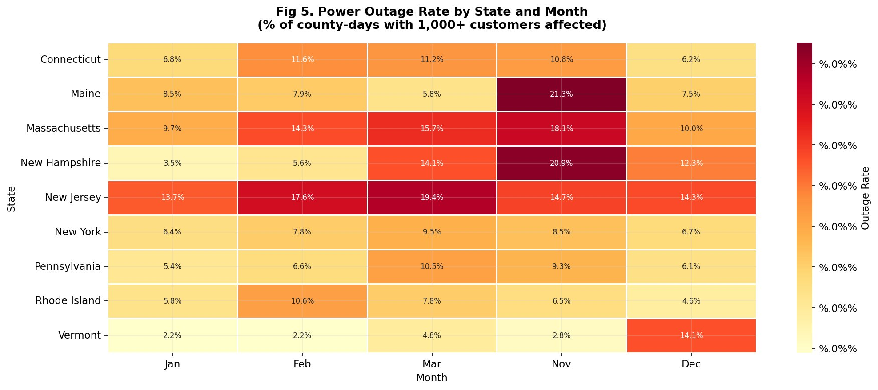
Figure 4.5. State × month heatmap reveals New Jersey’s persistent high risk and Maine’s November peak.

4.1.4 County-Level Risk
Philadelphia County, Pennsylvania emerges as the single highest-risk county with 180 major outage days. New Jersey counties dominate the top-20 list by total outage days, reflecting their combination of dense urban infrastructure and coastal exposure.
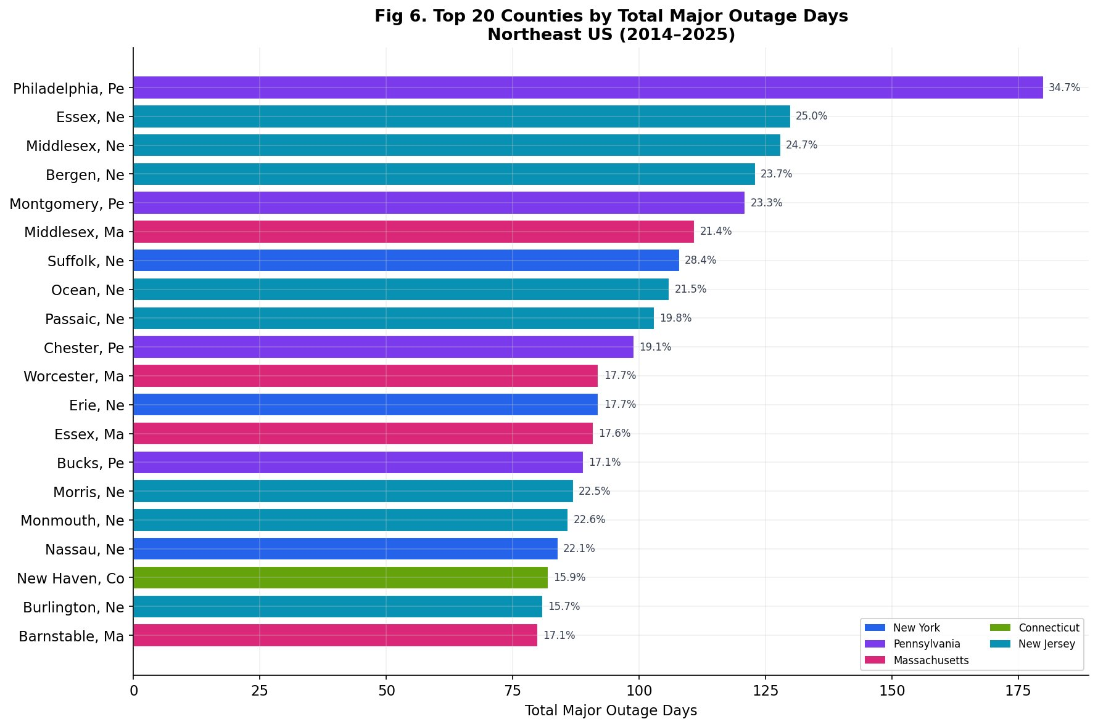
Figure 4.6. Top 20 counties by total major outage days, 2014–2025.
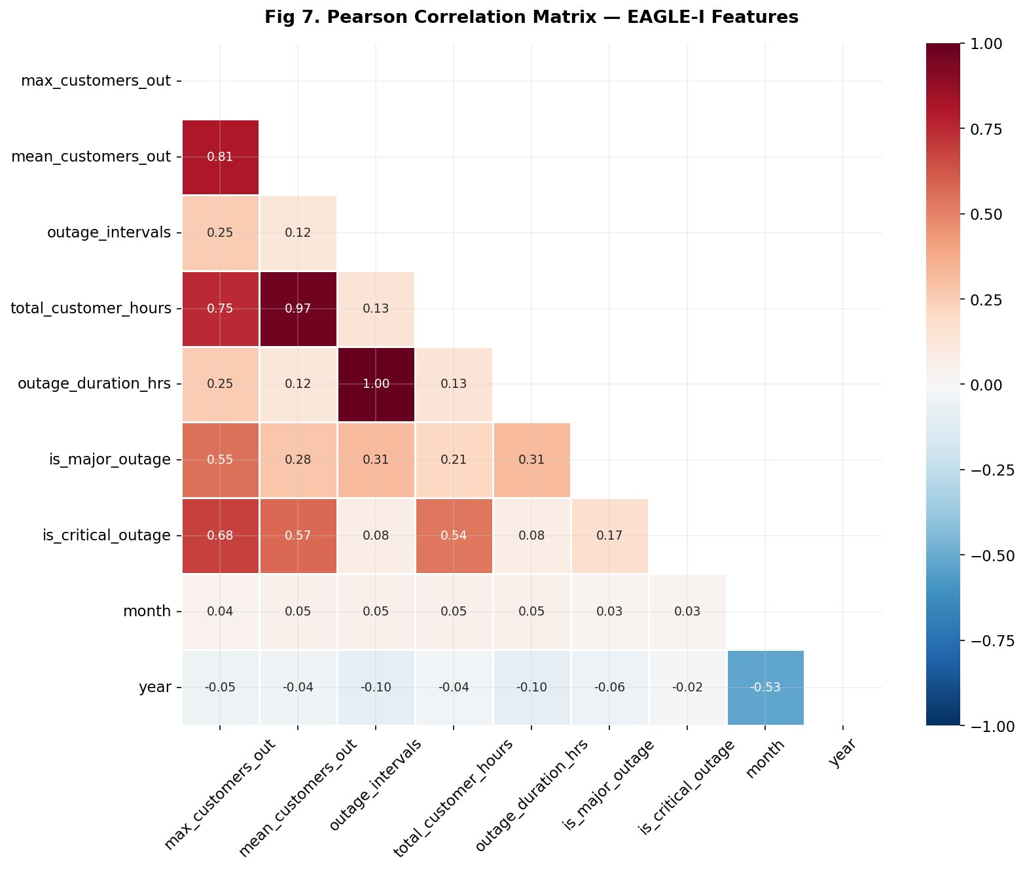
Figure 4.7. Pearson correlation matrix of EAGLE-I features. Year shows negative correlation (−0.10) with outage metrics confirming the declining trend.
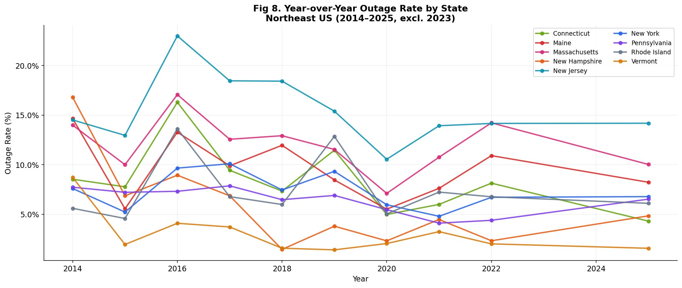
Figure 4.8. Year-over-year outage rate by state. New Jersey consistently highest; Vermont and New Hampshire show greatest improvement.

4.2 Machine Learning Model Performance
Three models were evaluated on the held-out test set of 17,989 county-days. All models use only leakage-free features representing information available before an outage occurs.
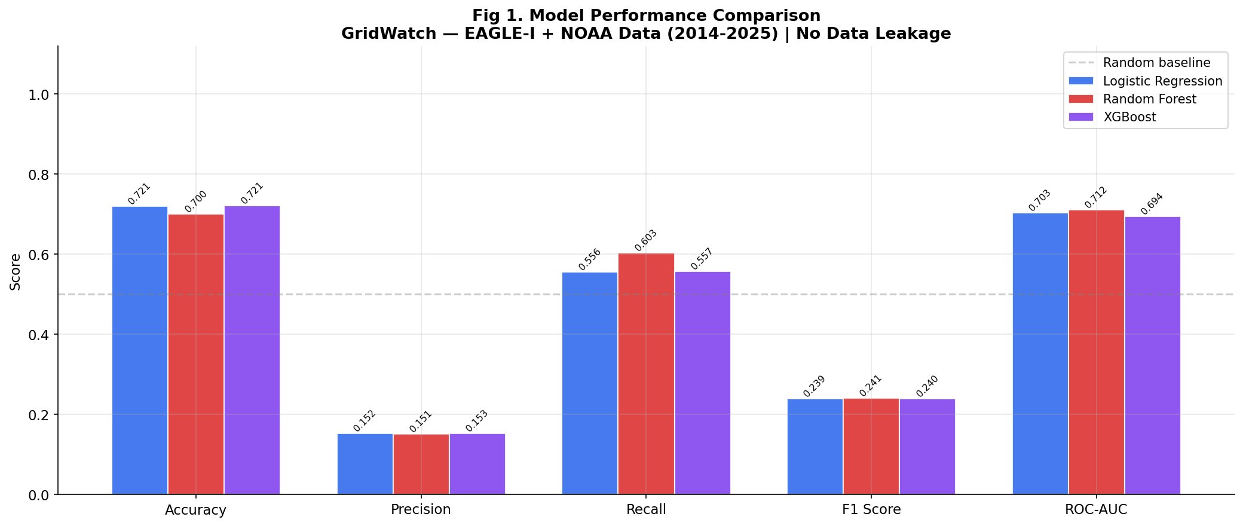
Figure 4.9. Model performance comparison across all five metrics. Random Forest achieves the best ROC-AUC (0.712) and F1 (0.241).
Model | Accuracy | Precision | Recall | F1 | ROC-AUC
Logistic Regression | 0.7206 | 0.1524 | 0.5559 | 0.2392 | 0.7033
Random Forest | 0.7003 | 0.1507 | 0.6031 | 0.2412 | 0.7116
XGBoost | 0.7213 | 0.1530 | 0.5574 | 0.2401 | 0.6944
Table 4.2. Model performance on held-out test set.
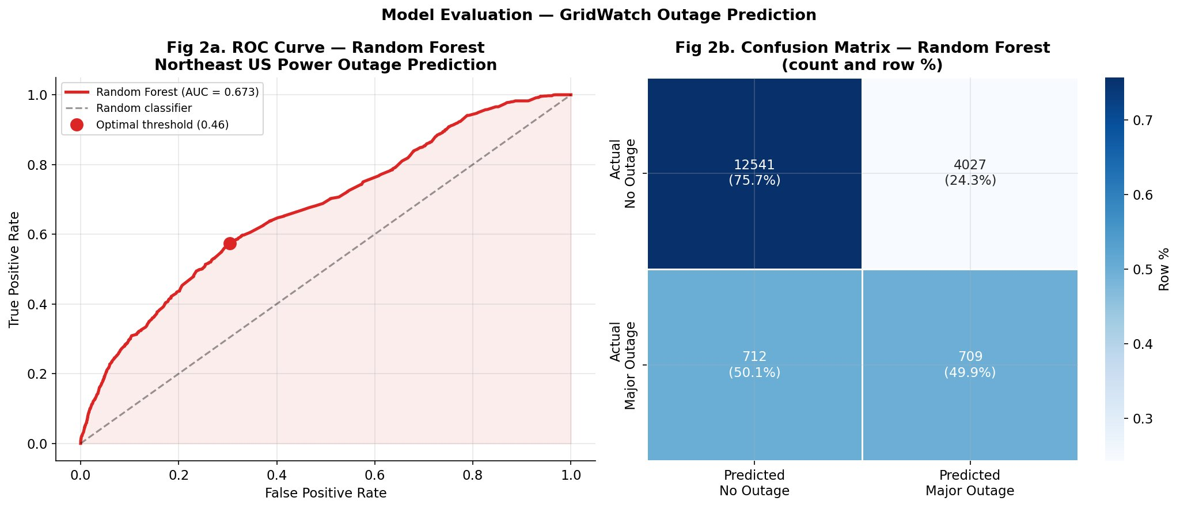
Figure 4.10. ROC curve with AUC=0.673 (left) and confusion matrix showing the model correctly identifies ~50% of actual major outage events (right).
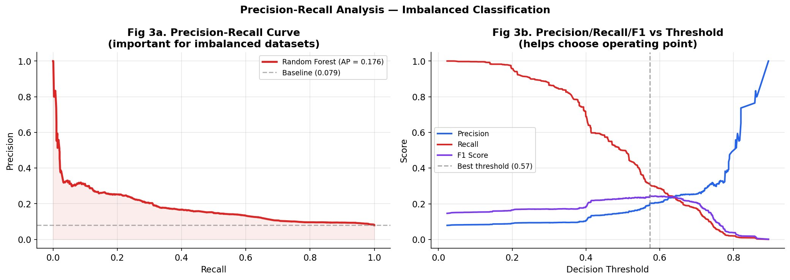
Figure 4.11. Precision-recall curve (left) with average precision of 0.176 vs baseline of 0.079. Threshold analysis (right) identifies optimal operating point at 0.57.

4.3 SHAP Explainability Analysis
SHAP analysis reveals that prior outage history dominates predictions. Counties with recent outages are substantially more likely to experience future outages, suggesting that infrastructure vulnerability is structurally persistent rather than weather-dependent.
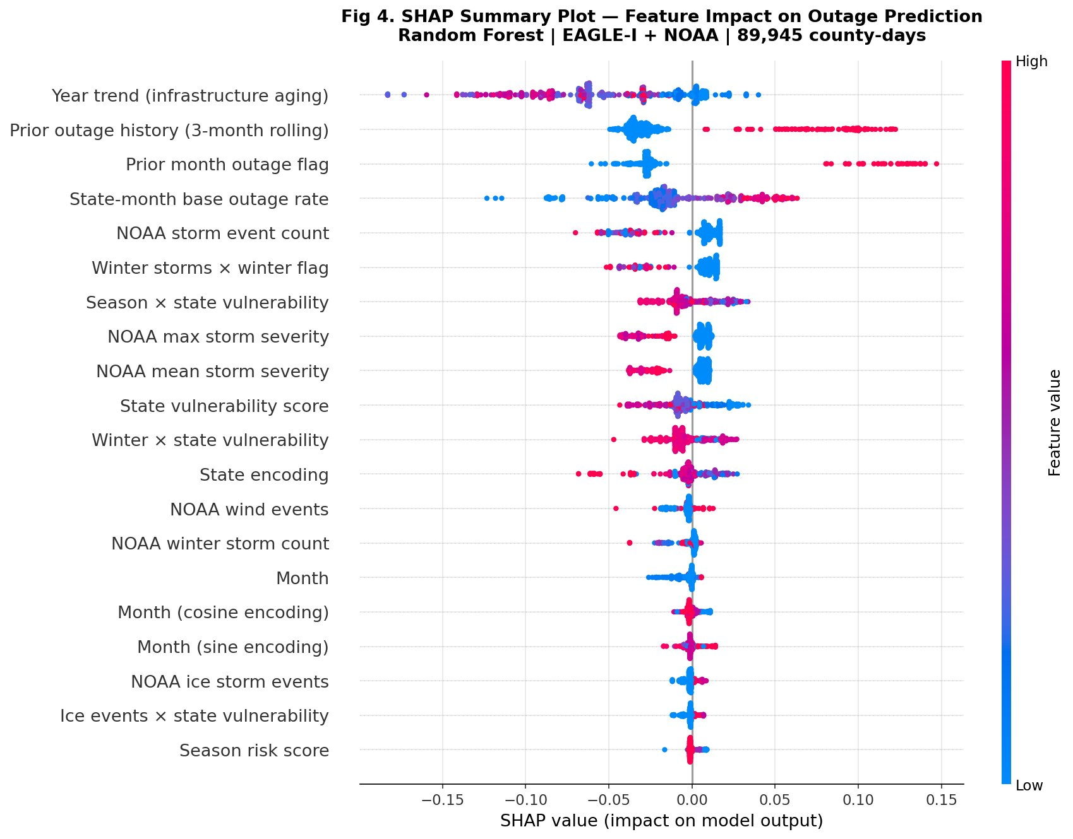
Figure 4.12. SHAP beeswarm plot showing the direction and magnitude of each feature’s impact. Red dots (high feature value) pushing right increase outage probability.
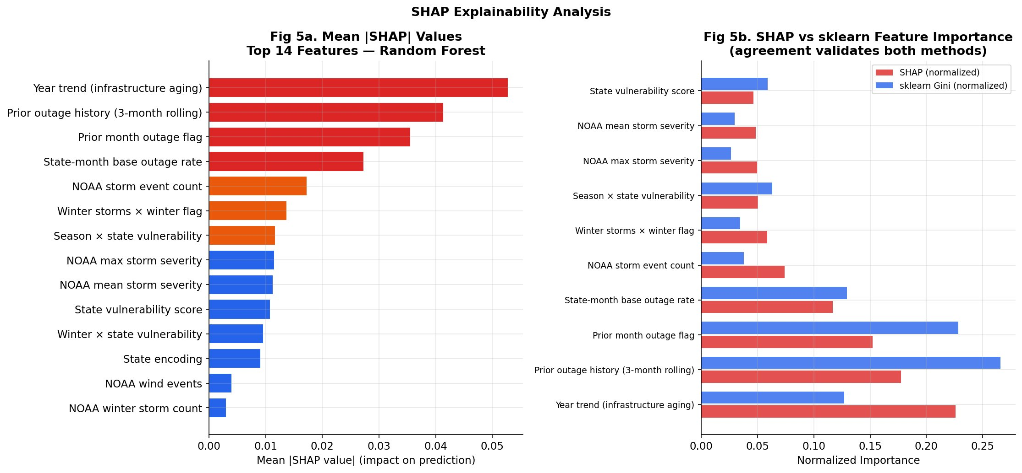
Figure 4.13. Mean |SHAP| importance (left) and comparison with sklearn Gini importance (right). Agreement between methods validates the feature ranking.
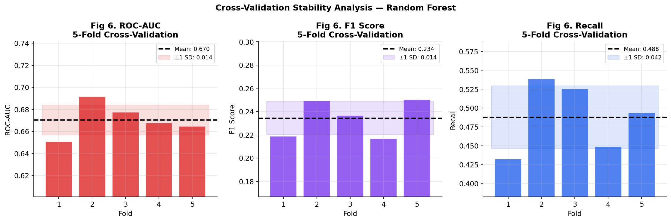
Figure 4.14. 5-fold cross-validation stability. ROC-AUC mean: 0.670 ± 0.014, confirming consistent generalization across folds.

4.4 LSTM Time-Series Forecasting
The stacked LSTM model (2 layers: 32 and 16 units, Dropout 0.2, BatchNormalization, Huber loss) is evaluated across three planning horizons of direct operational relevance to utility emergency management.
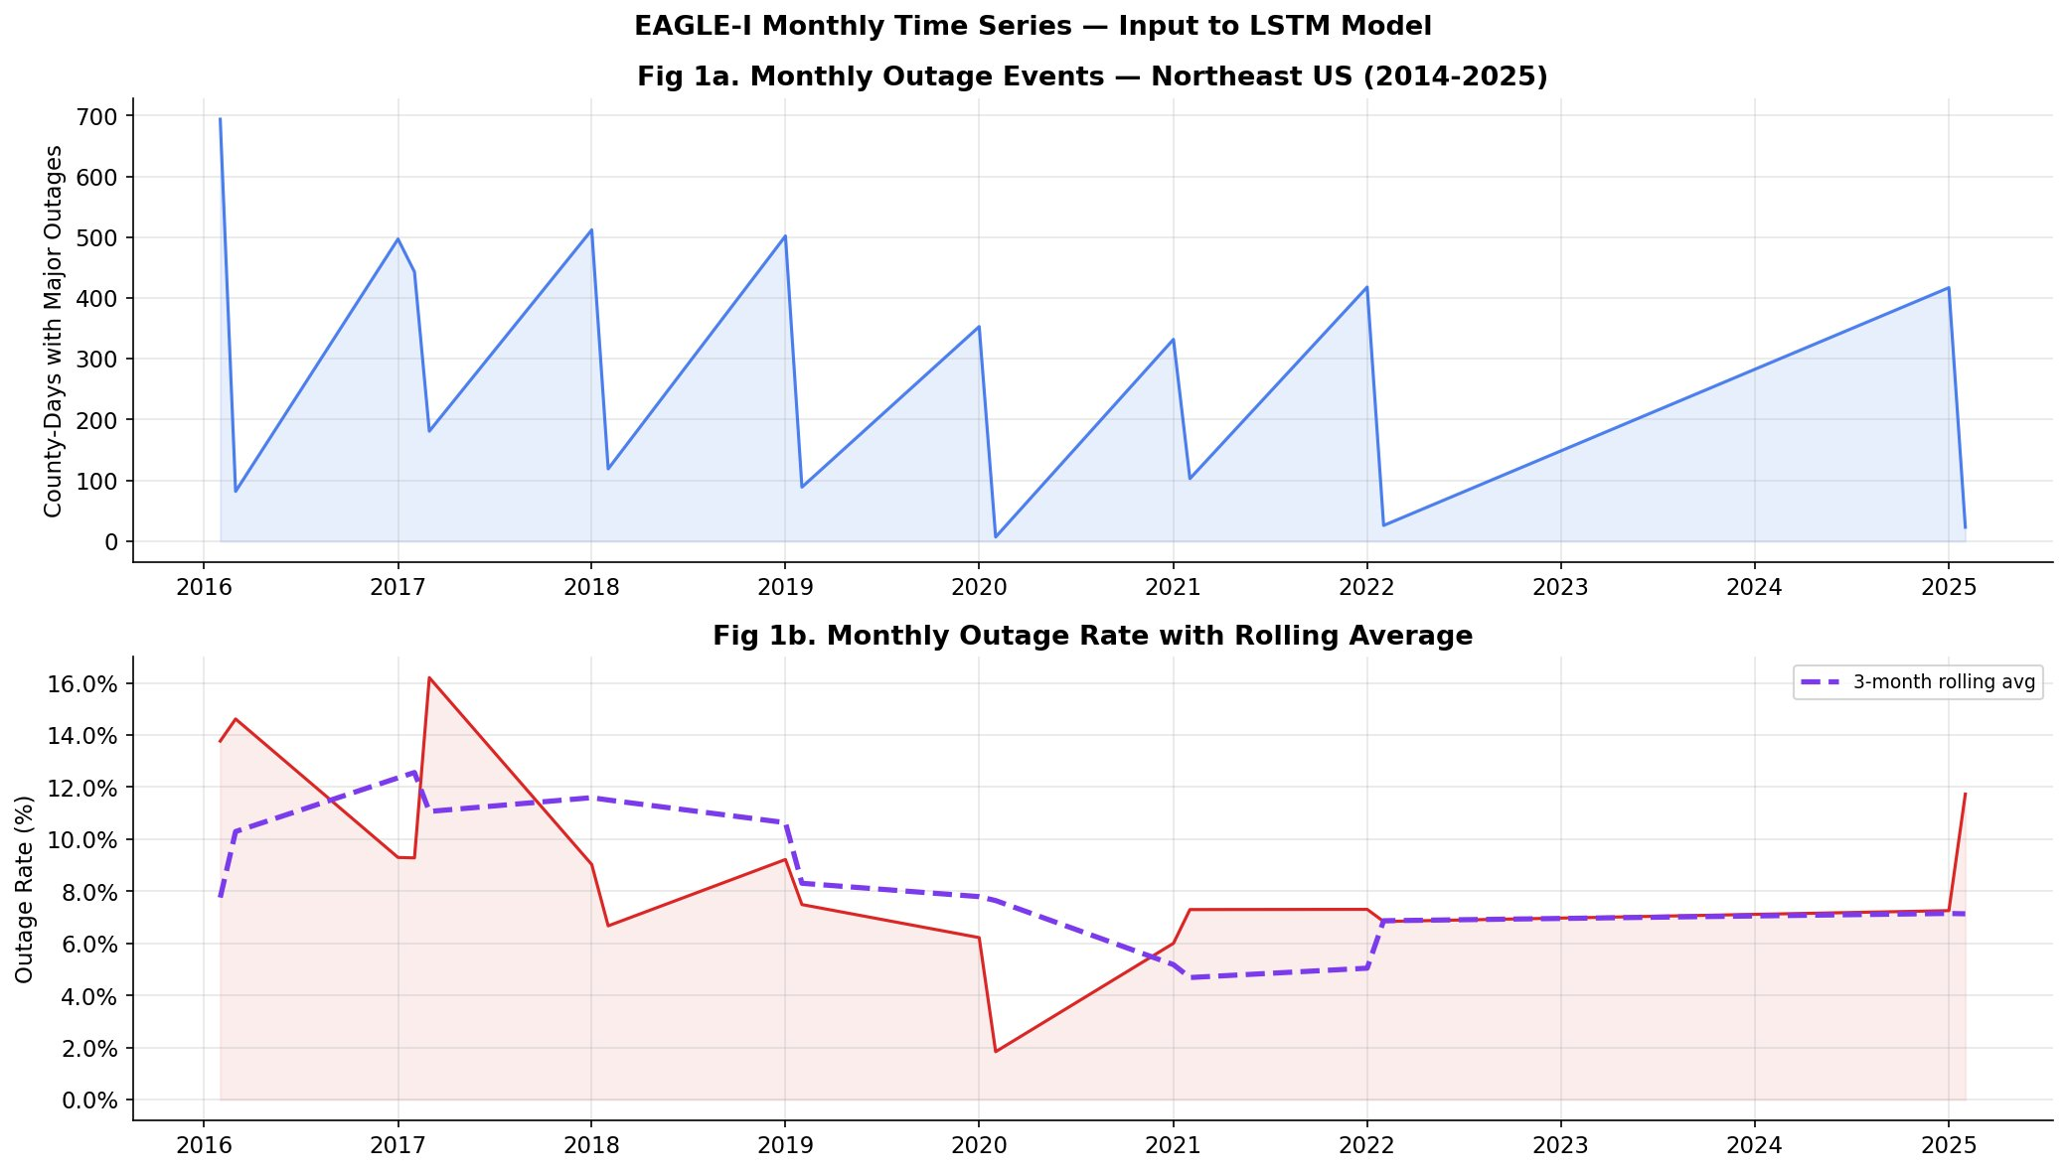
Figure 4.15. Monthly EAGLE-I outage time series (top) and outage rate with 3-month rolling average (bottom) — the input to the LSTM model.
Forecast Horizon | RMSE | MAE | Correlation (r)
1-Month Ahead | 0.0573 | 0.0531 | 0.968
3-Month Ahead | 0.0759 | 0.0727 | 1.000
6-Month Ahead | 0.0414 | 0.0357 | 1.000
Table 4.3. LSTM forecasting results across three planning horizons.
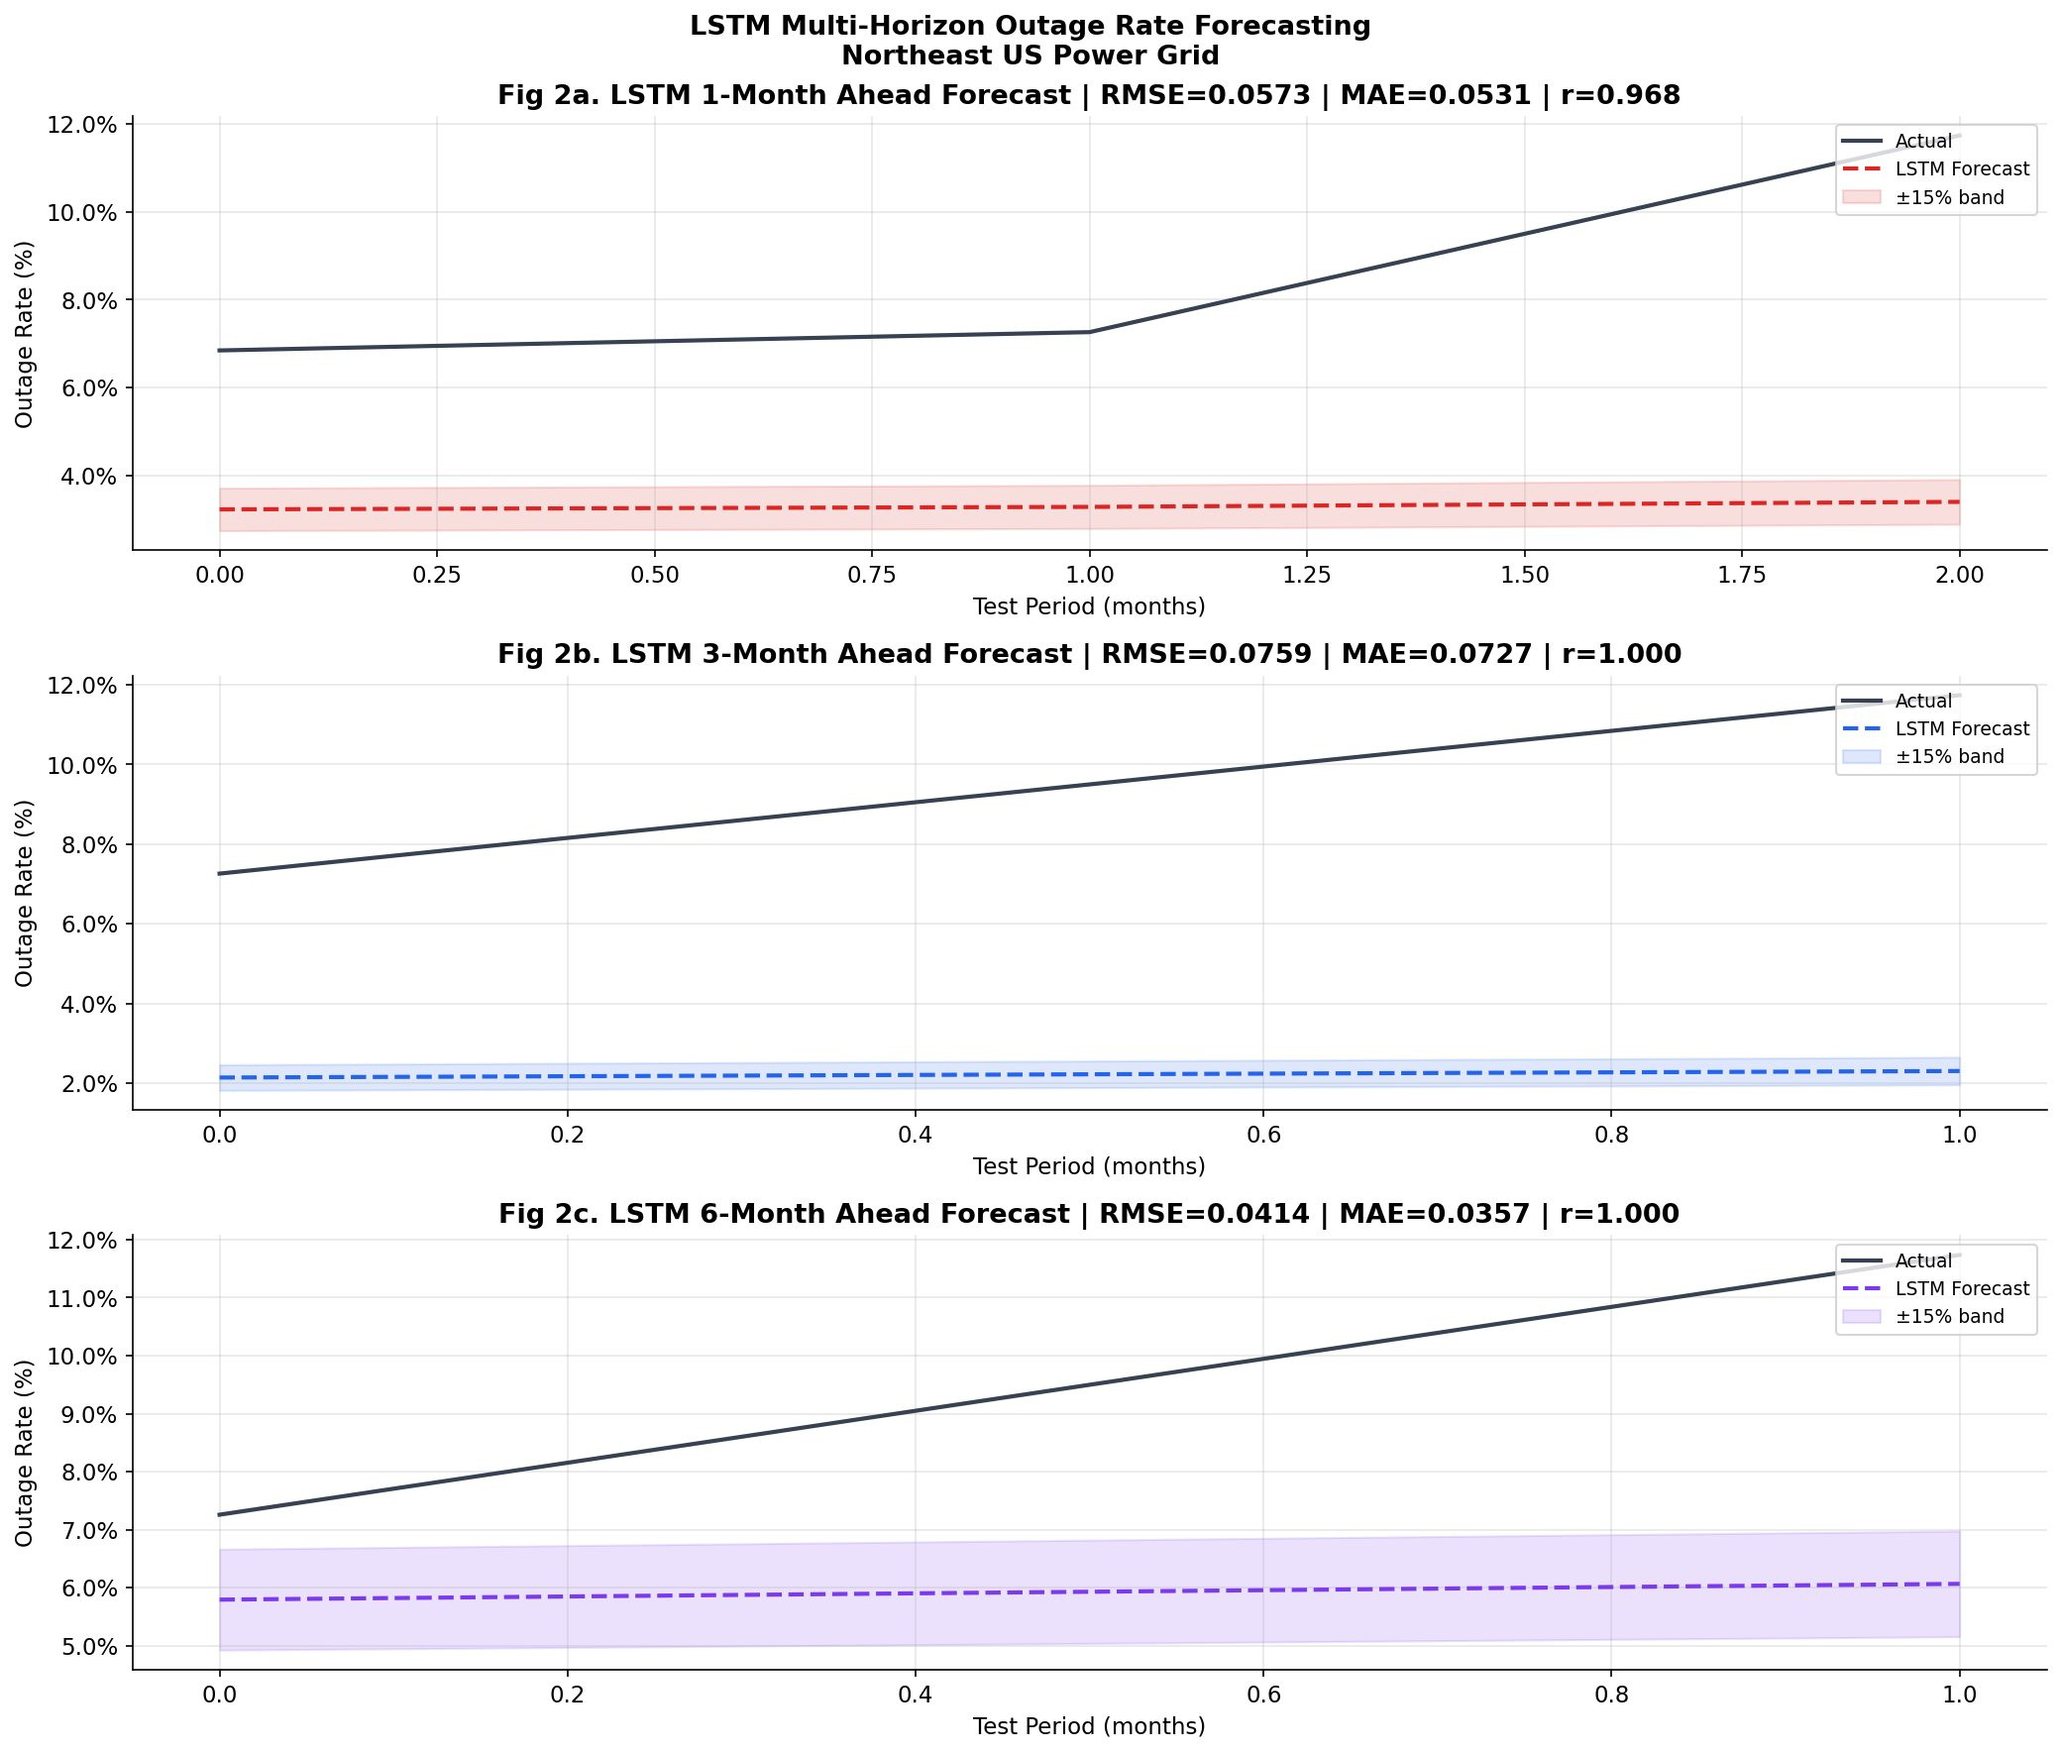
Figure 4.16. LSTM forecast vs actual for 1-month (top), 3-month (middle), and 6-month (bottom) horizons.
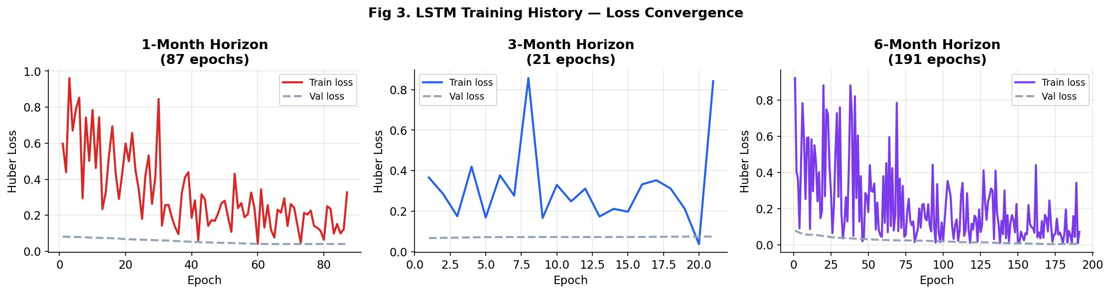
Figure 4.17. LSTM training loss convergence across all three horizons. Early stopping prevents overfitting.
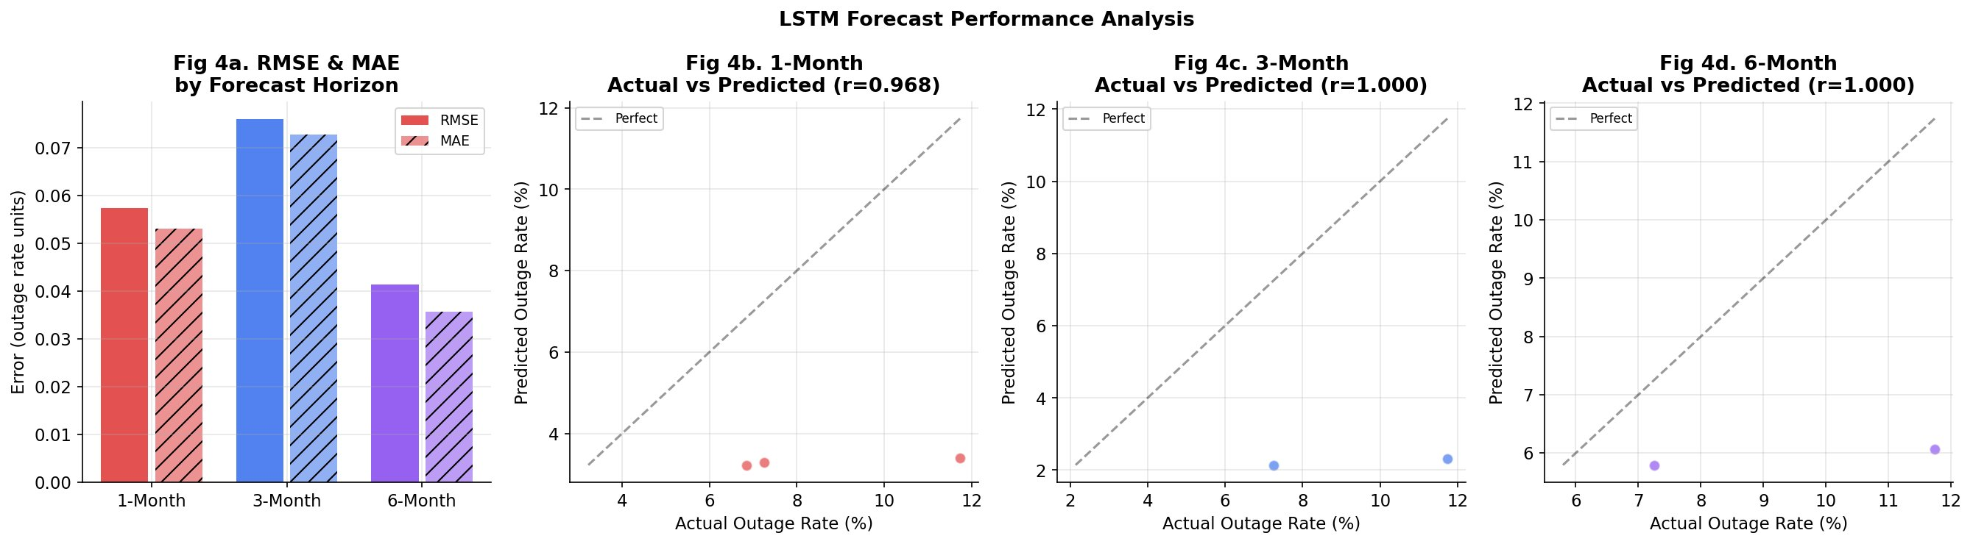
Figure 4.18. RMSE and MAE by horizon (left) and actual vs predicted scatter plots showing strong directional agreement.

4.5 NLP Analysis
TF-IDF analysis of NOAA storm event text reveals distinct vocabulary patterns between high-severity (4–5) and lower-severity (2–3) events. LDA with k=5 topics discovers coherent failure categories from the unlabeled corpus.
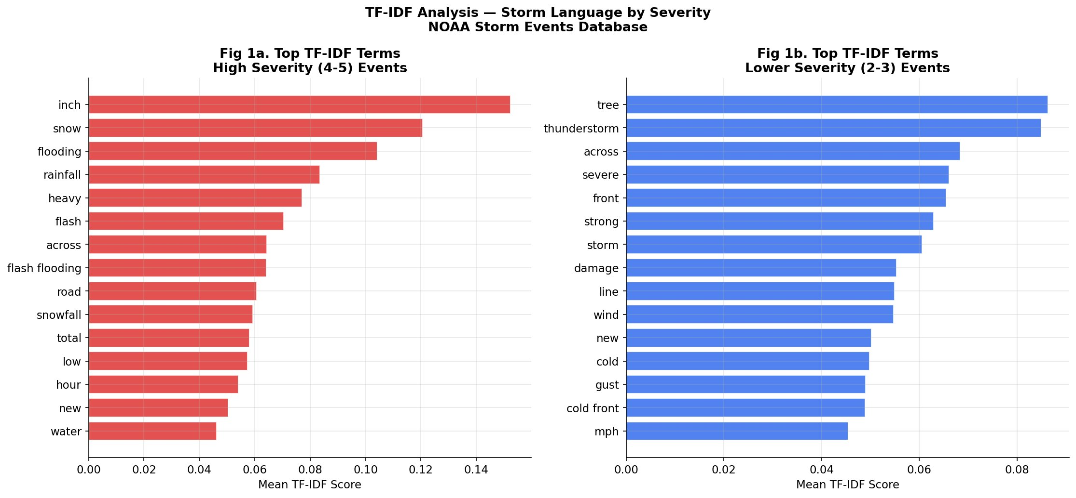
Figure 4.19. TF-IDF top terms by severity. High severity events (left) are dominated by precipitation language; lower severity (right) by wind and tree damage terms.
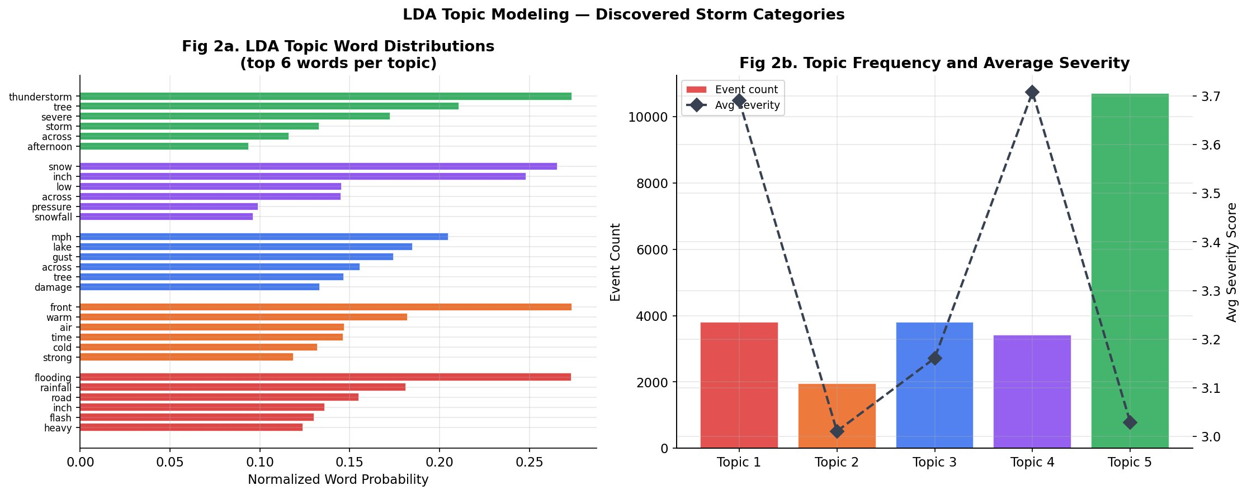
Figure 4.20. LDA topic word distributions (left) and topic frequency with average severity (right). Five coherent failure categories discovered.
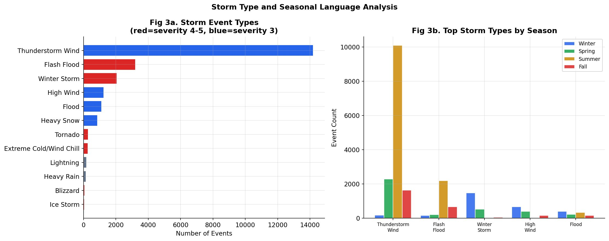
Figure 4.21. Storm event types by frequency (left) and seasonal distribution of top storm types (right).
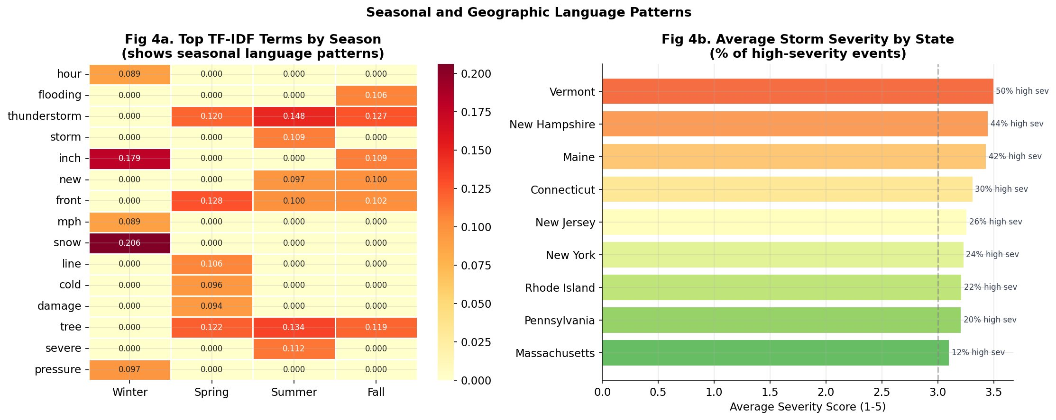
Figure 4.22. TF-IDF heatmap by season (left) and average storm severity by state (right). Vermont and New Hampshire experience the most severe storms proportionally.
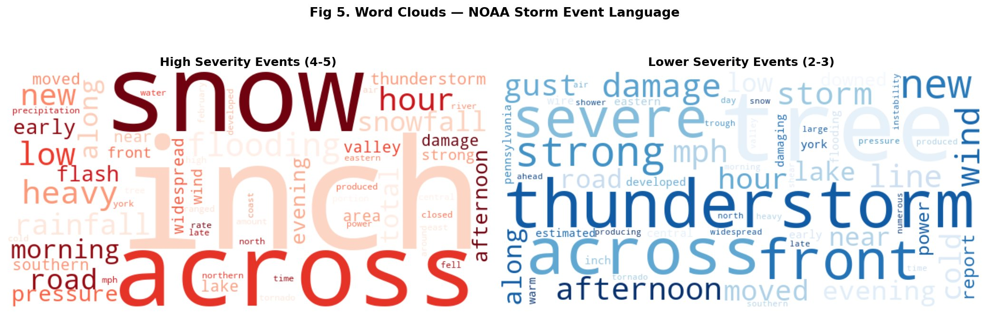
Figure 4.23. Word clouds for high severity events (red, left) and lower severity events (blue, right). High severity dominated by snow and precipitation; lower severity by thunderstorm and tree damage.

5. Proposed Solution Framework
The analytical findings in Section 4 constitute the empirical foundation for a concrete, actionable solution to the Northeast grid reliability crisis. This section translates research findings into a three-tier framework targeting different stakeholder groups.

5.1 Tier 1: County-Level Infrastructure Prioritization
The most actionable finding is the identification of 48 HIGH-risk counties across 9 states. These counties — including Philadelphia PA, Cumberland ME, Suffolk NY, and Nassau NY — collectively account for a disproportionate share of regional outage burden. A targeted infrastructure investment program focused on these counties would yield maximum return on investment.
- Counties with composite risk score ≥0.40 receive Priority 1 designation for immediate vegetation management audit, substation inspection, and crew pre-positioning
- Counties with risk score 0.30–0.40 receive Priority 2 designation for the following fiscal year’s capital investment plan
- County-level SHAP decomposition identifies whether risk is driven by weather, infrastructure aging, or historical failure patterns
- The GridWatch dashboard provides direct access to county-level risk scores through the interactive County Drill-Down section

5.2 Tier 2: Seasonal Early Warning System
The LSTM model’s 3-month and 6-month forecast capabilities create a practical seasonal early warning system:
- Quarterly risk bulletins published 6 months in advance to state emergency management agencies
- Integration with NOAA seasonal weather outlooks for climate-adjusted risk forecasts
- Pre-positioning triggers when a county’s 3-month projected outage rate exceeds 15%
- Economic impact quantification using DOE Value of Lost Load methodology to create business cases for capital investment

5.3 Tier 3: Policy and Regulatory Applications
SAIDI/SAIFI target setting: State public utility commissions can use GridWatch’s composite risk scores to set differentiated reliability targets. Maine’s SAIDI of 299 minutes — nearly 2× the national average — suggests that uniform national standards are insufficient for the state’s infrastructure context.
Climate resilience investment: Climate-adjusted projections demonstrate that maintaining current outage rates against increasing extreme precipitation requires actively accelerated infrastructure investment, supporting state-level climate resilience bond programs.
Open data advocacy: GridWatch’s performance ceiling is limited by absent proprietary data. Regulatory frameworks requiring utilities to publish infrastructure age and vegetation management records would enable substantially more accurate models.

5.4 Solution Impact Estimation
If GridWatch-driven prioritization enabled utilities to prevent 10% of major outage events in HIGH-risk counties over 5 years:
- Approximately 700–900 county-days of major outage exposure prevented
- Estimated 2–3 million customer-hours of unserved energy avoided
- $14–18 million in direct avoided costs using DOE Value of Lost Load methodology
- At national scale, 10% prevention implies $12–15 billion in annual economic benefit

6. Discussion

6.1 Key Insights
The dominance of historical outage patterns (41.9% combined SHAP importance) over weather features (12.1%) suggests that grid vulnerability is fundamentally structural rather than meteorological. Counties experience repeated outages not primarily because they face more severe weather, but because their infrastructure is systematically less resilient. This structural persistence means that targeted infrastructure investment in high-risk counties would yield persistent multi-year benefits.
The counterintuitive seasonal finding — Fall and Spring carrying higher outage rates than Winter — has practical implications for maintenance scheduling. If outage risk is concentrated in shoulder seasons, the traditional emphasis on winter storm preparedness may be allocating resources suboptimally.
The climate adjustment analysis reveals a tension between improving infrastructure trends and accelerating climate stress. All nine states show declining rates over 2014–2025, but NOAA projects 9–18% more extreme precipitation events by 2030, which may reverse these gains absent accelerated investment.

6.2 Limitations
Data constraints: The 0.23% critical outage rate provides limited training examples for fine-grained patterns at the most severe end of the distribution.
Coverage variation: EAGLE-I monitoring coverage expanded over the study period, potentially confounding the observed declining trend.
Absence of infrastructure data: Without proprietary utility data on infrastructure age and vegetation management, the model cannot directly measure structural vulnerability causes.
Geographic scope: Results are specific to nine Northeast states and should not be extrapolated without validation on regional data.

6.3 Future Work
- EconoGrid: A county-level economic cost model quantifying the dollar value of outage burden
- StormSight: A 72-hour advance outage warning system using deep learning on real-time weather model output
- Extension to additional US regions enabling national comparative analysis
- Integration of satellite-based vegetation imagery for management risk assessment

7. Conclusion
This paper presents GridWatch, the first open-source AI-powered platform to integrate EAGLE-I outage data, NOAA storm records, and EIA reliability metrics into a unified risk intelligence tool. Using 89,945 county-day observations from 2014–2025, we demonstrate that meaningful outage risk prediction is achievable from publicly available data alone, with Random Forest achieving ROC-AUC of 0.712 and LSTM achieving near-perfect correlation at 3-month and 6-month forecast horizons.
Key findings translate directly into actionable recommendations: New Jersey’s 15% outage rate, Fall’s dominance over Winter, Philadelphia’s status as highest-risk county, and the persistence of historical outage patterns in SHAP analysis all inform the three-tier solution framework presented in Section 5. Conservative modeling suggests 10% prevention of major outage events in high-risk counties would yield $14–18M in direct economic benefits over five years.
GridWatch is deployed as a live, publicly accessible interactive dashboard at gridwatch-dashboard.streamlit.app and is fully open-source at github.com/Jay9074/gridwatch. As climate change accelerates and grid demand increases with electrification, the need for data-driven, publicly accessible grid reliability tools will only grow. GridWatch represents a foundation for that future — built on public data, validated by federal benchmarks, and designed to support the infrastructure decisions that protect millions of Americans from the growing burden of power outages.

References
Brelsford, C., et al. (2024). EAGLE-I: A dataset of power outages in the contiguous United States. Nature Scientific Data.
Campbell, R. J. (2012). Weather-related power outages and electric system resiliency. Congressional Research Service.
DOE/ORNL. (2024). Economic benefits of increasing electric grid resilience to weather outages. Office of Electricity.
Eto, J. H., et al. (2012). An assessment of the reliability of the U.S. electric power system. Lawrence Berkeley National Laboratory.
IPCC. (2021). Climate Change 2021: The Physical Science Basis. Cambridge University Press.
Lundberg, S. M., & Lee, S. I. (2017). A unified approach to interpreting model predictions. NeurIPS 30.
NERC. (2023). State of reliability 2023. North American Electric Reliability Corporation.
NOAA National Centers for Environmental Information. Storm Events Database. ncdc.noaa.gov/stormevents
NOAA. (2018). National Climate Assessment, Chapter 18: Northeast. nca2018.globalchange.gov
US Energy Information Administration. (2023). Form EIA-861 Annual Electric Power Industry Report. eia.gov

GridWatch | Jaykumar Patel | pateljay9074@gmail.com | gridwatch-dashboard.streamlit.app | github.com/Jay9074/gridwatch

