WEEKLY REPORT-1

Completed Tasks:

1. Consolidated the initial internship orientation carried out at the start of the engagement and clarified that the system must support basin-scale hydro-climatic visualization for Himalayan analysis in a locally usable web environment.
2. Reviewed the planned project assets, including ERA5-Land tables, future CMIP6 projections, basin and glacier boundary layers, PMTiles-based map resources, and the provision for adding model and user-uploaded datasets later.
3. Inspected the repository structure and separated the solution into backend API, frontend dashboard, database, map assets, outcomes, and packaging modules so the development workflow remained well organized.
4. Defined the baseline scientific workflow for the application: dataset selection, year-range selection, variable loading, spatial visualization, elevation filtering, and time-series based regional interpretation.
5. Prepared the initial system architecture in which the backend performs indexed parquet reads, filtering, and aggregation, while the frontend handles map rendering, controls, legends, and graph interaction.
Figure:
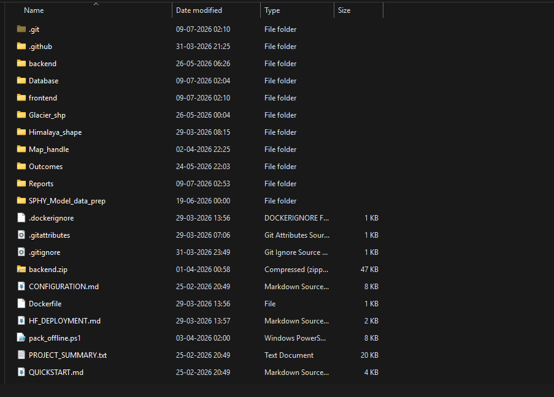
Figure 1. repository structure view.

Plans for next week:
1. Prepare reusable CSV-to-parquet conversion logic for the initial ERA5 data batches and verify that the exported schema remains consistent across yearly files.
2. Start implementing FastAPI endpoints for datasets, dates, variables, statistics, and filtered map responses.
3. Design the first backend indexing flow so incremental data additions can be handled without reworking the whole application structure.

References:
1. Project discussions and scientific requirements shared during the ISRO SAC internship initiation.
2. Repository structure and setup notes from README.md, QUICKSTART.md, and CONFIGURATION.md.
3. Initial ERA5-Land and CMIP6 export notes reviewed for dataset planning.

____________________________  Signature of External Guide | ____________________________  Signature of Internal Guide
Dr. Amit Kumar Dubey  Scientist/Engineer 'SF', SAC Ahmedabad | Sachi Joshi  Assistant Professor, DEPSTAR, CHARUSAT

