WEEKLY REPORT-2
Completed Tasks:
1. Converted large yearly CSV files into parquet format using the backend conversion workflow so that storage size and read latency could be reduced for runtime use.
2. Reviewed the available ERA5-oriented attributes such as date, latitude, longitude, elevation, temperature, snow water equivalent, snow depth, snowfall, precipitation, solar radiation, and wind-related variables.
3. Implemented backend logic to detect essential schema fields and to work with a growing variable collection without hard-coding every column position for each file.
4. Added lazy year-range indexing in the FastAPI backend so that only the relevant parquet files are considered for a selected analysis window instead of loading the entire database at application startup.
5. Developed API endpoints for dataset listing, available years, dates, variables, summary statistics, map data retrieval, basin mean time series, and selected-region mean time series.
6. Improved query efficiency by applying date, elevation, variable, and spatial filters before data is returned to the frontend, which reduced unnecessary browser transfer volume during testing.
Figure :
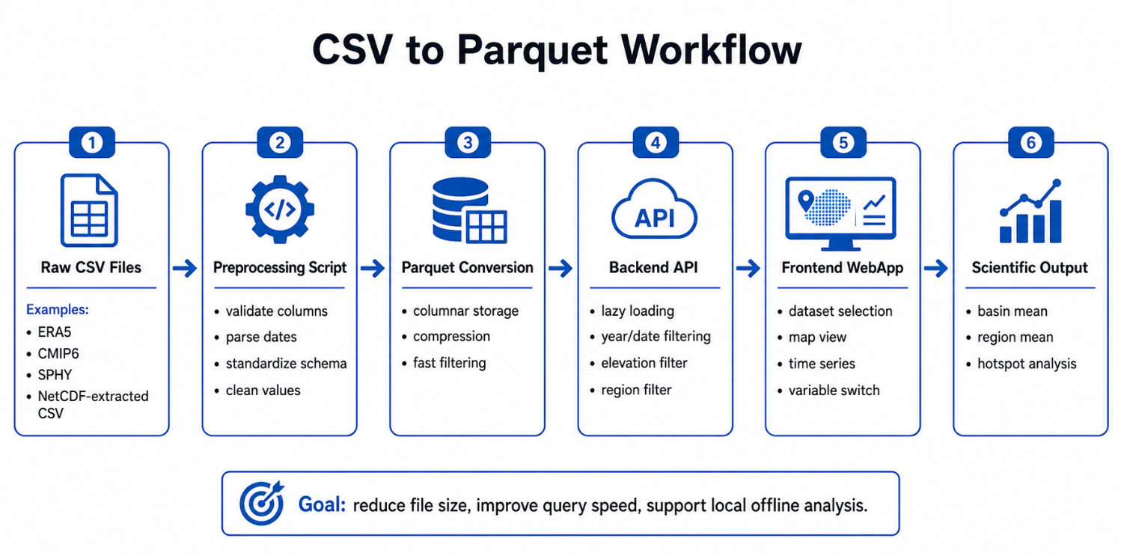
Figure 2. CSV-to-parquet conversion workflow.

Plans for next week:
1. Connect the backend responses with the dashboard interface and expose dataset and year-range selection on the frontend home screen.
2. Implement the first interactive map view with variable-based coloring and a readable legend.
3. Continue optimization so newly added variables and yearly data collections can be queried without degrading response time.

References:
1. backend/convert_csv_to_parquet.py and backend/main.py from the project repository.
2. Apache Parquet and PyArrow documentation for optimized tabular storage and column-wise reads.
3. FastAPI documentation for parameterized APIs and structured JSON responses.

____________________________  Signature of External Guide | ____________________________  Signature of Internal Guide
Dr. Amit Kumar Dubey  Scientist/Engineer 'SF', SAC Ahmedabad | Sachi Joshi  Assistant Professor, DEPSTAR, CHARUSAT

