WEEKLY REPORT-3
Completed Tasks:
1. Built the main frontend flow using React and Vite, with an entry page that requires dataset and year-range selection before the analytics dashboard is loaded.
2. Connected the frontend with backend APIs and integrated the map canvas so filtered hydro-climatic points can be visualized interactively without exposing raw full-database reads in the browser.
3. Added variable selection controls that work with the increasing collection of weather, snow, and climate fields and update the dashboard state based on the active dataset.
4. Implemented an improved color scale and legend strategy so scientific values are displayed in more meaningful ranges and the map no longer suffers from misleading visual breaks.
5. Added time-slider and playback controls together with elevation filtering and basin-context layers so date-wise changes can be explored more effectively on the map.
6. Optimized the UI state flow to avoid unnecessary full-screen reloads when only variable, date, or view settings change, thereby improving dashboard usability during repeated analysis.
Figure :
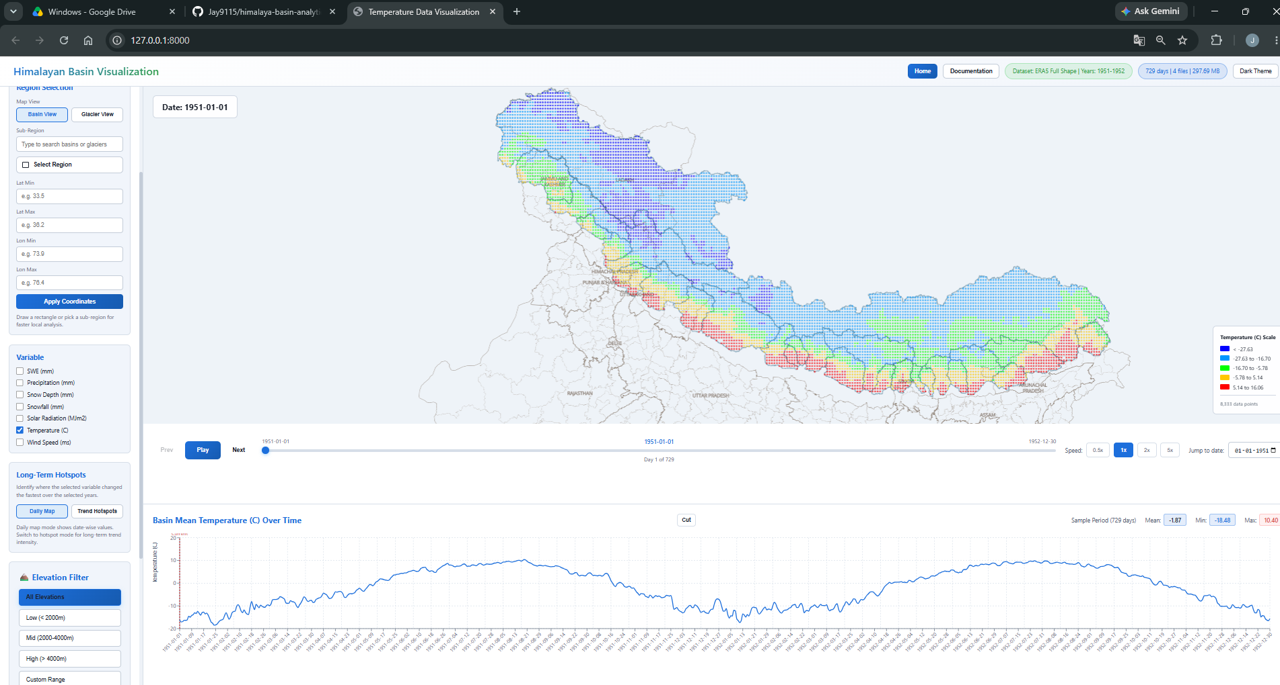
Figure 3. Dashboard map view.

Plans for next week:
1. Add coordinate-based rectangle selection and connect the selected area with region-wise graph generation.
2. Extend graph interaction for date-range cutting and closer visual inspection of selected periods.
3. Keep refining legend behavior and state synchronization as additional datasets and variables are introduced.

References:
1. frontend/src/App.jsx and frontend/src/components/MapView.jsx from the project repository.
2. React and Vite documentation used for dashboard implementation.
3. MapLibre, Deck.GL, and PMTiles references for map visualization and boundary overlays.

____________________________  Signature of External Guide | ____________________________  Signature of Internal Guide
Dr. Amit Kumar Dubey  Scientist/Engineer 'SF', SAC Ahmedabad | Sachi Joshi  Assistant Professor, DEPSTAR, CHARUSAT

