WEEKLY REPORT-4
Completed Tasks:
1. Implemented rectangle-based regional selection on the map so users can interactively define an analysis area for the currently loaded variable and period.
2. Added manual latitude-longitude boundary input for users who require precise coordinate-based selection instead of drawing regions visually on the map canvas.
3. Connected the selected region with time-series generation and displayed the contributing pixel count so the scientific strength of a plotted regional mean can be assessed more responsibly.
4. Implemented graph cut and zoom functionality through date-range selection, which improved temporal inspection of high-variability periods without re-running the entire session from scratch.
5. Introduced subregion selection from polygon boundaries and designed the hotspot-analysis workflow using annual means, grid-level linear trends, and percentile-based hotspot classes.
6. Refined spatial filtering logic with coordinate bounds and polygon-aware screening so regional analytics remain consistent as more subregions and variables are added into the system.
Figure :
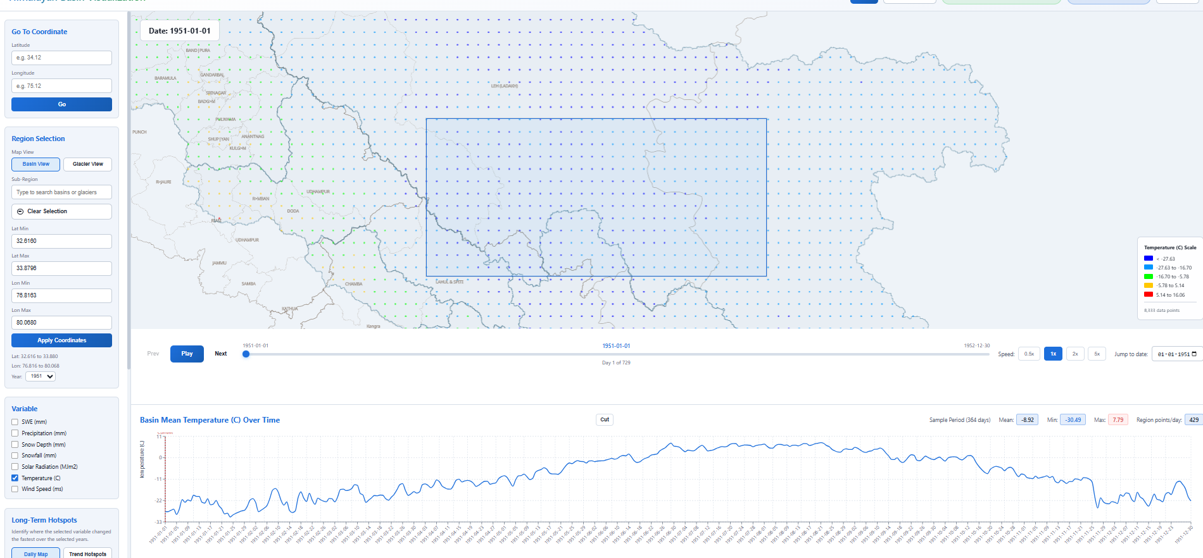
Figure 4. Regional time-series view.

Plans for next week:
1. Expand the application to support additional datasets beyond the initial ERA5 collection, beginning with CMIP6 and model-based inputs.
2. Prepare the data path and API design required for glacier-wise analysis and future raster-backed datasets.
3. Continue optimizing regional analytics so the added logic remains responsive for larger year ranges.

References:
1. Regional filtering and hotspot logic implemented in backend/main.py.
2. Geospatial filtering concepts based on coordinate-window and point-in-polygon methodology.
3. Trend analysis and percentile-based hotspot classification concepts reviewed for long-term change mapping.

____________________________  Signature of External Guide | ____________________________  Signature of Internal Guide
Dr. Amit Kumar Dubey  Scientist/Engineer 'SF', SAC Ahmedabad | Sachi Joshi  Assistant Professor, DEPSTAR, CHARUSAT

