WEEKLY REPORT-5
Completed Tasks:
1. Expanded the platform from a single-dataset workflow to a multi-dataset architecture by adding CMIP6 as a selectable source with its own date range, variables, and file paths.
2. Reviewed and incorporated variable-specific handling for CMIP6, including temperature conversion from Kelvin to Celsius, precipitation conversion to millimeters per day, and radiation conversion to operational analysis units.
3. Added the SPHY model ingestion pipeline by converting GeoTIFF-based layers into parquet files so they can be queried through the same backend structure used for point-style datasets.
4. Integrated glacier shapefiles into the region-selection flow and exposed glacier names where metadata was available so cryosphere-focused subregion analysis can be performed more conveniently.
5. Implemented NetCDF upload support and direct MOD10A1 monthly GeoTIFF support, thereby extending the platform to user-supplied and raster-backed inputs without disturbing the stable core workflows.
6. Continued performance optimization by limiting only the visual density of heavy raster responses while preserving full valid-pixel participation in backend mean calculations.
Figure :
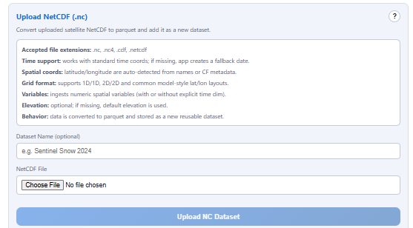
Figure 5. NetCDF integration.

Plans for next week:
1. Document the computational logic for each dataset and analysis mode inside the application and submission material.
2. Prepare an outcomes section for precomputed scientific products so expensive analyses do not need to be repeated at runtime.
3. Start deployment and offline packaging work so the current system can be shared outside the local development machine.

References:
1. SPHY_Model_data_prep/convert_geotiff_to_parquet.py and related backend integration code.
2. Rasterio, GeoTIFF metadata handling, and NetCDF ingestion references used for format integration.
3. MOD10A1 snow and albedo dataset notes reviewed during dashboard expansion.

____________________________  Signature of External Guide | ____________________________  Signature of Internal Guide
Dr. Amit Kumar Dubey  Scientist/Engineer 'SF', ISRO/SAC Ahmedabad | Sachi Joshi  Assistant Professor, DEPSTAR, CHARUSAT

