WEEKLY REPORT-6
Completed Tasks:
1. Created an Outcomes entry point on the home screen so precomputed scientific products are clearly separated from the interactive dashboard workflow.
2. Implemented the first outcome module for long-term hotspot band means by generating precomputed ERA5-based spatial summaries for fixed multi-year bands and storing the outputs in parquet form for rapid reuse.
3. Added a dedicated documentation page inside the application that explains data sources, variable conversions, filtering logic, mean calculations, hotspot methodology, map behavior, and interpretation limits for end users.
4. Reviewed validation logic against Google Earth Engine workflows and documented why application means may differ from simple point extraction due to grid alignment, temporal aggregation, and spatial sampling effects.
5. Prepared the deployment path and offline Windows package so the solution can be shared through separated frontend-backend hosting as well as a portable local bundle.
Figure :
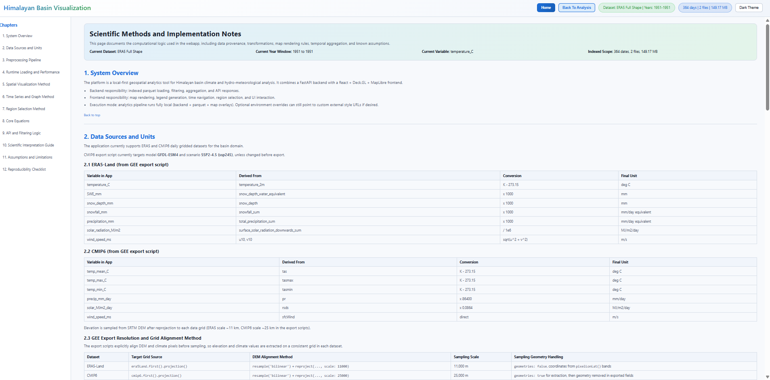
Figure 6. In-app documentation page.

Plans for next week:
1. Share the packaged build and current deployment-ready version with the project guide for technical review.
2. Collect scientific and usability feedback on datasets, variable interpretation, and additional outcome requirements.
3. Use the feedback to further improve validation notebooks, output products, and large-data deployment optimization in the next iteration.

References:
1. frontend/src/components/DocumentationPage.jsx and frontend/src/components/OutcomeLongTermHotspotPage.jsx.
2. README.md, HF_DEPLOYMENT.md, pack_offline.ps1, and start.bat from the project repository.
3. Google Earth Engine export and validation notes consulted during final documentation and verification work.

____________________________  Signature of External Guide | ____________________________  Signature of Internal Guide
Dr. Amit Kumar Dubey  Scientist/Engineer 'SF', SAC Ahmedabad | Sachi Joshi  Assistant Professor, DEPSTAR, CHARUSAT

