Clinical Opiate Withdrawal Scale

**Introduction**

The Clinical Opiate Withdrawal Scale (COWS) is an 11-item scale designed to be administered by a clinician. This tool can be used in both inpatient and outpatient settings to reproducibly rate common signs and symptoms of opiate withdrawal and monitor these symptoms over time. The summed score for the complete scale can be used to help clinicians determine the stage or severity of opiate withdrawal and assess the level of physical dependence on opioids. Practitioners sometimes express concern about

the objectivity of the items in the COWS; however, the symptoms of opioid withdrawal have been likened to a severe influenza infection (e.g., nausea, vomiting, sweating, joint aches, agitation, tremor), and patients should not exceed the lowest score in most categories without exhibiting some observable sign or symptom of withdrawal.

<http://www.drugabuse.gov/nidamed-medical-health-professionals>

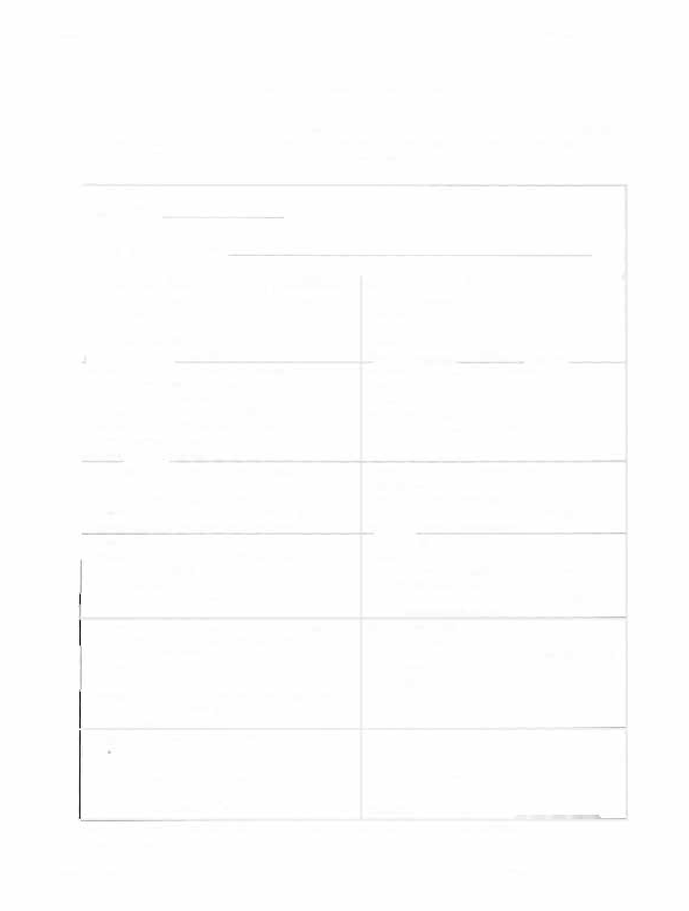Wesson & Ling Clinical Opiate Withdrawal Scale

Downloaded by [HSRL - Health Science Research Library] at 14:04 02 September 2015

APPENDIX 1

Clinical Opiate Withdrawal Scale

For each item, circle the number that best describes the patient' s signs or symptom. Rate on just the apparent relationship to opiate withdrawal. For example, if heart rate is increased because the patient was jogging just prior to assessment, the increase pulse rate would not add to the score.

|  |  |
| --- | --- |
| Patient' s Name: Date and Time _! !_  Reason for this assessment: | |
| Resting Pulse Rate: beats/minute  *Measured after patient is sitting or lying for one minute*  0 pulse rate 80 or below  1 pulse rate 81- 1 00  2 pulse rate 101-1 20  4 rate than 1 20 | GI Upset: *over last* 1/2 *hour*  0 no GI symptoms  1 stomach cramps  2 nausea or loose stool  3 vomiting or diarrhea  5 of diarrhea or |
| Sweating: *over past* 1/2 *hour not accounted for by room temperature or patient activity.*   1. no report of chills or flushing 2. subjective report of chills or flushing 3. flushed or observable moistness on face 4. beads of sweat on brow or face 5. sweat off face | Tremor *observation ofoutstretched hands*  0 no tremor  1 tremor can be felt, but not observed  2 slight tremor observable  4 gross tremor or muscle twitching |
| Restlessness *Observation during assessment*  0 able to sit still  1 reports difficulty sitting still, but is able to do so  3 frequent shifting or extraneous movements of legs/arms  5 unable to sit still for more than a few seconds | Yawning *Observation during assessment*  0 no yawning  1 yawning once or twice during assessment  2 yawning three or more times during assessment  4 several times/minute |
| Pupil size  0 pupils pinned or normal size for room light  1 pupils possibly larger than normal for room light  2 pupils moderately dilated  5 pupils so dilated that only the rim of the iris is visible | Anxiety or Irritability  0 none  1 patient reports increasing irritability or anxiousness  2 patient obviously irritable or anxious  4 patient so irritable or anxious that participation in the assessment is difficult |
| Bone or Joint aches *if patient was having pain previously, only the additional component attributed to opiates withdrawal is scored*  0 not present  1 mild diffuse discomfort  2 patient reports severe diffuse aching of joints/muscles 4 patient is rubbing joints or muscles and is unable to sit  still because of discomfort | Gooseflesh skin  0 skin is smooth  3 piloerrection of skin can be felt or hairs standing up on arms  5 prominent piloerrection |
| Runny nose or tearing *Not accounted for by cold*  *-symptoms or allergies*  0 not present  1 nasal stuffiness or unusually moist eyes  2 nose running or tearing  4 nose constantly running or tears streaming down cheeks | Total Score  The total score is the sum of all 11 items  Initials of person  completing assessment: |

Score: 5- 12 = mild; 13-24 = moderate; 25-36 = moderately severe; more than 36 = severe withdrawal This version may be copied and used clinically.

Journal of Psychoactive Drugs Volume 35 (2), April - June 2003

Source: Wesson, D. R., & Ling, W. (2003). The Clinical Opiate Withdrawal Scale (COWS). *J Psychoactive*

*Drugs,* 35(2), 253–9.