Appendix C: IEEE 830 Template
Software Requirements Specification for
“Smart University Guide App” for the freshmen and exchange students”

Version #03
Prepared by Volodymyr Hryshko
WEIIA, Computer Science (IFE)
28.04.2026

Table of Contents
Revision History

Name | Date | Reason for Changes | Version
Smart University Guide App | 23.03.2026 | No changes | 2.0
A Guide App | 20.03.2026 | A solution to the navigation problem In the university already exist (Navi.pl) | 1.5
Student Library System | 14.03.2026 | Too generic. Solutions for library management already exist | 1.0

1. Introduction
1.1. Purpose
Smart University Guide App is tool meant facilitate students’ integration upon arriving to the campuses. Instead of relying on several separate sources e.g Facebook for sport events, Outlook emails for news, and websites for student housing offers, the app aggregates the necessary sources and curates it into a stream of information that a user can handily access and use for their needs.
Figure 1. The App General Architecture
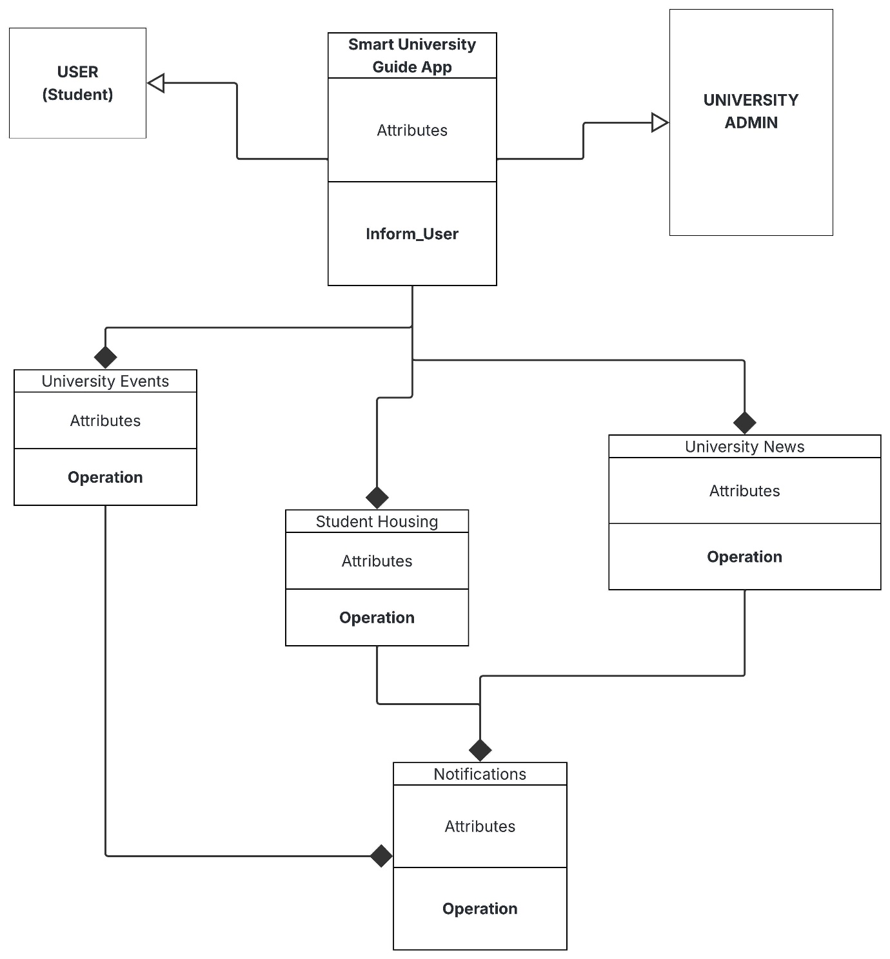

1.2. Document Conventions
This document uses shall for mandatory requirements and may for optional ones. Requirements are labeled FR-XX (functional) and NFR-XX (non-functional), each uniquely identifiable for traceability. Higher-level requirements do not automatically propagate priority to sub-requirements; each is rated independently as High / Medium / Low.
1.3. Intended Audience and Reading Suggestions
The software shall assist all newcomers, freshmen and Erasmus students who are to engage in universities system in some way.
1.4. Product Scope
SUGA is a cross-platform mobile and web application that shall act as a single digital hub for student life at Lodz University of Technology. It consolidates academic management, campus navigation, library access, cafeteria ordering, student services, social events, and transport tracking into one unified interface. The goal is to eliminate the need for students to use multiple different portals.
1.5.References
- IEEE Std 830-1998, Recommended Practice for Software Requirements Spesifications
- WIKAMP PLATFORM: SWE Lab presentations slides
2. Overall Description
SUGA is a new, self-contained product. It replaces the fragmented experience of using Facebook groups, Outlook email, departmental websites, and the USOS portal separately. It is not a follow-on to an existing system, but is designed to be extensible for other Polish universities in future versions.

2.1 Product Perspective
SUGA is a new, self-contained product. It replaces the fragmented experience of using Facebook groups, Outlook email, and the departmental websites. It is not a follow-on to an existing system, but is designed to be extensible for other Polish universities in future versions.
2.2. Product Features
- Seamless transition to the map navigating the user towards their campus destination via the Google/Apple Maps or, if installed, Navi.pl
- Unified and intuitive event feed (sports, cultural, academic events)
- Explicit tab-based system where each tab is responsible for the event or news similar to Google News mobile app
- Personalized onboarding wizard for new/exchange students

Figure 3. Architecture of product features

2.3. User Classes and Characteristics
Freshmen — primary users; low familiarity with campus systems, high frequency of onboarding-related queries, non-technical. Exchange/Erasmus students — similar to freshmen but may require multilingual support (English minimum). Returning students — occasional users for event discovery and cafeteria ordering. University staff (admin) — publish announcements and events; interact via a separate admin panel not covered in this SRS.
2.4. Operating Environment
The app shall run on Android 10+ and iOS 15+ as a React Native mobile application, and on modern web browsers (Chrome 110+, Firefox 110+, Safari 16+) as a Progressive Web App. The backend shall be hosted on a cloud platform (e.g. AWS or Azure) with a RESTful API. The system requires an active internet connection; offline caching of the campus map is a low-priority optional feature.
2.5. Design and Implementation Constraints
- The app must comply with GDPR (EU Regulation 2016/679) regarding student personal data.
- The development team consists of 2–3 students with limited server infrastructure budget; serverless or free-tier cloud services are preferred.
- The UI must support English and Polish languages from launch.

Figure 4 Design Implementation flow

2.6. User Documentation
- In-app onboarding tutorial (interactive walkthrough on first launch)
- In-app FAQ section accessible from the main menu
- PDF quick-start guide for distribution during freshman orientation

2.7. Assumptions and Dependencies
- It is assumed that Lodz University of Technology will provide or permit scraping of publicly available data (cafeteria menus, event listings, timetables).
- Google Maps SDK (free tier) is assumed sufficient for campus navigation at the expected user volume.
- Push notification delivery depends on Apple APNs and Google FCM services remaining available.
3. System Features
- Campus Navigation
- Unified Event Feed
- Library Access
- Student Services Hub
- Transport Tracker

4. External Interface Requirements
4.1. User Interfaces Overview
The app uses a bottom-navigation tab bar (Home, Map, Events, Services, Profile). Each screen follows Material Design 3 guidelines. Error messages appear as non-blocking toast notifications. All interactive elements must meet WCAG 2.1 AA contrast ratio
4.2. Hardware Interfaces
The mobile app shall access the device GPS module for location-based map centering. It shall request camera permission only for optional QR-code scanning (e.g., library book lookup). No other hardware interfaces are required.
4.3. Software Interfaces
- USOS REST API — read student schedule and grades (OAuth 2.0 authentication)
- Google Maps SDK — campus map rendering and routing
- Firebase Cloud Messaging — push notifications
- University library API (KOHA ILS) — book search and loan status queries
5. System Features/Modules
5.1. Campus Navigation
5.1.1 Description and Priority
5.1.1: High priority. Allows students to find buildings, rooms, and facilities on an interactive map. — 5.1.2: Stimulus: student searches for a building name → Response: map centers and highlights the location with a route. — 5.1.3: REQ-1.1: Upon entering a location name, the SUGA App shall display the campus route within 3 seconds.
5.2. Unified Event Field
5.2.1: High priority. Aggregates events from Facebook, Outlook, and university portals into one feed. — 5.2.2: Stimulus: student opens Events tab → Response: app displays chronologically sorted events from all sources. — 5.2.3: REQ-2.1: The system shall aggregate events from at least 3 university sources and refresh every 15 minutes.
5.3 Cafeteria Ordering — 5.3.1: Medium priority. Lets students browse menus and pre-order meals. — 5.3.2: Stimulus: student selects a meal → Response: item is added to cart and order is submitted on confirmation. — 5.3.3: REQ-3.1: The system shall allow a student to complete a cafeteria order within 2 user interactions after selecting an item.
5.4 Library Access — 5.4.1: Medium priority. Displays book availability and the student's active loan status. — 5.4.2: Stimulus: student opens Library tab after login → Response: app shows borrowed books, due dates, and search results. — 5.4.3: REQ-4.1: Upon successful authentication, the system shall display the student's current loans and due dates fetched from the KOHA library API.
5.5 Transport Tracker — 5.5.1: Medium priority. Shows real-time bus and tram departures near campus. — 5.5.2: Stimulus: student opens Transport tab → Response: app uses GPS to show next 3 departures from nearby stops. — 5.5.3: REQ-5.1: The system shall display upcoming departures for all public transport stops within 500 m of the student's GPS location.
5.6 Student Services Hub (optional 6th feature to strengthen the doc) — 5.6.1: Low priority. Centralises access to dean's office, housing, and scholarship links. — 5.6.2: Stimulus: student selects a service category → Response: app displays relevant contacts, forms, and deadlines. — 5.6.3: REQ-6.1: The system shall provide categorised access to at least 5 student administrative services from the main Services tab.
6. Nonfunctional Requirements
6.1. Performance
NF-1.1: The system shall load the home feed in under 2 seconds on a 4G connection with up to 500 concurrent users.
6.2. Security
NF-2.1: All authentication tokens shall be stored in the device secure enclave (Keychain on iOS, Keystore on Android) and never in plain-text local storage. NF-2.2: All data exchanged between the app and university servers shall be transmitted over HTTPS using TLS 1.2 or higher.
6.3. Reliability
NF-3.1: The backend API shall maintain 99.5% monthly uptime, excluding scheduled maintenance windows announced at least 24 hours in advance.

