19162121031

SMIT R PATEL

SEM 5

SOFTWARE ENGINEERING

PRACTICAL 7

Aim: Demonstration of Source Code &amp; Configuration Management using Git, Gitbash &amp; GitHub.

Demo Task:

For demo project, commands and steps to perform various source code and config management

activities using Git, Git bash and Github.

Task to be performed by Students:

Follow the below workflow for your project using SCM tools.

Make sure to add and get awareness for the following below tasks for your project/system

assigned to you.

1. Managing your organization’s GitHub account , Install Git

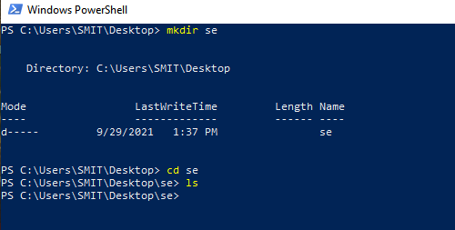

To initialize a git repository in the root of the folder, run the git init

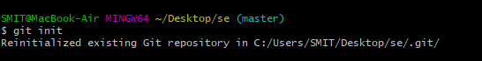

2. Create and adding new files to local git repository

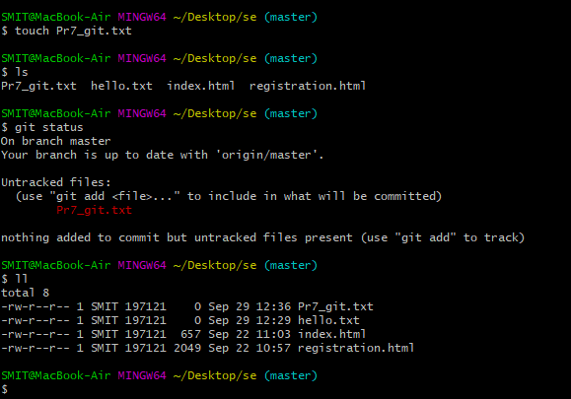

Here git has noticed that there is a new file called PR6_git.txt but unless we use “git add” command git will not do anything with it.

3. Demonstrate the staging environment and various commits

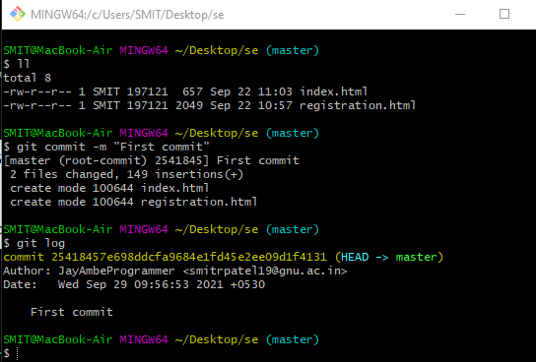

4. Add a file in to the staging environment

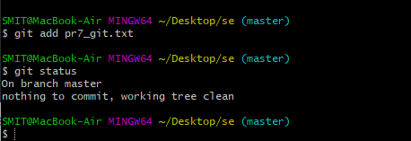

After doing git add “filename” when we see the status of the file using git status command we can see that the file is in the staging area.

5. Create commit and new branches

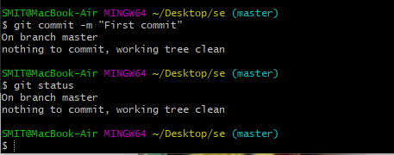

The file has been

commited.Now

creating new branch:-

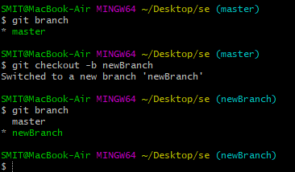

First there was only “master” branch but after using git checkout -b newBranch it will create a newbranch and will move us to the new branch.

6. Create a new repository on Github.

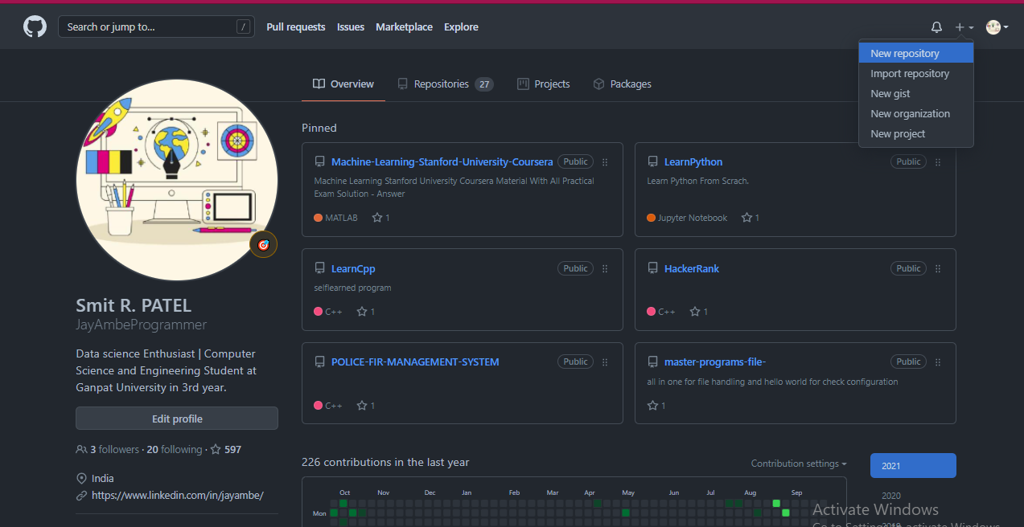

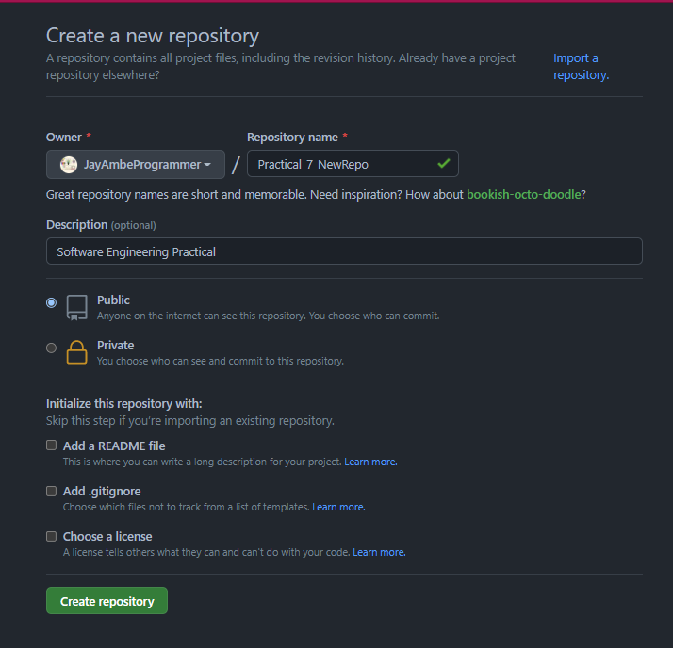

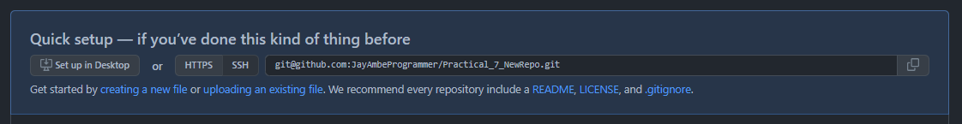



Added Git repository to local folder

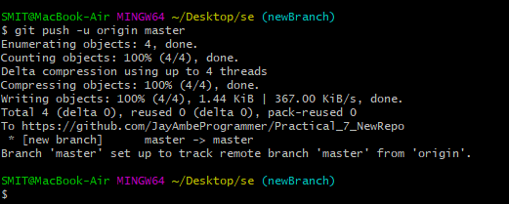

Pushed file to git.

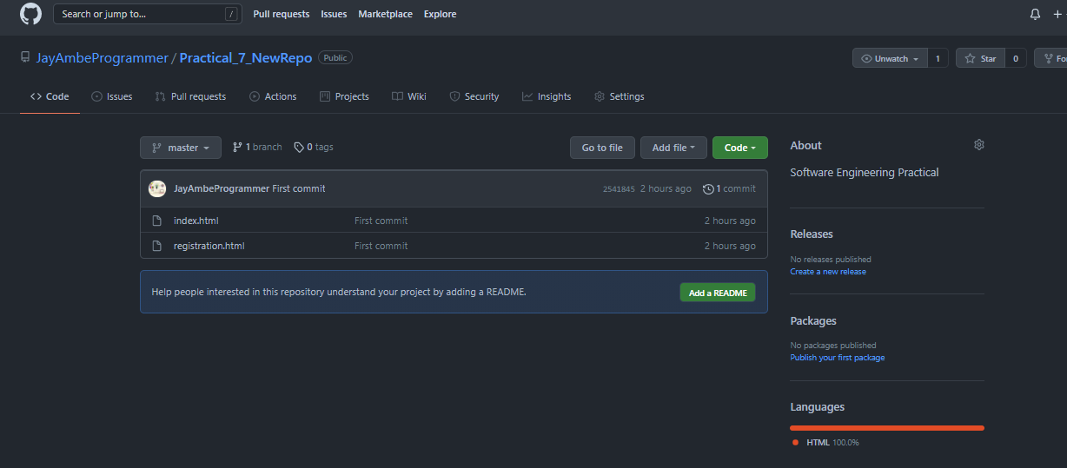

7. Pushing a branch to Github

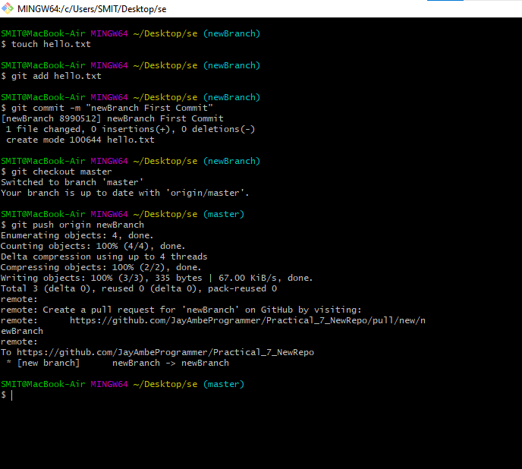

Here I created and commited a new file in newBranch branch then from master branch I PushednewBranch to github

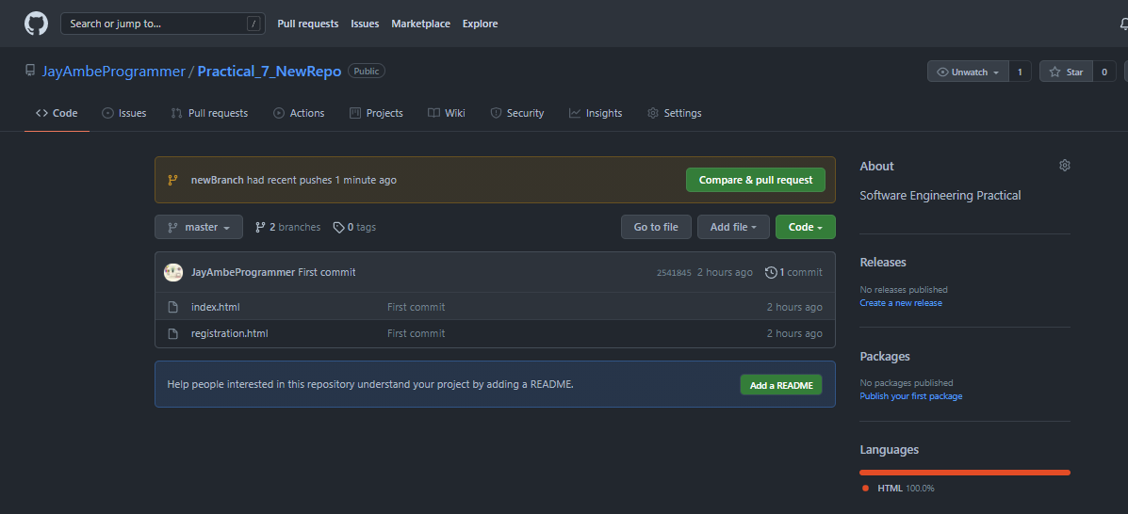

Here there are difference in master branch and newBranch so after clicking “Compare and pull request” it will change the master branch.

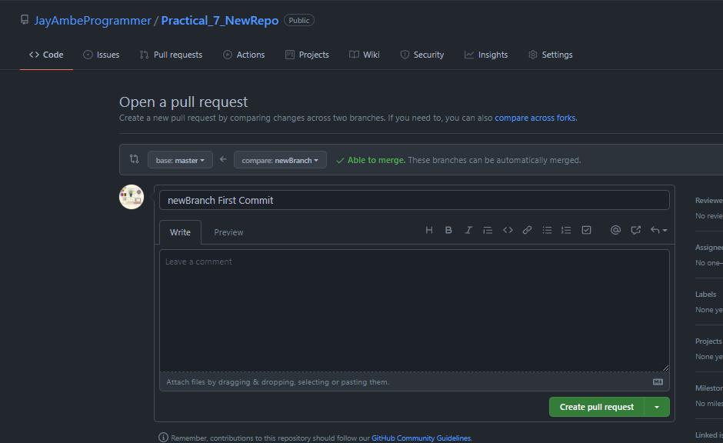

8. Managing Pull Request for your projects (PRs)

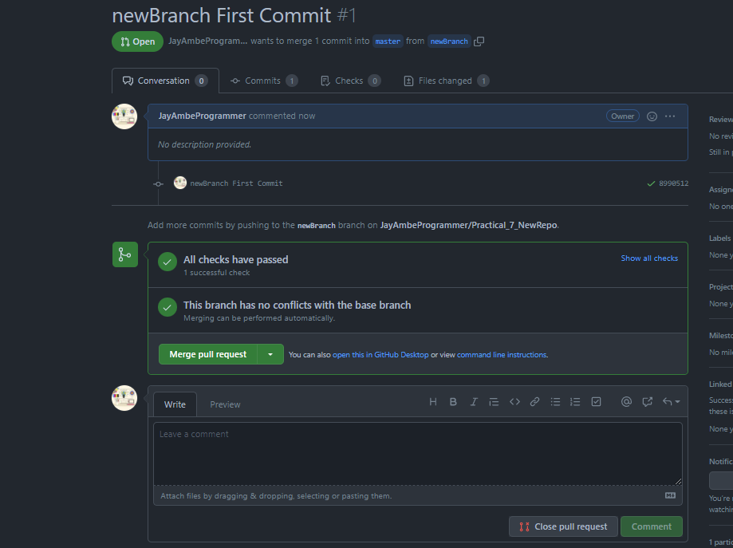

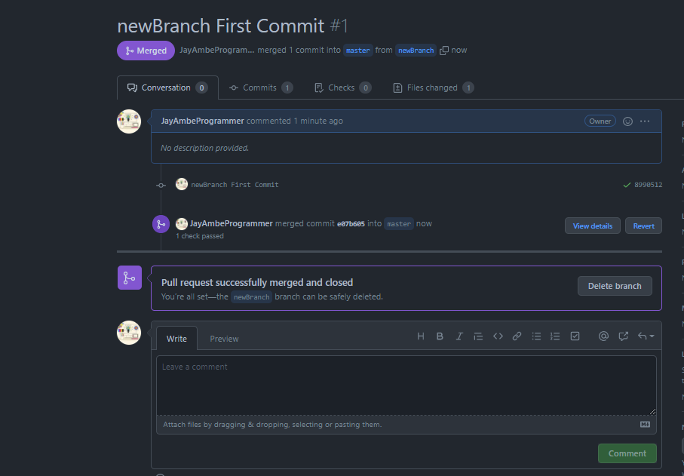

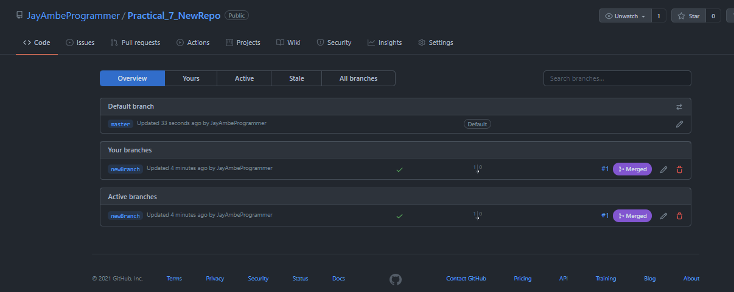

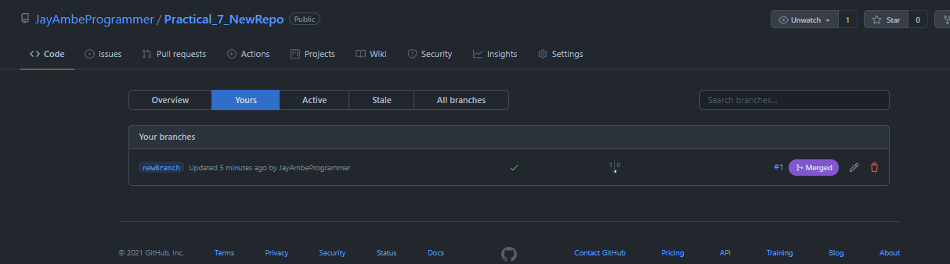

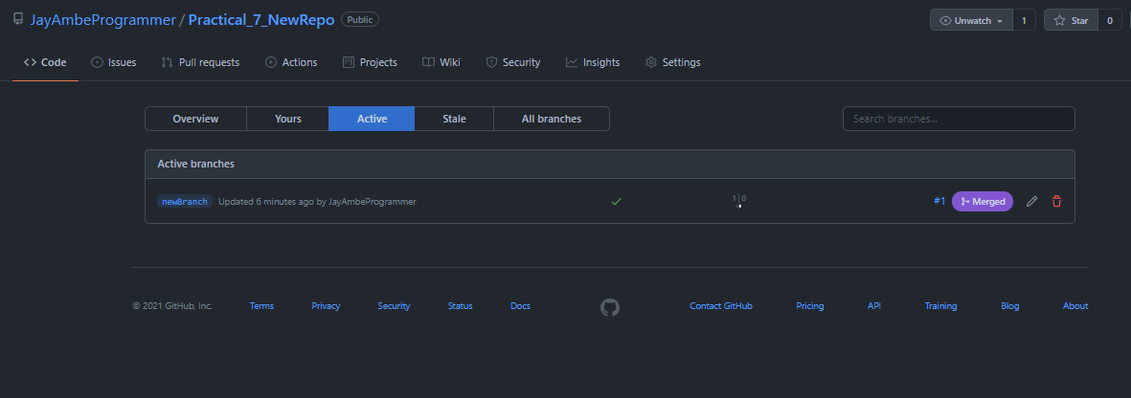

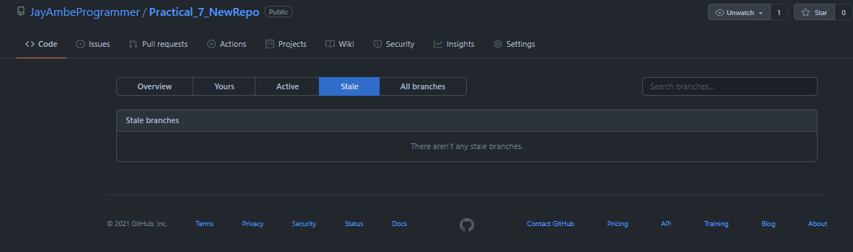

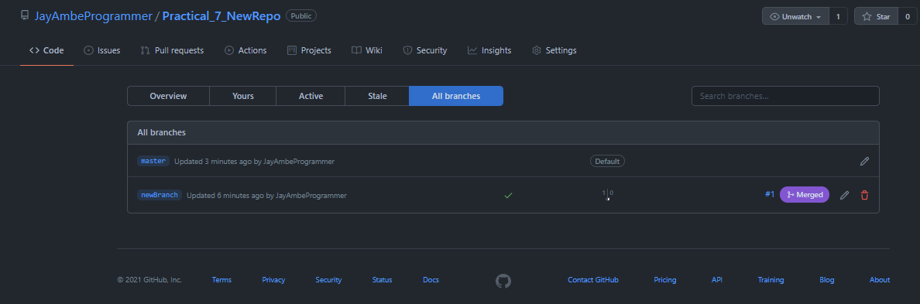

9. Managing changes back to your Local PC from Github

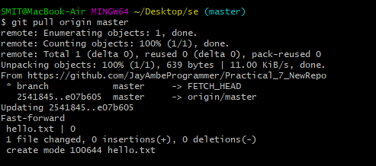

Using git log we are seeing the commit we have made:-

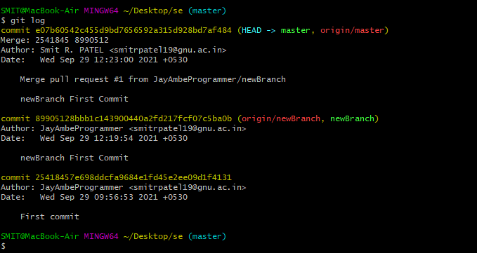

Extra :-

Prerequiste :

1. check connection:

command :-

$ ssh -T [git@github.com](mailto:git@github.com)



1. $ssh-keygen.exe

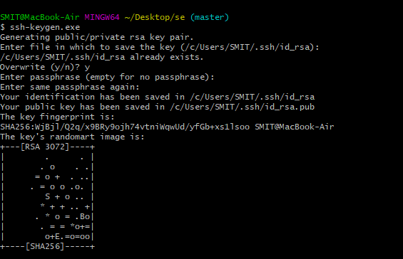

1. $cd "C:\Users\Admin\.ssh"



1. $ls



1. $cat id_rsa.pub

Note :- [Copy this public key & add to github-seeting -key : Paste the copied public key in ssh key and then add key.]

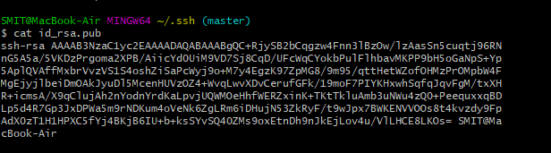

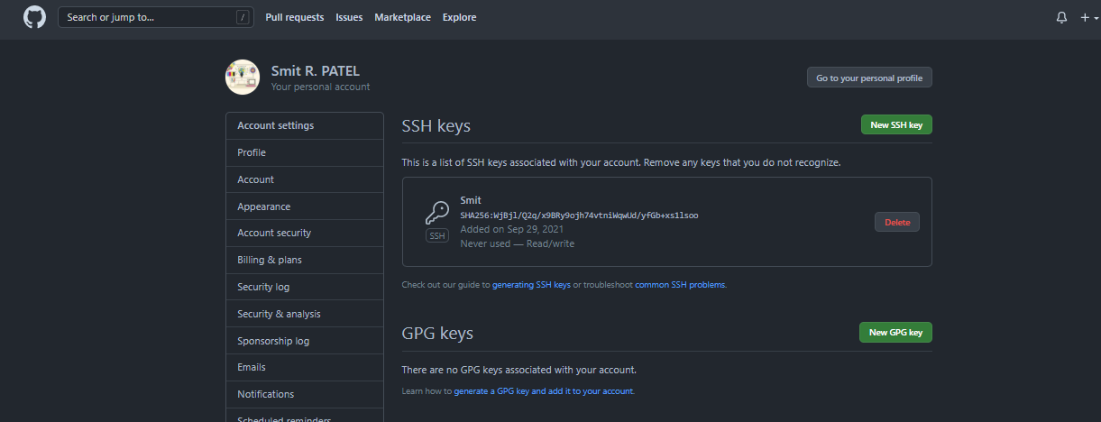

1. Check SST connection again using

$ssh -T git@github.com

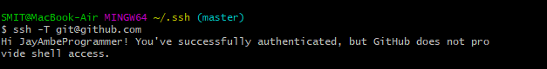

$git config --global user.name "Smit"

$git config --global user.email "smitrpatel19@gnu.ac.in"

