**DBS LAB-8: NORMALIZATION - 1**

ANSWER: 1

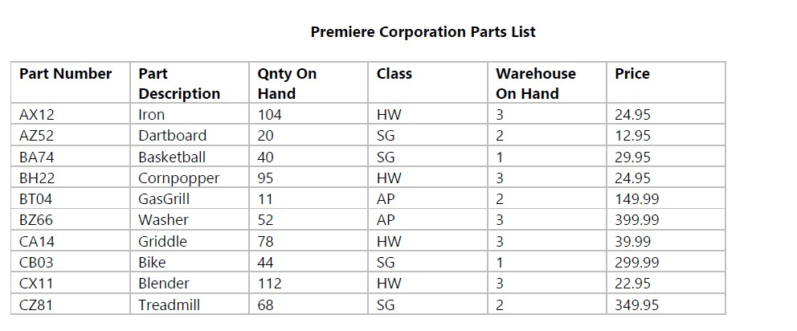

1. What type of data does each line in the report represent?

Ans: As we see the above table, we can see that the title at the top named – Premiere Corporation Parts List. The first column that have six headings describe the body of whole report. Each line contains the data of part. For example, the first column contains the part description Iron, which has the Part Number AX12 with the quantity on hand 104 and have a class HW. There is total 3 parts on hand in warehouse and the price is 24.95. Total 10 columns are there with unique Part Number. Count of quantity, class and the price could be same, but the Part Description and the Part Number is Unique.

1. What attributes can you identify from the user view?

We can identify the attribute by just simply understanding the heading of report. In our Premiere Corporation Parts List report, we can identify the attributes as following:

1.)Part Number 2.) Part Description 3.) Quantity On Hand 4.) Class 5.) Warehouse on Hand 6.) Price

C.) What would be a suitable name for the UNF relation?

Ans: The suitable name for the UNF relation could be the “PARTS” because each line is describing the detail information/data of parts like part number, part description, part class, the quantity, and the price of it.

D. ) Which attribute would be suitable as a primary key?

Ans: Part Number would be suitable as a Primary Key

E.) Describe the UNF relation using DBDL

Ans: the UNF using DBDL:

PARTS [PartNo, PartDesc, PartQuan, PartClass, WarehouseOnHand, PartPrice]

ANSWER 2

For the following User View, determine the UNF and the 1NF and hand in this page to your instructor.

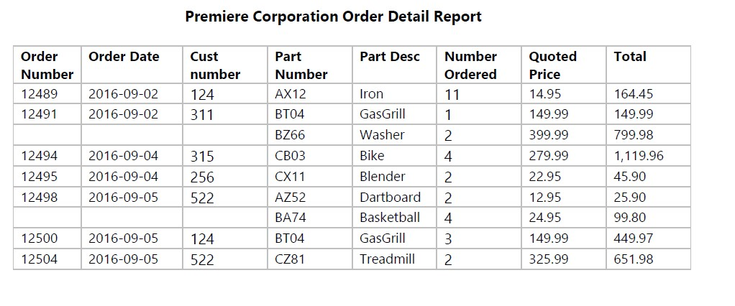UNF:

ORDERS [OrdNum, OrdDate, CustNum, ( PartNum, PartDesc, NumOrdered, Price, Total)]

1NF:

ORDERS [OrdNum, OrdDate, CustNum]

ORDER_PARTS [FK PartNum, FK OrdNum]

PARTS [PartNum,PartDesc, NumOrdered, Price, Total]