Photovoltaic (Solar) Power Prediction on Large-Scale Spatiotemporal Data
Machine Learning Course Project
Student: [YOUR NAME]
Course: ECE571 Machine Learning
Professor: [PROFESSOR NAME]
Date: [DATE]
Note: name, professor, and date are left as placeholders — they are not recorded anywhere in the project's files, so they are not invented here. Please fill these in before submitting.

Abstract
Photovoltaic (PV) power output is intermittent and entirely dependent on weather, which makes it a useful problem for exploring several different machine learning approaches on the same data. This project uses a multi-year irradiance, weather, and PV-output dataset covering five U.S. cities (Amherst MA, Davis CA, Huron SD, Santa Barbara CA, and La Jolla CA) to work through five machine learning paradigms: supervised classification, supervised regression, dimension reduction, semi-supervised learning, and transfer learning. Classical models (logistic regression, random forests, gradient boosting) and deep models (multi-layer perceptrons, a GRU, and an autoencoder) were compared under a consistent chronological train/test protocol designed to prevent data leakage. The strongest result was same-city Output Power regression for Davis (RMSE = 15.17 kW, R² = 0.953). Two of the five paradigms produced clearly negative results rather than improvements: dimension reduction reduced downstream performance at every tested compression level, and semi-supervised pseudo-labeling produced a small negative gain at every labeled-data fraction tested. Transfer learning, in contrast, clearly helped — a Davis-pretrained model fine-tuned on just 10 Amherst samples cut RMSE by 21.4% compared with training on those same 10 samples alone. The most interesting finding came from diagnosing why an early version of that transfer experiment actually made things worse: an overly conservative fine-tuning learning rate, not a fundamental limitation of transfer learning, was the cause, and correcting it reversed the result entirely. Overall, the project's main conclusion is that whether an advanced ML technique helps on a given problem is something that has to be tested directly, not assumed in advance.

1. Introduction
Solar photovoltaic generation is one of the fastest-growing sources of electricity, but it is also one of the hardest to plan around. Unlike a fossil-fuel plant, a PV installation cannot be turned up on demand — its output is set entirely by the weather. This property is usually called intermittency, and it creates real operational problems: grid operators need to know how much power to expect over the next hours so they can schedule other generation and reserves; battery storage systems need forecasts to decide when to charge and discharge; and utilities planning a new installation in an area with little or no historical data need some way to estimate what it will produce. All three of these problems are, at their core, machine learning problems — relating weather and irradiance conditions to electrical output, sometimes with plenty of historical data available and sometimes with very little.
The role of weather and irradiance here is direct: solar panels convert incoming sunlight (irradiance) into electricity, so the amount of irradiance reaching the panels — which depends on cloud cover, time of day, season, and atmospheric conditions — is the single biggest driver of how much power comes out. This is exactly why weather-based features are the whole basis for every model in this project.
This project uses a real dataset of irradiance, weather, and measured PV Output Power across five U.S. cities to explore this family of problems, broken into five distinct ML paradigms rather than a single end-to-end pipeline, so that each technique can be tested cleanly against its own appropriate baseline:
1. Supervised Classification — can weather features predict a discrete sky condition or generation level?
2. Supervised Regression (the project's core task) — how accurately can continuous Output Power be predicted, same-city, across cities, and as a short-term forecast?
3. Dimension Reduction — can the feature space be compressed without losing the information the earlier tasks depend on?
4. Semi-Supervised Learning — how much does having a large pool of unlabeled weather data help when only a few labels are available?
5. Transfer Learning — can a model trained on a data-rich city (Davis) help a data-poor city (Amherst)?
The goal of this project is not simply to produce the best possible number on each task, but to test, honestly, which of these five paradigms actually help for this kind of data — and to explain why, in each case, using the methods and vocabulary covered in this course.

2. Dataset
The dataset comes from a single Excel workbook with 9 sheets covering 5 cities: Amherst, MA (2018–2020, 12,056 rows), Davis, CA (2011–2016, 24,112 rows), Huron, SD (2011–2016, 24,112 rows), Santa Barbara, CA (2011–2016, 24,112 rows), and La Jolla, CA (2011–2016, 24,112 rows). Row counts are taken directly from the project's dataset profile document, not estimated. Four of the nine sheets are exact 2014–2016 subsets of the corresponding six-year sheets, used for a 3-year vs. 6-year data-volume comparison in Problem
2. Readings are taken every 30 minutes across an 11-sample daytime window (10:00–15:00) — the dataset does not include nighttime hours.
Each row contains 22 columns: irradiance measurements (GHI, DNI, DHI, and their theoretical clear-sky equivalents), weather variables (Temperature, Relative Humidity, Wind Speed, Wind Direction, Dew Point, Pressure, Surface Albedo, Precipitable Water), a categorical Cloud Type code, Solar Zenith Angle, and the target variable, Output Power, measured in kW. Missing data is minimal: the only gap in the entire workbook is 4 rows of missing Output Power in the Amherst sheet (2020-07-06, four consecutive 30-minute readings).
Table 1. Dataset overview.
City | Years | Rows | Mean Output Power (kW) | Std (kW)
Davis, CA | 2011–2016 | 24,112 | 164.0 | 67.4
Amherst, MA | 2018–2020 | 12,056 | 60.9 | 41.1
Huron, SD | 2011–2016 | 24,112 | 50.1 | 16.4
Santa Barbara, CA | 2011–2016 | 24,112 | 49.1 | 18.3
La Jolla, CA | 2011–2016 | 24,112 | 47.3 | 15.6

A central challenge running through this project is that Output Power has a different physical scale in every city — Davis's average output is roughly 2.7–3.5 times that of the other four cities, reflecting different installed plant capacities, not different weather quality. This scale difference turns out to matter enormously for Problems 2 and 5, both of which involve comparing or transferring information across cities.
Figure 1 shows this scale difference directly: Output Power distributions by city, with Davis's distribution visibly shifted well above the other four.
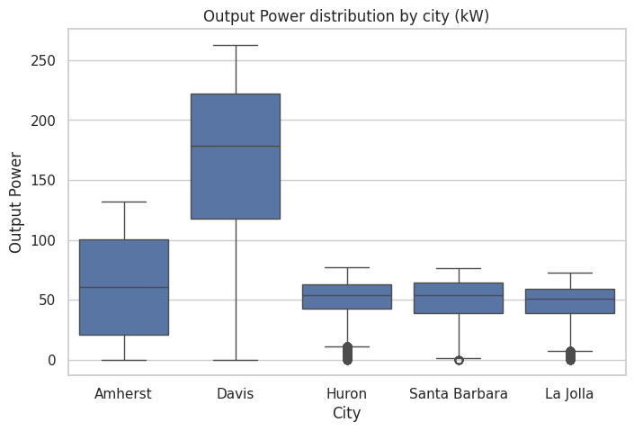

3. Data Preprocessing
Missing values. Only 4 rows across the entire dataset had a missing Output Power value (Amherst, 2020-07-06). These rows were dropped rather than filled in, since interpolating a target value and then training on it as if it were real ground truth would mean learning from fabricated data.
Categorical handling. Cloud Type is a categorical code (for example, code 3 vs. code 7), not a quantity — code 7 is not numerically "more" than code 3. Treating it as an ordinary number would imply a false ordering, so it is one-hot encoded everywhere it is used, turning each possible cloud-type value into its own 0/1 column.
Numerical scaling. All continuous numeric features are standardized (rescaled to zero mean, unit variance) using scikit-learn's `StandardScaler`. This matters most for the neural network models (Problems 1, 2, and 5's MLPs, and Problem 3's autoencoder), which train more reliably when input features are on comparable scales.
Clear-Sky Index. An engineered feature, `Clear-Sky Index = GHI / Clearsky GHI` (with safe handling for any zero-denominator rows), measuring how close actual irradiance is to the theoretical clear-sky maximum. This index is what Problem 1's sky-condition label is built from.
Cyclical time features. Hour-of-day, month, and day-of-year are each converted into a pair of sine/cosine features rather than left as raw integers. This is done because raw integers imply a false "distance" — for example, hour 23 and hour 0 are adjacent in real time but numerically as far apart as possible. Sine/cosine encoding places adjacent times close together in feature space.
Lag features and sequence windows. For Problem 2's sequence forecasting sub-task, a sliding window of the previous 12 readings (roughly 6 hours, at 30-minute spacing) is used to predict the next reading. This window size was chosen to give the model several hours of recent history without extending into the previous day's readings.
Train/test splitting. Every same-city experiment in this project uses a chronological 80/20 split: the earliest 80% of a city's timestamps, in order, form the training set, and the most recent 20% form the test set. This is a deliberate choice, not a default — randomly shuffling the data before splitting would be invalid for this kind of time-series problem, because it could place a later reading in the training set and an earlier reading in the test set, effectively letting the model "see the future" relative to what it is being tested on. That would make every reported metric optimistic and meaningless for genuine forecasting.
Cross-city protocol. Cross-city experiments (Problems 2 and 5) go further: a model is trained entirely on the source city and evaluated directly on a separate target city's data, with zero rows from the target city touching anything used to fit the model — not the model itself, and not any scaler or encoder.
Leakage prevention, generally. Every scaler and encoder in this project is fit on training data only, then applied unchanged to the corresponding test data — never fit on combined data, and never fit on test data at all. This rule was checked directly by reading the relevant code, not just assumed.

4. Experimental Setup
Hardware. All experiments in this project, including every neural network, were developed and run on CPU — no GPU was available in the development environment. The shared code automatically detects and uses a GPU when one is available (via `torch.cuda.is_available()`), so it would use the project owner's GPU hardware without any code changes if run there.
Software. Python 3.12, with pandas, NumPy, scikit-learn, PyTorch, and matplotlib as the core libraries. Exact package versions observed during development: pandas 3.0.2, numpy 2.4.4, scikit-learn 1.8.0, torch 2.14.0, matplotlib 3.10.8 (`requirements.txt` specifies minimum-compatible version ranges rather than exact pins, so a slightly different but compatible version set is expected on another machine).
Random seeds. Every randomized experiment (model initialization, few-shot sampling, stratified subset selection) used the same three seeds — 42, 123, and 2026 — and results are reported as mean ± standard deviation across all three seeds wherever three-seed data is available.
Train/test strategy. Chronological 80/20 splits for all same-city experiments (see Section 3); cross-city and transfer experiments use one city's full chronological training pool as the source and a separate city's chronological test split as the held-out evaluation set.
Evaluation metrics. Classification tasks use accuracy, balanced accuracy (the average of each class's recall, which prevents a majority class from inflating the score), and macro F1 (F1 averaged equally across classes). Regression tasks use RMSE (root mean squared error, which penalizes large errors more heavily since errors are squared before averaging), MAE (mean absolute error, the plain average error size), and nRMSE (RMSE divided by the target's observed range, which allows error comparison across cities or targets with different scales).
Model comparison strategy. Within each problem, every model is evaluated on the exact same train/test split and the exact same three seeds, so comparisons between models are apples-to-apples. Small hyperparameter searches (typically 3–5 candidate configurations) were used where tuning was explored, selected using a chronological inner validation split of the training data only — never the real test set.
Table 2. Experimental setup summary.
Problem | Task | Dataset(s) | Models Compared | Main Metric
1 | Sky-condition & generation-regime classification | Davis, Amherst | Majority baseline, logistic regression, decision tree, random forest, gradient boosting, MLP | Balanced accuracy
2 | Output Power regression | Davis, Amherst (same-city); Davis→Huron/Santa Barbara/La Jolla (cross-city) | Mean baseline, linear/ridge regression, decision tree, random forest, gradient boosting, MLP, GRU (sequence) | RMSE
3 | Dimension reduction (unsupervised) + downstream classification/regression | Davis | PCA, autoencoder, at d=2/5/10, vs. raw features | Downstream balanced accuracy / RMSE
4 | Semi-supervised sky-condition classification | Davis | Supervised-only baseline vs. pseudo-labeling (+ Label Spreading) | Macro F1, at 10%/30%/50% labels
5 | Transfer learning for Output Power regression | Davis → Amherst | Zero-shot, few-shot (fresh model), transfer (fine-tuned) | RMSE, at k=10/50/100 target samples

5. Problem 1 — Supervised Classification

Objective
Predict a discrete category from weather features. Two separate classification tasks were built:

Labels
- Sky-condition (Clear / Partly Cloudy / Overcast) — assigned by thresholding the Clear-Sky Index (`k`): Clear if k ≥ 0.85, Partly Cloudy if 0.4 ≤ k < 0.85, Overcast if k < 0.4. These thresholds come from the project specification, not chosen independently. - Generation-regime (Low / Medium / High) — assigned using per-city Output Power terciles computed from each city's training data only, so the target city's own boundaries never leak from test data.
Because sky-condition is defined by GHI and Clearsky GHI, both columns were excluded from the classifier's input features — using them would let the model see the answer directly instead of learning a genuine weather-to-sky-condition relationship. Solar Zenith Angle, DHI, and DNI were also excluded, because together they can approximately reconstruct GHI; this risk was verified directly, not just assumed — including them in a test run pushed accuracy from around 0.74–0.81 up to roughly 0.98, confirming the leak was real.

Methods
Only models actually implemented and evaluated are reported here: a majority-class baseline, logistic regression (plain and with balanced class weighting), decision tree, random forest, gradient boosting, and a small feed-forward multi-layer perceptron (MLP). Logistic regression fits a linear boundary between classes; decision trees and their ensemble variants (random forest, gradient boosting) split the data on feature thresholds repeatedly; the MLP is a small neural network with one or two hidden layers. Class-weighted and lightly-tuned variants of several models were also tested.

Results
Table 3. Problem 1 results — Davis sky-condition, mean across 3 seeds.
Model | Accuracy | Balanced Accuracy | Macro F1
Majority baseline | 0.704 | 0.333 | 0.275
Decision tree | 0.828 | 0.697 | 0.688
Decision tree (balanced weight) | 0.811 | 0.678 | 0.668
Random forest | 0.855 | 0.743 | 0.736
Random forest (balanced weight) | 0.855 | 0.746 | 0.737
Random forest (tuned) | 0.853 | 0.739 | 0.732
Gradient boosting | 0.855 | 0.752 | 0.740
Gradient boosting (tuned) | 0.856 | 0.754 | 0.742
MLP | 0.853 | 0.755 | 0.739
MLP (tuned) | 0.853 | 0.755 | 0.739
Logistic regression | 0.857 | 0.769 | 0.749
Logistic regression (balanced weight) | 0.831 | 0.772 | 0.720

The best model by balanced accuracy was logistic regression with balanced class weighting (0.772) — narrowly ahead of plain logistic regression (0.769), and ahead of every ensemble or neural-network model tried. This was not the expected outcome going in; it suggests that once the leakage-risk irradiance features are excluded, the remaining predictors (mainly Cloud Type and general weather variables) relate to sky-condition in a fairly direct way, so a simple, well-regularized linear model does not lose much by not modeling complex feature interactions.

Confusion Matrix
Figure 2 shows the confusion matrix for the best Davis sky-condition model.
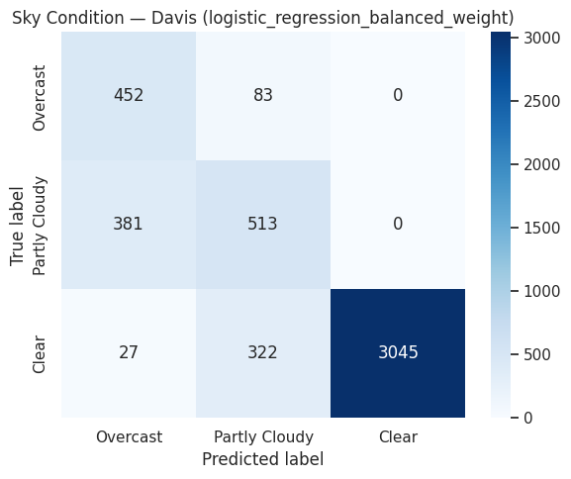
Per-class F1 scores for this model: Clear 0.946, Partly Cloudy 0.566, Overcast 0.648. Clear conditions were easiest to identify — Clear is also the majority class, at about 72% of the data. Partly Cloudy was the hardest class — it sits on the Clear-Sky Index scale between the other two classes and is confused with both neighbors rather than having one dominant failure mode. This is the expected pattern for a class defined by two adjacent thresholds instead of one: it inherits ambiguity from both boundaries.

Discussion
Balanced accuracy, not raw accuracy, was used as the primary metric because of class imbalance: Overcast is the rarest class (about 11% of Davis test rows), so a model that always predicted "Clear" would already reach roughly 70% raw accuracy while providing no real information. The finding that a simple linear model outperformed every ensemble and neural network tested is a genuinely useful result for this report — it suggests that, at least for this leakage-safe feature set, the sky-condition relationship does not require a complex model to capture well.

6. Problem 2 — Supervised Regression

Objective
Predict continuous Output Power (kW), the project's core task, using the full weather and irradiance feature set. Unlike Problem 1, there is no leakage restriction on GHI-family features here — Output Power is a physically measured quantity, not a rule-based function of these columns.

Same-City Experiment
Both Davis and Amherst were tested with a same-city chronological 80/20 split — training and evaluating within one city's own data.

Cross-City Experiment
The Davis-trained model (gradient boosting, the same-city winner) was applied directly, with no retraining, to three other cities actually tested in this project: Davis → Huron, Davis → Santa Barbara, and Davis → La Jolla. No other city pairs were evaluated in Problem 2.

Sequence Forecasting
A K=12 sequence window (the previous 12 readings, about 6 hours) was used to predict the next reading with a GRU (gated recurrent unit) recurrent neural network, trained and evaluated on Davis. This is compared against a naive persistence baseline (predicting no change from the last reading).

Results
Table 4. Problem 2 results (mean ± std across 3 seeds where applicable).
Model | City | RMSE (kW) | MAE (kW) | nRMSE
Gradient boosting | Davis (same-city) | 15.17 ± 0.00 | 8.31 | 0.0600
Gradient boosting (tuned) | Davis (same-city) | 15.39 | 8.44 | 0.0609
Random forest (tuned) | Davis (same-city) | 15.52 | 7.98 | 0.0614
MLP (tuned) | Davis (same-city) | 15.72 | 9.13 | 0.0622
Linear regression | Davis (same-city) | 16.93 | 10.01 | 0.0670
Mean baseline | Davis (same-city) | 71.84 | 60.72 | 0.2842
Gradient boosting (tuned) | Amherst (same-city) | 20.29 ± 0.01 | 13.62 | 0.1595
GRU (sequence, K=12) | Davis | 17.58 ± 0.10 | 10.04 | 0.0695
Persistence baseline | Davis (sequence) | 21.97 | 15.04 | 0.0869
Gradient boosting (zero-shot) | Davis → Huron | 125.81 ± 0.01 | 116.24 | 1.6920
Gradient boosting (zero-shot) | Davis → Santa Barbara | 125.48 ± 0.61 | 116.55 | 1.6994
Gradient boosting (zero-shot) | Davis → La Jolla | 124.39 ± 1.30 | 115.95 | 1.8146

nRMSE throughout this report is range-normalized (RMSE divided by the target's observed max − min), a convention fixed early in the project and applied consistently everywhere it is computed.

Visualization
Figure 3 shows predicted vs. actual Output Power for the best Davis same-city model.
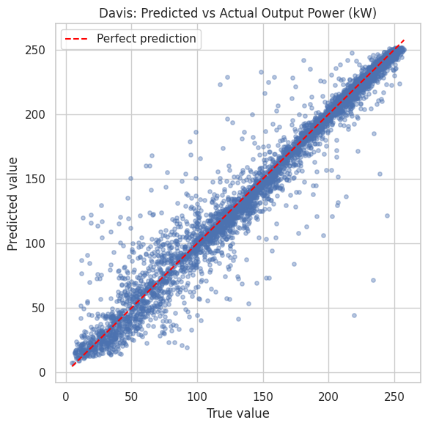
Points cluster tightly around the perfect-prediction diagonal line, consistent with the high R² (0.953) for this model.
Figure 4 compares the raw cross-city zero-shot RMSE against an oracle target-mean baseline and a scale-corrected diagnostic calculation.
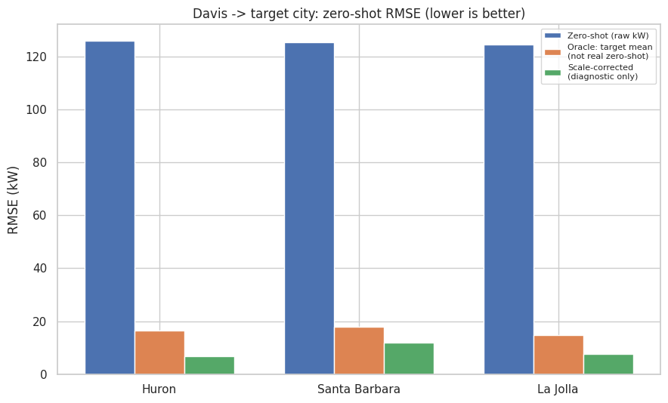

Discussion
Strongest model: gradient boosting, Davis same-city (RMSE = 15.17 kW, R² = 0.953) — notably, the untuned version, which slightly beat its own tuned variant (15.17 kW vs. 15.39 kW).
Weakest results: the three cross-city zero-shot experiments, all around RMSE = 124–126 kW — roughly 8 times worse than the same-city result.
Same-city vs. cross-city difference and likely cause: this gap is not evidence that weather fails to predict power in other cities. It is almost entirely a scale mismatch: the Davis-trained model's outputs are calibrated to Davis's own ~164 kW average, and applying them directly to cities whose true averages are 47–50 kW produces systematically oversized predictions. A diagnostic check — rescaling Davis's raw predictions using the target city's own mean, for analysis purposes only, since this uses information a genuine zero-shot deployment would not have — recovered R² values of 0.55–0.84, suggesting the underlying weather-to-power relationship transfers reasonably well once the scale problem is accounted for.
Sequence model: the K=12 GRU (17.58 kW) clearly beat the persistence baseline (21.97 kW), showing it learns genuine temporal structure rather than simply repeating the last reading. It does not beat the non-sequence same-city model (15.17 kW), but this is not a fair like-for-like comparison — the non-sequence model has access to the concurrent weather reading at the exact moment being predicted, while the sequence model must forecast using only past readings, a strictly harder task.

7. Problem 3 — Dimension Reduction

Objective
Test whether the 23-feature (after encoding) input space used elsewhere in this project can be compressed into fewer dimensions without losing the information that Problems 1 and 2 depend on. Dimension reduction is useful in general for reducing computation, for visualization, and for removing redundant or noisy features — this problem tests whether any of those benefits apply here, and whether compression comes at a cost.

Methods
Two methods were implemented and compared: PCA (principal component analysis — the classical, linear method) and a small feed-forward autoencoder (the deep, nonlinear method). Both are unsupervised — they are fit using only the input features, with no access to any label at all, and this was verified directly in the code: neither the PCA-fitting function nor the autoencoder's training function accepts a label argument. This matters because the whole point of the comparison is to see whether compressing the data's own structure (without looking at the answer) preserves enough information to still predict the answer well — using labels to shape the compression would be a different technique entirely, and would make the comparison meaningless. Both methods were evaluated at three latent dimensions: d = 2, 5, and 10. No other dimension-reduction methods (such as a VAE) were implemented in this project.

Explained Variance
Figure 5 shows PCA's explained-variance curve across dimensions.
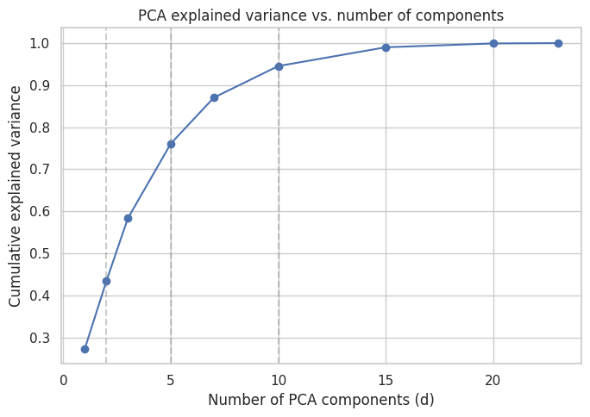
Cumulative explained variance was 0.434 at d=2, 0.761 at d=5, and 0.946 at d=10. d=10 was the largest dimensionality tested, chosen to represent a "generous" compression that keeps most of the original variance while still being a meaningful reduction from 23 dimensions.

Reconstruction
Figure 6 compares PCA and autoencoder reconstruction error across dimensions.
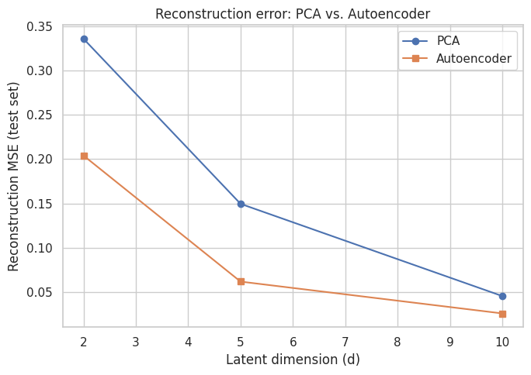
The autoencoder reconstructed the original features more accurately than PCA at every tested dimension (for example, at d=10: autoencoder MSE = 0.026 vs. PCA MSE = 0.046), consistent with its ability to learn nonlinear (curved) compressions where PCA is restricted to linear projections.

Downstream Classification
Figure 7 compares raw features against every tested PCA and autoencoder representation on the downstream sky-condition classification task.
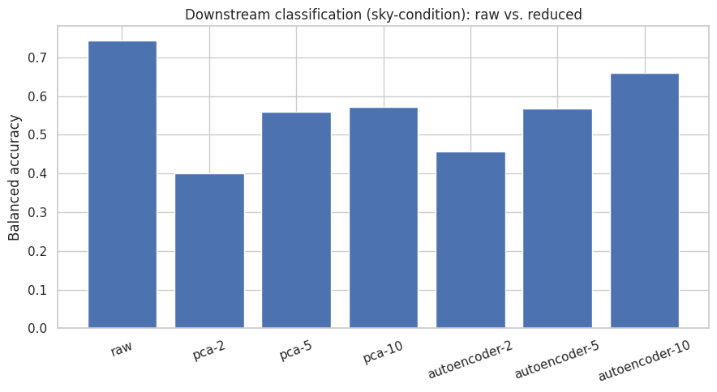
Table 5. Problem 3 results — downstream classification and regression, Davis.
Representation | Explained Variance | Reconstruction MSE | Classification Balanced Accuracy | Regression RMSE (kW)
Raw features | — | — | 0.743 | 23.86
PCA, d=2 | 0.434 | 0.336 | 0.401 | 44.86
PCA, d=5 | 0.761 | 0.150 | 0.559 | 33.96
PCA, d=10 | 0.946 | 0.046 | 0.571 | 32.10
Autoencoder, d=2 | — | 0.204 | 0.457 | 41.93
Autoencoder, d=5 | — | 0.062 | 0.568 | 36.29
Autoencoder, d=10 | — | 0.026 | 0.661 | 29.69

Note: to keep one shared representation valid for both downstream tasks, Problem 3 uses the same leakage-safe (no-irradiance) feature set as Problem 1 for both classification AND regression — so this table's "raw" regression RMSE (23.86 kW) is not directly comparable to Problem 2's own headline Davis result (15.17 kW), which uses the full feature set including irradiance.

Downstream Regression
The same comparison for the regression task appears in Table 5 above. Figure 8 shows this visually.
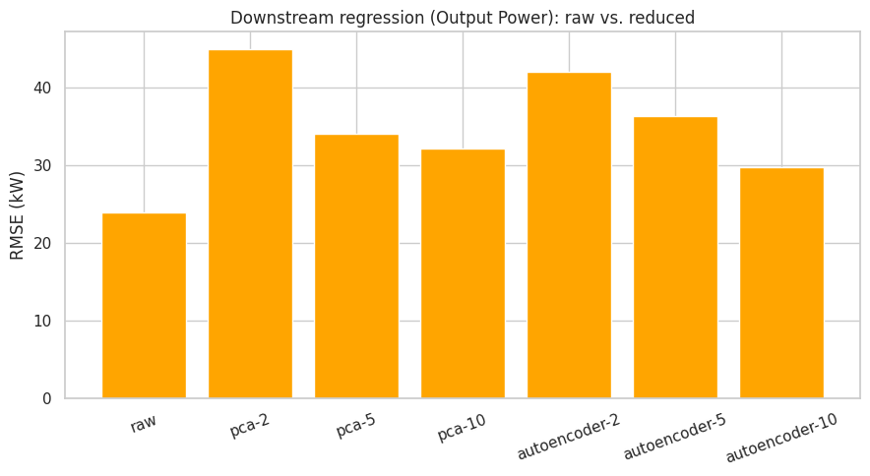

2-D Visualization
Figure 9 shows the PCA 2-D projection (d=2), colored by sky-condition class, for visual inspection only — this coloring was never used during fitting.
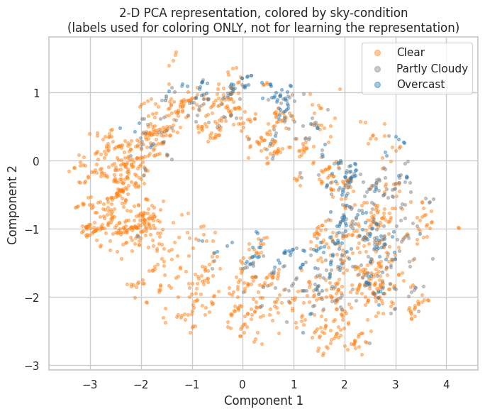
Some rough clustering by class is visible at d=2, but the classes overlap substantially rather than forming clean, separated groups — consistent with d=2's relatively low downstream accuracy (0.401). This figure shows that some class-related structure survives compression to 2 dimensions, but it does not show that this structure is enough to reliably predict the class — those are two different claims, and only the downstream accuracy numbers in Table 5 can support the second one.

Discussion
Did dimension reduction help? No — raw, uncompressed features outperformed every tested reduced representation, at every tested dimension, on both downstream tasks. This was not the expected outcome going into the experiment. A follow-up feature-ablation test helps explain why: removing Cloud Type from the PCA input raised explained variance (fewer total dimensions left to explain) but lowered both reconstruction quality and downstream accuracy — indicating that Cloud Type, despite being categorical, carries real predictive signal that a small number of continuous latent dimensions struggles to preserve. This is a reasonable explanation for the overall result: with only 23 features to begin with (a fairly small feature space already), and at least one of those features compressing poorly, there may simply be limited redundancy left for compression to exploit without losing something useful.

8. Problem 4 — Semi-Supervised Learning

Motivation
Weather and irradiance readings are cheap to collect, but assigning a sky-condition label to each one takes either manual annotation or an independent calculation — so, realistically, a deployment might have far more unlabeled weather readings than labeled ones. Semi-supervised learning (SSL) asks whether a large pool of unlabeled data can be used to make up for having only a small number of labels.

Experimental Setup
Three label fractions were tested on Davis's sky-condition task: 10%, 30%, and 50%. For each fraction, that percentage of the training pool was randomly selected (using stratified sampling, to guarantee every class is represented even at 10%) to remain labeled; the exact same rows' features (but not their labels) made up the remaining unlabeled pool. The true labels of the "unlabeled" rows exist in the underlying dataset — they were deliberately hidden from the SSL method, not actually missing, so that the experiment could be controlled. The same labeled subset was used for both the supervised baseline and the SSL method, for a fair comparison.

Baseline
A logistic regression classifier (balanced class weight — the same model family that won Problem 1) trained only on the labeled subset, with no access to the unlabeled data at all.

SSL Method
The method actually implemented was pseudo-labeling / self-training: train the classifier on the labeled subset; predict on the unlabeled pool; keep only predictions at or above a confidence threshold (0.90, selected by testing 0.80/0.90/0.95 on a held-out validation split, not assumed); add those rows, labeled with the model's own prediction, to the training set; retrain; repeat for up to 5 rounds or until no more predictions clear the threshold. A safety cap of 1,000 pseudo-labels per round was added after testing showed that, uncapped, the first round alone added 12,170 labels, 98% of them the same class — a real class-imbalance risk in the added pseudo-labels, not a hypothetical one. An optional second method, Label Spreading (a graph-based approach), was also tested and performed clearly worse than pseudo-labeling at every fraction (balanced accuracy 0.585–0.631, versus 0.744–0.767 for the supervised baseline).

Results
Table 6. Problem 4 results — Davis sky-condition, macro F1, mean ± std across 3 seeds.
Labeled Data | Supervised | Semi-Supervised | Gain
10% | 0.700 ± 0.007 | 0.695 ± 0.003 | −0.0048
30% | 0.704 ± 0.015 | 0.704 ± 0.015 | −0.0006
50% | 0.715 ± 0.007 | 0.714 ± 0.006 | −0.0010

Label-Efficiency Curve
Figure 10 shows the label-efficiency curve — supervised-only versus SSL, across all three label fractions.
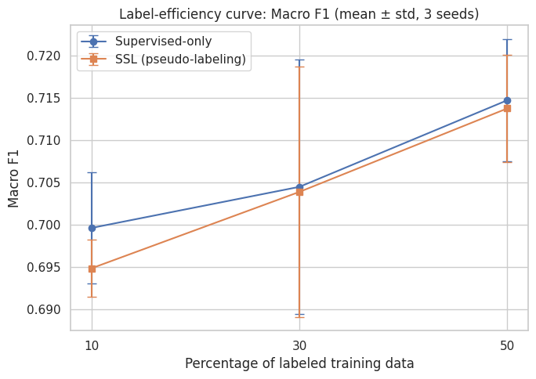
Whether SSL helped, and at which fraction: SSL did not help at any of the three label fractions tested, including 10% — the gain was small and negative in every case, not just at the smallest fraction. The two lines in Figure 10 sit almost on top of each other throughout.
Possible reasons: this was investigated directly rather than left unexplained. An offline check — using the hidden true labels purely as a diagnostic, computed only after training was already complete, and never used to influence training or the confidence threshold — found that the pseudo-labels were 100% accurate at every fraction and seed tested. The method was not adding incorrect information. Instead, the added pseudo-labels were heavily concentrated on the already-easy "Clear" class (98% of the first pseudo-labeling round, at 10% labels) — reinforcing what the labeled subset already taught the model, rather than providing new information about the harder Partly Cloudy / Overcast boundary identified in Problem 1.

9. Problem 5 — Transfer Learning

Motivation
Different PV installations, even ones responding to similar physical principles (more sunlight → more power), differ in plant size, local climate, and how much historical data is available. A brand-new or smaller installation is unlikely to have years of labeled history the way Davis does. Transfer learning tests whether knowledge learned from a data-rich city can be reused to help a data-poor city, rather than training that data-poor city's model completely from scratch.

Source and Target
Source: Davis (data-rich, 19,289 training rows). Target: Amherst (data-poor, 9,641 training rows, 2,411 held-out test rows). These are the only source/target pair tested in this project.

Zero-Shot
The Davis-pretrained model, applied directly to the Amherst test set, with zero Amherst rows used anywhere in training or fitting anything.

Few-Shot
A fresh model (random initialization — no connection to the Davis-trained model at all) trained only on a small number, k, of Amherst samples. This project tested k = 10, 50, and 100 — these were the only sample sizes actually evaluated.

Transfer Method
The Davis-pretrained model, fine-tuned (continuing training from its existing weights, not reinitialized) on the exact same k Amherst samples used for the few-shot baseline at that k, so the two methods are compared on identical data. The model architecture (a small feed-forward network: Dense(128) → ReLU → Dropout → Dense(64) → ReLU → Dense(1)) is identical across zero-shot, few-shot, and transfer — the only difference between few-shot and transfer is the starting point of the weights.

Results
Table 7. Problem 5 results (mean across 3 seeds).
Method | Target Samples (k) | RMSE (kW) | nRMSE | Gain
Zero-shot | 0 | 184.17 | 1.4479 | —
Few-shot | 10 | 38.22 | 0.3004 | —
Transfer | 10 | 30.03 | 0.2361 | +8.18 kW (+21.4%)
Few-shot | 50 | 24.72 | 0.1944 | —
Transfer | 50 | 23.35 | 0.1836 | +1.37 kW (+5.5%)
Few-shot | 100 | 23.02 | 0.1810 | —
Transfer | 100 | 22.80 | 0.1793 | +0.22 kW (+0.9%)

Gain = few-shot RMSE minus transfer RMSE at the same k, i.e. how much transfer improved on training from scratch on the same data.

Discussion
What transferred: the results indicate the underlying weather-to-power relationship transfers reasonably well — transfer clearly beat few-shot at every k tested, with the largest, most practically meaningful gain at k=10 (+21.4%), shrinking as k grows and the few-shot baseline gets enough real Amherst data to stand on its own. A domain-shift analysis found moderate differences between Davis and Amherst in Temperature, GHI, DNI, and Clear-Sky Index (standardized mean differences of roughly 0.66–0.92) — real but not extreme, consistent with a relationship that mostly carries over.
What did not transfer automatically: the output scale. Davis's average output (~164 kW) is roughly 2.7 times Amherst's (~61 kW), and this scale difference is the direct cause of the severe zero-shot failure (RMSE = 184.17 kW) — the same underlying issue seen in Problem 2's cross-city experiment.
Negative transfer: yes, negative transfer was observed directly during this project's development, though not in the final reported results above. An earlier version of the fine-tuning step used a smaller learning rate for fine-tuning than for pretraining — a strategy the project specification itself suggested as reasonable — and this produced severe negative transfer: RMSE = 140.9 kW at k=10, worse than the few-shot baseline's 38.2 kW. Investigating this directly showed the model's average prediction was stuck near Davis's ~164 kW scale, because the smaller learning rate could not shift the output level to Amherst's ~64 kW scale within a reasonable number of epochs on only 10 samples. Why: matching the fine-tuning learning rate to the pretraining rate, instead of shrinking it, resolved this completely and produced the results reported in Table 7. Two follow-up checks were run to make sure the right cause had been identified: an ablation comparing raw-kW fine-tuning against explicit target normalization showed no additional benefit once the learning rate was fixed (23.35 kW raw vs. 24.11 kW normalized, at k=50) — confirming the learning rate, not the absence of scale normalization, was the real problem — and a separate ablation freezing the first hidden layer during fine-tuning showed no meaningful difference either (23.35 kW full fine-tuning vs. 23.40 kW frozen), suggesting the general weather-to-output representation transferred largely intact.
Figure 11 shows zero-shot, few-shot, and transfer RMSE at each sample count.
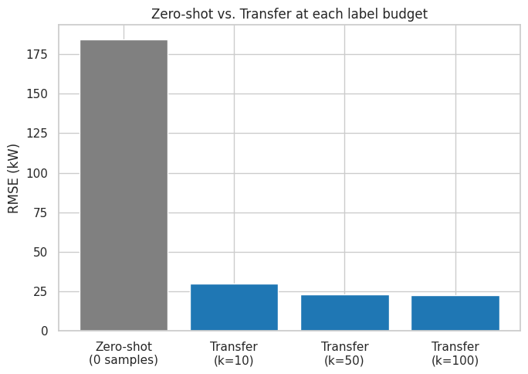
Figure 12 shows the Davis-vs-Amherst domain-shift comparison referenced above.
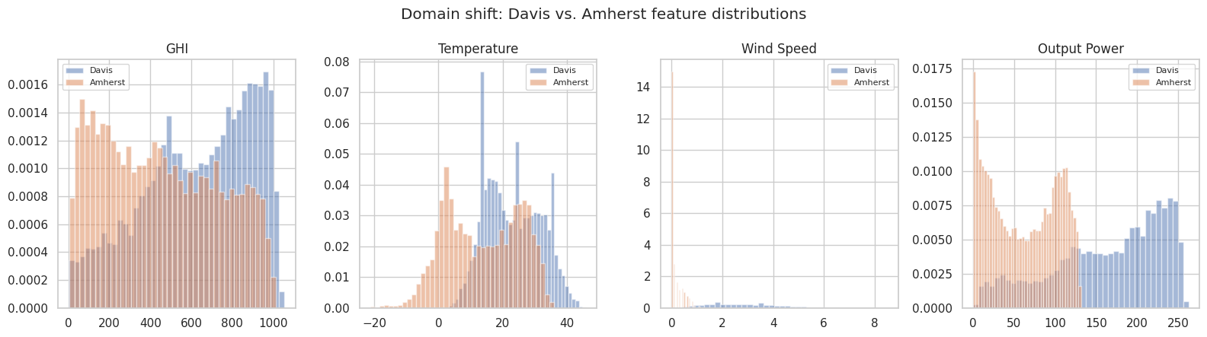

10. Overall Comparison
The five problems use different tasks and different metrics (balanced accuracy for classification, RMSE for regression), so their raw numbers cannot be meaningfully combined into a single ranking — a 0.77 balanced accuracy and a 15 kW RMSE are not comparable quantities. Instead, Table 8 summarizes the best result and headline finding from each problem side by side.
Table 8. Best result and main finding, by problem.
Problem | Best Method | Best Result | Main Finding
P1 — Classification | Logistic regression (balanced weight) | 0.772 balanced accuracy (Davis) | A simple linear model beat every ensemble and neural net tried
P2 — Regression | Gradient boosting | RMSE 15.17 kW, R²=0.953 (Davis) | Strongest single result in the project
P3 — Dimension Reduction | Raw features (no reduction) | 0.743 balanced accuracy / RMSE 23.86 kW | Compression hurt performance at every tested dimension
P4 — Semi-Supervised | Pseudo-labeling | Macro F1 ≈ 0.70 (all fractions) | SSL gain was ≈ 0 (slightly negative) at every label fraction
P5 — Transfer Learning | Transfer (fine-tuned), k=10 | RMSE 30.03 kW, +21.4% over few-shot | Transfer clearly helped, especially with scarce target data

At a glance: best classification result — 0.772 balanced accuracy (Davis sky-condition). Best regression result — RMSE 15.17 kW, R²=0.953 (Davis same-city). Dimension reduction effect — clearly negative (hurt both downstream tasks, every dimension tested). SSL effect — essentially none (small negative gain at every fraction). Transfer-learning effect — clearly positive (+21.4% at the smallest, most realistic sample size).

11. Key Findings

Finding 1 — A simple model beat every more complex model on Problem 1's classification task
Evidence: Logistic regression with balanced class weighting reached 0.772 balanced accuracy on Davis sky-condition, ahead of random forest (0.743–0.746), gradient boosting (0.752–0.754), and the tuned MLP (0.755) — see Table 3.
Interpretation: once leakage-risk irradiance features are removed from the input, the remaining relationship between weather features and sky-condition appears to be simple enough that a linear model captures it about as well as, or better than, more flexible models — added model complexity did not translate into better performance here.

Finding 2 — Dimension reduction consistently hurt performance
Evidence: raw features beat every tested PCA and autoencoder representation, at every tested dimension (d=2, 5, 10), on both the downstream classification task (0.743 vs. a best reduced score of 0.661) and the downstream regression task (23.86 kW vs. a best reduced score of 29.69 kW) — see Table 5.
Interpretation: this dataset's feature space (23 dimensions after encoding) may already be small enough that little redundancy remains to compress away. A feature-ablation test traced part of the effect to Cloud Type, a categorical variable that is highly predictive but compresses poorly into a small number of continuous dimensions.

Finding 3 — Semi-supervised pseudo-labeling did not improve on the supervised-only baseline at any label fraction tested
Evidence: SSL gain (macro F1) was −0.0048 at 10% labels, −0.0006 at 30%, and −0.0010 at 50% — see Table 6.
Interpretation: an offline diagnostic (using hidden true labels only after training was complete) showed the pseudo-labels added were 100% accurate but concentrated almost entirely on the already-easy "Clear" class. The method was not adding wrong information — it was adding redundant information, which explains why performance did not improve even though the added labels were correct.

Finding 4 — Cross-city and zero-shot transfer failed severely under raw-kW evaluation, primarily due to output-scale mismatch
Evidence: Davis-trained models applied directly to other cities produced RMSE around 124–184 kW (Problem 2's cross-city zero-shot, Problem 5's zero-shot baseline), compared with 15–20 kW for same-city models. A diagnostic rescaling of the Problem 2 cross-city predictions by the target city's own mean recovered R² of 0.55–0.84.
Interpretation: the underlying weather-to-power relationship appears to transfer reasonably well between cities; what fails without adaptation is the output calibration, which differs by roughly 2.7–3.5× depending on the pair of cities involved.

Finding 5 — Transfer learning provided a real, practically meaningful benefit, especially when target data was scarce
Evidence: fine-tuning the Davis-pretrained model on just 10 Amherst samples reduced RMSE by 21.4% (30.03 kW vs. 38.22 kW) compared with training a fresh model on those same 10 samples — see Table 7. The gain shrank to 5.5% at k=50 and 0.9% at k=100.
Interpretation: transfer learning's benefit is largest exactly where it is most useful in practice — a newly instrumented site with very few labeled readings — and diminishes naturally as more real target-city data becomes available, which is the expected shape for this technique to work as intended.

Finding 6 — A single hyperparameter choice was the difference between severe negative transfer and a clear positive result
Evidence: an early version of the Problem 5 fine-tuning step, using a smaller learning rate for fine-tuning than for pretraining, produced RMSE = 140.9 kW at k=10 — worse than training from scratch (38.2 kW). Matching the pretraining learning rate instead produced RMSE = 27.2 kW in that same diagnostic comparison.
Interpretation: negative transfer, in this case, was not a fundamental limitation of transfer learning for this problem — it was caused by a specific, fixable implementation choice (an overly-conservative learning rate that could not adjust the model's output scale quickly enough). This suggests that conclusions about whether transfer learning "works" for a given problem can depend heavily on implementation details that are easy to get wrong.

12. Limitations
- Limited geographic coverage. Only 5 cities were available, and only one source/target pair (Davis→Amherst) was tested for transfer learning — the other three cities (Huron, Santa Barbara, La Jolla) were only evaluated zero-shot in Problem 2, not with fine-tuning. - Mid-day-only, no nighttime data. Every reading in this dataset falls in the 10:00–15:00 window. Nothing in this project's results says anything about model behavior outside that window — a practical forecasting system would need nighttime and early-morning/ evening behavior (where output is near zero) handled separately, or the dataset would need to be extended to cover them. - City-specific PV plant scale. Output Power's different physical scale across cities was a recurring complication addressed through fine-tuning (Problem 5) or accepted as an explained failure mode (Problem 2's zero-shot results) — not a limitation this project claims to have generally solved. - Weather-distribution and domain-shift differences. The Problem 5 domain-shift analysis found a notably large Wind Speed difference between Davis and Amherst (standardized mean difference of 2.61) — flagged as possibly a sensor or unit artifact rather than a confirmed climate fact, since it was not independently verified against the two cities' raw instrument documentation. - Missing data. Minimal (4 rows total, one city), so this is not a significant limitation in practice, but it is worth noting the approach taken (dropping, not interpolating) as a stated choice. - Limited years of data for Amherst. 3 years vs. 6 for the other cities — this asymmetry is exactly what motivates Problem 5, but it also means Amherst's own same-city regression result (Problem 2) is based on less data than Davis's. - Deliberately small hyperparameter searches. Every tuning search in this project used 3–5 candidate configurations, not an exhaustive grid. This is a scope decision, not an oversight, but it does mean a larger search might find further improvements that were not explored. - No GPU during development. All models, including every neural network, were trained on CPU. This does not affect correctness, but training times reported informally during development would be faster on GPU hardware. - Evaluation protocol scope. Metrics are computed once per (model, seed) combination and averaged across 3 seeds; no formal statistical significance testing (e.g. paired t-tests between models) was performed, so claims like "gradient boosting beat random forest" reflect consistent mean differences across seeds, not a formal significance test.

13. Reproducibility
Software. Python 3.12; pandas, NumPy, scikit-learn, PyTorch, and matplotlib as the core libraries (`requirements.txt` specifies minimum-compatible version ranges; exact versions observed during development were pandas 3.0.2, numpy 2.4.4, scikit-learn 1.8.0, torch 2.14.0, matplotlib 3.10.8).
Hardware. Developed and run entirely on CPU — no GPU was available in the development environment. The shared `get_device()` utility automatically detects and uses a GPU (including an RTX 2070, if that is the hardware being used to run this project going forward) with no code changes required.
Random seeds. `[42, 123, 2026]`, defined once and imported identically by all five problems' code, used for every randomized step (model initialization, few-shot sampling, stratified label selection).
Dataset. `course/Further Consolidated Data, HnL.xlsx` — the single raw Excel workbook this entire project is built from; never modified.
Split strategy. Chronological 80/20 for all same-city experiments; cross-city and transfer experiments never allow target-city rows into training or preprocessing (see Section 3).
Code organization. `problems/problemN_*/` holds each problem's own code; `results/problemN/` holds its saved results, models, and preprocessing objects; `figures/problemN/` holds its figures; `src/` holds the shared framework code (data loading, cleaning, feature engineering, splitting, preprocessing, evaluation, visualization) reused by all five problems; `course_context/` holds the full written record of decisions and findings for every phase.
How to reproduce. From the project root, with dependencies installed (`pip install -r requirements.txt`), each problem's experiments can be run with `python problems/problemN_*/ run_experiments.py`. `scripts/check_setup.py` verifies the environment is set up correctly before running anything. Every experiment's result is appended to that problem's `results/problemN/ problemN_results.csv`, never overwritten.

14. AI Assistance Disclosure
AI coding assistants were used throughout this project to help with code scaffolding, debugging, documentation, experimentation ideas, and iterative development across all five ML problems, the exploratory data analysis, and this report. All generated code was reviewed and, where necessary, modified by the student before being run. Every result reported in this document comes from an experiment that was actually executed and its output actually saved — none are estimated or invented. Several real implementation issues were found and fixed during this review-and-execution process rather than being missed — for example, the Problem 5 learning-rate/negative-transfer episode discussed in Section 9, and a package-compatibility bug encountered during Problem 4's development. The student is responsible for understanding the methods used, interpreting the results, and being able to explain and defend every part of the submitted work.

15. Conclusion
This project tested five machine learning paradigms on the same solar power forecasting problem, using the methods covered in this course, and aimed to report honestly which paradigms helped and which did not. Supervised learning performed well throughout, with the strongest overall result being same-city Output Power regression for Davis (RMSE = 15.17 kW, R² = 0.953). Two paradigms produced clearly negative results under the conditions tested: dimension reduction reduced downstream performance at every tested compression level, and semi-supervised pseudo-labeling produced an essentially zero (slightly negative) gain at every labeled-data fraction tested — both are reported as genuine findings, not shortcomings to explain away. Transfer learning was the clearest success among the "does this technique help" questions this project asked: fine-tuning a Davis-pretrained model on just 10 Amherst samples improved RMSE by 21.4% over training on those same 10 samples from scratch, though only after a real negative-transfer episode was identified and corrected during development. The most interesting finding overall was that this negative-transfer episode traced back to a single hyperparameter (the fine-tuning learning rate) rather than any fundamental limitation of the technique — a reminder that whether an ML method "works" can depend on implementation details as much as on the underlying idea. Taken together, this project's main takeaway is that each of these five paradigms needs to be evaluated on its own, against a fair baseline, for the specific problem at hand — assuming in advance that an advanced technique will help is not a substitute for testing it. Future work suggested by these results includes a larger hyperparameter search now that working baselines exist for each paradigm, an investigation into the Wind Speed domain-shift anomaly noted in Problem 5, and extending the transfer-learning approach to the other data-scarce cities (Huron, Santa Barbara, La Jolla) that were only evaluated zero-shot in Problem 2.

References
1. Course material, ECE571 Machine Learning — lecture slides covering supervised classification, supervised regression, dimensionality reduction/PCA, semi-supervised learning, and transfer learning/ fine-tuning, as provided for this course.
2. Project dataset: Further Consolidated Data, HnL.xlsx — irradiance, weather, and PV Output Power records for Amherst MA, Davis CA, Huron SD, Santa Barbara CA, and La Jolla CA, provided as part of the course assignment.
3. Pedregosa, F., et al. (2011). Scikit-learn: Machine Learning in Python. Journal of Machine Learning Research, 12, 2825–2830.
4. Paszke, A., et al. (2019). PyTorch: An Imperative Style, High-Performance Deep Learning Library. Advances in Neural Information Processing Systems 32.
[Note: item 1 refers to the course's own lecture material generally, since no single citable title/author/year was found recorded for the individual PowerPoint files in the project's files — if a specific citation format is required (e.g., individual lecture titles/weeks), please provide it or confirm the general reference above is sufficient.]

