We have agreed to implement the following user stories in Iteration 1:

1. As a user, I want to check out a list of items bought by a customer
2. As a user, I want to update the inventory (change price, availability, add new products,...)

**Use Case Checkout:**

Steps:

1. The system displays the main screen

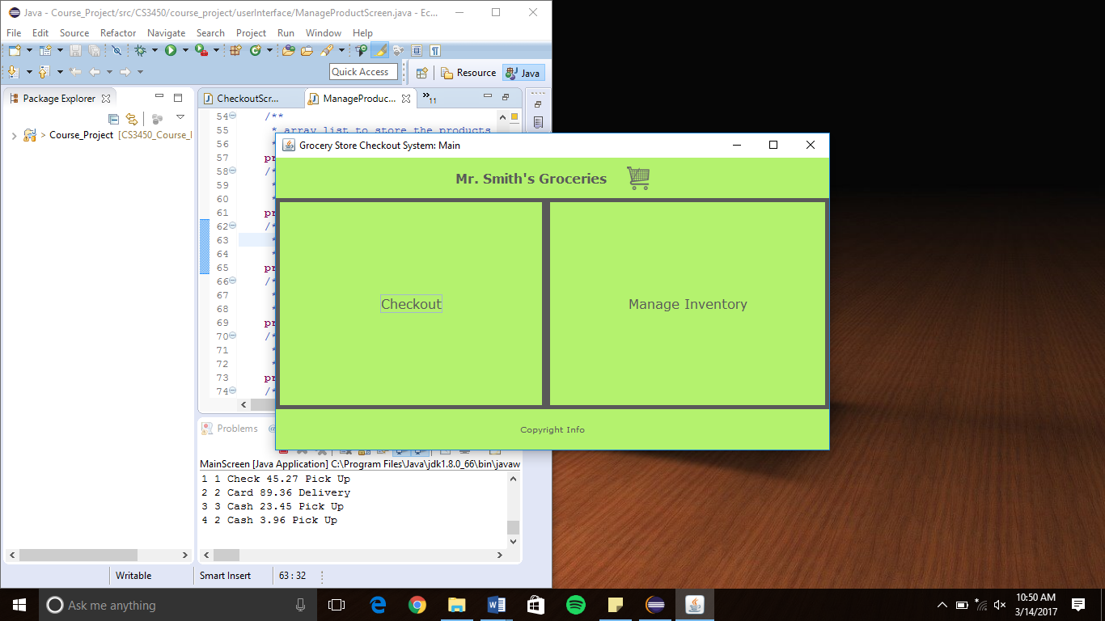

1. The user selects to checkout
2. The checkout screen is displayed

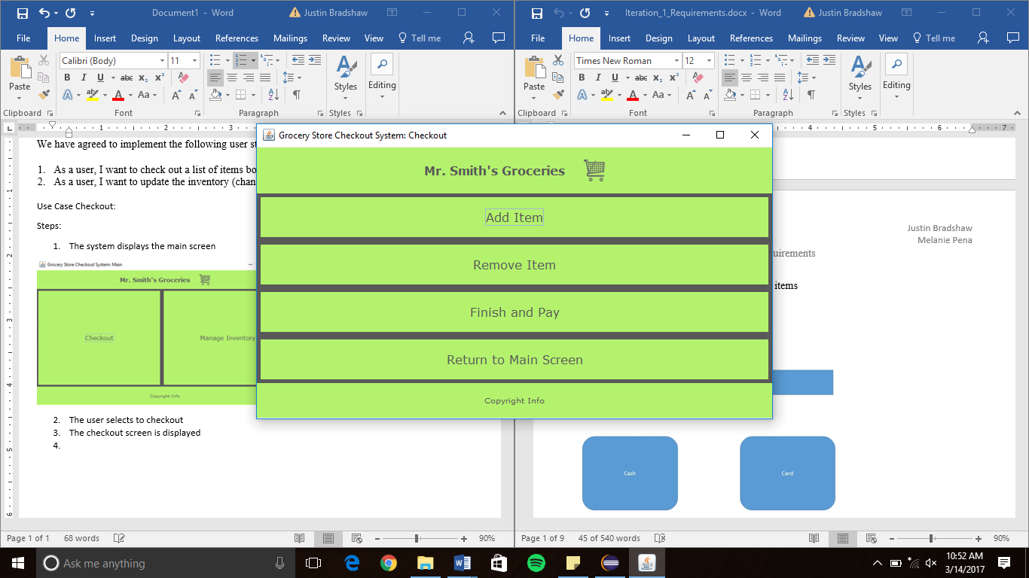

1. The user selects to add an item
2. The add item screen is displayed

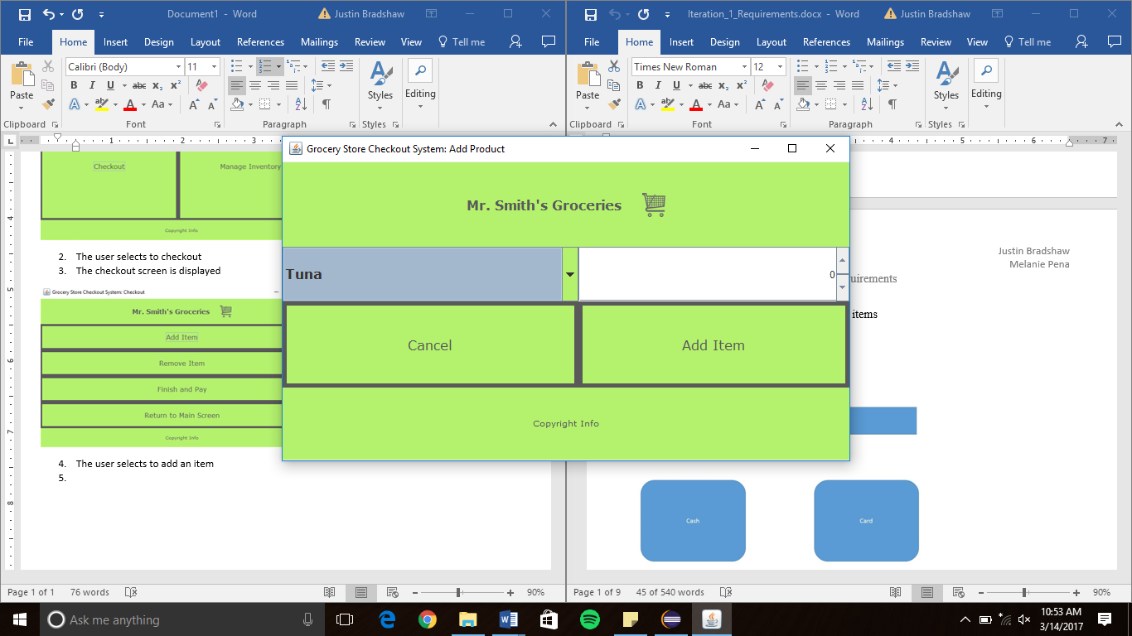

1. The user may then select to remove an item or continue adding items until the order is completed

Remove Item Screen:

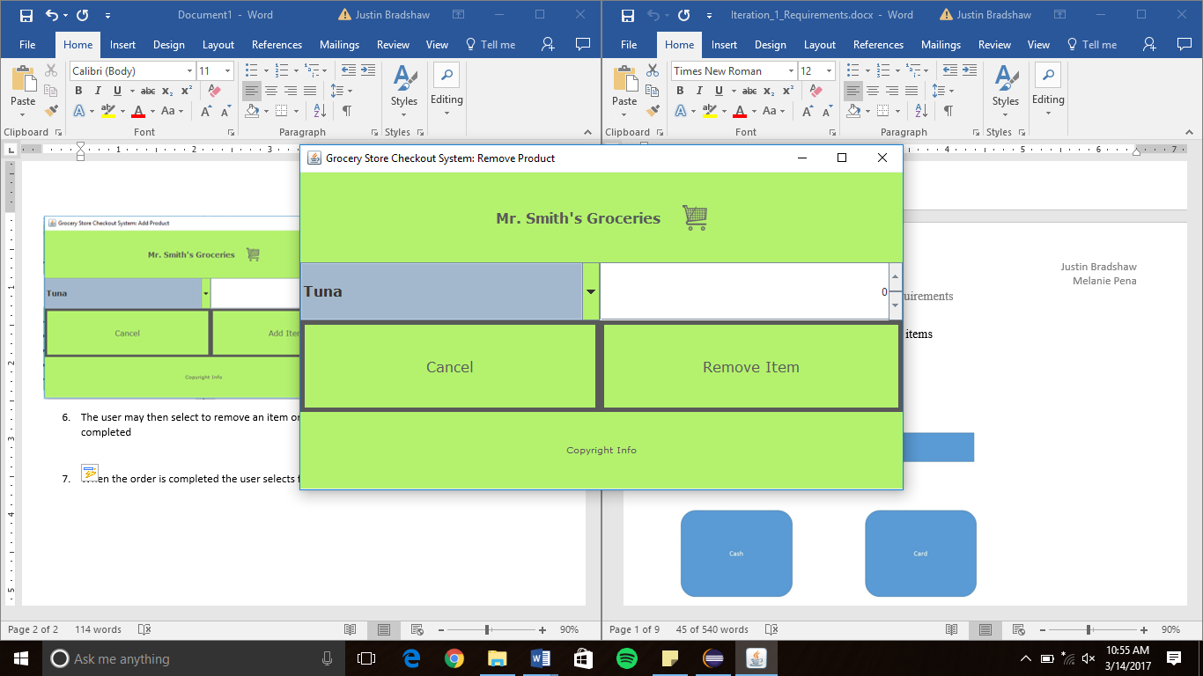

1. When the order is completed the user selects finish and pay
2. The user is taken through a series of popups that ask for payment method, delivery method, whether or not the user is an existing customer, etc.
   1. If the payment method is credit card, the user is prompted to enter their card information

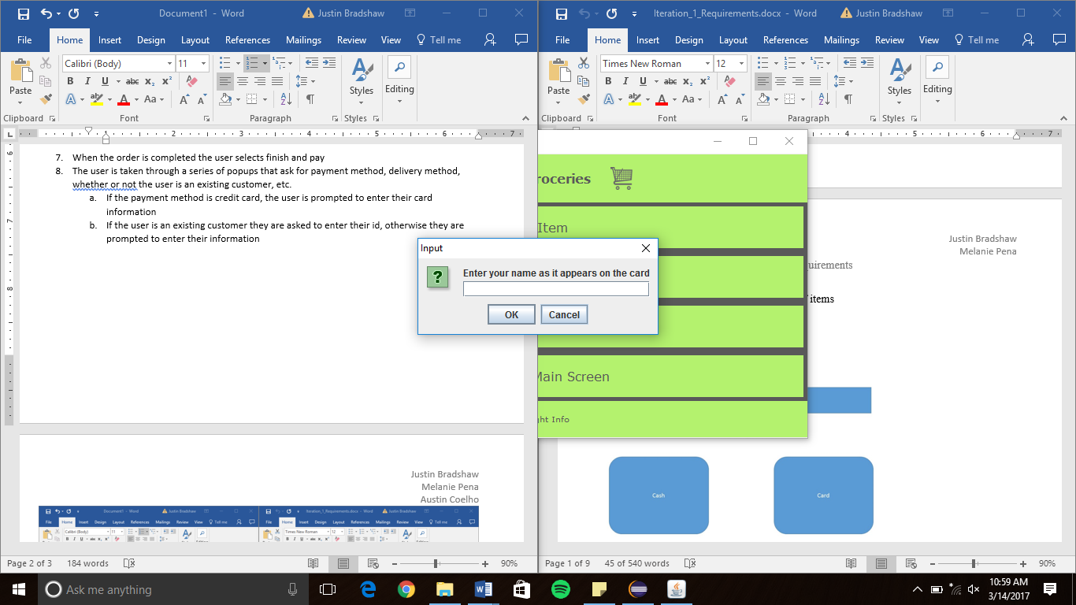

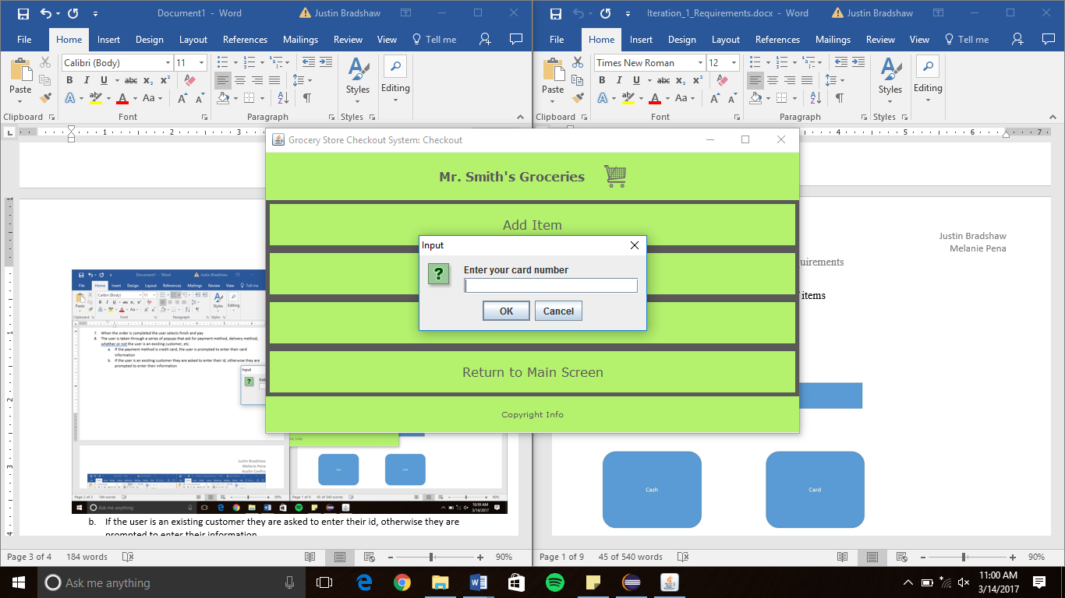

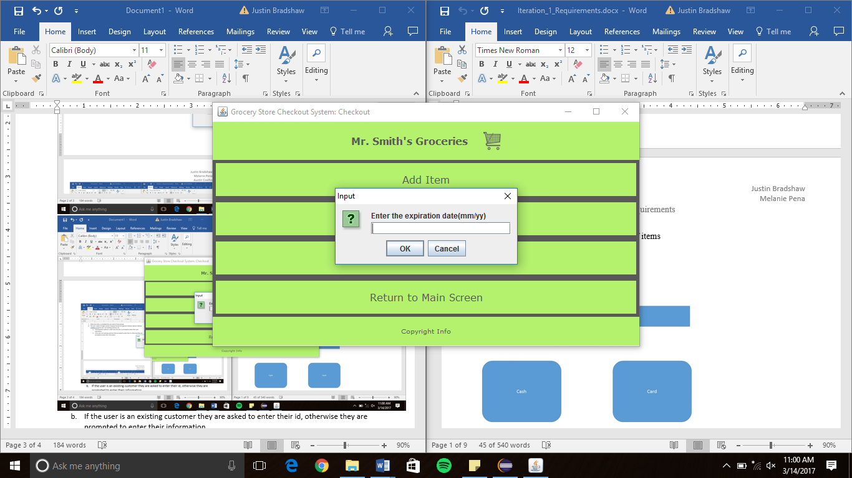

* 1. If the user is an existing customer they are prompted to enter their id, otherwise they are prompted to enter their information as a new customer

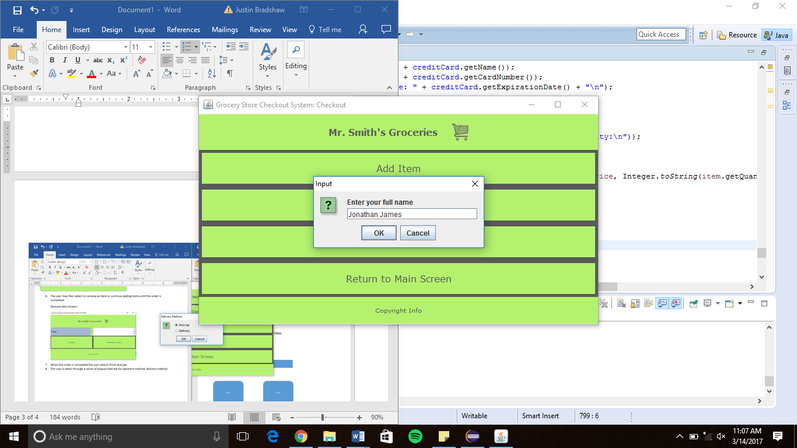

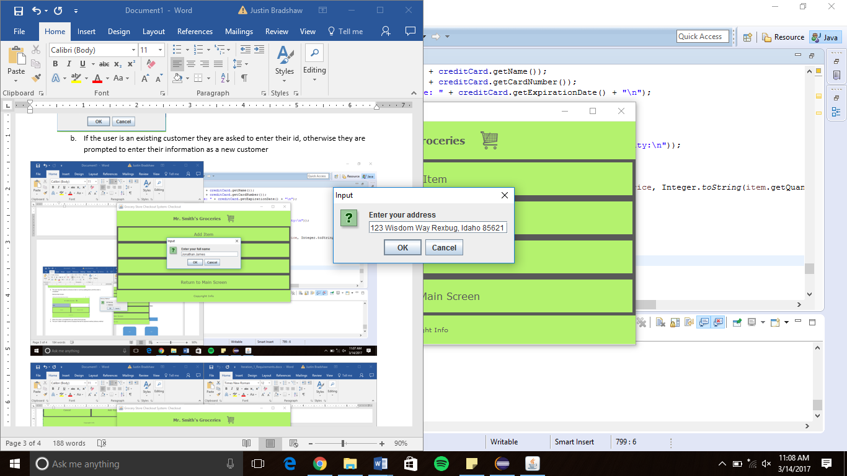

Payment Method Screen:

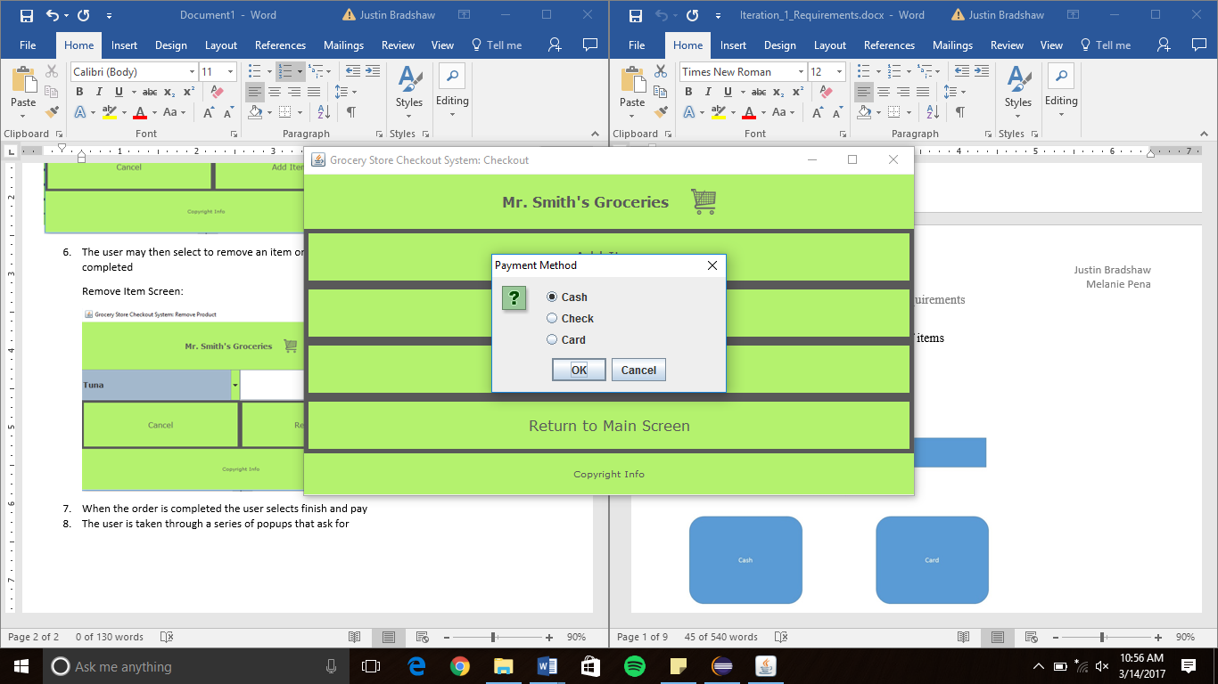

Delivery Method Screen:

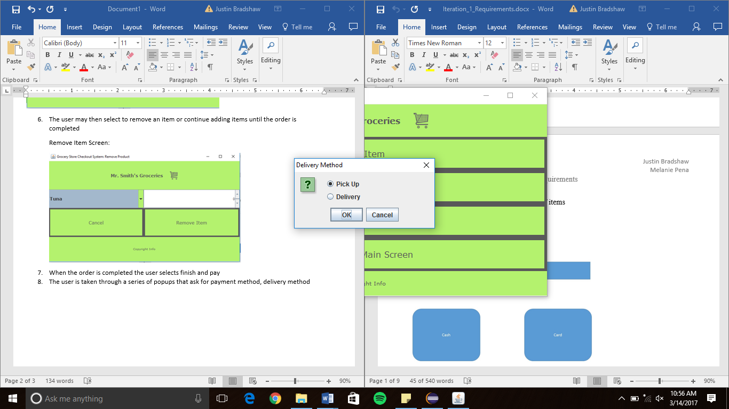

1. After all of the necessary information has been entered, a message is displayed thanking the user, a receipt is printed, and the user is taken back to the checkout screen

**Use Case Show Availability of Products:**

Steps:

1. The system displays the main screen



1. The user selects manage Inventory
2. The manage inventory screen is displayed

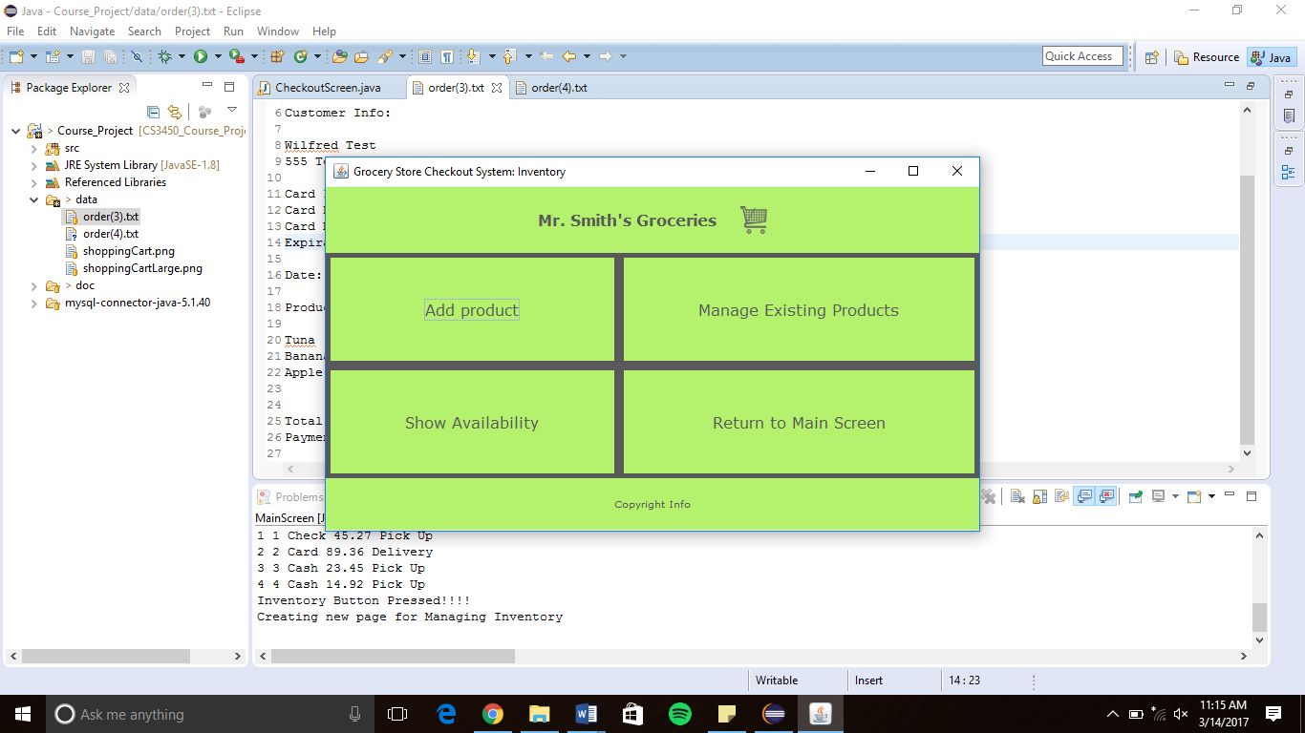

1. The user selects show availability
2. A screen is displayed showing the availability of the products

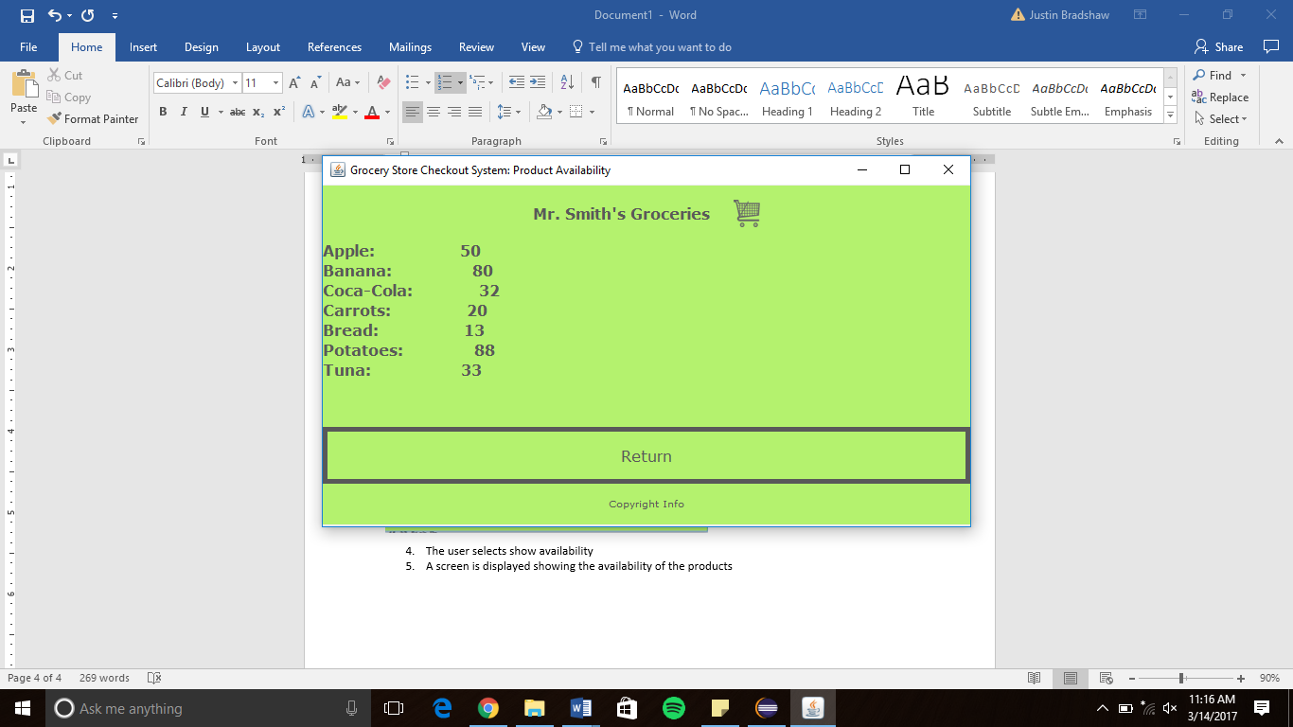

1. The user selects return and is returned to the manage inventory screen

**Use Case Manage Existing Products:**

Steps:

1. The system displays the main screen



1. The user selects Manage Inventory
2. The manage inventory screen is displayed



1. The user selects manage existing products
2. The manage existing products screen is displayed

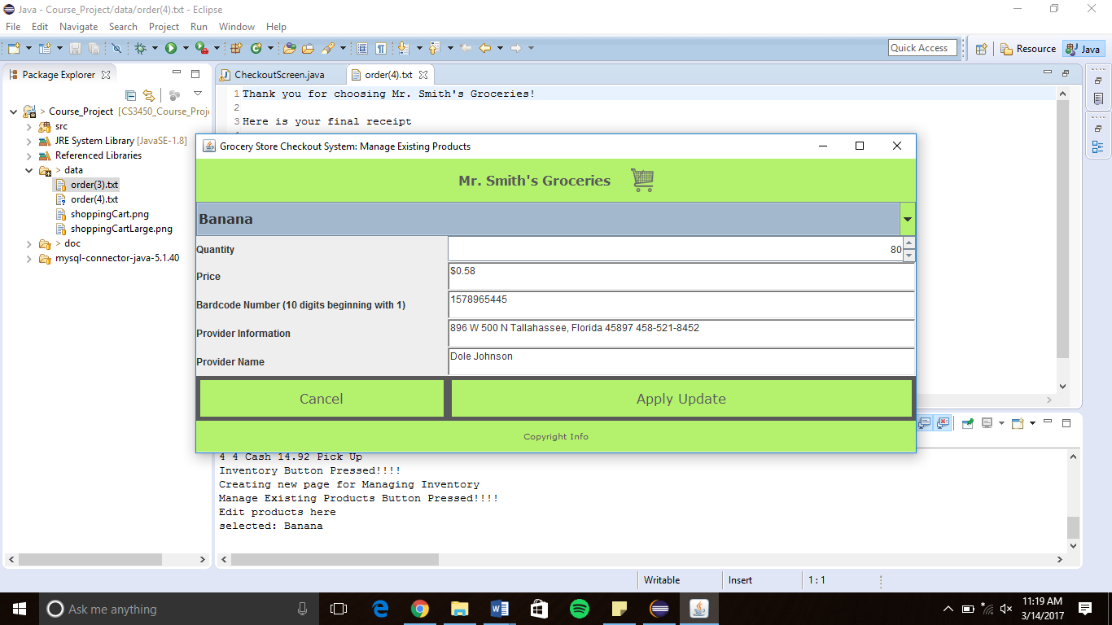

1. The user selects a product and edits the product’s information
2. The user selects apply update and is taken back to the manage inventory screen
   1. If the user selects to cancel, the user is taken back to the manage inventory screen and the product is not affected

**Use Case Add New Product:**

Steps:

1. The system displays the main screen



1. The user selects manage inventory
2. The manage inventory screen is displayed



1. The user selects add product
2. The add product screen is displayed

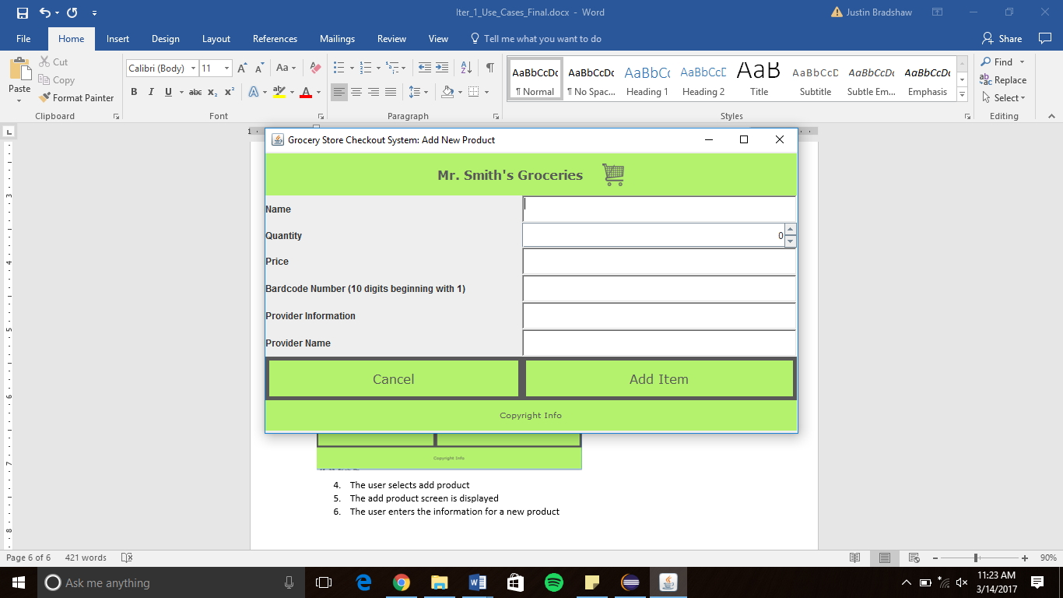

1. The user enters the information for a new product
2. The user selects add item and the new product is saved to the database
   1. If the user selects cancel the new product is not saved to the database