**Iteration 2 Requirements**

**User stories:**

1. As a cashier, I want to check out a list of items bought by a customer
2. As a manager, I want to update the inventory (change price, availability, add new products,...)
3. As an employee, I want to login into and logout from the system
4. As an employee, I want to change my display information (e.g. display name, photo...), my access code/password from the system
5. As a manager, I can assign or change the access rights to other employees
6. As a customer support employee, I want to help a customer returning an item bought previously

**Employee Access Levels**

* Level 1: User has access to all system abilities
* Level 2: User can change their display information, check out a list of items, and return items previously bought by a customer
* Level 3: User can change their display information and check out a list of items
* Level 4: User can change their display information and return items previously bought by customer

# Use Case: Login/out

1. System displays the Startup screen.

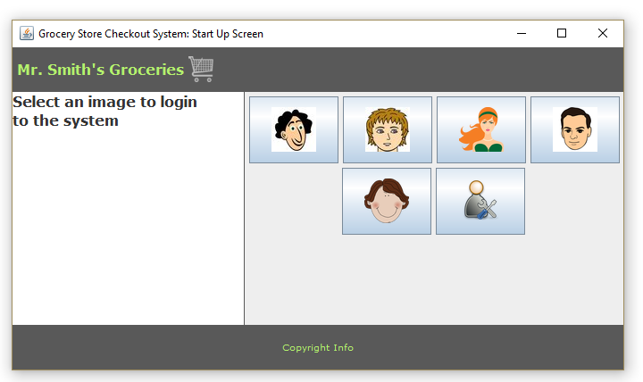

1. User clicks on their login icon.
2. System displays the Login screen.

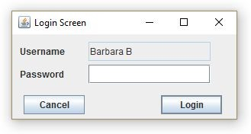

1. User enters in password.
2. If user enters in incorrect password system, displays a warning message

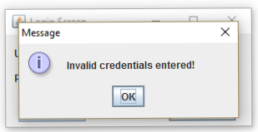

1. If user enters in incorrect password three times in a row, system displays warning message and program is exited

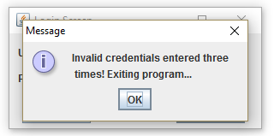

1. If user has access level 1 (and enters correct password) system displays this Main screen.

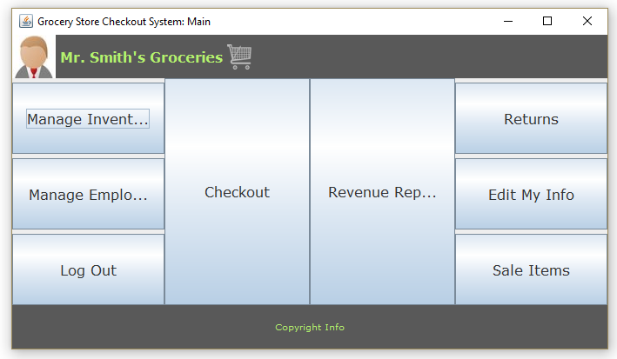

1. If user does not have access level 1, system displays this Main screen.

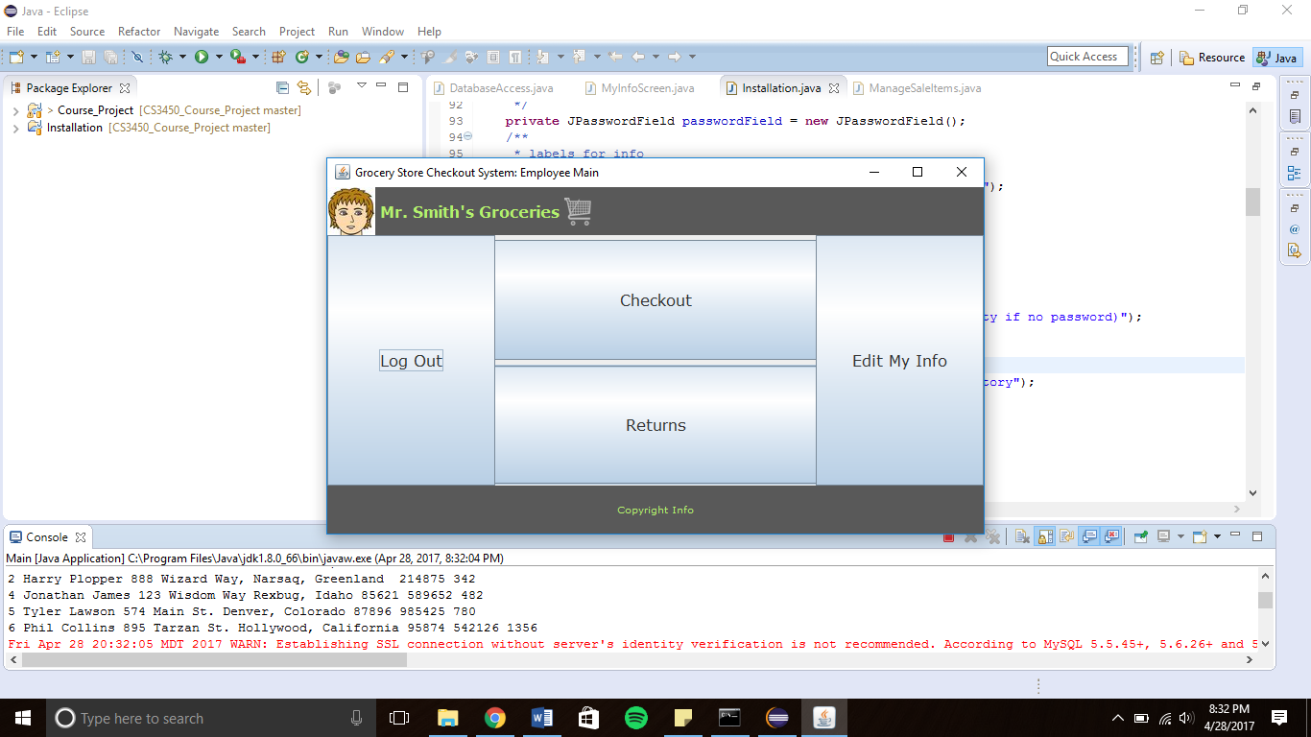

1. User clicks on “Log out” button.
2. System displays a Confirm Logout screen.

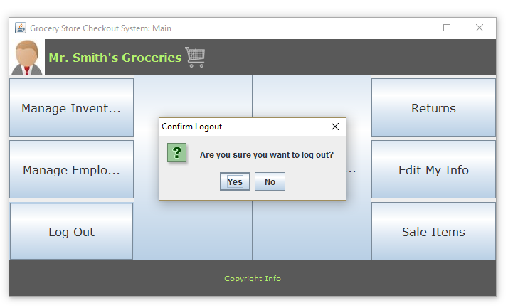

1. User clicks “Yes” button.
2. System returns to Startup screen.

# Use Case: Check Out

1. Repeat steps from Login/out Use Case to login.
2. If user access rights is not 1-3, system will display a Main screen with a disabled Checkout button.

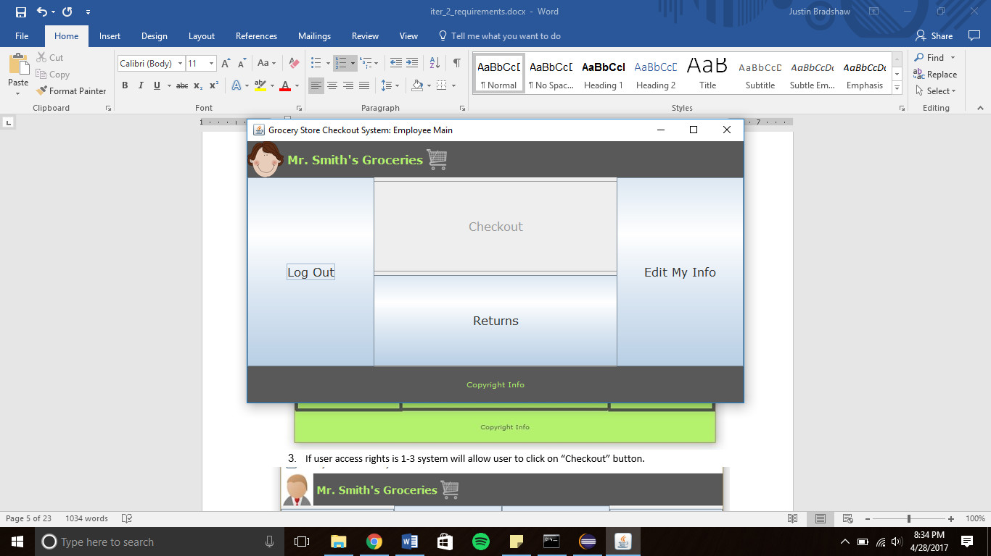

1. If user access rights is 1-3 system will allow user to click on “Checkout” button.

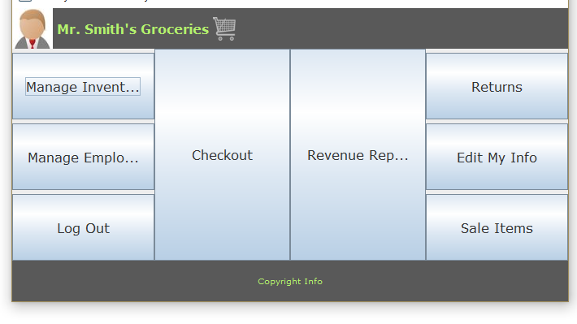



1. System then displays a customer type popup screen

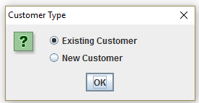

1. User selects the customer type.
2. If existing customer was selected system displays window to enter in customer ID

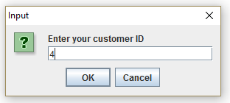

1. If new customer was selected system displays the following windows to enter in customer information

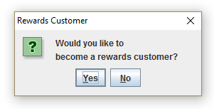 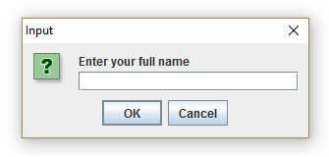 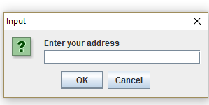

1. System then displays Checkout screen.

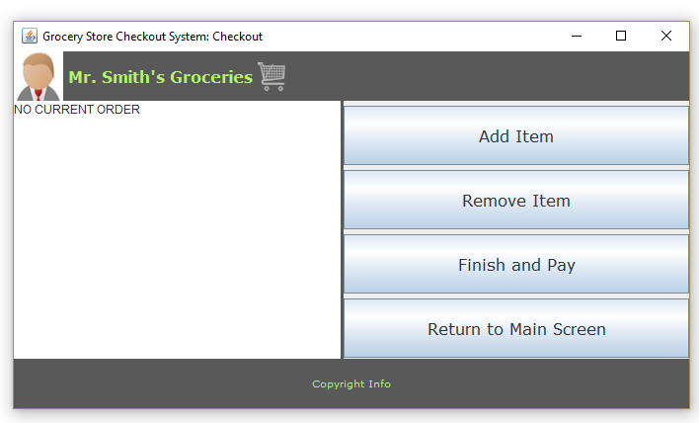

1. User clicks “Add Item” button.
2. System displays Add Item screen.

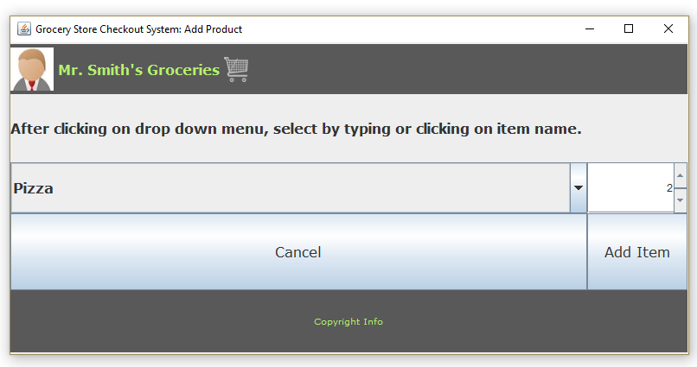

1. User selects an item and quantity and clicks on “Add item” button to add new item.
2. System updates information of the new item in the list of items.

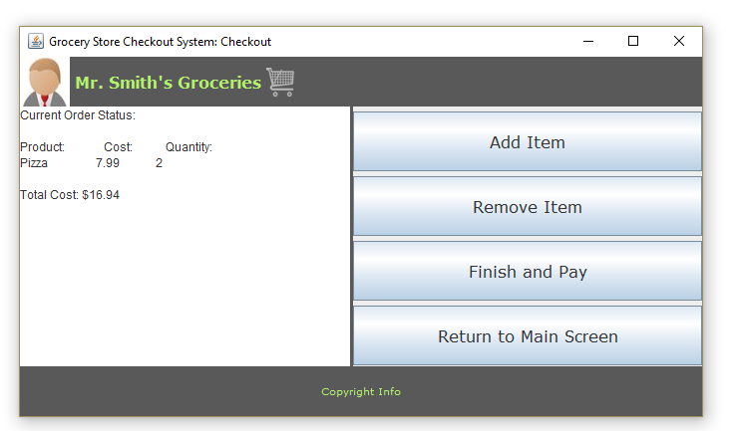

1. User repeats step 10 for all items.
2. To remove an item user clicks “Remove Item” button.
3. User selects an item and quantity from the list of items and clicks on “Remove Item” button to remove item.

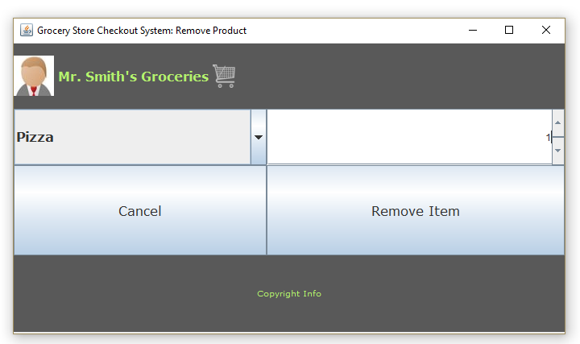

1. User clicks on “Finish and Pay” button.
2. System displays the Delivery Method pop up screen.

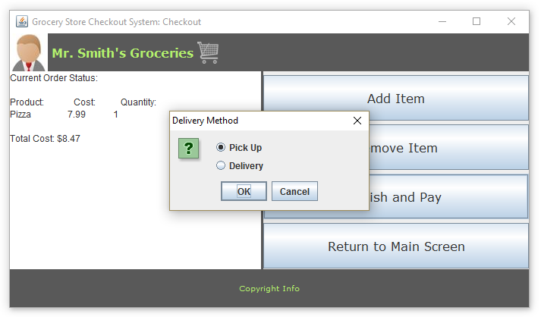

1. User selects delivery method.
2. System displays the Payment Method pop up screen.

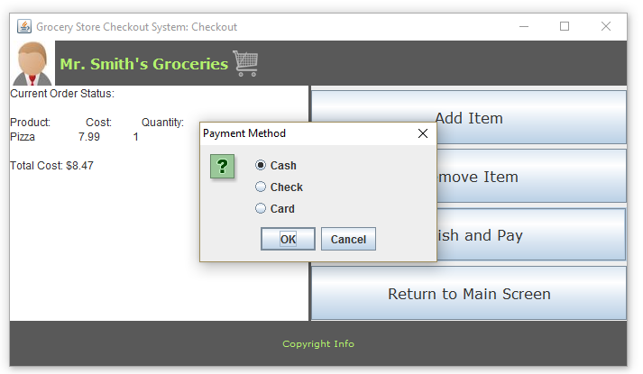

1. User selects payment method.
2. If user selects “Card” option system will display the following screens to input customer information

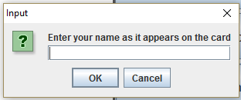

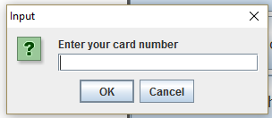 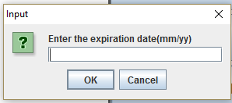

1. User inputs customer information
2. System displays price of order and updates customer and order information.

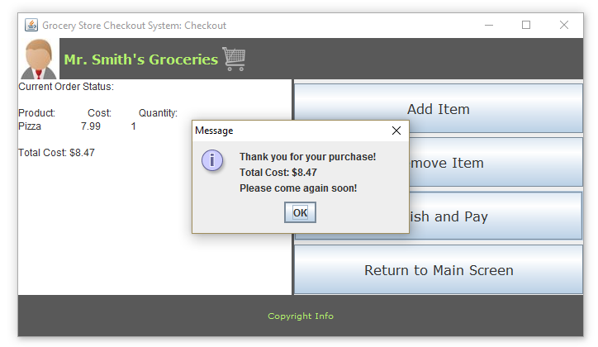

# Use Case: Manage Inventory

1. Repeat steps from Login/out Use Case to login.
2. If user access rights is not 1 system will display a Main screen without a “Manage Inventory” button.



1. If user access rights is 1 system will display a Main Screen with a “Manage Inventory” button.



1. User clicks on “Manage Inventory” button.
2. System displays Manage Inventory screen.

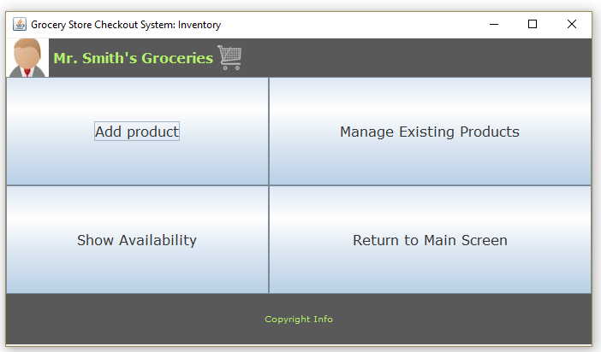

1. To add a product to the inventory, user clicks “Add Product” button.
2. System displays Add Product screen.

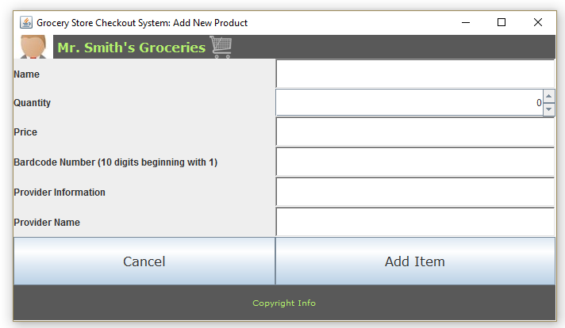

1. User enters in product information and clicks on “Add Item.”
2. System updates information of the new item in the inventory.
3. To manage existing products user clicks on “Manage Existing Products” button.
4. System displays Manage Product Screen with a default product to manage.

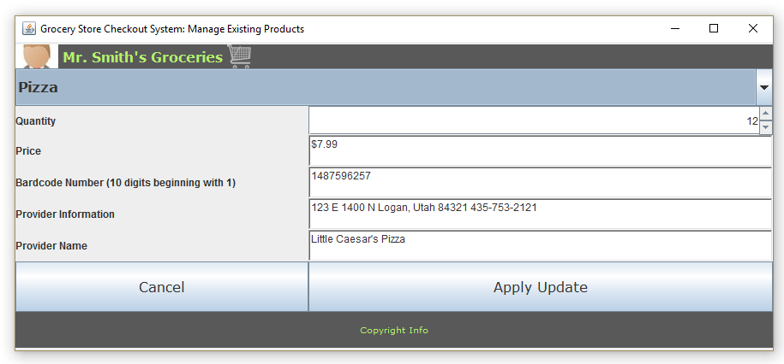

1. User selects which product to manage.
2. System displays information for that product.

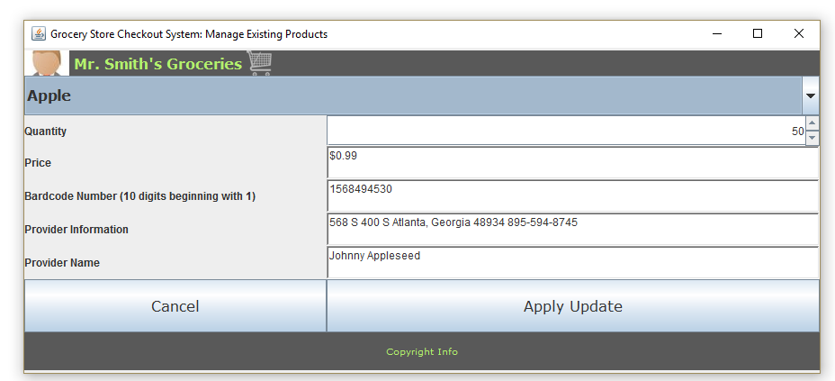

1. User makes necessary changes and clicks on “Apply Update” button.
2. System updates product information.
3. To check product availability user selects “Show Availability” button.
4. System displays list of products and their quantities.

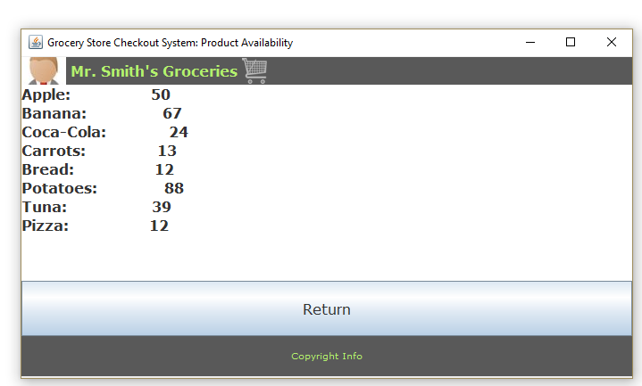

# Use Case: Change Display Information

1. Repeat steps from Login/out Use Case to login.
2. User clicks “Edit My Info” button.
3. 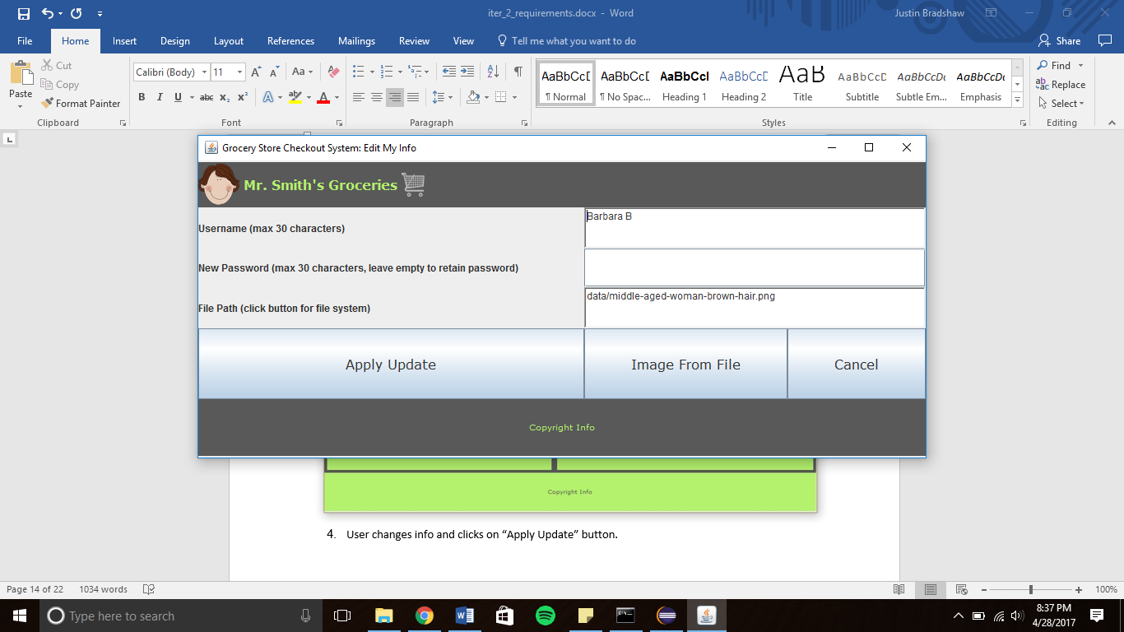System displays Edit My Info screen

1. User changes info and clicks on “Apply Update” button.
2. System updates employee information and returns to Main Screen.
3. If user changes their password system displays a confirm password screen.

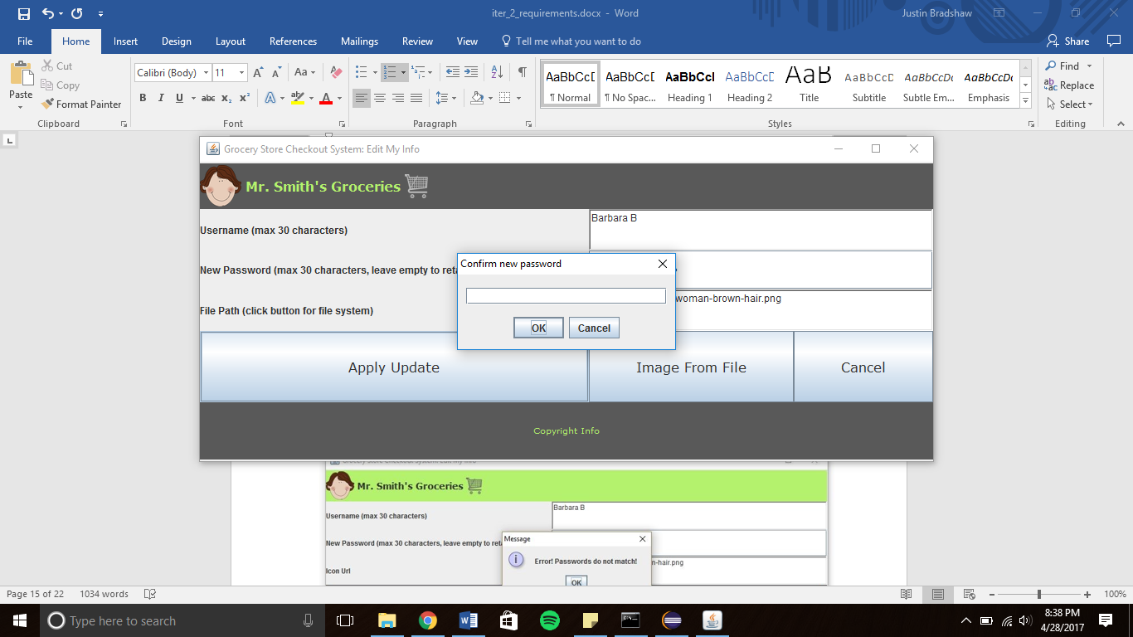

1. User types in new password.
2. If password is wrong system displays error message.



1. If password is correct system updates employee information.

**Use Case: Manage Employees and Access Rights**

1. Repeat steps from Login/out Use Case to login.
2. If user access rights is not 1 system will display a Main screen without a “Manage Employees” button.

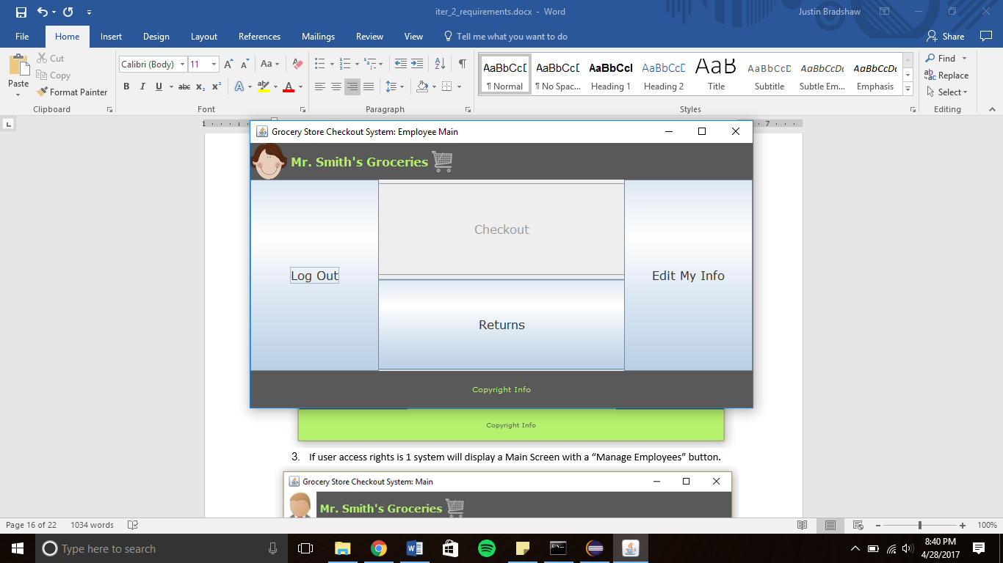

1. If user access rights is 1 system will display a Main Screen with a “Manage Employees” button.



1. User clicks on “Manage Employees” button.
2. System displays the Manage Employees screen.

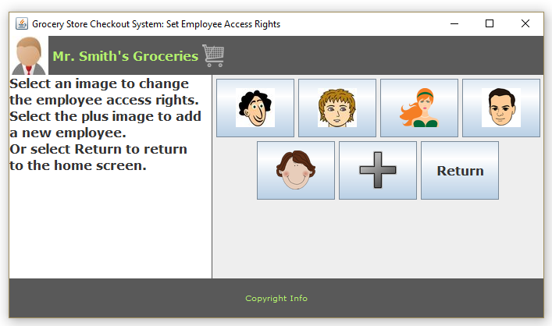

1. User clicks on an employee icon.
2. System displays a change access rights screen.

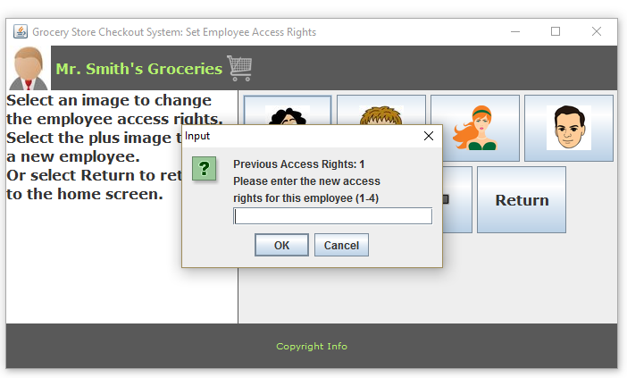

1. User types in new access rights level.
2. System updates employee access rights information.
3. To create new employee user clicks on “+” icon
4. System displays add new employee screen

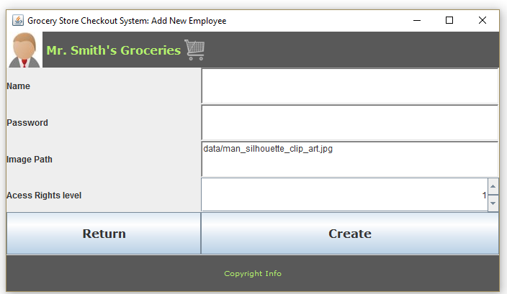

1. User types in employee information and clicks on “Create” button
2. System creates new employee in the database and returns to manage employees screen

# Use Case: Return Items

1. Repeat steps 1-5 from Login/out Case.
2. If user access rights is not 1,2 or 4 system will display a Main screen with a disabled “Returns” button.

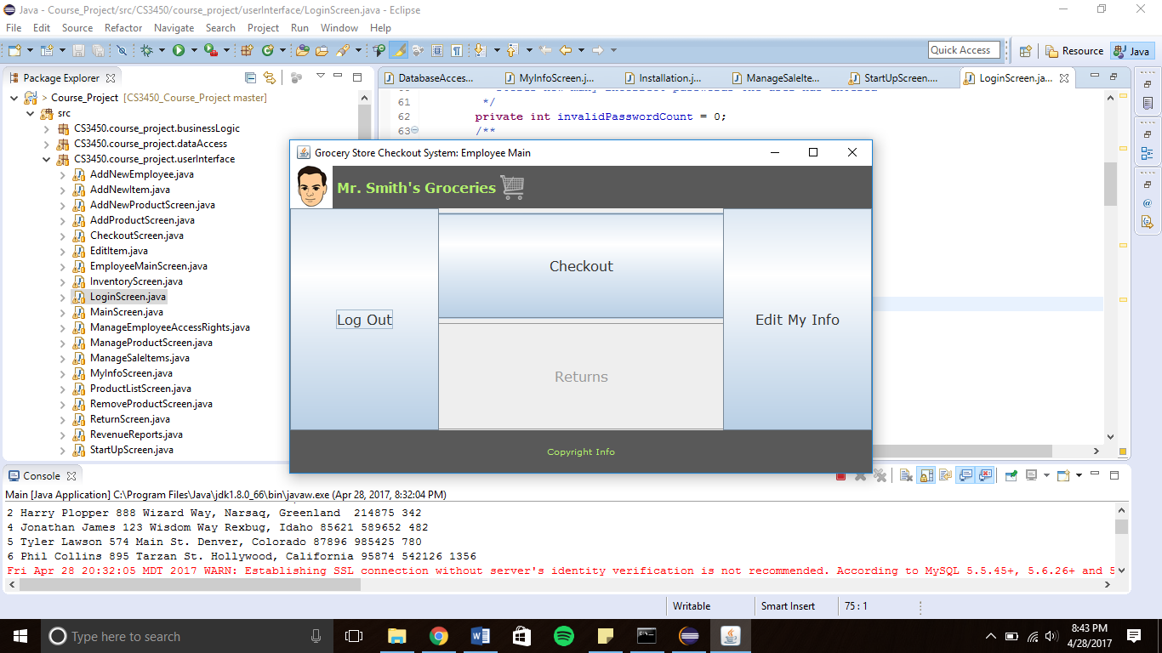

1. If user access rights is 1, 2 or 4 system will allow user to click on “Returns” button.



1. System then displays Return Order screen.

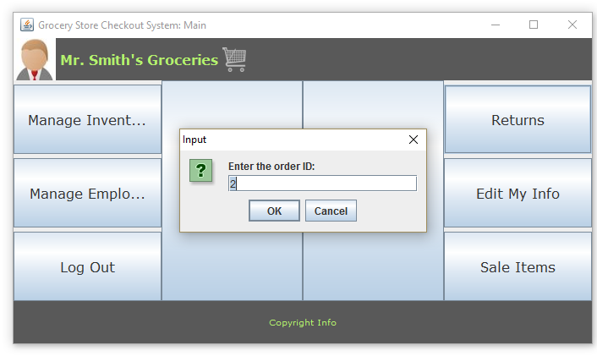

1. User types in the order number.
2. System displays order information.

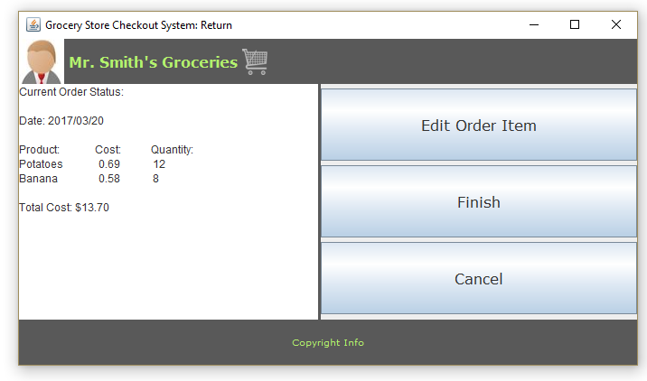

1. User clicks “Edit Order Item.”
2. System displays Input screens.

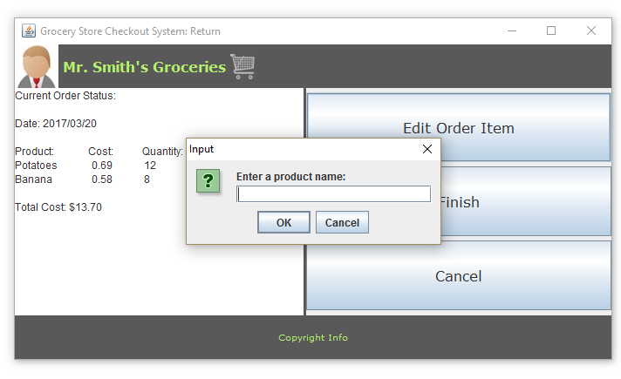 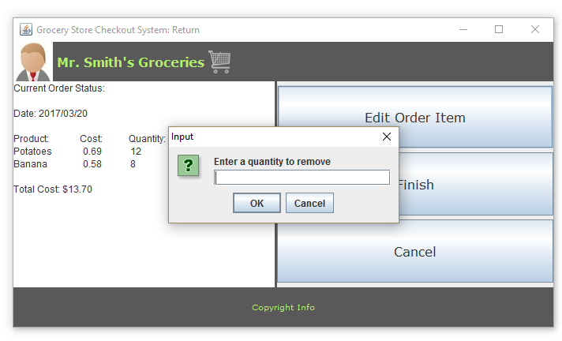

1. User types in product name and quantity they wish to return.
2. System updates order list and displays refund amount.

