**Iteration 3 Requirements**

**User stories:**

1. As a cashier, I want to check out a list of items bought by a customer
2. As a manager, I want to update the inventory (change price, availability, add new products...)
3. As an employee, I want to login into and logout from the system
4. As an employee, I want to change my display information (e.g. display name, photo...), my access code/password from the system
5. As a manager, I can assign or change the access rights to other employees
6. As a customer support employee, I want to help a customer returning an item bought previously
7. As a manager, I want to install the application for the first time, set up users, and convert the existing database in XLS into a SQL-based database (IN INSTALLATION PACKAGE)
8. As a cashier, I want to check-out differently for loyal program customers. If the customer has a loyal card, some items will have different prices
9. As a manager, I want to set up discount prices for some products
10. As a customer, I want to use the reward points to pay in checking out process. The reward points are accumulated while paying by actual dollars. The conversion rate is 1 point for $1 when buying, and 100 points for paying with points
11. As a manager, I want to have revenue reports for products, or customers, in a given period (e.g. a week, a month, or a quarter…)

**Note: Access levels are as follows:**

**1: Manager with access to all systems**

**2: Cashier with access to checkout and returns**

**3: Cashier with access to only checkout**

**4: Customer support employee with only access to returns**

**Also, if the user enters an incorrect password 3 times, the system will lock them out and shutdown.**

# Use Case: Login/out

1. System displays the Startup screen.

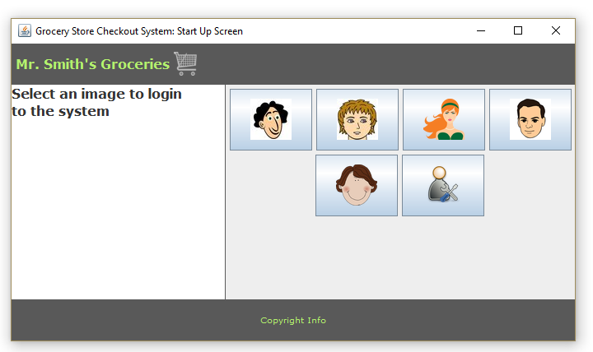

1. User clicks on their login icon.
2. System displays the Login screen.

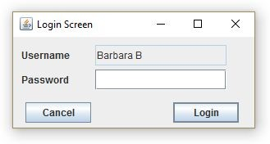

1. User enters in password.
2. If user enters in incorrect password system, displays a warning message

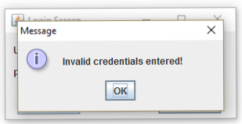

1. If user enters in incorrect password three times in a row, system displays warning message and program is exited

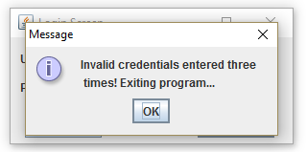

1. If user has access level 1 (and enters correct password) system displays this Main screen.

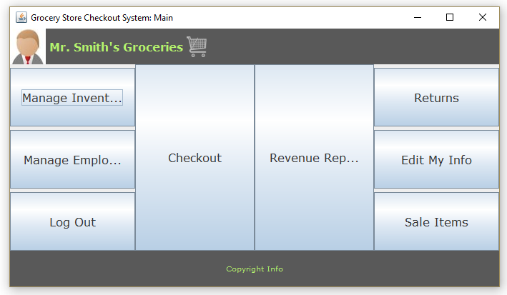

1. If user does not have access level 1, system displays this Main screen.

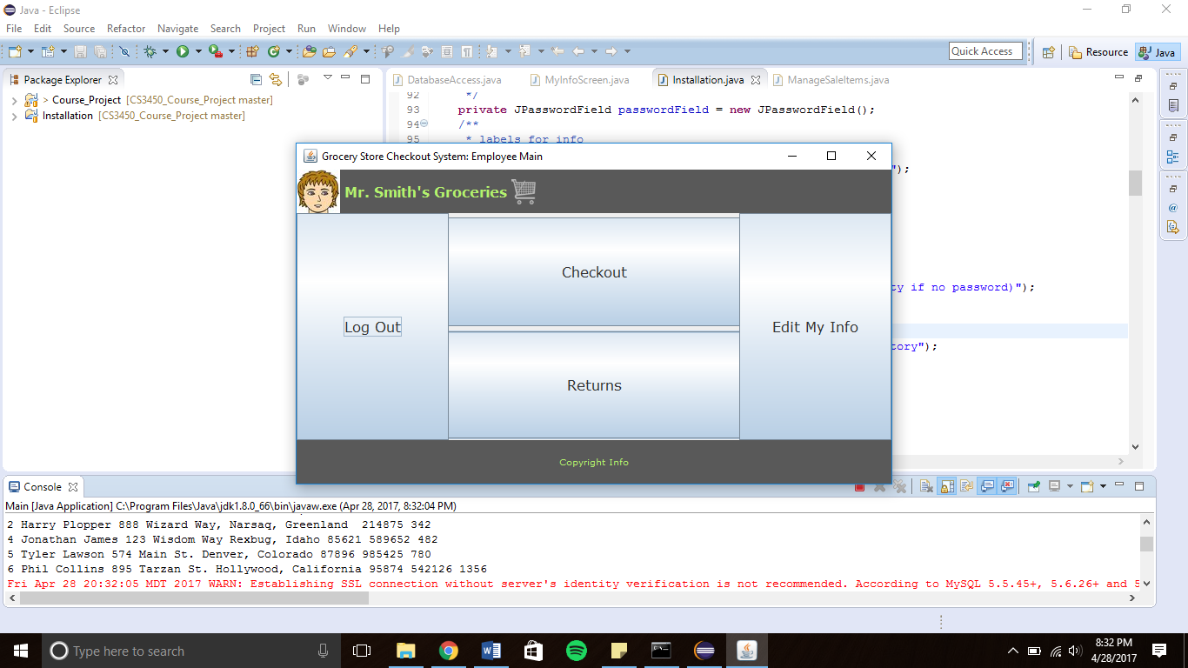

1. User clicks on “Log out” button.
2. System displays a Confirm Logout screen.

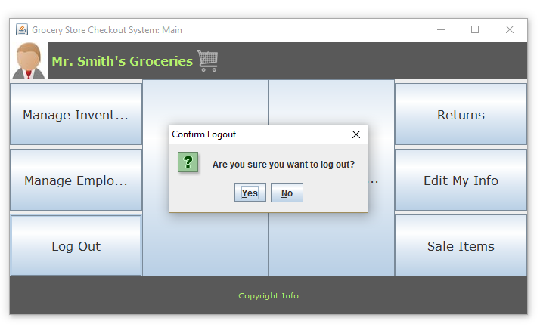

1. User clicks “Yes” button.
2. System returns to Startup screen.

# Use Case: Check Out

1. Repeat steps from Login/out Use Case to login.
2. If user access rights is not 1-3, system will display a Main screen with a disabled Checkout button.

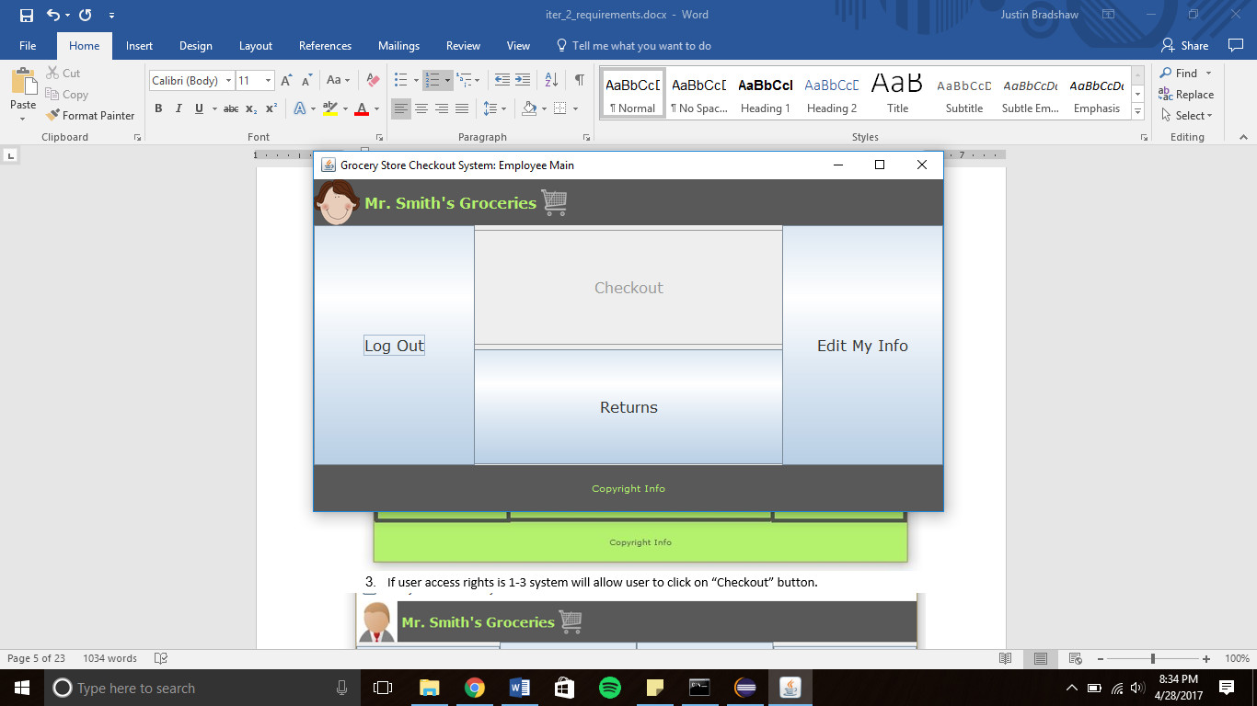

1. If user access rights is 1-3 system will allow user to click on “Checkout” button.

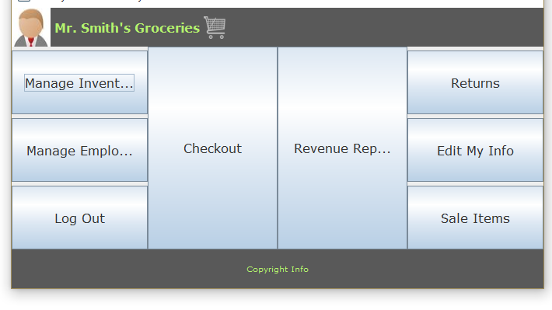



1. System then displays a customer type popup screen

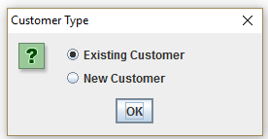

1. User selects the customer type.
2. If existing customer was selected system displays window to enter in customer ID

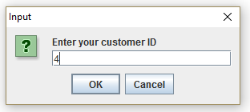

1. If new customer was selected system displays the following windows to enter in customer information

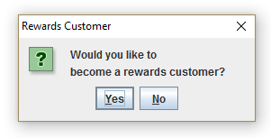 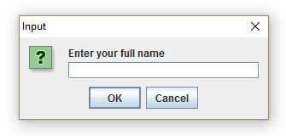 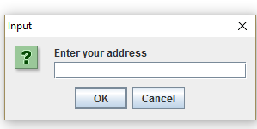

1. System then displays Checkout screen.

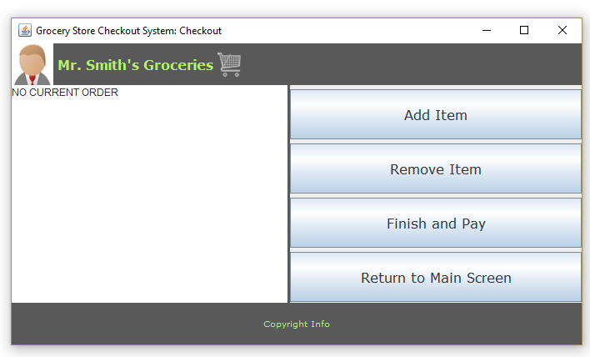

1. User clicks “Add Item” button.
2. System displays Add Item screen.

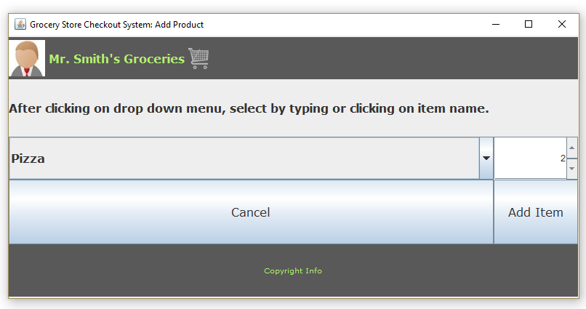

1. User selects an item and quantity and clicks on “Add item” button to add new item.
2. System updates information of the new item in the list of items.

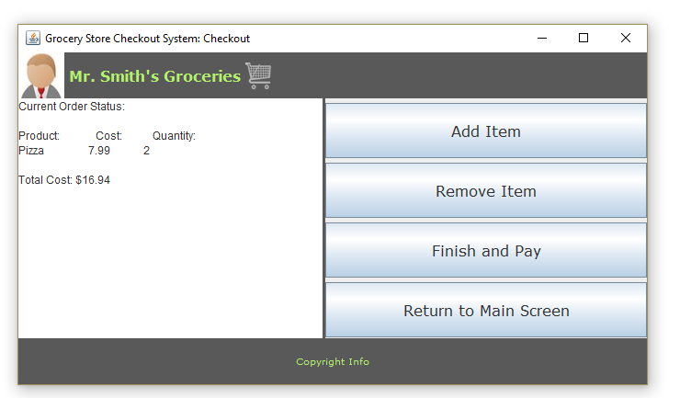

1. User repeats step 10 for all items.
2. To remove an item user clicks “Remove Item” button.
3. User selects an item and quantity from the list of items and clicks on “Remove Item” button to remove item.

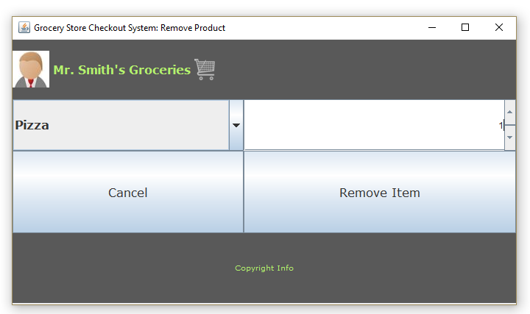

1. User clicks on “Finish and Pay” button.
2. System displays the Delivery Method pop up screen.

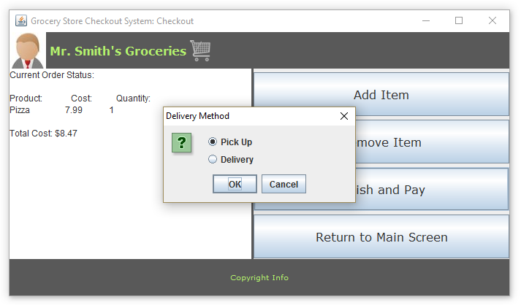

1. User selects delivery method.
2. System displays the Payment Method pop up screen.

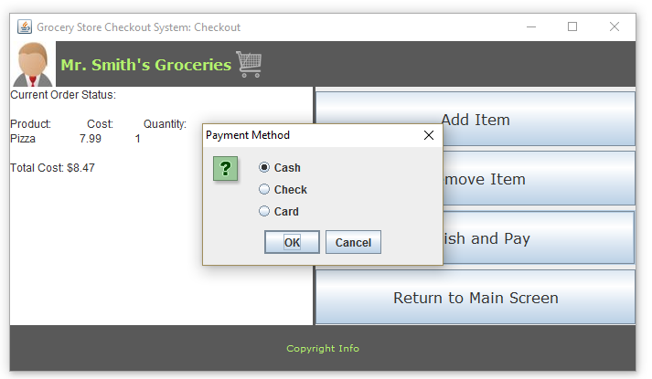

1. User selects payment method.
2. If user selects “Card” option system will display the following screens to input customer information

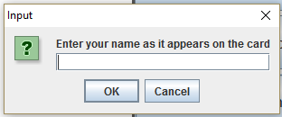

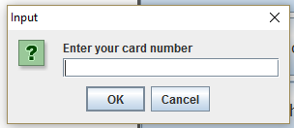 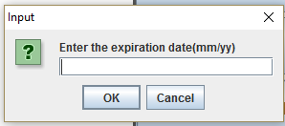

1. User inputs customer information
2. System displays price of order and updates customer and order information.

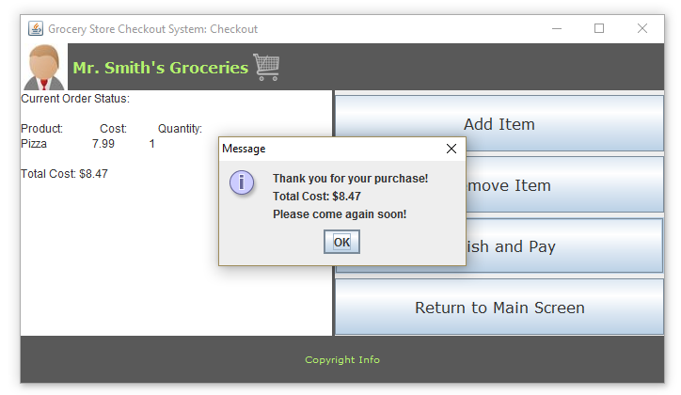

# Use Case: Manage Inventory

1. Repeat steps from Login/out Use Case to login.
2. If user access rights is not 1 system will display a Main screen without a “Manage Inventory” button.



1. If user access rights is 1 system will display a Main Screen with a “Manage Inventory” button.



1. User clicks on “Manage Inventory” button.
2. System displays Manage Inventory screen.

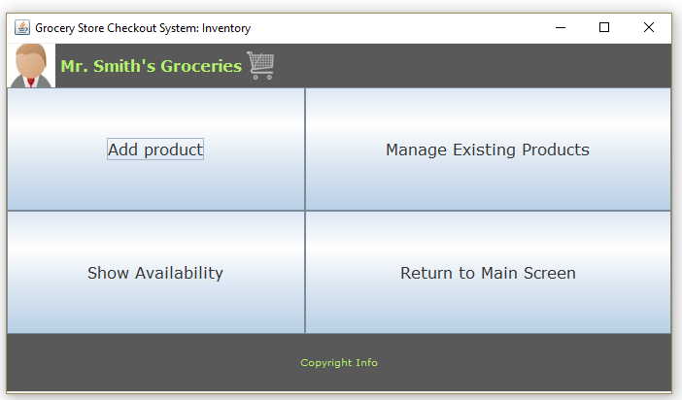

1. To add a product to the inventory, user clicks “Add Product” button.
2. System displays Add Product screen.

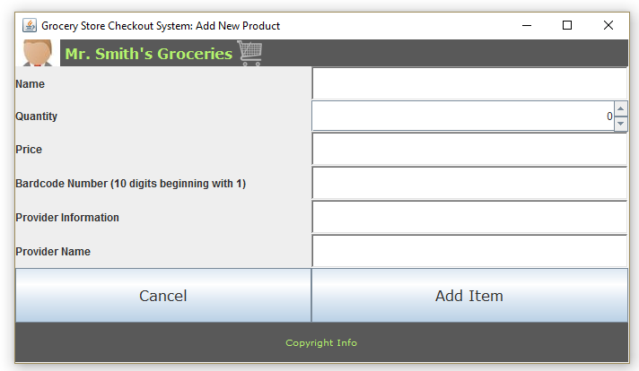

1. User enters in product information and clicks on “Add Item.”
2. System updates information of the new item in the inventory.
3. To manage existing products user clicks on “Manage Existing Products” button.
4. System displays Manage Product Screen with a default product to manage.

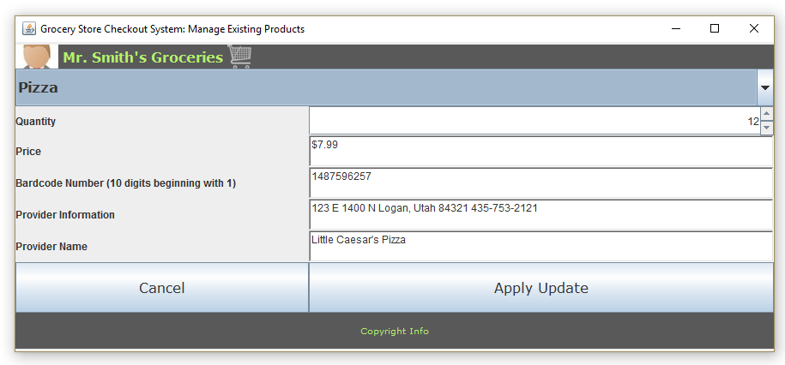

1. User selects which product to manage.
2. System displays information for that product.

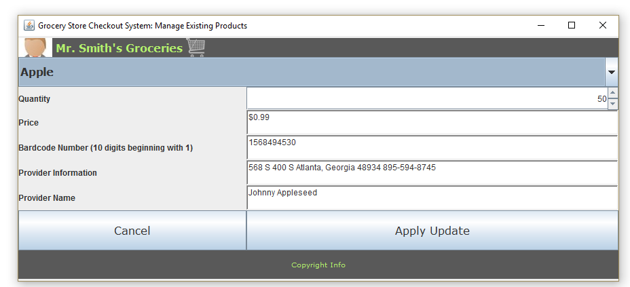

1. User makes necessary changes and clicks on “Apply Update” button.
2. System updates product information.
3. To check product availability user selects “Show Availability” button.
4. System displays list of products and their quantities.

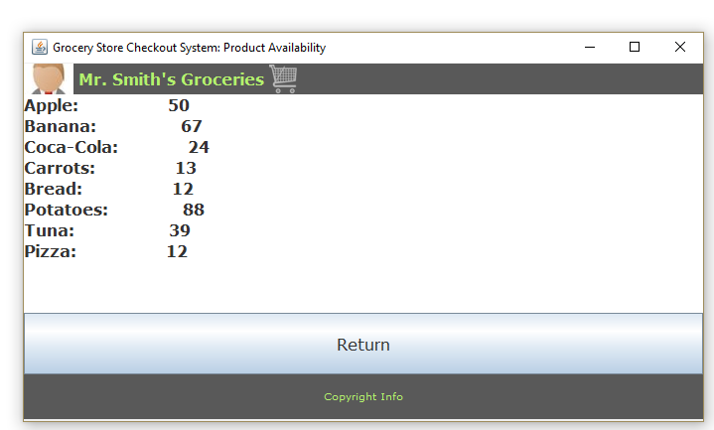

# Use Case: Change Display Information

1. Repeat steps from Login/out Use Case to login.
2. User clicks “Edit My Info” button.
3. 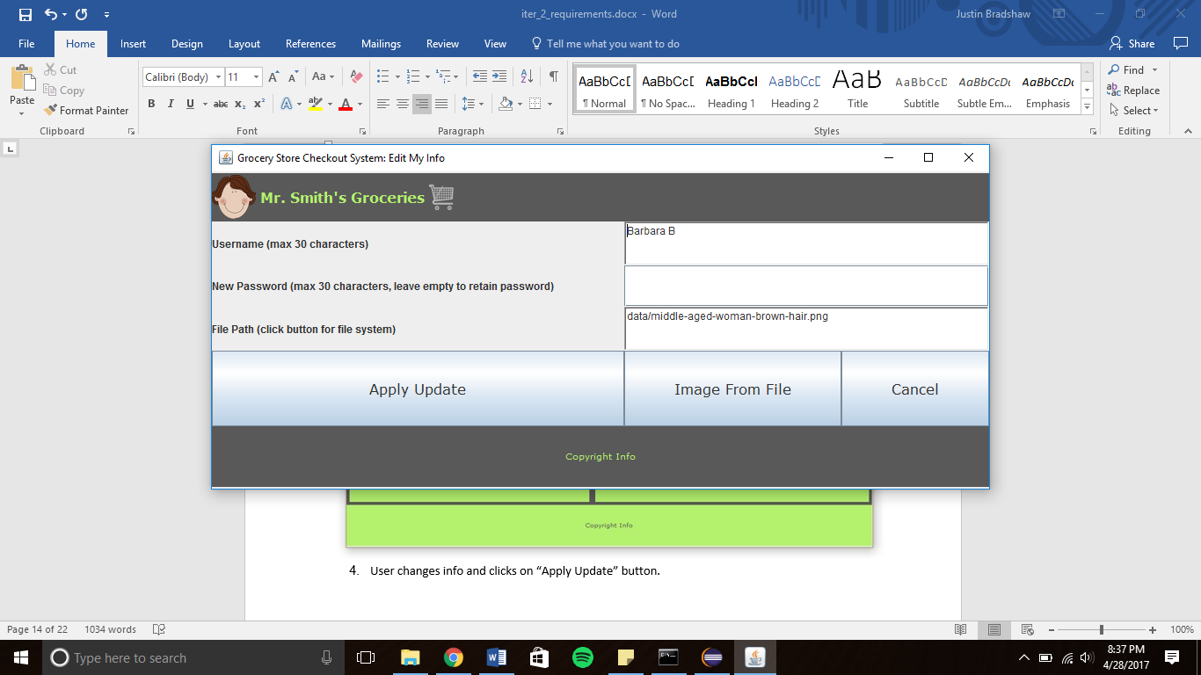System displays Edit My Info screen

1. User changes info and clicks on “Apply Update” button.
2. System updates employee information and returns to Main Screen.
3. If user changes their password system displays a confirm password screen.

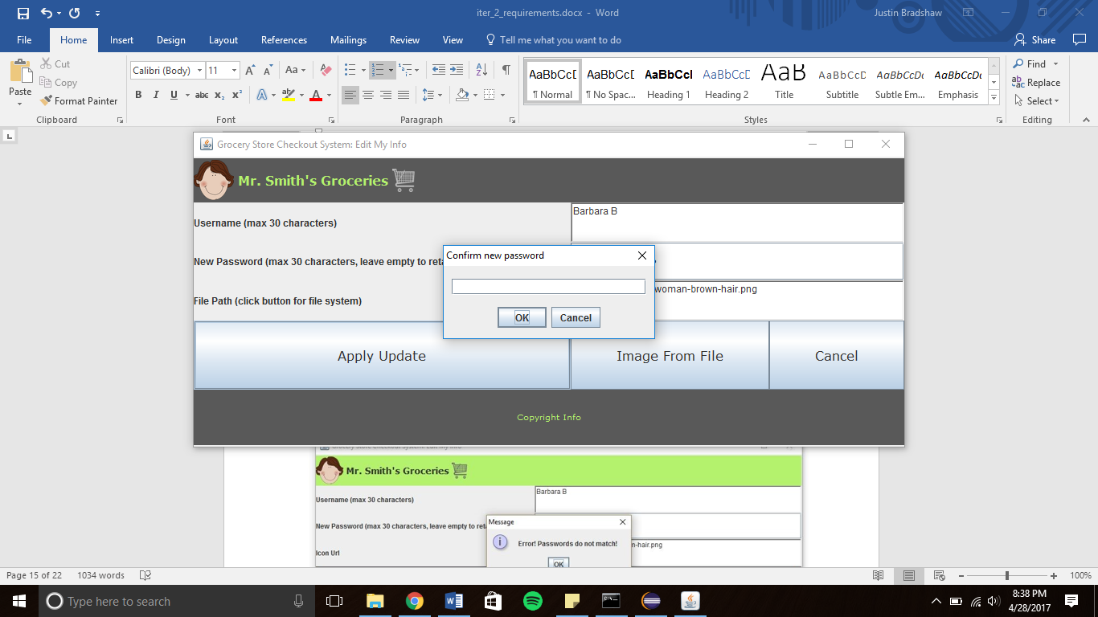

1. User types in new password.
2. If password is wrong system displays error message.



1. If password is correct system updates employee information.

**Use Case: Manage Employees and Access Rights**

1. Repeat steps from Login/out Use Case to login.
2. If user access rights is not 1 system will display a Main screen without a “Manage Employees” button.

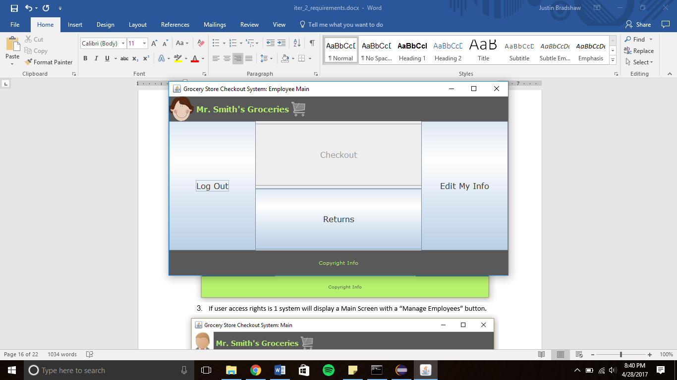

1. If user access rights is 1 system will display a Main Screen with a “Manage Employees” button.



1. User clicks on “Manage Employees” button.
2. System displays the Manage Employees screen.

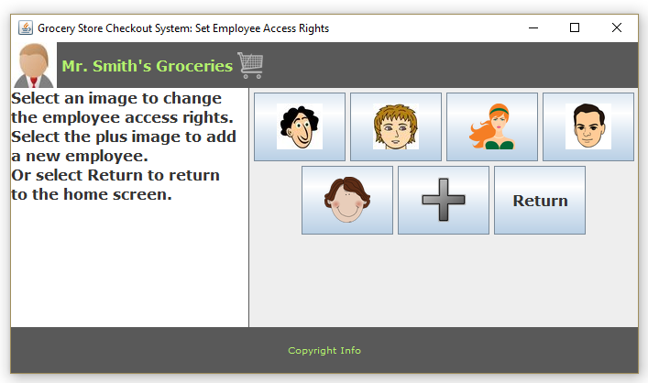

1. User clicks on an employee icon.
2. System displays a change access rights screen.

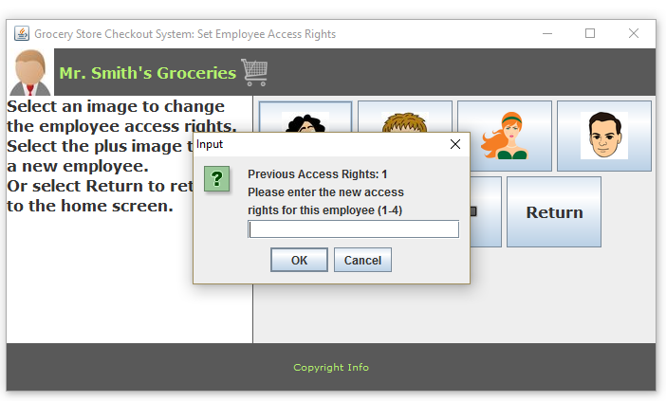

1. User types in new access rights level.
2. System updates employee access rights information.
3. To create new employee user clicks on “+” icon
4. System displays add new employee screen

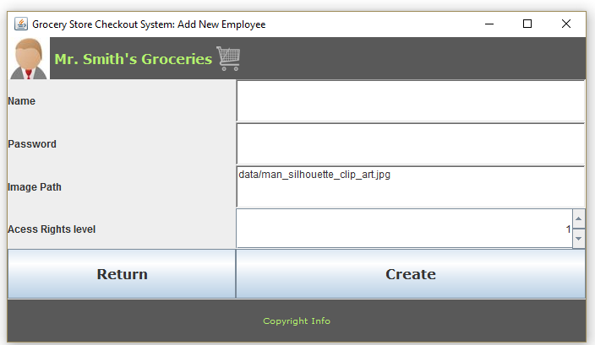

1. User types in employee information and clicks on “Create” button
2. System creates new employee in the database and returns to manage employees screen

# Use Case: Return Items

1. Repeat steps 1-5 from Login/out Case.
2. If user access rights is not 1,2 or 4 system will display a Main screen with a disabled “Returns” button.

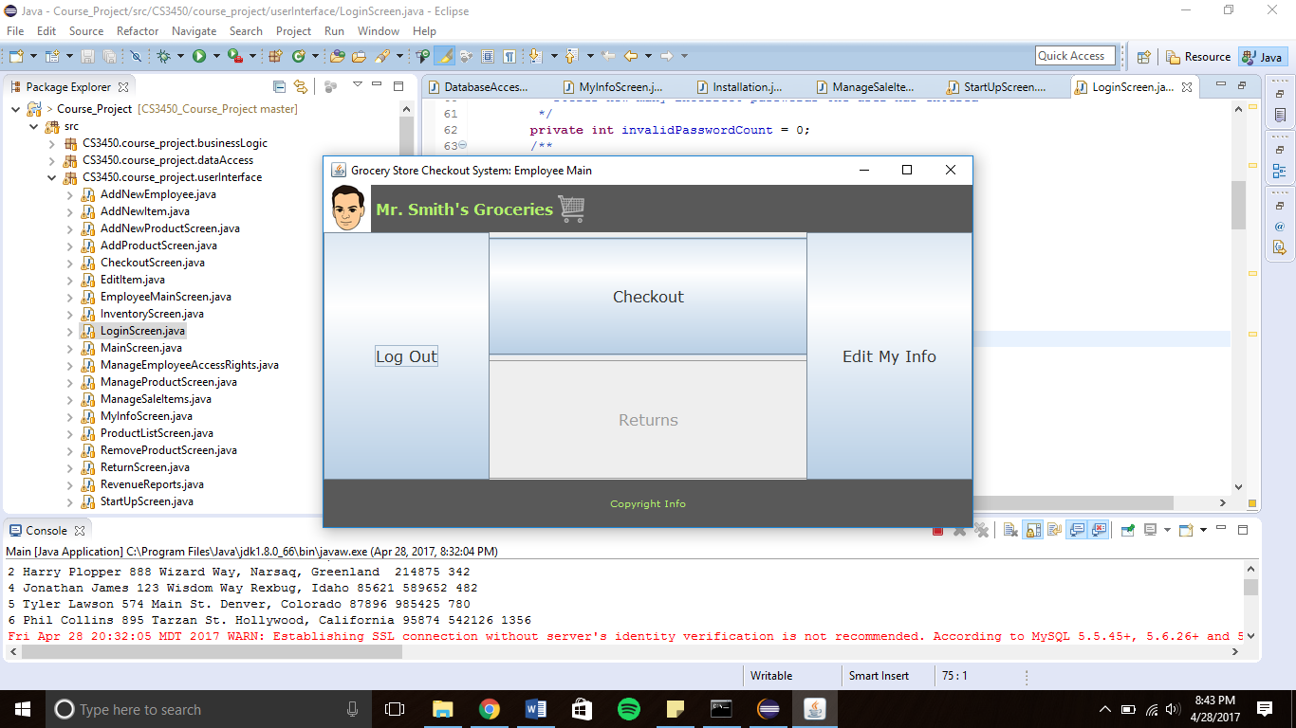

1. If user access rights is 1, 2 or 4 system will allow user to click on “Returns” button.



1. System then displays Return Order screen.

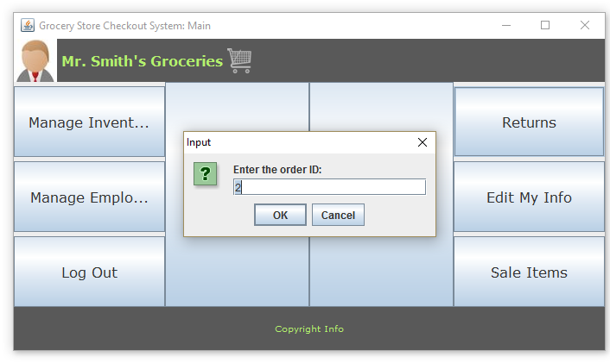

1. User types in the order number.
2. System displays order information.

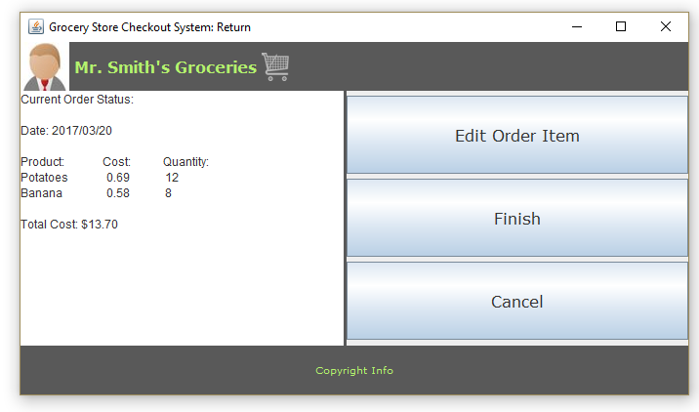

1. User clicks “Edit Order Item.”
2. System displays Input screens.

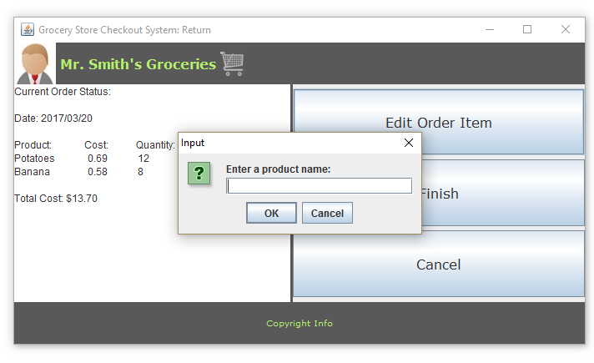 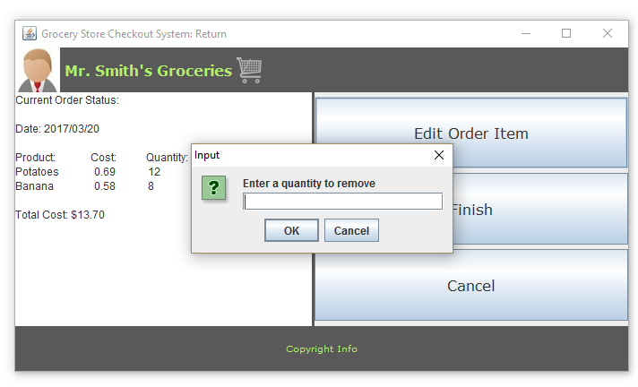

1. User types in product name and quantity they wish to return.
2. System updates order list and displays refund amount.

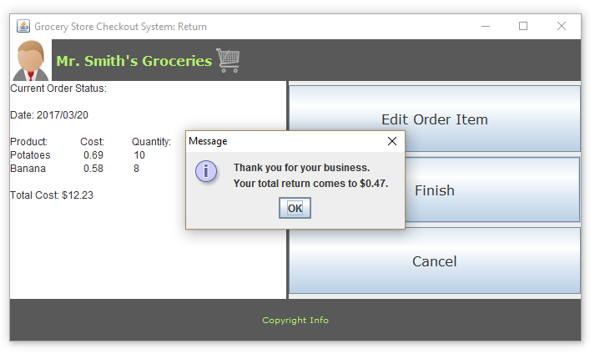

**Use Case: Installation**

**Note: If at any point the user selects cancel from the main screen, the program will exit**

1. System displays the installation screen

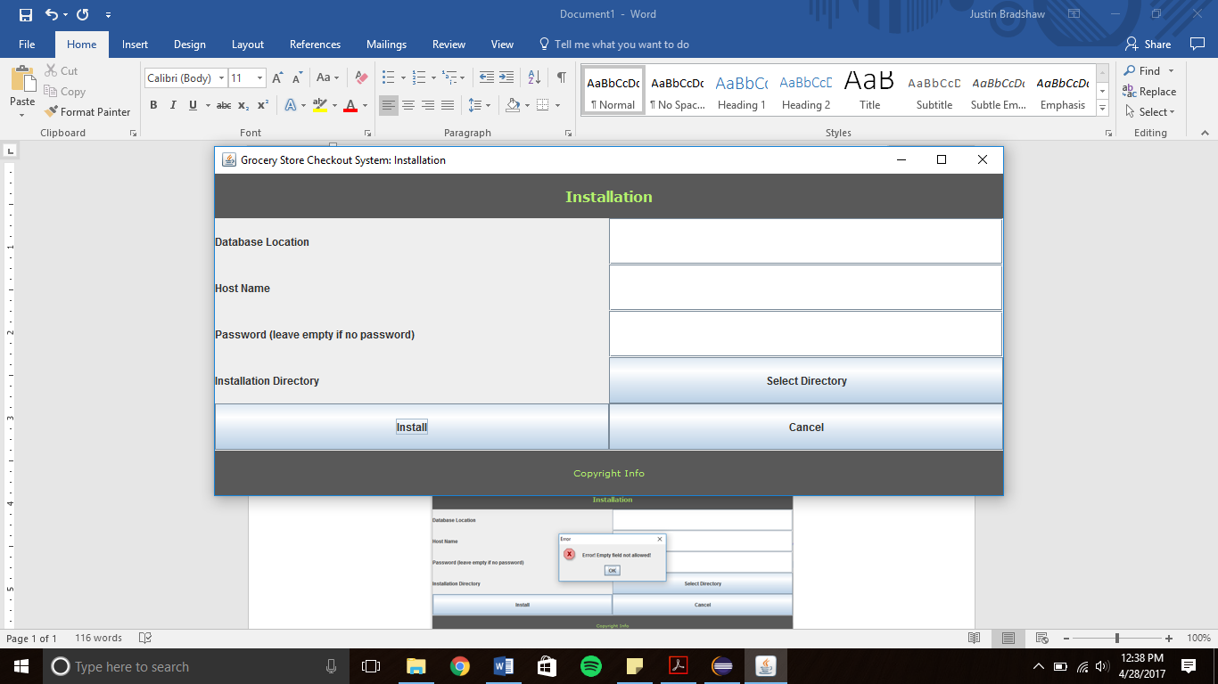

1. User enters the database location, host name, and password
2. User presses the select directory button
3. The File System directory is displayed
   1. If the user selects a directory, the directory is stored
   2. If the user selects cancel, no directory is stored

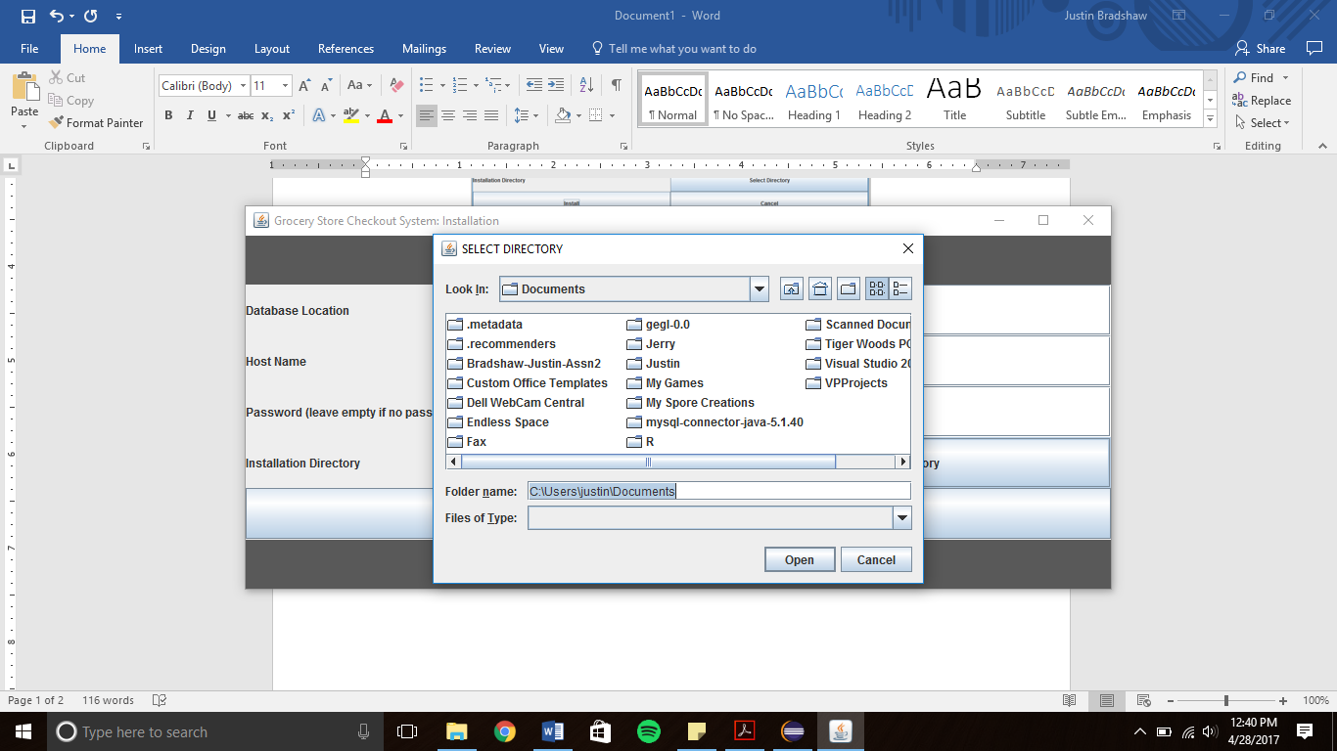

1. The user selects the install button
   1. If they have left any entries empty other than the password, an error message is displayed (if empty directory, empty directory error message is displayed)

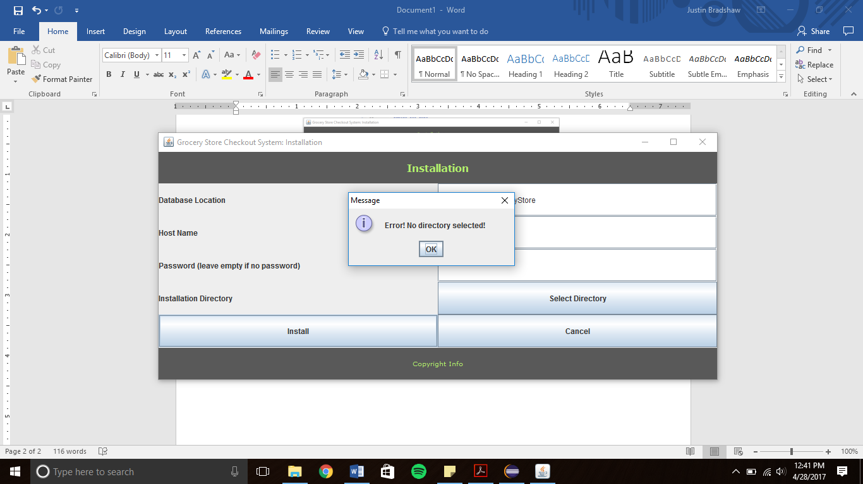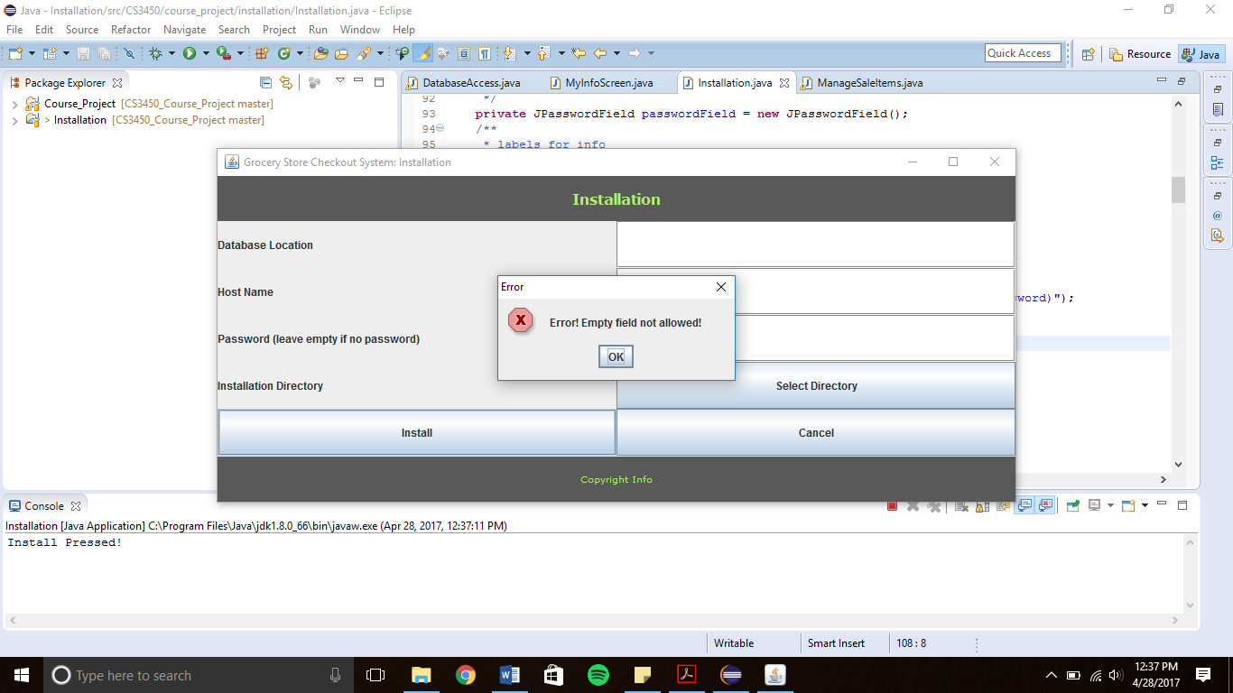

1. If all entries are valid, the installation process completes and a confirmation message appears

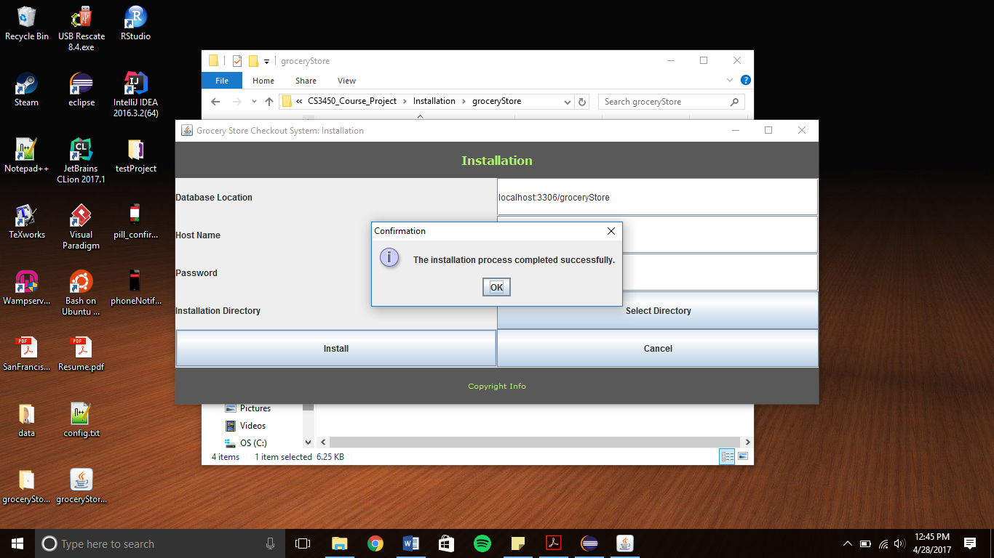

1. 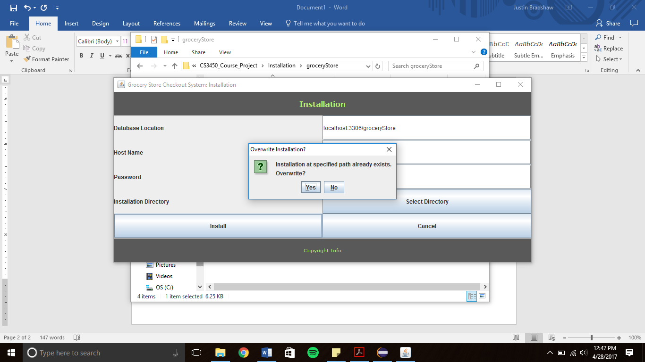If the program already exists at the installation location, the user may select whether or not to override the current installation.

**Use Case: Loyal Program Customers**

1. Repeat steps from Login/out Use Case to login.
2. Repeat steps from Checkout Use Case.
3. At check-out point if the customer is not in the Loyal Program items on sale will be at their normal price.

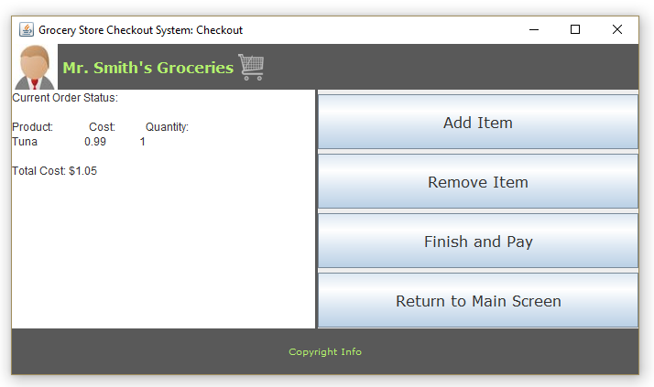

1. If the customer is in the Loyal Program items on sale will be at a discounted price.

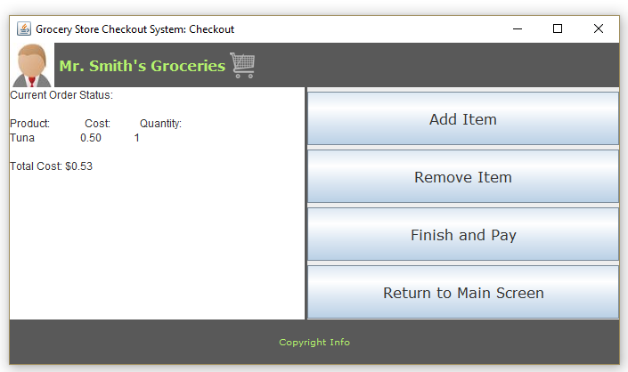

**Use Case: Discount Prices**

1. Repeat steps from Login/out Use Case to login.
2. System displays main screen



1. User clicks on “Sale Items” button.
2. System displays Manage Sale Items screen with all sales.

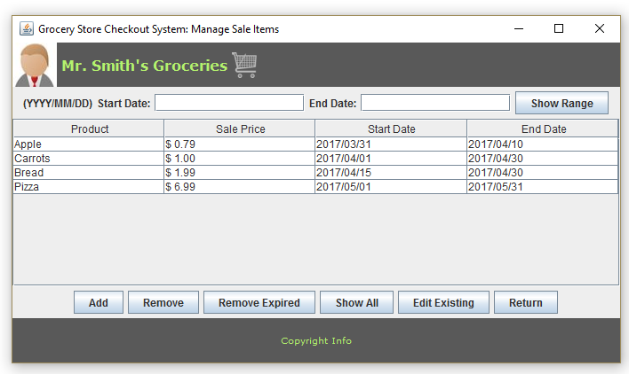

1. User clicks on “Add” button to add a sale
2. User clicks on “Remove” button to remove sale.
   1. System displays input screen.

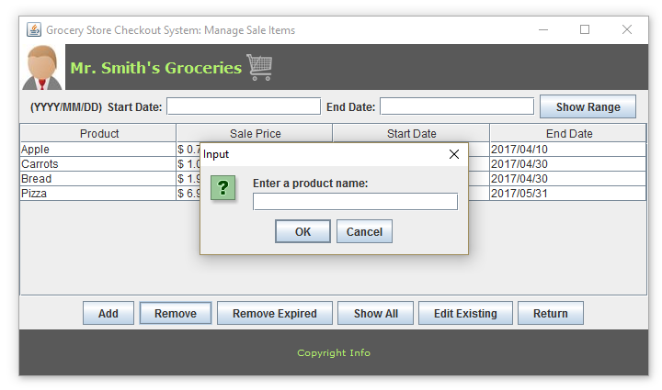

* 1. User enters in product name of the corresponding sale to remove.
  2. System removes sale and an updated Manage Sale Items screen is displayed.

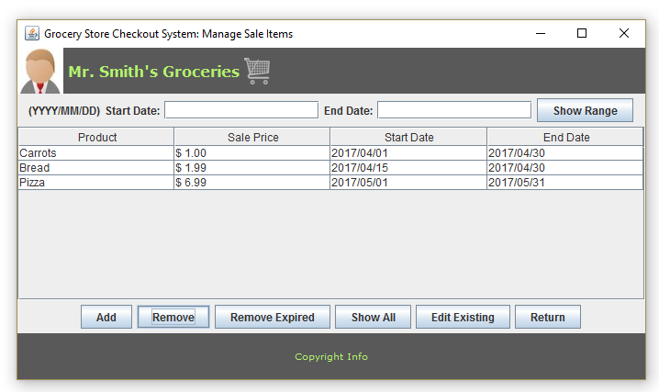

1. User clicks on “Edit Existing” button to edit existing sales.
   1. System displays input screen.
   2. 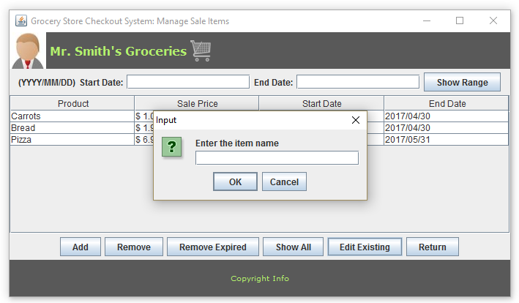
   3. User enters in item name.
   4. System displays the corresponding sale information.

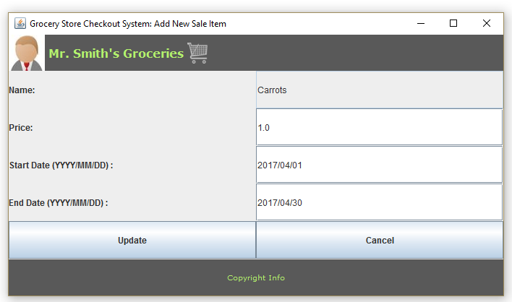

* 1. User edits information and clicks “Update” button.
  2. System updates sale information.

1. User clicks on “Remove Expired” button.
   1. System removes all expired sales from the list and the database.
2. User enters in a date range at the top of the screen and clicks “Show Range”
   1. System displays all sales within the date range.

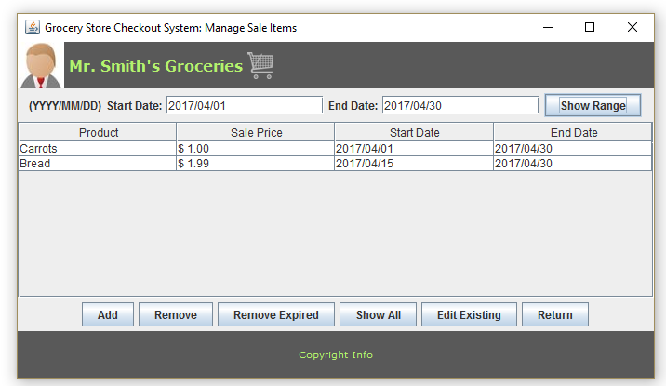

1. User clicks on “Show All” button.
   1. System displays all sales in the database.

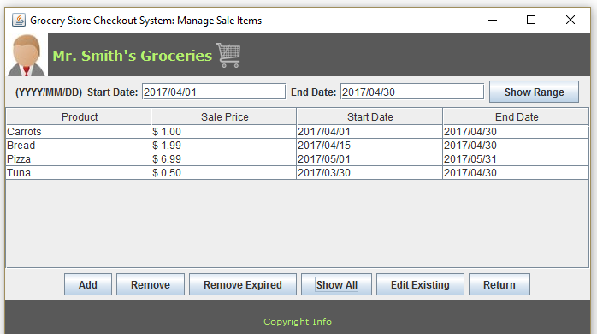

**Use Case: Reward Points**

1. Repeat steps from Login/out Use Case to login.
2. Repeat steps from Checkout Use Case.
3. At check-out point after user clicks on “Finish and Pay” button if Customer is part of the Loyal Program and has earned 100 or more rewards points system will display screen to use reward points.

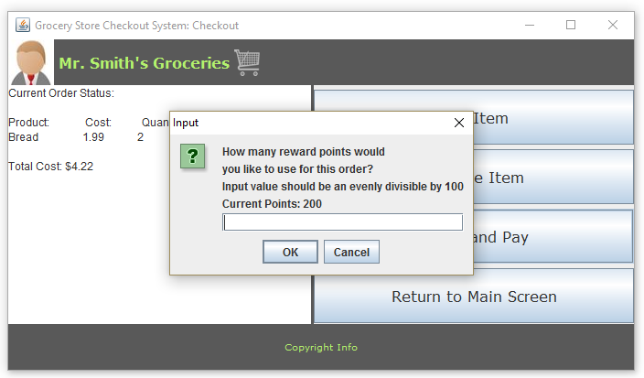

1. User enters in number of reward points costumer wishes to use.
2. If user enters in a number not evenly divisible by 100 system will display error message

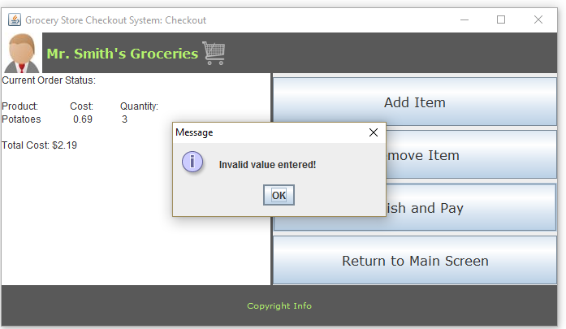

**Use Case: Revenue Reports**

1. Repeat steps from Login/out Use Case to login.
2. System displays main screen.

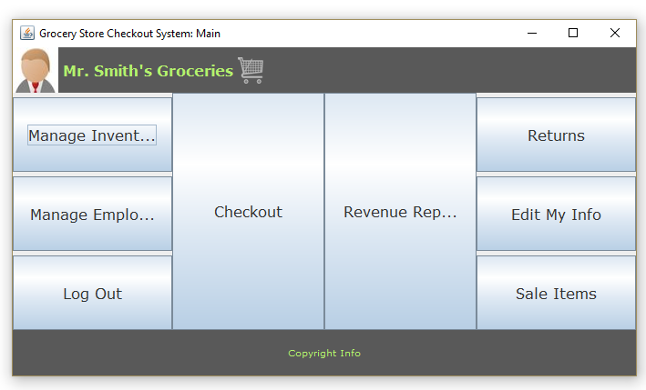

1. User clicks on “Revenue Reports” button.
2. System displays Revenue Reports screen.

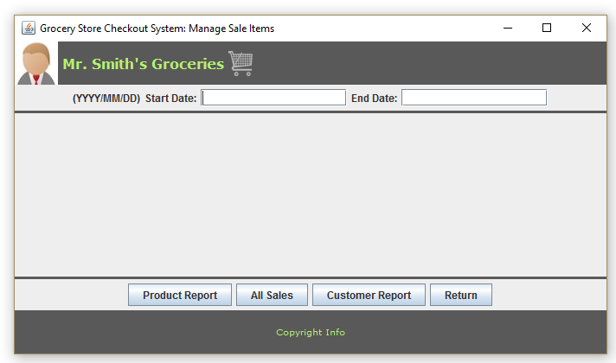

1. User enters in a start date and end date at the top of the screen and clicks on “Product Report” button.
   1. System displays input screen.

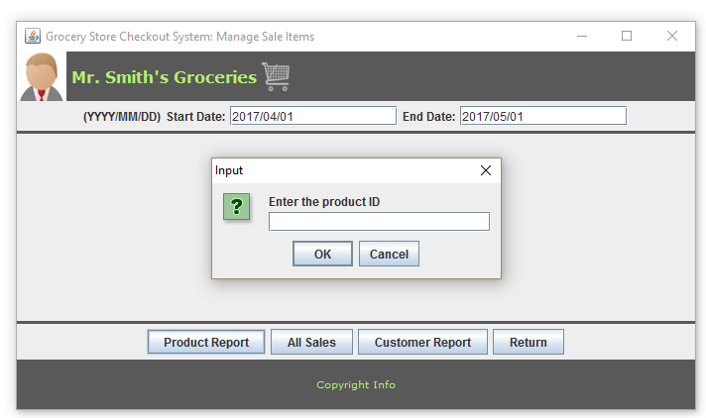

* 1. User enters in product ID
  2. System displays product revenue report at given date range.

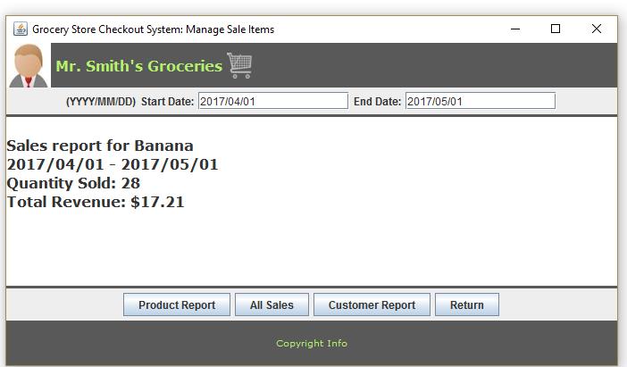

1. User enters in a start date and end date at the top of the screen and clicks on “Customer Report” button.
   1. System displays input screen.

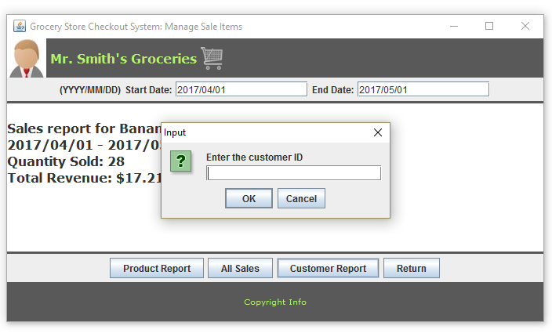

* 1. User enters in Customer ID.
  2. System displays customer revenue report at given date range.

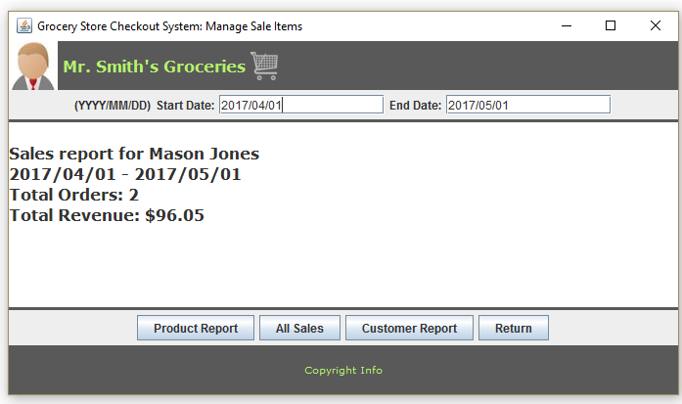

1. User clicks on “All Sales” button.
   1. System displays revenue for all products.

