We have agreed to implement the following user stories in Iteration 1:

1. As a user, I want to check out a list of items bought by a customer
2. As a user, I want to update the inventory (change price, availability, add new products,...)

Note: In Iteration 1, we do not implement the User Management Sub-system, i.e., the system has only one user and this user has all access rights.

Please describe in details all use cases related to those user stories (e.g., checking out, changing price and quantity, adding a new product...). The description should include drawings or sketches of the relevant screens the system displays in each use case.

Use Case: Checkout

Steps:

1. The system displays the main screen

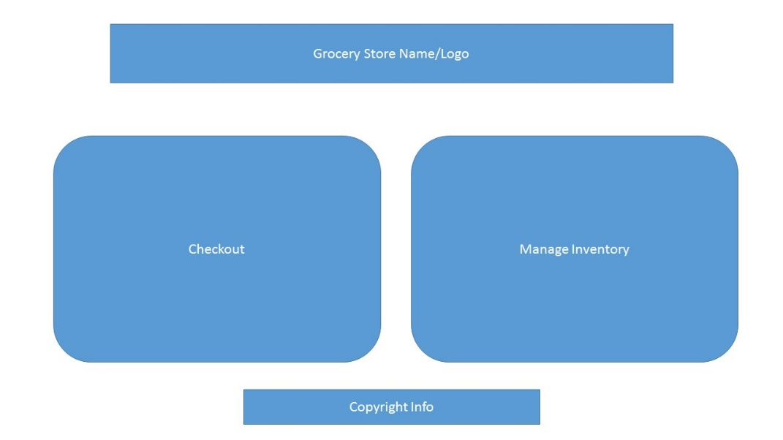

1. The system displays the checkout screen

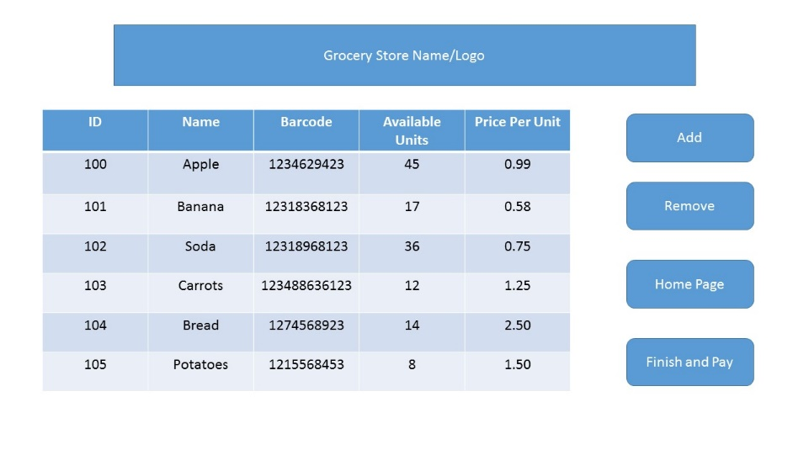

3. User clicks a button to add a new item

4.System updates info of the new item in the list of items

5. User repeats step 4 for all items

6. User clicks the button "Finish and pay"

7. System displays the payment screen

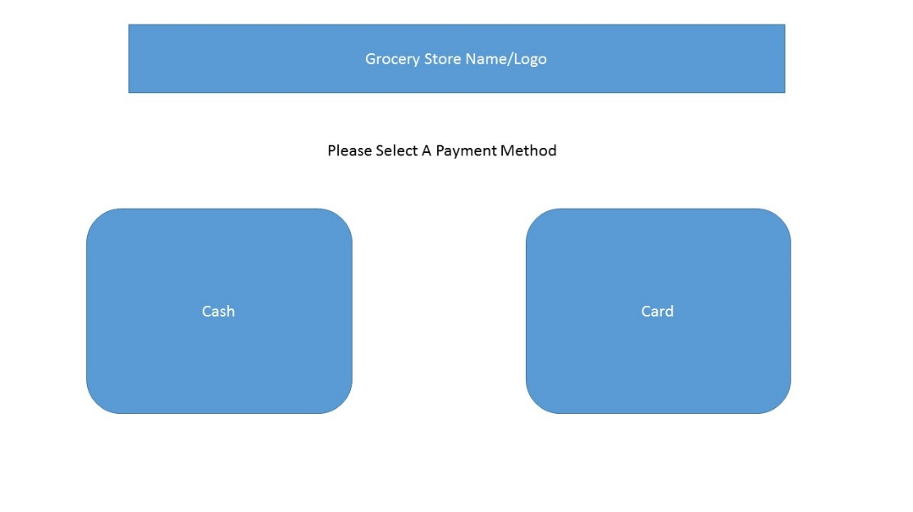

8. User chooses payment types

If cash, system displays the receipt screen for printing

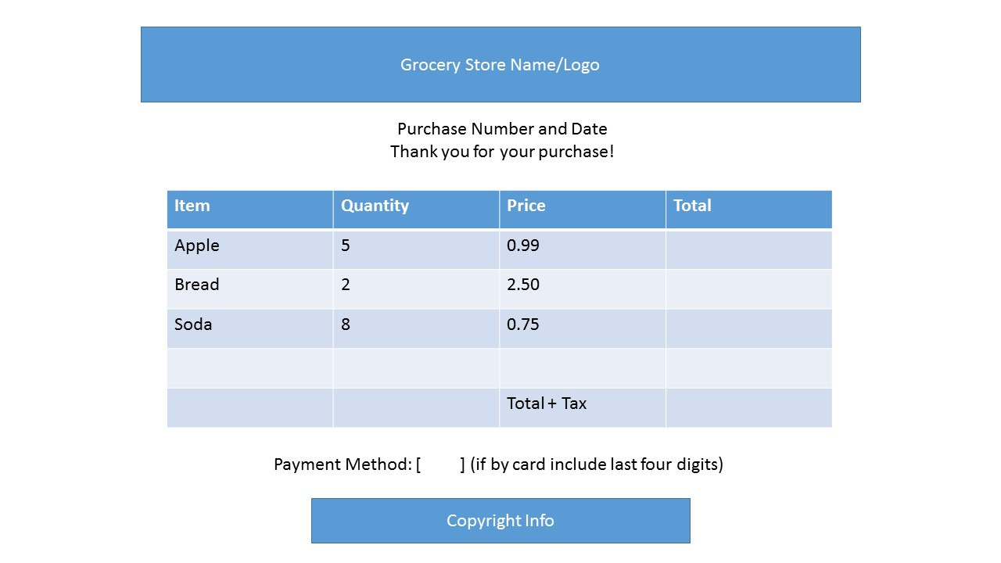

If credit card, system displays the credit card screen

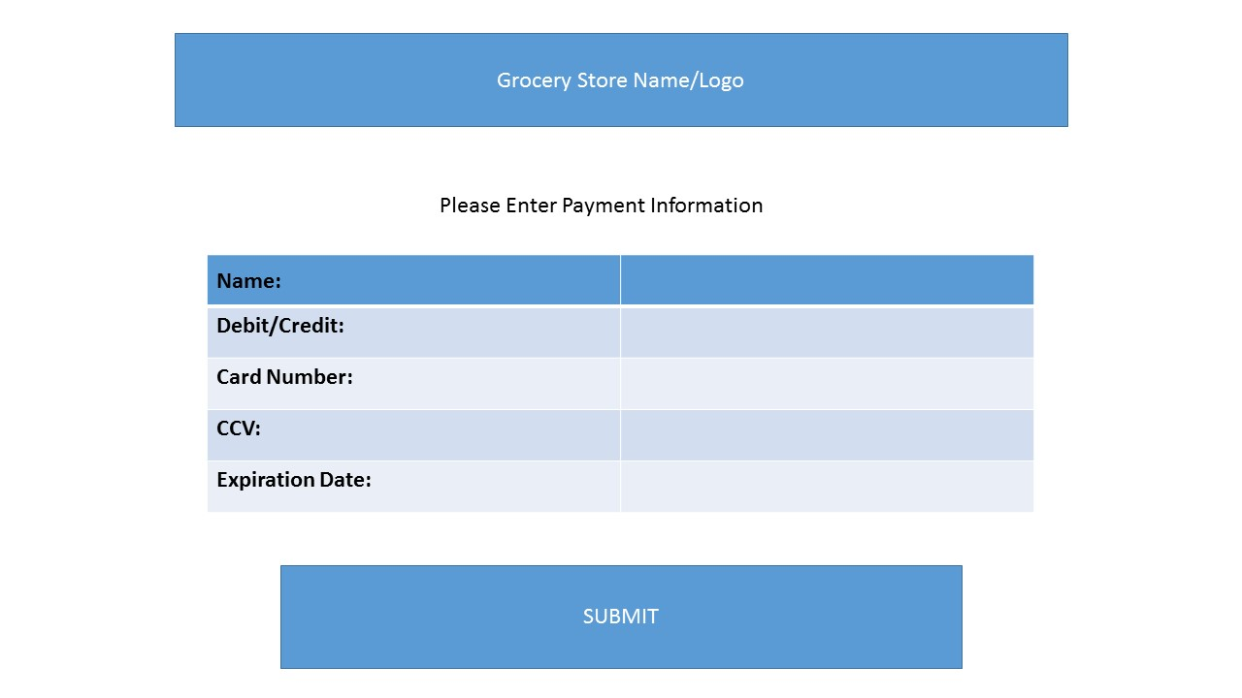

9. User inputs credit card information and clicks ok

10. System Displays receipt screen (see above)

Use Case: Changing Price and quantity

1. The system displays the main screen (show)



1. The user selects the Manage Inventory Button
2. Manage Inventory Screen is displayed (show)

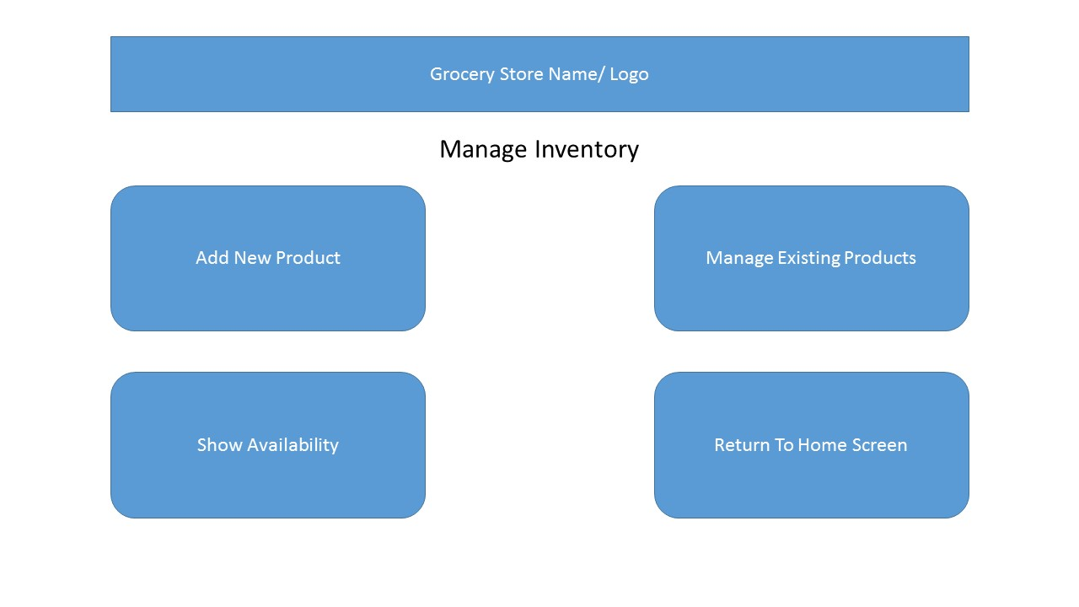

1. User selects manage existing products
2. A list of existing products and availability is shown (show)

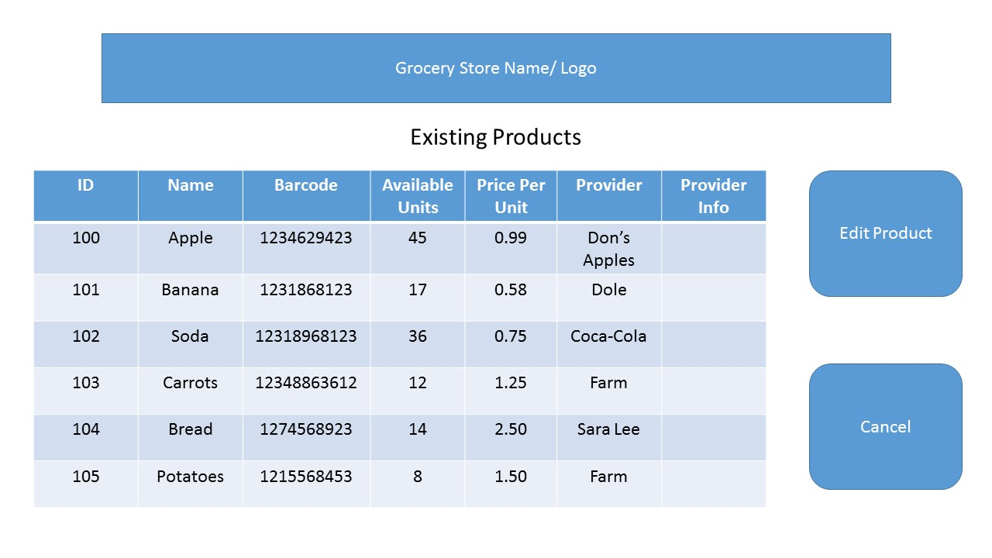

1. The user selects a product to edit
2. A screen appears to allow for changing of each attribute (show)

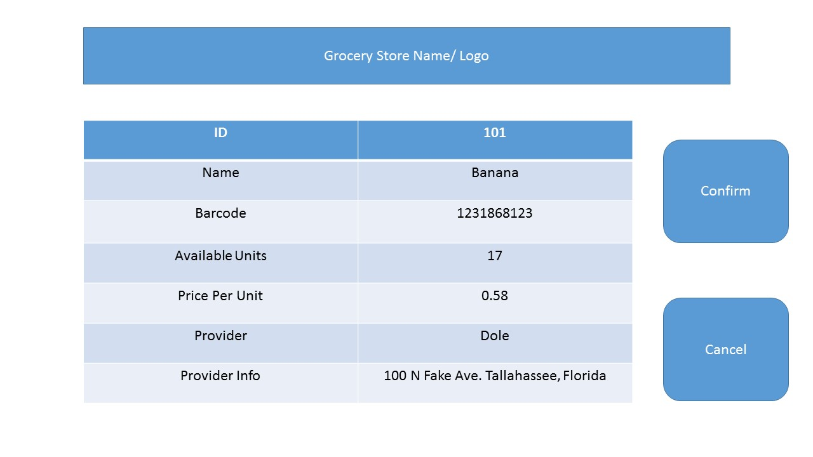

1. User hits the confirm button and is taken back to the home screen
2. Or user hits the cancel button and is also taken back to the home screen

Use Case: Adding a new product

1. The system displays the main screen (show)



1. The user selects the Manage Inventory button
2. Manage inventory screen is displayed (show)



1. User selects add new product
2. A screen is displayed to allow for the user to add new product information (show)

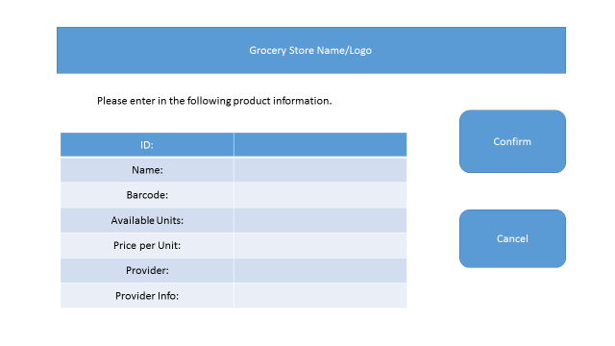

1. The user clicks to confirm or to cancel
2. If the user confirms they are taken back to the manage inventory screen
3. If the user cancels they are taken back to the home screen

Use Case: Checking inventory

Other Use Cases?