**EECS2040 Data Structure Hw #4 (Chapter 5 Tree)**

**due date 5/22/2022, 23:59**

**by 108011235 陳昭維**

**Part 2 Coding (5% of final Grade)**

You should submit:

(a) All your source codes (C++ file).

(b) Show the execution trace of your program, i.e., write a client main() to demonstrate all functions you designed using example data..

1. (30%) Develop a complete C++ template class for binary trees shown in **ADT 5.1**. You must include a **constructor**, **copy constructor**, **destructor**, the traversal methods as shown below, and functions in **ADT 5.1**.

void Inorder()

void Preorder()

void Postorder()

void LevelOrder()

**void** NonrecInorder()

**void** NoStackInorder()

**bool** **operator ==** (**const** BinaryTree& t) **const**

**ADT 5.1 BinaryTree**

**template**<**class** T>

**class** BinaryTree

{ // objects: A finite set of nodes either empty or consisting

// of a root node, left BinaryTree and right BinaryTree

**public**:

BinaryTree(); // constructor for an empty binary tree

**bool** IsEmpty(); // return true iff the binary tree is empty

BinaryTree(BinaryTree<T>& bt1, T& item, BinaryTree<T>& bt2);

// constructor given the root item and left subtrees bt1 and right subtree bt2

BinaryTree<T> LeftSubtree(); // return the left subtree

BinaryTree<T> RightSubtree();// return the right subtree

T RootData(); // return the data in the root node of \***this**

};

Write 2 setup and display functions to establish and display 2 example binary trees shown below. Then **demonstrate** the functions you wrote.



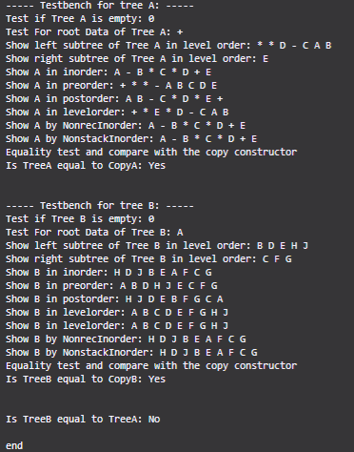

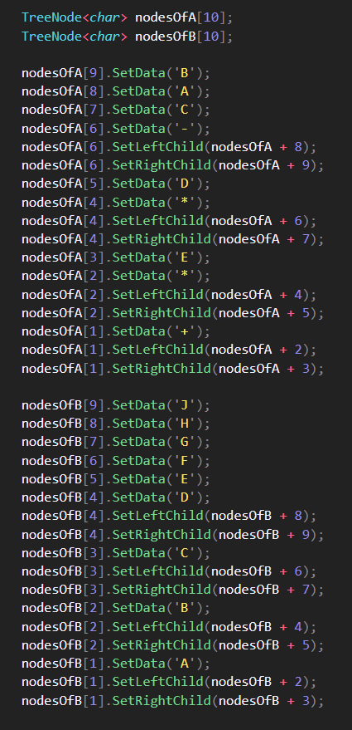

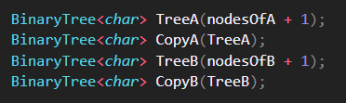

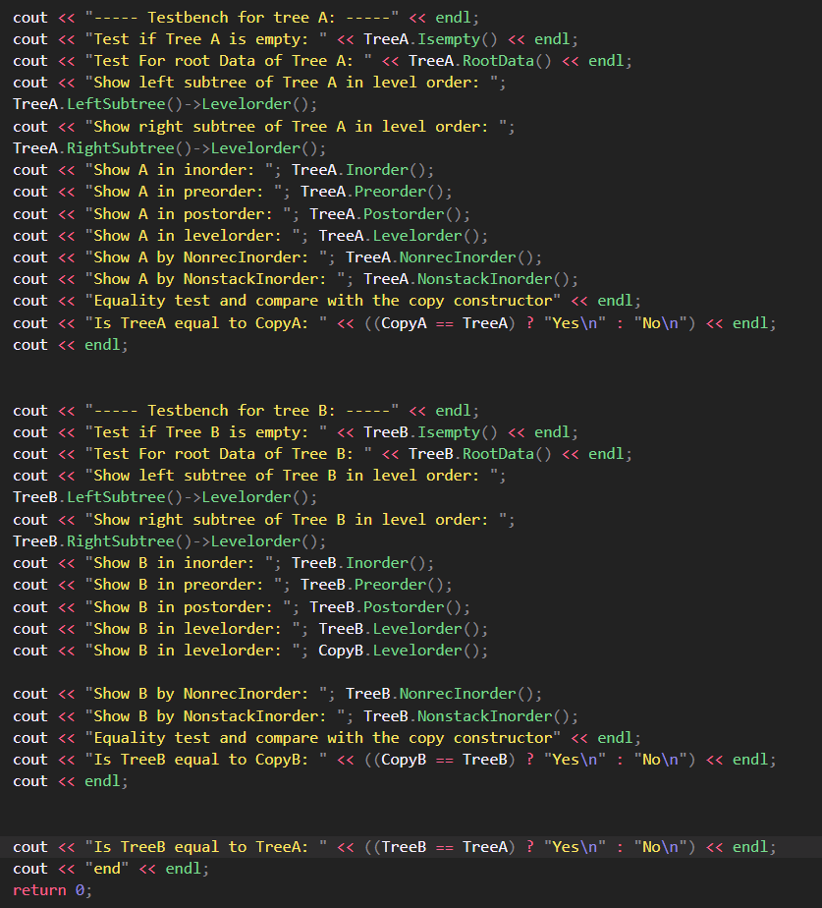

1. (35%) (a) Write a C++ class MaxHeap that derives from the abstract base class in **ADT 5.2 MaxPQ** and implement all the virtual functions of MaxPQ.

**ADT 5.2 MaxPQ**

**template** <**class** T>

**class** MaxPQ {

**public**:

**virtual** ~MaxPQ() {} // virtual destructor

**virtual** **bool** IsEmpty() **const** = 0; //return **true** iff empty

**virtual** **const** T& Top() **const** = 0; //return reference to the max

**virtual** **void** Push(**const** T&) = 0;

**virtual** **void** Pop() = 0;

};

The class MaxHeap should include a **bottom up heap construction initialization** function, the push function for inserting a new key and pop function for deleting and the max key. You should also write a client function (main()) to demonstrate how to construct a max heap from a sequence of 13 integer number: 50, 5, 30, 40, 80, 35, 2, 20, 15, 60, 70, 8, 10 by using a series of 13 pushes and by bottom up initialization. Add necessary code for displaying your result.

(b) Write a C++ abstract class similar to ADT 5.2 for the ADT **MinPQ**, which defines a min priority queue. Then write a C++ class MinHeap that derives from this abstract class and implement all the virtual functions of MinPQ.

The class MinHeap should include a **bottom up heap construction initialization** function, the push function for inserting a new key and pop function for deleting and the min key. You should also write a client function (main()) to demonstrate how to construct a min heap from a sequence of 13 integer number: 50, 5, 30, 40, 80, 35, 2, 20, 15, 60, 70, 8, 10 by using a series of 13 pushes and by bottom up initialization. Add necessary code for displaying your result.

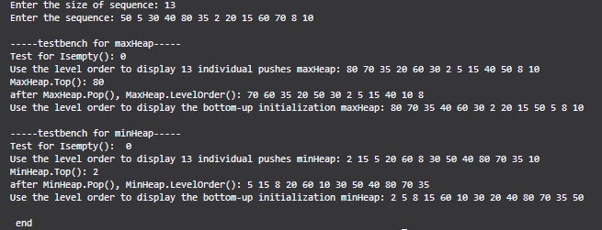

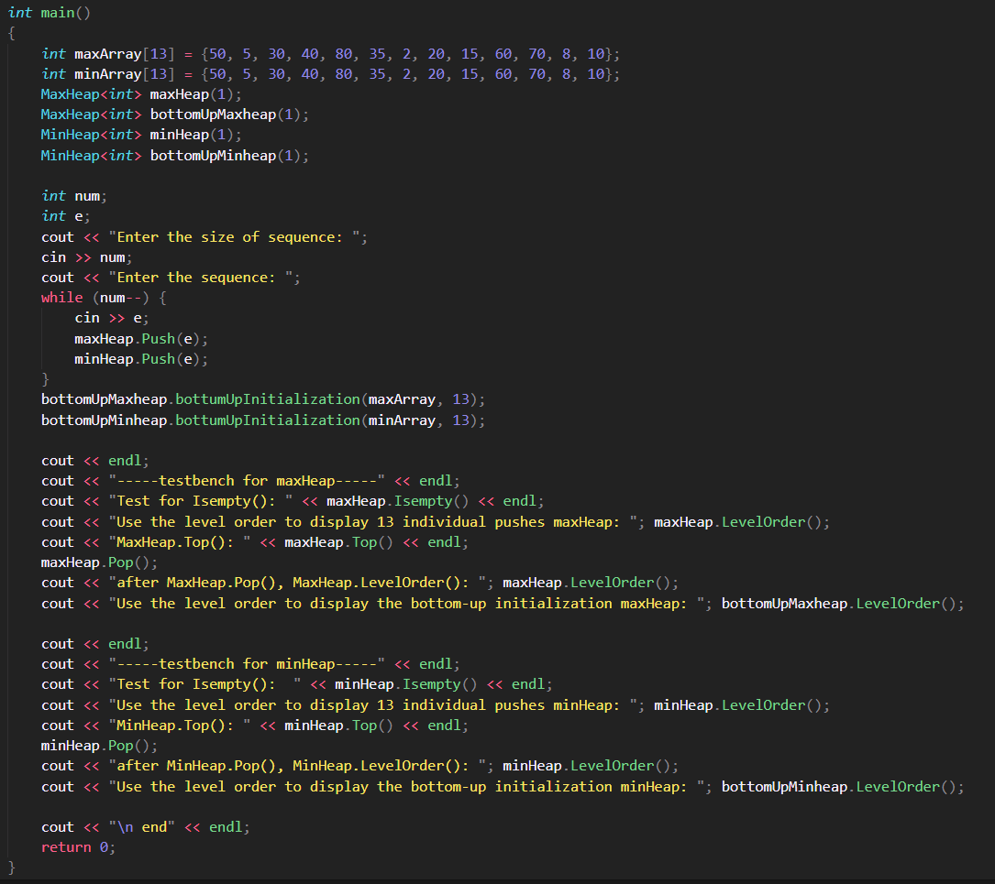

1. (35%) A Dictionary abstract class is shown in **ADT5.3 Dictionary**. Write a C++ class BST that derives from Dictionary and implement all the virtual functions. In addition, also implement

Pair<K, E>* RankGet(**int** r),

**void** Split(**const** K& k, BST<K, E>& small, pair<K, E>*& mid, BST<K, E>& big)

**ADT5.3 Dictionary**

**template** <**class** K, **class** E>

**class** Dictionary {

**public**:

**virtual** **bool** IsEmptay() **const** = 0; // return true if dictionary is empty

**virtual** pair <K, E>* Get(const K&) **const** = 0;

// return pointer to the pair w. specified key

**virtual** **void** Insert(**const** Pair <K, E>&) = 0;

// insert the given pair; if key ia a duplicate, update associate element

**virtual** **void** Delete(**const** K&) = 0; // delete pair w. specified key

};

Use a sequence of 13 integer number: 50, 5, 30, 40, 80, 35, 2, 20, 15, 60, 70, 8, 10 as 13 key values (type int) to generate 13 (key, element) (e.g., element can be simple char) pairs to construct the BST. Demonstrate your functions using this set of records.

