Joseph Green

April 10, 2020

Assignment 5

1. Use Case 1
   1. User types in their entry

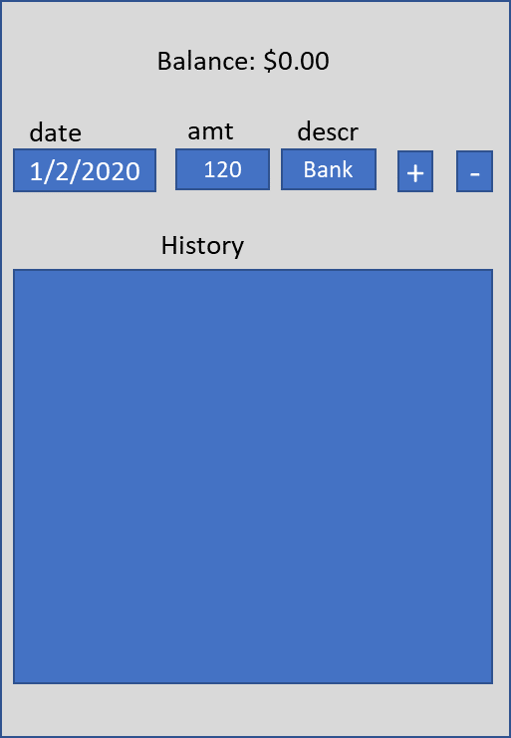

* 1. User presses the + button to add that to the balance and add the entry to the history

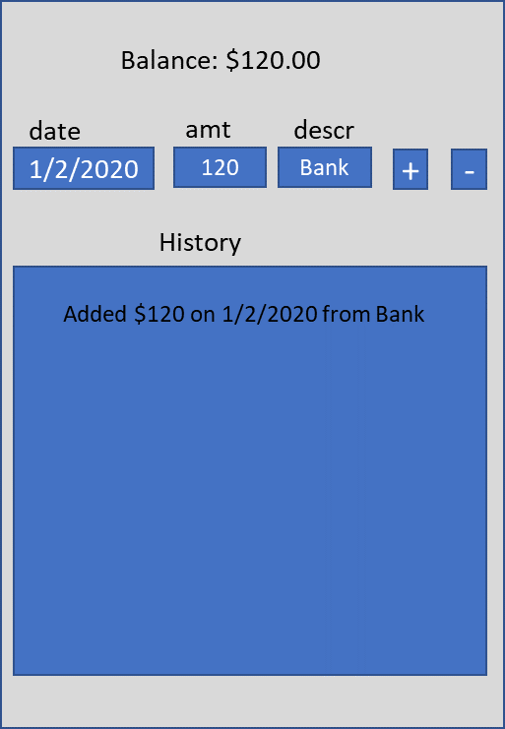

* 1. User types another entry and presses – button to remove from balance

