Joseph Green

2/12/20

Wireless Software- Assignment 2

Use Case 1:

1. User types in the Fahrenheit in the imperial box or the Celsius in the metric

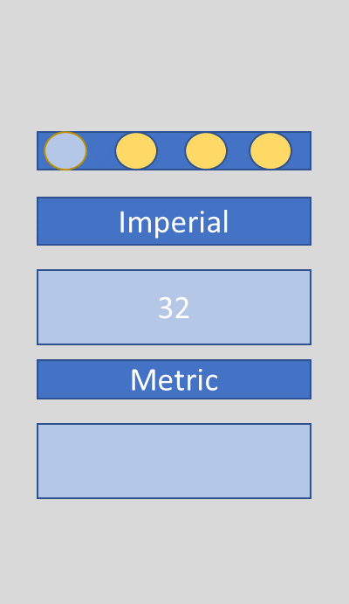

1. The program automatically fills in the other box with the correct conversion

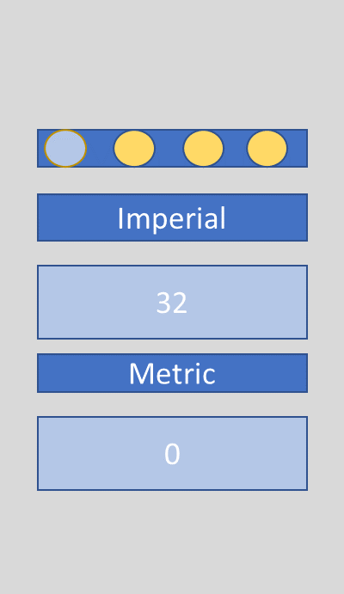

Use Case 2:

1. User types in the miles in the imperial box or the kilometer in the metric

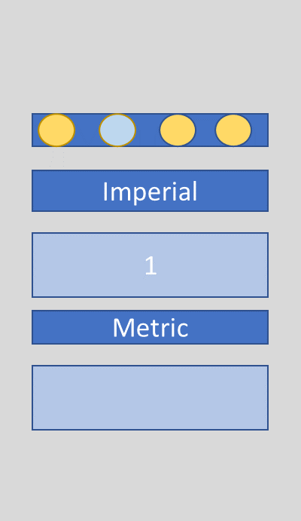

1. The program automatically fills in the other box with the correct conversion

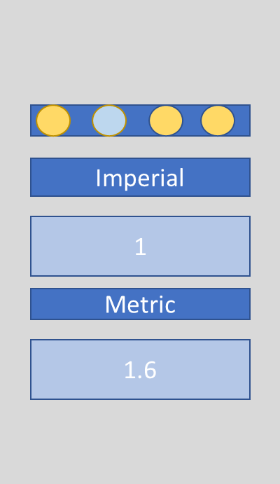

Use Case 3:

1. User types in the pounds in the imperial box or the kilogram in the metric

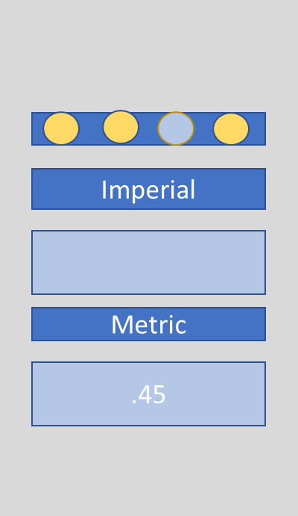

1. The program automatically fills in the other box with the correct conversion

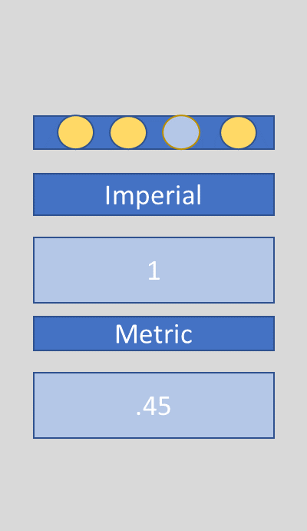

Use Case 4:

1. User types in the galloon in the imperial box or the liter in the metric

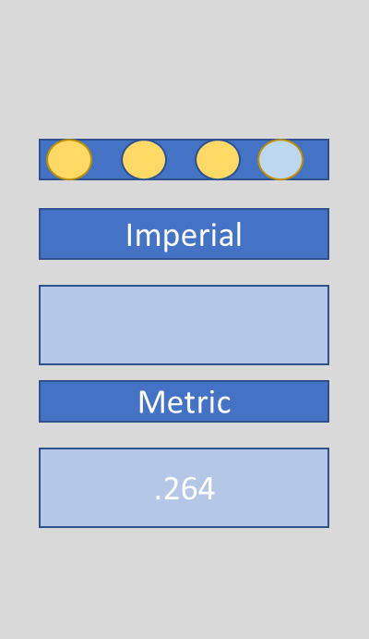

1. The program automatically fills in the other box with the correct conversion

