Joseph Green

2/1/20

Wireless Software- Assignment 1

Use Case 1:

1. User types in the degree Fahrenheit or Celsius

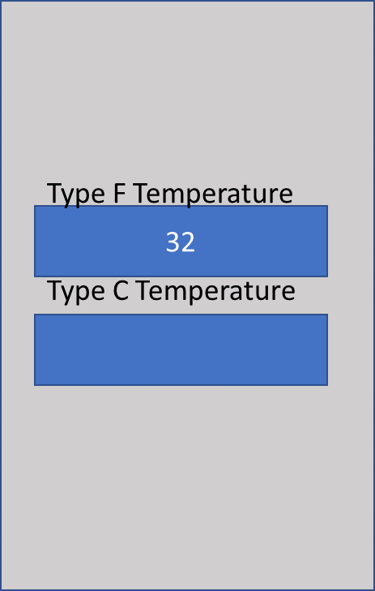

1. The program automatically fills in the other box with the correct conversion

