# Assignment no :3

**Name : CHOVATIYA JAY MAHESHBHAI**

# Student ID : 1161980

**Course: COMP5421 Deep Learning Topic:Datasets: CIFAR100**

**Requirements :**

**Last digit of ID: 0**

**Data set used: CIFAR100**

**Second last digit of ID: 8**

**DCNN used: Dense-Net**

**Notes : In this requirement 2 both convolutional neural network architectures such as Densnet and Alexnet i tried to implement in order to check the accuracy of the model which you can see below in the given output.**

**Explanation:**

**Q-Compare the performance gap between the pretrained DCNN model in the condition of transfer learning, and your customized model in assignment 2 in the condition of training from scratch. Explain why you obtained such results, and give a brief discussion about it.**

**Ans:** Obviously, **the performance** is **better** in **transfer learning**. To elaborate it,

In transfer learning, we have used the pretrained dense net model on the ImageNet which has 16 million data and directly use it to the cifar100.

So, the **testing time(93s/epoch)** is quite **less** compared to **training from scratch(137s/epoch)** and **accuracy(63.54)** is quite **higher** than **training from scratch(52.03).** Hence, we can get good results from pretrained models rather that scratch we had done in the assignment 2 by using the customized model.

## IMPLEMENTATION :

# import all the libraries

import numpy as np

import sklearn.metrics as metrics

from keras.applications import densenet

from keras.datasets import cifar100

from keras.utils import np_utils

from keras.optimizers import Adam

from keras.models import Sequential

from keras.layers import Dense,Flatten,Dropout

from keras.preprocessing.image import ImageDataGenerator

import matplotlib.pyplot as plt

# for removing warnings

import warnings

warnings.filterwarnings('ignore')

# define imagenet-pretrained model for densenet(cifar100)

model = Sequential()

model.add(densenet.DenseNet121(weights='imagenet', include_top=False,

input_shape=(32,32,3), pooling='max'))

# adding dense layer for flatten

model.add(Dense(256, activation='relu'))

# deactivating 50% nodes

model.add(Dropout(0.5))

model.add(Dense(100, activation='softmax'))

# find summary

model.summary()

# Splitting traning and testing set

(cifarx_train, cifary_train), (cifarx_test, cifary_test) = cifar100.load_data()

# Converting to float

cifarx_train = cifarx_train.astype('float32')

cifarx_test = cifarx_test.astype('float32')

# converting data into normalize form

cifarx_train = densenet.preprocess_input(cifarx_train)

cifarx_test = densenet.preprocess_input(cifarx_test)

# data augmentation

datagen = ImageDataGenerator(rotation_range=15, width_shift_range=0.1, height_shift_range=0.1, horizontal_flip=True)

datagen.fit(cifarx_train)

# one-hot encoding

Y_train = np_utils.to_categorical(cifary_train, 100)

Y_test = np_utils.to_categorical(cifary_test, 100)

# Using Adam optimizer to speed up training and set learning rate 0.001

optimizer = Adam(lr=1e-4)

# compile the model

model.compile(loss='categorical_crossentropy', optimizer=optimizer, metrics=["accuracy"])

# train the model

history = model.fit(datagen.flow(cifarx_train, Y_train, batch_size=64),

steps_per_epoch=len(cifarx_train) / 64, epochs=50,

validation_data=(cifarx_test, Y_test))

Preds = model.predict(cifarx_test)

y_Pred = np.argmax(Preds, axis=1)

y_true = cifary_test.flatten()

# finding accuracy and loss

accuracy = metrics.accuracy_score(y_true, y_Pred) * 100

# print testing accuracy

print("Accuracy : ", accuracy)

# Define plotchart function

def plotchart(history, value):

plt.figure(figsize=[8,6])

plt.plot(history.history['loss'], 'firebrick', linewidth=3.0)

plt.plot(history.history['accuracy'], 'turquoise', linewidth=3.0)

plt.legend(['Training loss', 'Training Accuracy'], fontsize=18)

plt.xlabel('Epochs', fontsize=16)

plt.ylabel('Loss and Accuracy', fontsize=16)

plt.title('Loss and Accuracy Curves for {}'.format(value), fontsize=16)

plt.show()

# Plot the training history

plotchart(history, 'CIFAR-100')

**Outputs:1** Here i have attached the screenshot of CIFAR100 datasets output which you can see below.

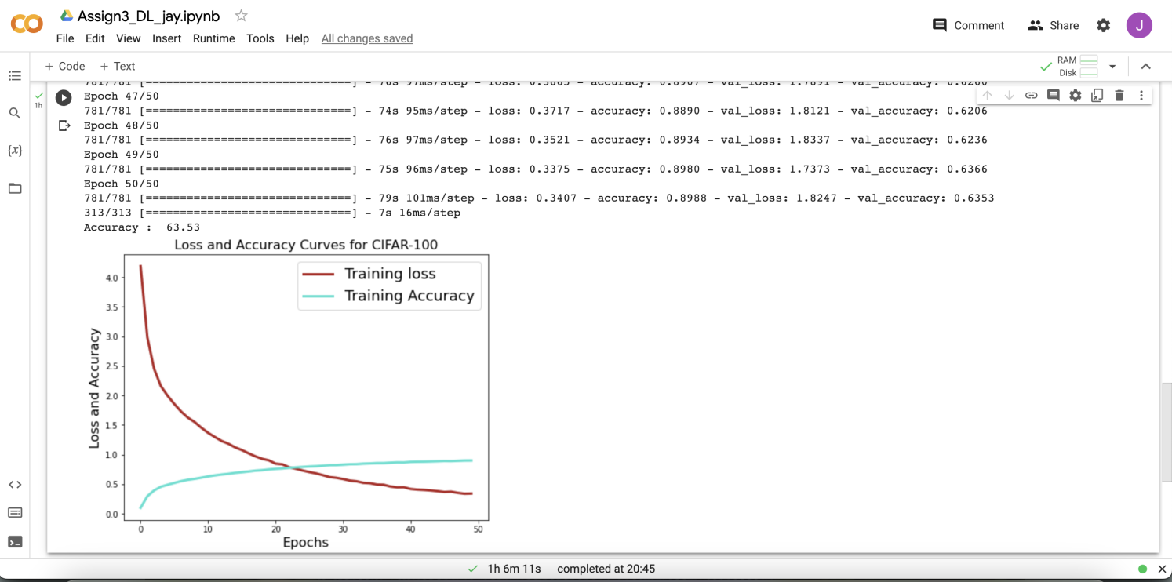

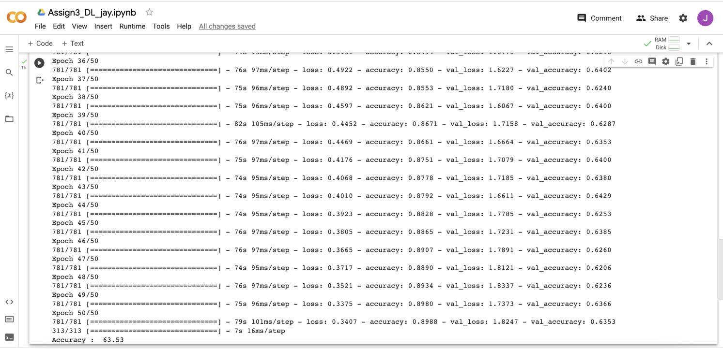

## Outputs:1.1

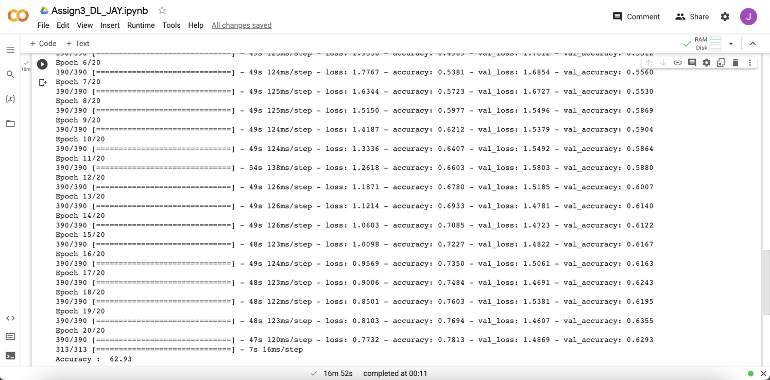

**Outputs:1.2**

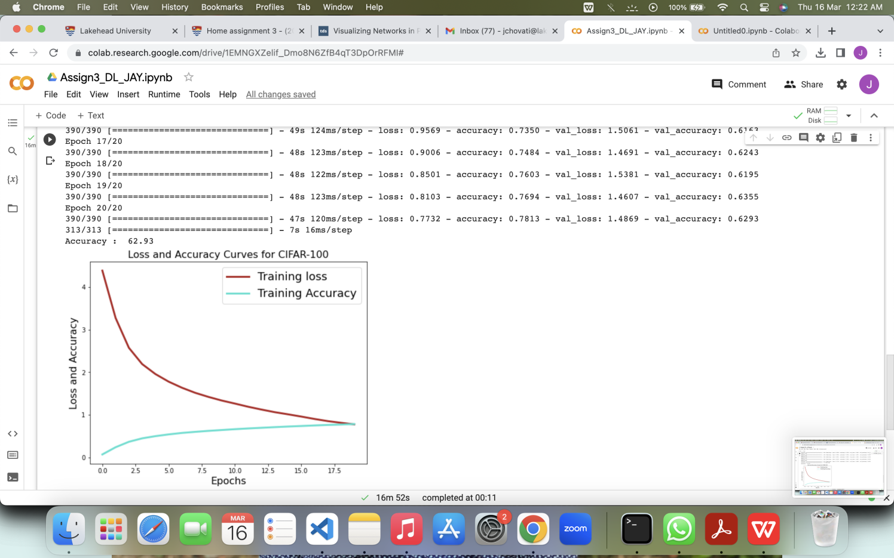

**Outputs:1.3**

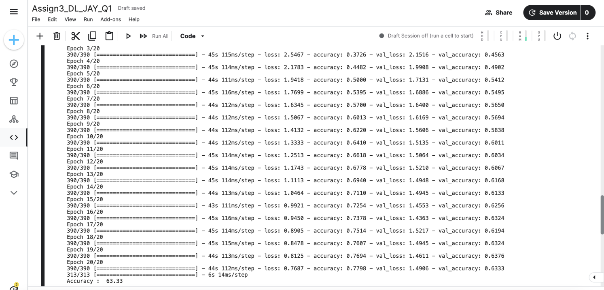

**Notes : In this question both convolutional neural network architectures such as Densnet and Alexnet i tried to implement in order to check the accuracy of the model which you can see below in the given output.**

**Requirement 2 :Use Freezing layers pretrained DCNN.**

**Q-Obtain the transfer learning features/deep features from a raw dataset.**

#importing library

import torch

import torch.nn as nn

import torchvision

import torchvision.transforms as transforms

# Declaring hyperparameters

epoch_no = 20 ; no_classes = 100

batch_size = 128 ; learning_rate = 0.1

# Define transformations for training and testing datasets

transform_train = transforms.Compose([transforms.RandomCrop(32, padding=4),transforms.RandomHorizontalFlip(),transforms.ToTensor(),transforms.Normalize((0.5071, 0.4865, 0.4409), (0.2673, 0.2564, 0.2762))])

transform_test = transforms.Compose([transforms.ToTensor(),transforms.Normalize((0.5071, 0.4865, 0.4409), (0.2673, 0.2564, 0.2762))])

# Loading CIFAR-100 dataset

cifer_train = torchvision.datasets.CIFAR100(root='./data', train=True, download=True, transform=transform_train)

cifer_test = torchvision.datasets.CIFAR100(root='./data', train=False, download=True, transform=transform_test)

# Defining data loaders for training and testing datasets

cifer_loader_train = torch.utils.data.DataLoader(dataset=cifer_train, batch_size=batch_size, shuffle=True)

cifer_loader_test = torch.utils.data.DataLoader(dataset=cifer_test, batch_size=batch_size, shuffle=False)

# Defining DenseNet-121 model and loss function and optimizer

model = torchvision.models.densenet121(pretrained=False, no_classes=no_classes)

criterion = nn.CrossEntropyLoss()

optimizer = torch.optim.SGD(model.parameters(), lr=learning_rate, momentum=0.9, weight_decay=1e-4)

# Training the model

total_step = len(cifer_loader_train)

for epoch in range(epoch_no):

for i, (images, labels) in enumerate(cifer_loader_train):

outputs = model(images)

loss = criterion(outputs, labels)

optimizer.zero_grad()

loss.backward()

optimizer.step()

if (i+1) % 100 == 0:

print('Epoch [{}/{}], Step [{}/{}], Loss: {:.4f}'

.format(epoch+1, epoch_no, i+1, total_step, loss.item()))

# Testing the model

model.eval()

with torch.no_grad():

correct = 0

total = 0

for images, labels in cifer_loader_test:

outputs = model(images)

_, predicted = torch.max(outputs.data, 1)

total += labels.size(0)

correct += (predicted == labels).sum().item()

accuracy = 100 * correct / total

print('Test Accuracy of the model on the {} test images: {:.2f}%'.format(total, accuracy))

**Outputs:2.1** Here i have attached the screenshot of obtain the transfer learning features from a raw dataset output which you can see below.

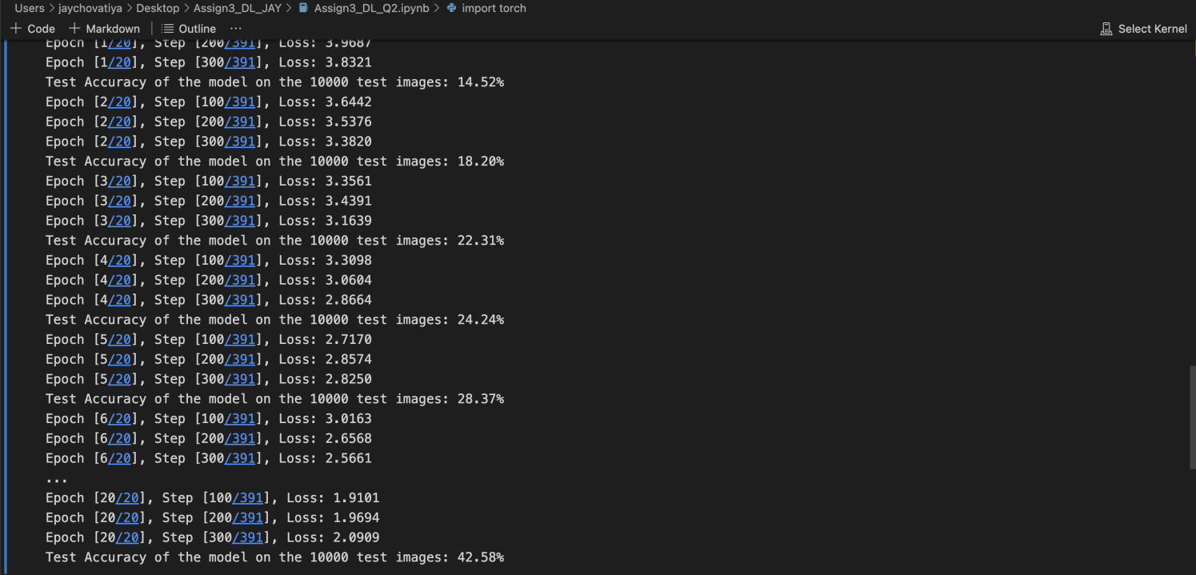

**Outputs:2.2**

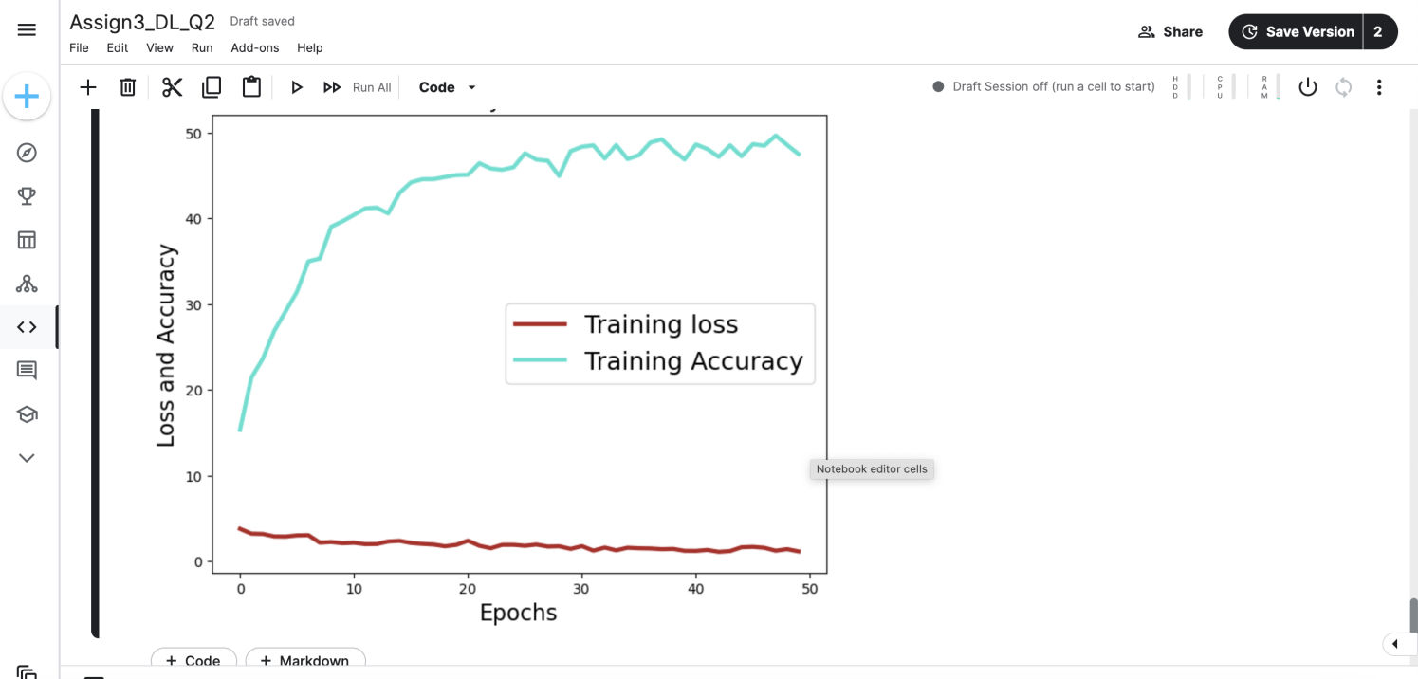

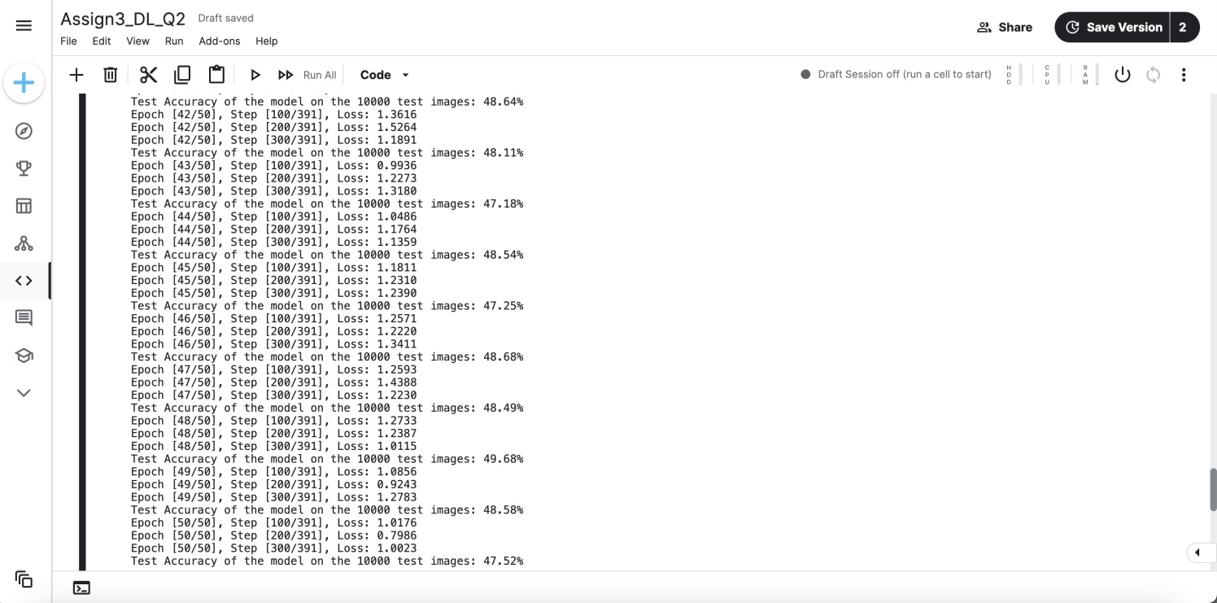

**Outputs:2.3**

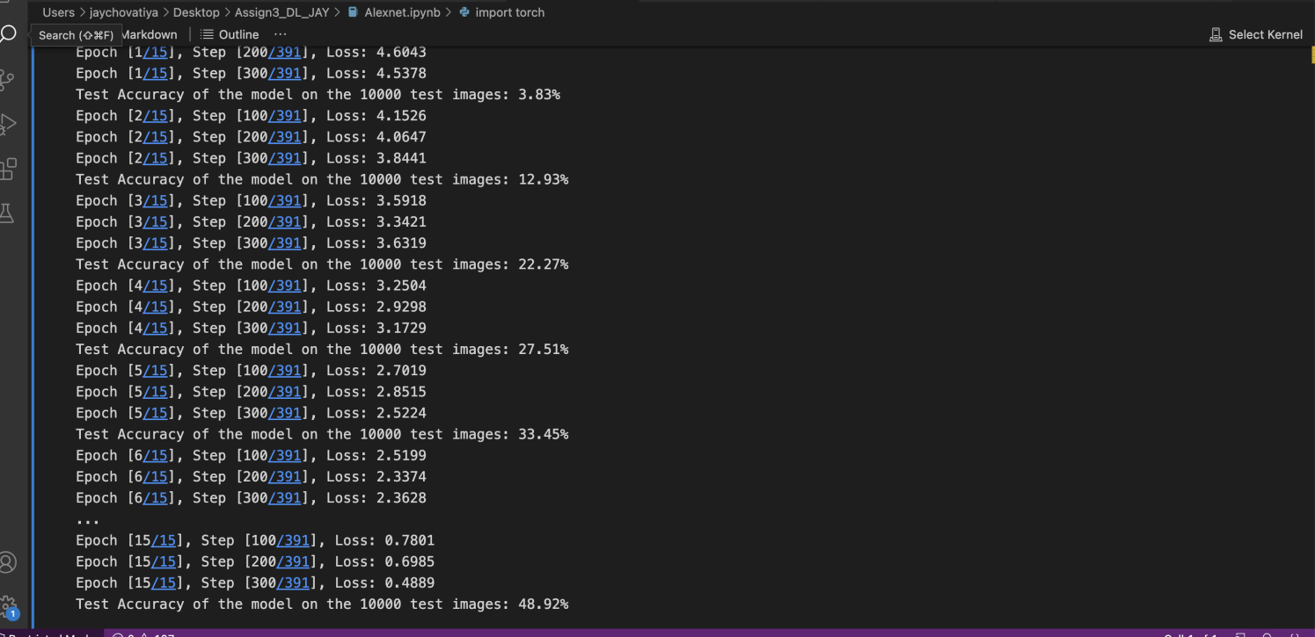

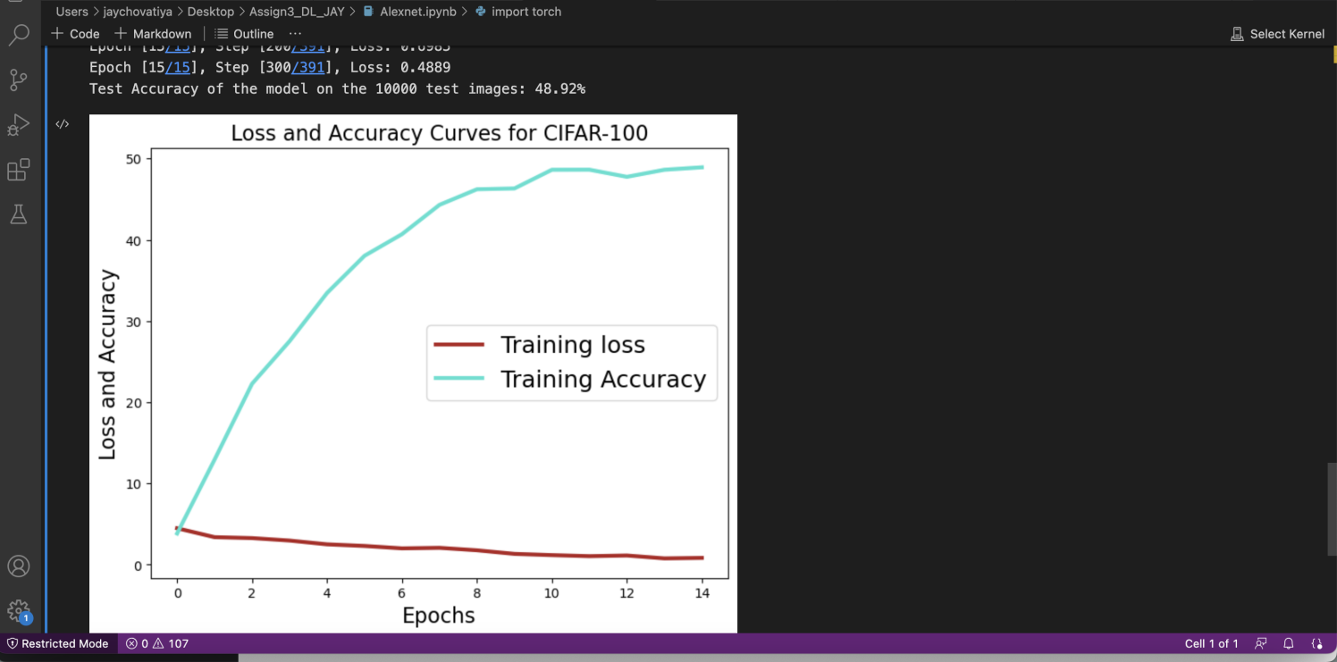

I have tried to implement using the keras as well in which i received the output like this.

