Rising CO₂ is rewiring Mediterranean coastal ecosystems
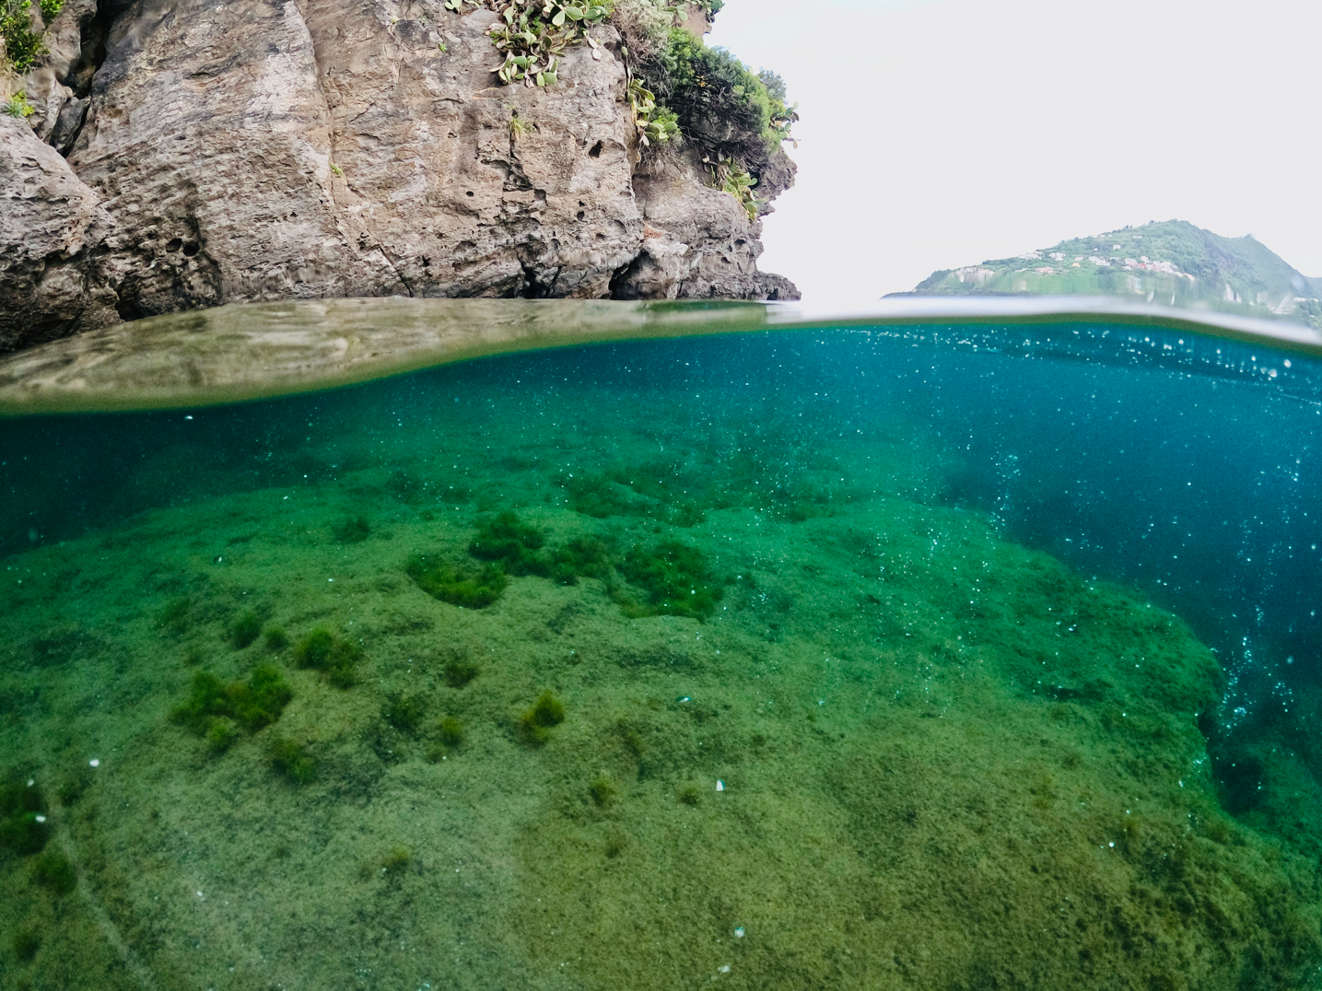
Underwater view of the natural CO₂ vents off Ischia, Italy, where researchers studied how ocean acidification alters marine community structure and ecosystem functioning. Photograph: Jérémy Carlot
A new international study shows that ocean acidification—triggered by increasing atmospheric CO₂—is not only reshaping marine biodiversity but also transforming how entire coastal ecosystems function. Although decades of research have documented how acidification affects individual species, surprisingly few studies have measured how multiple ecosystem processes change simultaneously, in situ, and at the level of whole communities. The team’s work at the natural CO₂ vents of Ischia (Italy) provides one of the clearest field-based demonstrations to date of how declining pH affects calcification, photosynthesis, respiration, and nutrient uptake in real marine habitats.
To investigate these changes, researchers deployed and transplanted marine settlement tiles along the well-studied underwater CO₂ gradients of Ischia, which naturally mirror future ocean acidification scenarios. This unique field system allowed the team to track how entire benthic communities reorganize—and how their ecological functioning shifts—as seawater pH declines.
The results reveal a marked ecological transition. As pH drops, calcifying organisms such as coralline algae and bryozoans disappear rapidly, while fast-growing, non-calcifying species—particularly fleshy and turf-forming algae—expand. This shift leads to substantial losses in biodiversity and biomass, simplifying the structure of coastal ecosystems.
These structural changes, in turn, strongly alter ecosystem functioning. Calcification rates fell by 50–90% under low-pH conditions and were entirely absent at the most extreme sites. By contrast, photosynthesis and nutrient uptake increased sharply when expressed per unit biomass—sometimes by more than 200-fold. Communities exposed to acidified conditions for nearly 15 years showed the same patterns, demonstrating that these shifts are stable over ecological timescales.
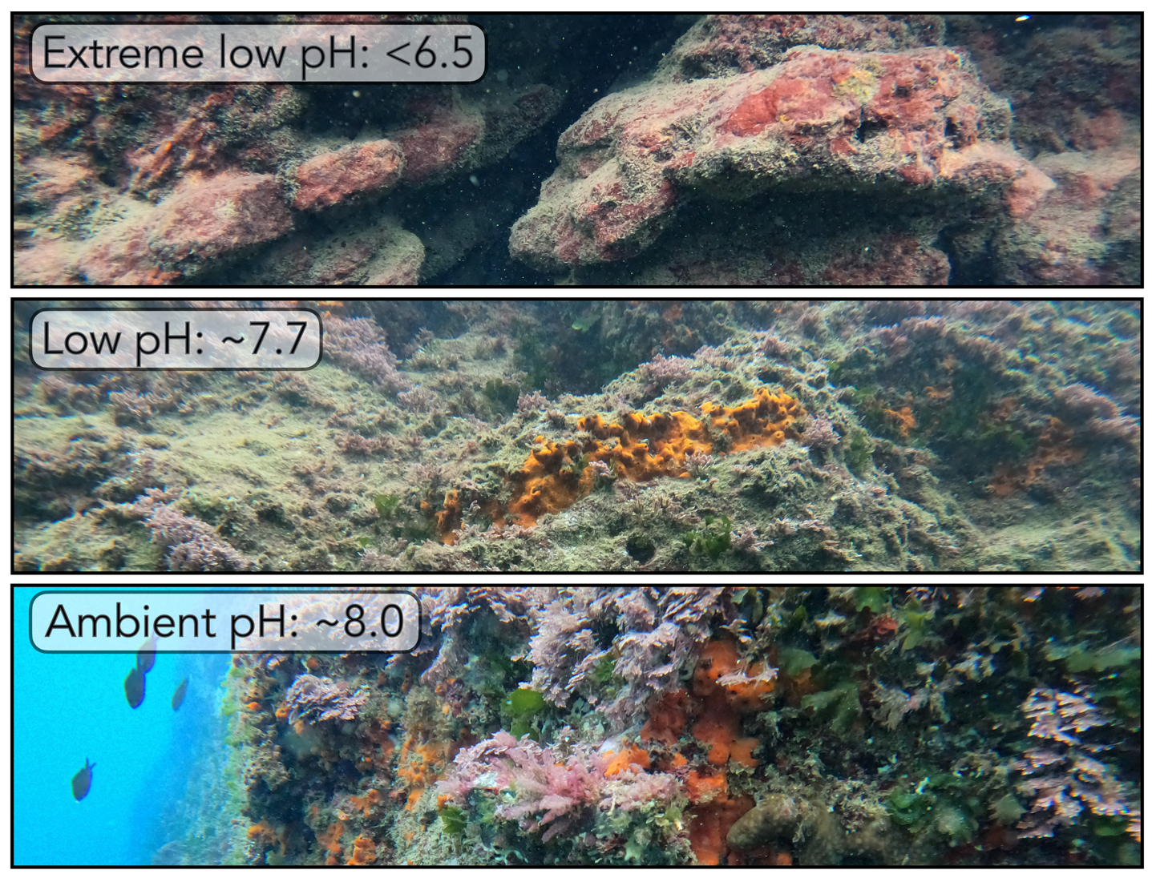
Snapshots from the CO₂ vents at Ischia, Italy, reveal how declining ocean pH reshapes marine communities. As pH drops from ~8.0 to below 6.5, calcifying species vanish and turf algae proliferate, highlighting the functional changes driven by ocean acidification. Photograph: Núria Teixidó
“Our findings show that ocean acidification does not simply weaken ecosystems—it reorganizes them,” explains Dr. Jérémy Carlot, lead author of the study. “As calcifying species disappear, fast-growing algae take over, reshaping how energy and nutrients flow through coastal habitats. These changes will redefine the functioning and resilience of Mediterranean ecosystems in a high-CO₂ world.”
The authors stress that, although some processes appear to intensify when normalized by biomass, these increases mask a substantial decline in total community biomass. As a result, overall productivity per square meter is expected to decrease under more extreme acidification. They also note that additional climate-related pressures—such as warming, deoxygenation, and nutrient limitation—are likely to amplify species loss and further disrupt ecosystem functioning.
The study demonstrates that understanding climate impacts requires looking beyond species and measuring how entire ecosystems function. By harnessing natural CO₂ gradients, the researchers provide rare in situ evidence that ocean acidification is already driving predictable functional shifts in Mediterranean rocky reefs—underscoring the urgent need to curb carbon emissions and reduce our global CO₂ footprint to protect coastal ecosystems.

Reference:
Carlot, J., Comeau, S., Chiarore, A., Mirasole, A., Alliouane, S., Micheli, F., Hurd, C. L., Gattuso, J.-P., & Teixidó, N. (2026). Unravelling marine benthic functioning shifts under ocean acidification. Ecology Letters. https://doi.org/10.1111/ele.70376

