**Calcification, respiration and photosynthesis rates of six prominent reef-building coral taxa**

Jeremy Carlot1,2,3*, Héloïse Rouzé1,2, Diego R. Barneche4,5, Alexandre Mercière2,6, Benoit Espiau2,6, Ulisse Cardini7,8, Simon J. Brandl1,2,3,9, Jordan M. Casey1,2,9, Gonzalo Pérez-Rosales1,2,6, Mehdi Adjeroud2,3,10, Laetitia Hédouin2,6 and Valeriano Parravicini1,2,3

**Affiliations:**

1PSL Université Paris, USR 3278 CRIOBE - EPHE-UPVD-CNRS, Perpignan, France

2Laboratoire d’Excellence “CORAIL”, Paris, France

3CESAB - FRB, 5 Rue de l'École de Médecine, 34000, Montpellier

4Australian Institute of Marine Science, Crawley, WA 6009, Australia

5Oceans Institute, The University of Western Australia, Crawley, WA 6009, Australia

6PSL Université - EPHE-UPVD-CNRS, USR 3278 CRIOBE, Papetoai, French Polynesia

7Integrative Marine Ecology Department, Stazione Zoologica Anton Dohrn, National Institute of Marine Biology, Ecology and Biotechnology, Napoli, Italy

8Marine Research Institute, University of Klaipeda, Klaipeda, Lithuania

9The University of Texas at Austin, Department of Marine Science, Marine Science Institute, Port Aransas, Tx 78373, USA

10ENTROPIE, IRD, Université de la Réunion, Université de la Nouvelle-Calédonie, CNRS, Ifremer, Perpignan, France

* Corresponding author. Email: [jay.crlt02@gmail.com](mailto:jay.crlt02@gmail.com)

**ORCID:**

Jérémy Carlot 0000-0003-0887-8005   
Héloïse Rouzé 0000-0003-3380-0883  
Diego R. Barneche 0000-0002-4568-2362  
Ulisse Cardini 0000-0002-0816-6158  
Simon J. Brandl 0000-0002-6649-2496   
Jordan M. Casey 0000-0002-2434-7207   
Gonzalo Peres Rosales 0000-0001-6577-3416  
Mehdi Adjeroud 0000-0002-6825-8759   
Valeriano Parravicini 0000-0002-3408-1625

**Abstract**

Coral reefs provide a range of important services to humanity, which are underpinned by community-wide ecological processes such as coral calcification or fish growth. Estimating these processes relies on our knowledge of organismal physiology and species-specific abundances in the field. For colonial animals such as reef-building corals, abundance is frequently expressed as the percentage of live coral cover, a metric that does not account for demographic parameters such as coral size. This is problematic because many physiological processes exhibit non-linear scaling over ontogeny, and failure to account for these patterns may lead to biased estimates of ecosystem functioning. In the present study, we characterise the ontogenetic scaling of three fundamental physiological rates—respiration, photosynthesis, and calcification—for six prominent reef-building coral taxa in Mo’orea (French Polynesia). Our results indicate that across all taxa, area-specific calcification rates are higher for smaller colonies. However, photosynthesis and respiration rates remain constant throughout the colony-size gradient. Furthermore, there was considerable species-specific variation in the respective rates. Resulting differences in the ratio between net primary production and calcification is correlated with the recent demographic dynamics of the six species in Mo’orea. Therefore, our findings suggest that intraspecific scaling of reef-building coral physiology not only alters our understanding of community-wide coral reef functioning, but also explains species’ responses to disturbances.

**Introduction**

Coral reefs are the among the most diverse marine ecosystems and provide essential services to more than 500 million people worldwide (Hoegh-Guldberg 2011). Healthy coral reefs protect coastlines from wave energy, reduce the risk of coastal flooding (Harris et al. 2018), and provide local populations with crucial food supplies (Cinner et al. 2020). These services are ensured by the maintenance of core ecological processes, but while there is broad agreement on which processes are fundamental for reef systems, our capacity to quantitatively define a ‘functional’ reef is still limited (Kennedy et al. 2013, Hughes et al. 2017, Brandl et al. 2019a). For example, it is well documented that fish-based herbivory can help corals to settle and grow. However, the cumulative rate of herbivory, as well as the species identities critical for facilitating this process, are still poorly resolved and may vary greatly among reefs (Mumby 2009, Arnold et al. 2010). Similarly, coral calcification is key to reef accretion, but the rates of calcification needed to keep up with sea level rise and their dominant drivers remain largely unquantified (Perry et al. 2018).

One reason why defining ‘functional’ reefs remains challenging is that functional studies on coral reefs traditionally employ qualitative, categorical traits as a proxy for functioning, while our capacity to directly quantify processes is still limited (Brandl et al. 2019a). Integrating empirically-measured processes into quantifications of functioning on reefs has been performed using two main approaches: i) the direct measurement of fluxes in the field (which consider interactions among species) and ii) the scaling of individual-level physiological processes to the community level using an additive approach (i.e., the summing of species-specific contributions to energy or elemental fluxes) (Allen et al. 2005, Barneche et al. 2014). Direct measurements of elemental fluxes in the field is the most accurate method to quantify ecological functions (Nakamura & Nakamori 2009). However, direct assessments are labour intensive and subject to local, current conditions, and are thus impractical for research integrating across large spatial and temporal scales. In contrast, the scaling up of organismal physiological processes to community-wide fluxes has been used to successfully estimate biomass production and nutrient cycling in coral reef fish (Allgeier et al. 2014, Brandl et al. 2019b, Morais et al. 2020), as well as the calcification and accretion in coral assemblages (Perry et al. 2012) across large spatial and temporal scales. While this method can leverage widely-available datasets of fish or coral community structure, reliable estimates inevitably depend on the availability and accuracy of physiological measurements conducted at both species and individual levels (Edmunds & Riegl 2020).

At the physiological level, corals consume dioxygen (O2)through respiration, while they produce O2 due to their symbiotic association with photosynthetic microalgae from Symbiodiniaceae family (LaJeunesse et al. 2018). The coral host provides the symbiotic algae with a protected environment and the essential compounds such as respiratory carbon dioxide (CO2) and nitrogenous waste necessary for the photosynthesis of the symbiotic algae (Muscatine & Porter 1977, Barnes 1987, Birkeland 1997). In turn, the coral host receives photosynthetically fixed carbon that may cover up to 95% of its metabolism (Muscatine 1990), which includes growth of the coral skeleton through biocalcification (i.e., calcification rate) (Barnes 1987, Muscatine 1990, Birkeland 1997, Barnes & Hughes 1999). These basic physiological processes at the organismal level are essential to ecological functions at community level since calcification, respiration and photosynthesis are interconnected elemental fluxes that allow the reef system to persist and accrete (Howard et al. 2017). Therefore, accurate quantifications of species-specific rates of calcification, respiration and photosynthesis rate are necessary if we are to extrapolate system-wide functioning based on coral community structure (Madin et al. 2016).

Several studies on coral calcification have highlighted that coral growth may be allometric (i.e., exhibiting varying rates according to colony size) (Edmunds & Burgess 2016, Dornelas et al. 2017) instead of isometric (i.e., exhibiting constant rates across colony size). Specifically, the growth rate of large colonies has been suggested to be substantially lower than that of smaller coral colonies, but the mechanisms behind this pattern are still unclear. For example, larger colonies may invest substantial energy in reproduction, which would reduce the energy available for growth (Richmond 1987). Likewise, larger colonies can experience higher partial mortality (e.g., localized tissue necrosis, overgrowth by other organisms, predation from parrotfishes), which may also reduce growth rates (Pratchett et al. 2015, Madin et al. 2020). Understanding whether, and why, organismal growth rates are isometric or allometric has important implications for our capacity to estimate community-level fluxes. Indeed, most community data report the substrate covered by each species without recording the size of individual colonies (Flower et al. 2017, Edmunds & Riegl 2020). Therefore, the estimation of community functions using the additive framework will be accurate only in the case of isometry. On the other hand, in the case of allometry we would need information on colony size distribution to properly calculate community-level fluxes.

In the present study, we quantify three primary physiological functions (*i.e.,* calcification, respiration and photosynthesis) for six different coral taxa along a gradient of colony size, to assess whether species exhibit isometric or allometric patterns.

**Material and Methods**

Coral species selection, preparation and acclimation

In September 2018, we collected 384 coral colonies from six distinct coral taxa: *Acropora hyacinthus, Astrea curta, Montipora verilli, Napopora irregularis, Pocillopora* cf. *verrucosa* and massive *Porites sp.* These taxa exhibit different life-history strategies and are among the most abundant coral species in Mo’orea (Putnam et al. 2012, Darling et al. 2019). We identified five taxa to the species level in the field, but were unable to distinguish massive *Porites* beyond the genus level because *P. lutea* and *P. lobata* are macro-morphologically indistinguishable. We sampled all coral colonies at 11–13 m of depth on the outer reef of the northern coast of the island. Before each collection, we recorded the following environmental parameters in situ: mean ambient seawater temperature, salinity, and photosynthetically active radiation (PAR: 400-700 nm). We collected colonies from the substratum using a hammer and chisel, transported from the field site to the lab in a cooler filled with seawater. Transportation took, on average, 15 minutes.

In the laboratory, each colony was quickly cleaned with Milli-Q water and epibionts or epiphytes were carefully removed. We attributed each colony to a size class: (S1) <100 cm2, (S2) 100-400 cm2 and (S3) >400 cm2 for further physiological measurements. Finally, we placed all colonies into tanks conditioned to reflect the environmental parameters recorded in situ for 7 days to allow for recovery and acclimation.

Respiration and photosynthesis

We assessed coral physiology using intermittent-flow respirometry, where colonies were immersed in chambers connected to both a closed recirculating pump system and an open flush-pump system to periodically record oxygen concentrations in the water. The colonies were incubated in permeable chambers of three different volumes from 0.5 L, 1 L and 4 L according to the ratio between the incubation volume and colony size. Colonies smaller than 100 cm2 were incubated into 0.5 L chambers, colonies between 100 and 400 cm2 were incubated into chambers of 1 L and colonies larger than 400 cm2 were incubated into chambers of 4 L. For each respirometry trial we assessed four controls and four corals of each size class (n = 12 colonies for each trial). Since we measured both photosynthesis and respiration, we took measures of O2 concentrations in the chambers both in light conditions and in the dark. For each trial, we exposed colonies to light for three hours. We then turned off the light, and started recording O2 consumption 30 minutes later. We limited the dark phase to 1 hour to prevent O2 concentrations to fall below 80% saturation (Kolb 2018). O2 concentration was recorded with PyroScience FireSting optical oxygen meters. We removed the first thirty minutes of each trial, which corresponded with a break and subsequent stabilization of the O2 concentration slopes in the closed stage of the system. For each trial, we included a chamber that was not populated with a coral colony to account for bacterial background respiration. Using these blanks, we corrected O2 concentrations for each trial for background respiration, ultimately yielding two consumption profiles that corresponded to physiological activity in daylight (i.e., net photosynthesis, or photosynthesis - respiration) and one equivalent to nocturnal conditions (i.e., respiration activity). All oxygen concentrations are described in mg (O2) h-1. The respirometry system was completely cleaned and bleached after each trial to minimize respiration by accumulating microorganisms.

Calcification

We collected 50 mL of water from each incubation chamber and the control chambers, both in light conditions and in the dark. We stored the samples in sealed, opaque vials in the dark at 4°C and then allowed them to stabilize for 2 hours at room temperature (25°C) before processing. We carried out three titrations per sample to define total alkalinity using a Titrando 888 (Metrohm) and Titripur c(HCl) (with a concentration of 100 mmol L-1). We defined titration controls, with water samples collected before coral incubations. We calculated the calcification rate based on the difference between total alkalinity measured at the beginning and the end of each incubation period (∆AT) (Dickson et al. 2007). Specifically, we assumed that one mole of CaCO3 is produced when alkalinity (∆AT) drops by two moles across a fixed time period (∆t), and by multiplying these parameters (i.e., - ∆AT/2∆t) by seawater density (ρsw). Finally, we converted the resulting value to g cm-2 yr-1 based on the molar mass of CaCO3.

Colony-size estimation using photogrammetry and out-planting

After each incubation, we took 100 to 200 overlapping high-resolution photos (300 dpi) of each colony. The photos were used to construct 3D models using the Agisoft PhotoScan software (LLC 2016), which allowed us to define the volume and live surface area of each colony (Harwin et al. 2015). All coral colonies (i.e., n = 384) were then placed in a large aquarium and ultimately returned to their natural habitat on the outer reef.

Statistical analysis

Before analysing the data, we removed data points if: 1) a coral colony exhibited a negative calcification rate (i.e., dissolution), 2) the tank temperature dropped below 27°C (i.e., failure of the tank heating system) or 3) the linear fit of O2 concentrations over time to quantify respiration or net photosynthesis rates exhibited an R2 value lower than 0.8 (Kolb 2018) . Following this quality control procedure, we retained 250 out of 384 (65 %) coral colonies for the analysis. We then applied Bayesian models to estimate the relationship between colony size and each physiological rate on the natural log scale using the R package *brms* (Bürkner 2017). Our models were specified with the following structure:

diagℤ)=

; ; ; ; ;

where is the natural logarithm of the rate of calcification (kg yr-1), O2 consumption (mg h-1)or O2 production (mg h-1) of species and individual ; is the natural logarithm of live coral surface area (cm2); is the among-species average intercept on the natural log scale; is the among-species average size scaling slope (i.e., exponent on the natural scale); is a vector comprising levels of species (*n* = 6), which, in turn, create a hierarchical matrix of rows and two columns respectively representing species-level additive deviations from and ; is the Cholesky factor of the correlation matrix between the hierarchical effects, is the two-by-two diagonal matrix whose diagonal is a vector of among-species standard deviations (), and is an -by-two matrix of standardised hierarchical effects. The prior sampling distributions were specified to follow Gaussian ((location, scale)), Gamma ((shape, inverse scale)) and log-LKJ (LKJ(shape)). We ran our models with three chains, 5,000 draws per chain, and a warm-up period of 2,500 steps, thus retaining 7,500 draws to construct posterior distributions. We verified chain convergence with trace plots and confirmed that Rhat (the potential scale-reduction factor) (Gelman et al. 1992) was lower than 1.05. For the three models, we obtained R2 values of 0.92, 0.77, and 0.77 for the calcification rate model, respiratory rate model, and photosynthetic rate model, respectively (Table 1, Fig. S1). We then divided our raw data by the respective surface area of each colony to express rates on an area-specific basis. To calculate the posterior distribution of the scaling exponent of area-specific rates against colony area, we used 1- (Fig. S2).

The ratio between net photosynthesis rate and calcification has been used as a proxy of how much energy is available to perform other functions (e.g., reproduction) (Rinkevich 1989). On reefs around Mo’orea, a series of recent disturbances have shifted coral composition in favour of *Pocillopora* corals (Adjeroud et al. 2018). We therefore investigated whether *Pocillopora* may have an energetic advantage compared to the other genera, as a potential mechanism to explain its post-disturbance success compared to other species. To do so, we performed simulations to evaluate the energy budget of monospecific assemblages composed of *Pocillopora vs.* the other genera. Specifically, we first defined average coral colony sizes for the six genera according to three simplified scenarios (Kayal et al. 2018): 1) dominance of small colonies, 2) an even size distribution and 3) dominance of large colonies. For each scenario, we randomly generated 100 size distributions which were then used to calculate species- and size-specific photosynthesis and calcification. These estimates were used to compare population-wide estimates of *Pocillopora sp*. against each of the other five species (i.e., *Acropora hyacinthus, Astrea curta, Montipora verilli, Napopora irregularis* and *Porites spp*.). Finally, we estimated the ‘energetic ratio’ for each population. All the statistical analyses and simulations were run in R version 4.0.3 (R Core Team 2019).

**Results**

For all coral species, we observed a linear increase in calcification, respiration and photosynthesis across the colony-size gradient on the log-log scale (Fig. 1). However, we identified both hypo-allometric and isometric relationships, depending on the physiological process. Calcification showed a hypo-allometric relationship with colony size, as evidenced by values of the that were lower than 1 (Table 1., Fig. 1). Although massive *Porites* spp., massive *Astrea curta*, and encrusting *Montipora verilli* had higher values than the other species, only 2% of the 5,000 posterior draws had a slope greater than 1. On the other hand, respiration and photosynthesis increased isometrically with colony size, as demonstrated by that did not differ from 1.

Because whole colony calcification rates were hypo-allometric, calcification rates per unit surface area decreased as colony size increased for all species, while photosynthesis and respiration per unit area were not size dependent for all species. However, we detected substantial among-species variation in the coefficients (i.e., the species-specific intercepts) for all three physiological processes (Fig. 1, Table 1). Indeed, *Acropora hyacinthus* showed the highest calcification, while *Montipora verilli* exhibited the lowest calcification. Yet, this trend was reversed for both respiration and photosynthesis, where *Montipora verilli* showed the highest values and *Acropora hyacinthus* showed the lowest rates. Further exploring the species-specific relationships between photosynthetic rates and calcification rates, we detected two main trends (Fig. 2). First, *Porites* spp., *Napopora irregularis*, and *Acropora hyacinthus* showed higher calcification rates than net photosynthetic rates, while *Astrea curta, Montipora verilli* and *Pocillopora* cf. *verrucosa* showed the opposite pattern. Using these ratios to model population-wide processes under hypothetical size structure scenarios, we found that monospecific stands of *Pocillopora* cf. *verrucosa* exhibited the highest rates of calcification vs. photosynthesis, regardless of the population structure (i.e., ratio ~ 3.5; Fig. 2).

**Discussion**

Organismal physiology underpins community-wide ecological processes that are often considered to define ecosystem functioning. On coral reefs, calcification by a range of coral species is the process responsible for habitat creation, reef accretion, and coastal protection. We analysed three fundamental physiological functions (i.e., calcification, respiration and photosynthesis) for six prominent coral taxa to test whether the relationships of these functions with colony size was isometric or allometric. Similar to recent results (Edmunds & Burgess 2016, Dornelas et al. 2017, Madin et al. 2020), we found that calcification per unit area increases hypo-allometrically across all six species. However, this was not the case for photosynthesis and respiration, which scaled isometrically with colony size. Previous work has highlighted allometry in respiration and photosynthesis in *Pocillopora sp.* (Edmunds & Burgess 2016). The consistent emergence of an isometric relationship across the six species tested in our study suggests that isometric scaling of respiration and photosynthesis rates across coral ontogeny may be more common among scleractinians, at least at the examined constant temperature conditions.

The isometric scaling of photosynthesis, as opposed to the allometric scaling of calcification, emphasizes the potential importance of coral growth in early life stages. Small, recently settled colonies generally experience intense mortality (Ritson-Williams et al. 2009, Penin et al. 2010, Wall & Stallings 2018), and a rapid increase in colony size (through extensive calcification) may offer the best chance for survival (Heino & Kaitala 1999, Doropoulos et al. 2012). Thus, while it is beneficial for small coral colonies to disproportionally invest in calcification, there are no immediately apparent benefits from increased photosynthesis. In fact, high photosynthesis per unit surface may hamper early-life stage success through exposure to oxidative stress (Fitt et al. 2001, Hoogenboom & Anthony 2006).

While the examined coral species showed comparable scaling relationships for calcification rates, *A. hyacinthus* had a consistently higher rate than the other species. These results are consistent with the high calcification rates documented for corals in the genus *Acropora*, which are generally classified as fast-growing corals (Huston 1985, Harriott 1999, Anderson et al. 2018). However, although *A. hyacinthus* had the highest calcification rate, its photosynthetic and respiratory rates were among the lowest in our experiments. This provides physiological evidence that *A. hyacinthus* indeed tends to allocate most of its energy to growth, rather than other essential organismal processes (e.g., increasing skeletal density, reproduction) (Razak et al. 2020). Conversely, *M. verilli* and *P. verrucosa* showed the highest photosynthetic rates (Fig. 1, Fig. S2), but markedly lower calcification rates than *A. hyacinthus*, which further highlights differences in the life-history strategies of the various species. For instance, Ward *et al*. (Ward 1995) suggested that high lipid concentrations (which arise from increased photosynthesis) correlate with reproductive activity, suggesting higher resource allocation to reproductive tissues in *M. verilli* and *P. verrucosa*. For *Pocillopora*, at least, brooding of sperm and egg bundles may require this investment and subsequently enhance the chances of *Pocillopora* offspring to survive(Hirose et al. 2001). Indeed, the high photosynthetic rate of *P. verrucosa* seems to explain the success of this species in Mo’orea, a reef system recently dominated by pocilloporids (Hédouin et al. 2020). Although *M. verilli* employs a broadcast spawning system, it is the second most abundant coral genus in Mo’orea (Bosserelle et al. 2014), suggesting that higher photosynthesis confer ecological success under the current environmental conditions in Mo’orea.

The distinct photosynthetic rates among coral taxa might arise from the different physiological and ecological attributes of associated symbiotic communities (Baird et al. 2009, Putnam et al. 2012, Rouzé et al. 2019) and their transmission. *P. verrucosa* generally shows a stable association with the genus *Cladocopium* (Stat et al. 2008, Baker et al. 2018), which exhibits high photosynthetic efficiency, and is transmitted vertically to offspring. *M. verilli* show a similar association and transmission dynamics. In contrast, *A. hyacinthus* exhibits flexible association with different Symbiodiniaceae genera, often obtained through horizontal transfer.While this can make acroporid corals dominant in a variety of environmental conditions, the present community composition around Mo’orea suggests that the physiological profile of *A. hyacinthus* and its variable symbionts are disadvantageous under current conditions, as the genus has become rare compared to *P. verrucosa* or *M. verilli* (Babcock et al. 2003). The other three coral species (i.e., *A. curta, N. irregularis* andmassive *Porites spp.*) show intermediate physiological performances and intermediate abundances around Mo'orea. Our findings suggest that the revealed differences in physiological profiles determine the energetic basis for processes unfolding at the population- and community-level.

In turn, understanding the nature of the examined scaling relationships open opportunities to estimate ecosystem-wide processes critical for coral reef functioning. In the case of photosynthesis and respiration, the isometric scaling permits relatively simple extrapolations of colony-level processes to entire communities. Specifically, if species identities of colonies and their relative combined surface areas are known, we may be able to compute reasonably accurate estimates of community-wide respiration and photosynthesis. In this case, standard coral survey methods that record the percentage of substrate cover by different species (English et al. 1997, Hill et al. 2004) allow for estimations of community-level photosynthetic capacity. In contrast, the size-dependency of calcification implies that an accurate estimation of community-levelcalcificationwould require information on the size distribution of individual colonies, which is seldom recorded in standard monitoring. Given that calcification is a crucial function performed by coral assemblages, which has direct implications for reef accretion (Perry et al. 2018) and wave-energy attenuation (Harris et al. 2018), the absence of colony size from most major coral reef monitoring programs precludes us from inferring community-level processes with a better accuracy.

The role of colony size in determining the rate of physiological processes and community-level parameters is an emergent topic in coral ecophysiology. However, because corals experience partial mortality, it was often assumed that colony size was irrelevant (Connell 1973, Hughes & Jackson 1985). Therefore, colony size is traditionally not considered in community assessments, whereas it is a standard practice for other key groups (e.g., fish and tree assemblages; (Schmidt-Nielsen & Knut 1984, Enquist et al. 1999, Damuth 2001, Niklas & Enquist 2001, Barneche et al. 2014). This gap in our understanding of the allometric relationship for corals may lead to miss-estimation of important functions performed by reef-building corals.

In summary, our results expand our understanding of coral physiology and species-specific traits that can confer ecological advantages under changing environmental conditions. Furthermore, our findings strengthen our capacity to predict community-wide rates of photosynthesis and respiration based on commonly collected coral survey data, while, at the same time, questioning the utility of most monitoring data that omit colony size information for community-wide estimates of calcification. Across many organisms and ecosystems, the documentation of organismal scaling relationships has greatly advanced the mechanistic understanding of ecological processes. Doing so for scleractinian corals, the foundation species of one of Earth’s most diverse and productive ecosystems, will greatly advance our capacity to understand and predict the status of coral reefs.

**References**

Adjeroud M, Kayal M, Iborra-Cantonnet C, Vercelloni J, Bosserelle P, Liao V, Chancerelle Y, Claudet J, Penin L (2018) Recovery of coral assemblages despite acute and recurrent disturbances on a South Central Pacific reef. Sci Rep 8:9680.

Allen AP, Gillooly JF, Brown JH (2005) Linking the global carbon cycle to individual metabolism. Funct Ecol 19:202–213.

Allgeier JE, Layman CA, Mumby PJ, Rosemond AD (2014) Consistent nutrient storage and supply mediated by diverse fish communities in coral reef ecosystems. Glob Chang Biol 20:2459–2472.

Anderson KD, Cantin NE, Heron SF, Lough JM, Pratchett MS (2018) Temporal and taxonomic contrasts in coral growth at Davies Reef, central Great Barrier Reef, Australia. Coral Reefs 37:409–421.

Arnold S, Steneck, RS, Mumby PJ (2010) Running the gauntlet: inhibitory effects of algal turfs on the processes of coral recruitment. Mar Ecol Prog Ser 414:91–105.

Babcock RC, Baird AH, Piromvaragorn S, Thomson DP, Willis BL (2003) Identification of scleractinian coral recruits from Indo-Pacific reefs. Zool Stud 42:211–226.

Baird AH, Guest JR, Willis BL (2009) Systematic and Biogeographical Patterns in the Reproductive Biology of Scleractinian Corals. Annu Rev Ecol Evol Syst 40:551–571.

Baker DM, Freeman CJ, Wong JCY, Fogel ML, Knowlton N (2018) Climate change promotes parasitism in a coral symbiosis. ISME J 12:921–930.

Barneche DR, Kulbicki M, Floeter SR, Friedlander AM, Maina J, Allen AP (2014) Scaling metabolism from individuals to reef-fish communities at broad spatial scales. Ecol Lett 17:1067–1076.

Barnes RD (1987) Invertebrate Zoology, Fifth Edit. ed.

Barnes RSK, Hughes RN (1999) An introduction to marine ecology. John Wiley & Sons.

Birkeland C (1997) Life and death of coral reefs. Springer Science & Business Media.

Bosserelle P, Berteaux-Lecellier V, Chancerelle Y, Hédouin L, Nugues M, Wallace C, Pichon M (2014) Guide d’identification des coraux de Moorea. CRIOBE.

Brandl S, Rasher DB, Côté IM, Casey JM, Darling ES, Lefcheck JS, Duffy JE (2019a) Coral reef ecosystem functioning: eight core processes and the role of biodiversity. Front Ecol Environ 17:445–454.

Brandl S, Tornabene L, Goatley CHR, Casey JM, Morais RA, Côté IM, Baldwin CC, Parravicini V, Schiettekatte NMD, Bellwood DR (2019b) Demographic dynamics of the smallest marine vertebrates fuel coral reef ecosystem functioning. Science 364:1189 LP – 1192.

Bürkner P-C (2017) Brms: An R Package for Bayesian Multilevel Models Using Stan. J Stat Software; Vol 1, Issue 1 .

Cinner JE, Zamborain-Mason J, Gurney GG, Graham NAJ, MacNeil MA, Hoey AS, Mora C, Villéger S, Maire E, McClanahan TR, Maina JM, Kittinger JN, Hicks CC, D\textquoterightagata S, Huchery C, Barnes ML, Feary DA, Williams ID, Kulbicki M, Vigliola L, Wantiez L, Edgar GJ, Stuart-Smith RD, Sandin SA, Green AL, Beger M, Friedlander AM, Wilson SK, Brokovich E, Brooks AJ, Cruz-Motta JJ, Booth DJ, Chabanet P, Tupper M, Ferse SCA, Sumaila UR, Hardt MJ, Mouillot D (2020) Meeting fisheries, ecosystem function, and biodiversity goals in a human-dominated world. Science 368:307–311.

Connell JH (1973) Population ecology of reef-building corals. Biol Geol coral reefs 2:205–245.

Damuth J (2001) Scaling of growth: Plants and animals are not so different. Proc Natl Acad Sci 98:2113–2114.

Darling ES, McClanahan TR, Maina J, Gurney GG, Graham NAJ, Januchowski-Hartley F, Cinner JE, Mora C, Hicks CC, Maire E, Puotinen M, Skirving WJ, Adjeroud M, Ahmadia G, Arthur R, Bauman AG, Beger M, Berumen ML, Bigot L, Bouwmeester J, Brenier A, Bridge TCL, Brown E, Campbell SJ, Cannon S, Cauvin B, Chen CA, Claudet J, Denis V, Donner S, Estradivari, Fadli N, Feary DA, Fenner D, Fox H, Franklin EC, Friedlander A, Gilmour J, Goiran C, Guest J, Hobbs J-PA, Hoey AS, Houk P, Johnson S, Jupiter SD, Kayal M, Kuo C, Lamb J, Lee MAC, Low J, Muthiga N, Muttaqin E, Nand Y, Nash KL, Nedlic O, Pandolfi JM, Pardede S, Patankar V, Penin L, Ribas-Deulofeu L, Richards Z, Roberts TE, Rodgers KS, Safuan CDM, Sala E, Shedrawi G, Sin TM, Smallhorn-West P, Smith JE, Sommer B, Steinberg PD, Sutthacheep M, Tan CHJ, Williams GJ, Wilson S, Yeemin T, Bruno JF, Fortin M-J, Krkosek M, Mouillot D (2019) Social–environmental drivers inform strategic management of coral reefs in the Anthropocene. Nat Ecol Evol 3:1341–1350.

Dickson AG, Sabine CL, Christian JR (2007) Guide to best practices for ocean CO2 measurements. North Pacific Marine Science Organization.

Dornelas M, Madin JS, Baird AH, Connolly SR (2017) Allometric growth in reef-building corals. Proc R Soc B Biol Sci 284:20170053.

Doropoulos C, Ward S, Marshell A, Diaz-Pulido G, Mumby PJ (2012) Interactions among chronic and acute impacts on coral recruits: the importance of size-escape thresholds. Ecology 93:2131–2138.

Edmunds PJ, Burgess SC (2016) Size-dependent physiological responses of the branching coral Pocillopora verrucosa to elevated temperature and PCO2. J Exp Biol 219:3896–3906.

Edmunds PJ, Riegl B (2020) Urgent need for coral demography in a world where corals are disappearing. Mar Ecol Prog Ser 635:233–242.

English S, Wilkinson C, Baker V (1997) Survey manual for tropical marine resources.

Enquist BJ, West GB, Charnov EL, Brown JH (1999) Allometric scaling of production and life-history variation in vascular plants. Nature 401:907–911.

Fitt WK, Brown BE, Warner ME, Dunne RP (2001) Coral bleaching: interpretation of thermal tolerance limits and thermal thresholds in tropical corals. Coral Reefs 20:51–65.

Flower J, Ortiz JC, Chollett I, Abdullah S, Castro-Sanguino C, Hock K, Lam V, Mumby PJ (2017) Interpreting coral reef monitoring data: A guide for improved management decisions. Ecol Indic 72:848–869.

Gelman A, Rubin DB, others (1992) Inference from iterative simulation using multiple sequences. Stat Sci 7:457–472.

Harriott VJ (1999) Coral growth in subtropical eastern Australia. Coral Reefs 18:281–291.

Harris DL, Rovere A, Casella E, Power H, Canavesio R, Collin A, Pomeroy A, Webster JM, Parravicini V (2018) Coral reef structural complexity provides important coastal protection from waves under rising sea levels. Sci Adv 4:eaao4350.

Harwin S, Lucieer A, Osborn J (2015) The Impact of the Calibration Method on the Accuracy of Point Clouds Derived Using Unmanned Aerial Vehicle Multi-View Stereopsis. Remote Sens 7:11933–11953.

Hédouin L, Rouzé H, Berthe C, Perez-Rosales G, Martinez E, Chancerelle Y, Galand PE, Lerouvreur F, Nugues MM, Pochon X, Siu G, Steneck R, Planes S (2020) Contrasting patterns of mortality in Polynesian coral reefs following the third global coral bleaching event in 2016. Coral Reefs 39:939–952.

Heino, Kaitala (1999) Evolution of resource allocation between growth and reproduction in animals with indeterminate growth. J Evol Biol 12:423–429.

Hill JJ, Wilkinson CCR, others (2004) Methods for ecological monitoring of coral reefs: a resource for managers. Australian Institute of Marine Science (AIMS).

Hirose M, Kinzie R, Hidaka M (2001) Timing and process of entry of zooxanthellae into oocytes of hermatypic corals. Coral Reefs 20:273–280.

Hoegh-Guldberg O (2011) Coral reef ecosystems and anthropogenic climate change. Reg Environ Chang 11:215–227.

Hoogenboom MO, Anthony KRN (2006) Energetic cost of photoinhibition in corals . Mar Ecol Prog Ser 313:1–12.

Howard J, Sutton-Grier A, Herr D, Kleypas J, Landis E, Mcleod E, Pidgeon E, Simpson S (2017) Clarifying the role of coastal and marine systems in climate mitigation. Front Ecol Environ 15:42–50.

Hughes TP, Jackson JBC (1985) Population Dynamics and Life Histories of Foliaceous Corals. Ecol Monogr 55:141–166.

Hughes TP, Kerry JT, Álvarez-Noriega M, Álvarez-Romero JG, Anderson KD, Baird AH, Babcock RC, Beger M, Bellwood DR, Berkelmans R, Bridge TC, Butler IR, Byrne M, Cantin NE, Comeau S, Connolly SR, Cumming GS, Dalton SJ, Diaz-Pulido G, Eakin CM, Figueira WF, Gilmour JP, Harrison HB, Heron SF, Hoey AS, Hobbs J-PA, Hoogenboom MO, Kennedy E V, Kuo C, Lough JM, Lowe RJ, Liu G, McCulloch MT, Malcolm HA, McWilliam MJ, Pandolfi JM, Pears RJ, Pratchett MS, Schoepf V, Simpson T, Skirving WJ, Sommer B, Torda G, Wachenfeld DR, Willis BL, Wilson SK (2017) Global warming and recurrent mass bleaching of corals. Nature 543:373–377.

Huston M (1985) Variation in coral growth rates with depth at Discovery Bay, Jamaica. Coral Reefs 4:19–25.

Kayal M, Lenihan HS, Brooks AJ, Holbrook SJ, Schmitt RJ, Kendall BE (2018) Predicting coral community recovery using multi-species population dynamics models. Ecol Lett 21:1790–1799.

Kennedy E V, Perry CT, Halloran PR, Iglesias-Prieto R, Schönberg CHL, Wisshak M, Form AU, Carricart-Ganivet JP, Fine M, Eakin CM, Mumby PJ (2013) Avoiding Coral Reef Functional Collapse Requires Local and Global Action. Curr Biol 23:912–918.

Kolb RW (2018) National Ambient Air Quality Standards (NAAQS). SAGE Encycl Bus Ethics Soc.

LaJeunesse TC, Parkinson JE, Gabrielson PW, Jeong HJ, Reimer JD, Voolstra CR, Santos SR (2018) Systematic Revision of Symbiodiniaceae Highlights the Antiquity and Diversity of Coral Endosymbionts. Curr Biol 28:2570-2580.e6.

LLC Agisoft (2016) Agisoft PhotoScan User Manual : Professional Edition, Version 1.2. User Manuals:97.

Madin JS, Anderson KD, Andreasen MH, Bridge TCL, Cairns SD, Connolly SR, Darling ES, Diaz M, Falster DS, Franklin EC, Gates RD, Harmer AMT, Hoogenboom MO, Huang D, Keith SA, Kosnik MA, Kuo C-Y, Lough JM, Lovelock CE, Luiz O, Martinelli J, Mizerek T, Pandolfi JM, Pochon X, Pratchett MS, Putnam HM, Roberts TE, Stat M, Wallace CC, Widman E, Baird AH (2016) The Coral Trait Database, a curated database of trait information for coral species from the global oceans. Sci Data 3:160017.

Madin JS, Baird AH, Baskett ML, Connolly SR, Dornelas MA (2020) Partitioning colony size variation into growth and partial mortality. Biol Lett 16:20190727.

Morais RA, Connolly SR, Bellwood DR (2020) Human exploitation shapes productivity–biomass relationships on coral reefs. Glob Chang Biol 26:1295–1305.

Mumby PJ (2009) Herbivory versus corallivory: are parrotfish good or bad for Caribbean coral reefs? Coral Reefs 28:683–690.

Muscatine L (1990) The role of symbiotic algae in carbon and energy flux in reef corals. Coral reefs 25:75–87.

Muscatine L, Porter JW (1977) Reef Corals: Mutualistic Symbioses Adapted to Nutrient-Poor Environments. Bioscience 27:454–460.

Nakamura T, Nakamori T (2009) Estimation of photosynthesis and calcification rates at a fringing reef by accounting for diurnal variations and the zonation of coral reef communities on reef flat and slope: a case study for the Shiraho reef, Ishigaki Island, southwest Japan. Coral Reefs 28:229–250.

Niklas KJ, Enquist BJ (2001) Invariant scaling relationships for interspecific plant biomass production rates and body size. Proc Natl Acad Sci 98:2922–2927.

Penin L, Michonneau F, Baird A, Connolly S, Pratchett M, M K, M A (2010) Early post-settlement mortality and the structure of coral assemblages. Mar Ecol Prog Ser 408:55–64.

Perry C, Alvarez-Filip L, Graham NAJ, Mumby PJ, Wilson SK, Kench PS, Manzello DP, Morgan KM, Slangen ABA, Thomson DP, Januchowski-Hartley F, Smithers SG, Steneck RS, Carlton R, Edinger EN, Enochs IC, Estrada-Saldívar N, Haywood MDE, Kolodziej G, Murphy GN, Pérez-Cervantes E, Suchley A, Valentino L, Boenish R, Wilson M, Macdonald C (2018) Loss of coral reef growth capacity to track future increases in sea level. Nature 558:396–400.

Perry CT, Edinger EN, Kench PS, Murphy GN, Smithers SG, Steneck RS, Mumby PJ (2012) Estimating rates of biologically driven coral reef framework production and erosion: a new census-based carbonate budget methodology and applications to the reefs of Bonaire. Coral Reefs 31:853–868.

Pratchett MS, Anderson KD, Hoogenboom MO, Widman E, Baird AH, Pandolfi JM, Edmunds PJ, Lough JM (2015) Spatial, temporal and taxonomic variation in coral growth-implications for the structure and function of coral reef ecosystems. Oceanogr Mar Biol An Annu Rev 53:215–295.

Putnam HM, Stat M, Pochon X, Gates RD (2012) Endosymbiotic flexibility associates with environmental sensitivity in scleractinian corals. Proc R Soc B Biol Sci 279:4352–4361.

R Core Team (2021) R: A Language and Environment for Statistical Computing.

Razak TB, Roff G, Lough JM, Mumby PJ (2020) Growth responses of branching versus massive corals to ocean warming on the Great Barrier Reef, Australia. Sci Total Environ 705:135908.

Richmond R (1987) Energetic Relationships and Biogeographical Differences among Fecundity, Growth and Reproduction in the Reef Coral Pocillopora Damicornis. Bull Mar Sci 41.

Rinkevich B (1989) The contribution of photosynthetic products to coral reproduction. Mar Biol 101:259–263.

Ritson-Williams R, Arnold S, Fogarty N, Steneck RS, Vermeij M, Paul VJ (2009) New perspectives on ecological mechanisms affecting coral recruitment on reefs. Smithson Contrib Mar Sci:437–457.

Rouzé H, Lecellier G, Pochon X, Torda G, Berteaux-Lecellier V (2019) Unique quantitative Symbiodiniaceae signature of coral colonies revealed through spatio-temporal survey in Moorea. Sci Reports (Nature Publ Group) 9.

Schmidt-Nielsen K, Knut S-N (1984) Scaling: why is animal size so important? Cambridge university press.

Stat M, Morris E, D. GR (2008) Functional diversity in coral dinoflagellate symbiosis. Proc Natl Acad Sci.

Wall KR, Stallings CD (2018) Subtropical epibenthos varies with location, reef type, and grazing intensity. J Exp Mar Bio Ecol 509:54–65.

Ward S (1995) The effect of damage on the growth, reproduction and storage of lipids in the scleractinian coral Pocillopora damicornis (Linnaeus). J Exp Mar Bio Ecol 187:193–206.

**Acknowledgements:** We thank the Service d’Observatoire CORAIL (SO CORAIL). **Funding:** This research was supported by the BNP Foundation (Reef Services Project), the French Polynesian government (RisqueRecif Project), the Fondation de France (Acid Reefs project) the Fondation pour la Recherche et Biodiversité and Ministère de la Transition Ecologique et Solidaire (Acid Reefs 2 project). VP was supported by the Institut Universitaire de France (IUF). **Author contributions:** J.C, H.R, D.B and V.P conceived the idea and methods. J.C, A.M, B.E and U.C performed the incubation experiments. J.C. performed the photogrammetry. J.C. created the metabolic model and D.B improved the R script. J.C wrote the first draft of the paper, and all co-authors contributed to revisions and approved the final draft. **Competing interests**: None declared. **Data availability:** Code and data are available on <https://github.com/JayCrlt/Coral_Physiology>

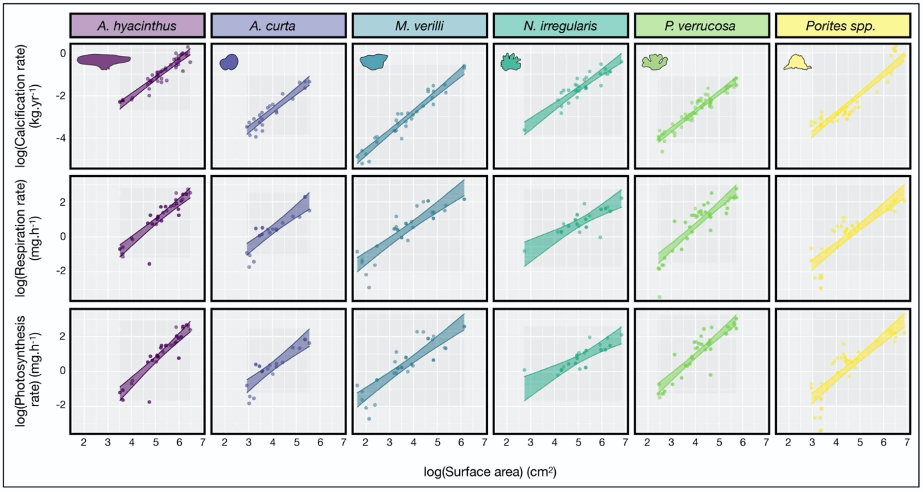

Figure 1 | Scaling relationships between three physiological processes (i.e., calcification rate, respiration rate, and photosynthesis rate, respectively, from top to bottom) and live coral surface area for six coral species (*Acropora hyacinthus, Astrea curta, Montipora verilli, Napopora irregularis, Pocillopora* cf. *verrucosa* andmassive *Porites*) with a ± 95% Bayesian credible interval. All relationships are depicted on the log-log scale, with dots representing the raw data points while regression lines and intervals represent posterior predictions from the Bayesian linear model (± 95% credible intervals). Coral silhouettes represent the current mature coral morphology.

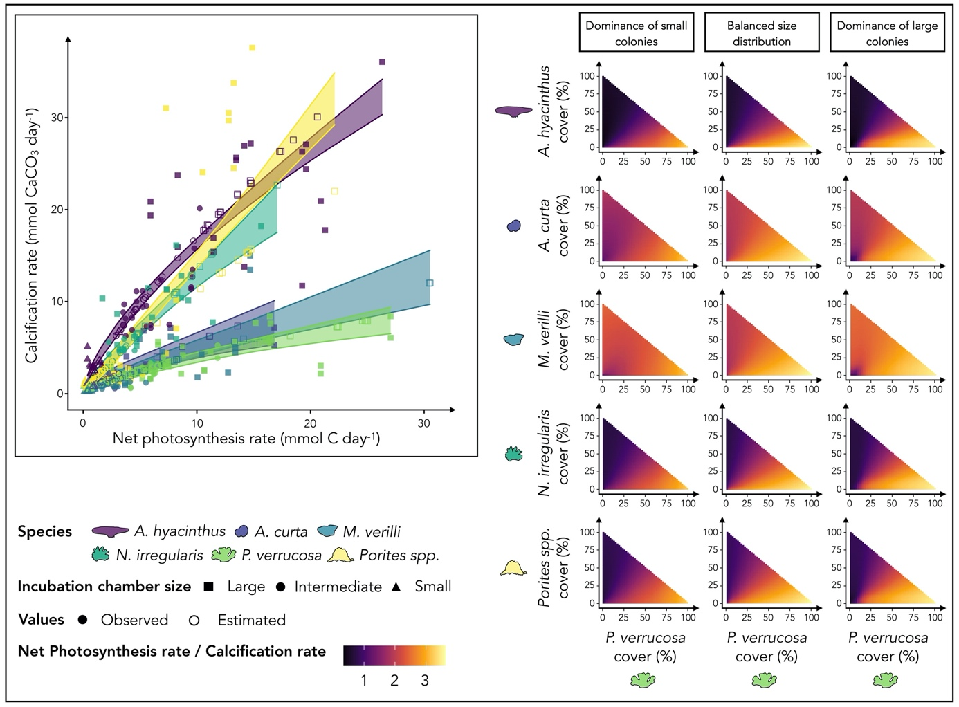

Figure 2 | Representation of hypothetical coral assemblages and their corresponding energy ratios (net photosynthesis rate/calcification rate). The plot on the left shows relationships between calcification and net photosynthesis, which underpin the community-wide models. Estimates from previous Bayesian models (unfilled points) were added to our observations (filled points). Matrices on the right represent scenarios of *Pocillopora* cf. *verrucosa* cover vs other species (*Acropora hyacinthus, Astrea curta, Montipora verilli, Napopora irregularis,*andmassive *Porites*). The three columns represent three size-structure scenarios.

Table 1 | Point estimates and 95% credible intervals for fitted parameters based on Bayesian linear models estimating calcification rate, respiration rate, and photosynthesis rate based on colony size and species identity.

|  |  |  |  |  |  |  |  |  |  |
| --- | --- | --- | --- | --- | --- | --- | --- | --- | --- |
|  | **Calcification** | | | **Respiration** | | | **Photosynthesis** | | |
| **Parameters** | **Mean** | **2.5%** | **97.5%** | **Mean** | **2.5%** | **97.5%** | **Mean** | **2.5%** | **97.5%** |
| **Fixed effects** | | | | | | | | | |
| ln(⍺) | -6.126 | -6.719 | -5.486 | -4.154 | -5.565 | -2.741 | -3.971 | -5.074 | -2.907 |
| ß | 0.881 | 0.792 | 0.966 | 1.074 | 0.796 | 1.351 | 1.033 | 0.800 | 1.256 |
| **Random effects** | | | | | | | | | |
| Std. Deviation of ln(⍺) | 0.613 | 0.228 | 1.408 | 1.437 | 0.624 | 3.006 | 1.081 | 0.383 | 2.376 |
| Std. Deviation of ß | 0.075 | 0.006 | 0.199 | 0.281 | 0.100 | 0.638 | 0.221 | 0.050 | 0.519 |
| Correlation of ln(⍺) and ß | -0.58 | -0.98 | 0.527 | -0.602 | -0.959 | 0.236 | -0.507 | -0.953 | 0.536 |

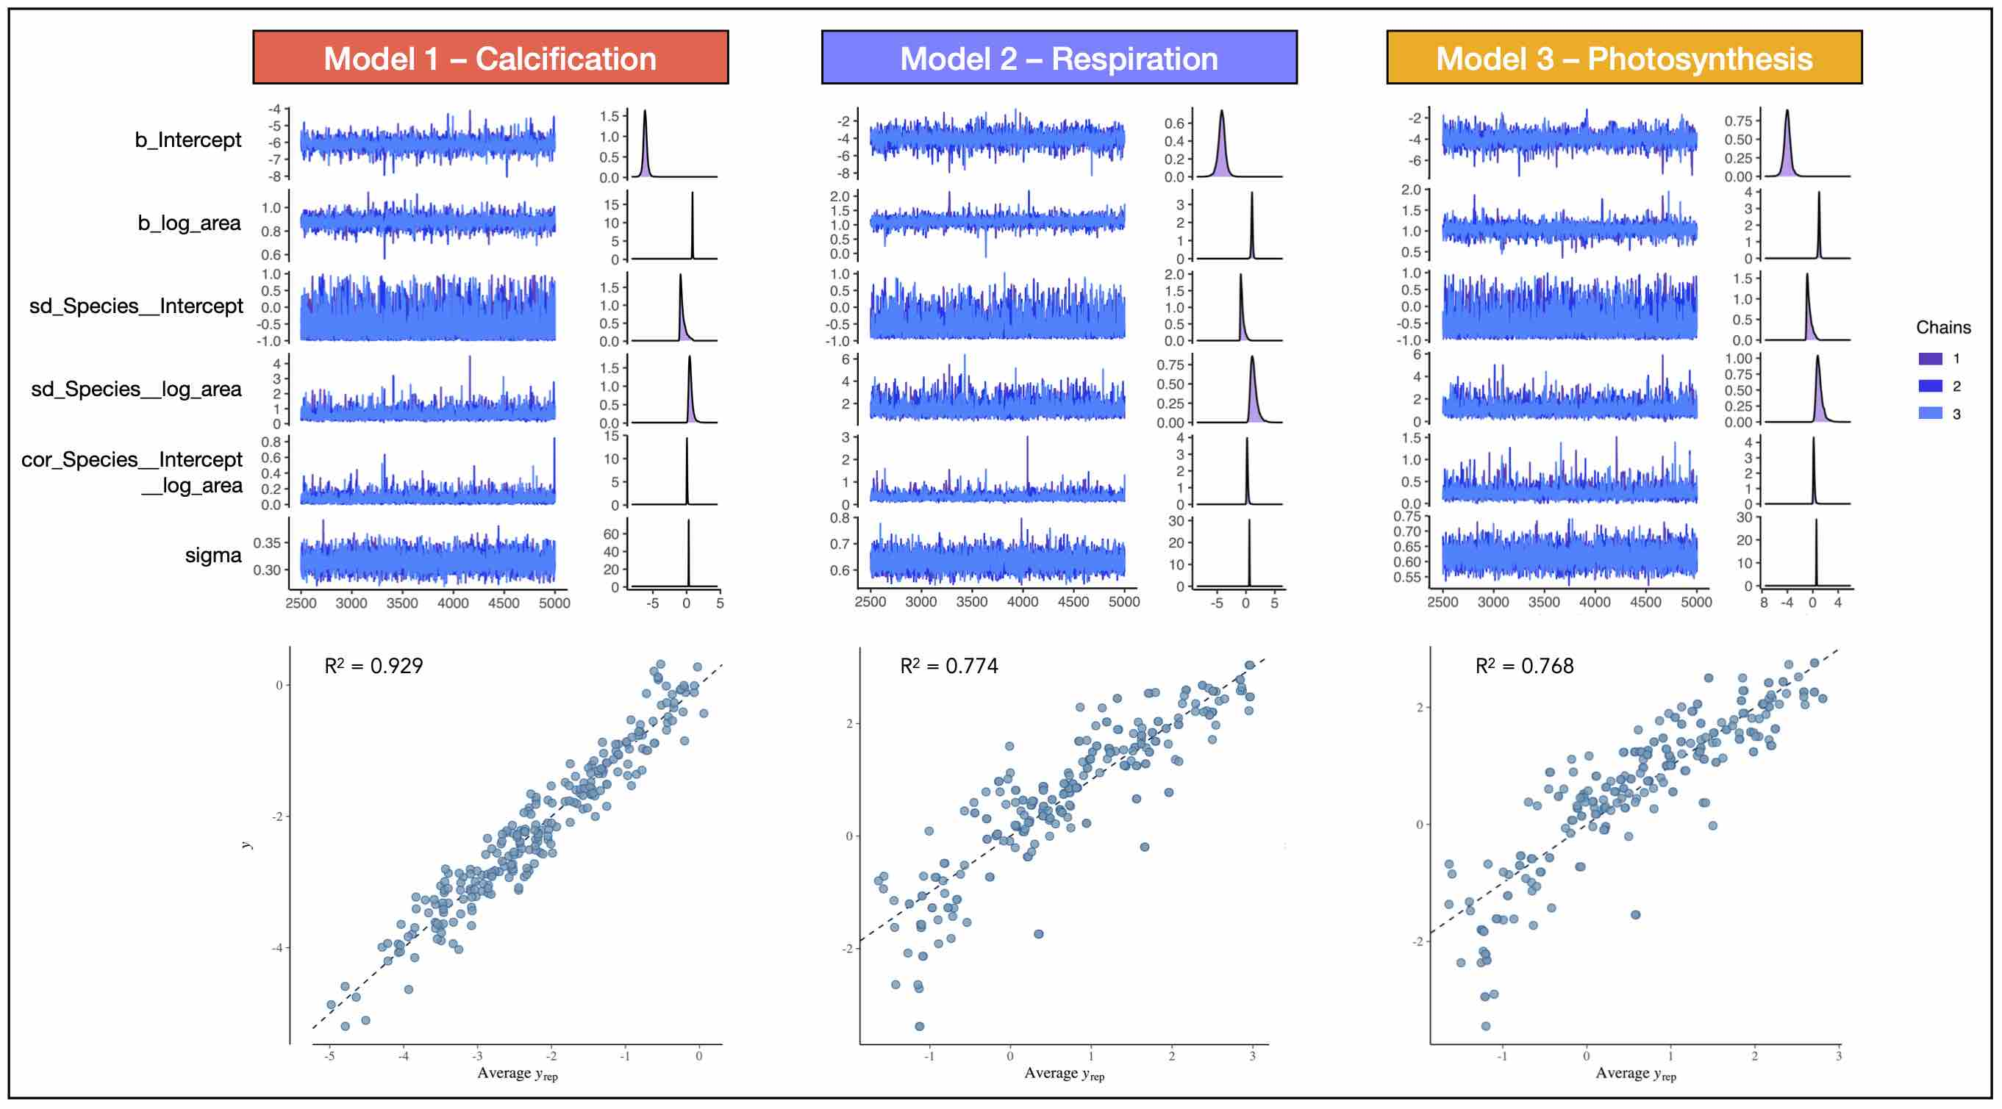

Figure S1 | Trace plots depicting the Monte Carlo chains from the three Bayesian models. Each model (i.e., calcification, respiration and photosynthesis) was run with three chains of 5,000 iterations, with the first 2,500 steps discarded. The scatterplots on the bottom represent posterior predictive checks with the respective R2 values estimated from the model.

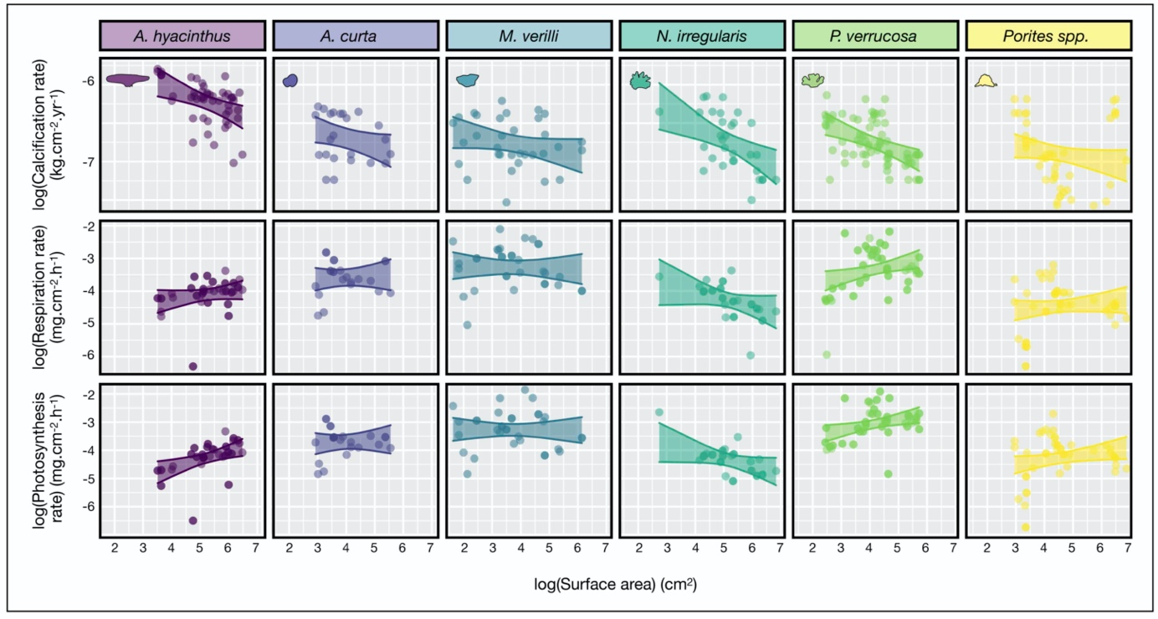

Figure S2 | Relationship between the surface-area-specific physiological processes (calcification rate, respiration rate, and photosynthesis rate, respectively, from the top to the bottom) and live coral surface area for six coral species (*Acropora hyacinthus, Astrea curta, Montipora verilli, Napopora irregularis, Pocillopora* cf. *verrucosa* andmassive *Porites*) with a ± 95% Bayesian credible interval. All relationships are depicted on the log-log scale, with dots representing the raw data points while regression lines and intervals represent posterior predictions from the Bayesian linear model (± 95% credible intervals). Coral silhouettes represent the current mature coral morphology.