**Calcification, respiration and photosynthesis trajectories of six prominent reef-building coral taxa**

Jeremy Carlot1,2,3*, Héloïse Rouzé1,2, Diego R. Barneche4,5, Alexandre Mercière2,6, Benoit Espiau2,6, Ulisse Cardini7,8, Simon J. Brandl1,2,3,9, Jordan M. Casey1,2,9, Gonzalo Peres-Rosales1,2, Mehdi Adjeroud2,3,10, Laetitia Hédouin2,6 and Valeriano Parravicini1,2,3

**Affiliations:**

1PSL Université Paris, USR 3278 CRIOBE - EPHE-UPVD-CNRS, Perpignan, France

2Laboratoire d’Excellence “CORAIL”, Paris, France

3CESAB - FRB, 5 Rue de l'École de Médecine, 34000, Montpellier

4Australian Institute of Marine Science, Crawley, WA 6009, Australia

5Oceans Institute, The University of Western Australia, Crawley, WA 6009, Australia

6PSL Université - EPHE-UPVD-CNRS, USR 3278 CRIOBE, Papetoai, French Polynesia

7Integrative Marine Ecology Department, Stazione Zoologica Anton Dohrn, National Institute of Marine Biology, Ecology and Biotechnology, Napoli, Italy

8Marine Research Institute, University of Klaipeda, Klaipeda, Lithuania

9University of Texas, Marine Science Institute

10ENTROPIE, IRD, Université de la Réunion, CNRS, Perpignan, France

* Corresponding author. Email: [jay.crlt02@gmail.com](mailto:jay.crlt02@gmail.com)

**ORCID:**

Jérémy Carlot 0000-0003-0887-8005   
Héloïse Rouzé 0000-0003-3380-0883  
Diego R. Barneche 0000-0002-4568-2362  
Ulisse Cardini 0000-0002-0816-6158  
Simon J. Brandl 0000-0002-6649-2496   
Jordan M. Casey 0000-0002-2434-7207   
Gonzalo Peres Rosales 0000-0001-6577-3416  
Mehdi Adjeroud 0000-0002-6825-8759   
Valeriano Parravicini 0000-0002-3408-1625

**Abstract**

Coral reefs provide a plethora of ecosystem services such as wave protection, habitat diversity and food security. These services are traditionally quantified by combining estimates of average species-level processes and data on species abundance. Often for colonial animals such as reef-building corals, abundance is expressed as substratum cover—a metric that does not account for demographic parameters such as coral size. This is problematic because many physiological processes exhibit non-linear scaling over ontogeny, and failing to account for such variation may lead to biased quantitative estimates of ecosystem functioning. In this study, we characterise the ontogenetic size scaling of three fundamental physiological rates—respiration, photosynthesis and calcification—for six prominent reef-building coral taxa in Mo’orea (French Polynesia). Our results indicate that area-specific calcification rates are higher for smaller individuals. However, are-specific photosynthesis and respiration rates remain constant throughout the colony-size gradient. The ratio between net primary production and calcification is correlated with the resilience of the six genera in Mo’orea, therefore our findings suggest that intraspecific scaling of reef-building coral physiology not only alters the energy budget on coral reefs, but also explain how species may respond to disturbance.

**Introduction**

Coral reefs are the most diverse marine ecosystems and provide essential services to more than 500 million people worldwide [1]. Healthy coral reefs protect coastlines from wave energy, reduce the risk of coastal flooding [2] and provide local populations with crucial food supplies [3]. These services are ensured by ecosystem functioning, but while there is agreement on which processes are fundamental for reef systems, our capacity to quantitatively define a ‘functional’ reef is still limited [4–6]. For example, it is well documented that herbivory and nutrient excretion from fishes help coral to settle and grow, but the degree of herbivory and the amount of nutrients needed to favour this process are still hard to determine [7–9]. Similarly, we know that coral calcification is key to reef accretion, but the quantification of the CaCO3 needed to keep up with sea level rise is still difficult to define precisely [10]. One of the reasons why defining ‘functional’ reefs remains challenging is that functional studies on coral reefs traditionally employ categorical traits as a proxy for functioning, while our capacity to directly quantify processes is still limited. In the literature two main approaches have been proposed to estimate ecosystem processes: i) the direct measurement of fluxes in the field (i.e.,, considering interaction among species) and ii) the scaling of individual-level physiological processes at community level using an additive approach (i.e.,, summing the contributions of each species to energy or elemental fluxes).

The direct measure of fluxes in the field is certainly the best and the more accurate method to quantify ecological functions [11]. However, direct assessments require impractical in situ chambers and are unfeasible at large spatial scales and across long time series. To overcome this limitation, several studies use individual-level estimates of fluxes based on species identity and relevant traits, and then scale-up these values at community-level using an additive framework. This approach has been successfully used to estimate biomass production and nutrient cycling in coral reef fish [12–14], as well as the calcification and accretion in coral assemblages [15]. This procedure has the obvious limitation of being based on indirect estimations, but also the major advantage of being applicable virtually to any community dataset. However, reliable estimates will inevitably depend on the availability and accuracy of measurements conducted at both species and individual levels [16].

Tropical corals perform a number of ecological functions that are essential to the overall health of reef ecosystems [7]. At the physiological level, corals consume dioxygen (O2)through respiration, but also produce O2 thanks to their symbiotic association with the photosynthetic microalgae in the Symbiodiniaceae family [17]. The coral host provides the symbiotic algae with a protected environment and the essential compounds such as respiratory carbon dioxide (CO2) and nitrogenous waste necessary for the photosynthesis [18–20]. In counterpart, the coral host receives photosynthetically fixed carbon that may cover up to 95% of its metabolism [21], including growth through the biocalcification (i.e.,, CaCO3 production) [19–22]. These basic physiological processes at colony levels amass to essential ecological functions at community level since respiration, photosynthesis and calcification are interconnected fluxes that allow the reef system to persist and accrete [23]. Therefore, the accurate quantification of CaCO3 production, respiration and photosynthesis is a priority for the functional ecology of coral reefs [24].

Several studies on coral calcification provided evidence that coral growth may be allometric (i.e.,, with a varying rate according to colony size) [25,26] instead of isometric (i.e.,, with a constant rate across colony size). In particular, the growth rate of large colonies is substantially lower than that of smaller coral colonies. The mechanisms behind this pattern are still unclear. Some authors propose that larger colonies may invest energy in reproduction, which would reduce the energy available for growth [27]. Other authors suggest that larger colonies are more subjected to partial mortality (e.g., localized tissue necrosis, overgrowth by other organisms, predation from parrotfishes), which implies a slower growth rate [28,29]. Whatever the mechanism, understanding whether fluxes scale isometrically or allometrically has important implications for our capacity to estimate community-level fluxes. Indeed, most community data report the substrate covered by each species without recording the size of individual colonies [16,30]. Therefore, the estimation of community functions using the additive framework will be accurate only in the case of isometry. In the case of allometry, instead, we would need information on colony size to apply a different rate to each colony.

In this study we assess three primary physiological functions (*i.e.,,* respiration, photosynthesis and calcification) for six different coral taxa along an extensive gradient in colony size in order to assess whether they show isometric or allometric patterns. We conducted our study in Mo’orea (French Polynesia) and focused on six coral taxa characterized with contrasting biological and life-history strategies.

**Material and Methods**

1. Coral species selection, preparation and acclimation

In September 2018, we collected 384 coral colonies of six distinct coral taxa: *Acropora hyacinthus, Astrea curta, Montipora verilli, Napopora irregularis, Pocillopora cf. verrucosa* and massive *Porites*. These taxa exhibit different life-history strategies and are among the most abundant in Mo’orea [31,32]. Five of these taxa were identified to species level in the field, massive *Porites* was collected at the genus level because *P. lutea* and *P. lobata* are macro-morphologically indistinguishable. All coral colonies were sampled at 11–13 m depth on the outer reef of the North side of the island. Before each collection, we recorded relevant environmental parameters in situ: mean ambient seawater temperature, salinity and photosynthetically active radiation (PAR: 400-700 nm). Colonies were removed from the substratum using a hammer and chisel, transported from the field site to the lab in a cool box. The transportation took on average 15 minutes.

In the laboratory, each colony was cleaned with Milli-Q water and epibionts or epiphytes were removed. Each colony was then attributed to a size class: (S1) <100 cm2, (S2) 100-400 cm2 and (S3) 400-1000 cm2 for further physiological measurements. Finally, all colonies have been placed for 7 days into tanks that mimicked the environmental parameters recorded in situ for recovery and acclimation.

1. Respiration and photosynthesis

The colonies were incubated in permeable chambers of three different volumes from 0.5 L, 1 L and 4 L according to the ratio between the incubation volume and colony size. Colonies smaller than 100 cm2 were incubated into 0.5 L chambers, colonies between 100 and 400 cm2 were incubated into chambers of 1 L and colonies larger than 400 cm2 were incubated into chambers of 4 L. For each respirometry run we assessed four controls and four corals of each size class (n = 12 corals for each run). Since we were measuring both photosynthesis and respiration, we took measures of O2 variation in the chambers both in light conditions and in the dark. For each run colonies were taken in light conditions for three hours, then light was turned off, and 30 minutes later we started recording O2 consumption in the dark. We limited the measurements of O2 consumption in the dark to 1 hour in order to not exceed an O2 reduction of 80% [33]. O2 activity was recorded with Pyrosciences and National Instrument software and removed the first thirty minutes corresponding to a break on the O2 slope consumption. Finally, using the blanks, we corrected the microorganism O2 consumption and defined thus two consumption profiles: one during the light activity (i.e.,, both respiration and photosynthesis activity) and one during the night activity (i.e.,, respiration activity). The measures were obtained in mg (O2) h-1.

1. Calcification

We collected water samples of 50 mL from each incubation chamber and the controls both in light conditions and in the dark. We stored the samples until analysis in sealed, plastic brown vials in the dark at 4°C and let them stabilize for 2 hours at a temperature of 25°C. Three titrations per sample were carried out to define total alkalinity with the Titrando 888 (Metrohm) by using the Titripur c(HCl) (with a concentration about 100 mmol.L-1). Titration controls were set up with the current water experiment collected beforehand coral incubations. Calcification rates were calculated from the difference between total alkalinity measured at the beginning and the end of each incubation period (∆AT) as defined by Dickson et al. (2007) [34]. Assuming a mole of CaCO3 is produced when the alkalinity measure (∆AT) drops by 2 moles throughout a fixed time (∆t), and by multiplying these parameters (i.e.,, - ∆AT/2∆t) by seawater density (ρsw) we defined the global CaCO3 production rate. We finally converted it in g cm-2 yr-1 based on the molar CaCO3 mass.

1. Colony-size estimation using photogrammetry

After each incubation we took 100 to 200 overlapping high-resolution photos (300 dpi) for each colony. The photos were used to construct 3D images using Agisoft PhotoScan modelling software [35]. The photo alignment (i.e.,, bundle adjustment) creates a 3D image that results from the projection and intersection of pixel rays from the different positions and oriented images. The software allowed us to define volume and live surface area from the final 3D model [36]. All coral colonies (i.e.,, 384 coral colonies) were thus stored in a central storage tank and re-introduced if they did not die, on the outer slope. Each week, all coral colonies already incubated and waiting for being reintroduced in the storage tank were transported in the cool box in direction to the diving site. A total of 308 coral colonies were transported and placed back carefully on the reef, at some spot with low current observations.

1. Statistical analysis

We removed data if: 1) a coral colony exhibited a negative calcification (i.e., dissolution), 2) the tank temperature dropped below 27°C (i.e., experimental fault) or 3) the linear fit between the O2 consumption and time to estimate respiratory/net photosynthesis rates exhibited R2 lower than 0.8 [33] . We thus kept 250 coral colonies out of XX (XX %) for the analysis. We then applied Bayesian methods using the R package *brms* [37] to estimate the allometry of each physiological rate on the natural log scale:

; ; ; ;

where is the natural logarithm of the rate of CaCO3 production (kg yr-1), O2 consumption (mg h-1)or O2 production (mg h-1) of species and individual ; is the natural logarithm live coral surface area (cm2); is the among-species average intercept on the natural log scale; is the among-species average size scaling slope (i.e., exponent on the natural scale); is a vector comprising levels of species (*n* = 6) which in turn compose a hierarchical vector of elements representing species-level additive deviations from ; is the vector of standardised hierarchical effects and represents the among-species standard deviation. The prior sampling distributions are the Gaussian ((location, scale)) and Gamma ((shape, inverse scale)). We ran our models with three chains, 5,000 draws per chain and a warm-up period of 2,500 steps, therefore retaining 7,500 draws (i.e. 3 (5,000 – 2,500) = 7,500) to construct posterior distributions. We verified chain convergence with trace plots and confirmed that the Rhat (the potential scale-reduction factor) [38] was lower than 1.05. Second, each functional process was standardized by the surface area and the same model with non-informative priors. We then predicted functional processes rates (area-normalized or not) throughout the size gradient studied (± 95% Bayesian credible intervals). We synthesized the main expected equivalent curves corresponding to the coefficients ⍺ and ß obtained with the log-log regression (Table 1, Fig S1).

Since the ratio between net photosynthesis rate and calcification is a proxy of how much energy is available to perform other functions (e.g., reproduction) we also explored the relationship between net photosynthesis rate and calcification for the different species. Moreover, since after recent disturbance the *Pocillopora* genusbecame dominant in Mo’orea [39], we explored the hypothesis that this genus may have an energetic advantage compared to the other genera. To do that we performed simulations to evaluate the energy budget of monospecific assemblages composed of *Pocillopora* vs the other genera. More specifically, we defined a common average coral size (mean and standard deviation) for the six genera on the base of Kayal *et al.* [40]. Then, we randomly sampled 100 size estimates according to 3 conditions: 1) one sampling with negative skewness (i.e.,, dominance of large colonies), 2) one sampling with null skewness and 3) one sampling with positive skewness (i.e.,, dominance of large colonies). Each set of 100 samples was stored into a dataset containing the size estimates the photosynthetic rate and the calcification rate. For each dataset, we determined five matrices opposing the *Pocillopora cf. verrucosa* to the five other species (i.e.,, *Acropora hyacinthus, Astrea curta, Montipora verilli, Napopora irregularis* and *Porites spp*.). Each matrix proposes 100x100 combinations (i.e.,, the number of individuals of *Pocillopora cf verrucosa* *vs*. the number of individuals of the other coral species). We summed both photosynthesis and calcification rates across the number of individuals. Finally, we estimated the accurate ‘energetic ratio’ of the combination by dividing the summed photosynthesis by the summed calcification. To visualize our results as a percentage of lived coral cover, we keep only species-combinations lower than 100 individuals. All the statistical analyses were run in R version 4.0.0 [41].

**Results**

For all coral species we observed a linear increase of the metabolic functions of calcification, photosynthesis and respiration across the colony-size gradient on the log-log scale (Fig. 1). However, we identified both hypo-allometric and isometric relationships depending on the function considered. Calcification showed a hypo-allometric relationship with colony size, as highlighted by the values of the ß coefficients lower than 1 (Fig. 1). Although massive *Porites spp.*, massive *Astrea curta* and encrusting *Montipora verilli* had higher ß coefficients than the other species, only 2% of the 5,000 posterior draws had a slope greater than 1. On the other hand, respiration and photosynthesis increased isometrically with colony size, as demonstrated by ß coefficients non-different from 1.

The relevance of the size dependence of metabolic functions becomes even more evident when standardized by coral surface area (Fig. S2): because whole colony calcification rates were hypo-allometric, calcification rate per surface area decreases as colony size increases. Moreover, we detected substantial among-species variation in the intercepts (i.e.,, ⍺ coefficients), thus suggesting species-level differences in the average calcification rate per unit area. Consistently with previous results, photosynthetic rate and respiration per unit area were relatively constant across the colony size gradient. However, we also estimated substantial differences in the intercept of the six species (Fig. 1, Fig. S2). Indeed, *Acropora hyacinthus* was recorded with the highest calcification rates while *Montipora verilli* presents the lowest rate. However,the trend is reversed for both respiration and photosynthesis functions (i.e.,, higher rate for *Montipora verilli* and lower rate for *Acropora hyacinthus*). Exploring the relationship between photosynthestic rates and calcification rates, we detected two main tendencies (Fig. 2). First, *Porites spp*.,*Napopora irregularis*and*Acropora hyacinthus* show higher calcification rates than net photosynthesis rates. Secondly, *Astrea curta, Montipora verilli*and*Pocillopora cf. verrucosa* show the opposite pattern. By attributing this ratio to the six theoretic monospecific communities defined (see Material and Methods), we observed that the highest ratio was attributed to 100% of *Pocillopora cf. verrucosa* cover (i.e.,, ratio ~ 3.5; Fig. 2).

**Discussion and conclusion**

We analysed three fundamental physiological functions (i.e.,, respiration, photosynthesis and calcification) for six prominent coral taxa to test whether the relationship of these functions with colony size was isometric or allometric. Our results are consistent with recent works on coral calcification that documented a higher production per unit area for smaller colonies [25,26,28]. However, we did not find any allometric relationship between photosynthesis or respiration and colony size. Such results slightly contrast with previous results on *Pocillopora*spp. obtained by Edmunds *et al.* [26]. However, despite Edmunds *et al.* were able to define a significant decline in area-specific respiration and photosynthesis across the gradient in colony size, the slope of this relationship was extremely close to zero. Moreover, the authors [26] highlighted an influence of the sea surface temperature with the report of a significant relationship for photosynthesis and respiration with size for colonies at 26.5°C, while they were unable to detect any trend for photosynthesis and respiration at 29.7°C. We performed our measurement at the average ambient temperature for the period of sampling, which corresponds to 28.5°C.

The lack of relationship between colony size and photosynthesis may be related to the fact that a high photosynthetic rate can lead to a significant decrease in coral productivity or exposition to oxidative stress [42,43]. Therefore, photosynthetic rate of corals does not shift, whereas the production of CaCO3 does. Indeed, younger and smaller colonies are subjected to higher mortality rate [44–46]. The life-stage that follows colonization, from the time corals settle to recruitment, largely determine their demography [47]. It is mostly during this temporal window that corals will allocate most of their energy to CaCO3 production, which allows them to reach the size-escape thresholds quicker [48]. Indeed, even within very small size classes, size-escape can be an important mechanism of predator avoidance for newly settled recruits making rapid early growth vital to survivorship [49]. While the different coral species follow a similar trend for CaCO3 production, *A. hyacinthus* has a much higher CaCO3 production rate than the other coral species. These results are consistent with the high calcification rate for *Acropora* genus largely documented across the world [50–52]. However, although CaCO3 production is the highest *for A. hyacinthus*, its photosynthetic and respiration rates are among the lowest in our experiments. This suggests that *A. hyacinthus* tends to allocate most of its energy to grow, suggesting less energy-intensive strategies for other essential functions (e.g., skeletal density, reproduction) [53]. Inversely, *M. verilli* and *P. verrucosa* show the highest photosynthetic rates (Fig. 1, Fig. S2) and are associated with smaller growth rate.

Ward *et al*. [54] suggested that the quantity of lipid (originated from the photosynthesis) found in the tissue of corals was highly corelated with the coral reproduction activity. One hypothesis that could explain the higher photosynthetic rate observed for *M. verilli* and *P. verrucosa* is that these two species may allocate comparatively more energy to reproduction. For example, pocilloporids promote the massive production of smaller sperm egg-bundles, allowing higher diffusion [55]. The high photosynthetic rate of *P. verrucosa* seems to explain the success of this species in Mo’orea, a reef system dominated by Pocilloporids since recently [56]. Furthermore, *M. verilli* which is sharing with *P. verrucosa* similar physiological traits, is the second most abundant coral genus in Mo’orea [57]. It contrasts with *A. hyacinthus* which presents the lower photosynthetic rate, higher calcification rate and larger azooxanthellate eggs, likely implying an energy budget strategy for reproduction more limited. In addition, distinct photosynthetic rates among coral taxa could be attributed to transmission ways and different physiological and ecological attributes of associated symbiotic communities [32,58,59]: stable association with the high efficiency genus *Cladocopium* [60,61] for *P. verrucosa* and most likely *M. verilli* (vertical transfer) *vs*. flexible association with different Symbiodiniaceae genera for *A. hyacinthus* (horizontal transfer).These traits might have disadvantaged *A. hyacinthus*, which might explain in part why this genus is more sensitive and becomes to be rare compared to *P. verrucosa* or *M. verilli* [62]. In addition, in Mo’orea the sensitivity to bleaching for *Acropora* genus is about 3 times higher than for *Montipora* genus [63]. The combination of higher photosynthetic activity (e.g.,, more lipids) coupled with greater tolerance to global stressors [64,65] may explain the success of *P. verrucosa* and *M. verilli* in Mo’orea, especially while reefs were recovering from the effects of the Oli cyclone in 2010. The other three coral species (i.e.,, *A. curta, N. irregularis* andmassive *Porites spp.*) show intermediate physiological performances and intermediate abundances around Mo'orea. We hypothesize that physiological traits may determine the energy available for different crucial processes at population and community level such as the reproduction or the capacity to rapidly reach the size-escape [49], thus favouring certain species under given environmental contexts.

In the case of photosynthesis and respiration, the isometric nature of their relationship with colony-size makes it more predictable to scale colony-level estimates to the community level (*i.e.,,* if the total surface area and the number of species are known, we may be able to define the accurate estimate). In these cases, standard coral monitoring that records the percentage of substrate cover by the different species [66,67] allows to estimate community-level photosynthetic capacity. Nevertheless, calcification is a crucial function performed by coral assemblages, which has direct implications for reef accretion [10] and waves energy attenuation [2]. In this regard, our results highlight that the calcification process is size-dependent [25,26]. This implies that an accurate estimation of community-level CaCO3 would require information on the size distribution of individual colonies, which is seldom recorded in standard monitoring. Although many monitoring programs have developed regional variants, such as the Atlantic and Gulf Rapid Reef Assessment [68], the Caribbean Coastal Marine Productivity Program [69], the Great Barrier Reef long-term monitoring program [70], and Reef Check [71], only few programs record demographic parameters (e.g., LTER program [72]).

The role of colony size in determining colony-level physiological processes and community-level parameters is emerging recent researches. Given their colonial nature, it was often assumed that size was irrelevant for corals [73,74]. Therefore, colony-size is traditionally not considered in traditional community assessment, while it is a standard practice for other key groups, e.g., fish assemblages. Moreover, the effects of size dependence on physiological rates, and their implications to community and ecosystem-level are already well studied in terrestrial ecology for animals, plants or even some microbes [75–77]. For example, in tropical forests, different tree species can differ greatly in their growth rates (allometric relationship) and ages of maturity but still attain similar canopy sizes [75]. Another example is the relative scaling of metabolism *vs.* the volume of the digestive tract, which affects the potential diets of herbivorous mammals (and thus their social behavior) [77]. Over the last century, the analysis of the implications of allometric relationship in ecology have been growing exponentially for the terrestrial realm [78] and aquatic consumers such as fishes [79]. However, there is still a gap in our understanding of allometric relationship for colonial marine organisms such as corals. Recent literature highlights that not only CaCO3 production, but also other important processes such as mortality and partial mortality are size-dependent [28]. This calls for the introduction of colony-size among the crucial variables that needs to be measured to monitor coral reefs and their functioning.

**References**

1. Hoegh-Guldberg O. 2011 Coral reef ecosystems and anthropogenic climate change. *Reg. Environ. Chang.* **11**, 215–227. (doi:10.1007/s10113-010-0189-2)

2. Harris DL, Rovere A, Casella E, Power H, Canavesio R, Collin A, Pomeroy A, Webster JM, Parravicini V. 2018 Coral reef structural complexity provides important coastal protection from waves under rising sea levels. *Sci. Adv.* **4**, eaao4350. (doi:10.1126/sciadv.aao4350)

3. Cinner JE *et al.* 2020 Meeting fisheries, ecosystem function, and biodiversity goals in a human-dominated world. *Science .* **368**, 307–311. (doi:10.1126/science.aax9412)

4. Hughes TP *et al.* 2007 Phase Shifts, Herbivory, and the Resilience of Coral Reefs to Climate Change. *Curr. Biol.* **17**, 360–365. (doi:https://doi.org/10.1016/j.cub.2006.12.049)

5. Burkepile D. 2009 Nutrient versus herbivore control of macroalgal community development and coral growth on a Caribbean reef. *Mar. Ecol. Prog. Ser.* **389**, 71–84.

6. Woodhead AJ, Hicks CC, Norström A V, Williams GJ, Graham NAJ. 2019 Coral reef ecosystem services in the Anthropocene. *Funct. Ecol.* **33**, 1023–1034. (doi:https://doi.org/10.1111/1365-2435.13331)

7. Brandl S, Rasher DB, Côté IM, Casey JM, Darling ES, Lefcheck JS, Duffy JE. 2019 Coral reef ecosystem functioning: eight core processes and the role of biodiversity. *Front. Ecol. Environ.* **17**, 445–454. (doi:https://doi.org/10.1002/fee.2088)

8. Moreno-Mateos D *et al.* 2017 Anthropogenic ecosystem disturbance and the recovery debt. *Nat. Commun.* **8**, 14163. (doi:10.1038/ncomms14163)

9. McWilliam M, Pratchett MS, Hoogenboom MO, Hughes TP. 2020 Deficits in functional trait diversity following recovery on coral reefs. *Proc. R. Soc. B Biol. Sci.* **287**, 20192628. (doi:10.1098/rspb.2019.2628)

10. Perry C *et al.* 2018 Loss of coral reef growth capacity to track future increases in sea level. *Nature* **558**, 396–400. (doi:10.1038/s41586-018-0194-z)

11. Nakamura T, Nakamori T. 2009 Estimation of photosynthesis and calcification rates at a fringing reef by accounting for diurnal variations and the zonation of coral reef communities on reef flat and slope: a case study for the Shiraho reef, Ishigaki Island, southwest Japan. *Coral Reefs* **28**, 229–250. (doi:10.1007/s00338-008-0454-8)

12. Allgeier JE, Layman CA, Mumby PJ, Rosemond AD. 2014 Consistent nutrient storage and supply mediated by diverse fish communities in coral reef ecosystems. *Glob. Chang. Biol.* **20**, 2459–2472. (doi:https://doi.org/10.1111/gcb.12566)

13. Brandl S *et al.* 2019 Demographic dynamics of the smallest marine vertebrates fuel coral reef ecosystem functioning. *Science .* **364**, 1189 LP – 1192. (doi:10.1126/science.aav3384)

14. Morais RA, Connolly SR, Bellwood DR. 2020 Human exploitation shapes productivity–biomass relationships on coral reefs. *Glob. Chang. Biol.* **26**, 1295–1305. (doi:https://doi.org/10.1111/gcb.14941)

15. Perry CT, Edinger EN, Kench PS, Murphy GN, Smithers SG, Steneck RS, Mumby PJ. 2012 Estimating rates of biologically driven coral reef framework production and erosion: a new census-based carbonate budget methodology and applications to the reefs of Bonaire. *Coral Reefs* **31**, 853–868. (doi:10.1007/s00338-012-0901-4)

16. Edmunds PJ, Riegl B. 2020 Urgent need for coral demography in a world where corals are disappearing. *Mar. Ecol. Prog. Ser.* **635**, 233–242.

17. LaJeunesse TC, Parkinson JE, Gabrielson PW, Jeong HJ, Reimer JD, Voolstra CR, Santos SR. 2018 Systematic Revision of Symbiodiniaceae Highlights the Antiquity and Diversity of Coral Endosymbionts. *Curr. Biol.* **28**, 2570-2580.e6. (doi:https://doi.org/10.1016/j.cub.2018.07.008)

18. Muscatine L, Porter JW. 1977 Reef Corals: Mutualistic Symbioses Adapted to Nutrient-Poor Environments. *Bioscience* **27**, 454–460. (doi:10.2307/1297526)

19. Barnes RD. 1987 Invertebrate Zoology, Fifth Edit. ed.

20. Birkeland C. 1997 *Life and death of coral reefs*. Springer Science & Business Media.

21. Muscatine L. 1990 The role of symbiotic algae in carbon and energy flux in reef corals. *Coral reefs* **25**, 75–87.

22. Barnes RSK, Hughes RN. 1999 *An introduction to marine ecology*. John Wiley & Sons.

23. Howard J, Sutton-Grier A, Herr D, Kleypas J, Landis E, Mcleod E, Pidgeon E, Simpson S. 2017 Clarifying the role of coastal and marine systems in climate mitigation. *Front. Ecol. Environ.* **15**, 42–50. (doi:https://doi.org/10.1002/fee.1451)

24. Madin JS *et al.* 2016 The Coral Trait Database, a curated database of trait information for coral species from the global oceans. *Sci. Data* **3**, 160017. (doi:10.1038/sdata.2016.17)

25. Dornelas M, Madin JS, Baird AH, Connolly SR. 2017 Allometric growth in reef-building corals. *Proc. R. Soc. B Biol. Sci.* **284**, 20170053. (doi:10.1098/rspb.2017.0053)

26. Edmunds PJ, Burgess SC. 2016 Size-dependent physiological responses of the branching coral Pocillopora verrucosa to elevated temperature and PCO2. *J. Exp. Biol.* **219**, 3896–3906. (doi:10.1242/jeb.146381)

27. Richmond R. 1987 Energetic Relationships and Biogeographical Differences among Fecundity, Growth and Reproduction in the Reef Coral Pocillopora Damicornis. *Bull. Mar. Sci.* **41**.

28. Madin JS, Baird AH, Baskett ML, Connolly SR, Dornelas MA. 2020 Partitioning colony size variation into growth and partial mortality. *Biol. Lett.* **16**, 20190727. (doi:10.1098/rsbl.2019.0727)

29. Pratchett MS, Anderson KD, Hoogenboom MO, Widman E, Baird AH, Pandolfi JM, Edmunds PJ, Lough JM. 2015 Spatial, temporal and taxonomic variation in coral growth-implications for the structure and function of coral reef ecosystems. *Oceanogr. Mar. Biol. An Annu. Rev.* **53**, 215–295. (doi:10.1201/b18733)

30. Flower J, Ortiz JC, Chollett I, Abdullah S, Castro-Sanguino C, Hock K, Lam V, Mumby PJ. 2017 Interpreting coral reef monitoring data: A guide for improved management decisions. *Ecol. Indic.* **72**, 848–869. (doi:https://doi.org/10.1016/j.ecolind.2016.09.003)

31. Darling ES *et al.* 2019 Social–environmental drivers inform strategic management of coral reefs in the Anthropocene. *Nat. Ecol. Evol.* **3**, 1341–1350. (doi:10.1038/s41559-019-0953-8)

32. Putnam HM, Stat M, Pochon X, Gates RD. 2012 Endosymbiotic flexibility associates with environmental sensitivity in scleractinian corals. *Proc. R. Soc. B Biol. Sci.* **279**, 4352–4361. (doi:10.1098/rspb.2012.1454)

33. Kolb RW. 2018 National Ambient Air Quality Standards (NAAQS). *SAGE Encycl. Bus. Ethics Soc.* (doi:10.4135/9781483381503.n817)

34. Dickson AG, Sabine CL, Christian JR. 2007 *Guide to best practices for ocean CO2 measurements.* North Pacific Marine Science Organization.

35. LLC Agisoft. 2016 Agisoft PhotoScan User Manual : Professional Edition, Version 1.2. *User Manuals*. , 97.

36. Harwin S, Lucieer A, Osborn J. 2015 The Impact of the Calibration Method on the Accuracy of Point Clouds Derived Using Unmanned Aerial Vehicle Multi-View Stereopsis. *Remote Sens.* **7**, 11933–11953. (doi:10.3390/rs70911933)

37. Bürkner P-C. 2017 brms: An R Package for Bayesian Multilevel Models Using Stan. *J. Stat. Software; Vol 1, Issue 1*  (doi:10.18637/jss.v080.i01)

38. Gelman A, Rubin DB, others. 1992 Inference from iterative simulation using multiple sequences. *Stat. Sci.* **7**, 457–472.

39. Adjeroud M, Kayal M, Iborra-Cantonnet C, Vercelloni J, Bosserelle P, Liao V, Chancerelle Y, Claudet J, Penin L. 2018 Recovery of coral assemblages despite acute and recurrent disturbances on a South Central Pacific reef. *Sci. Rep.* **8**, 9680. (doi:10.1038/s41598-018-27891-3)

40. Kayal M, Lenihan HS, Brooks AJ, Holbrook SJ, Schmitt RJ, Kendall BE. 2018 Predicting coral community recovery using multi-species population dynamics models. *Ecol. Lett.* **21**, 1790–1799. (doi:https://doi.org/10.1111/ele.13153)

41. R Core Team. 2019 R: A Language and Environment for Statistical Computing.

42. Fitt WK, Brown BE, Warner ME, Dunne RP. 2001 Coral bleaching: interpretation of thermal tolerance limits and thermal thresholds in tropical corals. *Coral Reefs* **20**, 51–65. (doi:10.1007/s003380100146)

43. Hoogenboom MO, Anthony KRN. 2006 Energetic cost of photoinhibition in corals . *Mar. Ecol. Prog. Ser.* **313**, 1–12.

44. Ritson-Williams R, Arnold S, Fogarty N, Steneck RS, Vermeij M, Paul VJ. 2009 New perspectives on ecological mechanisms affecting coral recruitment on reefs. *Smithson. Contrib. Mar. Sci.* , 437–457. (doi:10.5479/si.01960768.38.437)

45. Wall KR, Stallings CD. 2018 Subtropical epibenthos varies with location, reef type, and grazing intensity. *J. Exp. Mar. Bio. Ecol.* **509**, 54–65. (doi:https://doi.org/10.1016/j.jembe.2018.09.005)

46. Penin L, Michonneau F, Baird A, Connolly S, Pratchett M, M K, M A. 2010 Early post-settlement mortality and the structure of coral assemblages. *Mar. Ecol. Prog. Ser.* **408**, 55–64.

47. Vermeij MJA, Sandin SA. 2008 Density-dependent settlement and mortality structure the earliest life phases of a coral population. *Ecology* **89**, 1994–2004. (doi:https://doi.org/10.1890/07-1296.1)

48. Heino, Kaitala. 1999 Evolution of resource allocation between growth and reproduction in animals with indeterminate growth. *J. Evol. Biol.* **12**, 423–429. (doi:https://doi.org/10.1046/j.1420-9101.1999.00044.x)

49. Doropoulos C, Ward S, Marshell A, Diaz-Pulido G, Mumby PJ. 2012 Interactions among chronic and acute impacts on coral recruits: the importance of size-escape thresholds. *Ecology* **93**, 2131–2138. (doi:https://doi.org/10.1890/12-0495.1)

50. Huston M. 1985 Variation in coral growth rates with depth at Discovery Bay, Jamaica. *Coral Reefs* **4**, 19–25. (doi:10.1007/BF00302200)

51. Harriott VJ. 1999 Coral growth in subtropical eastern Australia. *Coral Reefs* **18**, 281–291. (doi:10.1007/s003380050195)

52. Anderson KD, Cantin NE, Heron SF, Lough JM, Pratchett MS. 2018 Temporal and taxonomic contrasts in coral growth at Davies Reef, central Great Barrier Reef, Australia. *Coral Reefs* **37**, 409–421. (doi:10.1007/s00338-018-1666-1)

53. Razak TB, Roff G, Lough JM, Mumby PJ. 2020 Growth responses of branching versus massive corals to ocean warming on the Great Barrier Reef, Australia. *Sci. Total Environ.* **705**, 135908. (doi:https://doi.org/10.1016/j.scitotenv.2019.135908)

54. Ward S. 1995 The effect of damage on the growth, reproduction and storage of lipids in the scleractinian coral Pocillopora damicornis (Linnaeus). *J. Exp. Mar. Bio. Ecol.* **187**, 193–206. (doi:https://doi.org/10.1016/0022-0981(94)00180-L)

55. Hirose M, Kinzie R, Hidaka M. 2001 Timing and process of entry of zooxanthellae into oocytes of hermatypic corals. *Coral Reefs* **20**, 273–280. (doi:10.1007/s003380100171)

56. Hédouin L *et al.* 2020 Contrasting patterns of mortality in Polynesian coral reefs following the third global coral bleaching event in 2016. *Coral Reefs* **39**, 939–952. (doi:10.1007/s00338-020-01914-w)

57. Bosserelle P, Berteaux-Lecellier V, Chancerelle Y, Hédouin L, Nugues M, Wallace C, Pichon M. 2014 *Guide d’identification des coraux de Moorea*. CRIOBE.

58. Baird AH, Guest JR, Willis BL. 2009 Systematic and Biogeographical Patterns in the Reproductive Biology of Scleractinian Corals. *Annu. Rev. Ecol. Evol. Syst.* **40**, 551–571. (doi:10.1146/annurev.ecolsys.110308.120220)

59. Rouzé H, Lecellier G, Pochon X, Torda G, Berteaux-Lecellier V. 2019 Unique quantitative Symbiodiniaceae signature of coral colonies revealed through spatio-temporal survey in Moorea. *Sci. Reports (Nature Publ. Group)* **9**. (doi:http://dx.doi.org/10.1038/s41598-019-44017-5)

60. Baker DM, Freeman CJ, Wong JCY, Fogel ML, Knowlton N. 2018 Climate change promotes parasitism in a coral symbiosis. *ISME J.* **12**, 921–930. (doi:10.1038/s41396-018-0046-8)

61. Stat M, Morris E, D. GR. 2008 Functional diversity in coral{\textendash}dinoflagellate symbiosis. *Proc. Natl. Acad. Sci.* (doi:10.1073/pnas.0801328105)

62. Babcock RC, Baird AH, Piromvaragorn S, Thomson DP, Willis BL. 2003 Identification of scleractinian coral recruits from Indo-Pacific reefs. *Zool. Stud.* **42**, 211–226.

63. Pratchett MS, McCowan D, Maynard JA, Heron SF. 2013 Changes in bleaching susceptibility among corals subject to ocean warming and recurrent bleaching in Moorea, French Polynesia. *PLoS One* **8**, e70443.

64. Al-Sofyani AA, Floos YAM. 2013 Effect of temperature on two reef-building corals Pocillopora damicornis and P. verrucosa in the Red Sea. *Oceanologia* **55**, 917–935. (doi:https://doi.org/10.5697/oc.55-4.917)

65. Haryanti D, Yasuda N, Harii S, Hidaka M. 2015 High tolerance of symbiotic larvae of Pocillopora damicornis to thermal stress. *Zool. Stud.* **54**, 52. (doi:10.1186/s40555-015-0134-7)

66. English S, Wilkinson C, Baker V. 1997 *Survey manual for tropical marine resources*.

67. Hill JJ, Wilkinson CCR, others. 2004 *Methods for ecological monitoring of coral reefs: a resource for managers*. Australian Institute of Marine Science (AIMS).

68. Lang JC, Marks KW, Kramer PA, Kramer PR, Ginsburg RN. 2010 AGRRA protocols version 5.4. Atlantic and Gulf Rapid Reef Assessment Program, University of Miami, Florida.

69. CARICOMP CCMP. 2001 CARICOMP Methods Manual Levels 1 & 2: Methods for Mapping and Monitoring of Physical and Biological Parameters in the Coastal Zone of the Caribbean. *Cent. Mar. Sci. Univ. West Indies, Kingston, Jamaica*

70. Sweatman H *et al.* 2005 Long-term monitoring of the Great Barrier Reef.

71. Hodgson G, Hill J, Kiene W, others. 2006 Reef Check instruction manual. *A Guid. to Reef Check coral reef Monit. Reef Check Found. Pacific Palisades*

72. Edmunds P. 2007 MCR LTER: Coral Reef: Long-term Population and Community Dynamics: Corals.

73. Hughes TP, Jackson JBC. 1985 Population Dynamics and Life Histories of Foliaceous Corals. *Ecol. Monogr.* **55**, 141–166. (doi:https://doi.org/10.2307/1942555)

74. Connell JH. 1973 Population ecology of reef-building corals. *Biol. Geol. coral reefs* **2**, 205–245.

75. Enquist BJ, West GB, Charnov EL, Brown JH. 1999 Allometric scaling of production and life-history variation in vascular plants. *Nature* **401**, 907–911. (doi:10.1038/44819)

76. Niklas KJ, Enquist BJ. 2001 Invariant scaling relationships for interspecific plant biomass production rates and body size. *Proc. Natl. Acad. Sci.* **98**, 2922–2927. (doi:10.1073/pnas.041590298)

77. Damuth J. 2001 Scaling of growth: Plants and animals are not so different. *Proc. Natl. Acad. Sci.* **98**, 2113–2114. (doi:10.1073/pnas.051011198)

78. Schmidt-Nielsen K, Knut S-N. 1984 *Scaling: why is animal size so important?* Cambridge university press.

79. Barneche DR, Robertson DR, White CR, Marshall DJ. 2018 Fish reproductive-energy output increases disproportionately with body size. *Science .* **360**, 642–645. (doi:10.1126/science.aao6868)

**Acknowledgements:** We thank the Service d’Observatoire CORAIL (SO CORAIL). **Funding:** This research was supported by the BNP Foundation (Reef Services Project), the French Polynesian government (RisqueRecif Project), the Fondation de France (Acid Reefs project) the Fondation pour la Recherche et Biodiversité and Ministère de la Transition Ecologique et Solidaire (Acid Reefs 2 project). VP was supported by the Institut Universitaire de France (IUF). **Author contributions:** J.C, H.R, D.B and V.P conceived the idea and methods. J.C, A.M, B.E and U.C performed the incubation experiments. J.C. performed the photogrammetry. J.C. created the metabolic model. J.C wrote the first draft of the paper, and all co-authors contributed to revisions and approved the final draft. **Competing interests**: None declared. **Data availability:** Code and data are available on <https://github.com/JayCrlt/Coral_Physiology>

Table 1 | Different regression shapes and ecological implications according to the slope and the intercept of the power-law regression: y = ⍺xβ. The current equation may also be written as: log(y) = β.log(x) + log(⍺) where x represents the surface area and y, the metabolic rate (see Fig. S1)

|  |  |  |  |
| --- | --- | --- | --- |
| **Slope** | **Intercept** | **Regression shape** | **Ecological implications** |
| **ß < 0** | **⍺ > 0** | Positive concave up, decreasing | Fast positive decrease of the metabolic activity following by a slower positive decrease of the metabolic activity along the coral size gradient |
| **⍺ < 0** | Negative concave down, increasing | Fast negative increase of the metabolic activity following by a slower negative increase of the metabolic activity along the coral size gradient |
| **ß = 0** | **⍺ > 0** | Constant | Constant metabolic activity along the coral size gradient (respectively positive or negative) |
| **⍺ < 0** |
| **0 < ß < 1** | **⍺ > 0** | Positive concave down, increasing | Fast positive increase of the metabolic activity following by a slower positive increase of the metabolic activity along the coral size gradient |
| **⍺ < 0** | Negative concave up, decreasing | Fast negative decrease of the metabolic activity following by a slower negative decrease of the metabolic activity along the coral size gradient |
| **ß = 1** | **⍺ > 0** | Positive linear up, increasing | Proportional positive increase of the metabolic activity along the coral size gradient |
| **⍺ < 0** | Negative linear down, decreasing | Proportional negative decrease of the metabolic activity along the coral size gradient |
| **ß > 1** | **⍺ > 0** | Positive concave down, decreasing | Slow positive increase of the metabolic activity following by a faster positive increase of the metabolic activity along the coral size gradient |
| **⍺ < 0** | Negative concave up, increasing | Slow negative decrease of the metabolic activity following by a faster negative decrease of the metabolic activity along the coral size gradient |

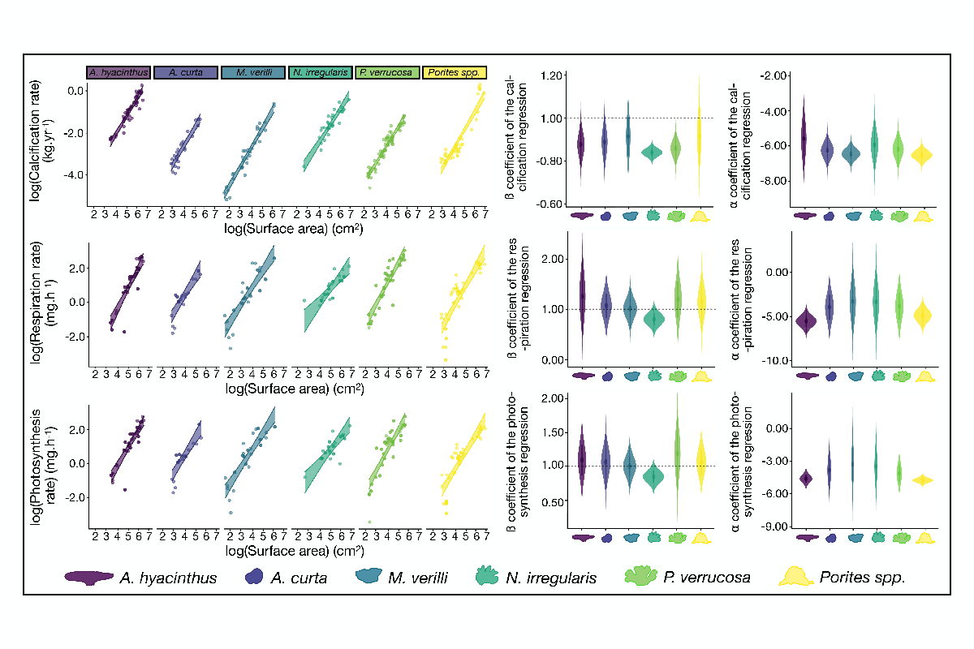

Figure 1 | The three plots from the left represent the relationship between the function studied (calcification rate, respiration rate and photosynthesis rate respectively from the top to the bottom) and live coral surface area for six coral species (*Acropora hyacinthus, Astrea curta, Montipora verilli, Napopora irregularis, Pocillopora cf. verrucosa* andmassive *Porites*) with a ± 95% Bayesian credible interval. The six other plots represent the coefficient from the regression: log(Functional process) = ß × log(Live coral surface area) + ⍺. The current equation may be written as: Functional process = exp(⍺) × (Live coral surface area)ß. The mid column represents the slope estimates of the log-linear regression for each coral species and the right column represents the intercept estimates of the log-linear regression for each coral species (calcification rate, respiration rate and photosynthesis rate respectively from the top to the bottom). The dashed line on the slope estimates plots (y = 1) symbolized the threshold between the conservation of the function studied throughout the coral size gradient, and the decrease of the function rate studied throughout the coral size gradient if the estimate is lower than one or the increase of the function rate studied throughout the coral size gradient if the estimate is upper than one. Coral silhouettes represent the current mature coral morphology.

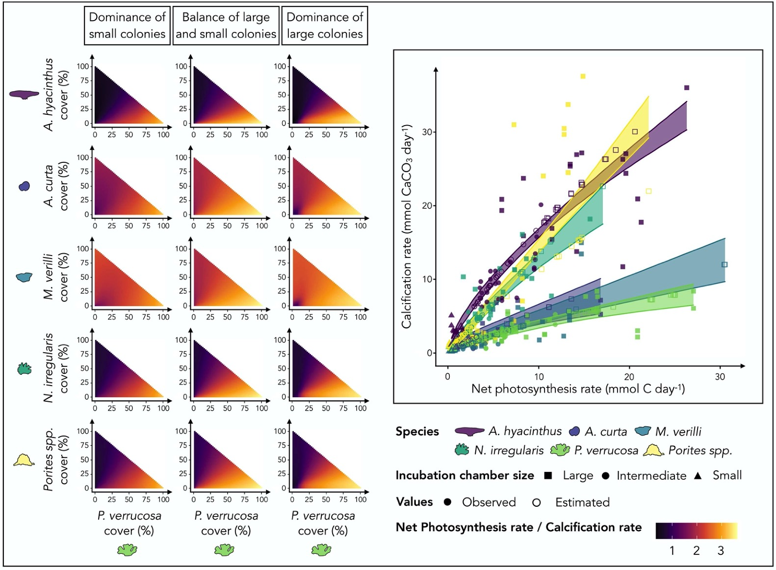

Figure 2 | Representation of the different coral assemblages and their corresponding energy ratio (Net Photosynthesis rate/Calcification rate). The left matrices represent the different theoretic coral cover (*Acropora hyacinthus, Astrea curta, Montipora verilli, Napopora irregularis,*andmassive *Porites*) in the function of the *Pocillopora cf. verrucosa* cover. The three columns represent three sampling methods (two asymmetrical samplings, favoring either juvenile or adult selection, and a balanced sampling with as many adults as juveniles). The same theoretic size assemblages were used for each column. According to the six-coral species, the plot on the right shows the relationship between calcification and net photosynthesis. Estimates from previous Bayesian models (unfilled points) were added to our observations (filled points).

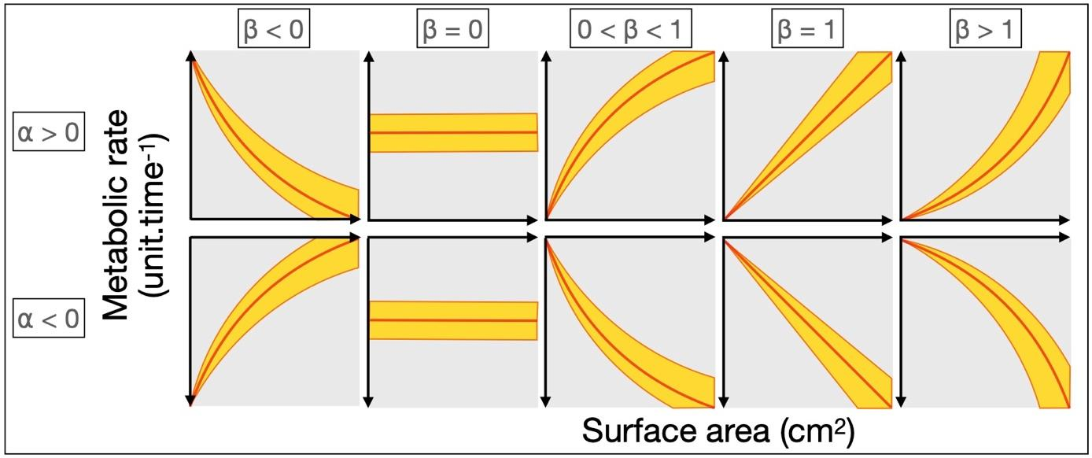

Figure S1 | Trendlines corresponding to the power-law regression: y = ⍺xβ. The current equation may also be written as: log(y) = β.log(x) + log(⍺) where x represents the surface area and y, the metabolic rate. When the coefficient ß is lower than 0 or higher than 1, the curve is respectively negative or positive convex (i.e.,, metabolic rate standardized by the surface area is lower for the younger stages). When the coefficient ß is equivalent to 0, the metabolic rate is equal to the coefficient ⍺, throughout the size gradient whereas when the coefficient ß is equivalent to 1, the metabolic rate is growing constantly and proportionally along the size gradient. Finally, when the coefficient ß is understood between 0 and 1, the trendline is concave meaning that the metabolic rate standardized by the surface area is higher for the younger stages.

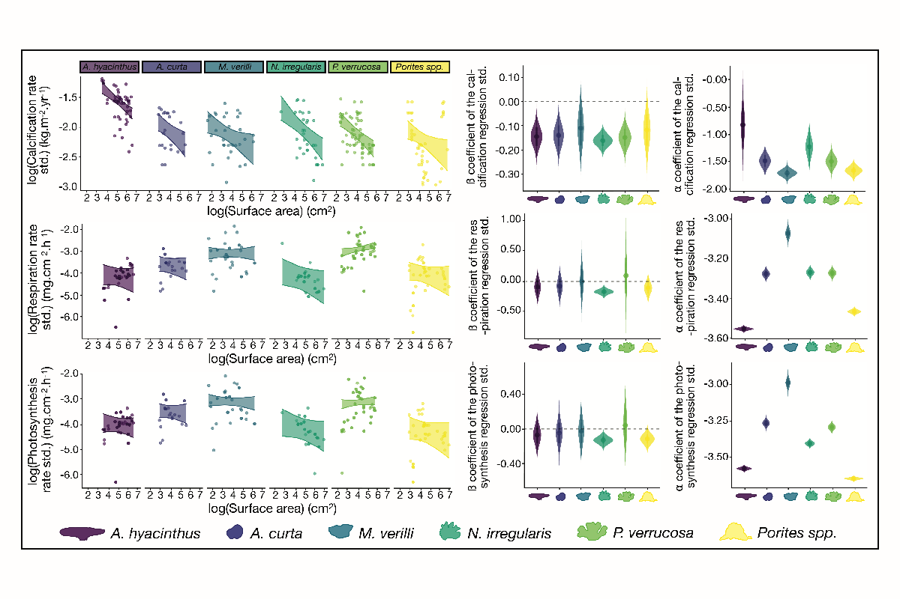

Figure S2 | The three plots from the left represent the relationship between the function studied standardised by the live coral surface area (calcification rate, respiration rate and photosynthesis rate respectively from the top to the bottom) and live coral surface area for six coral species (*Acropora hyacinthus, Astrea curta, Montipora verilli, Napopora irregularis, Pocillopora cf. verrucosa* and massive *Porites*) with a ± 95% Bayesian credible interval. The six other plots represent the coefficient from the regression: log(Functional process standardized) = ß × log(Live coral surface area) + ⍺. Both coefficients ⍺ and ß are on the log-scale. The mid column represents the slope estimates of the regression for each coral species and the right column represents the intercept estimates of the regression for each coral species (calcification rate, respiration rate and photosynthesis rate respectively from the top to the bottom). The dashed line on the slope estimates plots (y = 0) symbolized the threshold between the conservation of the function studied throughout the coral size gradient, and the decrease of the function rate studied throughout the coral size gradient if the estimate is lower than zero or the increase of the function rate studied throughout the coral size gradient if the estimate is upper than zero. Coral silhouettes represent the current mature coral morphology.