Two decades of fish community change reshape biogeochemical functioning in the Mediterranean Sea
Authors: Jérémy Carlot et al. – currently under review in Global Change Biology
Corresponding author: jay.crlt02@gmail.com

- Introduction
Understanding how biodiversity change influences ecosystem functioning remains a central challenge in ecology, particularly under accelerating global pressures. In marine systems, fish communities play a pivotal role in carbon (C), nitrogen (N), and phosphorus (P) cycling through growth, metabolism, feeding, and excretion, yet the basin-scale functional consequences of shifting fish assemblages remain largely unresolved. These uncertainties are especially critical in the Mediterranean Sea, a region undergoing rapid warming, long-term fishing exploitation, and strong productivity gradients, making it a natural laboratory to explore the links between biodiversity change and biogeochemical processes.
Despite the recognised importance of animals in mediating elemental fluxes, most large-scale biogeochemical assessments still focus on microbes, phytoplankton, and abiotic processes. As global change reshapes fish communities through redistribution, compositional turnover, and altered trait structures, the degree to which these reorganisations buffer, enhance, or erode ecosystem functioning remains poorly quantified. Recent research suggests that functional traits—such as body size, growth rate, metabolic demand, and trophic strategy—determine species-specific contributions to elemental cycling, and that changes in community trait composition may offset or exacerbate functioning losses caused by declining taxa or shifting biomass distributions.
Objective and research questions
This case study evaluates how two decades of fish community change in the Mediterranean Sea influence key biogeochemical functions across the C, N, and P cycles. Specifically, we (1) quantify five functional rates representing major carbon and nutrient flux pathways, (2) map spatial patterns and temporal trends in functioning across the basin, and (3) identify the environmental and anthropogenic drivers associated with changes in ecosystem multifunctionality. We ask:
(i) Do shifts in Mediterranean fish communities lead to functional losses, maintenance, or gains?
(ii) How do functional traits and functional divergence structure spatial and temporal patterns of ecosystem functioning?
(iii) Which environmental and human pressures most strongly modulate changes in multifunctionality?
- Materials and Methods
2.1 Study area and fish community data
We analysed 23 years of standardised biomass data (1999–2021) from the MEDITS bottom-trawl survey program, which samples continental shelf and upper-slope habitats (50–800 m depth) across the European Mediterranean using harmonised gear and protocols. The compilation included 25,863 stations, 402 fish species, and 18 Geographical Sub-Areas (GSAs). Biomass was standardised to swept area and expressed as g m⁻² d⁻¹.
2.2 Estimating functional rates through the FishFlux framework
We used the FishFlux Bayesian metabolic–stoichiometric model to estimate five ecosystem functions capturing major biogeochemical fluxes: 1) Carbon production; 2) Nitrogen excretion; 3) Phosphorus excretion; 4) Carbon ingestion through planktivory; and 5) Carbon ingestion through benthivory.
Six parameter classes fed into the model: metabolic, growth, morphological, trophic, survey-specific, and constants. Species traits (e.g., asymptotic length, growth parameters, trophic level, diet composition, fin morphology) were assembled primarily from FishBase, complemented by literature values for metabolic rates. Missing data were imputed phylogenetically.
Metabolic parameters were derived from Bayesian power-law fits between metabolic rate and body mass, accounting for temperature via activation-energy scaling. Excretion rates used consistent N and P turnover constants from previous FishFlux studies. Dietary stoichiometry and assimilation efficiencies were assigned from literature sources, and elemental body composition was predicted as Bayesian functions of trophic level.
Because survey data provide total biomass but not full size distributions, individuals of each species–station combination were assumed to share average mass. While this reduces fine-scale individual variation, community-level functional patterns are dominated by biomass and species identity.
Functional rates were scaled from individual to species, station, and regional levels. Planktivory and benthivory were estimated via species assignments to trophic guilds, partitioning generalist diets proportionally.
2.3 Functional traits, functional entities, and functional divergence
Each species was characterised using five functional traits representing ecological strategy: maximum length, lifespan, vertical habitat, diet, and thermal preference. These traits were combined to form 144 functional entities, representing unique multidimensional trait combinations. A Gower-distance matrix capturing pairwise functional dissimilarity was ordinated using PCoA; a 3-dimensional functional space was selected based on optimal space quality.
Functional divergence (F_{Div}) was quantified as a biomass-weighted measure of how species are distributed within trait space. High F_{Div} indicates dominance by species with extreme trait combinations, reflecting functional complementarity; low F_{Div} reflects clustering near the centre of trait space.
2.4 Environmental and anthropogenic drivers
We extracted bottom temperature anomalies and surface chlorophyll-a from Copernicus reanalyses and used a multi-criteria Fishing Pressure Index (FPI) integrating trawling, purse-seining, and small-scale fisheries. Depth was included as an abiotic structuring variable.
2.5 Temporal trends and modelling ecosystem multifunctionality
Stations sampled for ≥10 years (n = 20,416) were aggregated to hexagonal spatial units. For each hexagon, linear regressions quantified temporal trends for each functional variable. A Bayesian GLMM evaluated the probability that multifunctionality increased over time as a function of temperature anomaly, depth, chlorophyll-a, fishing pressure, and functional divergence, with GSA as a random effect. A Bernoulli response represented increasing (1) or decreasing (0) multifunctionality. Posterior distributions and conditional effects were used to quantify the direction and strength of each predictor.
- Results and Discussion
3.1 Functional trade-offs across taxa
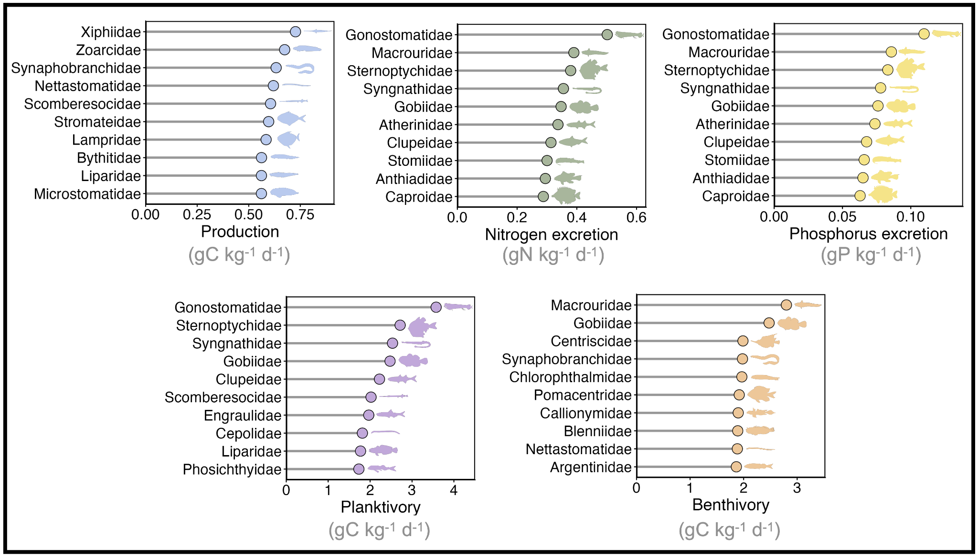
Figure 1. Relative contributions of fish families to five key ecosystem functions, expressed as maximum mass-specific rates (per kg of fish). For each function, the ten families with the highest contributions are shown. Functions include carbon production through somatic growth (blue), nitrogen excretion (green), phosphorus excretion (yellow), carbon ingestion through planktivory (purple), and carbon ingestion through benthivory (orange). Values represent family-level maxima across all species.
Across all processes, no fish family maximised all functions simultaneously, demonstrating strong functional trade-offs and indicating that ecosystem functioning emerges from community-level complementarity rather than dominance by a few taxa. Families such as Gonostomatidae ranked highly for nutrient excretion and planktivory, while large-bodied or fast-growing families dominated carbon production. Benthivory was largely driven by demersal taxa. This mosaic of specialists illustrates that maintaining high ecosystem functioning requires retaining species with contrasting ecological strategies.
3.2 Spatial heterogeneity in ecosystem functioning
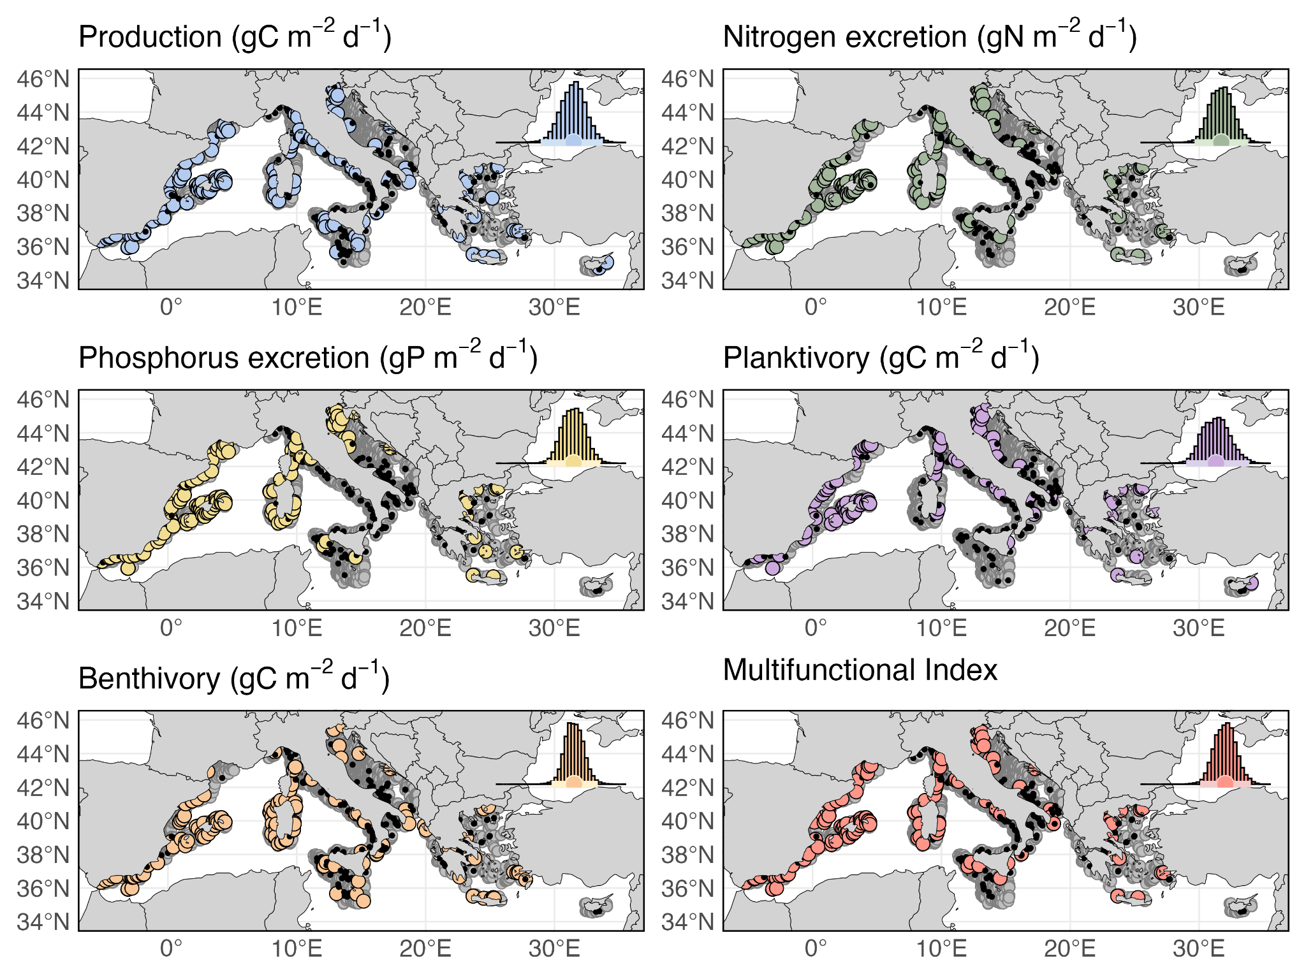
Figure 2. Spatial distribution of hotspots and coldspots of five key ecosystem functions in the Mediterranean Sea. Colored points represent hotspots (upper 5% of all station values), black points represent coldspots (lower 5%), and grey points represent intermediate values. Each point corresponds to a single sampling station. The inset (upper right) shows the lognormal distribution of biomass values across all stations in the dataset.
Functional rates varied across several orders of magnitude, producing distinct hotspots and coldspots for each function. Hotspots were most common in the western Mediterranean, linked to higher productivity, biomass, and more functionally diverse communities. Coldspots were common in deeper or oligotrophic regions. Importantly, hotspot locations rarely overlapped across functions, confirming that ecosystem multifunctionality rarely peaks in single locations. The multifunctionality index mirrored this spatial pattern: high values occurred where complementary functional roles coexist, rather than where any single function was maximised.
3.3 Temporal trajectories of ecosystem functioning
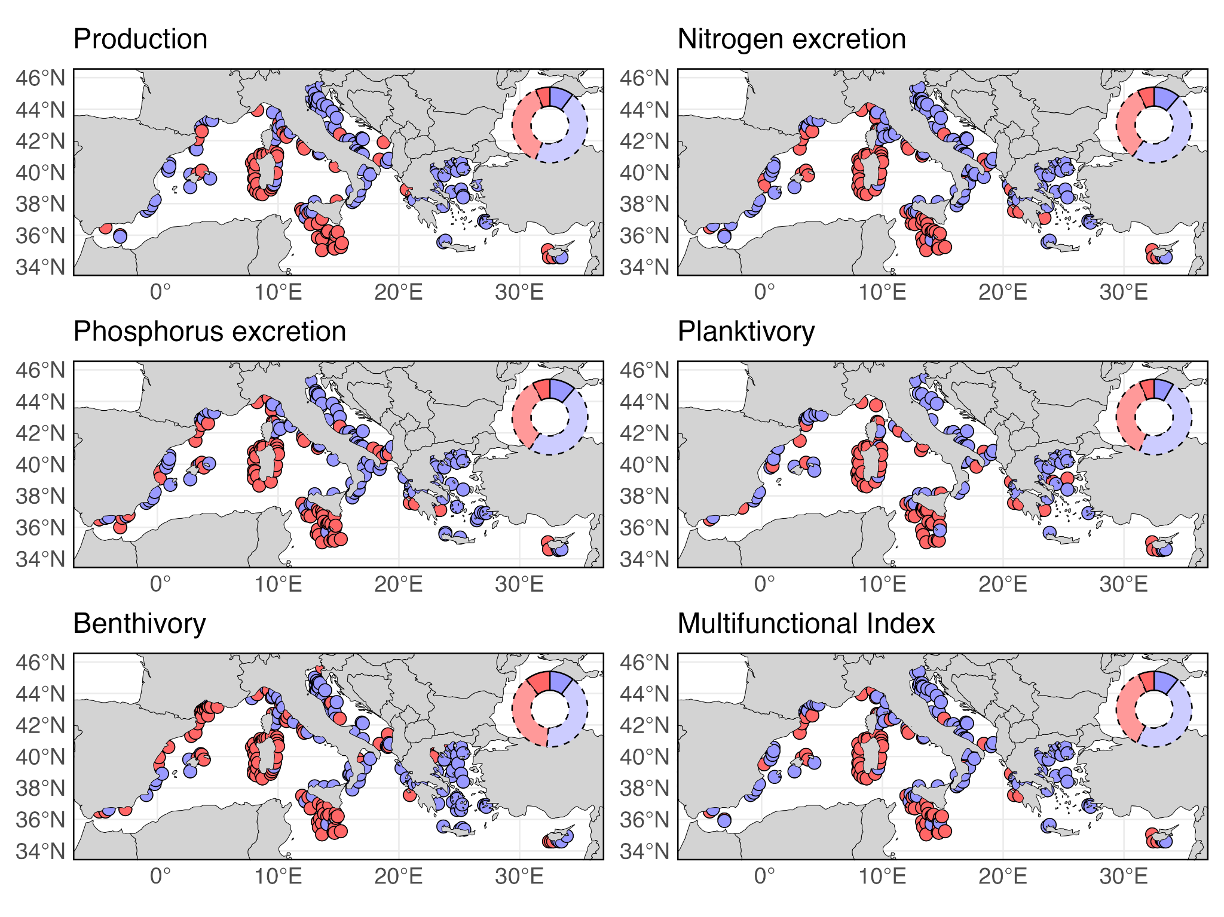
Figure 3. Temporal trends in ecosystem functions, including (carbon production via somatic growth; nitrogen and phosphorus excretion; and carbon ingestion through planktivory and benthivory) and in the multifunctionality index. Blue points denote significant positive trends, whereas red points denote significant negative trends. Doughnut plots (upper right of each panel) summarize the proportional distribution of trends across the full dataset, with dashed outlines indicating non-significant trends and solid outlines indicating significant trends.
Temporal trends revealed regionally coherent but spatially heterogeneous trajectories. The Adriatic and Aegean Seas exhibited predominantly increasing trends across functions, whereas Sicily and Sardinia showed more consistent declines. Yet, only ~15–21% of time series showed statistically significant trends, emphasising strong interannual variability driven by environmental fluctuations. Basin-wide, positive trends modestly outweighed negative ones for all functions, suggesting a slight net increase in fish-mediated biogeochemical functioning over the 23-year period.
  - Drivers of multifunctionality change
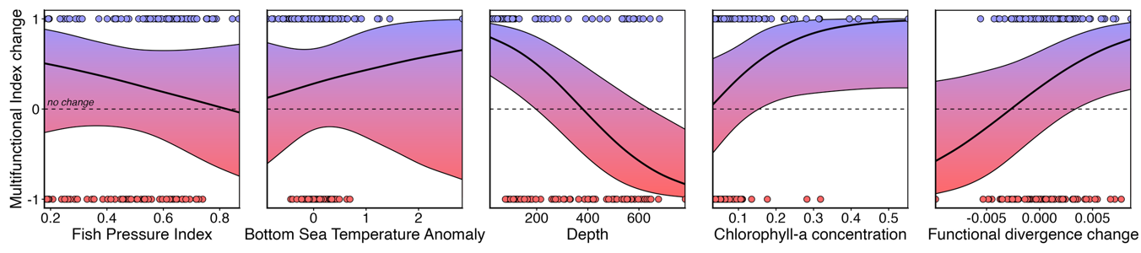Figure 4. Effect of drivers on the probability of increasing (blue), or decreasing (red) temporal trends in multifunctionality. The dashed line at y = 0 represents equal probability of increasing and decreasing trends under the binomial model. Shaded ribbons show the 5th–95th credible intervals from the Bayesian model.
Our Bayesian model identified four key patterns: 1) Chlorophyll-a increased the probability of multifunctionality gains, highlighting strong coupling between primary production and fish-mediated carbon and nutrient fluxes; 2) Functional divergence (F_{Div}) positively predicted functional increases, supporting theory that high functional complementarity enhances multifunctionality. Communities dominated by species with extreme trait combinations were more likely to sustain or enhance functioning despite community turnover; 3) Depth negatively influenced multifunctionality, reflecting declining biomass and a shift toward taxa with limited contributions to benthic and pelagic nutrient pathways; and 4) Fishing pressure (FPI) and temperature anomalies showed weaker, more uncertain effects, but their directional tendencies were consistent with expectations: higher fishing pressure suppressed multifunctionality, while warming (via metabolic acceleration) slightly favoured increases.
- Summary and Conclusions

- Fish-mediated biogeochemical functioning in the Mediterranean is shaped by strong functional trade-offs, with no taxon dominating all ecosystem processes; multifunctionality emerges from complementary species roles.
- Spatial patterns reveal pronounced heterogeneity, with multifunctionality hotspots concentrated in the western Mediterranean where biomass, productivity, and functional divergence are higher.
- Functional divergence and primary productivity are the strongest predictors of multifunctionality increases, whereas depth reduces functioning and fishing pressure likely suppresses biogeochemical fluxes.

