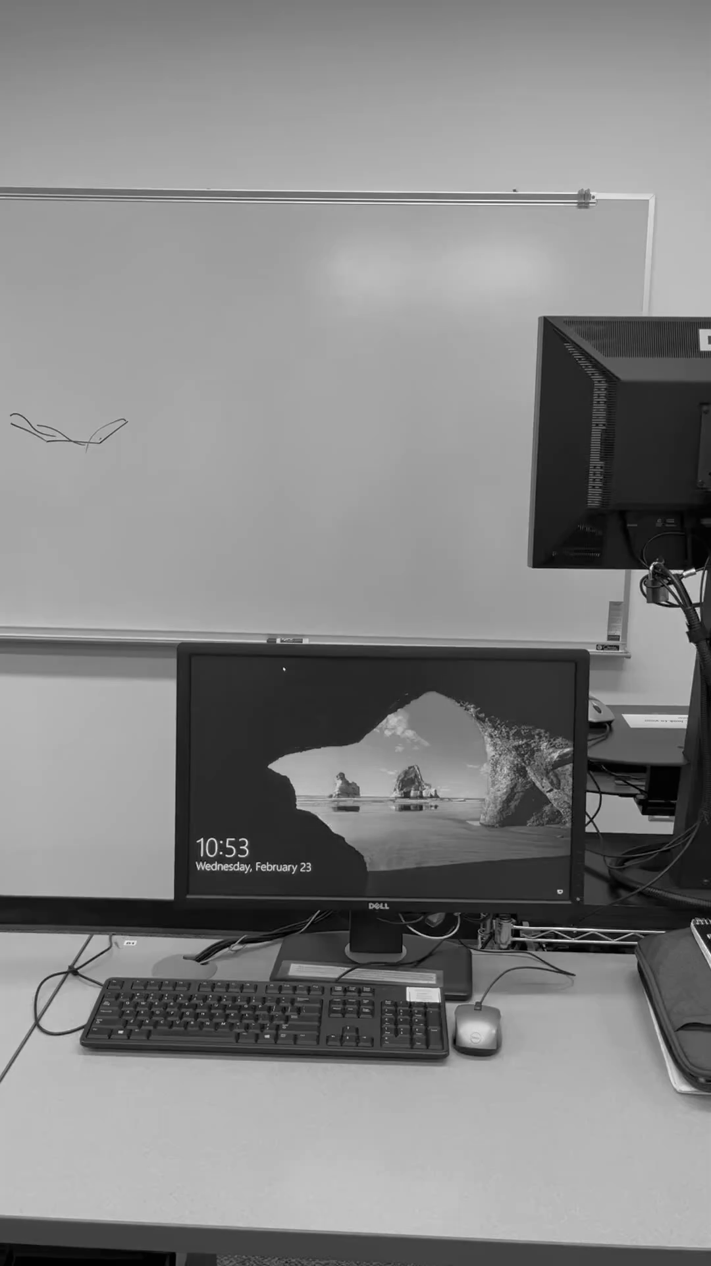

This figure shows the monitor being the object of focus for P3.