**ABOUT US**

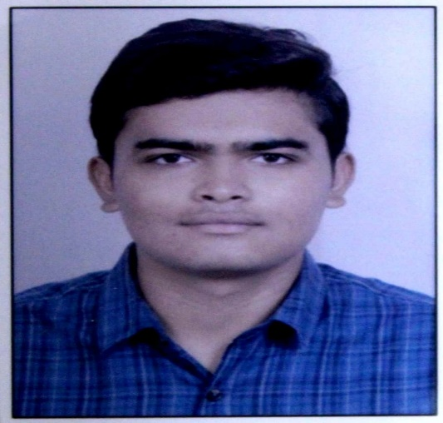

**NIMESH ITALIYA**

Designation –

* Project Manager
* Developer
* Algorithm Designer
* Integration Developer

**JAY DESAI**

Designation –

* Business Analyst
* High Level Designer
* White Box Tester

 

**SHUBHAM DHAMELIYA**

Designation –

* GUI Designer
* Integration Designer

**KAPIL KAPURIYA**

Designation –

* Black Box Tester



**ISHA KIMSURIYA**

Designation –

* XD Designer



**AYUSH GAJJAR**

Designation –

* Developer
* Dataset Creator

Welcome to DarkCoders, your number one source for all and one requirement which is automated cell counting. We're dedicated to providing you the very best of this system, with an emphasis on greater accuracy, less time consumption and stress-free routines.

We hope you enjoy our products as much as we enjoy offering them to you. If you have any questions or comments, please don't hesitate to contact us.

Sincerely,

Nimesh Italiya

(Project Manager)