**Code**

**package** final_for_223J;  
  
**public class** Main {  
  
 **public static void** main(String[] args) {  
 *// write your code here* **new** PathFinder();  
 }  
}

**package** final_for_223J;  
  
**import** java.awt.*;  
  
**public enum** JNodeState {  
 ***EMPTY***(Color.***white***), ***WALL***(Color.***blue***),  
 ***START***(Color.***green***), ***END***(Color.***red***),  
 ***VISITED***(Color.***yellow***), ***ERROR***(**new** Color(204, 0, 0));  
  
 **private** Color **color**;  
 JNodeState(Color _color)  
 {  
 **color** = _color;  
 }  
  
 **public** Color getColor(){ **return color**;}  
}

**package** final_for_223J;  
  
**import** javax.swing.*;  
**import** java.util.*

**public class** JNode **extends** JButton {  
 **private int row**, **col**;  
 **private** JNodeState **state**;  
 **private** JNode **previous**;  
 **private int gCost**, **hCost**, **fCost**;  
  
 **public** JNode(**int** _row, **int** _col, JNodeState _state) {  
 **super**();  
 setBackground(_state.getColor());  
  
 **row** = _row;  
 **col** = _col;  
 **state** = _state;  
  
 **previous** = **null**;  
 **gCost** = 0; *//Distance to start node* **hCost** = 0; *//Distance to end node* **fCost** = 0; *//gCost + hCost*  
 }

**public** JNode(**int** _row, **int** _col){  
 **this**(_row, _col, JNodeState.***EMPTY***);  
 }  
  
 **public void** setState(JNodeState _state){  
 **if** (**state** == _state) **return**;  
 **state** = _state;  
 setBackground(**state**.getColor());  
 }  
  
 **public void** setPrevious(JNode _previous){ **previous** = _previous;}  
  
 **public void** setG(**int** g)  
 {  
 **gCost** = g;  
 }  
  
 **public void** setH(**int** h)  
 {  
 **hCost** = h;  
 }  
  
 **public void** setF()  
 {  
 **fCost** = **gCost** + **hCost**;  
 }  
  
 **public** JNodeState getState(){ **return state**; }  
 **public** JNode getPrevious(){ **return previous**;}  
 **public int** getRow(){ **return row**;}  
 **public int** getCol(){ **return col**; }  
 **public int** getG(){ **return gCost**; }  
 **public int** getH(){ **return hCost**; }  
 **public int** getF(){ **return fCost**; }  
  
 **public** String toString()  
 {  
 **return "("** + **row** + **", "** + **col** + **")"**;  
 }  
  
 **public boolean** equals(Object o)  
 {  
 **if** (o == **this**)  
 **return true**;  
  
 **if** (!(o **instanceof** JNode))  
 **return false**;  
  
 JNode c = (JNode)o;  
  
 **boolean** sameRow = **row** == c.getRow();  
 **boolean** sameCol = **col** == c.getCol();  
 **return** sameRow && sameCol;  
 }  
}

**package** final_for_223J;  
  
**import** javax.swing.*;  
**import** java.awt.*;  
**import** java.awt.event.*;  
**import** java.util.ArrayList;  
**import** java.util.Collections;  
  
**public class** PathFinder **extends** JFrame **implements** MouseListener, ItemListener {  
  
 *//Size of the frame* **private final int FRAME_WIDTH** = 500;  
 **private final int FRAME_HEIGHT** = 650;  
  
 *//All the panels in the frame* **private** JPanel **instructionsPanel** = **new** JPanel();  
 **private** JPanel **configPanel** = **new** JPanel();  
 **private** JPanel **gridSizesPanel** = **new** JPanel();  
 **private** JPanel **drawDelayPanel** = **new** JPanel();  
 **private** JPanel **boxPanel** = **new** JPanel();  
 **private** JPanel **gridPanel** = **new** JPanel();  
  
 *//Grid information i.e. size & gap of the grid* **private int gridSize** = 10;  
 **private int gridGap** = 1;  
 **private** JNode [] [] **grid** = **new** JNode[**gridSize**][**gridSize**];  
 **private** ArrayList<JNode> **path** = **new** ArrayList<JNode>(**gridSize** * **gridSize**);  
  
 *//Main nodes for the path to find* **private** JNode **startNode** = **null**;  
 **private** JNode **endNode** = **null**;  
  
 *//Shows that we found an error during the A* algorithm* **private** Boolean **foundError** = **false**;  
  
 *//Variables that are associated with drawing the path* **private** Timer **tracePath**, **followTrail**;  
 **private long startSearch**, **finishSearch**;  
 **private int currentIndex** = 0;  
 **private int delay** = 100;  
  
 *//Instructions that tell the user what to do and what is going on* **private** JLabel **rightInstruction** = **new** JLabel(**"Right Click to Add Wall "**, JLabel.***CENTER***);  
 **private** JLabel **leftInstruction** = **new** JLabel(**" Left Click to Add Start "**, JLabel.***CENTER***);  
  
 *//Swing components with the grid size panel* **private** JLabel **gridSizesLabel** = **new** JLabel(**"Grid Size"**, JLabel.***CENTER***);  
 **private** JSlider **gridSizesSlider** = **new** JSlider(5, 50, **gridSize**);  
  
 *//Swing components for the draw delay panel* **private** JLabel **drawDelayLabel** = **new** JLabel(**"Delay (in milliseconds)"**, JLabel.***CENTER***);  
 **private** JSlider **drawDelaySlider** = **new** JSlider(0, 500, **delay**);  
  
 *//Checkboxes that go below the draw delay panel and above the instructions* **private** JCheckBox **includeDiagonals** = **new** JCheckBox(**"Include Diagonals"**);  
 **private** JCheckBox **generateMaze** = **new** JCheckBox(**"Generate Maze"**);  
  
  
 **public** PathFinder() {  
 **super**(**"Jalen's Pathfinder"**);  
 setSize(**FRAME_WIDTH**, **FRAME_HEIGHT**);  
 setResizable(**false**);  
 setDefaultCloseOperation(JFrame.***EXIT_ON_CLOSE***);  
 setLocationRelativeTo(**null**);  
  
 setLayout(**new** BorderLayout());  
 **configPanel**.setLayout(**new** BorderLayout(0, 20));  
 **gridSizesPanel**.setLayout(**new** BorderLayout(0, 1));  
 **drawDelayPanel**.setLayout(**new** BorderLayout(0, 1));  
 **boxPanel**.setLayout(**new** BorderLayout(10, 0));  
 **instructionsPanel**.setLayout(**new** BorderLayout(0, 10));  
 **gridPanel**.setLayout(**new** GridLayout(**gridSize**, **gridSize**, **gridGap**, **gridGap**));  
  
 **leftInstruction**.setFont(**new** Font(**"Microsoft Sans Serif"**, Font.***BOLD***, 15));  
 **rightInstruction**.setFont(**new** Font(**"Microsoft Sans Serif"**, Font.***BOLD***, 15));  
 **gridSizesLabel**.setFont(**new** Font(**"Microsoft Sans Serif"**, Font.***PLAIN***, 14));  
 **gridSizesSlider**.setFont(**new** Font(**"Microsoft Sans Serif"**, Font.***PLAIN***, 12));  
 **drawDelayLabel**.setFont(**new** Font(**"Microsoft Sans Serif"**, Font.***PLAIN***, 14));  
 **drawDelaySlider**.setFont(**new** Font(**"Microsoft Sans Serif"**, Font.***PLAIN***, 12));  
 **includeDiagonals**.setFont(**new** Font(**"Microsoft Sans Serif"**, Font.***PLAIN***, 14));  
 **generateMaze**.setFont(**new** Font(**"Microsoft Sans Serif"**, Font.***PLAIN***, 14));  
  
 **instructionsPanel**.add(**configPanel**, BorderLayout.***NORTH***);  
 **instructionsPanel**.add(**leftInstruction**, BorderLayout.***WEST***);  
 **instructionsPanel**.add(**rightInstruction**, BorderLayout.***EAST***);  
  
 **configPanel**.add(**gridSizesPanel**, BorderLayout.***NORTH***);  
 **gridSizesPanel**.add(**new** JPanel(), BorderLayout.***NORTH***);  
 **gridSizesPanel**.add(**gridSizesLabel**, BorderLayout.***CENTER***);  
 **gridSizesPanel**.add(**gridSizesSlider**, BorderLayout.***SOUTH***);  
 **gridSizesSlider**.setMajorTickSpacing(5);  
 **gridSizesSlider**.setMinorTickSpacing(1);  
 **gridSizesSlider**.setPaintTicks(**true**);  
 **gridSizesSlider**.setSnapToTicks(**true**);  
 **gridSizesSlider**.setPaintLabels(**true**);  
 **gridSizesSlider**.addMouseListener(**this**);  
  
 **configPanel**.add(**drawDelayPanel**, BorderLayout.***CENTER***);  
 **drawDelayPanel**.add(**drawDelayLabel**, BorderLayout.***NORTH***);  
 **drawDelayPanel**.add(**drawDelaySlider**, BorderLayout.***SOUTH***);  
 **drawDelaySlider**.setMajorTickSpacing(50);  
 **drawDelaySlider**.setMinorTickSpacing(10);  
 **drawDelaySlider**.setPaintTicks(**true**);  
 **drawDelaySlider**.setPaintLabels(**true**);  
 **drawDelaySlider**.addMouseListener(**this**);  
  
 **configPanel**.add(**boxPanel**, BorderLayout.***SOUTH***);  
 **boxPanel**.add(**includeDiagonals**, BorderLayout.***WEST***);  
 **boxPanel**.add(**generateMaze**, BorderLayout.***EAST***);  
 **includeDiagonals**.setHorizontalAlignment(JCheckBox.***LEFT***);  
 **generateMaze**.setHorizontalAlignment(JCheckBox.***LEFT***);  
 **generateMaze**.addItemListener(**this**);  
  
 add(**instructionsPanel**, BorderLayout.***NORTH***);  
 add(**gridPanel**, BorderLayout.***CENTER***);  
 **for** (**int** i = 0; i < **gridSize**; i++) {  
 **for** (**int** j = 0; j < **gridSize**; j++) {  
 **grid**[i][j] = **new** JNode(i, j);  
 **grid**[i][j].addMouseListener(**this**);  
 **gridPanel**.add(**grid**[i][j]);  
 }  
 }  
  
 *//Animation where it highlights each node in the path frame by frame* **tracePath** = **new** Timer(**delay**, **new** ActionListener() {  
 @Override  
 **public void** actionPerformed(ActionEvent e) {  
 **if** (**currentIndex** < **path**.size()) {  
 **path**.get(**currentIndex**++).setState(JNodeState.***VISITED***);  
 **gridPanel**.revalidate();  
 **gridPanel**.repaint();  
 } **else** {  
 **currentIndex** = 0;  
 **rightInstruction**.setText(**"Following Trail... "**);  
  
 **followTrail**.start();  
 **tracePath**.stop();  
 }  
 }  
 });

*/*Animation where it removes all of the highlights in order frame by frame  
 Then, it makes the last node the new start node  
 */* **followTrail** = **new** Timer(**delay**, **new** ActionListener() {  
 @Override  
 **public void** actionPerformed(ActionEvent e) {  
 **if** (**currentIndex** < **path**.size() - 1) {  
 **path**.get(**currentIndex**++).setState(JNodeState.***EMPTY***);  
 **gridPanel**.revalidate();  
 **gridPanel**.repaint();  
 } **else** {  
 **path**.get(**currentIndex**).setState(JNodeState.***START***);  
 **startNode** = **path**.get(**currentIndex**);  
 **endNode** = **null**;  
  
 **gridPanel**.revalidate();  
 **gridPanel**.repaint();  
  
 **currentIndex** = 0;  
 **path**.clear();  
  
 **leftInstruction**.setText(**" Left Click to Add End "**);  
 **rightInstruction**.setText(**"Right Click to Add Wall "**);  
 **gridSizesSlider**.setEnabled(**true**);  
 **generateMaze**.setEnabled(**true**);  
  
 **followTrail**.stop();  
 }  
 }  
 });  
  
 setVisible(**true**);  
 }  
  
 *//For more details on the Recursive Algorithm, visit...  
 //http://weblog.jamisbuck.org/2011/1/12/maze-generation-recursive-division-algorithm* **public void** GenerateMaze()  
 {  
 *//1. Begin with a empty grid* Divide(0, 0, **gridSize** - 1, **gridSize** - 1);  
 **gridPanel**.revalidate();  
 **gridPanel**.repaint();  
 }  
  
 **public void** Divide(**int** minRow, **int** minCol, **int** maxRow, **int** maxCol)  
 {  
 **int** width = maxRow - minRow; *//Width of the wall* **int** height = maxCol - minCol; *//Height of the wall* **if** (width < 2 || height < 2)  
 {  
 *//Maze has reached its desired resolution* **return**;  
 }  
  
 *//2. Split the maze into fourths with a horizontal wall and a vertical wall* **int** wallRow = minRow + 1 + (**int**) (Math.*random*() * (maxRow - minRow - 1));  
 **int** wallCol = minCol + 1 + (**int**) (Math.*random*() * (maxCol - minCol - 1));  
 **int** row = minRow;  
 **int** col = minCol;  
 **while** (row <= maxRow) **grid**[row++][wallCol].setState(JNodeState.***WALL***);  
 **while** (col <= maxCol) **grid**[wallRow][col++].setState(JNodeState.***WALL***);  
  
 *//3. Add two passages through each side of the horizontal and the vertical wall* **int** northHole = minRow + (**int**) (Math.*random*() * (wallRow - minRow));  
 **int** southHole = (wallRow + 1) + (**int**) (Math.*random*() * (maxRow - wallRow - 1));  
 **int** westHole = minCol + (**int**) (Math.*random*() * (wallCol - minCol));  
 **int** eastHole = (wallCol + 1) + (**int**) (Math.*random*() * (maxCol - wallCol - 1));  
 **grid**[northHole][wallCol].setState(JNodeState.***EMPTY***);  
 **grid**[southHole][wallCol].setState(JNodeState.***EMPTY***);  
 **grid**[wallRow][westHole].setState(JNodeState.***EMPTY***);  
 **grid**[wallRow][eastHole].setState(JNodeState.***EMPTY***);  
  
 *//4. Recursively divide each of the four sides until it reaches its desired resolution* Divide(minRow, minCol, wallRow - 1, wallCol - 1);  
 Divide(minRow, wallCol + 1, wallRow - 1, maxCol);  
 Divide(wallRow + 1, minCol, maxRow, wallCol - 1);  
 Divide(wallRow + 1, wallCol + 1, maxRow, maxCol);  
 }  
  
 *//Gets the nodes nearby the current node. Includes diagonal nodes if requested* **public** ArrayList<JNode> GetNeighborsOf(JNode current, Boolean includeDiagonals)  
 {  
 *//Create a list that stores the nodes nearby the current node* ArrayList<JNode> neighbors = **new** ArrayList<JNode>();  
  
 *//Get the row and column of the current node* **int** row = current.getRow();  
 **int** col = current.getCol();  
  
 *//Check if it is a valid move to go left, right, up, and down* **boolean** left = col - 1 >= 0 && col - 1 < **grid**[row].**length**;  
 **boolean** right = col + 1 >= 0 && col + 1 < **grid**[row].**length**;  
 **boolean** up = row - 1 >= 0 && row - 1 < **grid**.**length**;  
 **boolean** down = row + 1 >= 0 && row + 1 < **grid**.**length**;  
  
 *//If a direction is valid, add the node that goes to that direction in the neighbors list* **if**(up) neighbors.add(**grid**[row - 1][col]);  
 **if** (down) neighbors.add(**grid**[row + 1][col]);  
 **if** (left) neighbors.add(**grid**[row][col - 1]);  
 **if** (right) neighbors.add(**grid**[row][col + 1]);  
  
 *//If diagonals are included, add the NE, NW, SE, SW, nodes to the neighbors list* **if** (includeDiagonals)  
 {  
 **if** (up && left) neighbors.add(**grid**[row - 1][col - 1]);  
 **if** (up && right) neighbors.add(**grid**[row - 1][col + 1]);  
 **if** (down && left) neighbors.add(**grid**[row + 1][col - 1]);  
 **if** (down && right) neighbors.add(**grid**[row + 1][col + 1]);  
 }  
  
 *//Return the neighbors* **return** neighbors;  
 }  
  
  
 **private int** GetDistance(JNode start, JNode end) {  
 **if** (start == **null** || end == **null**)  
 **return** 0;  
  
 **int** dstCol = Math.*abs*(start.getCol() - end.getCol()); *//X* **int** dstRow = Math.*abs*(start.getRow() - end.getRow()); *//Y* **if** (**includeDiagonals**.isSelected())  
 **return** Math.*max*(dstRow, dstCol); *//Diagonal Distance* **else  
 return** dstRow + dstCol; *//Manhattan Distance* }  
  
 *//Clears the nodes with the state specified in the grid* **public void** ClearGrid(JNodeState state)  
 {  
 **if** (state == JNodeState.***START***) **startNode** = **null**;  
 **if** (state == JNodeState.***END***) **endNode** = **null**;  
  
 **for** (**int** i = 0; i < **gridSize**; i++) {  
 **for** (**int** j = 0; j < **gridSize**; j++) {  
  
 **if** (**grid**[i][j].getState() == state)  
 **grid**[i][j].setState(JNodeState.***EMPTY***);  
 }  
 }  
  
 **gridPanel**.revalidate();  
 **gridPanel**.repaint();  
 }  
  
 *//Clears all nodes in the grid* **public void** ClearGrid()  
 {  
 **startNode** = **null**;  
 **endNode** = **null**;  
  
 **for** (**int** i = 0; i < **gridSize**; i++) {  
 **for** (**int** j = 0; j < **gridSize**; j++) {  
 **grid**[i][j].setState(JNodeState.***EMPTY***);  
 }  
 }  
  
 **gridPanel**.revalidate();  
 **gridPanel**.repaint();  
 }  
  
 *//A* Algorithm* **public void** FindPath()  
 {  
 ArrayList<JNode> openList = **new** ArrayList<JNode>(); *//Open = Nodes that need to be evaluated* ArrayList<JNode> closedList = **new** ArrayList<JNode>(); *//Closed = Nodes that were already evaluated  
  
 //By default, the start node is evaluated first* openList.add(**startNode**);  
  
 *//As long as they are nodes in the open list...* **startSearch** = System.*nanoTime*();  
 **while** (!openList.isEmpty())  
 {  
 *//Find the node with the least f cost i.e. closest distance to the end node* JNode currentNode = openList.get(0);  
 **for** (**int** i = 0; i < openList.size(); i++)  
 {  
 **if** (openList.get(i).getF() < currentNode.getF())  
 currentNode = openList.get(i);  
 **else if**(openList.get(i).getF() == currentNode.getF())  
 {  
 **if** (openList.get(i).getG() > currentNode.getG())  
 currentNode = openList.get(i);  
 **else if**(openList.get(i).getG() == currentNode.getG())  
 {  
 **if** (openList.get(i).getH() < currentNode.getH())  
 currentNode = openList.get(i);  
 }  
 }  
 }  
  
 *//If the current node is the end node, then we have finally found the path.* **if** (currentNode.equals(**endNode**))  
 {  
 *//Now lets construct it so it can be traced* ConstructPath();  
 **return**;  
 }  
  
 *//Otherwise, remove the current node out of the open list & add it to the closed list* openList.remove(currentNode);  
 closedList.add(currentNode);  
  
  
  
 *//Loop through each neighbor in the current node... (include diagonals if requested)* **for** (JNode neighbor : GetNeighborsOf(currentNode, **includeDiagonals**.isSelected()))  
 {  
 *//Skip this neighbor if its a wall or its already been evaluated* **if** (neighbor.getState() == JNodeState.***WALL*** || closedList.contains(neighbor))  
 **continue**;  
  
 *//Otherwise check if the new path in neighbor is shorter* **int** possibleG = currentNode.getG() + GetDistance(neighbor, currentNode);  
  
 *//Make sure all neighbors that are not in the open list be added for evaluation* **if** (!openList.contains(neighbor))  
 openList.add(neighbor);  
 **else** {  
 *//Skip this neighbor if it makes the path longer* **if** (possibleG >= neighbor.getG())  
 **continue**;  
 }  
  
 *//G Cost = Distance from this node to the current node* neighbor.setG(possibleG);  
  
 *//H Cost = Distance from this node to the end node* neighbor.setH(GetDistance(neighbor, **endNode**));  
  
 *//F Cost = G Cost + H Cost* neighbor.setF();  
  
 *//Set the neighbor's previous node to the current node* neighbor.setPrevious(currentNode);  
 }  
 }  
  
 *//Path cannot be found since all nodes were evaluated except the end node* **startNode**.setState(JNodeState.***ERROR***);  
 **endNode**.setState(JNodeState.***ERROR***);  
  
 **startNode** = **null**;  
 **endNode** = **null**;  
  
 **foundError** = **true**;  
 **leftInstruction**.setText(**" Cannot Find Path"**);  
  
 *//Repaint the grid to show our results in one click* **gridPanel**.revalidate();  
 **gridPanel**.repaint();  
 }  
  
 **private void** ConstructGrid(**int** size)  
 {  
 ClearGrid();  
  
 **gridPanel**.removeAll();  
 **gridSize** = size;  
 **gridPanel**.setLayout(**new** GridLayout(**gridSize**, **gridSize**, **gridGap**, **gridGap**));  
 **grid** = **new** JNode[**gridSize**][**gridSize**];  
  
 **for** (**int** i = 0; i < **gridSize**; i++)  
 {  
 **for** (**int** j = 0; j < **gridSize**; j++)  
 {  
 **grid**[i][j] = **new** JNode(i, j);  
 **grid**[i][j].addMouseListener(**this**);  
 **gridPanel**.add(**grid**[i][j]);  
 }  
 }  
  
 **if** (**generateMaze**.isSelected())  
 GenerateMaze();  
  
 **gridPanel**.revalidate();  
 **gridPanel**.repaint();  
 }  
  
 **private void** ConstructPath()  
 {  
 *//=================================Updating the App==================================  
  
 //Store the time it took to find the path in microseconds* **finishSearch** = System.*nanoTime*();  
 **long** searchElapsed = (**finishSearch** - **startSearch**) / (**long**)Math.*pow*(10, 3);  
  
 *//Update instructions to show the search time and tell the user the path is being traced* **leftInstruction**.setText(**"Found Shortest Path in "** + searchElapsed + **" microseconds "**);  
 **rightInstruction**.setText(**"Retracing Path... "**);  
  
 *//No maze generation or grid size changing allowed while path is being traced* **gridSizesSlider**.setEnabled(**false**);  
 **generateMaze**.setEnabled(**false**);  
  
 *//==========================Actual Construction of the Path==========================  
  
 //Instantiate the current node then declare it as the end node* JNode currentNode = **endNode**;  
  
 *//As long as the current node didn't reach to the start node...* **while** (!currentNode.equals(**startNode**))  
 {  
 *//Add the current to the path then traverse the current node to its parent* **path**.add(currentNode);  
 currentNode = currentNode.getPrevious();  
 }  
  
 *//Reverse the path list since we traversed the current node backwards* Collections.*reverse*(**path**);  
  
 *//Add the start node at the beginning of the path list* **path**.add(0, currentNode);  
  
 *//=============================Start Drawing the Path=============================* **tracePath**.start();  
 }  
  
 @Override  
 **public void** mousePressed(MouseEvent e) {  
 **if** (**tracePath**.isRunning() || **followTrail**.isRunning())  
 **return**;  
  
 Object source = e.getSource();  
  
 **if** (**foundError**)  
 {  
 ClearGrid(JNodeState.***ERROR***);  
 **foundError** = **false**;  
 }  
  
 **for** (**int** i = 0; i < **gridSize**; i++)  
 {  
 **for** (**int** j = 0; j < **gridSize**; j++)  
 {  
 **if** (source == **grid**[i][j])  
 {  
 **if** (**grid**[i][j].getState() == JNodeState.***EMPTY***)  
 {  
 **if** (SwingUtilities.*isLeftMouseButton*(e))  
 {  
 **if** (**startNode** == **null**)  
 {  
 **startNode** = **grid**[i][j];  
 **startNode**.setState(JNodeState.***START***);  
  
 **leftInstruction**.setText(**" Left Click to Delete Start "**);  
 }  
 **else** {  
 **if** (**endNode** == **null**) {  
 **endNode** = **grid**[i][j];  
 **endNode**.setState(JNodeState.***END***);  
  
 FindPath();  
 }  
 }  
 }  
 **else if** (SwingUtilities.*isRightMouseButton*(e))  
 {  
 **if** (**grid**[i][j].getState() == JNodeState.***EMPTY***)  
 **grid**[i][j].setState(JNodeState.***WALL***);  
 }  
 }  
 **else if**(**grid**[i][j].getState() == JNodeState.***START*** || **grid**[i][j].getState() == JNodeState.***END***)  
 {  
 **if** (**grid**[i][j].equals(**startNode**))  
 {  
 **if** (SwingUtilities.*isLeftMouseButton*(e))  
 {  
 **if** (**grid**[i][j].getState() == JNodeState.***START***)  
 ClearGrid(JNodeState.***START***);  
 **else** ClearGrid(JNodeState.***END***);  
  
 **leftInstruction**.setText(**" Left Click to Add Start "**);  
 }  
 }  
 }  
 **else if**(**grid**[i][j].getState() == JNodeState.***WALL***)  
 {  
 **if** (SwingUtilities.*isRightMouseButton*(e))  
 **grid**[i][j].setState(JNodeState.***EMPTY***);  
 }  
 }  
 }  
 }  
  
 **gridPanel**.revalidate();  
 **gridPanel**.repaint();  
 }  
  
 @Override  
 **public void** mouseReleased(MouseEvent e) {  
 Object source = e.getSource();  
  
 **if** (source == **gridSizesSlider**)  
 {  
 **int** newSize = **gridSizesSlider**.getValue();  
 ConstructGrid(newSize);  
 }  
 **else if**(source == **drawDelaySlider**)  
 {  
 **delay** = **drawDelaySlider**.getValue();  
 **tracePath**.setDelay(**delay**);  
 **followTrail**.setDelay(**delay**);  
 }  
 }  
  
 @Override  
 **public void** mouseEntered(MouseEvent e) {  
 **if** (**followTrail**.isRunning() || **tracePath**.isRunning())  
 **return**;  
  
 Object source = e.getSource();  
 **for** (**int** i = 0; i < **gridSize**; i++)  
 {  
 **for** (**int** j = 0; j < **gridSize**; j++)  
 {  
 **if** (source == **grid**[i][j])  
 {  
 **if** (SwingUtilities.*isRightMouseButton*(e))  
 {  
 **if** (**grid**[i][j].getState() == JNodeState.***EMPTY***)  
 {  
 **rightInstruction**.setText(**"Right Drag To Add More Walls "**);  
 **grid**[i][j].setState(JNodeState.***WALL***);  
 }  
 **else if** (**grid**[i][j].getState() == JNodeState.***WALL***)  
 {  
 **rightInstruction**.setText(**"Right Drag To Delete More Walls "**);  
 **grid**[i][j].setState(JNodeState.***EMPTY***);  
 }  
 }  
 **else** {  
 **if** (**grid**[i][j].getState() == JNodeState.***EMPTY***)  
 **rightInstruction**.setText(**"Right Click to Add Wall "**);  
 **else if** (**grid**[i][j].getState() == JNodeState.***WALL***)  
 **rightInstruction**.setText(**"Right Click to Delete Wall "**);  
 }  
  
 **if** (**startNode** != **null** && !**followTrail**.isRunning() && !**tracePath**.isRunning())  
 {  
 **if** (**grid**[i][j].equals(**startNode**))  
 **leftInstruction**.setText(**" Left Click to Delete Start "**);  
 **else  
 leftInstruction**.setText(**" Left Click to Add End "**);  
 }  
 }  
 }  
 }  
 }  
 @Override  
 **public void** itemStateChanged(ItemEvent e) {  
 **if** (e.getStateChange() == ItemEvent.***SELECTED***)  
 {  
 ClearGrid();  
 GenerateMaze();  
 **gridPanel**.revalidate();  
 **gridPanel**.repaint();  
 }  
 }  
  
 @Override  
 **public void** mouseClicked(MouseEvent e) {  
  
 }  
 @Override  
 **public void** mouseExited(MouseEvent e) {  
  
 }  
  
}

**Sample Output**

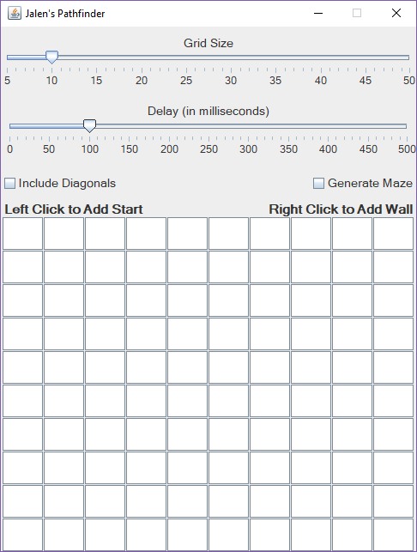

App Launched

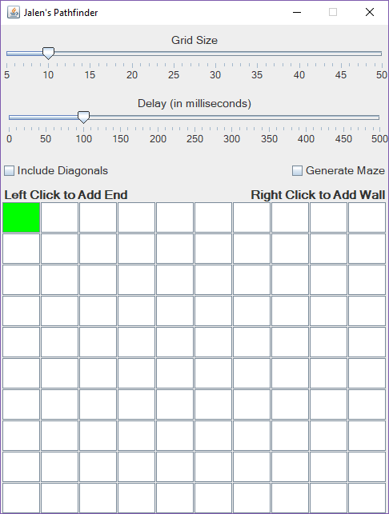

Added Start Node

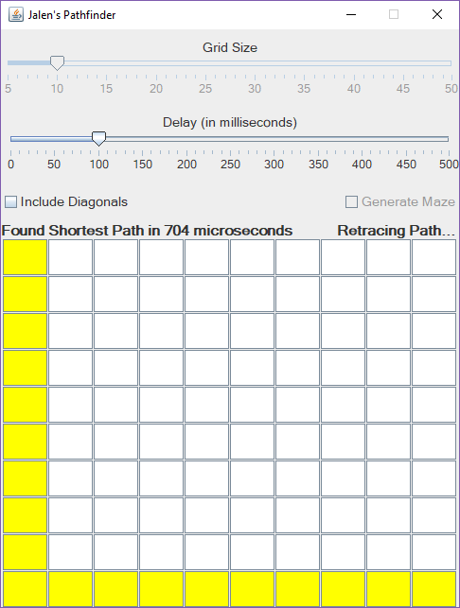

Added End Node

Found then Drawn Shortest Path

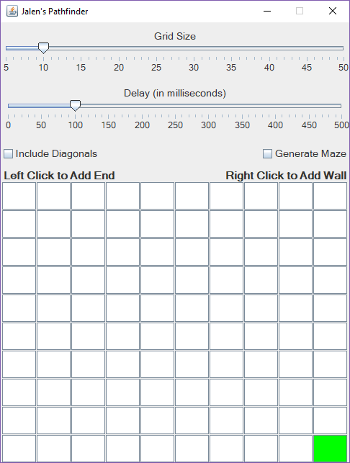

Start Node Moved to End Node’s Spot

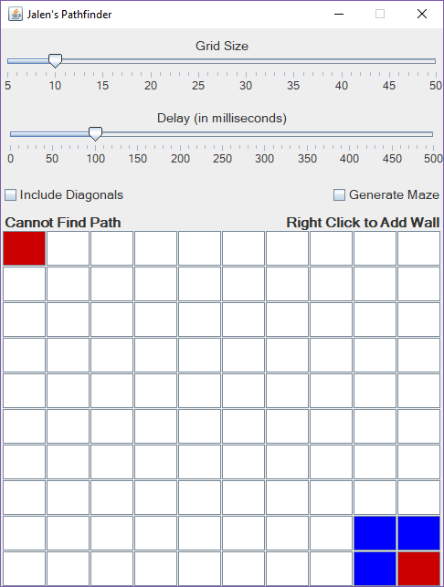

Added Start & End Node

Added Walls Surrounding End Node

Couldn’t Find Path

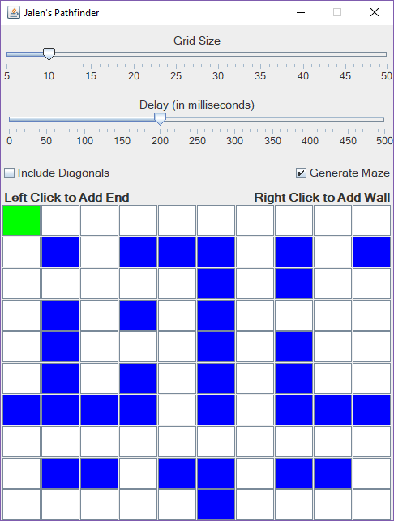

Checked “Generate Maze” Box

Added Start Node

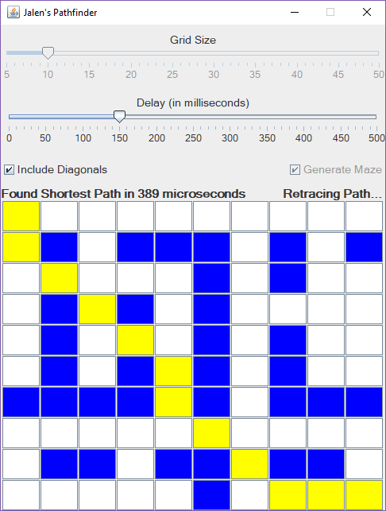

Checked “Included Diagonals” Box

Added End Node

Found then Drawn Shortest Path

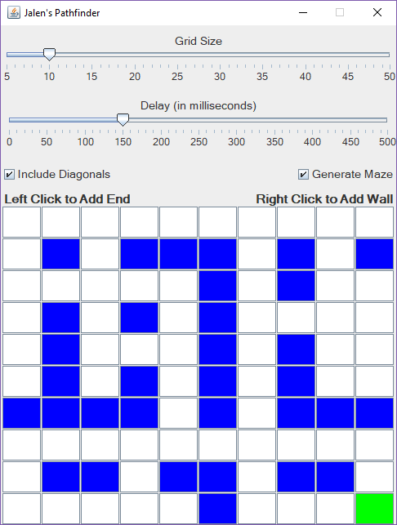

Start Node Moved to End Node’s Spot

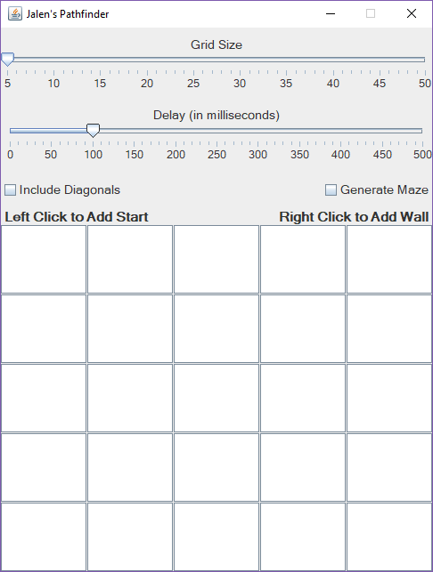

Dragged “Grid Size” Slider to 5 cells

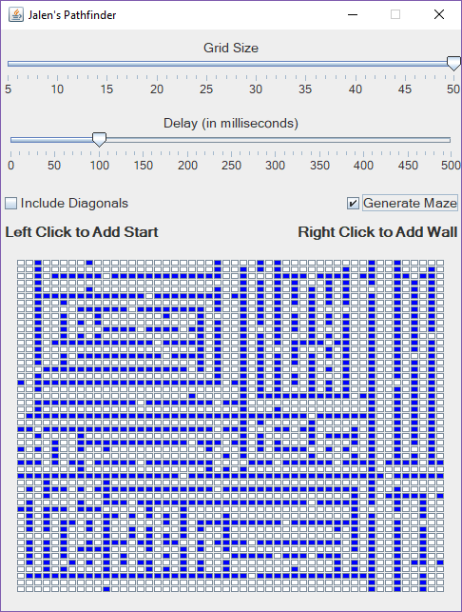

Dragged “Grid Size” Slider to 50 cells

Checked “Generate Maze” Box