* The Dataset is generated such that μML ∈ [0, 0.4) U (0.6, 1.0]
* For the Prior (Beta Distribution): a = 2*k, b = 3*k, => Mean = 2/(2+3) = 0.4

**A- Sequential Learning:**

* ‘Part_A_Code.py’ generates plots of Prior vs μ for N = 160 data points and saves the data in the directory - ‘Image Data’
* ‘Part_A_GIF_Maker.py’ combines the plots generated in the previous step into a GIF.

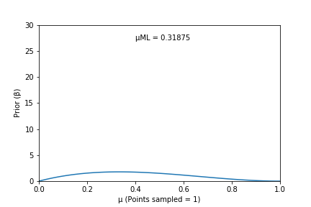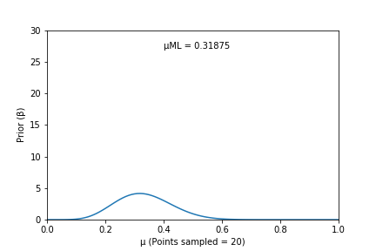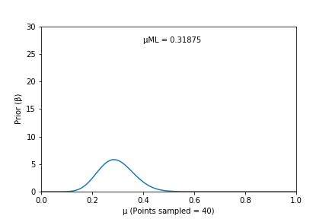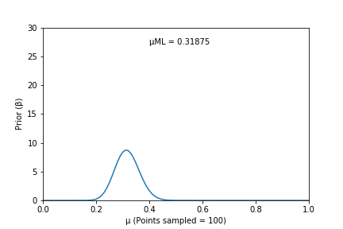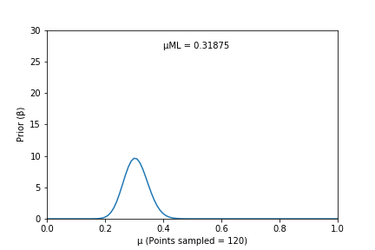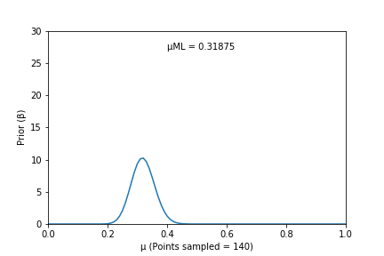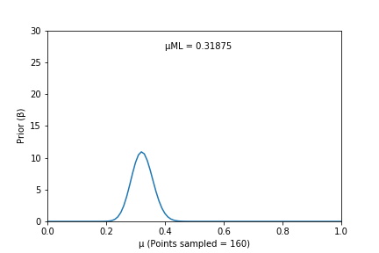

**Part- B:**

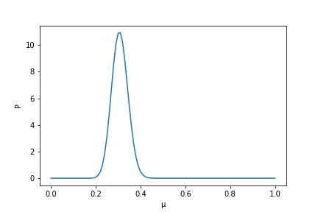

**Part- C:**

* The formula used is:

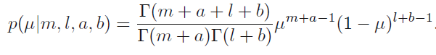

* At the end of sequential learning (Part-A): l + m = N. Therefore, the graphs for Part-A become identical to the graph of Part- B as number of points sampled → 160.
* As the value of N is increased above 160, the Gamma Function increases and makes the value of the entire function → ∞
* At μML = 0.5, the following plot is obtained-

