Taslim Dosunmu

Professor Awad Mussa

Computer Organization and Programming

31 Aug 2017

Assignment 1

1. Image of running Visual Studio CE 2015

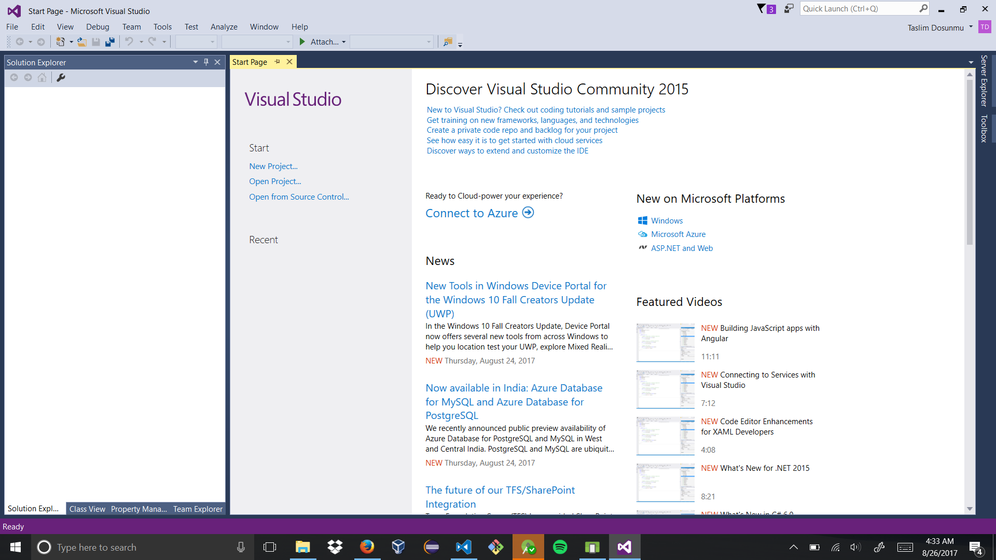

1. An assembly program produced using a Mac would not be able to run on an HP computer even if they are both using an Intel processor. This is because the assembler used for each: NASM for Mac, and MASM for HP respectively, do not translate the same way.

carry: 111

10101011

+11110000

=**10011011** with **1** in **CF**

1. It is not possible to perform the operation -9 - 2 on a 4 bit machine architecture. The minimum value possible with signed 4 bit architecture is -2^3 = -8. -9 is less than -8 and therefore, out of range.
2. 1243E8CF -> 12 43 E8 CF -> 0001 0010 0100 0011 1110 1000 1100 1111 -> **00010010010000111110100011001111**
3. -29 ->

2’s complement:

_ _ _ _ _ _ _ _ 128 64 32 16 8 4 2 1

0 0 0 0 0 0 0 0 0 0 0 1 1 1 0 1 (represent 29)

1 1 1 1 1 1 1 1 1 1 1 0 0 0 1 0 (flip bit values)

1 1 1 1 1 1 1 1 1 1 1 0 0 0 1 1 (add 1)

1111 1111 1110 0011 -> FF E3 -> **FFE3**

2. 10110101

10110110 (add 1)

01001001 (flip bit values)

answer: **-73**

1. 01110111 -> 1 + 2 + 4 + 16 + 32 + 64 -> **119**
3. carry: 111

8CF

+ AD1

=**13A0**

1. carry:101

D49

+ 7AB

=**14F4**

1. largest value for signed 86 bit Integer: 285-1