# Investigator Initiated

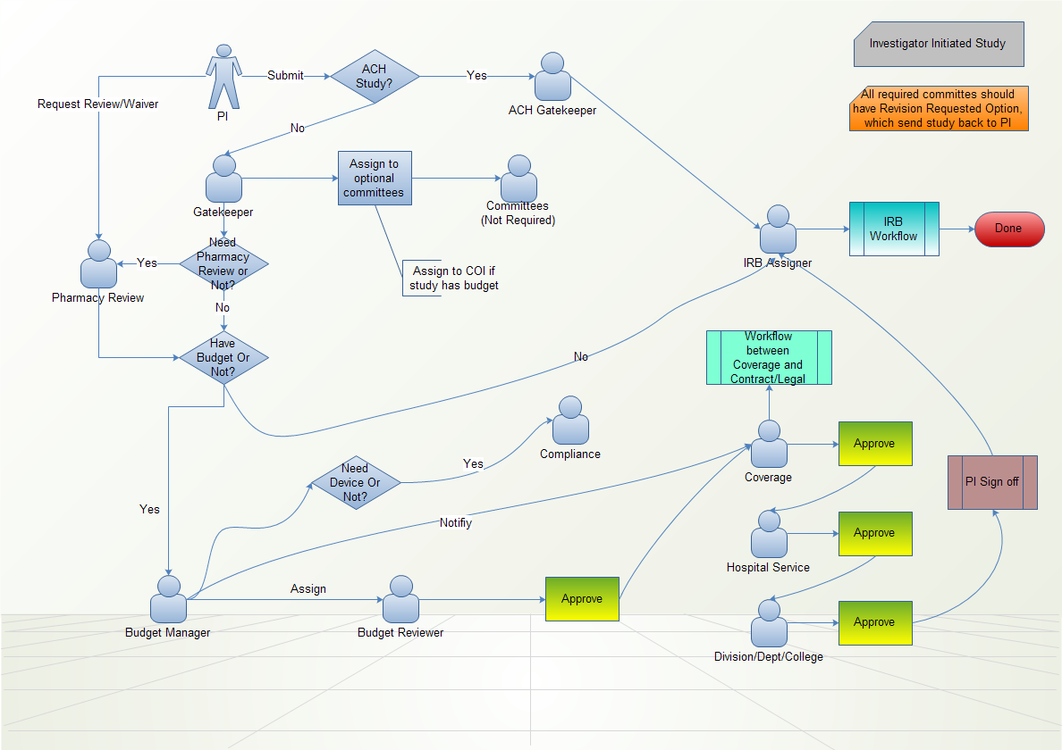

## PI

* 1. Fill out New Submission form, request Pharmacy review if it has drugs.
  2. Submit to Gakekeeper (UAMS studies) or ACH Gatekeeper (ACH studies).
  3. If protocol has budget, when college is done with review, sign off on the budget and route to IRB.

## Gatekeeper

* 1. Review protocol submitted by PI. If it’s not OK, send back to PI to modify. If it’s OK, assign couple of optional Committees to review the protocol and route protocol to Pharmacy (if Pharmacy review is needed) or Budget Manager (if budget review is needed) or IRB (if both Pharmacy review and Budget review are not needed).

## ACH Gatekeeper

* 1. Review protocol submitted by PI. If it’s not OK, send back to PI to modify. If it’s OK, notify couple of optional Committees to review the protocol and route protocol to IRB.

## Optional Committees

* 1. Review protocol and make review decisions, such as Approve, Not Applicable and Reject.

## Pharmacy

* 1. Review Protocol when requested by PI or assigned by Gatekeeper.
  2. If assigned by Gatekeeper, when review is done, send to Budget Manager (if need budget review) or IRB (if budget review is not needed).

## Budget Manager

* 1. Assign Budget and Coverage reviewer. Route protocol to Budget review and notify Coverage review.

## Budget Review

* 1. Review/Develop budget and route to Coverage review or send back to PI for revision.

## Coverage Review

* 1. Review protocol and work with Legal on consent, when review is done, route to Hospital Service – Department - College – PI.

## IRB Office

* 1. IRB internal workflow.

# NOT Investigator Initiated

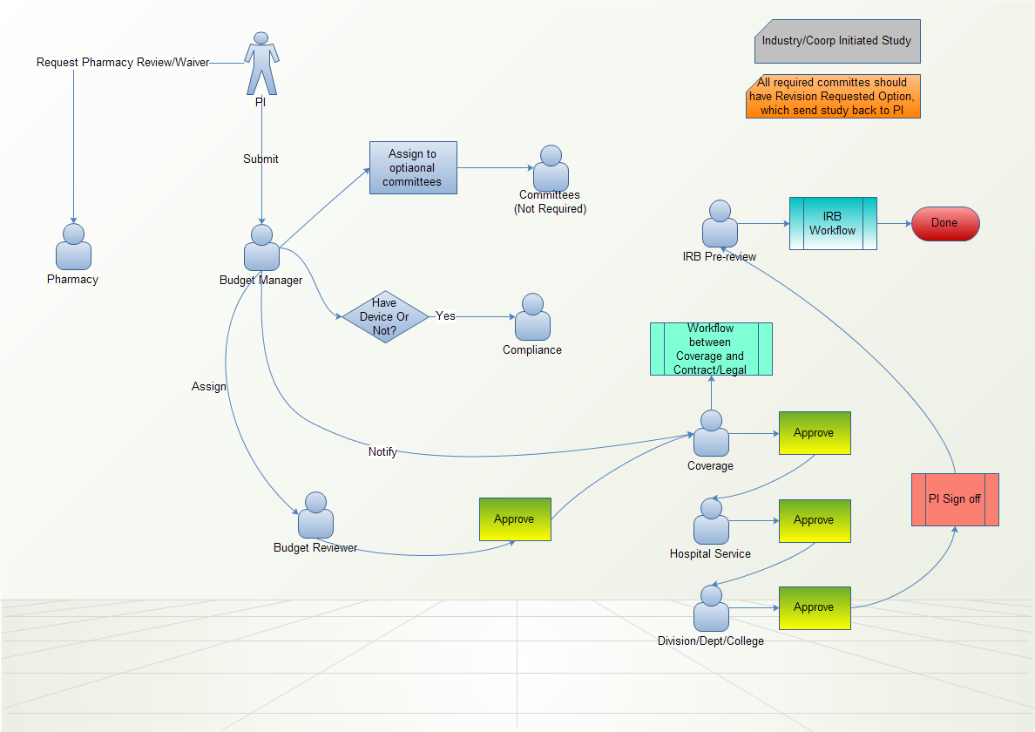

## PI

* 1. Fill out New Submission form, request Pharmacy Review if it has drugs.
  2. Submit to Budget Manager.
  3. Sign off on the budget when college review is done and route to IRB.

## Budget Manager

* 1. Assign to Optional committees for review and route protocol to Budget Review.

## Optional Committees

* 1. Review protocol and make review decisions, such as Approve, Not Applicable and Reject.

## Pharmacy

* 1. Review Protocol when requested by PI.

## Budget Review

* 1. Review/Develop budget and route to Coverage review or send back to PI for revision.

## Coverage Review

* 1. Review protocol and work with Legal on consent, when review is done, route to Hospital Service – Department - College – PI.

## IRB Office

* 1. IRB internal workflow.