Professor Deng

COSC 412

December 13, 2018

Team ABC123 Project Report

(Matthew Oberteuffer, Joey Drasal, Scott Guthier, Charles Lejtman)

GitHub: <https://github.com/JayDr3/Final-Claims-Project>

The development process of the project was managed through Trello, <https://trello.com/b/8dyR71U4/final-project>, where user stories were submitted during sprints and put into the sprint/product backlog before being implemented. User stories were given an initial time estimate, a set of confirmations, and a description following the Agile format given in class. We used labels for user stories and different categories that gave different meaning and importance. Progress on the user stories was tracked through the burndown chart, as hours allocated to user stories were tracked and matched against the initial time estimated, in some cases causing a re-estimate of the required time to implement. User stories include user registration, user login, password encryption, password requirements, and HTML/Javascript separation.

Team meetings were held every week before class, and the project development was discussed, with the discussion taking the form of the Scrum daily meetings. During the set of three sprints, role of scrum master was changed between team members. We usually met an hour before class and divided up the work. Sometimes, we would continue working on the project during that hour. Throughout the whole project, we had to learn all of the development tools used, as we were inexperienced/beginning to learn HTML, Javascript, Node.js, PHP and the Express Framework.

In the very start of the project and most of Sprint 1, we were figuring out creating the User Login page. We started off with basic HTML login text boxes for a username and password. During our time working on the User Login, we followed mostly this User Story:

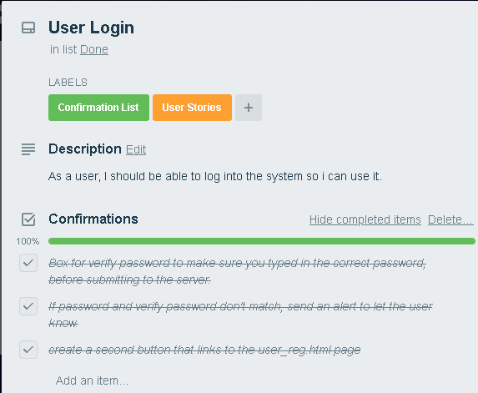

We wanted to add more security features like password verification, but felt that was more useful for the User_Reg.html page. We tried connecting the login using PHP, but that ultimately didn’t end up working and was more time consuming then it was worth. Towards the end, we started looking more into the Express side of user logins. Express and Node.js use bcrypt to hash and salt the passwords into the database. So, we were just working on getting that up and running.

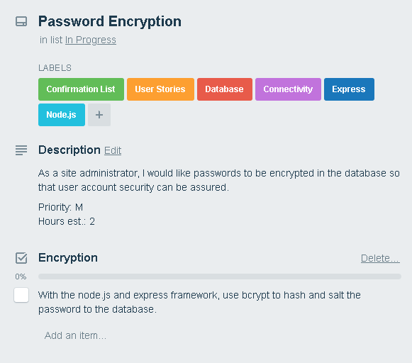

After the User Login was created, we started to work on getting a user registration form together. We used HTML and Javascript to try to connect the two HTML sites together and give the password verification some animation, such as appearing when clicked on the password field. As well as, learning more about Javascript and creating the javascript for the password verification field.

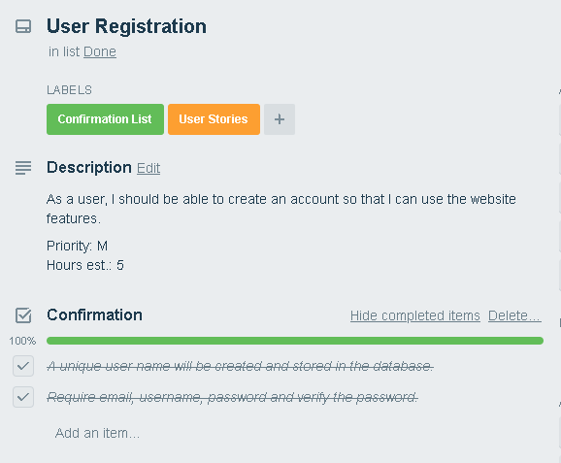

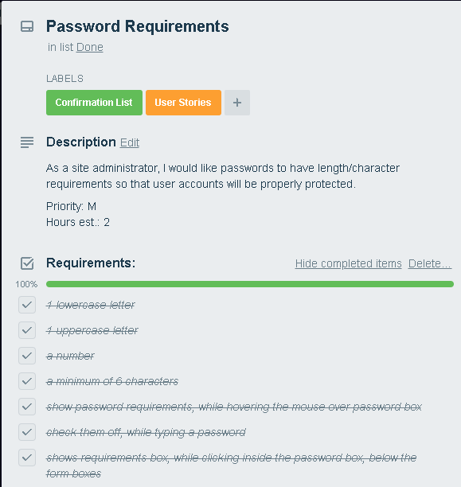

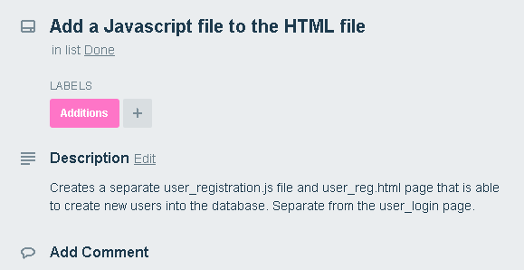

We had these two pages connected via a button, but we needed a database and needed to be able to connect to the database with the login and registration. We started doing research on how we could do this. At first, we started to look into Node.js, however do to inexperience and lack of time this was going to take more time to learn Node.js and more about HTML and Javascript. Meanwhile, we started to use PHP for the next sprint, Sprint 2, but it didn’t work out so well. The Project was at a stand still and the PHP coding seemed more difficult. We found a tutorial that could of helped, but lead to a dead end and frustration. We finally turned to some tutorials from the internet, which helped shape our database and admin site.

These led to the Express framework, with more work on Node.js. We started to learn more about Node.js and Express and started to create our database and website forms toward the middle/end of Sprint 3. We used Express files to create the webpages and linked them together. Using Xampp, we were able to setup a MySQL database using the phpMyAdmin dashboard. We used Node.js, to connect to the database and connect our express webpages to the database. When connected, we were able to view a table of the database and add/edit/delete entries from the database. We tracked the following user stories, during this process:

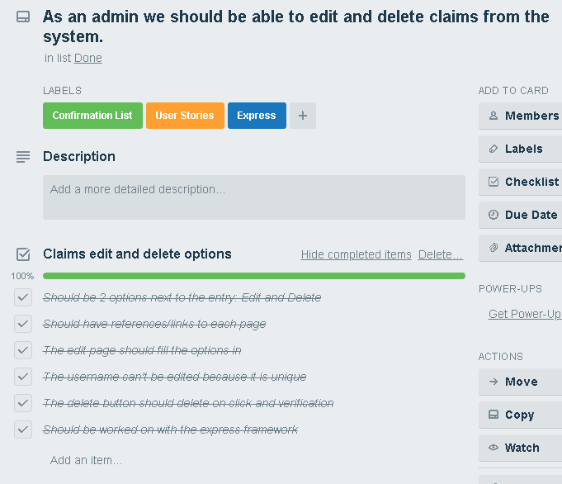

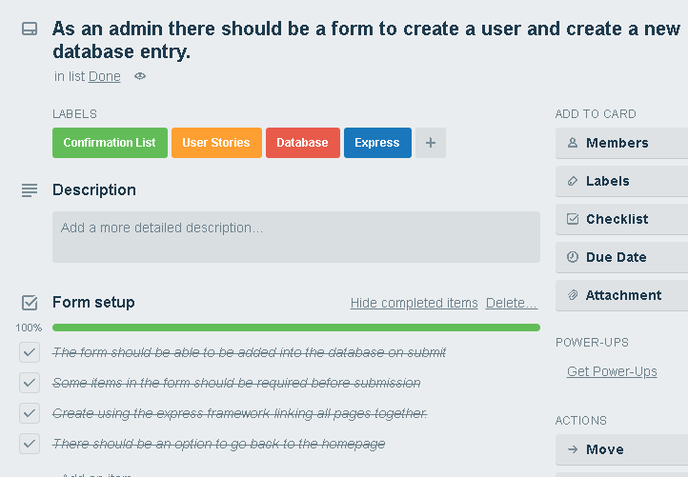

Now as we are onto Sprint 4, we have cards for updating the user login and registration pages to the express framework and getting the password encrypted to send and store in the database. We plan on tracking these as we finish them and research this more. We are currently doing this, with more in our Backlog. Mostly, our backlog consists of connecting all pages together to make the user and admin receive what is needed for a claims system. The product backlog is connecting everything onto a server and hosting the website to facilitate the secure connection to the claims database.

### In Progress

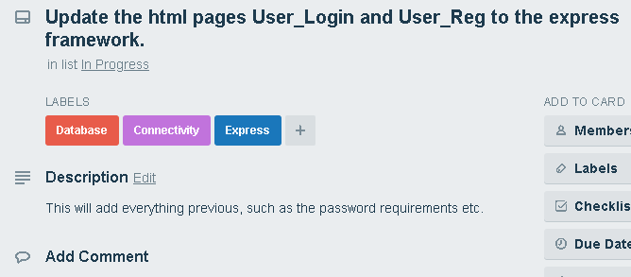.

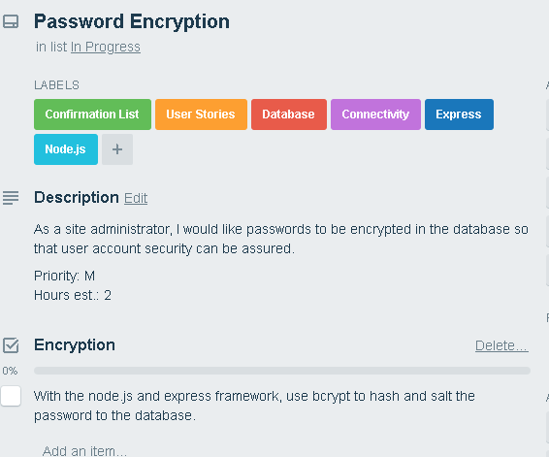

### Sprint Backlog

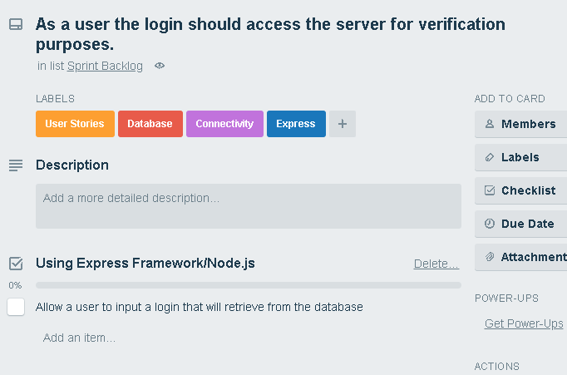

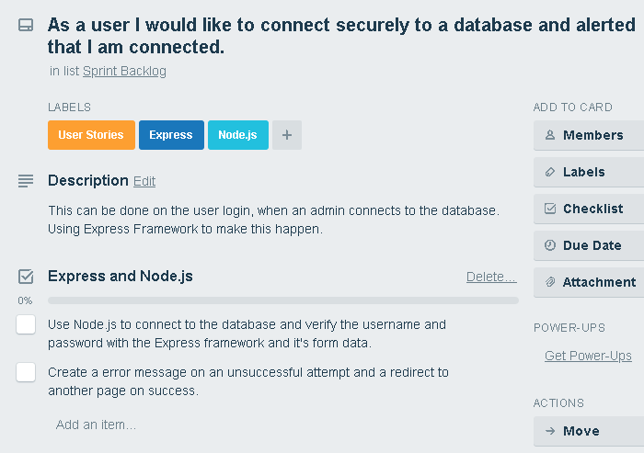

### Product Backlog

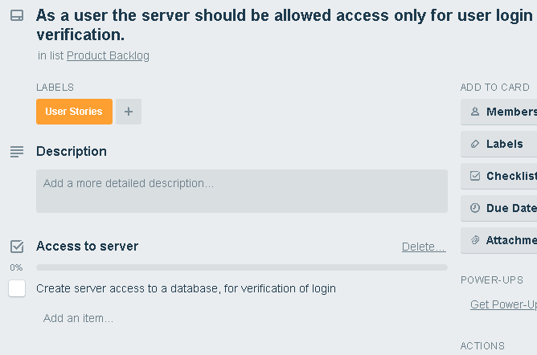

### Burndown Chart

Our burndown chart shows higher time. This is because of our team’s time constraints and inexperience with the software/coding. We were learning as we went and all worked to get the project up and running.

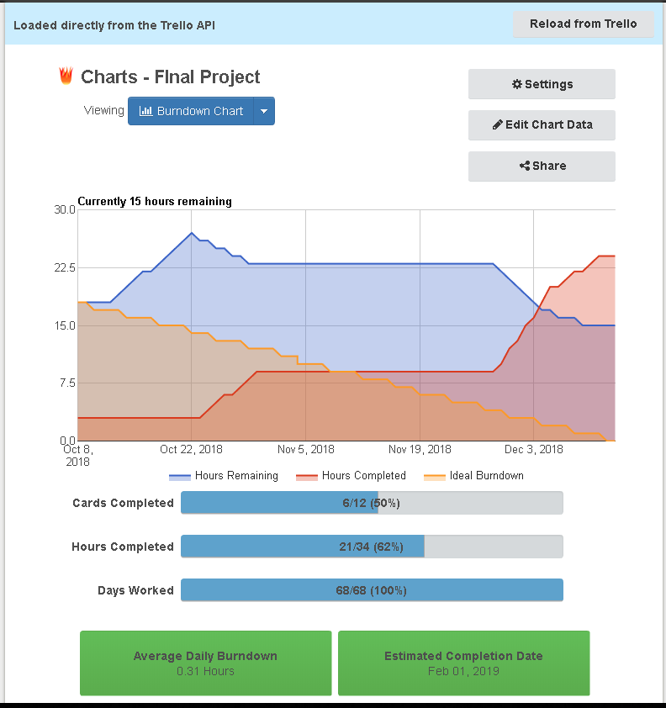

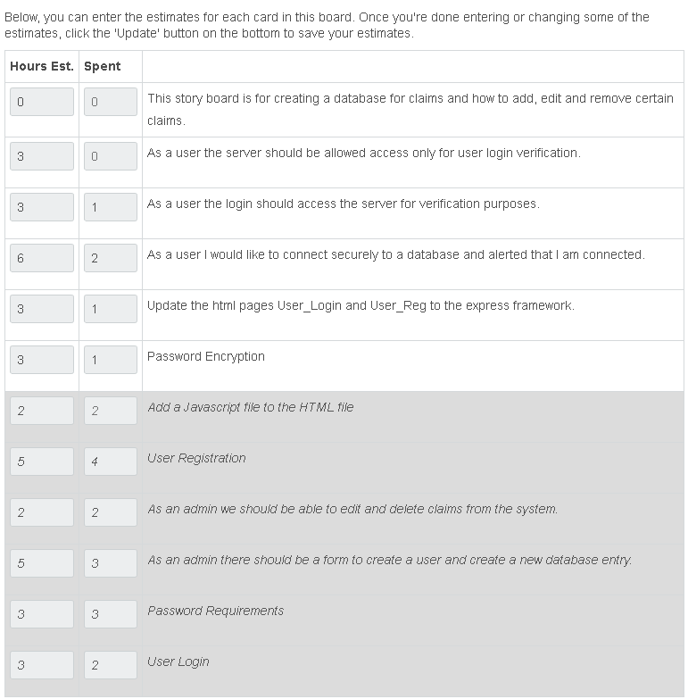

Finally, the future features we would have liked to add, if time permitted and more experience allowed us to:

* Password Hash and Salt
* Login verification with the database
* User login and edit of claim
* 2-Factor Authentication
* Password Reset