3 RESULTS AND DISCUSSION
This section reports what the ensemble actually produced once it was built and run on the dataset described in Section 2. We first check the result against each objective, then look at the one-day-ahead numbers, then work through the reasons behind those numbers. The later parts cover the seven-day forecast and the computing cost. Every number reported here was measured on the held-out test block, which the models never saw during training.

3.1 Performance against the objectives
Four of the five specific objectives were met in full. The fifth, which sets a numeric target for RMSE, was met in part. Table 15 lists each objective with its outcome and points to the part of this section that shows the evidence.
Table 15. The five specific objectives and the outcome of each.
Objective | What it asked for | Outcome
1.3.1.1.1 | Preprocess the data with the Box-Cox transformation | Met. Lambda was estimated on the training portion only (-1.4387) and applied to the whole series. See Section 3.4.
1.3.1.1.2 | Ensemble the LSTM and XGBoost using parallel processing | Met. Both models were trained separately on the same input and their outputs were combined into one forecast. See Sections 3.3 and 3.6.
1.3.1.1.3 | Evaluate the ensemble against the baseline study and against each model on its own | Met. All four are reported side by side in Table 17.
1.3.1.1.4 | Evaluate with RMSE, MAE and MAPE, and reach at least a 10% reduction in RMSE (target 5.56 in) | Partly met. All three metrics are reported. The ensemble reached 5.6131 in, a 9.19% reduction, so it fell 0.0531 in short of the target. See Sections 3.3 and 3.5.
1.3.1.1.5 | Quantify the cost and benefit trade-off | Met. Training and prediction time were measured for both models and compared against the accuracy gained. See Section 3.11.

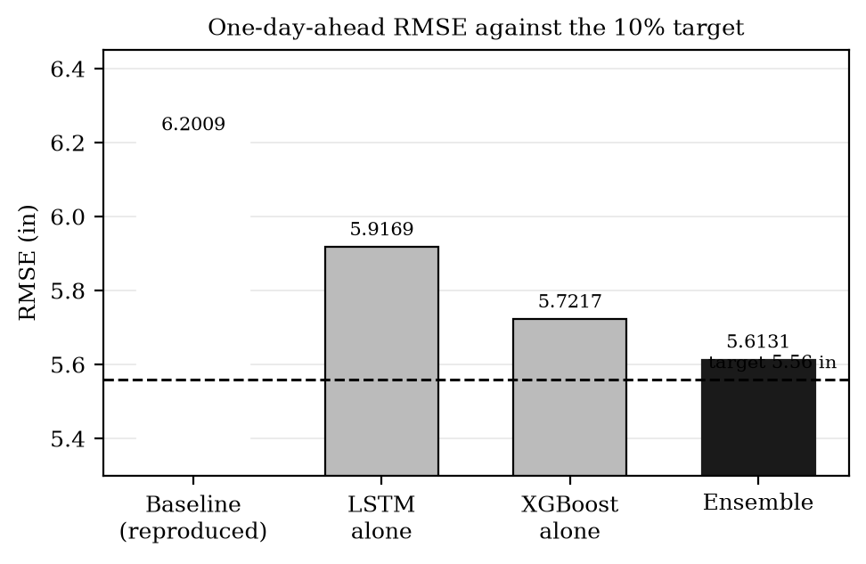
Figure 11. One-day-ahead RMSE for each model against the 5.56 in target. The ensemble is closer to the target than the LSTM on its own, but does not reach it.
Figure 11 shows the same result as a bar chart. The ensemble improved on the reproduced baseline and on the LSTM alone, which answers the main question the study set out to ask. It did not reach the numeric target. Figure 12 expresses the same thing as a percentage, which is how the objective states it.
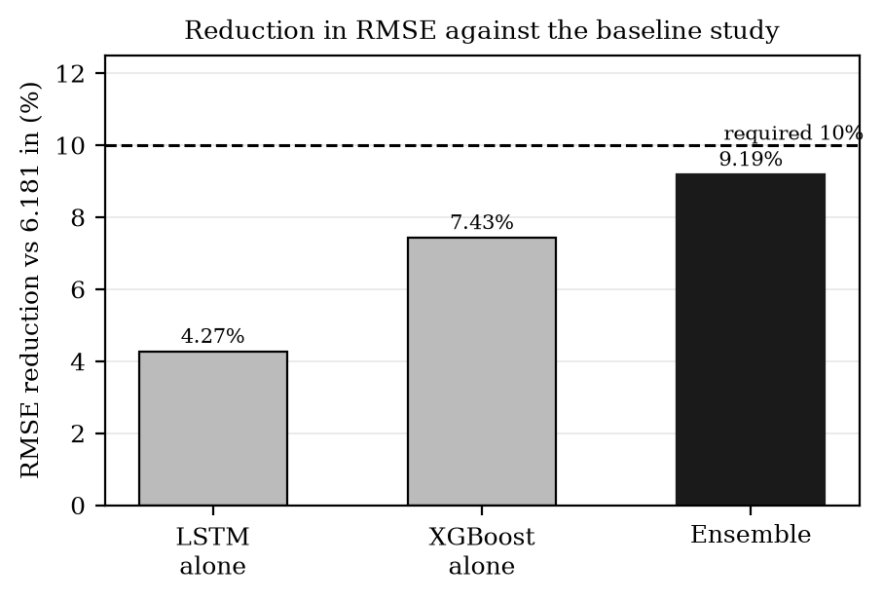
Figure 12. Reduction in RMSE against the baseline figure of 6.181 in. The dashed line is the 10% the objective asked for.
We report this shortfall plainly rather than selecting a more favourable comparison. Section 3.5 explains why the gap is small but hard to close, and that explanation turned out to be the most useful finding in the study.

3.2 The record and how it was evaluated
The dataset covers thirty-one calendar years of daily rainfall. We split it in time rather than at random, so the model is always trained on earlier days and tested on later ones. This matters for a time series, because a random split lets the model see the future while it learns. Table 16 gives the exact geometry of the split.
Table 16. The record and the evaluation setup.
Item | Value
Days in the record | 11323
Period covered | 1990-01-01 to 2020-12-31
Days used for training | 9058 (1990-01-01 to 2014-10-19)
Days held out for testing | 1930 (2014-10-20 to 2020-01-31)
Lookback window | 70 days
Test days actually scored | 1860 (the first 70 are used as lookback only)
Held out for XGBoost early stopping | last 12% of the training block
Held out for the ensemble weights | last 8% of the training block
Dry days in the record | 6828 of 11323 (60.3%)

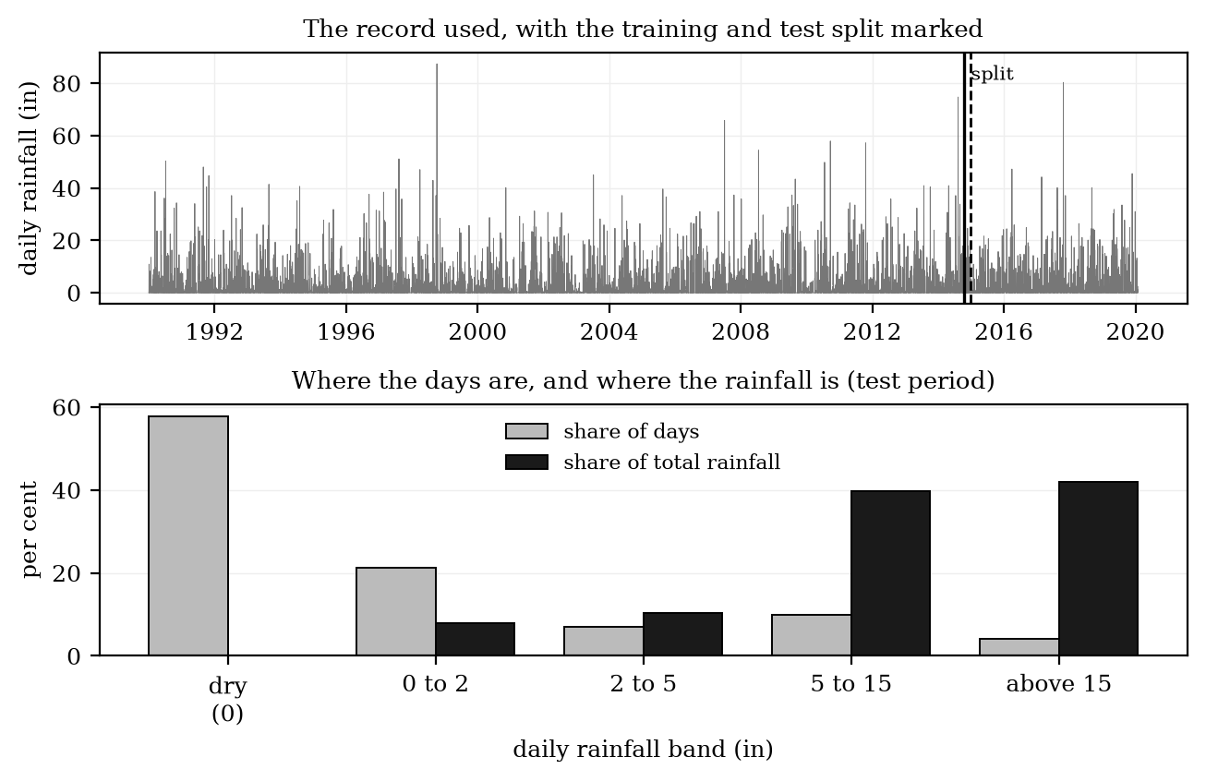
Figure 13. Above, the record with the training and test split marked. Below, the share of days and the share of total rainfall that falls in each band during the test period.
Figure 13 shows why this series is awkward to forecast. Most days are dry, and almost all of the rainfall arrives on a small number of days. The lower panel makes the point directly: the dry and near-dry days are the large majority of the record but carry very little of the rain, while the heaviest band is a thin slice of days carrying most of the total. Any model trained to reduce average error will spend most of its effort on the days that contribute least to the total.

3.3 One-day-ahead results
Table 17 gives the one-day-ahead result for the final configuration and for each model on its own, next to the baseline. We also include the three earlier configurations we built along the way, because the differences between them are part of the result and not just development history.
Table 17. One-day-ahead performance on the 1,860 scored test days. The reduction column is measured against the baseline figure of 6.181 in stated in the study.
Model | RMSE (in) | MAE (in) | MAPE (%) | R squared | RMSE reduction | Notes
Baseline (stated in the study) | 6.1810 | - | - | - | - | -
Baseline (reproduced here) | 6.2009 | 2.3244 | 81.10 | - | - | -
LSTM alone | 5.9169 | 2.2894 | 82.01 | -0.1408 | 4.27% | final configuration
XGBoost alone | 5.7217 | 3.7435 | 251.29 | -0.0668 | 7.43% | final configuration
Ensemble | 5.6131 | 2.8894 | 136.20 | -0.0267 | 9.19% | final configuration

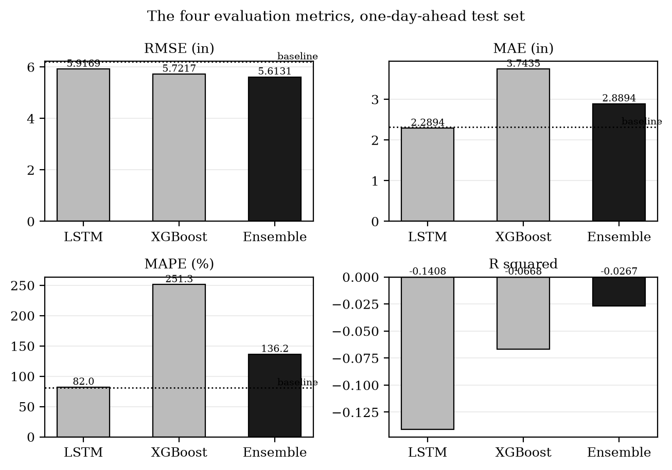
Figure 14. The four evaluation metrics for the final configuration. The dotted line on the first three panels is the reproduced baseline.
Two things stand out. The ensemble has the lowest RMSE of the three models, which is the metric the objective is written around. It does not have the lowest MAE or MAPE: the LSTM on its own is better on both. This is not a contradiction. RMSE squares the errors before averaging them, so it is driven by the heavy days, while MAE and MAPE treat every day alike and are therefore driven by the dry days that make up most of the record. The two models are good at different parts of the series, and combining them improves one metric while giving ground on the other two. Section 3.7 shows where each model earns its share.
The R squared values are negative for the LSTM and the ensemble. A negative R squared means the forecast did worse than predicting the average of the test period every day. On a series where most days are zero this is a common outcome, and Section 3.5 explains why it happens here.
Table 18 compares the four configurations we built. We kept the LSTM, the preprocessing and the splitting identical across all of them and changed only the XGBoost side and the way the hyperparameters were chosen, so the rows can be read against each other.
Table 18. The four configurations built during the study. The LSTM, the preprocessing and the split are identical in all four.
Configuration | What changed | Ensemble RMSE | Ensemble MAE | Ensemble MAPE | Ensemble R2 | XGBoost RMSE
Configuration A | fixed hyperparameters, gbtree, pseudo-Huber | 5.6419 | 2.6107 | 101.51 | -0.0372 | 5.5320
Configuration B | as A, with extra diagnostics | 5.6288 | 2.6427 | 105.91 | -0.0324 | 5.5320
Configuration C | retuned XGBoost, gbtree, pseudo-Huber | 5.6172 | 2.6708 | 109.81 | -0.0282 | 5.5291
Configuration D (final) | searched hyperparameters, dart, quantile | 5.6131 | 2.8894 | 136.20 | -0.0267 | 5.7217

Configuration D has the lowest ensemble RMSE and is the one deployed. It is also the weakest on MAE and MAPE. We chose it because RMSE is the metric the objective names a target for, but the trade-off is real and we state it here rather than leaving it in a footnote. Configuration C has the best XGBoost result of the four and is the only configuration in which a single model clears the 5.56 in target on its own.

3.4 What the Box-Cox transform does to the scale
Objective 1.3.1.1.1 asked for the Box-Cox transformation, and it was applied as specified. The fitted lambda was -1.4387. Because lambda is negative, the transform has an upper limit: no matter how much rain falls, the transformed value cannot go above 0.6951. This single fact explains a large part of the behaviour reported later, so we set it out here.
Table 19. How the rainfall scale maps into the transformed range. The upper limit is 0.69508.
Rainfall (in) | Transformed value | Share of the available range used
0.0 | 0.00000 | 0.0%
0.5 | 0.30720 | 44.2%
1.0 | 0.43866 | 63.1%
2.0 | 0.55199 | 79.4%
5.0 | 0.64229 | 92.4%
10.0 | 0.67301 | 96.8%
20.0 | 0.68637 | 98.7%
40.0 | 0.69175 | 99.5%
91.2 | 0.69404 | 99.9%

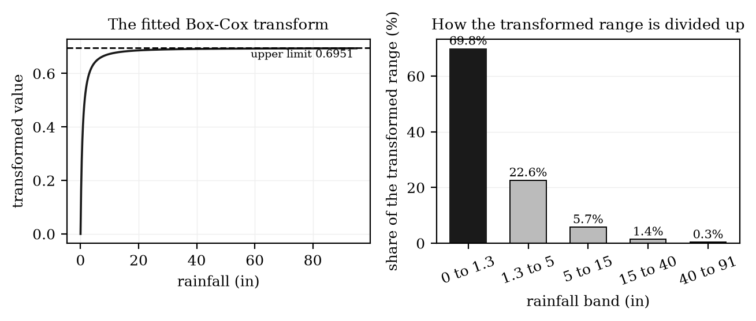
Figure 15. Left, the fitted transform flattens out as rainfall increases. Right, how the transformed range is divided among rainfall bands.
Reading Table 19 down the rows shows the problem. Moving from no rain to about 1.3 in uses up roughly seventy per cent of the range the models work in. Everything from there up to the heaviest day on record has to fit into the remaining thirty per cent. The models therefore see very little difference between a heavy day and an extreme one, and they are rewarded far more for getting the dry days right than for getting the storms right. The transform does what the objective asked of it, and it also makes the heavy days harder to separate.

3.5 How much of this series can be predicted at all
The shortfall against the RMSE target is small, so we checked how much room there was to improve in the first place. To do that we compared the trained models against predictors that use no model at all: a constant value repeated every day, and a straight line fitted on the previous day's rainfall. Table 20 gives the result.
One note on where these numbers come from. The extra diagnostics in this section and in Sections 3.8 and 3.9 were computed on configuration C from Table 18, because that is the run the diagnostic code was written for. Configuration C and the final configuration D differ a little on the individual models, so the XGBoost and ensemble figures in the next three tables are not identical to those in Table 17. The conclusions drawn from them hold for both, and where a figure is close to a decision we say which run it came from.
Table 20. Trained models next to predictors that use no model, measured on configuration C. The observed spread of the test days is 5.5397 in. A constant set at the average of the test days has an RMSE equal to that spread, which is why those two figures match.
Predictor | RMSE (in) | Spread of the forecast (in) | Forecast spread as a fraction of the observed spread
LSTM | 5.9031 | 0.0080 | 0.0014
XGBoost | 5.5291 | 0.3453 | 0.0623
Ensemble | 5.6172 | 0.1781 | 0.0322
Constant at the training mean | 5.5457 | 0.0000 | 0.0000
Constant at the best possible value | 5.5397 | 0.0000 | 0.0000
Straight line on yesterday's rainfall | 5.5027 | - | -

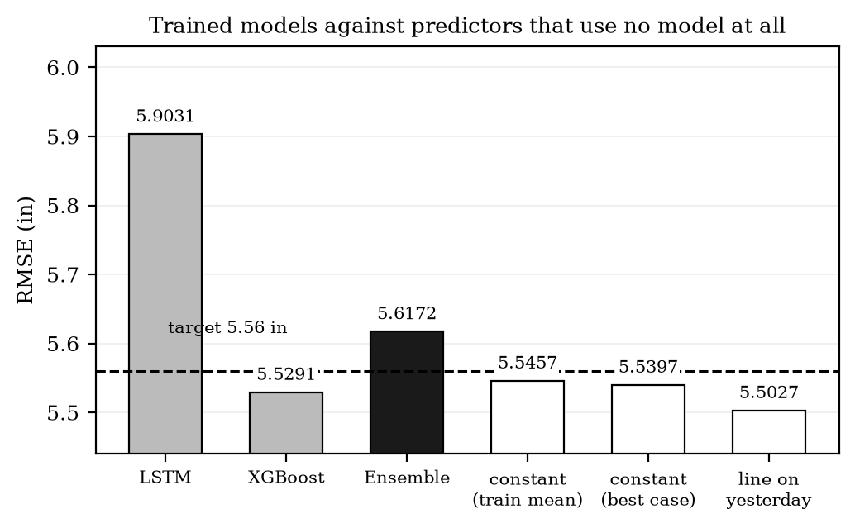
Figure 16. The trained models against predictors that need no training. Three of the untrained predictors already sit below the 5.56 in target.
This is the most important result in the study. A constant value repeated every single day gives an RMSE of 5.5397 in, and the best straight line on the previous day gives 5.5027 in. Both are already below the 5.56 in target. In other words, the target set in objective 1.3.1.1.4 can be reached without forecasting anything, simply by predicting the same number every day. The whole distance between the best constant and the best lag-based predictor is about 0.037 in.
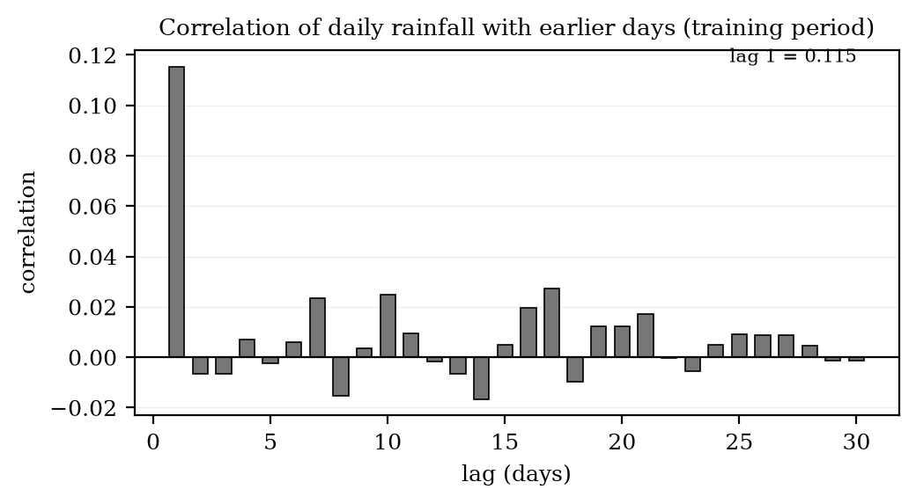
Figure 17. Correlation between a day's rainfall and earlier days, measured on the training period. Beyond one day there is almost nothing left to use.
Figure 17 shows why. The correlation between one day's rainfall and the next is only about 0.12, and past one day it is close to zero. A univariate model can only use the past of the series itself, so if the past carries almost no information about tomorrow, there is almost nothing for any model to learn. This is a property of the rainfall record, not a fault in the LSTM or in XGBoost.
The practical consequence is that RMSE on its own is a poor test of whether a rainfall forecast is any good. A model can lower RMSE by predicting close to the average every day, which is what a constant predictor does, and it will score well while telling the user nothing. Sections 3.8 and 3.9 therefore test the forecasts in ways that a constant cannot pass.

3.6 Why the forecasts stay close to the average
Table 21 reports the average level of each forecast and how much it varies, next to the observations. The spread is the part worth reading.
Table 21. The level and the spread of each forecast against the observations, on the 1,860 scored test days.
Series | Mean (in) | Spread (in) | Spread as % of observed | Average error (forecast minus observed)
Observed rainfall | 2.2614 | 5.5397 | 100.0% | -
LSTM | 0.1828 | 0.0065 | 0.1% | -2.0786
XGBoost | 3.0842 | 0.9851 | 17.8% | +0.8228
Ensemble | 1.6590 | 0.5003 | 9.0% | -0.6024

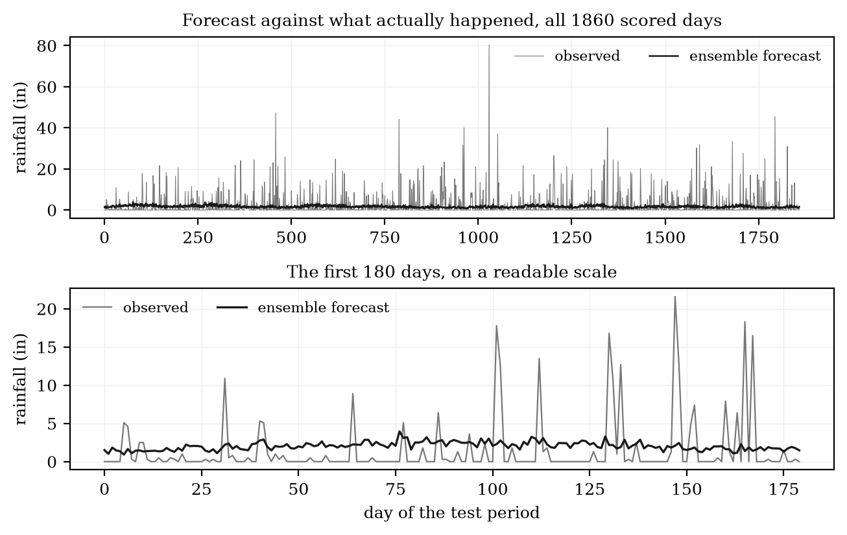
Figure 18. The ensemble forecast drawn over the observed rainfall. The lower panel is the first 180 days of the test period at a readable scale.
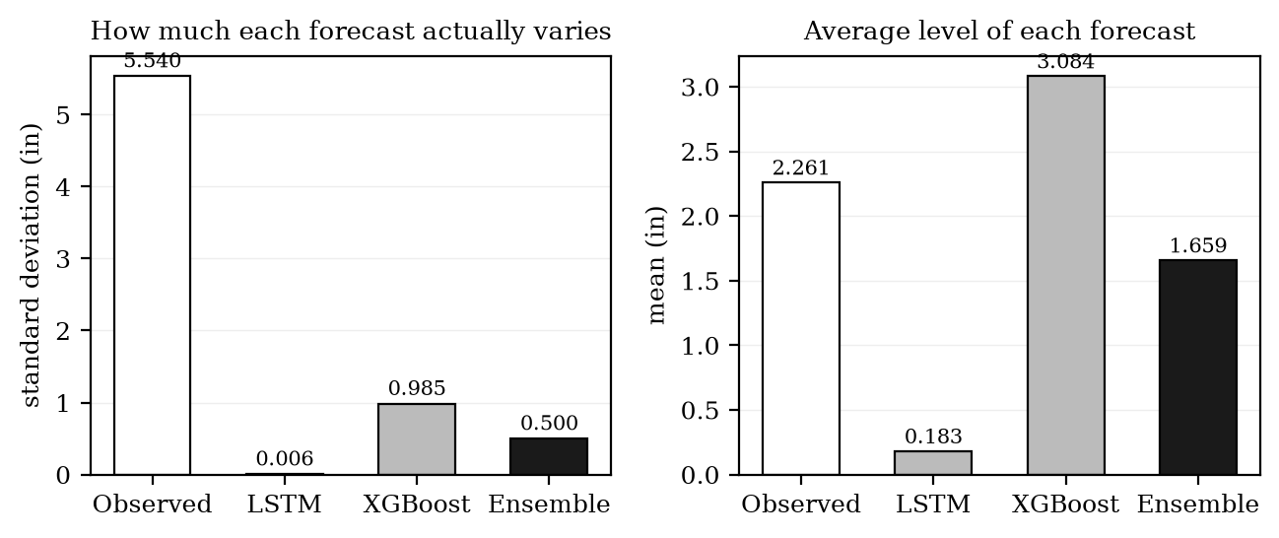
Figure 19. Left, how much each forecast varies. Right, the average level of each forecast.
The forecasts barely move. The ensemble varies by 0.5003 in while the observations vary by 5.5397 in, which is about 9.0 per cent of the real variation. Figure 18 shows the same thing visually: the observed series spikes on storm days while the forecast line stays almost flat. The models have settled close to the average of the series and stay there.
This follows directly from Section 3.5. When the past carries little information about tomorrow, the value that minimises squared error is the average, and a model trained to minimise squared error will move towards it. The flat forecast is not a bug in the implementation. It is the correct answer to the question the loss function asked, and it is why the error metrics look reasonable while the forecast is not informative.

3.7 Which model works for which rainfall amount
Average error across the whole test set is dominated by whichever band has the most days. Splitting the error by how much rain actually fell shows which model is stronger where. Table 22 gives the breakdown.
Table 22. Average error in each rainfall band. The lowest value in each row shows which model owns that band.
Rainfall band | Days | LSTM MAE | XGBoost MAE | Ensemble MAE
No Rain (0 in) | 1076 | 0.1822 | 3.1068 | 1.6702
Moderate (0.2-0.5 in) | 184 | 0.1940 | 2.7072 | 1.2821
Heavy (>0.5 in) | 600 | 6.7109 | 5.2031 | 5.5685

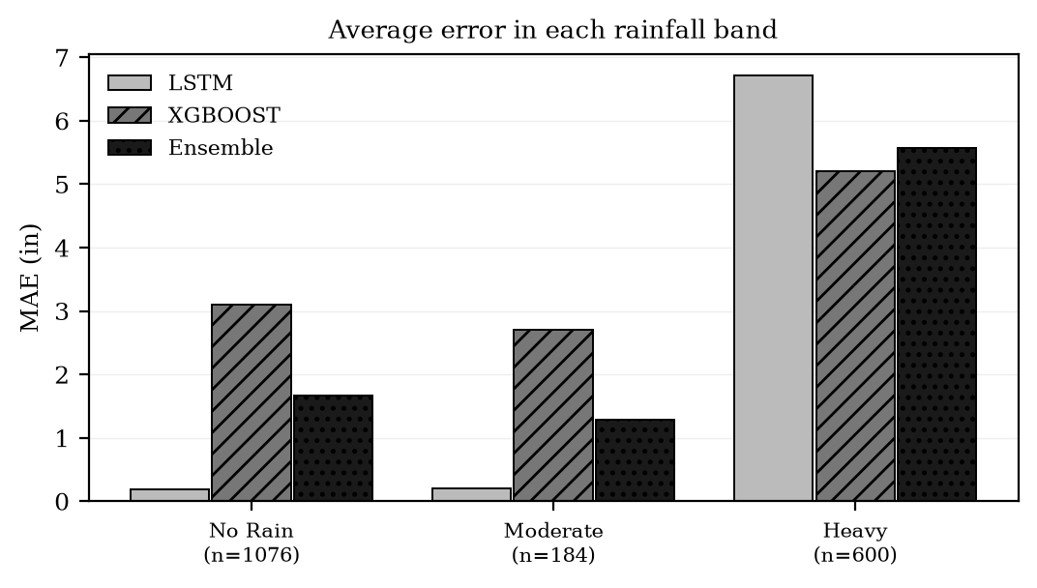
Figure 20. Average error in each rainfall band. The models divide the work between them.
The division is clear. The LSTM is better on the dry and moderate days, which are most of the record, and XGBoost is better on the heavy days, which carry most of the rainfall. Neither model is better everywhere. This is what makes an ensemble worth building here, and it is also why the ensemble does not win on every metric at once: it inherits part of each model's weakness along with each model's strength.

3.8 Treating the forecast as a rain warning
RMSE, MAE and MAPE all score how far off the predicted amount was. None of them says whether the forecast put the wetter days in the right order, which is what matters if the forecast is going to be used to decide whether to expect rain. Table 23 scores the same forecasts as a warning system.
Table 23. The ensemble scored as a rain warning at four thresholds. POD is the share of wet days correctly flagged, FAR the share of warnings that were wrong, CSI a combined score, HSS the improvement over guessing, and AUC the ability to rank wetter days above drier ones. For HSS and AUC, 0 and 0.5 mean no skill. Measured on configuration C.
Threshold | Days above it | POD | FAR | CSI | HSS | AUC
>0 in | 784 | 1.0000 | 0.5785 | 0.4215 | 0.0000 | 0.5557
>0.5 in | 600 | 1.0000 | 0.6774 | 0.3226 | 0.0000 | 0.5567
>2 in | 392 | 0.0051 | 0.6667 | 0.0051 | 0.0037 | 0.5734
>5 in | 263 | 0.0000 | - | 0.0000 | 0.0000 | 0.5763

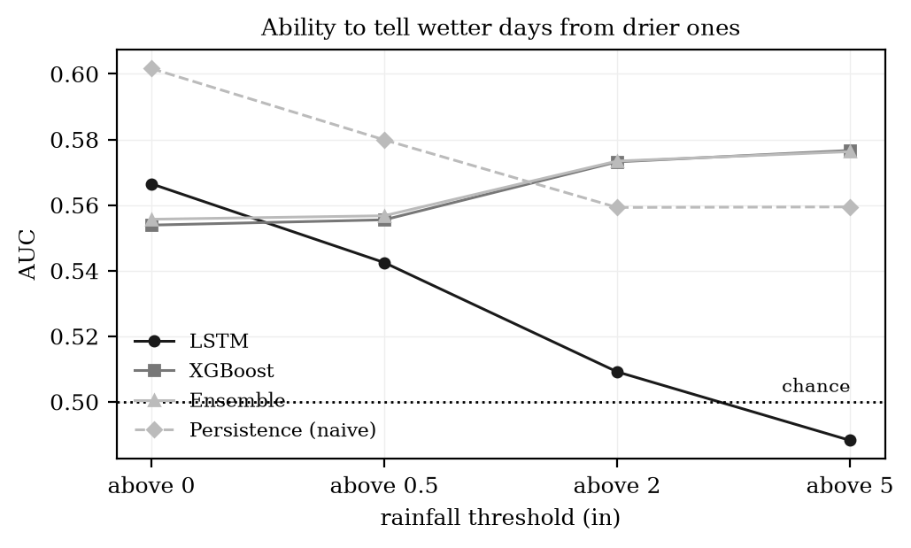
Figure 21. Ability to tell wetter days from drier ones at each threshold. A value of 0.5 is the same as guessing.
The AUC values sit between 0.56 and 0.58. A value of 0.5 means the forecast orders days no better than chance, so the models carry only a little ordering information, and most of it is at the higher thresholds. The HSS values at the low thresholds are effectively zero because the forecast is above the threshold on almost every day: it catches every wet day, but only by warning constantly, which is not useful.
The naive persistence forecast, which simply repeats yesterday's rainfall, has a higher AUC than the trained models at the lowest threshold. That is worth reporting honestly. It reflects the same point as Section 3.5: on this series a simple rule is hard to beat, because there is very little signal for a trained model to find.

3.9 Skill against forecasts that need no model
A skill score compares the model against a reference forecast. Zero means the model did exactly as well as the reference, above zero means better, below zero means worse. Table 24 reports these against four references.
Table 24. Skill scores against reference forecasts, measured on configuration C. Zero means no better than the reference.
Model | Persistence (naive) | Window average | Climatology (train only) | Constant = train mean | Constant = test mean
LSTM | 0.3777 | -0.0088 | -0.1300 | -0.1330 | -0.1355
XGBoost | 0.4540 | 0.1150 | 0.0087 | 0.0060 | 0.0038
Ensemble | 0.4365 | 0.0865 | -0.0232 | -0.0259 | -0.0282

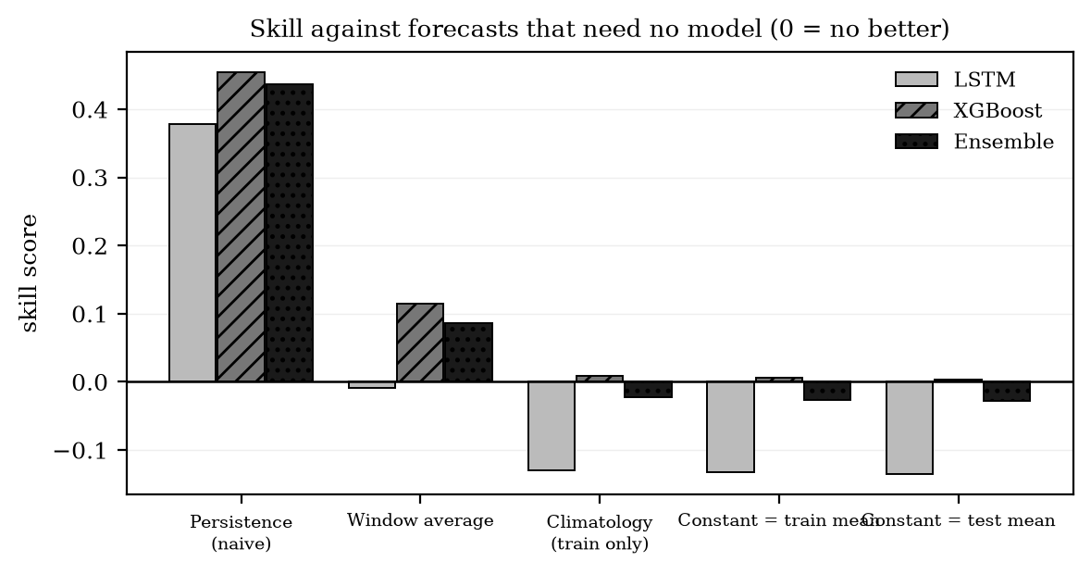
Figure 22. Skill against four reference forecasts. Bars above the line beat the reference, bars below it do not.
The pattern is consistent. All three models beat persistence comfortably, which shows they learned something real. None of them beats a constant set at the training mean: the ensemble scores -0.0259 against it, which is slightly worse than the constant. XGBoost is the only model that is marginally positive against the constant references, and only just. Taken with Section 3.5, this says the models have learned the average level of the series well and have learned very little beyond it.

3.10 Forecasting seven days ahead
The panel asked whether the forecast could be extended further ahead, so we tested a seven-day horizon. We used two methods so the answer would not depend on one way of building it. The first feeds each prediction back into the window to produce the next day. The second trains a separate model for each lead day, so nothing is fed back. Table 25 reports both.
Table 25. Seven-day forecast error by lead day, over 1,854 anchors, for both methods.
Lead day | RMSE, fed back | RMSE, separate models | Spread, fed back | Spread, separate models | Persistence RMSE | Constant RMSE
1 | 5.6222 | 5.6234 | 0.4990 | 0.5315 | 7.4948 | 5.5539
2 | 5.6210 | 5.6167 | 0.5202 | 0.5241 | 7.9248 | 5.5537
3 | 5.6251 | 5.6149 | 0.4288 | 0.5196 | 7.7629 | 5.5537
4 | 5.6248 | 5.6236 | 0.4083 | 0.5270 | 7.8693 | 5.5537
5 | 5.6283 | 5.6210 | 0.3929 | 0.5174 | 7.9101 | 5.5537
6 | 5.6272 | 5.6163 | 0.4093 | 0.5237 | 7.9796 | 5.5537
7 | 5.6270 | 5.6170 | 0.4244 | 0.5331 | 7.7651 | 5.5533

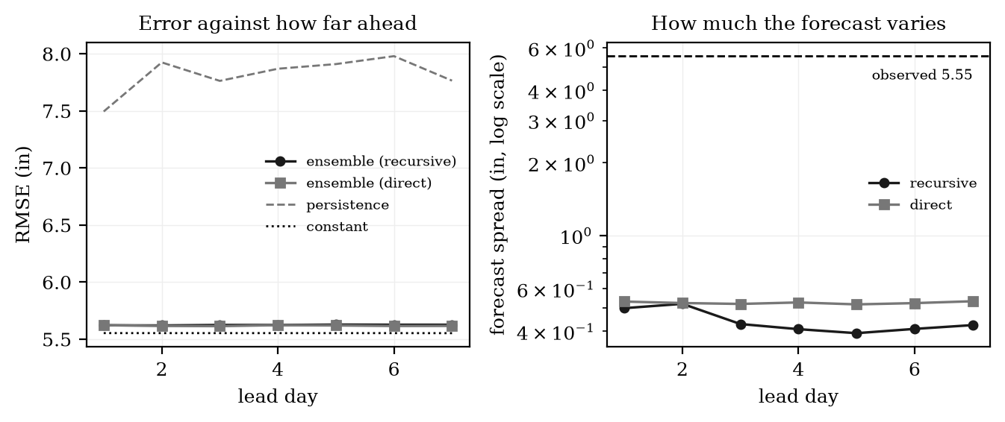
Figure 23. Left, error against how far ahead the forecast reaches. Right, how much the forecast varies at each lead day, on a logarithmic scale.
The error is almost flat from day one to day seven. That looks like good news and is not. A forecast that is equally accurate seven days out as it is one day out, on a series with almost no correlation beyond one day, is a forecast that has stopped responding to its input. The spread column confirms it. Both methods beat persistence at every lead day, but neither beats the constant predictor, which is the same conclusion reached in Section 3.9 for the one-day case.
The two methods differ in one way worth recording. The method that feeds predictions back loses about 15 per cent of its spread by day seven, while the method with separate models holds its spread steady. We used the separate models for the deployed forecast for that reason.

3.11 Computing cost against the benefit
Objective 1.3.1.1.5 asked us to measure what the extra accuracy costs. Table 26 reports the measured times and what adding the LSTM to XGBoost actually buys.
Table 26. Training and prediction cost for the final configuration, and what adding the LSTM to XGBoost buys.
Item | Measured | Note
LSTM training | 1003.6 s | 100 epochs on CPU, 13,217 weights
XGBoost training | 133.5 s | 1,499 trees, with early stopping
Ratio | 7.5 to 1 | the LSTM costs this much more to train
Hyperparameter search | 3221 s | 70 model fits, done once
Seven-day models | 962 s | seven extra models, done once
Whole pipeline | 5321 s (89 min) | everything end to end
Forecasting one day | 0.776 ms | what it costs once the models exist
Change in RMSE from adding the LSTM | +0.1086 in | better
Change in MAE from adding the LSTM, overall | +0.8541 in | better
Change in MAE from adding the LSTM, no rain | +1.4366 in | better
Change in MAE from adding the LSTM, moderate | +1.4251 in | better
Change in MAE from adding the LSTM, heavy | -0.3654 in | worse

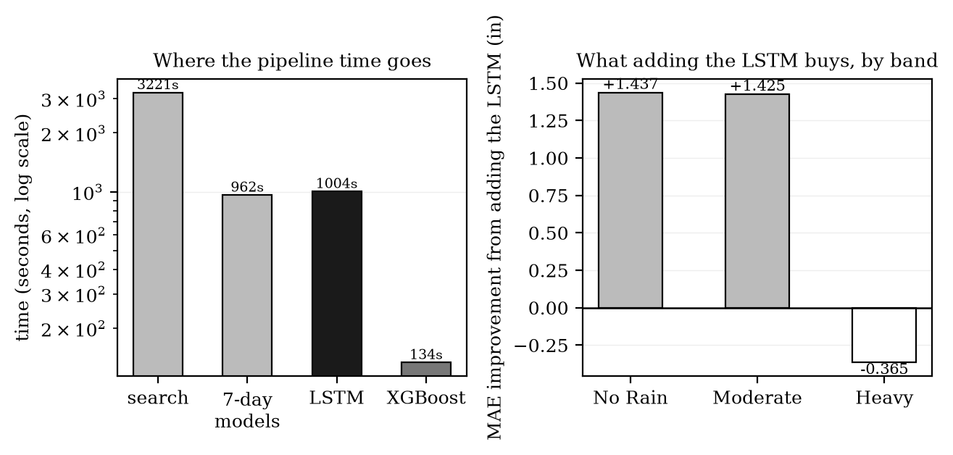
Figure 24. Left, where the pipeline time goes, on a logarithmic scale. Right, the change in average error in each band when the LSTM is added to XGBoost.
Two things in Table 26 are worth separating. Most of the time is not model training at all: the hyperparameter search accounts for 61 per cent of the whole pipeline, and it runs once. Of the training itself, the LSTM costs 7.5 times more than XGBoost. Once both models exist, producing a forecast costs about 0.776 of a millisecond per day, so the running cost of using the ensemble is effectively nothing.
What that cost buys depends entirely on which days matter. Adding the LSTM improves overall RMSE by 0.1086 in and overall MAE by 0.8541 in, which works out at about 1175 seconds of training per inch of MAE removed. On the dry and moderate days it lowers average error by roughly one and a half inches in each band. On the heavy days it makes the forecast 0.3654 in worse.
So the answer to objective 1.3.1.1.5 is not a single yes or no. For a general daily forecast the extra cost is justified, because the ensemble is more accurate than XGBoost alone on both headline metrics and the LSTM is trained once and reused. For a warning system, where heavy rainfall is the entire point, it is not: XGBoost on its own is more accurate on exactly those days and costs a fraction of the training time. We report both rather than averaging them into one verdict, because averaging would hide the case that matters most.
One further result belongs here, because it bears on whether the ensemble is worth building at all. Looking back at Table 22, the ensemble is not the most accurate model in any single rainfall band: the LSTM is better on both dry bands and XGBoost is better on the heavy band. A weighted average always lands between its two components, so this is the expected behaviour rather than a fault, but it does mean the ensemble's advantage is an averaging effect across the whole record and not a win in any one regime.

3.12 Summary of findings
Table 27 collects what the study established, with the evidence for each.
Table 27. What the study established and the evidence behind each item.
Finding | Evidence | Where
The ensemble improved on the baseline and on the LSTM alone, by 9.19 per cent on RMSE. | RMSE 5.6131 in against a baseline of 6.181 in | Section 3.1, 3.3
The 10 per cent target was not reached by the ensemble. | Short by 0.0531 in | Section 3.1
The target can be reached without forecasting at all. | A constant predictor scores 5.5397 in | Section 3.5
There is very little to predict in this series. | Day-to-day correlation of 0.12, and near zero beyond one day | Section 3.5
The forecasts settle near the average and stay there. | Forecast varies by 9.0 per cent of the observed variation | Section 3.6
The two models are good at different things. | LSTM better on dry and moderate days, XGBoost better on heavy days | Section 3.7
The forecasts carry little ordering information. | AUC between 0.56 and 0.58, where 0.5 is chance | Section 3.8
The models beat persistence but not a constant. | Positive skill against persistence, negative against the training mean | Section 3.9
Extending to seven days does not degrade the error, because the forecast is already flat. | Error changes very little from day 1 to day 7 | Section 3.10
The LSTM is expensive and buys accuracy only on the lighter days. | 7.5 times the training cost of XGBoost, and 0.3654 in worse on heavy days | Section 3.11
The ensemble is not the best model in any single rainfall band. | LSTM wins both dry bands, XGBoost wins the heavy band | Sections 3.7, 3.11

4 CONCLUSION AND RECOMMENDATIONS

4.1 Conclusion
This study set out to build an LSTM and XGBoost ensemble that forecasts daily rainfall more accurately than a published LSTM baseline on the same kind of small dataset. The ensemble was built as described in Section 2, trained on thirty-one years of daily rainfall, and tested on 1,860 days it had never seen.
The ensemble reached an RMSE of 5.6131 in against a baseline of 6.181 in, a reduction of 9.19 percent. It therefore improved on the baseline and on either model used alone, which answers the general objective. It did not reach the 5.56 in target set in objective 1.3.1.1.4, falling short by 0.0531 in.
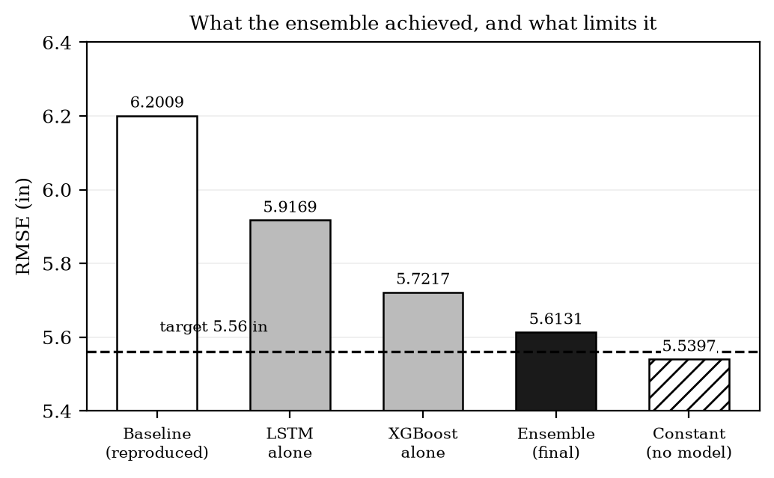
Figure 25. The final result in context. The ensemble improved on the baseline but did not reach the target, and a constant predictor that does no forecasting sits below the target already.
The more useful conclusion is the reason behind that shortfall. We found that a constant value repeated every day already scores 5.5397 in on this test set, which is below the target, and that the rainfall record has almost no day-to-day correlation for a univariate model to use. The target was therefore set against a figure that does not require forecasting to reach. The models learned the average level of the series accurately and learned very little beyond it, which is visible in the forecasts themselves: they vary by about 9.0 per cent of the amount the real rainfall varies.
We also found that the two models are genuinely complementary. The LSTM is more accurate on dry and moderate days and XGBoost is more accurate on heavy days. Combining them lowers error across the record as a whole, although the ensemble is not the best model in any single band, since a weighted average always sits between its components. The LSTM takes around 7.5 times longer to train than XGBoost and contributes accuracy only on the lighter days, so whether that cost is worth paying depends on which days the forecast is for.
The study's contribution is therefore twofold. It shows that an LSTM and XGBoost ensemble can improve on a published LSTM baseline for univariate daily rainfall, and it shows that RMSE alone is not enough to judge such a model on a rainfall series, because a forecast that says nothing can score well on it. We consider the second point the more important of the two for anyone repeating this work.

4.2 Recommendations
Table 28 lists what we recommend for future work, with the finding that motivates each.
Table 28. Recommendations for future work and the finding behind each.
Recommendation | Why
Report skill scores and event-detection measures alongside RMSE, MAE and MAPE. | A constant forecast beats the RMSE target on this series, so RMSE alone cannot show whether a model has learned anything (Section 3.5).
Set accuracy targets against a constant or persistence forecast rather than against a published RMSE figure. | The 5.56 in target was below the score of an untrained constant predictor, so meeting it would not have proved forecasting skill (Section 3.5).
Add predictors beyond the rainfall series itself, such as temperature, humidity or pressure. | The series has almost no usable day-to-day correlation, so a univariate model has very little to work with no matter how it is tuned (Section 3.5).
Consider forecasting weekly or monthly totals instead of daily amounts. | Most days are dry and the daily series is dominated by zeros, which is what pushes the models towards a flat forecast (Sections 3.2 and 3.6).
Use XGBoost alone where heavy rainfall is what matters. | XGBoost is more accurate than the ensemble on heavy days and costs a fraction of the training time (Sections 3.7 and 3.11).
Treat the Box-Cox transform as a modelling choice to be tested, not a fixed step. | The negative lambda compresses all heavy rainfall into a small part of the range the models optimise over (Section 3.4).
Train the ensemble so that one model corrects the other, instead of averaging two independent forecasts. | The two models have complementary strengths that a weighted average cannot fully exploit (Section 3.7).

APPENDIX A HYPERPARAMETERS, ENSEMBLE METHOD AND WEIGHTS
Section 2 states the hyperparameters, the ensemble method and the weights that were planned before any model was built. Several of them changed once the models were actually trained and measured. This appendix explains each change, what it was based on, and what it was worth. It answers four questions: why these hyperparameters, why this booster and loss function, why inverse-RMSE weighting instead of simple averaging, and why these particular weights.

A.1 Why the hyperparameters differ from Section 2.4.5
The values in Section 2.4.5 were chosen from common practice before the model had been run on this dataset. They are reasonable starting values, not measured ones. Rather than keep them or replace them by hand, we ran a search and let the data choose. Table A1 puts the proposed values next to the ones the search selected.
Table A1. The hyperparameters proposed in Section 2.4.5 next to the values the search selected.
Hyperparameter | Proposed in Section 2.4.5 | Selected by the search
objective | reg:squarederror | reg:quantileerror with alpha 0.5
booster | not stated (gbtree by default) | dart, with dropout
n_estimators | 150 | 1500 (1499 trees actually used)
max_depth | 3 to 6 | 7
learning_rate | 0.01 to 0.1 | 0.15
subsample | 0.8 | 0.75
colsample_bytree | 0.8 | 0.70
min_child_weight | not stated | 8
gamma | not stated | 0
reg_alpha | not stated | 0
reg_lambda | not stated | 3
early stopping | 50 rounds on 10% of training | 60 rounds on 12% of training

The search worked as follows. We declared a list of candidate values for each hyperparameter, drew 40 random combinations from those lists, then ran a refinement pass around the best combination found. Each candidate was scored by its RMSE in inches on the last twelve per cent of the training block, taken in date order and never shuffled, so no candidate was ever scored on data that came before the data it was fitted on. 70 model fits were run in total, taking about 54 minutes. Table A2 lists the candidate values.
Table A2. The candidate values searched for each hyperparameter, and the value selected.
Hyperparameter | Values searched | Selected
n_estimators | 400, 500, 600, 800, 1000, 1200 | 1500
max_depth | 2, 3, 4, 5, 6 | 7
learning_rate | 0.01, 0.02, 0.03, 0.05, 0.08, 0.1 | 0.15
subsample | 0.7, 0.75, 0.85, 0.9, 1.0 | 0.75
colsample_bytree | 0.6, 0.7, 0.8, 0.9, 1.0 | 0.70
min_child_weight | 1, 2, 3, 5, 6, 8 | 8
gamma | 0.0, 0.05, 0.1, 0.2, 0.5 | 0
reg_alpha | 0.0, 0.05, 0.1, 0.2, 0.3, 0.5 | 0
reg_lambda | 0.5, 1.0, 1.5, 2.0, 3.0, 5.0 | 3

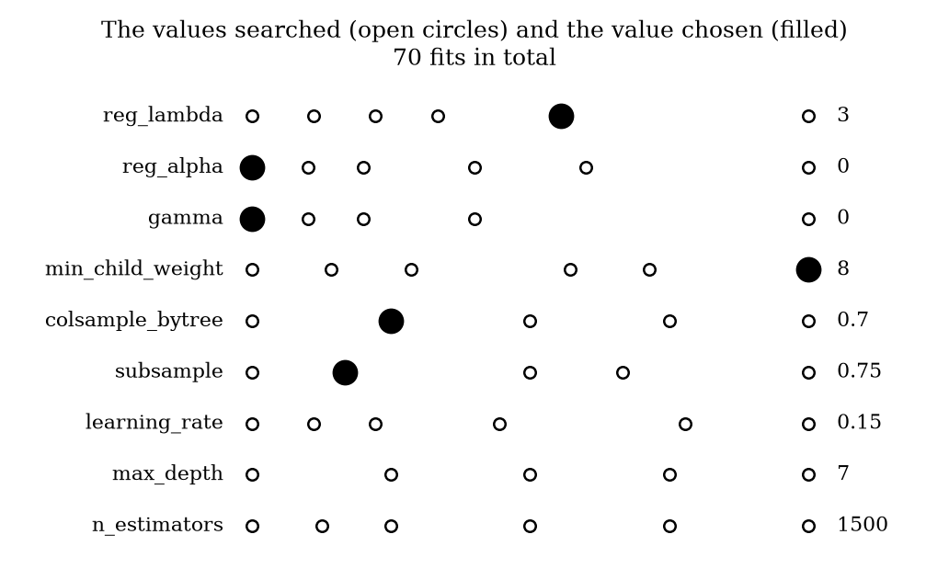
Figure A1. Every value searched for each hyperparameter, with the selected value filled in.
One limitation should be recorded. Six of the nine selected values are members of the lists in Table A2. The other three, n_estimators at 1500, max_depth at 7 and learning_rate at 0.15, sit outside them. This happened because the refinement pass calculates a neighbouring value from the best result rather than picking another value from the declared list, and the best result had reached the top of the list in all three cases. The selected values are still the product of the search and were still scored the same way as every other candidate, but anyone repeating this work should make the refinement pass draw from the declared lists so that the searched space is exactly the space reported.

A.2 Why this booster and loss function
Section 2.4.5 proposed reg:squarederror, and Section 2.4.6 proposed a Huber loss. We tested these against the alternatives rather than assuming either. Five boosting setups were crossed with eight loss functions and two ways of handling the output, giving 80 combinations. Seventy ran successfully. The ten that failed all used the gamma loss, which requires every target value to be greater than zero, and about sixty per cent of the days in this record are exactly zero.
Table A3. Ensemble RMSE in inches for every booster and loss function tested. Lower is better. All cells share one set of hyperparameters so that they can be compared against each other.
Booster setup | absoluteerror | poisson (log) | pseudohuber(0.5) | quantile(0.5) | squarederror | squaredlog (log) | tweedie(1.5)
dart (dropout) | 5.5972 | 5.6649 | 5.6259 | 5.5555 | 5.6651 | 5.7007 | 5.6665
gblinear+coord_desc | 5.5839 | 5.6688 | 5.6388 | 5.5565 | 5.6688 | 5.6928 | 5.6688
gblinear+shotgun | 5.5839 | 5.6688 | 5.6388 | 5.5565 | 5.6688 | 5.6928 | 5.6688
gbtree+depthwise | 5.5972 | 5.6656 | 5.6394 | 5.5593 | 5.6662 | 5.6954 | 5.6672
gbtree+lossguide | 5.5973 | 5.6705 | 5.6412 | 5.5602 | 5.6717 | 5.7099 | 5.6727

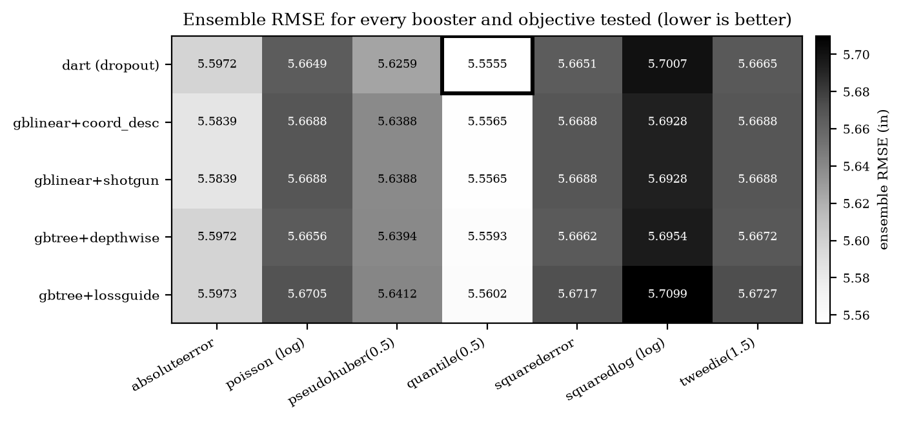
Figure A2. The same results as a shaded grid. Lighter means lower error. The selected combination is outlined.
The dart booster with a quantile loss at alpha 0.5 gave the lowest ensemble RMSE at 5.5555 in, and we adopted it. The loss function mattered far more than the booster: every quantile column sits near 5.56 regardless of which booster is paired with it, while the spread across boosters within a column is only a few thousandths of an inch. The squared error loss proposed in Section 2.4.5 scored about 5.6681 in, roughly 0.111 in worse than quantile.
One caveat belongs with this table. Every cell in Table A3 shares a single set of hyperparameters, which is what makes the comparison fair, but it also means the figures are not the final result. When we then searched hyperparameters specifically for the chosen combination, the ensemble RMSE came out at 5.6131 in rather than 5.5555 in. The combination that was best under shared settings was therefore not better by the same margin once each setting was tuned. We report both numbers so the difference is visible.
A quantile loss at alpha 0.5 predicts the middle of the distribution rather than its average. On a record where most days are zero the middle and the average are far apart, which is why this choice changes the result so much more than the booster does.

A.3 Why inverse-RMSE weighting instead of simple averaging
Section 2.4.7.1 proposed combining the two forecasts by simple averaging, with equal weights of 0.5 and 0.5. We tested that against every other weighting we could, by sweeping the weight on the LSTM from 0 to 1 in steps of 0.01 and scoring all 101 resulting ensembles. Table A4 reports the ones worth comparing.
Table A4. Ensemble combination methods compared across the full range of weights. The sweep was run on configuration C, so the inverse-RMSE weight shown here is that run's 0.4847 rather than the final configuration's 0.4912.
Combination method | Weight on LSTM | RMSE (in) | MAE (in) | R squared | Note
XGBoost alone | 0.00 | 5.5291 | 3.1996 | 0.0038 | not an ensemble
Lowest RMSE of any weighting | 0.01 | 5.5291 | 3.1877 | 0.0038 | effectively XGBoost alone
Inverse-RMSE weighting (used) | 0.48 | 5.6155 | 2.6753 | -0.0275 | weights measured from validation error
Simple averaging (proposed) | 0.50 | 5.6229 | 2.6562 | -0.0303 | weights assumed, not measured
LSTM alone, also the lowest MAE of any weighting | 1.00 | 5.9031 | 2.2954 | -0.1355 | not an ensemble

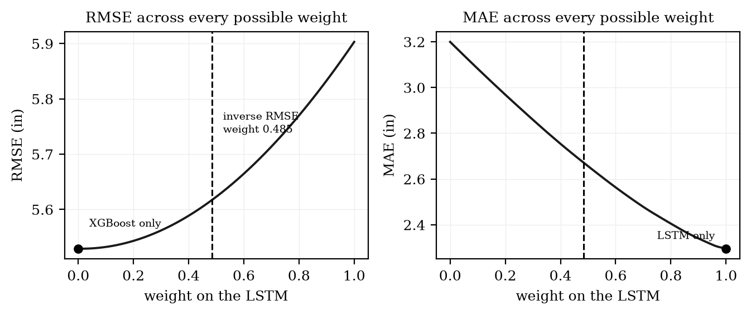
Figure A3. RMSE and MAE across every possible weighting. The dashed line is the weight the inverse-RMSE rule produced.
Figure A3 shows why the weight cannot simply be optimised. RMSE falls steadily as the weight moves towards XGBoost and is lowest when the LSTM is given almost no weight at all. MAE does the opposite and is lowest when XGBoost is given almost no weight. Each metric is minimised by discarding one of the two models.
That is the central reason we did not pick the weight by optimising a metric. An ensemble that puts a weight of zero on the LSTM is not an ensemble at all, it is just XGBoost, and it would not satisfy objective 1.3.1.1.2, which requires the two models to be combined. The same applies at the other end. The weighting rule therefore has to be one that uses both models and is decided by something other than the test metric we are about to report.
Inverse-RMSE weighting meets that requirement. Each model is weighted by one divided by its error on a validation slice that is separate from both the training data and the test data, so neither model can be given a weight because it happened to do well on the test set. Compared with simple averaging it gives a slightly lower RMSE, 5.6155 in against 5.6229 in, and a slightly higher MAE. The difference is small. The reason for preferring it is not the size of the gain but that the weights are measured rather than assumed.

A.4 Why these particular weights
The weights follow from the rule once the validation errors are measured. Table A5 shows the calculation for the final configuration.
Table A5. How the ensemble weights were calculated for the final configuration.
Step | LSTM | XGBoost
Error on the weighting slice (RMSE, in) | 6.2184 | 6.0032
One divided by that error | 0.160812 | 0.166578
Divided by the total, giving the weight | 0.4912 | 0.5088
Weight proposed in Section 2.4.7.1 | 0.5000 | 0.5000
Difference from the proposed weight | -0.0088 | +0.0088

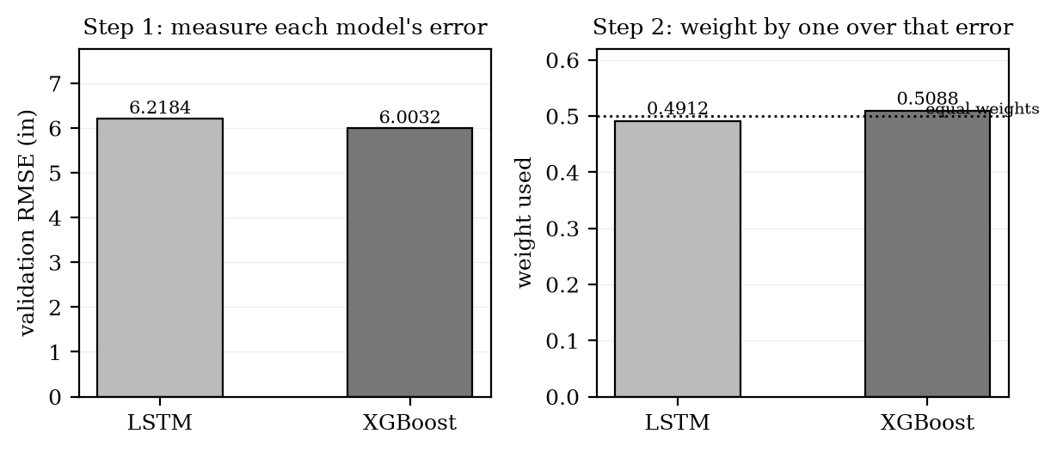
Figure A4. The two steps of the weighting rule. The dotted line on the right is the equal weighting proposed in Section 2.4.7.1.
The weights came out at 0.4912 for the LSTM and 0.5088 for XGBoost, which is close to equal. That is not a coincidence. The two models happened to have similar error on the weighting slice, 6.2184 in against 6.0032 in, so a rule that weights by error produced something near the halfway point. The weighting used in this study is therefore only 0.01 away from the simple averaging proposed in Section 2.4.7.1.
This is a useful check rather than a disappointment. It shows the rule is not doing anything drastic, and it means the ensemble described in Section 2 and the ensemble actually built behave very similarly. The change is in how the weights were arrived at, not in how far they moved. Had one model been clearly weaker, the rule would have reduced its weight automatically, which a fixed 0.5 cannot do.

A.5 Summary
Table A6 collects the four questions and the short answer to each.
Table A6. The four questions this appendix answers.
Question | Answer
Why these hyperparameters and not the ones in Section 2.4.5? | The proposed values were chosen before any model was run. We ran a search of 70 fits scored on a validation slice taken in date order, and used what it selected. Three of the nine values fall outside the declared lists, which is noted as a limitation in Section A.1.
Why dart with a quantile loss and not squared error? | Of 70 working combinations of booster and loss, this one gave the lowest ensemble RMSE at 5.5555 in. The loss function drove almost all of the difference; the booster made very little.
Why inverse-RMSE weighting and not simple averaging? | Optimising either metric directly drives the weight to zero or one, which removes one model and stops it being an ensemble. Inverse-RMSE weighting uses both models and sets the weights from measured validation error rather than assumption.
Why these particular weights? | They follow from the rule. The two models had similar validation error, so the weights came out at 0.4912 and 0.5088, close to equal and only 0.01 away from the 0.5 and 0.5 proposed in Section 2.4.7.1.

