
RECORA
Offline Receipt Reconstruction and Purchase Tracking System
Using On-Device OCR and Automated Receipt Validation

Baseline engineering specification • Version 1.0 • October 2026

Design principle: Capture → Reconstruct → Validate → Track

1. Executive Summary
Recora is a privacy-focused, offline-first mobile application that converts photographed printed receipts into structured, validated, searchable purchase records. The application is intentionally simple at the user-interface level while maintaining substantial technical depth in image preparation, on-device OCR, receipt structure reconstruction, confidence scoring, numerical reconciliation, local correction learning, and item-level purchase history.
The project is not positioned as an invention of OCR or receipt scanning. Its engineering contribution is the reliable transformation of imperfect receipt images into usable local records while explicitly detecting uncertainty rather than silently accepting extraction errors.
Approval condition: Recora must remain focused on receipt reconstruction and purchase tracking. Banking, payments, cloud accounts, social features, and full personal finance management are outside the approved scope.

2. Project Identity
Application name | Recora
Name rationale | Receipt + Organize
Formal system title | Recora: An Offline Receipt Reconstruction and Purchase Tracking System Using On-Device OCR and Automated Receipt Validation
Primary platform | Mobile application
Operating model | Offline-first / local-first
Core value proposition | Turn a physical receipt into a validated, searchable item-level purchase record without requiring an internet connection.

3. Problem Definition
Physical receipts are common records of everyday purchases but are difficult to retain, organize, and search. Photos preserve visual evidence but remain unstructured. Manual encoding creates structured records but imposes high effort. OCR reduces encoding effort, yet raw OCR output is not equivalent to a reliable purchase record because receipts vary by merchant and often contain ambiguous spacing, abbreviations, multiple numeric columns, discounts, taxes, and poor print quality.
The core engineering problem is therefore not simply “read text from an image.” Recora must determine which extracted lines represent merchant metadata, individual products, quantities, prices, discounts, taxes, and totals; evaluate whether the values are internally consistent; identify uncertain fields; and allow the user to correct the record before it becomes part of purchase history.

4. Project Objectives

4.1 General Objective
Design and develop an offline mobile receipt-management system capable of converting photographed printed receipts into validated, structured, and searchable purchase records using on-device OCR and local processing.

4.2 Specific Objectives
1. Develop a receipt-capture workflow using the device camera or an existing image.
2. Preprocess receipt images through cropping, rotation, perspective correction, and readability enhancement.
3. Perform text recognition locally without requiring a remote OCR API for normal operation.
4. Reconstruct merchant metadata, purchased items, quantities, unit prices, line totals, discounts, taxes, and final totals from OCR output.
5. Assign confidence values to extracted fields and direct user attention toward uncertain information.
6. Validate numerical relationships between line items, discounts, taxes, charges, subtotals, and printed totals.
7. Provide an efficient review-and-correction interface before saving.
8. Store receipt data, images, corrections, and history locally.
9. Provide search by item, merchant, category, and date.
10. Build item-level price and purchase history while preserving the original receipt text.
11. Allow merchant-specific correction patterns to improve future local parsing without cloud training.

5. Scope and Boundaries

5.1 In Scope
- Receipt photo capture and gallery import
- Image quality preparation
- Offline OCR
- Receipt field extraction
- Line-item reconstruction
- Confidence scoring
- Numerical receipt validation
- User correction before save
- Local receipt and item storage
- Search and filtering
- Basic item categories
- Price history and purchase frequency
- Merchant-specific local correction rules
- Optional local export/backup as a later controlled feature

5.2 Explicitly Out of Scope
- Bank account integration
- Payment processing
- Point-of-sale integration
- Cloud account requirement
- Remote AI dependency for primary receipt processing
- Social/community features
- Loyalty and rewards programs
- Advertising
- Enterprise expense approval workflows
- Tax filing or accounting compliance automation
- Full budgeting or investment management
- Price scraping from online stores
Any proposed feature that does not directly improve receipt reconstruction, verification, storage, retrieval, or purchase history requires a separate scope review.

6. Target Users and Primary Use Cases
Recora is intended for individuals who want a lightweight way to preserve and organize purchase details without maintaining paper receipts or depending on cloud services. The app should remain usable by non-technical users.
Use Case | User Goal | Required System Response
Scan a new receipt | Digitize a recent purchase | Capture, extract, reconstruct, validate, review, save
Find an old purchase | Locate when/where an item was bought | Search item-level history and open source receipt
Check previous price | Compare current vs earlier purchase | Show historical prices with dates and merchants
Correct OCR error | Fix a wrong item or amount | Allow field edit and recalculate validation
Review suspicious receipt | Resolve mismatch or low confidence | Highlight affected fields and explain the issue

7. End-to-End System Workflow
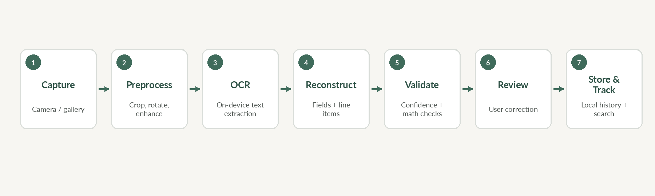
1. Capture: user photographs a receipt or imports an existing image.
2. Preprocess: system corrects crop, orientation, perspective, brightness, and contrast where required.
3. OCR: text and spatial information are extracted on-device.
4. Reconstruct: parser groups lines into merchant metadata, item rows, and summary fields.
5. Validate: confidence rules and receipt arithmetic are evaluated.
6. Review: uncertain or inconsistent values are surfaced for correction.
7. Store and track: validated data is saved locally and becomes searchable purchase history.

8. Functional Requirements
ID | Requirement | Specification | Priority
FR-01 | Capture receipt | Camera capture shall support a clear receipt-focused framing flow. | Must
FR-02 | Import image | User shall be able to select an existing receipt image. | Must
FR-03 | Crop/rotate | User/system shall correct crop and orientation before OCR. | Must
FR-04 | Perspective correction | System shall reduce keystone distortion when practical. | Should
FR-05 | Image enhancement | System shall apply restrained contrast/brightness/sharpness enhancement when useful. | Should
FR-06 | Offline OCR | Primary OCR shall execute without network connectivity. | Must
FR-07 | Merchant extraction | System shall attempt to identify merchant/store name. | Must
FR-08 | Date/time extraction | System shall identify transaction date and time when present. | Must
FR-09 | Line-item reconstruction | System shall group product names, quantities, unit prices, and line totals into structured rows. | Must
FR-10 | Summary extraction | System shall extract subtotal, discount, tax/charges, and final total when present. | Must
FR-11 | Confidence scoring | Each critical field shall carry a confidence or review state. | Must
FR-12 | Numerical validation | System shall compare reconstructed totals against the printed total using tolerance rules. | Must
FR-13 | Review screen | System shall present extracted data before permanent save. | Must
FR-14 | Manual editing | User shall be able to edit critical fields and line items. | Must
FR-15 | Validation recalculation | Validation status shall update after an edit. | Must
FR-16 | Local storage | Receipt records shall be stored locally. | Must
FR-17 | History | Saved receipts shall be chronologically browsable. | Must
FR-18 | Search | User shall search by item, merchant, category, and supported date range. | Must
FR-19 | Price history | System shall show prior purchases for a normalized item. | Should
FR-20 | Correction learning | System may remember merchant-specific corrections locally. | Should
FR-21 | Delete record | User shall be able to delete a receipt and associated derived records safely. | Must
FR-22 | Original evidence | When enabled, the original receipt image shall remain linked to its structured record. | Must

9. Non-Functional Requirements
ID | Quality | Requirement
NFR-01 | Offline availability | Core scanning, extraction, review, storage, search, and history shall remain functional without internet.
NFR-02 | Privacy | Receipt data shall remain local unless the user explicitly exports or shares it.
NFR-03 | Performance | Normal receipt processing should provide visible progress and avoid blocking the UI.
NFR-04 | Reliability | A failed scan shall not corrupt previously saved receipt data.
NFR-05 | Transparency | The system shall distinguish confident extraction from uncertain or mismatched data.
NFR-06 | Usability | A normal successful scan should require minimal taps after capture.
NFR-07 | Accessibility | Critical information shall not rely on color alone; text size and touch targets must remain readable and usable.
NFR-08 | Maintainability | OCR, parsing, validation, storage, and UI logic shall be separated into testable modules.
NFR-09 | Data integrity | Amounts shall use decimal-safe storage rather than binary floating-point for persisted currency calculations.
NFR-10 | Recoverability | App interruption during processing shall not create a false completed receipt record.

10. System Architecture
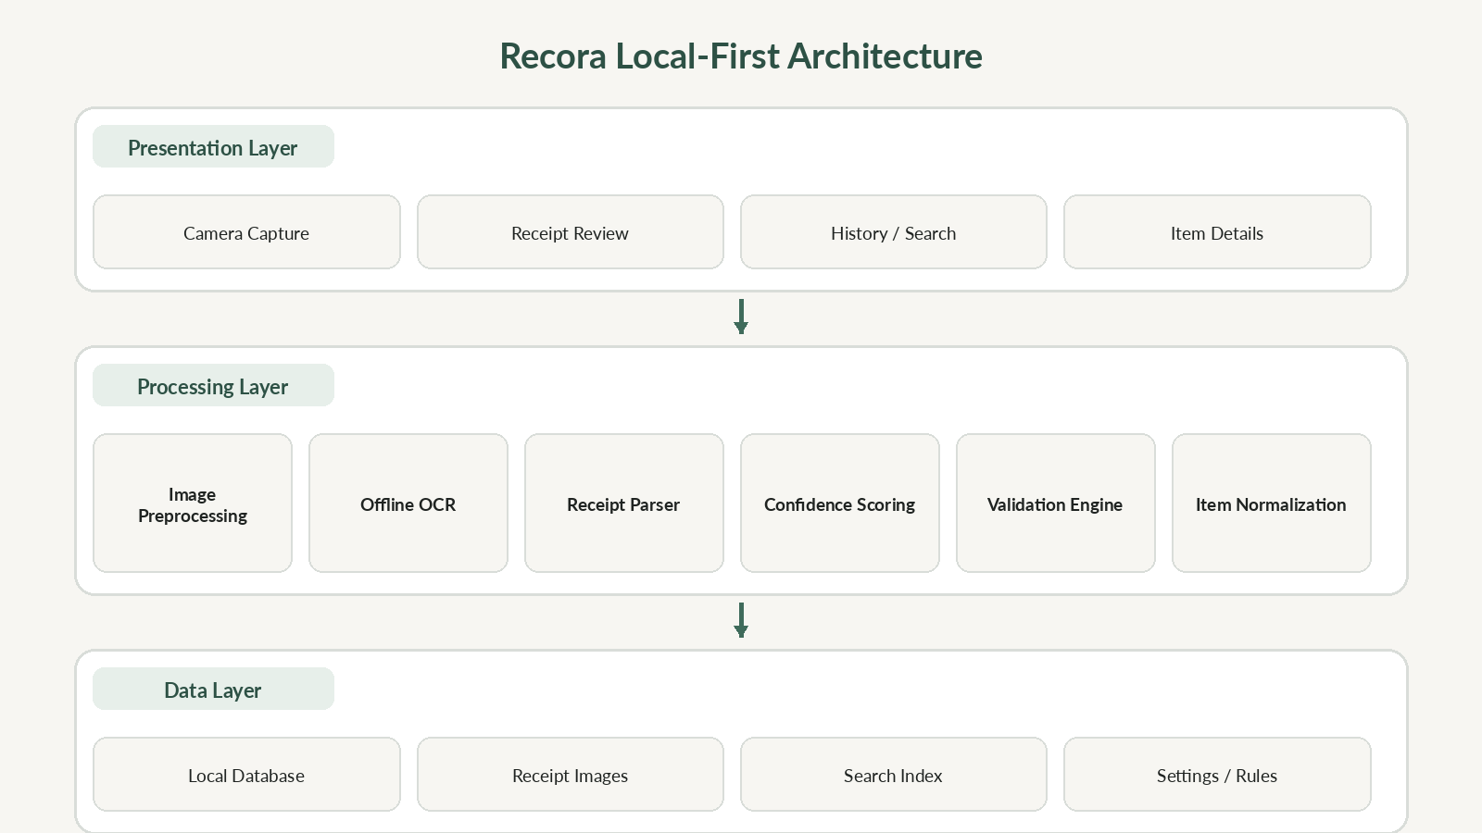

10.1 Architectural Principle
Recora shall use a modular local-first architecture. Camera and review interfaces must not contain receipt parsing rules. OCR should produce observations; the parser converts observations into candidate fields; the validation engine evaluates consistency; storage persists only reviewed/accepted records. This separation is required to make the system testable and to avoid coupling UI changes with OCR logic.

10.2 Recommended Modules
- CaptureService – image acquisition and metadata
- ImagePreprocessor – crop, orientation, perspective, readability enhancement
- OcrEngine – on-device OCR adapter
- ReceiptParser – line grouping and field classification
- ValidationEngine – numerical checks and rule evaluation
- ConfidenceEngine – field confidence and review priority
- NormalizationService – item aliases and merchant-specific mappings
- ReceiptRepository – transactional local persistence
- SearchIndex – item/merchant/date lookup
- HistoryService – price and purchase history queries

11. OCR and Receipt Reconstruction Pipeline

11.1 Image Quality Gate
Before OCR, the app should detect obvious quality problems such as severe blur, extreme darkness, clipping, or incomplete receipt framing. The app should request a retake only when quality is clearly insufficient; unnecessary rejection would make the workflow frustrating.

11.2 OCR Output
The OCR layer should return recognized text together with bounding boxes and confidence values when supported. Spatial information is important because receipt interpretation depends on row alignment and column position, not text alone.

11.3 Structural Reconstruction
- Detect merchant/header region near the top.
- Detect date/time using constrained patterns and contextual labels.
- Identify candidate item rows between header and totals sections.
- Associate quantities and prices using spatial alignment and numeric patterns.
- Detect subtotal, discount, tax/VAT, service/other charges, and final total labels.
- Preserve raw OCR text alongside normalized values for traceability.

11.4 Ambiguity Policy
The parser must prefer “uncertain” over “confidently wrong.” If multiple interpretations are plausible, the app should retain alternatives or mark the field for review rather than invent a definitive value.

12. Receipt Validation Model
Validation is a core differentiator. Recora should reconcile extracted amounts while accounting for rounding and receipt-specific adjustments.
Baseline rule: Sum(line totals) − discounts + taxes/charges ± rounding ≈ printed final total. The rule is a consistency check, not proof that every field is semantically correct.

Validation Check | Example | System Response
Line arithmetic | Qty × unit price differs from line total | Flag line; prefer printed line total until reviewed
Subtotal match | Sum of line totals differs from subtotal | Flag likely missing/misread item or promotion
Final total match | Subtotal − discounts + charges differs from total | Flag summary fields and affected lines
Date plausibility | Recognized date is malformed/impossible | Require correction
Negative/zero amount | Unexpected negative or zero line | Check whether it is a discount/return
Duplicate line | Same OCR row captured twice | Suggest merge, never auto-delete without confidence

13. Confidence and Review Model
Confidence should be derived from multiple signals rather than OCR confidence alone. A field can have clear text but still be structurally inconsistent.
- OCR confidence
- Expected data pattern (date, currency, quantity)
- Spatial alignment with neighboring fields
- Receipt arithmetic consistency
- Merchant-specific learned formatting
- Agreement between repeated/summary values
State | Meaning | UI Behavior
Verified | High confidence and consistent | Normal display
Review | Uncertain but usable candidate | Highlight field; user confirmation recommended
Mismatch | Conflicts with receipt arithmetic or rules | Prominent warning and affected-field navigation

14. Local Learning and Item Normalization
Receipts often abbreviate products. Recora should preserve the raw description exactly while optionally linking it to a normalized item identity. Example: “COKE1.5PET,” “COKE 1.5L,” and “CK 1.5 PET” may later be linked to a user-confirmed normalized item such as “Coca-Cola 1.5 L.”
Normalization must not overwrite the original receipt text. The original extracted value is evidence; the normalized value is an organizational layer.

Merchant-specific correction learning should remain local and conservative. If a user repeatedly corrects the same token or layout pattern for one merchant, Recora may increase confidence in that correction for future receipts from the same merchant. The system should allow learned rules to be reset.

15. Data Model and Storage
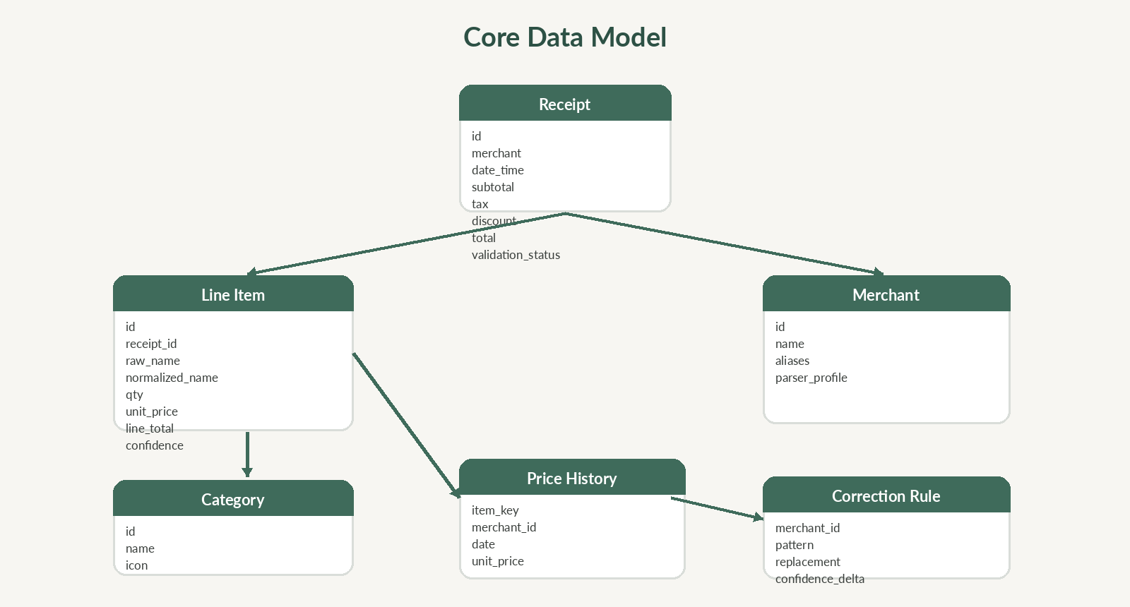

15.1 Core Entities
Entity | Purpose | Critical Fields
Receipt | Transaction-level record | merchant, date/time, subtotal, discounts, tax/charges, total, validation status, image reference
LineItem | Individual purchased item | raw name, normalized item, quantity, unit price, line total, confidence
Merchant | Store identity and optional local parsing profile | name, aliases, local formatting/correction rules
Category | Optional organizational grouping | name, icon/label
PriceHistory | Derived historical view | normalized item, merchant, date, unit price
CorrectionRule | User-confirmed local learning | merchant scope, pattern, correction, confidence adjustment

15.2 Currency Storage Rule
Persist monetary values using integer minor units (for example centavos) or a decimal-safe numeric type. Do not store persisted currency calculations as binary floating-point values because rounding errors can invalidate reconciliation logic.

16. User Interface and Theme Specification
The visual language should communicate organization and trust rather than banking or investment. The interface should resemble a clean digital receipt organizer.
Token | Value | Purpose
Background | #F7F6F2 | Warm paper-inspired canvas
Surface | #FFFFFF | Cards and receipt panels
Primary | #3F6B5B | Primary actions and brand accents
Primary Dark | #2D5145 | Headers and strong emphasis
Text | #1F2321 | Primary readable text
Secondary | #6F756F | Supporting information
Border | #E2E1DC | Dividers and table structure
Warning | #D99A3E | Review required
Error | #C94A4A | Validation mismatch

16.1 Primary Screens
- Home – recent receipts, search entry, and primary Scan Receipt action
- Capture – camera framing and quality guidance
- Review – structured receipt table with confidence/mismatch indicators
- Receipt Detail – immutable/raw evidence plus editable organizational metadata where appropriate
- History – chronological receipt list
- Search – item/merchant/date/category filtering
- Item History – previous prices, merchants, and purchase dates
- Settings – privacy, image retention, local learning reset, export/backup when implemented

16.2 UI Rules
- Do not hide validation status behind secondary screens.
- Warnings must explain what is wrong and which fields are affected.
- Do not use color as the only error indicator.
- Keep the primary successful flow to Capture → Review → Save.
- Avoid dashboard clutter and decorative analytics without a clear user decision attached.

17. Privacy and Security Requirements
Receipts can reveal purchasing behavior, merchant locations, timestamps, and payment fragments. Recora should therefore minimize data exposure.
- Process core receipt data on-device.
- Do not upload receipt images by default.
- Do not require an account for primary use.
- Use application-private storage for databases and retained images.
- Avoid storing full payment card numbers even if OCR detects them; sensitive payment strings should be excluded or redacted.
- Require explicit user action before export or sharing.
- Delete derived item/history records transactionally when their source receipt is deleted, unless the design explicitly retains anonymized aggregates.
- Document backup behavior clearly if device backups can include local app data.

18. Error and Edge-Case Handling
Scenario | Risk | Required Handling
Faded thermal paper | Low OCR confidence | Enhance conservatively; request retake if unusable
Long receipt | Cropping / memory pressure | Support segmented capture or downscaled processing while preserving text clarity
Crumpled receipt | Distorted line geometry | Perspective/deskew where possible; require review
Multiple tax/discount lines | Incorrect total formula | Represent summary adjustments explicitly instead of forcing one formula
Return/refund receipt | Negative amounts | Recognize transaction type or require manual classification
Duplicate OCR lines | Inflated total | Detect spatial duplicates and flag
Quantity encoded as “2@85” | Parser ambiguity | Use merchant/context rules and expose candidate quantity/unit price
Item spans two lines | Broken product name | Merge continuation line using geometry/context
No printed subtotal | Validation gap | Validate using available fields; do not fabricate subtotal
App closed mid-scan | Partial record | Discard or recover draft; never mark complete automatically
Wrong normalized item | Corrupt price history | Allow unlink/reassign; preserve raw item description

19. Testing and Quality Assurance Plan

19.1 Test Categories
- Unit tests – parsing rules, currency math, date recognition, normalization, confidence logic
- Integration tests – OCR output through parser and validation engine
- Database tests – transactions, delete cascades, migration, search consistency
- Offline tests – full scan/review/save/search with network disabled
- Image robustness tests – blur, perspective, shadows, low contrast, long receipts
- Merchant-layout tests – multiple receipt formats and summary structures
- Regression tests – saved corpus of representative receipt images with expected structured output
- Usability tests – successful scan effort, correction discoverability, error comprehension

19.2 Core Metrics
Metric | Definition | Baseline Acceptance Target
Critical-field accuracy | Correct merchant/date/total after extraction | ≥ 95% on defined test corpus after user-free extraction target phase
Line-item exactness | Correct item/amount pairing | Measured separately; target ≥ 90% on supported clean receipts
Total validation detection | Known arithmetic mismatches flagged | 100% for deterministic test cases
False mismatch rate | Valid supported receipts incorrectly flagged | ≤ 5% on controlled corpus
Offline completion | Scan→save without network | 100% for supported device/test set
Crash-free test runs | No app crash during defined scenarios | 100% in release candidate QA suite
Correction usability | User can locate and edit flagged field | 100% of tested critical fields reachable from review screen
Accuracy targets must be measured on a declared receipt corpus. Do not claim universal OCR accuracy from a small or curated sample.

20. Acceptance Criteria
1. A user can capture or import a supported printed receipt while offline.
2. The app produces a structured receipt containing at minimum merchant/date when available, line items, and final total candidates.
3. Low-confidence critical fields are visibly identified before saving.
4. An arithmetic mismatch is detected and clearly explained for deterministic mismatch test cases.
5. The user can edit extracted values and validation recalculates immediately or on explicit recheck.
6. A reviewed receipt can be saved locally and reopened after app restart.
7. An item from a saved receipt can be found through search.
8. Item history can show prior purchases without changing the original receipt evidence.
9. Deleting a receipt does not leave orphaned line items in user-facing history.
10. The primary scan-to-save workflow operates with network connectivity disabled.

21. Risks and Engineering Controls
Risk | Impact | Likelihood | Control
Receipt layout variability | High | High | Modular parser, confidence states, corpus-driven tests, manual correction
OCR numeric errors | High | Medium-High | Currency pattern checks and arithmetic reconciliation
Over-normalization of products | Medium | Medium | Preserve raw text; require reversible mappings
Slow on-device processing | Medium | Medium | Progressive processing, image sizing, profiling, modular optimization
Scope creep into finance app | High | High | Enforce explicit out-of-scope list and feature review
User distrust from silent errors | High | Medium | Surface uncertainty; never imply perfect extraction
Sensitive receipt information exposure | High | Low-Medium | Local storage, explicit export, payment-data redaction

22. Development Sequence
Phase | Focus | Exit Condition | Priority
1 | Project foundation + local database | Schema, migrations, repository tests pass | Critical
2 | Capture + image preprocessing | Reliable crop/orientation flow on target devices | Critical
3 | Offline OCR integration | Text + coordinates available offline | Critical
4 | Receipt parser | Structured fields and item rows from test corpus | Critical
5 | Validation + confidence | Mismatches and uncertain fields surfaced correctly | Critical
6 | Review + correction UI | User can resolve and save records safely | Critical
7 | History/search/price history | Structured data provides practical retrieval value | High

23. Features Deferred Until Core Quality Is Proven
- PDF/CSV export
- Encrypted manual backup/restore
- Advanced charts
- Multi-receipt batch capture
- User-defined tagging
- More sophisticated local product aliasing
- Optional multilingual receipt support
These features may be valuable, but none should delay accuracy, validation, correction, and data integrity. A smaller system that reliably reconstructs and validates receipts is stronger than a feature-rich system with unreliable extraction.

24. Project Evaluation
Recora has sufficient substance if development prioritizes correctness and transparency. The project becomes weak if it is reduced to camera + OCR + table display, because that capability is already common. Its defensible depth depends on structured reconstruction, confidence-aware review, receipt arithmetic validation, preservation of raw evidence, local learning, and reliable item-level retrieval.
Engineering verdict: APPROVED FOR DEVELOPMENT, with validation accuracy and parser robustness treated as the primary project risks. Feature count is not a success metric.

25. Definition of Done for Version 1
Version 1 is complete only when the core offline workflow is reliable enough to demonstrate end-to-end receipt reconstruction and validation on a defined test corpus.
- Offline capture/import works
- OCR works without network
- Structured receipt reconstruction works on supported corpus
- Critical fields expose confidence/review state
- Arithmetic validation works
- Manual correction works
- Local save/reopen works
- Search works at item level
- Price history is based on reviewed data
- Deletion and restart recovery preserve data integrity
- QA corpus and documented metrics exist
- No critical or high-severity unresolved defect remains in the demonstration path
RECORA
Capture. Reconstruct. Validate. Track.

