RESEARCH & ENGINEERING

TDC-KV Weekly Project Analysis
  - Tier-based KV Cache with Dependency-Aware Chunk Scoring
Reporting window: 30 July 2026 - 6 August 2026

An evidence-based review of repository evolution, experimental tooling, notebook pilots, validation status, risks, and the next execution priorities.
COMMITS IN SCOPE | NET FILES CHANGED | PILOT RUNS COMPLETED | CURRENT TESTS PASSED
19 | 68 | 80/80 | 121

Prepared 6 August 2026
Evidence sources: Git history and working tree, project documentation, saved notebook outputs, and a fresh test run

1. Executive Summary
OVERALL ASSESSMENT The week converted TDC-KV from a trace-driven prototype into a substantially more complete live-HuggingFace experiment system. The engineering foundation is now much stronger than the saved pilot quality results, which remain exploratory and expose several budget and retrieval failures that must be rerun under the new qualification path.
The most important outcomes were:
- A sparse chunk-dependency graph, cache manager, Transformers v4/v5 cache adapter, blockwise prefill path, and repeated decode-time re-eviction were added or materially strengthened.
- Dataset-aware metrics were implemented for GSM8K, NIAH, and HotpotQA, along with result aggregation, plotting, notebook-based staged execution, and exact-budget diagnostics.
- A paper-qualification work package now exists in the working tree: one-time prompt serialization and hashing, a fixed GSM8K eight-shot protocol, FullKV parity checks, stage timing and CUDA memory logging, checkpoint/resume, provenance, and a hard qualification gate.
- The saved Qwen2.5-0.5B pilot completed all 80 configured runs without runtime failures. However, GSM8K quality was weak, compressed NIAH retrieval was 0/15, and older GSM8K/NIAH runs underfilled requested budgets.
- A fresh current-state test run passed 121 tests. This validates the code paths covered by the suite, but it does not replace full GPU qualification or publication-scale experiments.

Decision-grade takeaways
Assessment | Scope
READY | Core architecture, cache compatibility, metrics, aggregation, regression coverage
CONDITIONAL | Local small-model qualification path and notebook orchestration
NOT READY | Final model-quality claims, official baseline claims, 7B/8B results, statistical significance

RECOMMENDATION Commit and tag the reconstructed Phase-1 qualification changes, then rerun the three pilots with the current dataset-aware metrics and exact-budget contract before investing in 7B/8B experiments.

2. Scope, Evidence, and Interpretation Rules
This report covers work visible in the repository from 00:00 IST on 30 July through the review performed on 6 August 2026. July 30-31 contained no commits in the current branch history; the first in-scope commit was on August 1.

Evidence hierarchy
- Git commits establish the dated record of committed activity. Nineteen commits touched 70 unique paths during the window.
- The current working tree establishes work completed after the August 5 reverts but not yet committed: 13 modified tracked files plus nine untracked modules/tests.
- Saved notebook outputs establish the reported exploratory numbers. Only notebooks/test.ipynb contains executed outputs; the quickstart and controlled-testing notebooks are staged runbooks without saved execution results.
- A fresh pytest run on August 6 establishes current regression status: 121 passed in 49.87 seconds, with one non-functional cache-write warning.

Change-volume snapshot
NET INSERTIONS VS. JUL 29 BASE | NET DELETIONS VS. JUL 29 BASE | CURRENT WORKING-TREE FILES | NOTEBOOKS IN REPOSITORY
11,228 | 2,355 | 22 | 3

Net change compares the current working tree with commit 4118943, the final commit before the reporting window. It includes current uncommitted work and excludes ignored/generated output directories.

Interpretation limits
- Commit messages describe intent, not proof of correctness; test and notebook evidence are reported separately.
- Notebook pilots use Qwen/Qwen2.5-0.5B-Instruct with only 5-10 samples per task/configuration. They are diagnostic, not statistically stable.
- The notebook runs predate parts of the current qualification layer, so budget underfill and missing dataset-aware fields in older outputs are themselves findings.
- No motive is inferred for the August 5 reverts. The report records the rollback and the subsequent reconstructed working-tree state only.

3. Weekly Activity Record
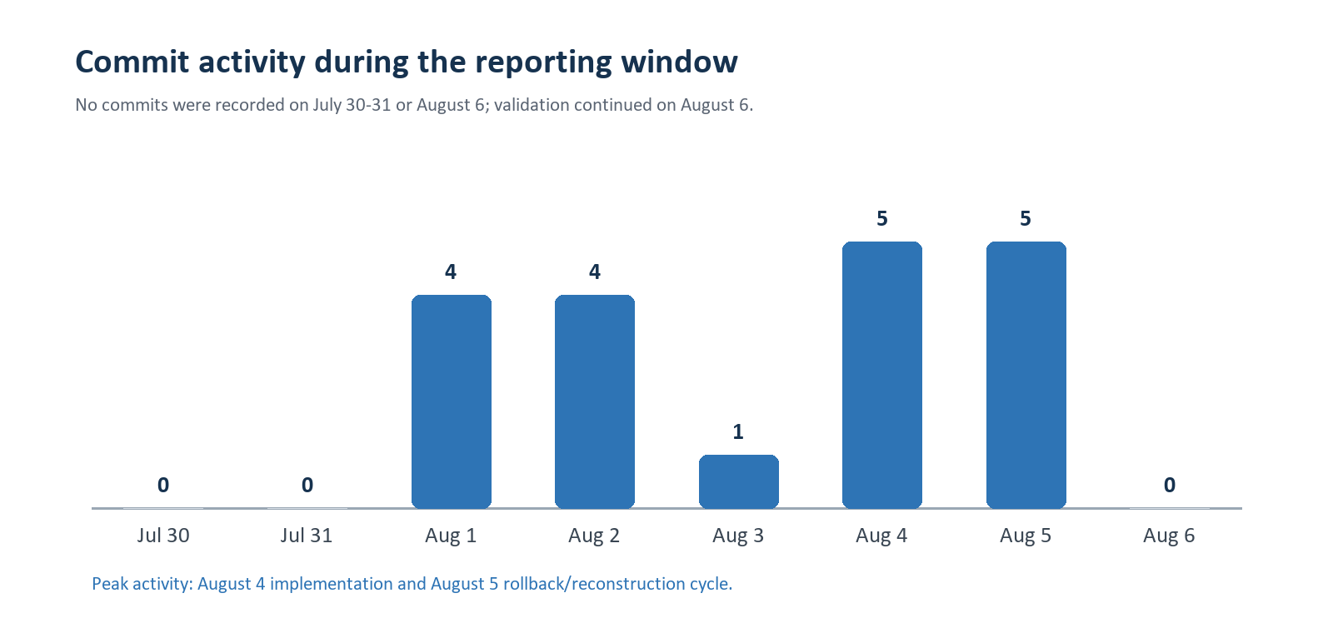
Figure 1. Commit activity by date.

Milestones by day
Date | Theme | Evidence-backed summary
30-31 Jul | No commits found | Period is included for completeness; no Git activity is visible on branch-h.
1 Aug | Experiment and architecture expansion | Ablation/result plotting work, dataset naming cleanup, GSM8K generation changes, dependency graph, cache manager, HF end-to-end tests, and grouped aggregation.
2 Aug | Compatibility and metric correctness | GPT-2 eager attention fix; Transformers v4/v5 cache adapter; Llama/Qwen cache updates; dataset-aware GSM8K, NIAH, and HotpotQA metrics across runner and analysis paths.
3 Aug | Controlled execution notebook | Added the staged actual-testing notebook and updated the live HF runner/grid path.
4 Aug | Paper protocol and qualification prototype | Fixed GSM8K prompt/judging work, prompt serialization, FullKV parity, dtype changes, and notebook refinements.
5 Aug | Rollback and reconstruction | Five commits reverted the August 4 paper-qualification sequence. Later working-tree changes reconstructed and extended the qualification layer without a new commit.
6 Aug | Independent validation and reporting | No new commit. Full local test suite executed successfully and the present analysis was assembled.

4. Engineering Work Delivered

4.1 Core dependency-aware eviction architecture
The central architecture moved beyond independent per-token pruning toward a chunk- and dependency-aware cache policy. The dependency_graph module accumulates sparse historical chunk relationships during blockwise prefill, while scorer and masker changes route importance and protect sink/recent regions. The cache manager enforces re-eviction during generation so the decode path remains bounded.
- Sentence/punctuation chunk construction and a maximum chunk size guard limit pathological punctuation-free spans.
- Tier 0/1/2 policy separation distinguishes eviction candidates, soft protection, and hard protection.
- Whole-chunk ranking is combined with a partial boundary trim to support token-granular matched budgets.
- Blockwise prefill releases dense attention blocks after their scores and dependency edges are consumed, reducing attention-memory pressure.

4.2 HuggingFace compatibility and generation correctness
The live model path was substantially hardened for modern Transformers cache semantics. The hf_cache_adapter and cache_utils changes support v4/v5 cache forms, global logical positions, and repeated compressed-cache decoding across tiny GPT-2, Llama, and Qwen2 fixtures.
Model/path | Engineering change | Verification intent
GPT-2 | Eager attention compatibility | Offline end-to-end regression coverage
Llama | Dynamic/cache-position compatibility | Compressed-cache parity and decode coverage
Qwen2 | Transformers v4/v5 cache compatibility | Local small-model qualification target
All compressed paths | Exact retained-position handling | Repeated decode-time re-eviction tests

4.3 Experiment runner, baselines, and aggregation
The HF grid runner became the primary orchestrator for multi-model, multi-dataset, multi-method experiments. It records per-run cache diagnostics and grouped results while supporting FullKV and compressed methods. H2O and SnapKV were refactored to accept externally computed scores so scoring occurs once and is passed into eviction; ChunkKV remains independently attention-scored.
BASELINE CAVEAT StreamingLLM, H2O, SnapKV, and ChunkKV are currently labeled as local approximations. The repository documentation correctly avoids claiming bit-for-bit parity with official reference implementations.

5. Evaluation, Reproducibility, and Qualification

5.1 Dataset-aware judging
Dataset | Primary metric | Implemented interpretation
GSM8K | Final numeric exact match | Extract and normalize the final numerical answer; gold answers use the value after #### when present.
NIAH | Needle retrieval accuracy | Check whether the complete normalized needle appears contiguously in the generated answer.
HotpotQA | Official normalized answer F1 | Lowercase, punctuation/article normalization, plus exact-match as a secondary metric.
Generic diagnostics | Full-output EM/F1 | Retained for debugging only; not used as the headline result for the three main tasks.

5.2 Phase-1 qualification layer (current working tree)
After the August 5 rollback, a broader qualification implementation is present locally but is not committed. Its purpose is to stop weak or incomparable runs from entering paper tables.
Control | What it now records or enforces
Prompt identity | Serialize exactly once as raw/chat/auto; store raw, rendered, and token-ID SHA-256 hashes.
Protocol lock | ChunkKV-style GSM8K eight-shot protocol with canonical metadata and incompatible-template rejection.
Generation parity | Compare HuggingFace FullKV generation with the unpruned custom-cache path on identical token IDs.
Runtime accounting | CUDA-synchronized model load, prefill, scoring, policy, and decode timings; peak allocated/reserved memory.
Reproducibility | Git/environment provenance, deterministic seeds and fingerprints, model revision, and dataset/protocol metadata.
Checkpoint/resume | Atomic checkpoint after each completed row; immutable successful run keys; retry failed or mismatched rows.
Hard qualification gate | Reject errors, parity failures, empty outputs, missing measurements, missing CUDA when required, and budget-contract violations.

Working-tree status at review time: 13 modified tracked files (1,496 insertions and 148 deletions) plus nine untracked modules/tests. These changes should be committed before they are treated as a stable milestone.

6. Validation and Current Repository State
TESTS PASSED | TEST FAILURES | TEST DURATION | NON-FUNCTIONAL WARNING
121 | 0 | 49.87 s | 1

VALIDATION RESULT The full current test suite passed. Pytest emitted one warning because it could not create .pytest_cache in the workspace; test execution and assertions were unaffected.

Coverage represented by the current suite
- Core chunker, dependency graph, scorer/masker/evictor, cache manager, and baseline utilities.
- Transformers cache adapter and offline GPT-2/Llama/Qwen2 end-to-end generation paths.
- Dataset-aware evaluation metrics, grouped aggregation, prompt protocol/serialization, runtime metrics, reproducibility metadata, and qualification failures.
- Budget utilization, prompt hashing, checkpoint/resume semantics, and FullKV/custom-cache parity scaffolding.

Current working-tree state
Category | State | Interpretation
Tracked modifications | 13 files | Runner, metrics, docs, baselines, cache utilities, and regression tests
Untracked additions | 9 files | Four benchmark modules and five focused test modules
Tracked diff volume | +1,496 / -148 | Excludes untracked-file line counts
Branch | branch-h | HEAD is the August 5 revert sequence; reconstructed work is local

RELEASE RISK The code passes tests, but the qualification layer is not yet protected by a commit. A clean checkpoint commit is the immediate source-control priority.

7. Notebook Experiments and Results
Three notebooks were created or updated during the week. Their roles are distinct:
Notebook | Purpose | Saved evidence
tdc_kv_colab_quickstart.ipynb | Environment, imports, unit tests, trace smoke, tiny HF smoke | No saved execution outputs
tdc_kv_actual_testing.ipynb | Guarded GSM8K/NIAH/HotpotQA smoke and pilot runbook | No saved execution outputs
test.ipynb | Executed Colab development and pilot evidence | Contains saved environment, test, run, table, and sample outputs

7.1 Experimental setup represented in saved outputs
Field | Saved notebook value
Model | Qwen/Qwen2.5-0.5B-Instruct
Environment | PyTorch 2.11.0+cu128; CUDA 12.8; Transformers 5.13.1
Budgets | FullKV plus requested retention ratios 0.25, 0.50, 0.75
GSM8K | 10 samples x 4 configurations = 40 runs
NIAH | 5 samples x 4 configurations = 20 runs
HotpotQA | 5 samples x 4 configurations = 20 runs
Completion | 80 successful, 0 failed

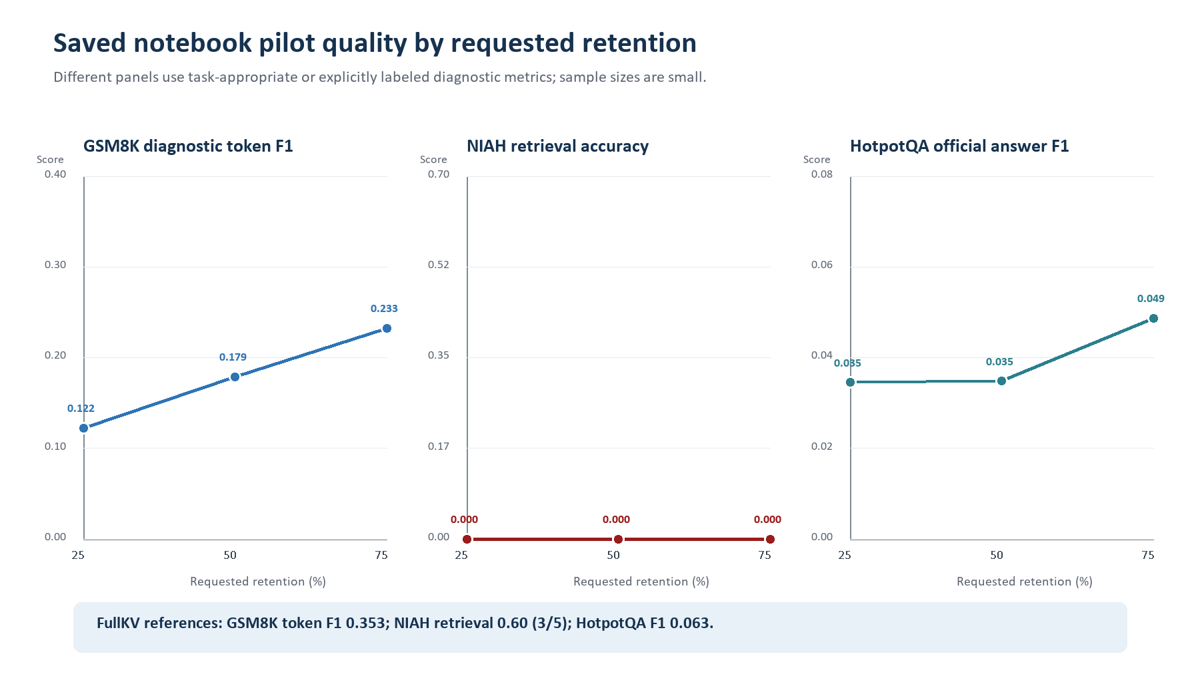
Figure 2. Saved pilot quality curves by requested retention.

8. Detailed Pilot Results

8.1 GSM8K
All 40 runs completed. The 0.5B model produced no correct FullKV final answers in the 10-sample pilot, while TDC-KV produced one correct final answer at the 75% requested ratio. This isolated 1/10 result is not evidence of improvement; diagnostic token F1 remained below FullKV at every compressed setting.
Method | Actual retention | Compression | Multiplier | Token F1 | Final EM | Evict ms | Budget gap
FullKV | 100.0% | 0.0% | 1.00x | 0.3525 | 0.00 | 0.000 | 0.0
TDC-KV 25% | 16.0% | 84.0% | 8.05x | 0.1223 | 0.00 | 1.274 | -8.4
TDC-KV 50% | 41.7% | 58.3% | 2.44x | 0.1788 | 0.00 | 0.925 | -8.0
TDC-KV 75% | 67.6% | 32.4% | 1.49x | 0.2325 | 0.10 | 0.801 | -6.8

FINDING GSM8K quality was model-limited and budget matching was imperfect in the older notebook run. The current exact-budget contract and fixed numerical judging should be used for the rerun.

8.2 Needle-In-A-Haystack (NIAH)
All 20 runs completed, but the result is a clear failure signal. FullKV retrieved the exact needle in 3 of 5 samples (60%); every compressed TDC-KV run missed it (0 of 15). Two FullKV failures occurred at the 2,048-token limit, consistent with truncation at the end of the constructed context.
Method | Actual retention | Needle retrieval | Token F1 | Multiplier | Evict ms | Budget gap
FullKV | 100.0% | 60% (3/5) | 0.1733 | 1.00x | 0.000 | 0.0
TDC-KV 25% | 0.6% | 0% (0/5) | 0.0000 | 192.44x | 0.868 | -494.0
TDC-KV 50% | 20.4% | 0% (0/5) | 0.0000 | 76.22x | 1.253 | -596.4
TDC-KV 75% | 50.8% | 0% (0/5) | 0.0000 | 1.97x | 2.015 | -490.2

CRITICAL FINDING NIAH exposed severe underfill at the requested 25% and 50% ratios and zero compressed retrieval. This pilot must be rerun after exact-budget enforcement, longer max length, and evidence/needle-survival logging.

8.3 HotpotQA
All 20 runs completed with exact budget matching. FullKV official answer F1 was 0.0627; TDC-KV reached 0.0345, 0.0348, and 0.0487 at 25%, 50%, and 75% retention. The 75% setting preserved about 77.6% of the FullKV F1, but the absolute scores are too low and the sample too small for a research claim.
Method | Retention | Official F1 | F1 vs FullKV | Multiplier | Evict ms | Exact budget
FullKV | 100.0% | 0.0627 | 100.0% | 1.00x | 0.000 | 100%
TDC-KV 25% | 25.0% | 0.0345 | 55.1% | 4.00x | 7.575 | 100%
TDC-KV 50% | 50.0% | 0.0348 | 55.5% | 2.00x | 6.012 | 100%
TDC-KV 75% | 75.0% | 0.0487 | 77.6% | 1.33x | 5.180 | 100%

FINDING HotpotQA is the cleanest budget-fidelity result in the notebook. It demonstrates the intended retention control, while quality degradation shows the need for larger models, more samples, and baseline comparisons.

8.4 Budget-fidelity comparison
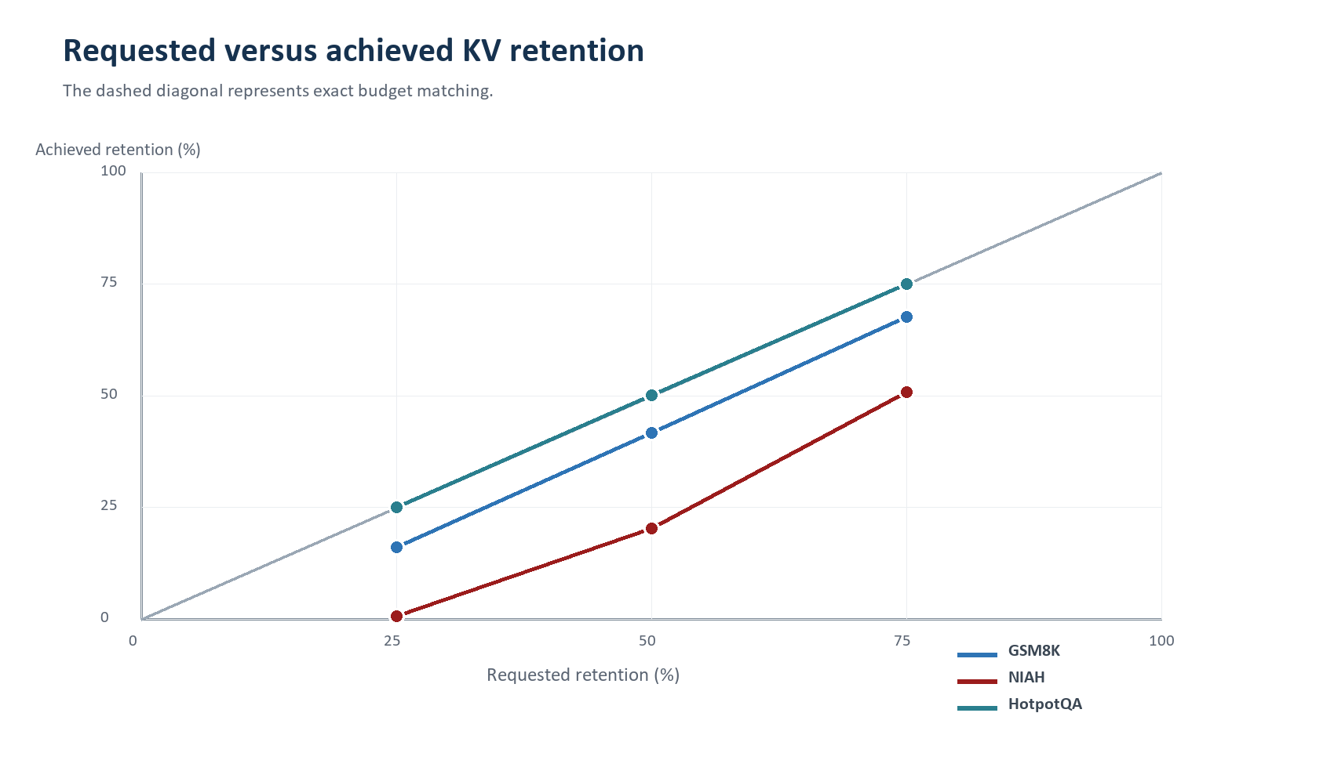
Figure 3. Requested versus achieved KV retention.

9. Cross-Result Assessment
Dimension | Assessment | Evidence
Execution reliability | Strong in pilot | 80/80 runs completed; notebook guard cells passed.
Regression reliability | Strong locally | 121/121 current tests passed.
Budget fidelity | Mixed | Exact for HotpotQA; underfill in older GSM8K and severe underfill in NIAH.
Task quality | Not yet sufficient | Small model and tiny samples; NIAH compressed retrieval failed; absolute QA scores low.
Reproducibility controls | Implemented, uncommitted | Prompt hashes, provenance, run keys, checkpoints, parity, qualification gate.
Paper readiness | Not ready | No official external baselines, no 7B/8B qualified runs, no repeated seeds or significance tests.

What the week successfully proved
- The implementation can execute real HuggingFace cache-compression grids across three task families and aggregate cache/quality diagnostics without run failures in the saved pilot.
- Exact budget matching is achievable in the current eviction framework, as demonstrated cleanly on HotpotQA and reinforced by the later qualification checks.
- The testable architecture now separates prompt protocol, model/cache compatibility, scoring, policy, generation, metrics, and qualification concerns.

What the week did not prove
- That TDC-KV improves quality over FullKV or strong official baselines at a matched budget.
- That the local H2O, SnapKV, ChunkKV, or StreamingLLM approximations reproduce official implementations.
- That performance generalizes to 7B/8B models, long contexts, multiple seeds, or publication-scale sample counts.
- That the current uncommitted qualification path has completed an end-to-end CUDA qualification run on the target hardware.

10. Risks, Open Issues, and Recommended Next Steps
Priority | Risk | Impact | Required action
High | Uncommitted qualification layer | A rollback can erase or fragment the strongest reproducibility work. | Commit a clean Phase-1 checkpoint with tests and a concise migration note.
High | NIAH retrieval collapse | Zero compressed retrieval prevents any long-context preservation claim. | Rerun with exact budget, larger max length, needle/evidence survival metrics, and sample-level failure traces.
High | Weak small-model quality | Near-zero GSM8K accuracy and low HotpotQA F1 obscure policy effects. | Use the 0.5B model only for qualification; move claims to 7B/8B models after qualification passes.
Medium | Approximate baselines | Comparisons may be challenged as non-standard. | Integrate or clearly separate official reference baselines; retain approximation labels.
Medium | Tiny sample counts | Single examples materially change percentage scores. | Run staged 50-sample tuning, then full evaluation with three seeds and paired statistics.
Medium | Older notebook/output mismatch | Saved results predate current metrics and budget gate. | Regenerate outputs from the controlled-testing notebook and archive JSON as source of truth.

Recommended execution sequence
- Stabilize source control: review, commit, and tag the current qualification work; preserve the successful 121-test baseline.
- Run a two-sample local CUDA qualification with FullKV parity, exact budgets, prompt hashes, runtime/memory logging, checkpoint/resume, and the hard gate enabled.
- Rerun the controlled GSM8K, NIAH, and HotpotQA pilots using the current code. Use 50 samples per dataset for the tuning stage and archive raw JSON plus grouped results.
- Fix NIAH context truncation and add explicit needle-token survival/evidence metrics before interpreting retrieval quality.
- Confirm method fairness under the common decode policy and complete official/reference baseline integration or clearly partition approximation results.
- Only after the gate passes, run the planned 7B/8B model x dataset x budget grid on A100-class hardware and report mean, standard deviation, latency, throughput, and peak VRAM.
NEAR-TERM SUCCESS CRITERION A rerun is ready for interpretation only when every row is successful, FullKV parity passes, prompt identity is fixed, generations are non-empty, runtime/memory measurements exist, and matched budgets meet the utilization/shortfall contract.

Appendix A. Commit Chronology
Date | Commit | Message
01 Aug | 38095bd | ablations, result tables and graphs for full scale run
01 Aug | c29d845 | dataset name change
01 Aug | b190848 | gsm8k generation result modifications
01 Aug | fd3acf2 | major upgrades
02 Aug | 8a4d7c6 | Fix GPT2 eager attention compatibility test
02 Aug | 97fe299 | Add Transformers v4 and v5 cache compatibility
02 Aug | b318952 | llama updates
02 Aug | 68f3154 | Add proper GSM8K, NIAH, and HotpotQA metrics.
03 Aug | 9c2dd14 | actual testing added
04 Aug | 077b493 | small changes
04 Aug | 620ffd1 | implement the paper-compatible GSM8K prompt, judging protocol, and 100%-retention parity evaluation
04 Aug | 181764f | small changes
04 Aug | ade97b6 | FullKV qualification and generation-path parity
04 Aug | 3dca70d | float16 to float32 change
05 Aug | 17bc250 | Revert float16 to float32 change
05 Aug | b957737 | Revert FullKV qualification and generation-path parity
05 Aug | 1f785fc | Revert small changes
05 Aug | 3fa9da7 | Revert paper-compatible GSM8K prompt/judging/parity evaluation
05 Aug | 471fde0 | Revert small changes

Commit timestamps are local (+05:30) and were read from branch-h. Five August 5 revert commits share near-identical timestamps and are listed in Git order.

Appendix B. Source Artifacts
Evidence type | Artifact or command
Git | branch-h log, status, diff and net comparison against 4118943
Notebook | notebooks/test.ipynb saved outputs for environment, tests, GSM8K, NIAH and HotpotQA
Runbooks | notebooks/tdc_kv_colab_quickstart.ipynb and notebooks/tdc_kv_actual_testing.ipynb
Project docs | README.md, context.md, specifications.md, tdc_kv_results_experiment_plan.md
Validation | Fresh `py -m pytest -q` run on 6 August 2026

End of report.

