**Current State**

The U.S. economy is currently in the mid-expansion phase of its business cycle, with GDP growth moderating after a strong recovery from the COVID-19-induced recession. In Q3 2024, GDP grew at an annualised rate of 2.66%, supported by resilient consumer spending and business investments. However, growth has decelerated compared to the post-pandemic rebound in 2021, 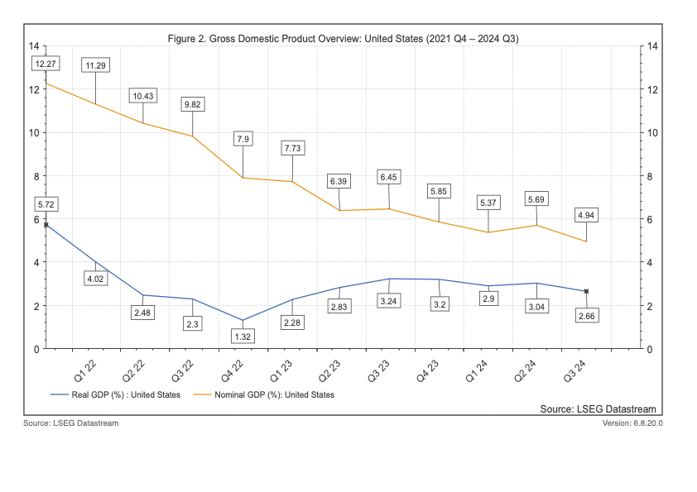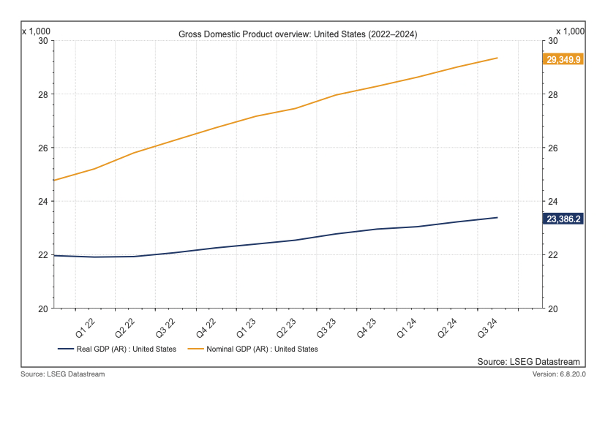where GDP surged by 5.72% annually.

The labor market continues to demonstrate resilience despite signs of slowing. The unemployment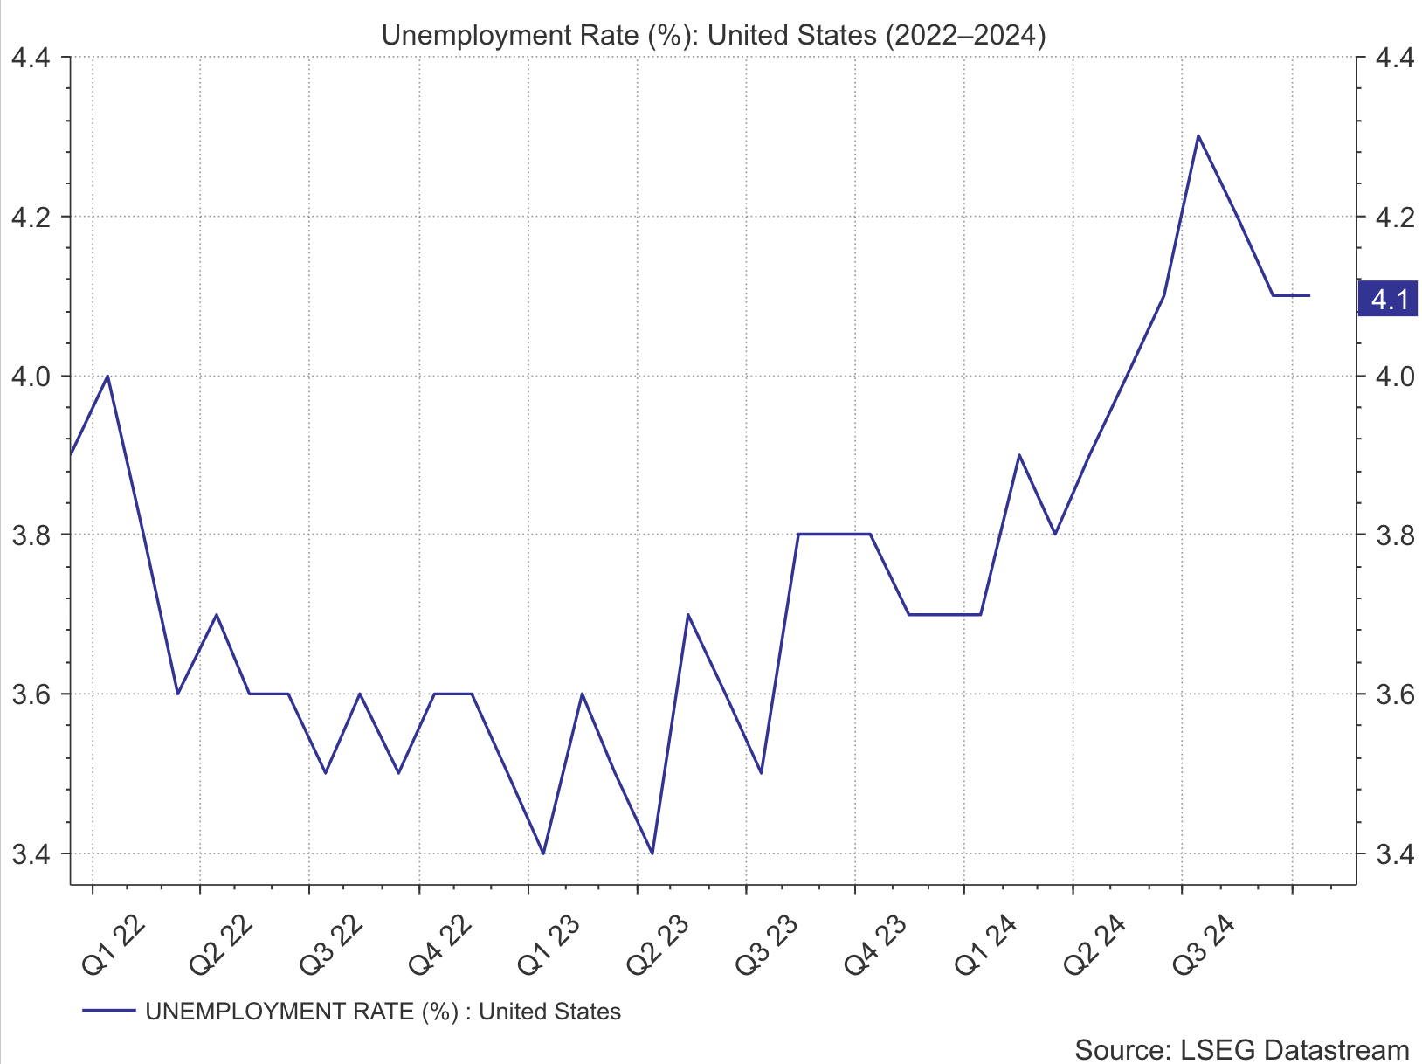 rate remains historically low at 4.1% as of October 2024. However, job creation has moderated compared to the rapid post-pandemic hiring surge. Labor market conditions are tight, with some sectors experiencing difficulty filling positions, a trend consistent with the 2018–2020 pre-pandemic period. Future projections indicate a gradual rise in unemployment to 4.5% by 2025, driven by slower economic growth and monetary tightening.

Inflation remains a central concern for policymakers and businesses. As of October 2024, the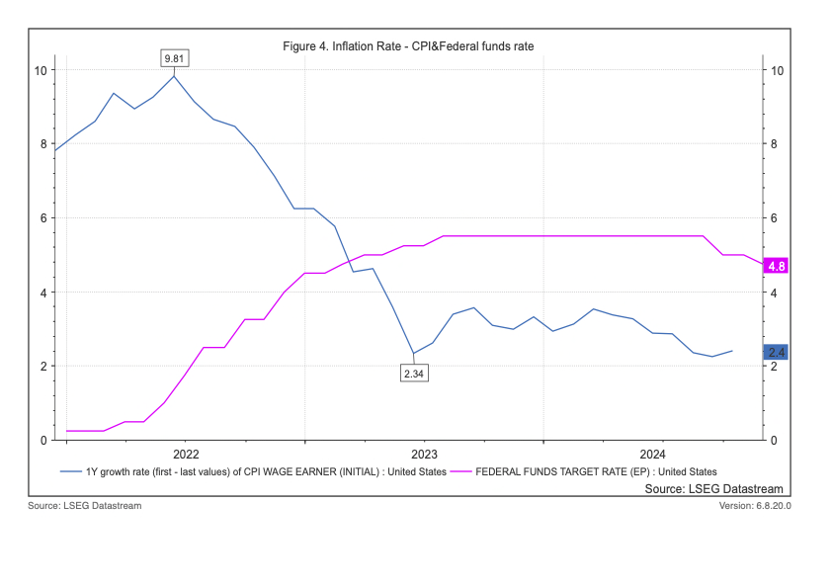 Consumer Price Index (CPI) recorded a year-over-year increase of 2.4%, down significantly from the 9.81% peak in mid-2022. The Federal Reserve has maintained the federal funds rate at 4.75% in November, reflecting its commitment to achieving its 2% inflation target. This aggressive monetary tightening has curbed demand-side inflationary pressures but also raised borrowing costs, impacting investment and consumer spending.

Consumer spending, which accounts for nearly 70% of U.S. GDP, remains a key driver of economic activity. While spending has remained robust, contributing to Q3 2024 GDP growth, it has started to decelerate. Factors such as higher interest rates, inflation, and reduced real disposable income are constraining household budgets. Durable goods spending, in particular, has weakened due to rising credit costs.

**Future Outlook**

The Conference Board Economic Forecast

for the US Economy

Updated 23 October 2024

Q4 Soft Patch Likely

* The economy may still lose some momentum at the end of this year reflecting continued dampening effects on housing from high prices and interest rates, and net exports drag. However, consumer spending may not weaken as much as previously believed, as income growth has been stronger, wage growth remains robust for many industries, and the level of payrolls probably will remain elevated as CEOs continue to signal a penchant for hiring and hoarding labor. This should provide continued capacity for households to spend as well as to pare down accumulated credit card debt.
* Additionally, consecutive natural disasters in the southeast region of the US, suggest a slow start to real GDP growth at the top of Q3 quarter.

Faster Quarterly Economic Activity Expected in 2025

* Quarterly economic activity should pick up over the course of 2025 as the Fed continues its rate cutting cycle and inflation settles at the central bank’s 2-percent target around mid-year.
* Real GDP growth should rise slightly above 2 percent on a quarterly annualised basis by reflecting the achievement of the Fed’s 2-percent inflation target and lower interest rates. Still, tepid momentum heading into the start of 2025 may result in a 1.7 percent year-over year growth rate for the US economy in 2025. This rate would be below the potential rate of growth (2.1 percent) projected by the Congressional Budget Office for 2025.

US Consumers Hanging in There

* Tracking data for Q3 2024 suggests that real consumer spending rose by 3.5 percent annualised over the July-August period, matching the Q2 pace. The spending continues to be driven in large part by purchases of durable goods and services. Notably, consumers are purchasing more big-ticket items likely autos and furniture as prices are falling. This might continue as interest rates fall and financing is more affordable. Still, we are seeing that other consumer purchases are rotating towards cheaper and necessary goods and services.

Labor Market Remains Solid

* The US labor market remains solid. The cooling that has occurred in the labor market is following outsized growth that was necessary for restoring employment post-pandemic. Nonfarm payrolls were outsized in September, and July and August readings were revised upward. The unemployment rate ticked down again to 4.1 percent, and only half of unemployed persons are not working due to a layoff, as opposed to most which was the case the past when the US economy descended into recession. Hours worked remain stable, and wage growth continues to be elevated.
* Both we and the Fed continue to judge that the labor market is in better balance and remains relatively healthy. The unemployment rate is quite low historically speaking, and as many industries have rehired workers let go during the pandemic, it makes sense that payroll gains need not be exceptionally large going forward. Additionally, labor shortages are continuing to drive hiring in key industries as Baby Boomers retire and front-line and manual worker jobs remain hard to fill.
* The labor market may moderate ahead, but not collapse as large US firms continue to hoard workers, and small firms indicate that they plan to continue to hire. While these dynamics are keeping many people employed, labor market churn associated with labor shortages continue to keep wages and benefits elevated – costs many firms are passing onto consumers. Indeed, The Conference Board US Salary Increase Budgets 2024-2025 Survey indicates that firms continue to plan to devote notable shares of their budgets to compensation next year, relative to pre-pandemic norms.

United States Economic Forecast

20 SEPTEMBER 2024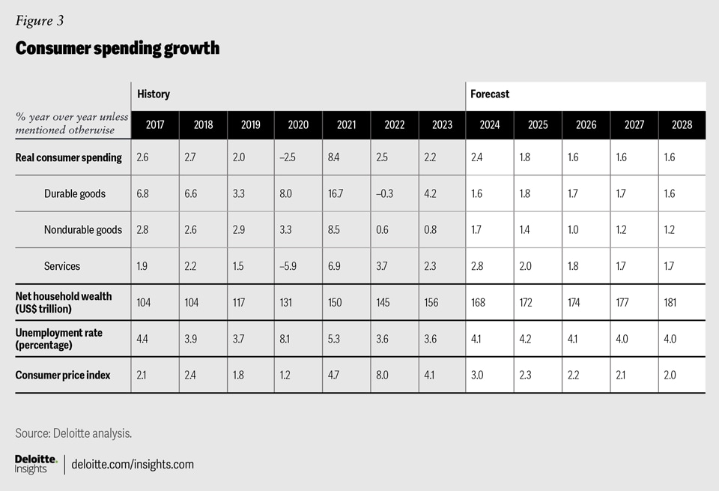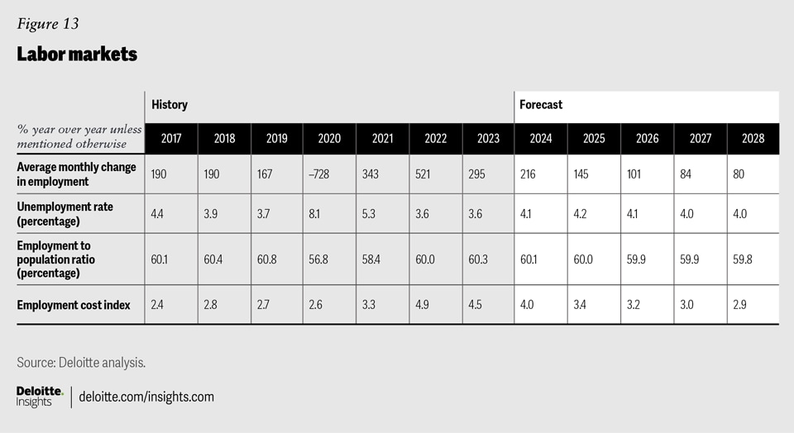

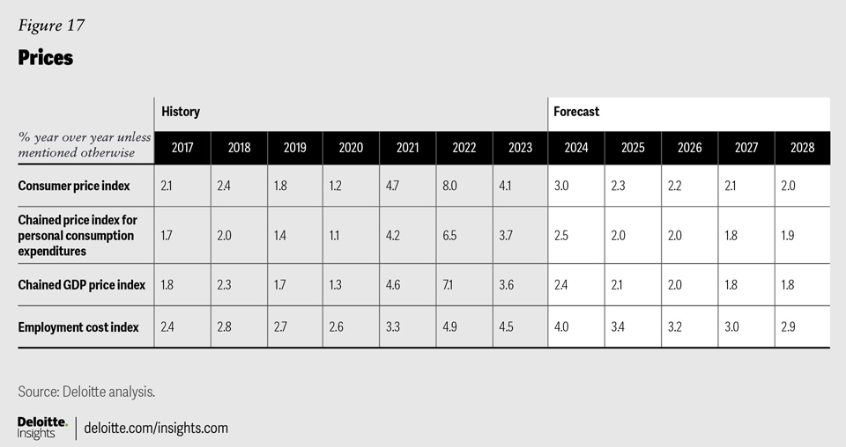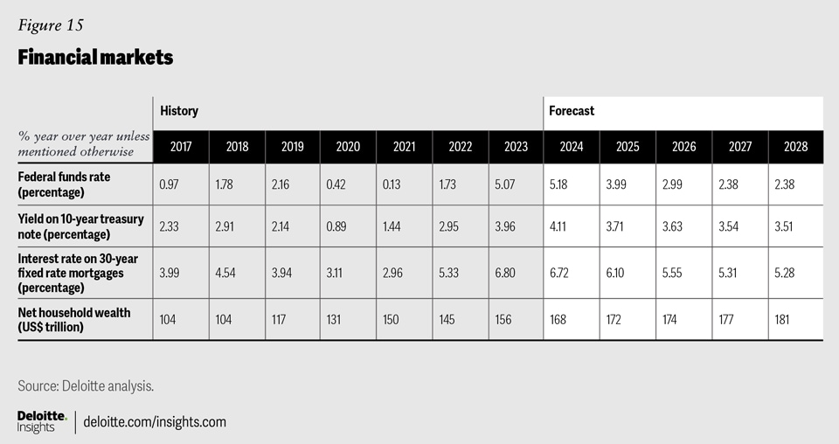

Bibliography

1. Kalish, I. and Gibbard, R. (2024). *United States Economic Forecast*. [online] Deloitte Insights. Available at: <https://www2.deloitte.com/us/en/insights/economy/us-economic-forecast/united-states-outlook-analysis.html> [Accessed 26 Nov. 2024].
2. Peterson, D.M. (2024). *Economic Forecast for the US Economy*. [online] The Conference Board. Available at: <https://www.conference-board.org/research/us-forecast> [Accessed 26 Nov. 2024].
3. analyse the current state and future outlook of a selected country/economy from a macroeconomic and financial perspective.
4. MUST include figures and/or tables from various data sources, as well as research reports or studies that justify and support the analysis conducted.

PESTLE analysis/SWOT/Scenario planning

|  |  |  |  |
| --- | --- | --- | --- |
| Best case |  |  |  |
| Most likely |  |  |  |
| Worst case |  |  |  |

Econ indicators

1. GDP Growth
2. Unemployment: Present the unemployment rate and trends to show labor market health.
3. Inflation: Analyse recent inflation trends and monetary policies.
4. Interest Rates: Examine changes in central bank rates, such as the Federal Funds Rate, and their implications.
5. macroecon performance (GDP, consumption, investment, and international trade)
6. stability (central government budgets, prices, the money supply, and the balance of payments)

Projections suggest GDP growth will stabilise around 2.0% in 2025, aligning with long-term trends and reflecting tighter monetary policies designed to combat inflation.