MK20DX128VFM5 – QFN32

Pin17_PTA18 (EXTAL0)

Pin18_PTA19 (XTAL0)

Pin3_USB0_DP

Pin4_USB0_DM

Pin12_PTA0 (JTAG_TCLK/SWD_CLK)

Pin13_PTA1 (JTAG_TDI)

Pin14_PTA2 (JTAG_TDO)

Pin15_PTA3 (JTAG_TMS/SWD_DIO)

Pin19_RESET_b

Pin24_PTC3 (UART1_RX)

Pin25_PTC4 (UART1_TX)

Pin29_PTD4

Pin16_PTA4

Pin20_PTB0

Pin26_PTC5 (SPI0_SCK)

Pin27_PTC6 (SPI0_SOUT)

Pin28_PTC7 (SPI0_SIN)

Pin21_PTB1

8MHz

无源晶振

**K20 JTAG/SWD**

5x2插头

1.28mm

蓝色LED

Boot按键

USB接口

Mini_B,1x5

UART接口

TTL

**Target SWD**

74LVC缓冲器

SWD_CLK

SWD_DIO

SIM_EN

SIM_OE

SIM_SWD

OpenSDA

UART_RXD

UART_TXD

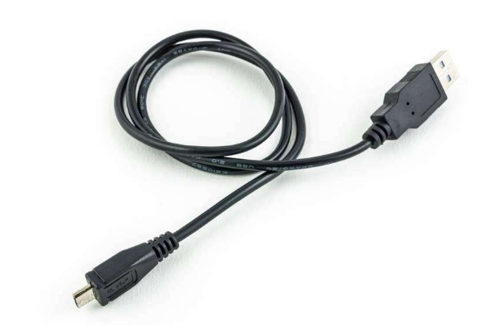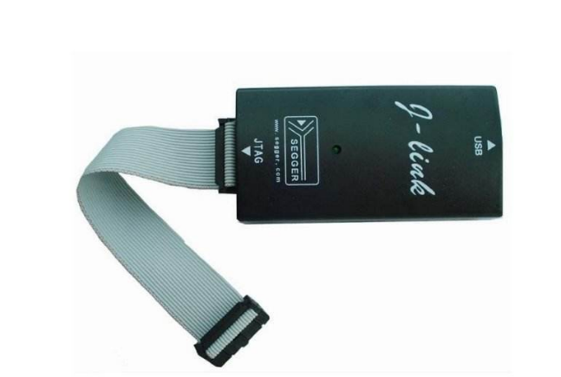

SWD_RST

SIM_RST